**(CS-243)-DataBase Systems-Section-A**



Topic:

**Matchmaking**

Submitted by:

**Maida Kosser(221400091)**

**Muhammad Noman(221400087)**

Submitted to:

**Mam Anam Shehzadi**

**BS Software Engineering(IV)**

**GIFT University, Gujranwala**

**Project Requirements:**

**Problem Statement:**

**Marriage is about uniting two souls physically and spiritually under the pure and true vows to follow Sunnah. For this purpose, a platform is required to help people, so they can find out their perfect match remotely. Keeping in mind the present traditions, values, and consents, the proposed solution is an online matchmaking system that will reflect the commitments and interests of every person looking for a relationship. The application will allow the user to put the personal information, educational details, job details, religious details, House details, and some Family details after the registration. The person can search and contact the desired profile that matches their requirements. A predefined amount will be charged to display the desired results. The system will allow the individuals to search for their match by Gender, Age, Religion, and Caste.**

**Functional Requirements:**

**• System will allow admin to login/logout.**

**• System will allow candidate to login/logout.**

**• System will allow candidates to register with a simple signup (they could either be free or paid members).**

**• System will allow Admin to set paid members status active so their profile could be published with contact details and they can contact with their desired member.**

**• System will allow Admin to set free members status inactive so their profile could be published with contact details but they can only view other member’s profile.**

**• System will allow candidate to put the personal information (Name, Age, Height, Email-Id, Contact Number, Profile Image, Marital status, religion, sect, Father and Mother Name etc.).**

**• System will allow candidate to put the educational details (list down the achievements in educational filed), and the job/Business details (Designation, income etc.).**

**• System will allow candidate to put the Own House/ Property details (if any).**

**• System will allow candidate to put the Family details (number of siblings, Father and Mother Occupation, Married persons in house etc.)**

**• System will allow candidate to search their desired match by Gender, Age, Religion, and Caste. Religion and caste will be prioritized.**

**Stake holders:**

**• Admin**

**• Groom/bride**

**ERD Diagram:**

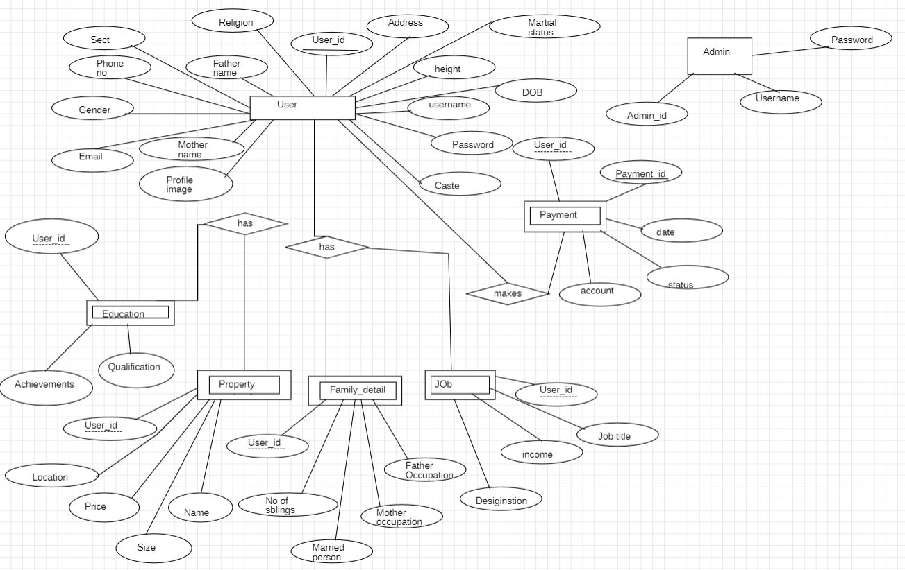

**Relational Model:**

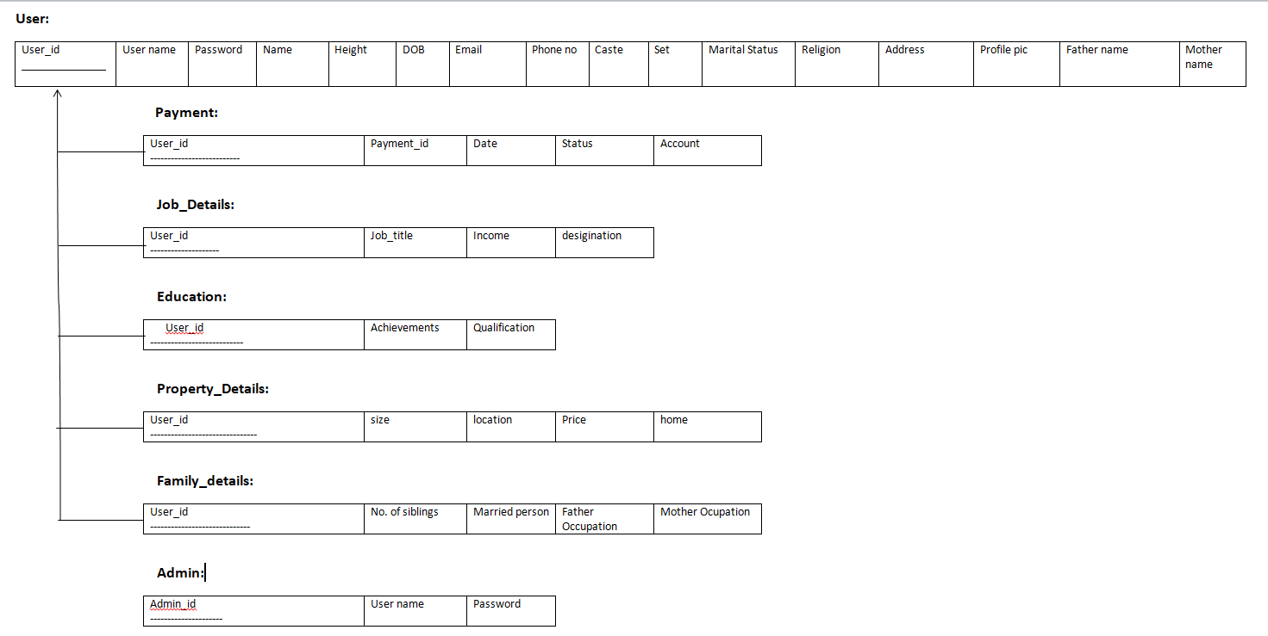

**Screenshots:**



