PSEUDOCODE

Question:1 Find if the number is multiple of 5.

# **START**

# // Input/Output

Input number1

# // variables and Initialization

Set multiple to 5

# // Process Steps

SET remainder to number1 % multiple

# // Conditional Statements

IF remainder = 0 THEN

PRINT “your number is multiple of 5”

ELSE

PRINT “your number is not a multiple of 5”

**END**

Question:2 Check if a character is uppercase or lowercase.

# // Input/Output

INPUT character

# // Process Steps

SET uppercase to [A,B,C,D,E,F,G,H,I,J,K,L,M,N,O,P,Q,R,S,T,U,V,W,X,Y,Z]

# // Conditional Statements

IF character == uppercase THEN

PRINT “your character is in uppercase”

ELSE

PRINT “your character is in lowercase”

**END**

Question:3 Create a small calculator which only does ‘+’ or ‘*‘Operations. (Hint: Take three variable inputs with one being used for the operator)

# **START**

# // Input/Output

INPUT number1

INPUT number2

INPUT operation

# // Process Steps

SET number1 (operation) number2

# // Conditional Statements

IF operation = ‘+’ THEN

PRINT “number1 + number2”

ELSE IF operation = ‘*’ THEN

PRINT “number1 * number2”

ELSE

PRINT “invalid operation”

**END**

Question:4 Check whether a given number is positive, negative, or zero.

# **START**

# // Input/Output

INPUT number

# // variables and Initialization

SET check to 0

# // Conditional Statements

IF number > check THEN

PRINT “your number is positive”

ELSE IF number < check THEN

PRINT “your number is negative”

ELSE

PRINT “your number is 0”

**END**

Question:5 Determine if a person is a teenager (between 13 and 19 years old).

# **START**

# // Input/Output

INPUT age

# // variables and Initialization

SET range1 to 13

SET range2 to 19

# // Conditional Statements

IF age >= range1 && age<=range2 THEN

PRINT “you are teenager”

ELSE

PRINT “you are not a teenager”

**END**

GITHUB IMAGE

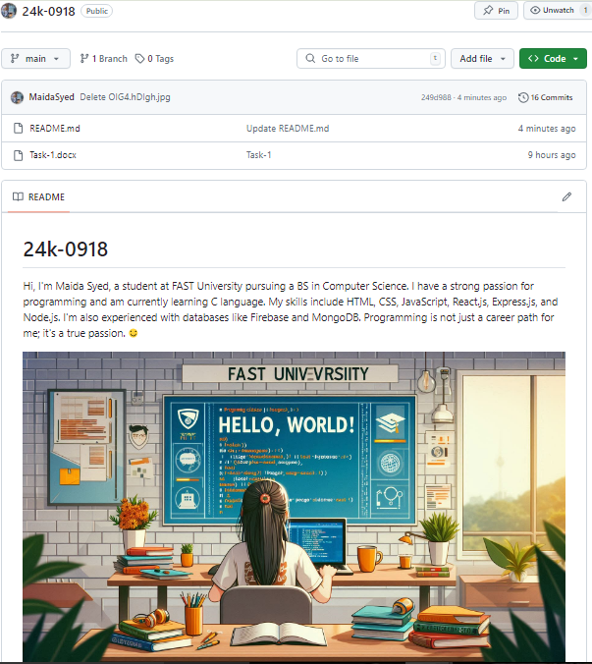

ALGORITHM