**Intial scripting activity with Load runner**

1. Click on VUGen.exe

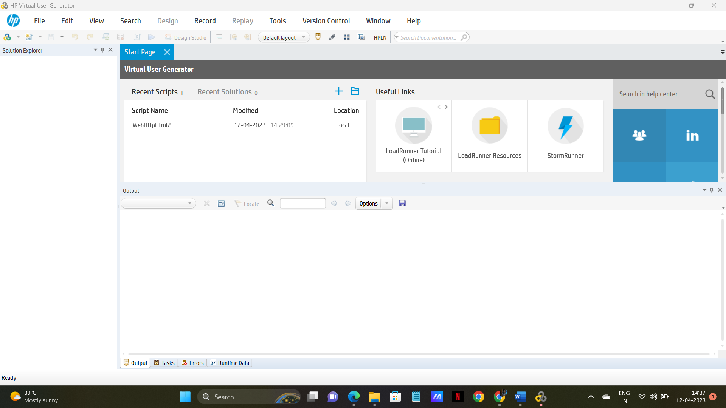

1. Click on Add new script button. (after vugen symbol) or File 🡪 Add 🡪 New Script

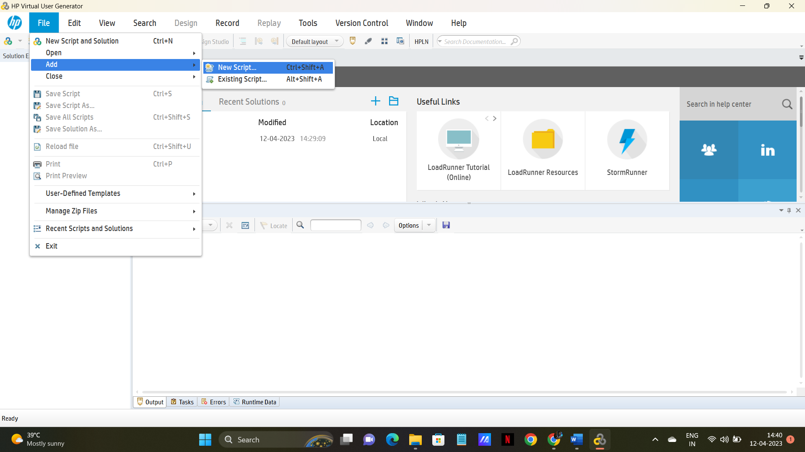

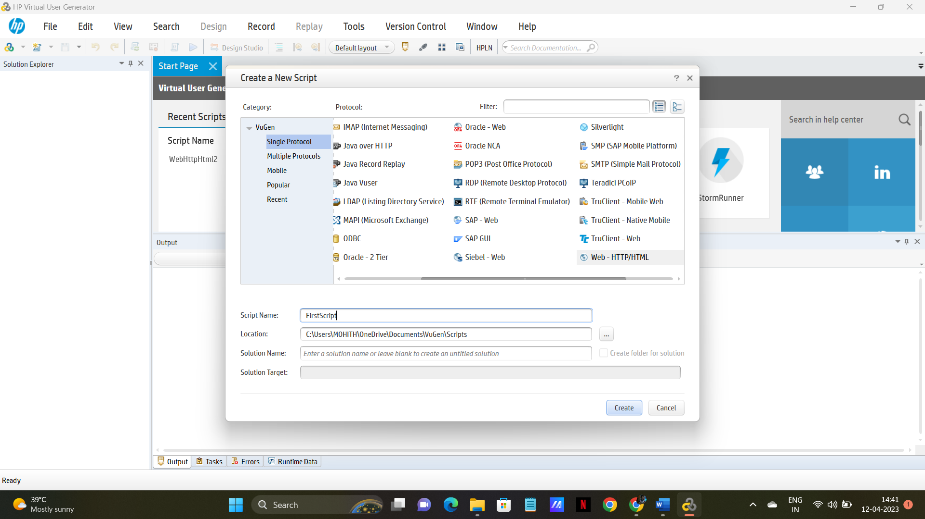

1. Select “web Http/HTML” and click Create.It should display like this

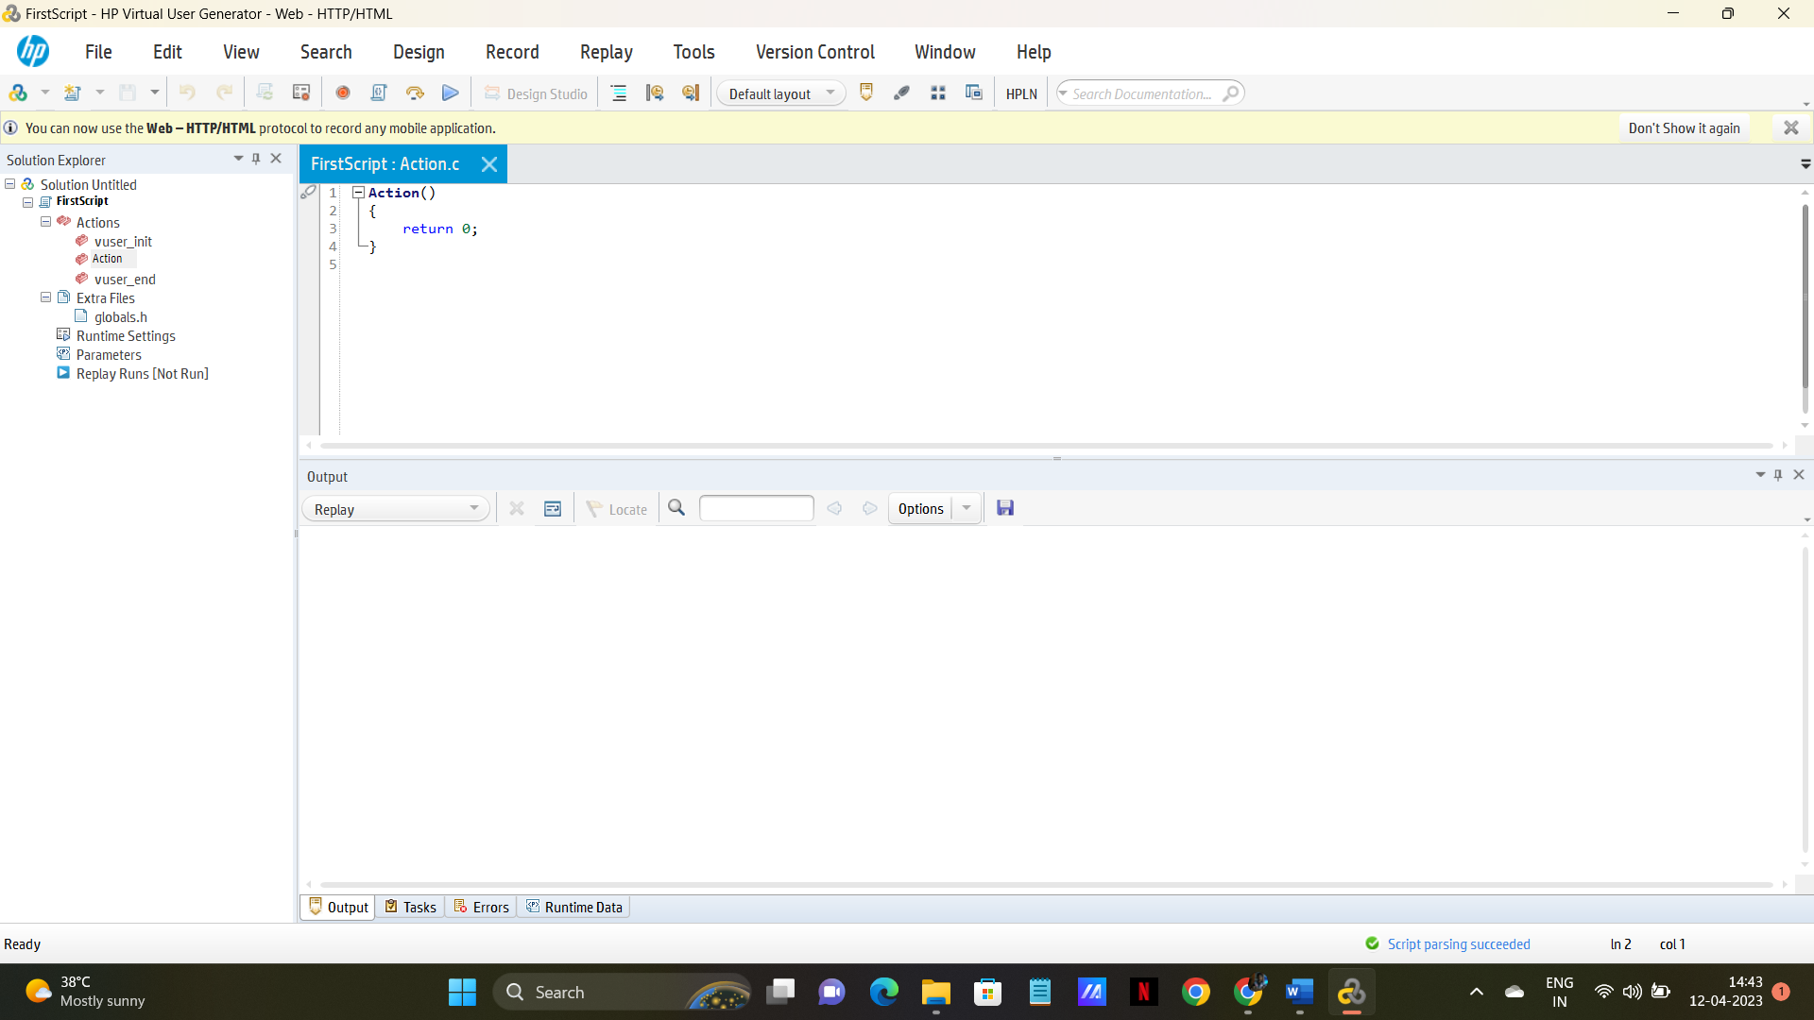

1. Select action and add below stmt.

lr_output_message("Output Message");

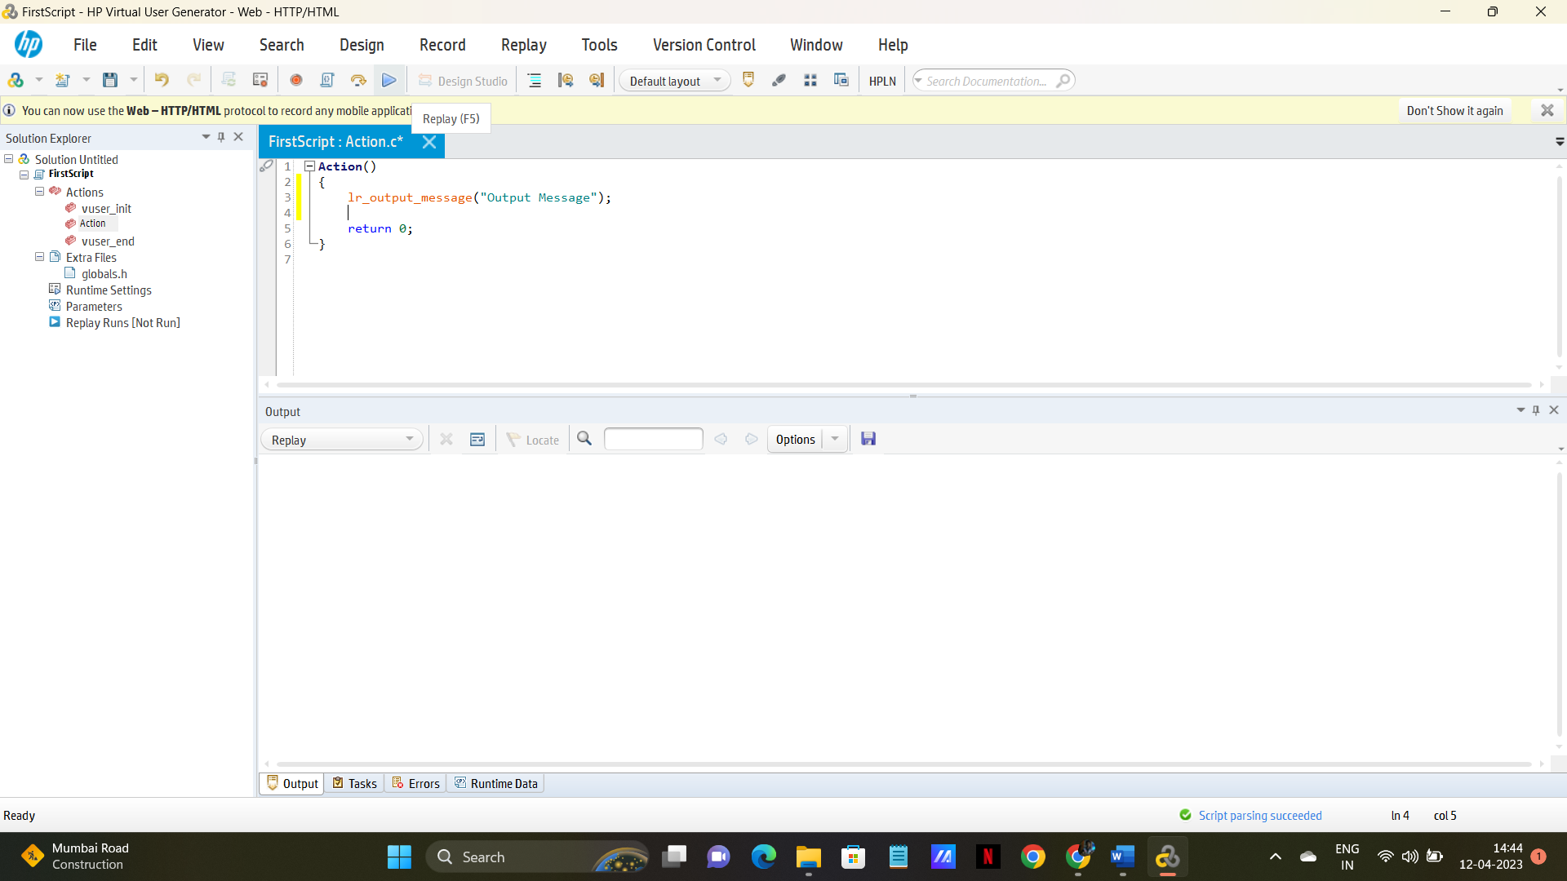

Note: 1. Load Runner related functions will be displayed in Red color, by seeing that we can guess that function is correct or not.

1. Click Replay button.( Or F5)

Observe below screen shot

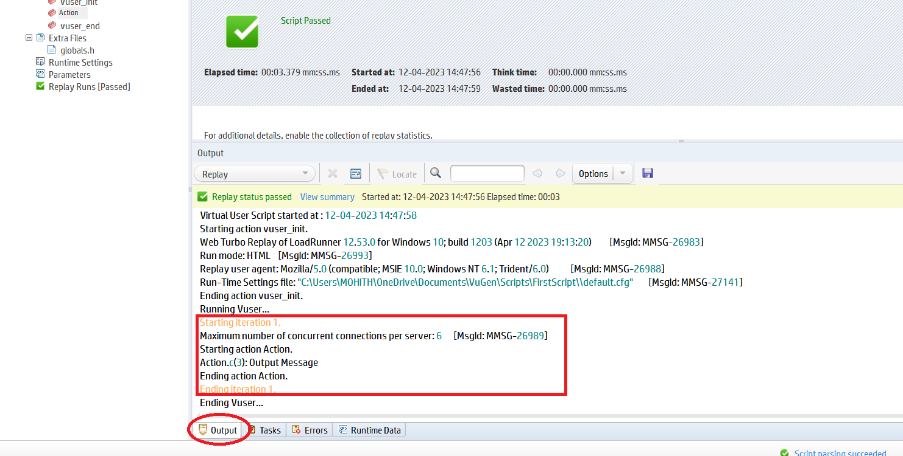

After replay you are presented as in the above screen shot.

Ensure you select **Action** at Right side.

Select **Output** tab

In The Red Rectangle, you observe that the message which we gave in Action. (Starting iteration, from this point it is starting Action )

Copy the below 3 statement and add to Action.

lr_output_message("Output Message");

    //lr_message("its just message");

   // lr_error_message("This is Error Message");

At a time you need to execute one statement, and observe the out put.

Use // to comment a statement, as shown below.

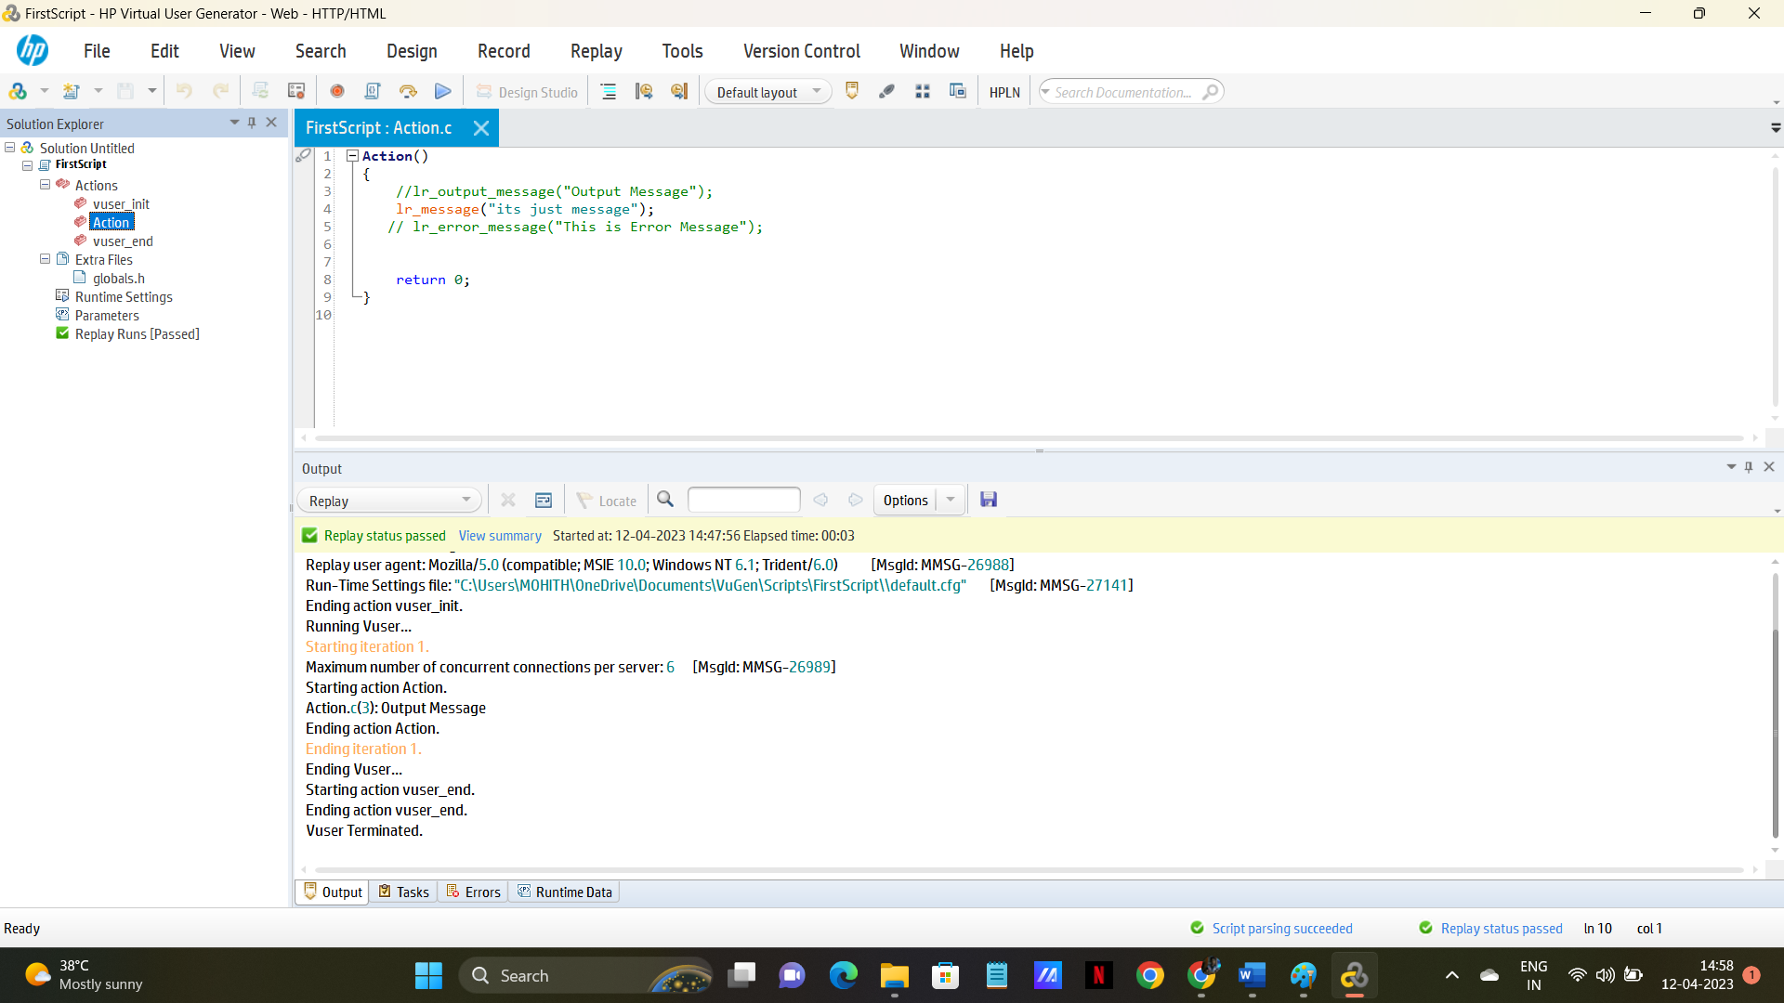

Execute /Replay (f5) and observe what is the message you are getting after execution.

These 3 statement are very important while debugging or during Script Enhancement.

2  lr_save_string("Virtusa","Data");  
    lr_output_message("%s",lr_eval_string("{Data}")); (“{

**Note**1: Please double check while entering Quotation. **If you want to check the online help, Select the lr statement and Click F1, to open help**

2. lr_eval_string is use to evaluate the value in the string.

Here, in save string statement, we are saving the value **Virtusa** in **Data** variable.

Then in order get the value during Execution, we use this notation **(“{variable name}”)**

3. lr_save_int(“10","Value");  
    lr_output_message("%s",lr_eval_string("{Value}"));

4.   lr_save_datetime("Todays is %b %d %y", **DATE_NOW**,"Todays Date");  
     lr_output_message("%s", lr_eval_string("{Todays Date}"));  
       
     lr_save_datetime("Tomorrow is %B %d %Y", **DATE_NOW** +  (**ONE_DAY)**, "next");  
    lr_output_message(lr_eval_string("{next}"));

Please go through the Date Time functions, with different formats how toget.

---------------------------------------------------------------------------------------------------------------------

1. In Action part write below code.

int r;  
      
    r=**rand**()%20+40;  
      
    lr_output_message("%d",r);

Note: the above function is used to get a random no between 40 to 60.

**[ Rand()% 20+40; means Starting with 40 + another 20 numbers]**