**Intial scripting activity with Load runner**

1. Click on VUGen.exe

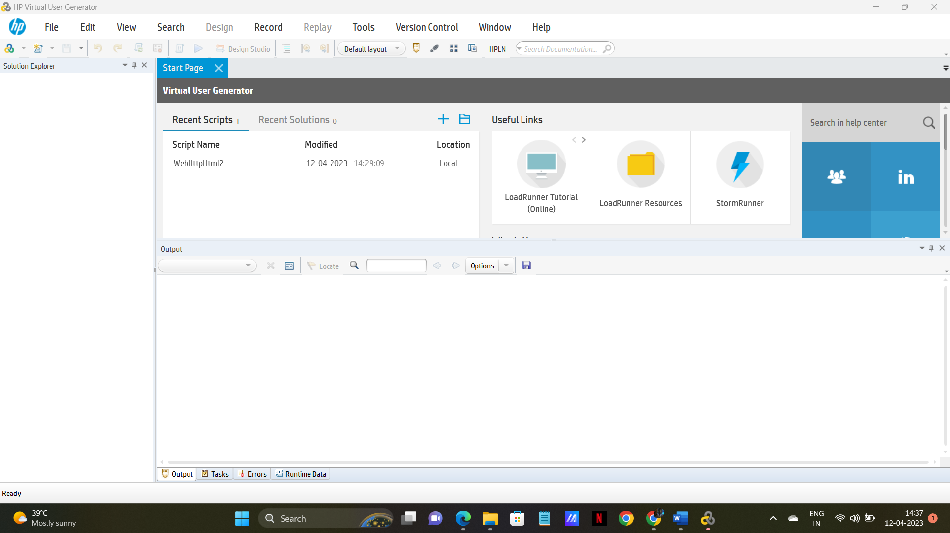

1. Click on Add new script button. (after vugen symbol) or File 🡪 Add 🡪 New Script

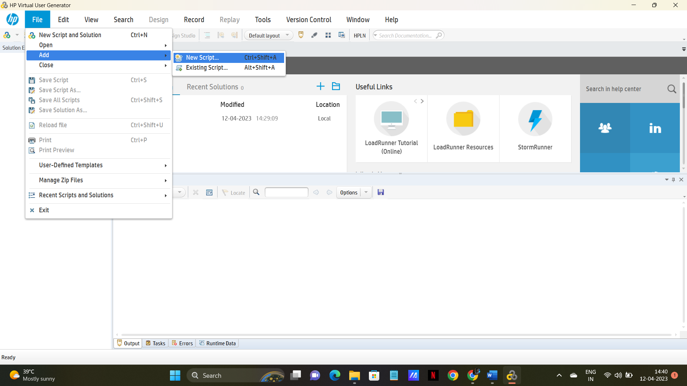

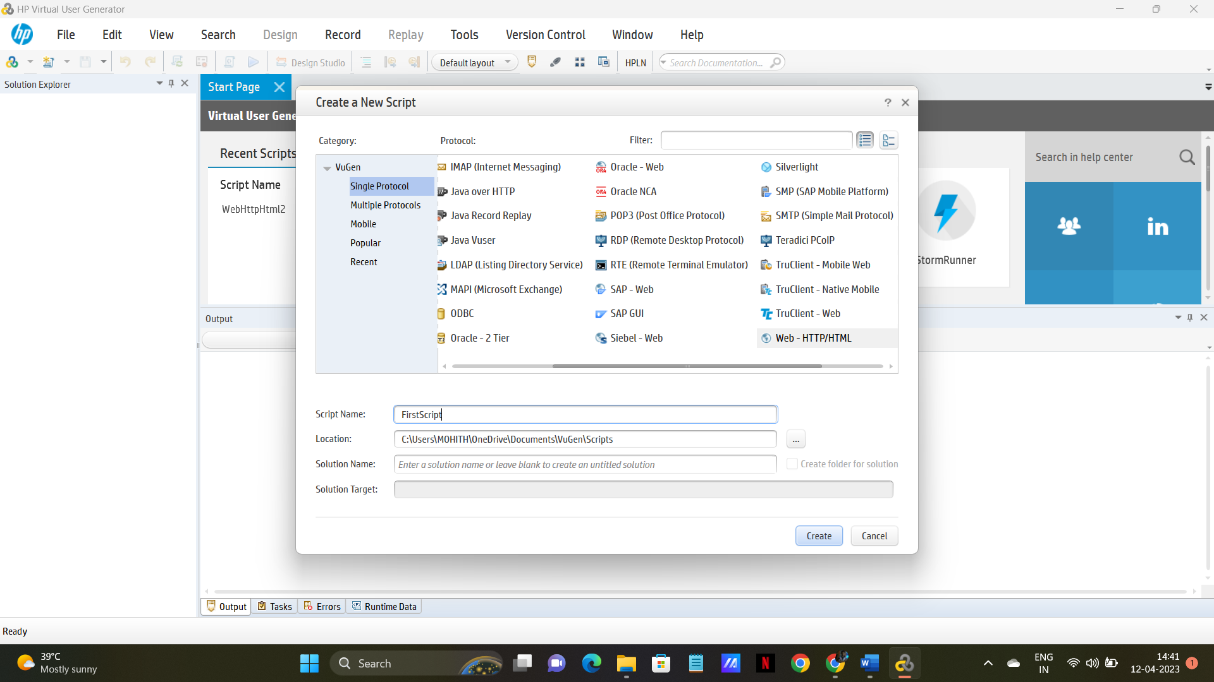

1. Select “web Http/HTML” and click Create.It should display like this

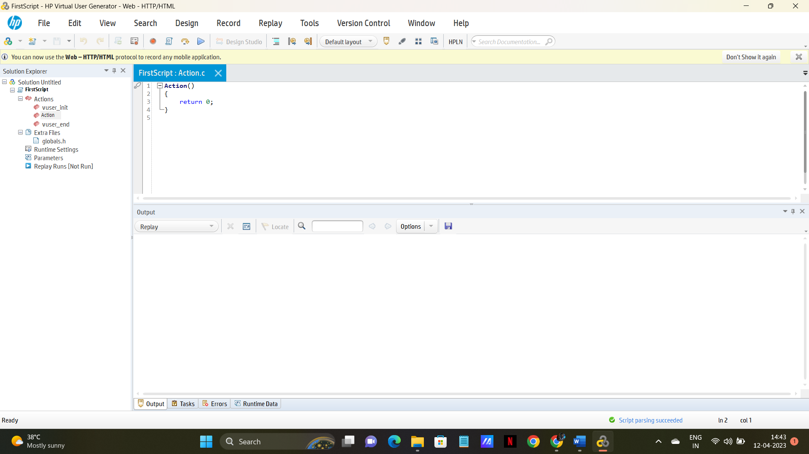

1. Select action and add below stmt.

lr_output_message("Output Message");

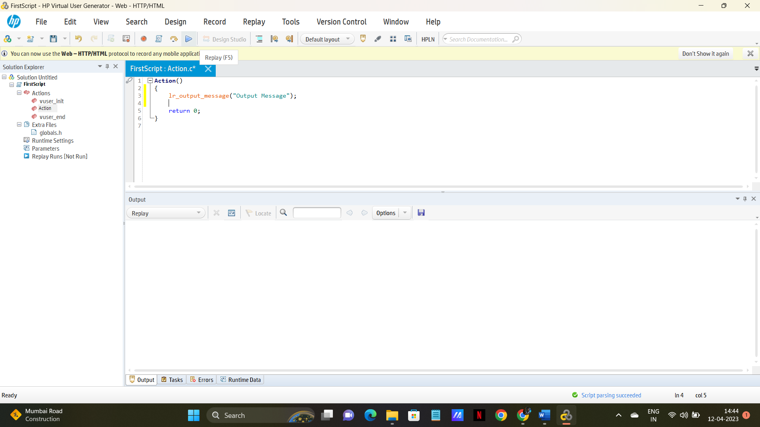

Note: 1. Load Runner related functions will be displayed in Red color, by seeing that we can guess that function is correct or not.

1. Click Replay button.( Or F5)

Observe below screen shot

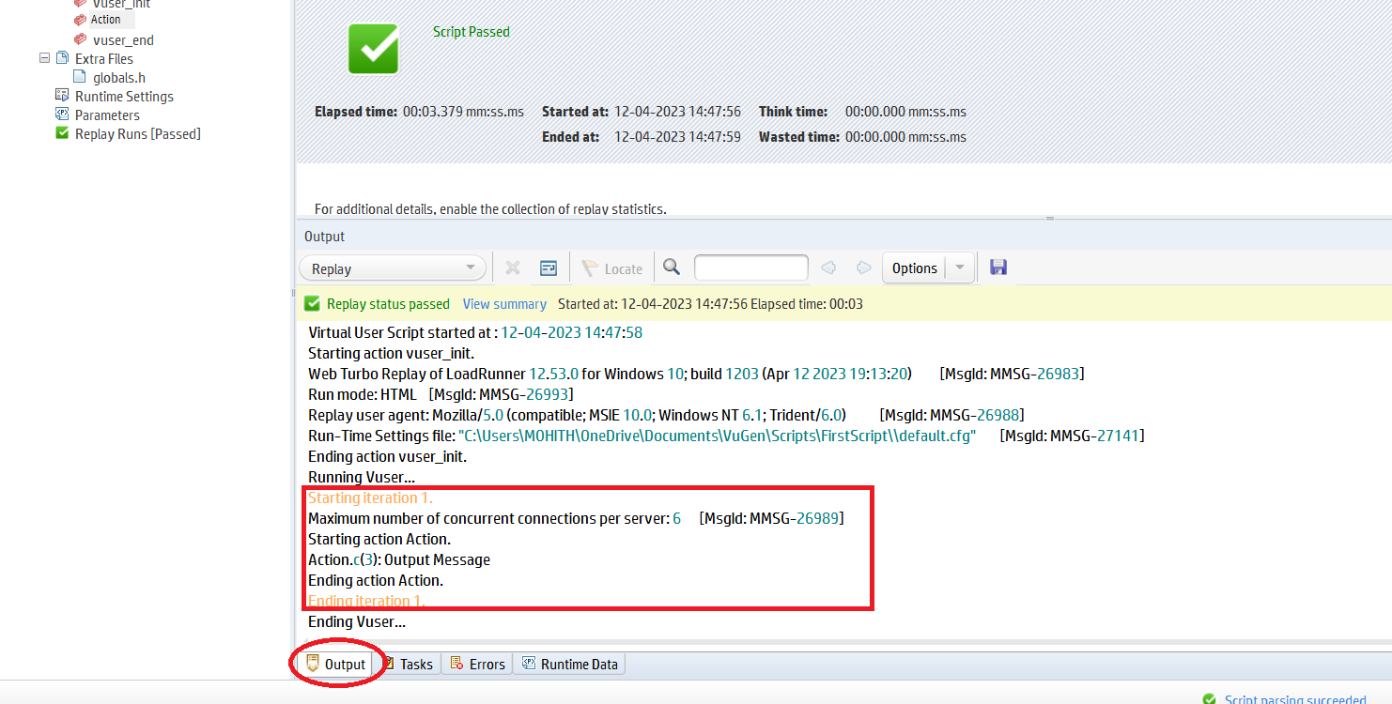

After replay you are presented as in the above screen shot.

Ensure you select **Action** at Right side.

Select **Output** tab

In The Red Rectangle, you observe that the message which we gave in Action. (Starting iteration, from this point it is starting Action )

Copy the below 3 statement and add to Action.

lr_output_message("Output Message");

    //lr_message("its just message");

   // lr_error_message("This is Error Message");

At a time you need to execute one statement, and observe the out put.

Use // to comment a statement, as shown below.

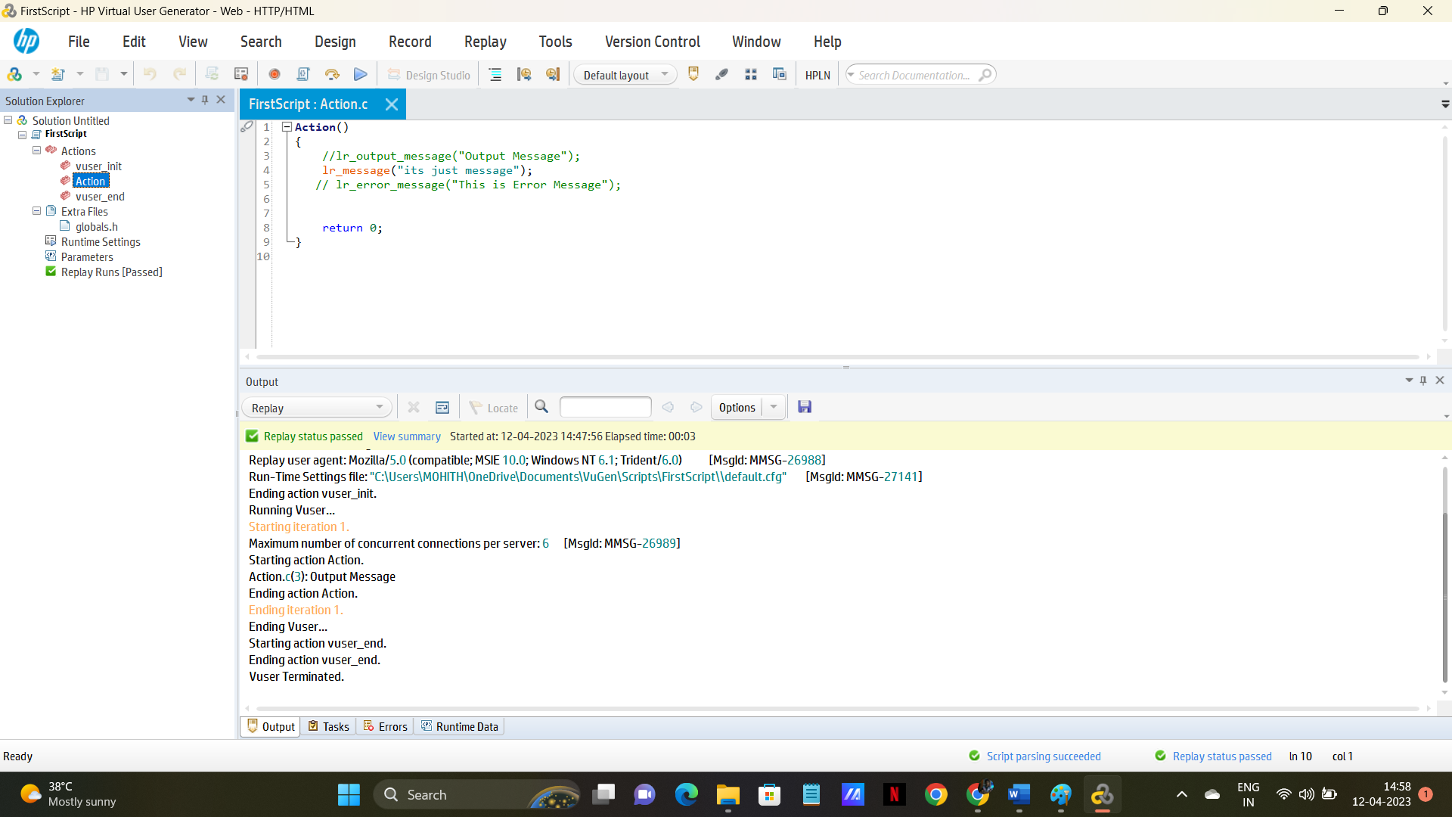

Execute /Replay (f5) and observe what is the message you are getting after execution.

These 3 statement are very important while debugging or during Script Enhancement.

2  lr_save_string("Virtusa","Data");  
    lr_output_message("%s",lr_eval_string("{Data}")); (“{

**Note**1: Please double check while entering Quotation. **If you want to check the online help, Select the lr statement and Click F1, to open help**

2. lr_eval_string is use to evaluate the value in the string.

Here, in save string statement, we are saving the value **Virtusa** in **Data** variable.

Then in order get the value during Execution, we use this notation **(“{variable name}”)**

3. lr_save_int(“10","Value");  
    lr_output_message("%s",lr_eval_string("{Value}"));

4.   lr_save_datetime("Todays is %b %d %y", **DATE_NOW**,"Todays Date");  
     lr_output_message("%s", lr_eval_string("{Todays Date}"));  
       
     lr_save_datetime("Tomorrow is %B %d %Y", **DATE_NOW** +  (**ONE_DAY)**, "next");  
    lr_output_message(lr_eval_string("{next}"));

Please go through the Date Time functions, with different formats how toget.

---------------------------------------------------------------------------------------------------------------------

1. In Action part write below code.

int r;  
      
    r=**rand**()%20+40;  
      
    lr_output_message("%d",r);

Note: the above function is used to get a random no between 40 to 60.

**[ Rand()% 20+40; means Starting with 40 + another 20 numbers]**

1. **Action Calling**

**Create a Vugen script to select an action based on the output of “IF” condition .**

**Create 3 actions as shown below.**

1. **Select Action 🡪 Right click 🡪 create Action**

**Or**

**Design 🡪 Action 🡪 Create New Action**

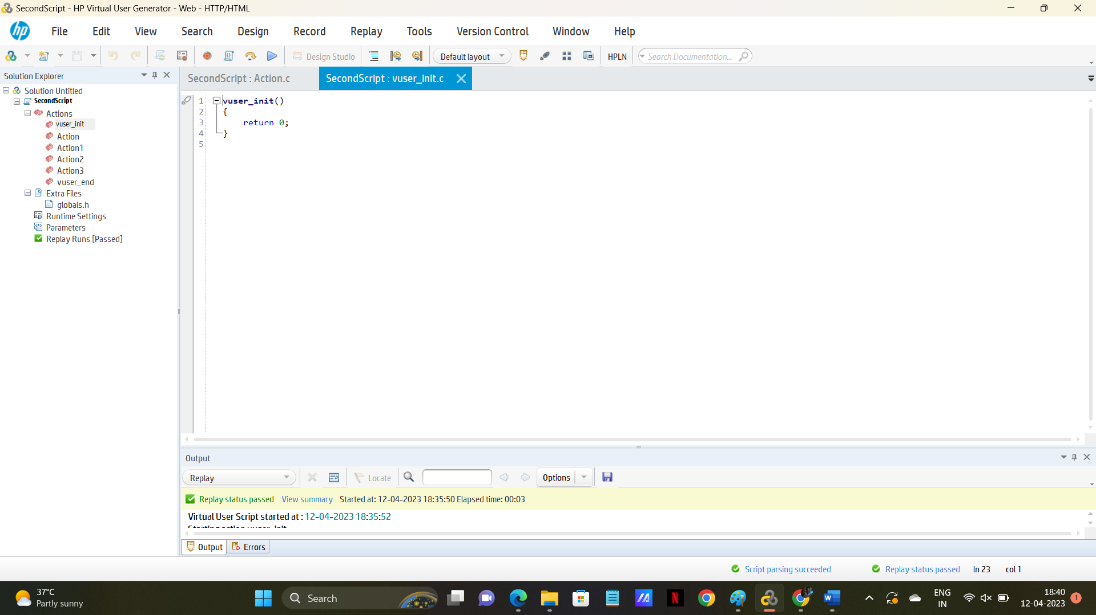

**Observe that left side you are able to see Action1, Action2, Acttion3.**

1. **Click the Run time setting, it will display like this**

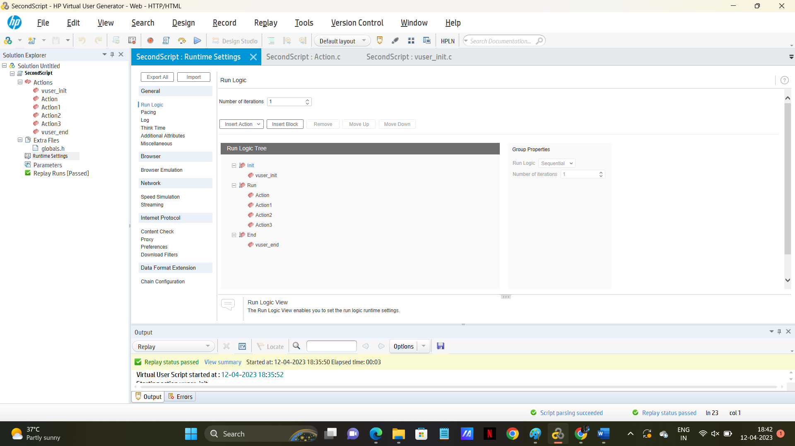

1. **Select action1 and click remove.**
2. **Select action2 and click remove.**
3. **Select action3 and click remove.**
4. **Then it should be display like below.**

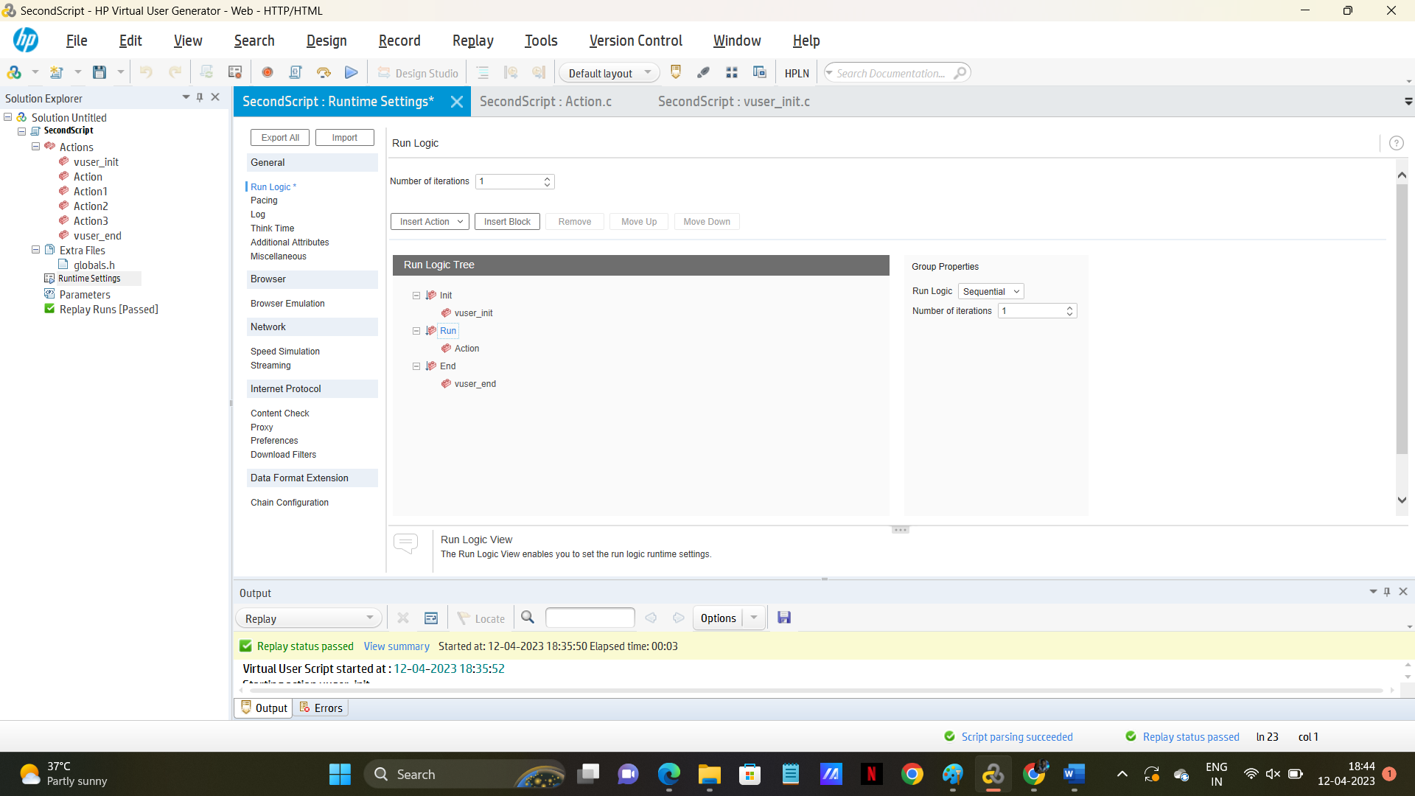

1. **Click save.**
2. **Observe that , actions are disabled in left side pane.**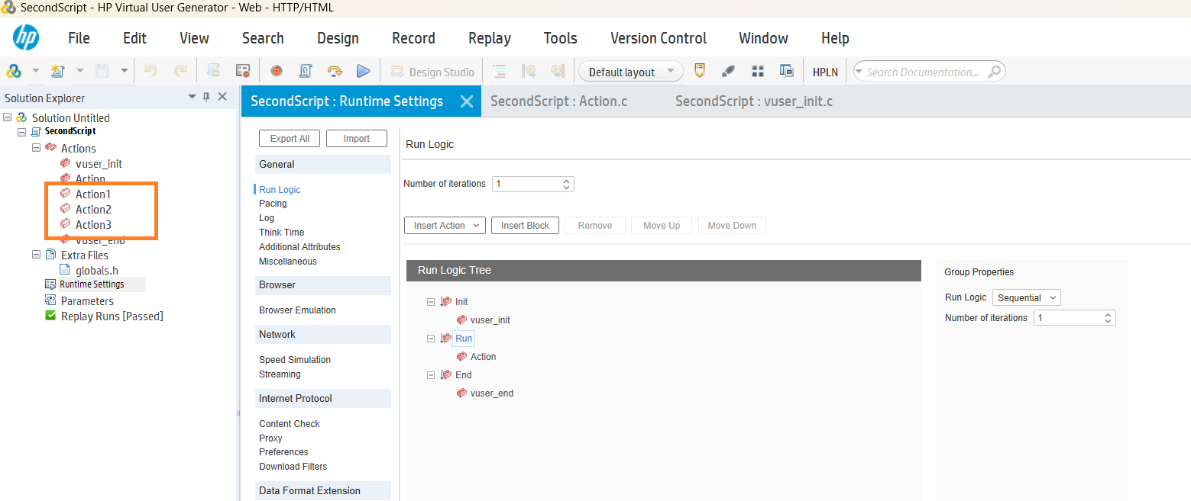

**9.click action and write the code mentioned as below.**

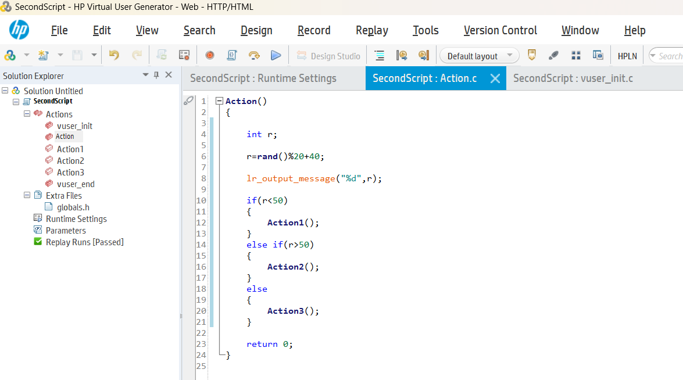

Replay the script.

**Create a VUGen Script , to display 100 no’s using For loop and print the message.**

**FunctionsCalling**

**Create new action (action1)**

**Write below code in Action**

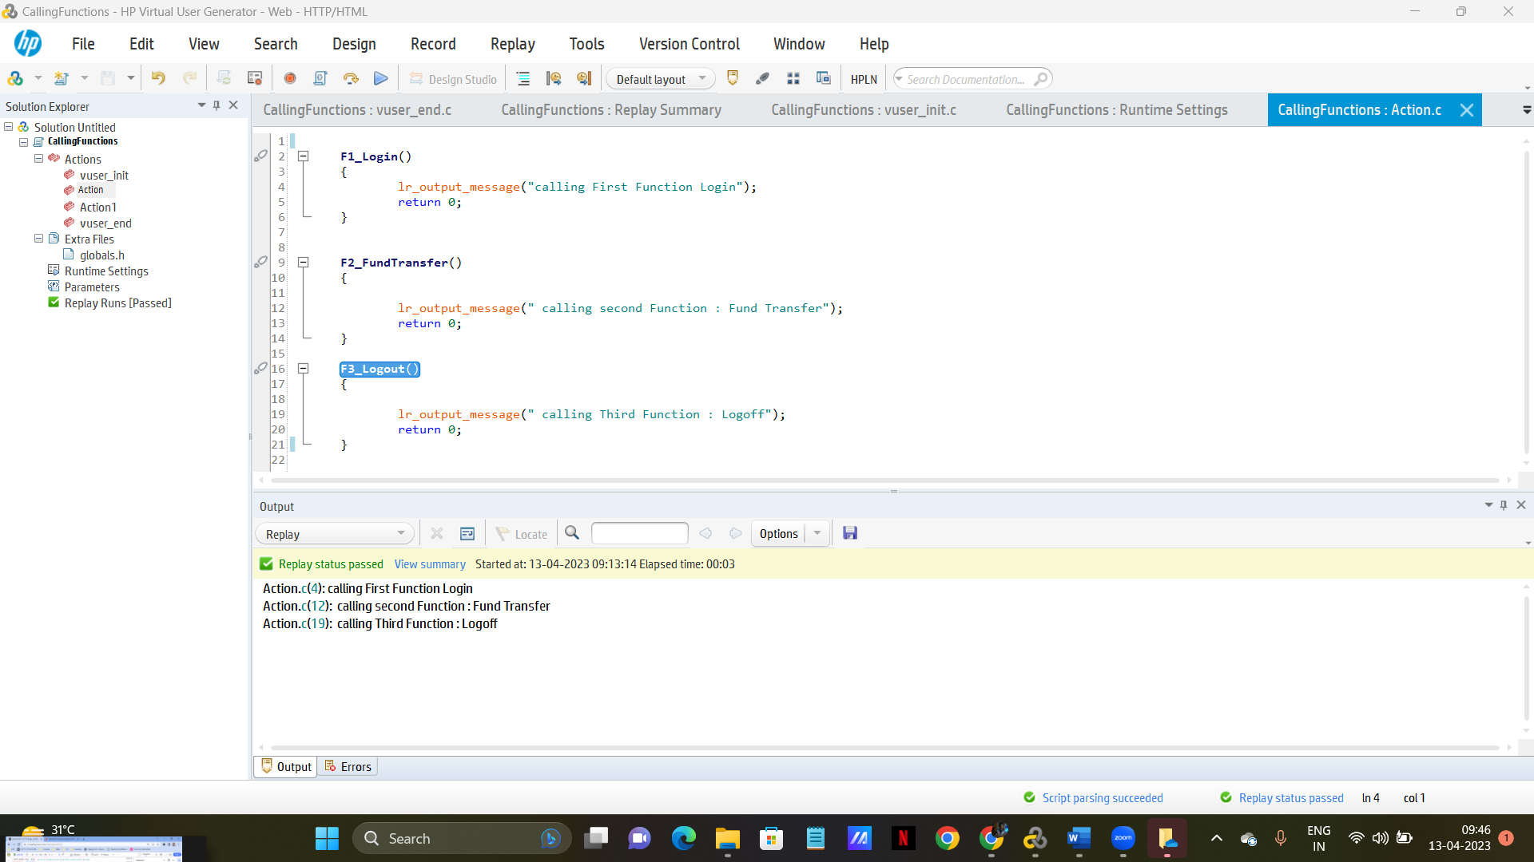

**2. Click the runtime setting mentioned in left side panel**

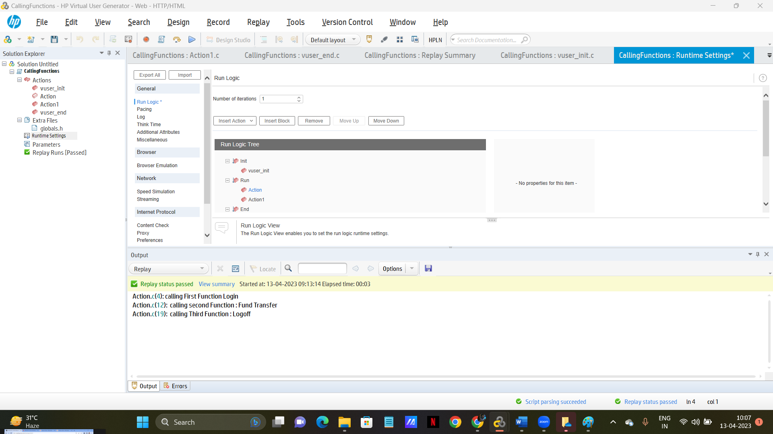

**3. Select the Action and Click Remove button**

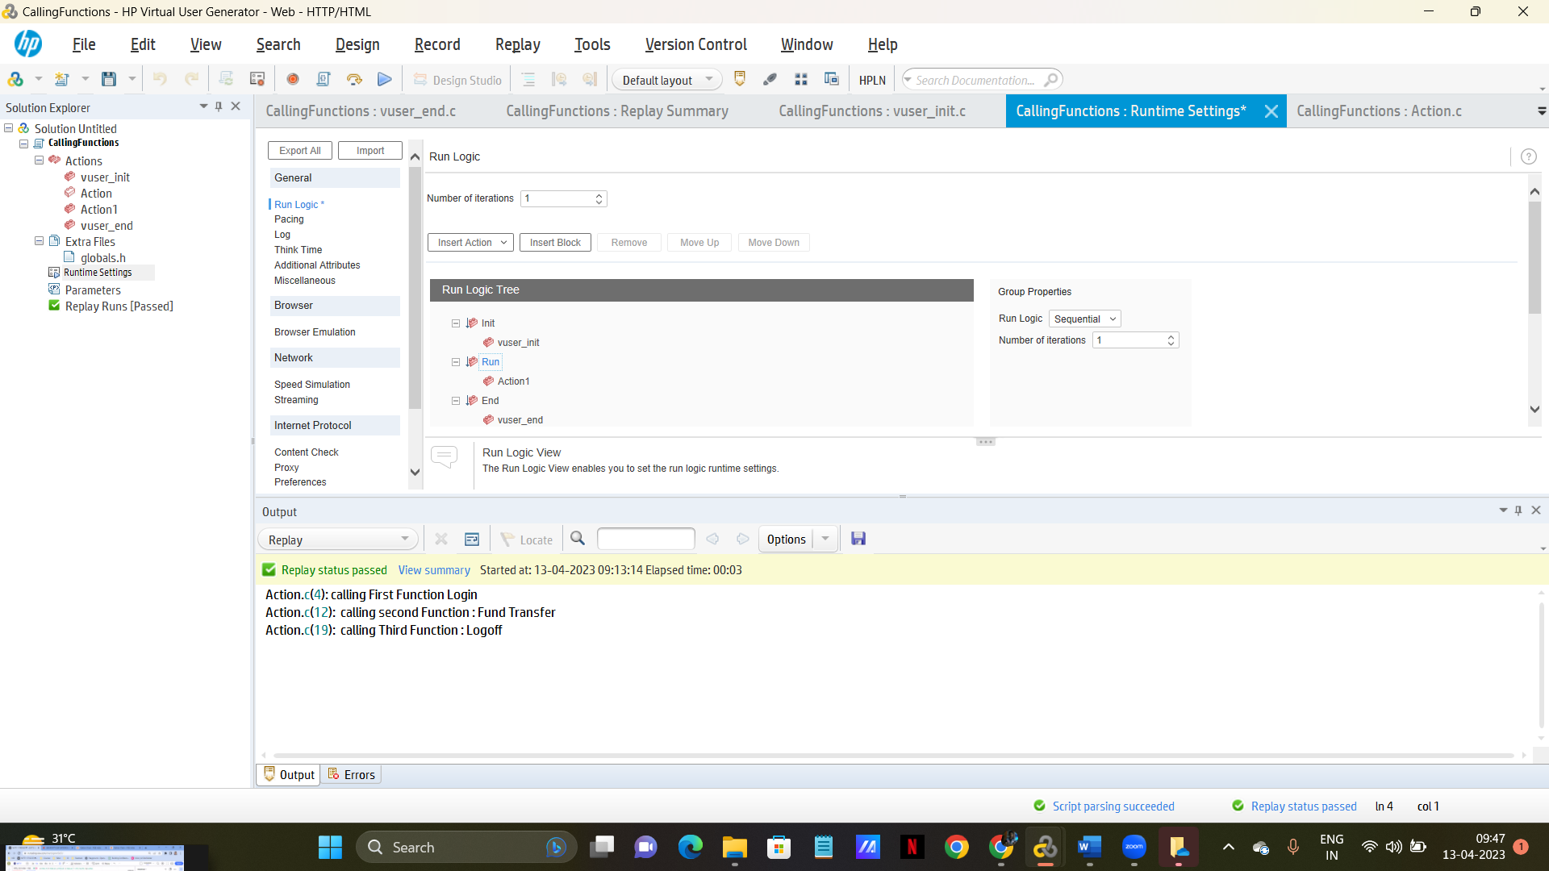

**6. Click Vuser init , write the below code**

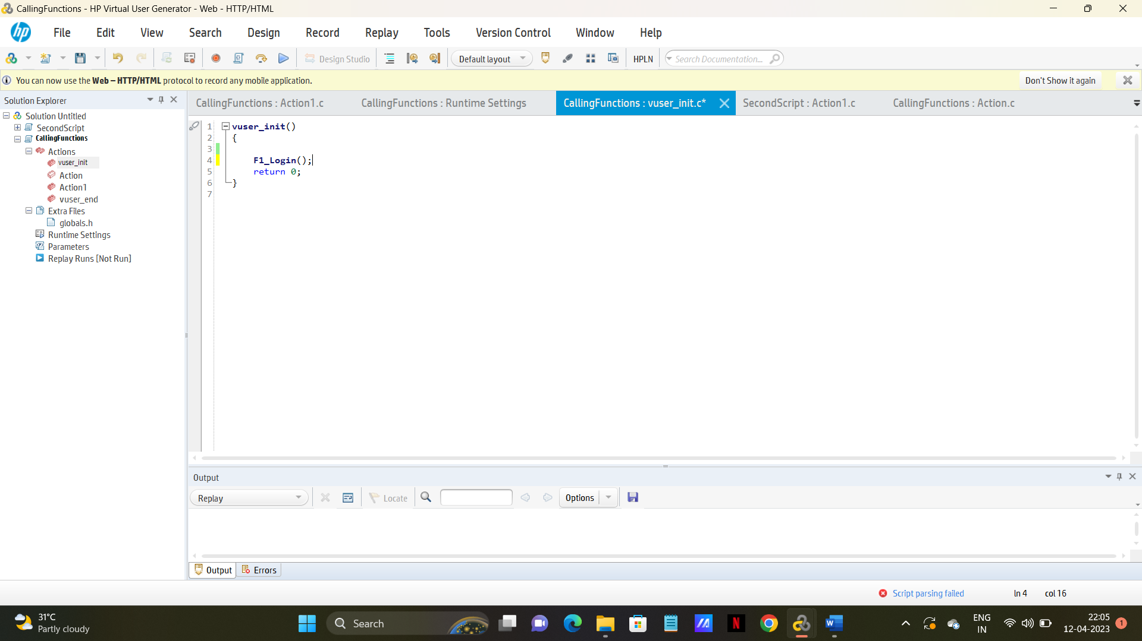

**Click Action1 and add below function**

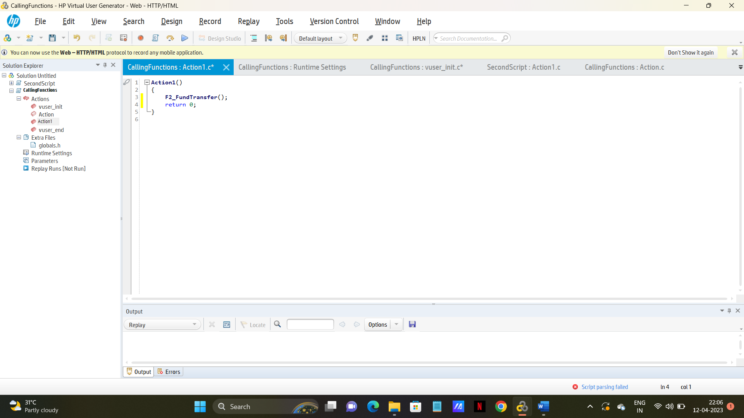

**Click Vuser end and add the below function**

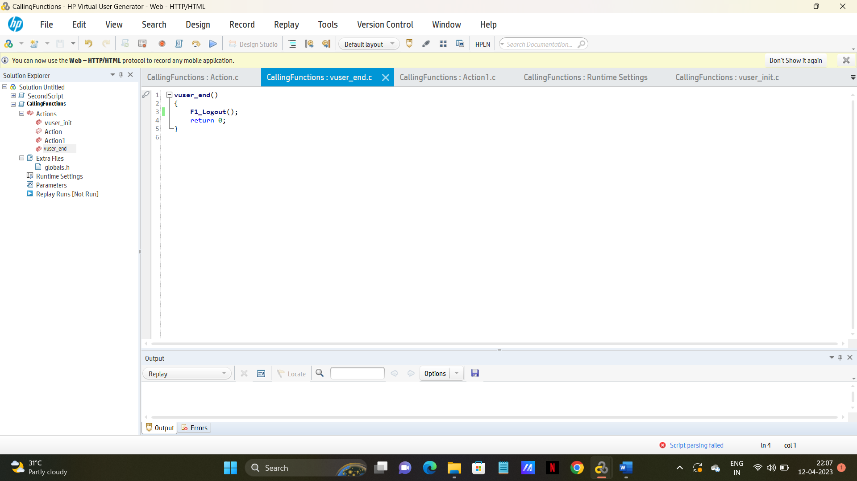

**Click Runtime settings and Enable Logging and Execute.**

**Check the Output window results**

**Click Runtime settings and Disable Logging and Execute.**

**Check the Output window results**

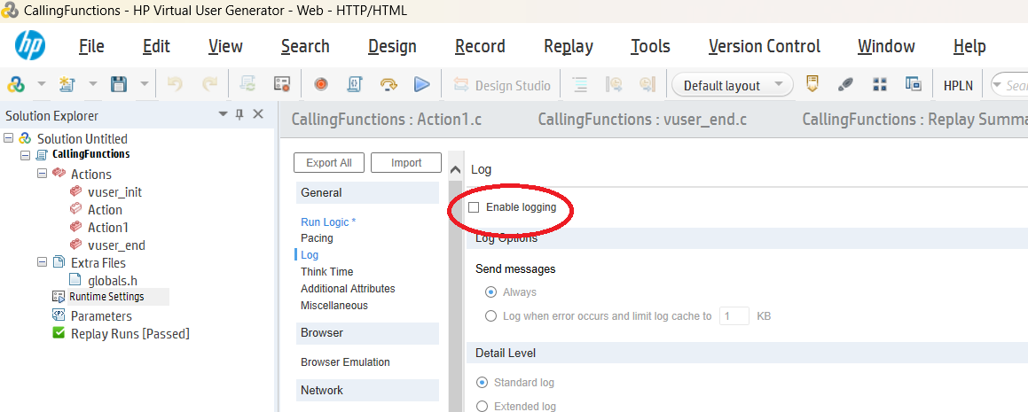

**Understand the difference between this script and Previous script. (Function calling and Action Calling)**