# **Overview**

* **About your team** – Our team consist of 3 members
  + **Members and their roles**

**Maksut Malik**. student id: 203044, email: 203044@astanait.edu.kz, role: create homepage and write part of documentation

**Symbat Maidanova.** student id: 203046, email: [203046@astanait.edu.kz](mailto:203046@astanait.edu.kz), role: create page books and write part of documentation

**Dariga Tasbolatova.** student id: 203017, email: 203017@astanait.edu.kz, role: create page borrow a book and write part of documentation

* + **Communication strategy**

We used a verbal communication strategy. We organized meetings using Microsoft teams. Also, we have a chat, where we can discuss some little problems and other stuff. During the brainstorm, we have additional meetings where we can describe our problems and find the solution to the problems we have.

* + **Motivation**

We want to create a website to give people an opportunity to read more and make it easy. For this we need to create this website, make it simple for students and who interested in science. To reach our goals, we improve our skills in web-programming by learning technologies like Bootstrap and CSS grid. Also, this project gives our team a real experience of teamwork, work during brainstorms and usage of git repositories.

* **High-level project scope** - This is absolutely a brand-new website, but some parts were spied on from other websites
* **Target audience/market**

**A website aimed at all categories of people who are interested in IT and science. The target market can also have different areas like science, education, finance, etc.**

**Project goals and team interests**

**Project goals**

* Create a good looking and functionally well-managed Library Website
* Make website user friendly and easy to use

**Team interests**

* Understand the work with Bootstrap and CSS grid
* Become confident with Github
* Improve teamwork skills

# **Phases**

* Phase 1 – Basic library website with HTML (Currently)
* Phase 2 – Create an authentication and ability to create account
* Phase 3 – Improve design of website by adding different images and using bright colors
* Phase 4 - Adapting the site for different gadgets by creating a grid system
* Phase 5 – Develop a search function and book recommendations for user

# **Content structure**

**Site map**

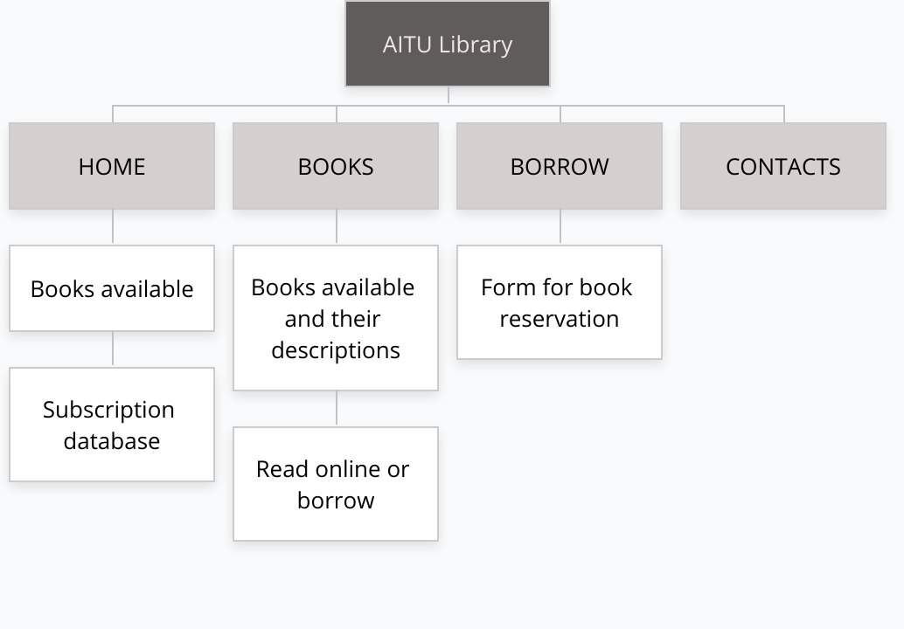

**Design**

* Colors were chosen through a special color palette: basic colors such as white, red, cornsilk, orange, gray, lightslategray; and individual color such as rgba(27, 105, 250, 0.952), rgb(233, 231, 231), #BDB76B.
* As fonts mainly Cormorant have been used.
* Hover states were applied for buttons in the form for the book reservation.
* We have managed with animation for image carousel in page Books from Bootstrap.
* Grid system has been designed in pages of Home and Books from Bootstrap as well.

**Functionality**

We have three main pages of Online Library which are Home page, Books and Borrow Books. Each of the pages has its functionality: for instance, Home page is required for audience (mainly students of our university) to familiarize with main content of University Library, about it correlation with other organizations and daily news; while Books presents a full catalogue of available book items with their descriptions and provides with a choice to read online books or to borrow them; whereas Borrow Books web page has a form for book reservation, the fulfillment of what will help the student to be confident in getting an intended book.

**Hosting**

Hosting on GitHub by steps:

1. Sign up in GitHub account;

2. Create Repository: https://maidanovasymbat.github.io/

3. Upload files in RAR/ZIP form;

4. Click on settings and find GitHub Page;

5. Share the link.

**Accessibility**

Our website has good accessibility. All the content is good looking. It’s easy to find the main functions and information, there is no problem with colors and how they are connected. But due to its inexperience, our site is not yet available for visually impaired people. But in the future this flaw will be fixed, also in the future it is possible to create a mode for color blinded.

**Deadlines**

* Phase 1 – October 7, 19:00
* Phase 2 –October 8, 20:00
* Phase 3 –October 9, 20:00
* Phase 4 – October 10, 21:00
* Phase 5 – October 11, 22:00

# **Summary**

In conclusion, we want to say that this project was very interesting for us. We have gained tremendous experience that will be very useful in the future. Our knowledge of html and css has improved a lot. There were moments when it was difficult for us, because of our inexperience, we made a lot of mistakes, we initially failed much. But in the end, we were able to overcome these difficulties and create our website. Our skills in using the grid system have also greatly advanced which is quite difficult to use. In general, we have only positive emotions from this project and are very grateful for such an experience.

It is worth making assessment of your own work.