Norwegian Dam Infrastructure

Data and Methodology
The analysis of Norwegian dam infrastructure draws on data maintained by the Norwegian Water Resources and Energy Directorate (Norges vassdrags- og energidirektorat, NVE), the national authority responsible for water resource management and hydropower regulation in Norway. The NVE database provides comprehensive spatial and temporal coverage of Norwegian hydropower infrastructure, encompassing 4,953 documented dam structures, 2,997 reservoirs with operational parameters, and associated infrastructure distributed across Norway's mountainous terrain. The dataset spans 225 years of documented construction history from 1800 to 2025, with construction year documentation available for 3,874 structures representing 78.2% of the total inventory.
The NVE dataset emphasizes operational characteristics relevant to hydropower system management, including reservoir storage capacities measured in million cubic meters (MCM), regulation ranges representing operational water level variation between highest regulated water level (HRV, høyeste regulerte vannstand) and lowest regulated water level (LRV, laveste regulerte vannstand), and purpose classifications documented in Norwegian with translations provided for international accessibility. This operational focus reflects Norway's historical development of hydropower as the predominant electricity source, with hydroelectric generation accounting for approximately 88% of total Norwegian electricity production in recent years according to Statistics Norway. The coordinate system employed in the NVE database is ETRS89 / UTM Zone 33N, converted to WGS84 (EPSG:4326) for spatial analysis and visualization.
A methodological limitation of the publicly available NVE dataset is the absence of systematic structural dam height measurements, which precludes direct height-based classification schemes. This reflects differing regulatory reporting priorities between national dam safety programmes, with Norwegian oversight emphasizing operational parameters for hydropower management while structural characteristics may be documented in project-specific archives maintained by dam owners and detailed safety assessment reports. For the present analysis, county-level geographic attribution employs approximate coordinate-based assignment referenced to Norway's 2024/2025 administrative system of 15 fylker (counties) following the 2024 dissolution of the merged Viken county. Precise administrative boundary attribution would require integration with official Statistics Norway boundary shapefiles, which is noted as a refinement for future detailed spatial analysis.

Historical Development and Construction Patterns
Norwegian dam infrastructure development exhibits distinct temporal patterns reflecting national economic and energy policy trajectories over more than two centuries. Analysis of the 3,874 dams with documented construction years reveals that the period from 1945 to 1980 accounts for 1,789 structures representing 46.2% of dated infrastructure, with peak construction occurring during the 1960s when 528 dams were completed. This post-war development boom corresponds with Norway's strategic emphasis on hydropower expansion for national electrification, rural development, and establishment of energy-intensive industries including aluminum smelting and electrochemical production that historically relied on inexpensive hydroelectric power.
The concentration of construction activity in the three decades following World War II reflects several concurrent factors documented in Norwegian energy policy literature. Thaulow et al. (1997) describe the systematic development of mountainous catchments for hydroelectric generation as part of Norway's post-war reconstruction and modernization programme, while Midttømme et al. (2008) analyze the relationship between hydropower expansion and industrial policy during this period. The 1960s peak coincides with establishment of the national grid system enabling power transmission from remote mountain catchments to population and industrial centers, as well as completion of major multipurpose hydropower complexes in regions including Telemark and Hordaland (now part of Vestland county following the 2020 administrative reform).
Construction activity in earlier periods provides context for the post-war boom. The period from 1800 to 1945 includes 734 documented dam structures representing 18.9% of dated infrastructure, encompassing early water mill installations, industrial power sources, and initial hydroelectric developments. The modern era from 1980 to 2025 includes 1,351 structures representing 34.9% of dated infrastructure, reflecting a combination of system expansion and optimization, replacement and upgrading of aging infrastructure, small-scale hydropower development, and integration of environmental considerations in project design following implementation of increasingly stringent regulatory requirements.

Figure 1: Decade-wise Construction Pattern of Norwegian Dams
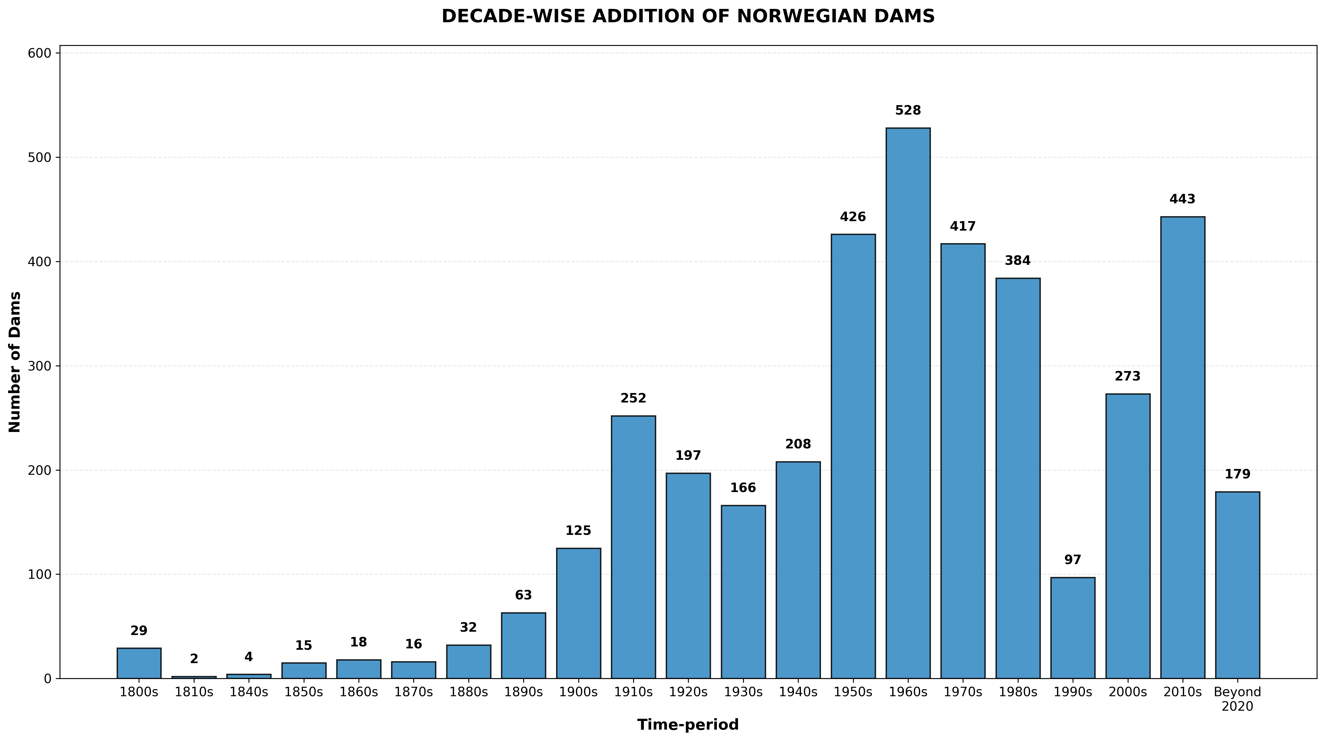

Infrastructure Age Profile and Maintenance Implications
The age distribution of Norwegian dam infrastructure, calculated with reference to 2025, reflects the historical construction patterns and presents characteristic challenges associated with aging infrastructure management. The predominant age cohort comprises 2,331 structures in the 50 to 99 year range, representing 60.2% of dams with documented construction years and an average infrastructure age of 60.8 years. This concentration of mature infrastructure necessitates ongoing attention to structural integrity assessment, regulatory compliance with evolving safety standards, and strategic planning for rehabilitation or replacement as structures approach or exceed design life expectations.
The Norwegian dam safety regulatory framework, administered by NVE, employs a consequence-based classification system that determines inspection frequency, instrumentation requirements, and emergency preparedness obligations. Høeg (2005) describes the four-class consequence classification system ranging from Class 0 (minimal downstream hazard) to Class 3 (severe consequence potential requiring most stringent oversight), with classification driving specific technical requirements for monitoring and safety review. High-consequence dams undergo annual comprehensive inspections supplemented by continuous instrumentation monitoring of critical parameters including seepage, deformation, and uplift pressures, with periodic dam safety reviews conducted at intervals determined by consequence class and structural characteristics.
Infrastructure exceeding 100 years of age, comprising 252 documented structures representing 6.5% of the dated inventory, presents particular considerations regarding structural deterioration assessment, compliance with safety standards that have evolved substantially since original construction, and selective decisions regarding continued operation, major rehabilitation, or decommissioning balanced against historical and cultural heritage values. The oldest documented structure dates to 1800, representing 225 years of operational history. At the opposite end of the age spectrum, 476 structures completed within the past 25 years represent 12.3% of dated infrastructure, reflecting ongoing system development incorporating contemporary design standards and construction practices. An additional 19 structures documented with under-construction status represent ongoing projects at the time of the NVE database snapshot.

Figure 2: Age Distribution of Norwegian Dam Infrastructure
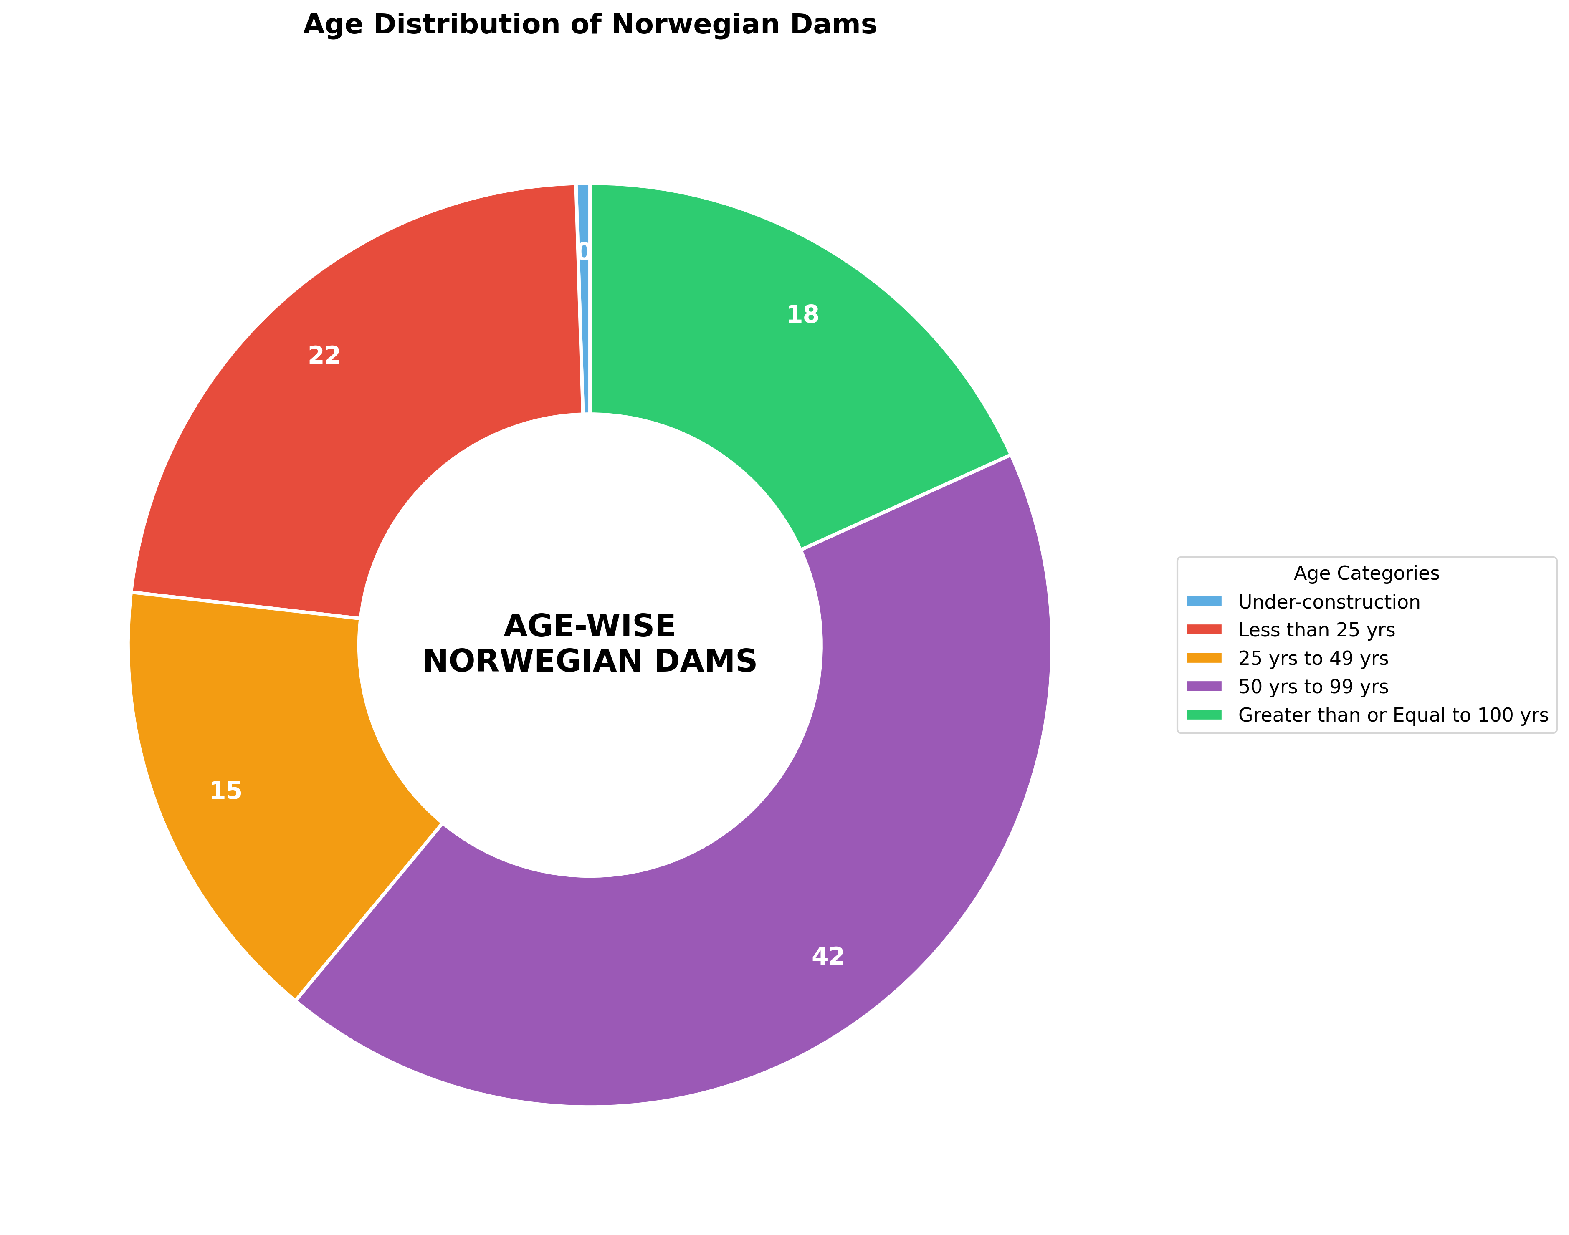

Spatial Distribution and Geographic Patterns
Geographic analysis of Norwegian dam infrastructure reveals distinct spatial concentrations aligned with topographic and hydrological characteristics that determine hydropower development potential. Approximate county-level attribution using coordinate-based geographic assignment identifies Innlandet (the merged county of former Hedmark and Oppland established in the 2020 administrative reform) as the region with highest dam concentration at 1,258 structures representing 25.4% of documented infrastructure, followed by Vestland (merged Hordaland and Sogn og Fjordane) at 963 structures (19.4%), and Trøndelag (merged Nord-Trøndelag and Sør-Trøndelag unified in 2018) at 830 structures (16.8%). These three central and western mountainous regions collectively account for 61.6% of documented dam infrastructure, reflecting optimal conditions for hydropower development.
The concentration of infrastructure in these regions corresponds with documented hydropower resource assessments and development patterns in Norwegian energy literature. Bakken et al. (2012) analyze the relationship between topographic characteristics and hydropower potential across Norwegian regions, identifying steep elevation gradients in western and central mountainous terrain as primary determinants of high-head hydropower viability. The western coastal regions including Vestland benefit additionally from abundant precipitation associated with maritime climate influence, with annual precipitation exceeding 2,000 mm in many western mountainous areas according to Norwegian Meteorological Institute climatological data. These high-precipitation zones replenish reservoir storage and maintain streamflow supporting power generation, particularly during winter months when electricity demand peaks for heating.
Topographic influence on spatial patterns extends beyond simple elevation considerations to include glacially-modified landscape features that provide natural reservoir sites. Nesje et al. (2008) describe the role of Pleistocene glaciation in creating the overdeepened valleys and fjord systems characteristic of western and central Norway, noting that these inherited bathymetric features enable construction of high storage capacity reservoirs with relatively limited surface area inundation. The spatial pattern thus demonstrates the compound influence of steep terrain enabling high-head generation schemes, abundant precipitation supporting reliable water supply, glacially-carved valleys providing natural reservoir basins, and major river systems draining extensive mountainous catchments.
Northern regions including Nordland (587 structures, 11.9% of total) and Troms (371 structures, 7.5%) contain 20.7% of documented infrastructure collectively, supporting local power supply, industrial operations including mining and processing facilities, and increasingly, inter-regional power transmission via the national grid system. Southern regions proximate to major population centers show moderate dam concentrations, reflecting balance between power generation requirements and environmental or recreational considerations in more densely populated areas.

Figure 3: Regional Distribution of Norwegian Dam Infrastructure by County
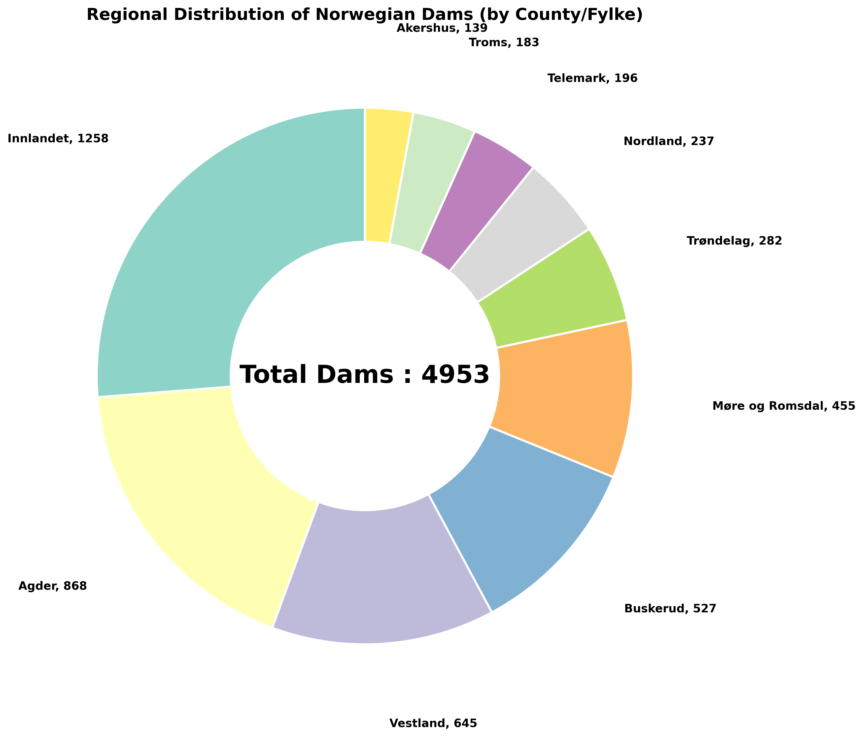
Note: County assignment uses approximate coordinate-based geographic method. Precise administrative boundary attribution requires integration with official Statistics Norway shapefiles.

Storage Characteristics and Morphometric Analysis
Norwegian reservoir infrastructure exhibits distinctive storage characteristics that can be quantified through morphometric analysis of volume-to-surface area relationships. The documented reservoir inventory includes total storage capacity of 61,784 million cubic meters distributed across 2,997 reservoirs, with average storage per reservoir of 53.0 MCM. Storage efficiency, calculated as the ratio of storage volume to reservoir surface area (MCM/km²), averages 10.80 MCM/km² for the 2,145 reservoirs with both volume and area data available (71.6% of the reservoir inventory). This metric serves as a morphometric indicator of reservoir depth characteristics, with high values indicating deep reservoir basins relative to surface area extent.
The concept of storage efficiency as a reservoir morphometric parameter is discussed in reservoir engineering and geomorphology literature, though terminology and specific applications vary by context. Graf (1999) employs volume-to-area relationships in analyzing dam impacts on riverine sediment systems in the United States, noting that deep storage reservoirs with high volume-to-area ratios exhibit different sediment trapping characteristics compared to shallow impoundments. While Graf's analysis focuses primarily on sediment dynamics, the morphometric principle of using volume-to-area ratios to characterize reservoir geometry has broader applicability to understanding how topographic context influences reservoir design and operational characteristics.
The average Norwegian storage efficiency of 10.80 MCM/km² reflects the predominance of deep valley reservoir configurations where steep terrain enables substantial water volume accumulation with comparatively limited surface area inundation. This characteristic is directly attributable to the glacially-carved valley morphology prevalent in Norwegian mountainous regions, where Pleistocene glaciation created overdeepened valley profiles through a combination of glacial erosion and subsequent isostatic adjustment as described in the Norwegian landscape evolution literature. The practical implications of high storage efficiency include reduced land acquisition and inundation impacts per unit storage volume, lower evaporation losses due to smaller surface area exposure, concentrated storage enabling multi-year regulation strategies for managing inter-annual precipitation variability, and efficient utilization of topographic relief for hydropower head generation.
Among documented reservoirs, the largest by storage capacity is Storglomvatn in Trøndelag county with 3,506 MCM capacity, followed by Enare in Finnmark (2,584 MCM) and Tustervatn-Røsvatn in Trøndelag (2,309 MCM). Application of the ≥1000 MCM threshold commonly used for large dam classification identifies 10 Norwegian reservoirs meeting this criterion. The accompanying data file provides technical specifications for the 30 largest Norwegian reservoirs including storage capacity, surface area, storage efficiency, regulation range, geographic coordinates, and operational status, enabling detailed examination of large reservoir characteristics.

Figure 4: Storage Efficiency Analysis - Volume vs. Area Relationship
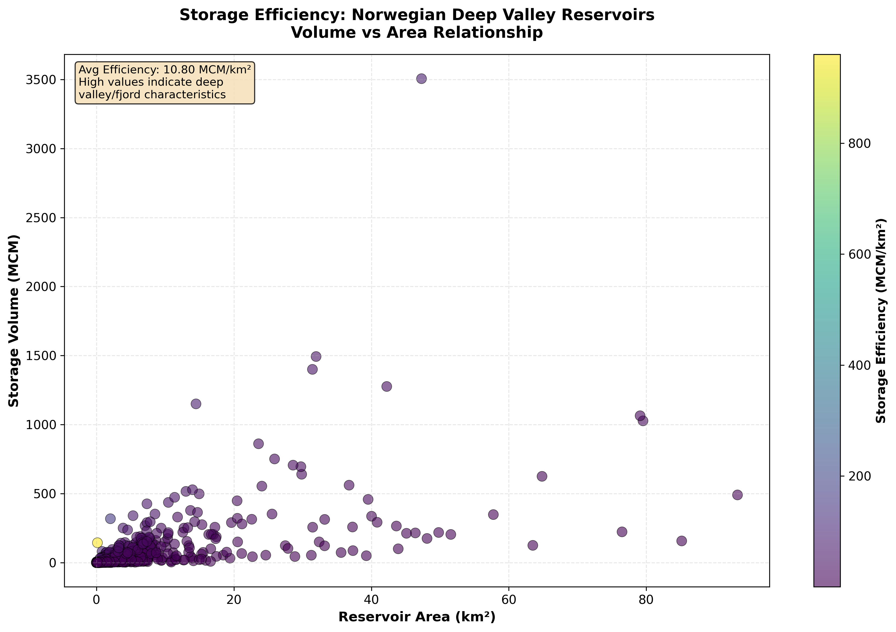

Operational Flexibility and Regulation Range
A distinctive feature of the Norwegian NVE dataset is the documentation of regulation range data for 1,585 reservoirs (52.9% of the reservoir inventory), representing the vertical difference in meters between highest regulated water level (HRV) and lowest regulated water level (LRV). Regulation range quantifies the usable storage volume that can be cycled for power generation operations and serves as a direct indicator of operational flexibility. The documented average regulation range of 10.9 meters, with a maximum value of 193.5 meters, demonstrates substantial operational capability within the Norwegian hydropower system. The distribution includes 285 high-flexibility reservoirs with regulation ranges exceeding 30 meters (18.0% of reservoirs with regulation data), 612 moderate-flexibility reservoirs with ranges between 10 and 30 meters (38.6%), and 688 limited-flexibility reservoirs with ranges below 10 meters (43.4%).
The operational significance of regulation range in Nordic hydropower systems is extensively discussed in the hydropower engineering and energy systems literature. Killingtveit and Sælthun (1995) provide detailed treatment of regulation range concepts in the context of Norwegian hydropower planning and operations, explaining how larger regulation ranges enable greater hydropower peaking capability through rapid response to demand variations, seasonal storage optimization to capture spring snowmelt runoff for winter generation periods, and multi-year storage strategies to manage inter-annual precipitation variability characteristic of Norwegian climate patterns. More recently, Graabak et al. (2017) analyze Norwegian hydropower operational flexibility in the context of Nordic and European energy system integration, describing how substantial regulation capability enables Norway's hydropower system to function as a "battery" for variable renewable energy sources including wind and solar power across northern Europe.
The strategic significance of operational flexibility extends to electricity market participation and grid balancing services. Norway's hydropower system, characterized by substantial regulation ranges enabling significant volume cycling, provides rapid-response generation capability supporting grid frequency control and power system stability. This operational capability has particular value in the context of increasing renewable energy penetration across European electricity systems, where intermittent generation from wind and solar resources creates demand for flexible balancing power. Norwegian hydropower participation in Nordic electricity markets (Nord Pool) and growing interconnection capacity with neighboring countries including Denmark, Netherlands, Germany, and the United Kingdom through submarine HVDC cable links enables cross-border power exchange utilizing Norwegian regulation capability.
The distribution of regulation ranges within the Norwegian reservoir inventory indicates that operational flexibility is not uniformly distributed across all infrastructure, but rather concentrated in particular installations. The subset of reservoirs with high regulation ranges (>30 meters) provides disproportionate operational value for system balancing and market participation despite representing a minority of the total reservoir count. This suggests that strategic operational planning may prioritize utilization of high-flexibility reservoirs for market-responsive generation while lower-flexibility installations serve more continuous baseload generation roles or specific local supply functions.

Figure 5: Distribution of Regulation Ranges in Norwegian Reservoirs
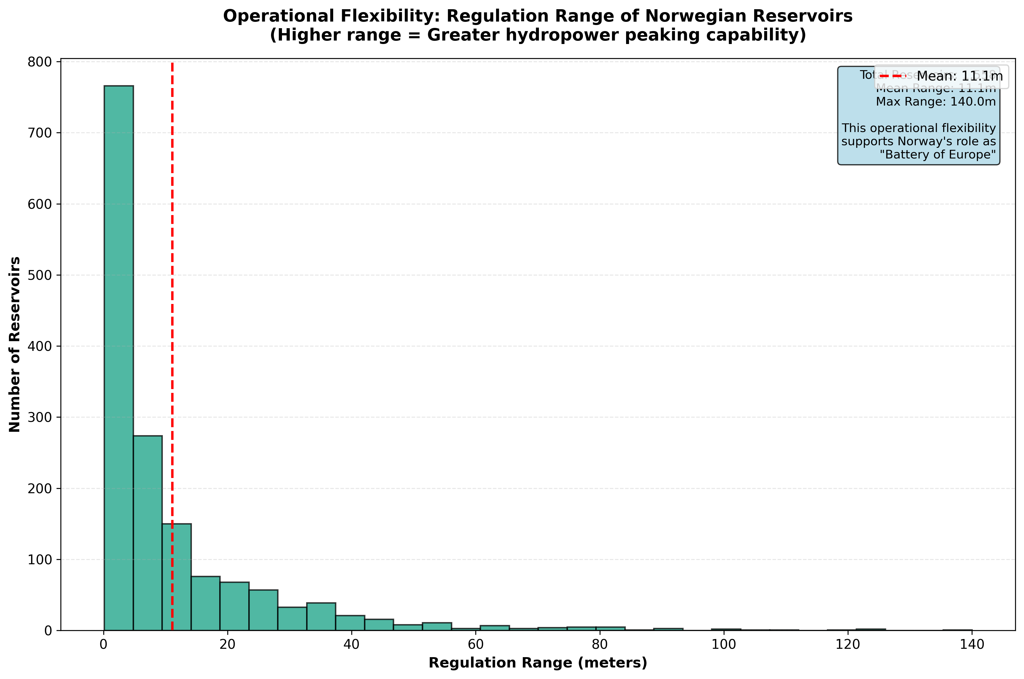

Purpose Classification and Development Philosophy
Classification of reservoir purposes in the NVE database confirms the dominance of power production (Kraftproduksjon) as the primary function for Norwegian dam infrastructure, with 1,830 reservoirs designated for power production representing 61.1% of reservoirs with documented purpose classifications. This predominance reflects Norway's historical development trajectory focused on hydroelectric generation as the foundation of the national electricity system. Secondary purposes include water supply (Vannforsyning) at 461 reservoirs (15.4%), recreation (Rekreasjon) at 195 reservoirs (6.5%), aquaculture operations at 172 combined reservoirs (5.7%), and various other purposes including snow production for ski facilities and industrial water supply.
The single-purpose orientation of Norwegian dam infrastructure contrasts with multipurpose development approaches employed in other contexts where individual projects serve combined objectives including irrigation water supply, flood control, power generation, and municipal water supply. The predominance of single-purpose hydropower design in Norway reflects several factors including topographic suitability for hydropower generation in mountainous terrain, adequate natural precipitation reducing irrigation requirements across most of the country, separation of municipal water supply systems as dedicated infrastructure independent of power generation reservoirs, and flood management approached primarily through distributed catchment management rather than large flood control reservoirs.
This single-purpose design philosophy, while not universal across all Norwegian infrastructure, enables operational optimization for power generation efficiency without the complex trade-offs among competing water allocation requirements characteristic of multipurpose systems. Operational protocols can prioritize electricity generation and market participation without constraints from pre-committed irrigation water releases or flood storage space requirements that must be maintained during specific seasons. Ownership and regulatory responsibilities are similarly simplified when projects serve clearly defined hydropower objectives under unified management.
The 15.4% of reservoirs designated for water supply represent dedicated municipal and industrial water sources operated independently from the hydropower generation system. Recreation classifications (6.5%) include reservoirs with formal designations for public access and recreational use, though many power production reservoirs also accommodate recreational activities including fishing, boating, and waterside camping without formal recreational purpose designation in the NVE database. Aquaculture purposes (5.7%) reflect Norway's significant aquaculture industry, particularly salmon farming and inland fish hatchery operations utilizing reservoir water supplies.

Figure 6: Purpose Distribution of Norwegian Dam Infrastructure
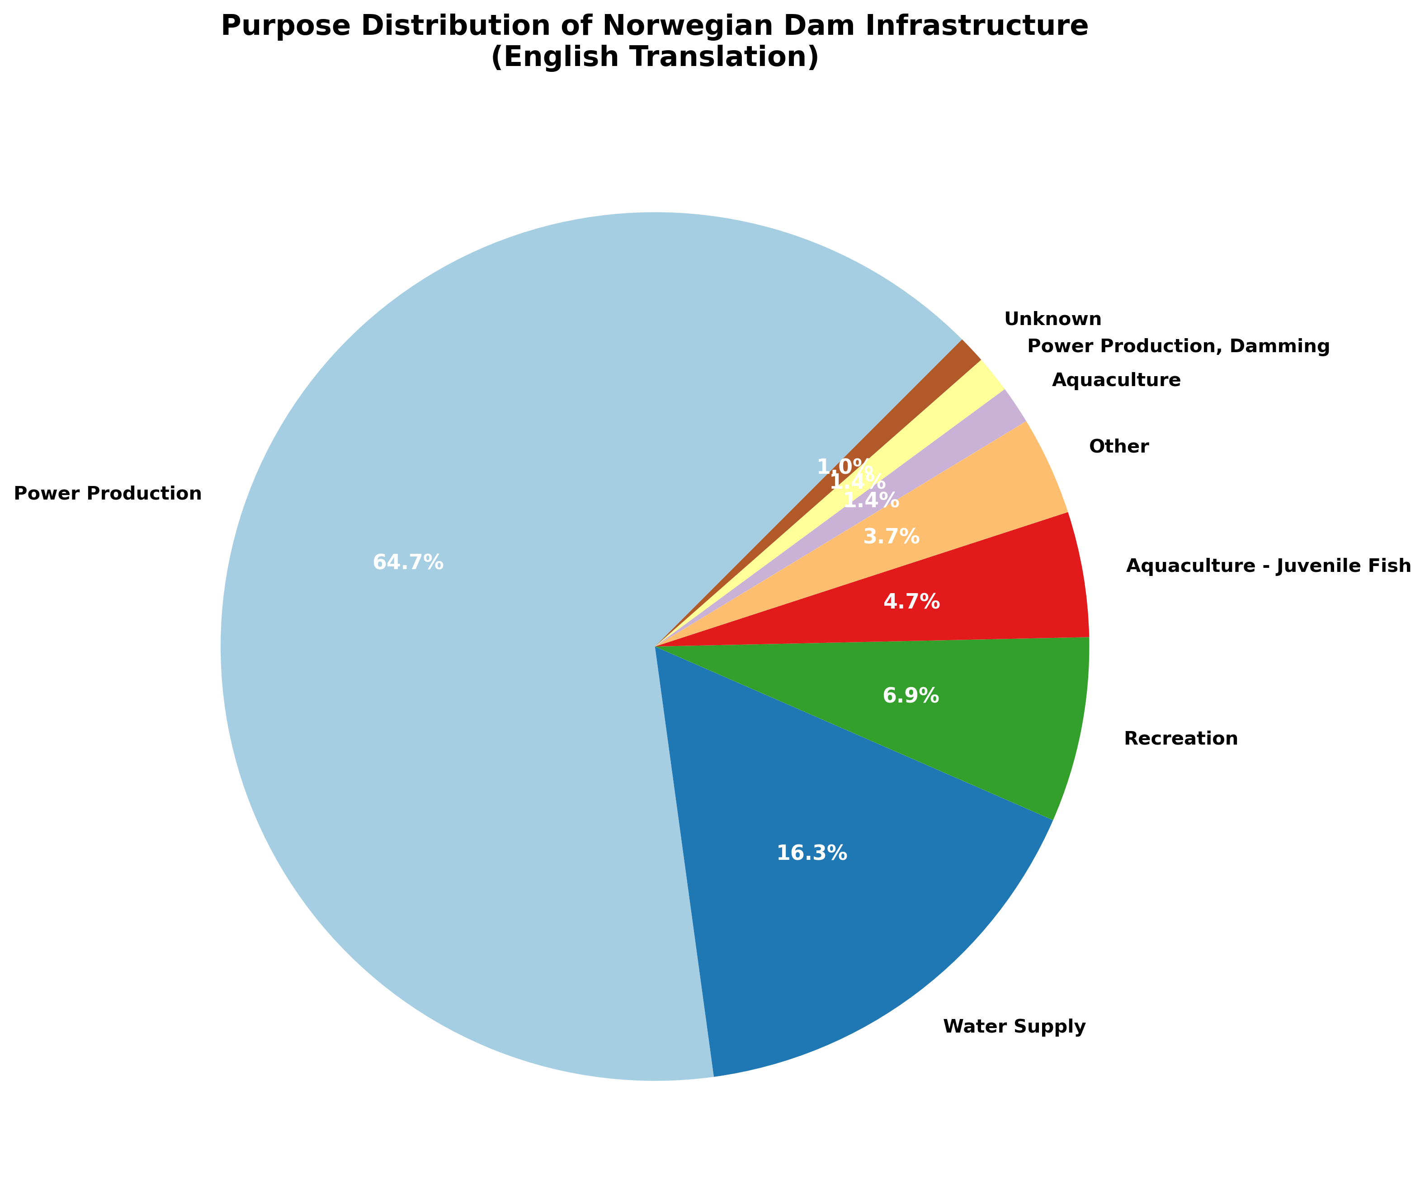
Note: Purpose classifications translated from Norwegian (Kraftproduksjon = Power Production, Vannforsyning = Water Supply, etc.) for international accessibility.

Regulatory Framework and Governance
Norwegian dam safety and water resource management operates under a unified regulatory framework administered by the Norwegian Water Resources and Energy Directorate (NVE), which functions as the national competent authority for water resource planning, hydropower licensing and regulation, dam safety oversight and enforcement, watercourse regulation approvals, and coordination of emergency preparedness related to dam incidents. Primary legislation includes the Water Resources Act (Vannressursloven) of 1940 as amended and the Watercourse Regulation Act (Vassdragsreguleringsloven) of 1917 as amended, supplemented by implementation of the European Union Water Framework Directive (Directive 2000/60/EC) which Norway adopts despite non-EU member status through the European Economic Area agreement.
The dam safety regulatory system employs consequence-based classification determining inspection frequency, instrumentation requirements, emergency preparedness obligations, and design standards. The four-class system ranges from Class 0 (minimal downstream hazard) through Class 3 (severe consequence potential requiring most stringent requirements), with classification methodology considering downstream population at risk, critical infrastructure, and economic consequences of potential failure scenarios. High-consequence dams (Class 3) undergo annual comprehensive inspections by qualified engineers, maintain continuous instrumentation monitoring of critical parameters, develop and regularly update emergency action plans, and conduct periodic comprehensive dam safety reviews examining structural adequacy, operational procedures, and compliance with current standards.
Norway's implementation of the Water Framework Directive, as analyzed by Hanssen et al. (2016), requires integration of ecological status assessment and environmental flow requirements into water resource management decisions. This creates ongoing reconciliation between historical hydropower development with established water rights and contemporary environmental protection objectives including maintenance of ecological flows, protection of aquatic species including salmonids, and achievement of good ecological status in water bodies as defined by the directive. River basin management planning under the WFD incorporates public participation in decision-making and coordination with neighboring countries (Sweden, Finland, Russia) for transboundary watercourses, introducing additional complexity to regulatory processes for hydropower operations and infrastructure modifications.

Comparative Analysis: India and Norway Dam Infrastructure
The preceding analysis of Norwegian dam infrastructure provides the foundation for comparative examination alongside Indian dam development patterns. Table 1 summarizes key differences across four analytical dimensions: construction trends, age distribution, structural characteristics, and governance frameworks.

Table 1: Comparative Summary of Indian and Norwegian Dam Infrastructure
Dimension | India | Norway
Total Dams | 6,138 (NRLD-2023) [1] | 4,953 (NVE database)
Peak Construction | 1980s (irrigation/multipurpose) | 1960s (hydropower/electrification)
Age Profile | 61.7% > 25 years [2] | 60.2% in 50-99 year range
Primary Purpose | Multipurpose (irrigation/flood/power) | Single-purpose (hydropower 61%)
Topography | Broad alluvial valleys | Narrow mountain valleys
Storage Efficiency | Lower (shallow impoundments) | 10.80 MCM/km² (deep valleys)
Governance | Dam Safety Act 2021 (federal) [3] | NVE unified framework [8]

Construction Trajectories
Table 2 contrasts the temporal construction patterns between India and Norway, revealing distinct development timelines driven by different national priorities.

Table 2: Construction Timeline Comparison
Parameter | India | Norway
Development Period | Post-independence (1947+) | Post-war (1945+)
Peak Decade | 1980s | 1960s
Peak Dams/Decade | ~1,200-1,300 dams | 528 dams
Primary Driver | Irrigation & food security | Rural electrification
Development Context | Five-Year Plans, river basin schemes | Industrial development, cheap power

The two-decade gap between peaks (1960s Norway vs. 1980s India) reflects different post-war development trajectories. Norway prioritized hydroelectric generation for industrial growth, while India focused on agricultural self-sufficiency requiring extensive irrigation infrastructure [1].

Age Distribution
Both countries face aging infrastructure challenges. Table 3 compares age distribution profiles and regulatory responses.

Table 3: Age Profile Comparison
Parameter | India | Norway
Mature Infrastructure | 61.7% > 25 years [2] | 60.2% in 50-99 year range
Average Age | Not specified (varied) | 60.8 years
Historic Structures | Colonial-era dams exist | 252 dams > 100 years (6.5%)
Oldest Dams | Pre-1900 structures | 1800 (225 years old)
Safety Framework | Dam Safety Act 2021 [3] | NVE consequence-based system [4]
Inspection Regime | Multi-tier (NCDS/NDSA/SCDS/SDSO) | Annual for high-consequence dams

Both countries have similar proportions of aging infrastructure requiring rehabilitation planning. The regulatory responses differ in structure (federal coordination in India vs. centralized authority in Norway) but share common elements including risk-based classification and periodic inspection requirements.

Structural Characteristics
Dam typology and reservoir configurations reflect underlying topographic contexts. Table 4 contrasts structural characteristics.

Table 4: Structural and Operational Characteristics
Characteristic | India | Norway
Dominant Dam Types | Earthen, composite [5] | Rock-fill, concrete gravity [6]
Valley Context | Broad alluvial valleys | Narrow mountain valleys
Foundation Geology | Alluvial/semi-alluvial | Competent bedrock
Storage Efficiency | Lower (shallow) | 10.80 MCM/km² (deep)
Regulation Range | Data not available | Avg 10.9m (max 193.5m)
Operational Flexibility | Constrained (multipurpose) | High (peaking/balancing)

Topographic context drives structural choices: India's broad valleys suit earth-fill dams for irrigation reservoirs, while Norway's narrow valleys enable high-head rock-fill/concrete structures optimized for hydropower generation. Norway's documented regulation ranges indicate substantial operational flexibility unavailable in multipurpose contexts.

Spatial Concentration
Infrastructure concentrations reflect different development drivers in each country. Table 5 compares regional patterns.

Table 5: Regional Distribution Patterns
Aspect | India | Norway
Top Region 1 | Maharashtra (2,696) [2] | Innlandet (1,258, 25.4%)
Top Region 2 | Madhya Pradesh (1,370) | Vestland (963, 19.4%)
Top Region 3 | Gujarat (525) | Trøndelag (830, 16.8%)
Top 3 Concentration | ~65% of total | 61.6% of total
Geographic Pattern | Water-stressed agricultural regions | Mountainous western/central
Driving Factor | Irrigation demand + flood control | Hydropower potential [7]

Both countries show similar concentration levels (~60-65% in top three regions), but drivers differ fundamentally. Indian concentrations follow irrigation needs in major river basins (Godavari, Krishna, Narmada), while Norwegian concentrations follow hydropower resource availability in steep, high-precipitation terrain.

Governance and Safety Frameworks
Institutional structures reflect different political systems while incorporating common safety principles. Table 6 compares governance frameworks.

Table 6: Governance Framework Comparison
Element | India | Norway
Primary Legislation | Dam Safety Act 2021 [3] | Water Resources Act 1940 [8]
Structure | Federal (multi-tier) | Unitary (centralized)
National Authority | NDSA (statutory) | NVE (directorate)
Policy Body | NCDS (CWC-chaired) | Integrated within NVE
State/Local Level | SCDS + SDSO (each state) | N/A (national only)
Classification | Risk-based | Consequence-based (0-3)
International Framework | Domestic standards | EU Water Framework Directive [9]

India's federal structure necessitates multi-tier coordination between central and state authorities, while Norway's unitary system enables centralized oversight through NVE. Both incorporate risk/consequence-based classification and periodic inspection requirements, though organizational structures differ.

Implications for Infrastructure Performance and Adaptive Management
The comparative analysis reveals that hydrological regimes, topographic constraints, structural typology choices, age profiles, and governance models collectively shape long-term dam infrastructure performance, sustainability, risk exposure, and rehabilitation needs in context-specific ways. The findings suggest several implications for infrastructure management and policy development in both countries.
First, the differing primary purposes (Norwegian hydropower focus versus Indian multipurpose orientation) create distinct operational constraints and flexibility opportunities. Norwegian single-purpose designs enable optimization for power generation and electricity market participation, while Indian multipurpose projects require complex trade-offs among competing water allocation requirements. Second, topographic contexts (Norwegian narrow mountain valleys versus Indian broad alluvial valleys) fundamentally influence structural characteristics, storage efficiency, and operational capabilities, with Norwegian high-head configurations providing advantages for flexible peaking operations that may be less feasible in broad valley contexts. Third, both countries confront aging infrastructure challenges requiring strategic rehabilitation planning, though the specific approaches must reflect differing structural typologies, foundation conditions, and operational requirements.
The analysis underscores the importance of context-specific approaches to dam safety, rehabilitation strategies, operational optimization, and regulatory framework design. Direct transplantation of technical or institutional approaches between contexts may be inappropriate given fundamental differences in geographic, hydrological, and institutional conditions. However, exchange of experience regarding aging infrastructure management, safety assessment methodologies, instrumentation and monitoring technologies, and emergency preparedness planning offers opportunities for mutual learning while respecting context-specific requirements.

References
[1] Central Water Commission (CWC). (2023). National Register of Large Dams (NRLD-2023). Ministry of Jal Shakti, Government of India. Available at: https://cwc.gov.in/
[2] Digital Sansad. (2023). Parliamentary documentation on dam infrastructure statistics. Government of India. Available at: https://sansad.in/
[3] Government of India. (2021). Dam Safety Act, 2021 (Act No. 41 of 2021). Gazette Notification S.O. 5422(E), effective 30 December 2021. Ministry of Jal Shakti. Available at: https://indiacode.nic.in/
[4] Høeg, K. (2005). Norwegian dam safety: International perspectives and evolving challenges. Proceedings of the International Symposium on Dam Safety, Lausanne, Switzerland.
[5] Central Water Commission (CWC). (2019). Analysis of dam types and characteristics in Indian inventory. Technical Report, Government of India.
[6] Graabak, I., Bakken, T. H., Feilberg, N., & Belsnes, M. M. (2017). Strategies for Norwegian hydropower in a changing Nordic energy system. Energies, 10(11), 1780. https://doi.org/10.3390/en10111780
[7] Bakken, T. H., Killingtveit, Å., Engeland, K., Alfredsen, K., & Harby, A. (2012). Water consumption from hydropower plants - review of published estimates and an assessment of the concept. Hydrology and Earth System Sciences Discussions, 9, 787-812.
[8] Killingtveit, Å., & Sælthun, N. R. (1995). Hydropower Development, Vol. 7: Water Power Planning. Norwegian Institute of Technology, Department of Hydraulic Engineering, Trondheim.
[9] Hanssen, F., Barton, D. N., Venter, O., Nowell, M. S., & Fjeldstad, H.-P. (2016). The Norwegian framework for implementing the Water Framework Directive. In River Basin Management: Implementing the Water Framework Directive. IWA Publishing.
Additional References:
Graf, W. L. (1999). Dam nation: A geographic census of American dams and their large-scale hydrologic impacts. Water Resources Research, 35(4), 1305-1311.
Midttømme, G. H., Petterson, R., & Westermann, K. (2008). Norwegian hydropower development: History and key policy decisions. Energy Policy, 36(9), 3255-3262.
Nesje, A., Bakke, J., Dahl, S. O., Lie, Ø., & Matthews, J. A. (2008). Norwegian mountain glaciers in the past, present and future. Global and Planetary Change, 60(1-2), 10-27.
Norwegian Water Resources and Energy Directorate (NVE). (2025). Hydropower Database. Public GIS datasets. Available at: https://www.nve.no/
Statistics Norway (Statistisk sentralbyrå). (2024). Energy Statistics. Available at: https://www.ssb.no/
Thaulow, H., Tvede, A. M., & Hagem, G. (1997). Hydropower Development in Norway. Norwegian Institute of Technology Press, Trondheim.

