DOCUMENTATION

Assignment 4

NUME STUDENT: Maier Catalin-Andrei
GRUPA: 30422

CUPRINS

1. Assignment purpose 3
2. Analisys, scenarios, use cases 3
3. Design 3
4. Implementation 3
5. Results 3
6. Conclusions 3
7. Resources 3

Project purpose
- This web application has the purpose of simulating an food order management system where users can authenticate, add orders to their shopping cart, place orders on these particular selected items. The system is also using an type-based authentication (or rather it is simulating it by parsing emails in the front-end of the application)

- This process can be split into several implementation steps:
- Choosing the appropriate data structures used to store information about the clients, the products and the orders
- Implementing the back end component of the web service, namely the REST API which will manage requests from the front-end component, such as CRUD operations on the products, mocking a rudimentary login system ( no Spring Security or HTTPS implemented :c ) etc.
- Designing the front end component which will allow users to interact with the server, acting as clients.
- Creating utility functionalities such as:
  - Logging of events in the backend server
  - Creating an admin panel with whom the admin can interact with: adding products, deleting products, managing orders, generating reports
  - Creating an employee panel to simulate a real-time work environment where orders are received and prepared.

Analysis, Scenarios, Use Cases

Functional requirements:
- The application should allow the user to register and enter a valid password, email, address and date if birth. These credentials will be validated in a soft manner in the front – end and in a more rigorous manner in the back – end, with the use of design by contract methods.
- The application should allow the user to log in and access its own dashboard, if an entry from the hash tables in the backend matches with his account.(email and password are verified)
- The application should allow users to purchase certain items that are available in the simulation

Non-functional requirements

- The application should be intuitive and easy to use.
- The application should be responsive.
- The application should be aesthetically pleasing to look at.(which I did not do a good job at)

Scenarios:

- User successfully registers
  - Application should respond accordingly and greet the user with a success message

- User failed to register
  - Application should display an error message on the screen with the purpose of providing the user with the necessary information to know why the operation failed. Some typical examples are: the username was already taken, the password was too weak, the back-end server crashed, etc.

- User failed to login
  - Application should display an error message on the screen with the purpose of providing the user with the necessary information to know why the operation failed. Common failure scenarios: user inputted the wrong username/password combination, backend server crashed.

- User failed to order a certain product

  - Application should display an error message on the screen with the purpose of providing the user with the necessary information to know why the operation failed. Common failure scenarios: back end server crashed.

Use cases:

- This product can be seen as more of a general template e commence web application than a traditional order management system. With this is mind, the use cases for this type of product are endless: any marketable product can be sold on these kinds of websites. This kind of applications could also serve as intermediaries and not actually provide any sort of physical product whatsoever, they would only put the client in touch with the product (one famous example would be Bolt Food)

Design

The code design methods include the use of the composite design pattern and a lazy use of the observer pattern.
Composition is used for the structure of the products, where each product can be an individual one or consist of several different products. E.g.: tomato soup can be a product. Tomato soup with cheesecake as desert can be another product.
The observer pattern is not rigorously implemented and is more of a “when finished, reflect” pattern. The employee panel will make a request to the backend, waiting for information related to the orders. Once this information is provided (with the help of a utility class named JSONOrderWrapper ), the orders will be shown in a good-vue-table component.
In addition to these 2 design principles, additional concepts need to be discussed: serialization and stream processing. Stream processing was used for generating certain admin-specific statistics which will aid towards program data / traffic inspection.
Serialization was used to persist information, lacking a database system. The clients, orders, products are serialized at the ending of the server by using a special Spring Bean which will activate on all close signals (SIG_TERM or SIG_KILL or normal termination without a signal

Class Diagram:
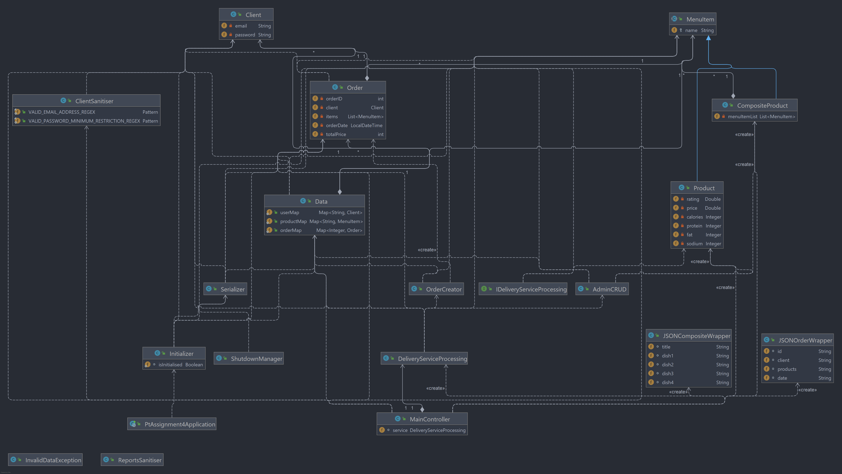

Package Diagram:
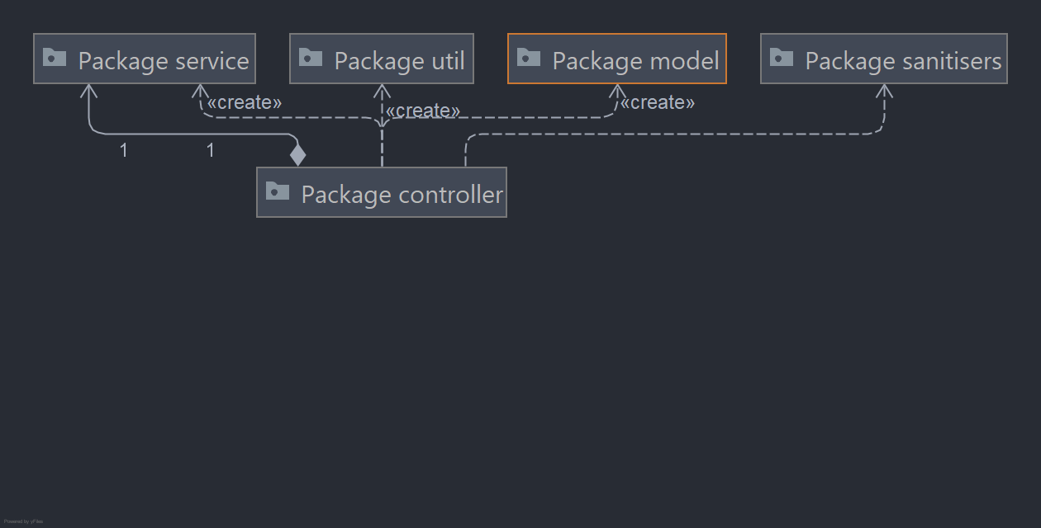

Implementation

To keep things brief, discussion will be held on the packages, not on each and every class.
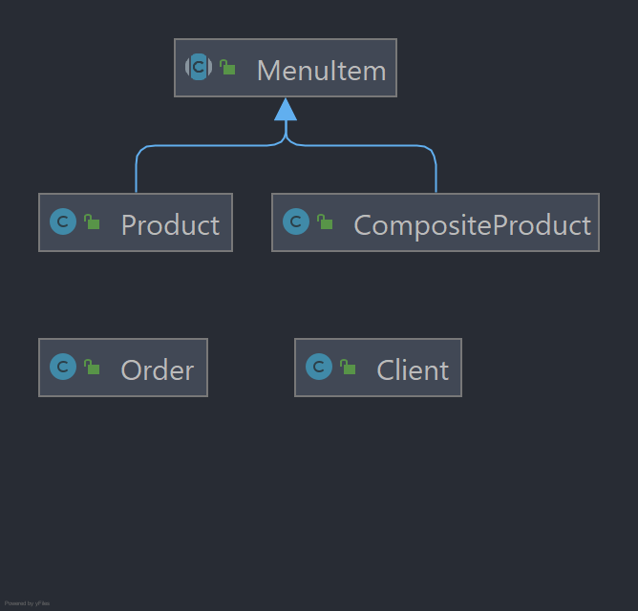
Back-end:

- Model
.
The model package contains the basic structures
that will be used in the application. One important aspect in this stage is
that each class needs to be serializable, that is, to implement the Serializable
class and to have each field serializable. This is needed in order to be able
to persist the data trough means of serialization. The java bytecode of each
class will be stored in a file and will be retrieved later, achieving
persistence not only on the static data fields, but also on the dynamic state-changing logic of the class.

- Service
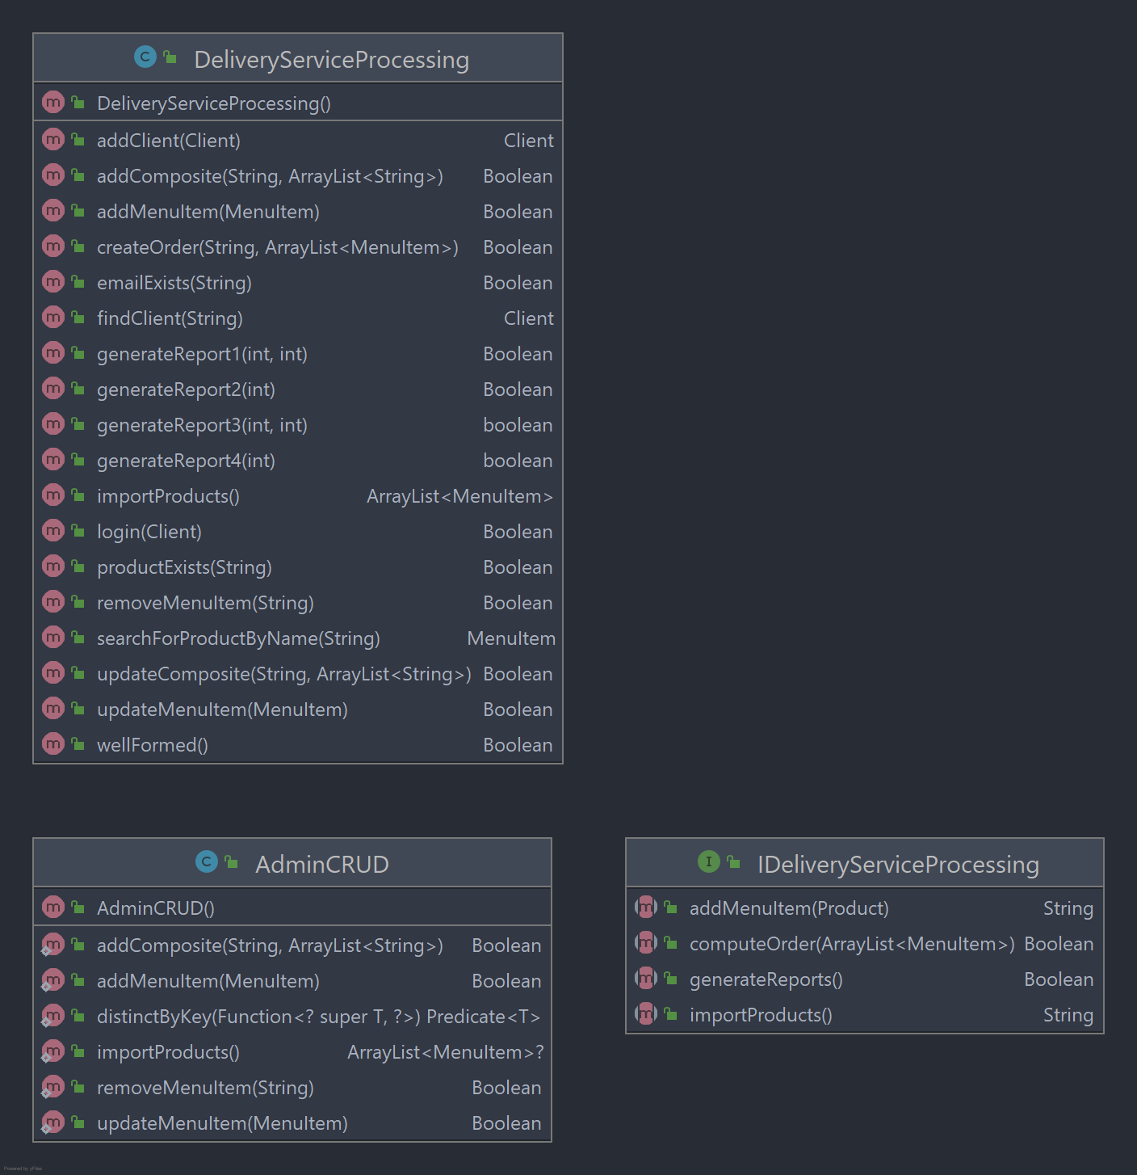

The service class represents the core of this application, especially the Delivery Service Processing class. This class will handle each logical operation of the application. Some examples are: adding a product to the product Hash Table, adding a client to the Client Hash Table, a order to the Order Hash Table, finding clients to simulate a log in process, generating admin reports with the use of stream processing to ensure speed and consistency on the data.
Other examples include other related CRUD operations on classes from the model, such as updating products, simple and composite, deleting products. Operations are encapsulated with validations following a design by contract methodology: each method has precodintions which ensure the well formness of the data (which is an invariant, a concept that means: valid always, not changing, not varying) as well as other validations like lite parameter sanitization.

The ADMINCRUD class is a wrapper class for the main operations that the admin needs. These include CRUD on the products and also to initially import them from a products.csv file which contains waay too much data for a web application to handle in this form ( I certainly don’t know how to work with big data and optimize vue to process it correctly, this is the reason why I chose to only import 2000 initial products out of the 14000 that were presend in the products.csv file). This import operation is only done at the first lifecycle of the server, aka when no product serialization file is present. Afterwards, when the server shuts down for the first time, the products will be serialized in a special file and on further usages of the server, it will be imported from that file, which now contains additional products and also composite products. A choice was made here: because the products are revieced from a csv file, in plain text data ( not bytecode of a serialization ), we could have continued to add every new item to this products.csv. The problem with this approach is that we can have composite products and since the file would have had two types of parsing necessary on each line, depending on the length of the line when splitted by commas, importing would have been more sluggish. At the same time, at each import, the composite products would have been needed to get the corresponding menuItem array component in its creation, its constructor. Since we only have text in our products.csv, an additional step is needed: to create the product objects. Taken all this into account, I chouse to serialize the products and use the .csv file only at the beginning.

- Controller

The controller package contains all the controllers, which
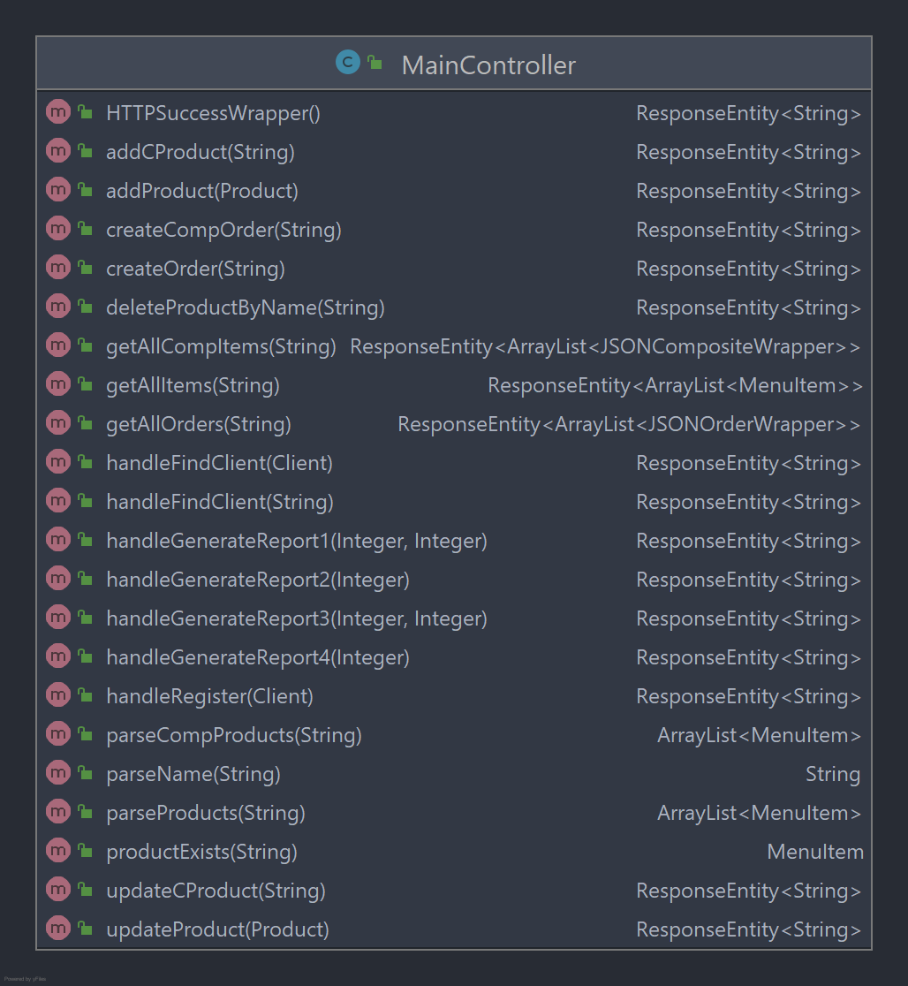
link our java spring backend application to our
vue front-end.
This is a good moment to start talking about
Spring, which is a java framework used for
multiple purposes.
The server-creation part was done with spring
.Spring created a RESTful API that can be
accesses via this controller, whom respects the
singleton principle.
The controller is used for all the operations
seen in the right-side of the page.
Each method is annotated with either a
GetMapping or PostMapping annotation, to
specify the needed HTML method of
manipulating the endpoint. Several problems
were encountered at this stage, the most
important one being the fact that in a
PostMapping, two parameters cannot share
the @Body annotation. This meant that for a
post request, everything that the server receives
must be incorporated in a class-type. When
ordering, vue exports a JSON object containing
the name of the account that is currently
ordering and a list of products. This could have
been done with a Order object, but at the time,
I did not think about it. Instead, I used a String
object for fetching the data and implemented
the “parseName” and “parseProducts” methods
for successfully dealing with the nuisance that
was caused, This, in retrospect, is not a best
practice. Also, the whole project lacks craft
unfortunately, due to lack of time and bad time
management.

Front-end
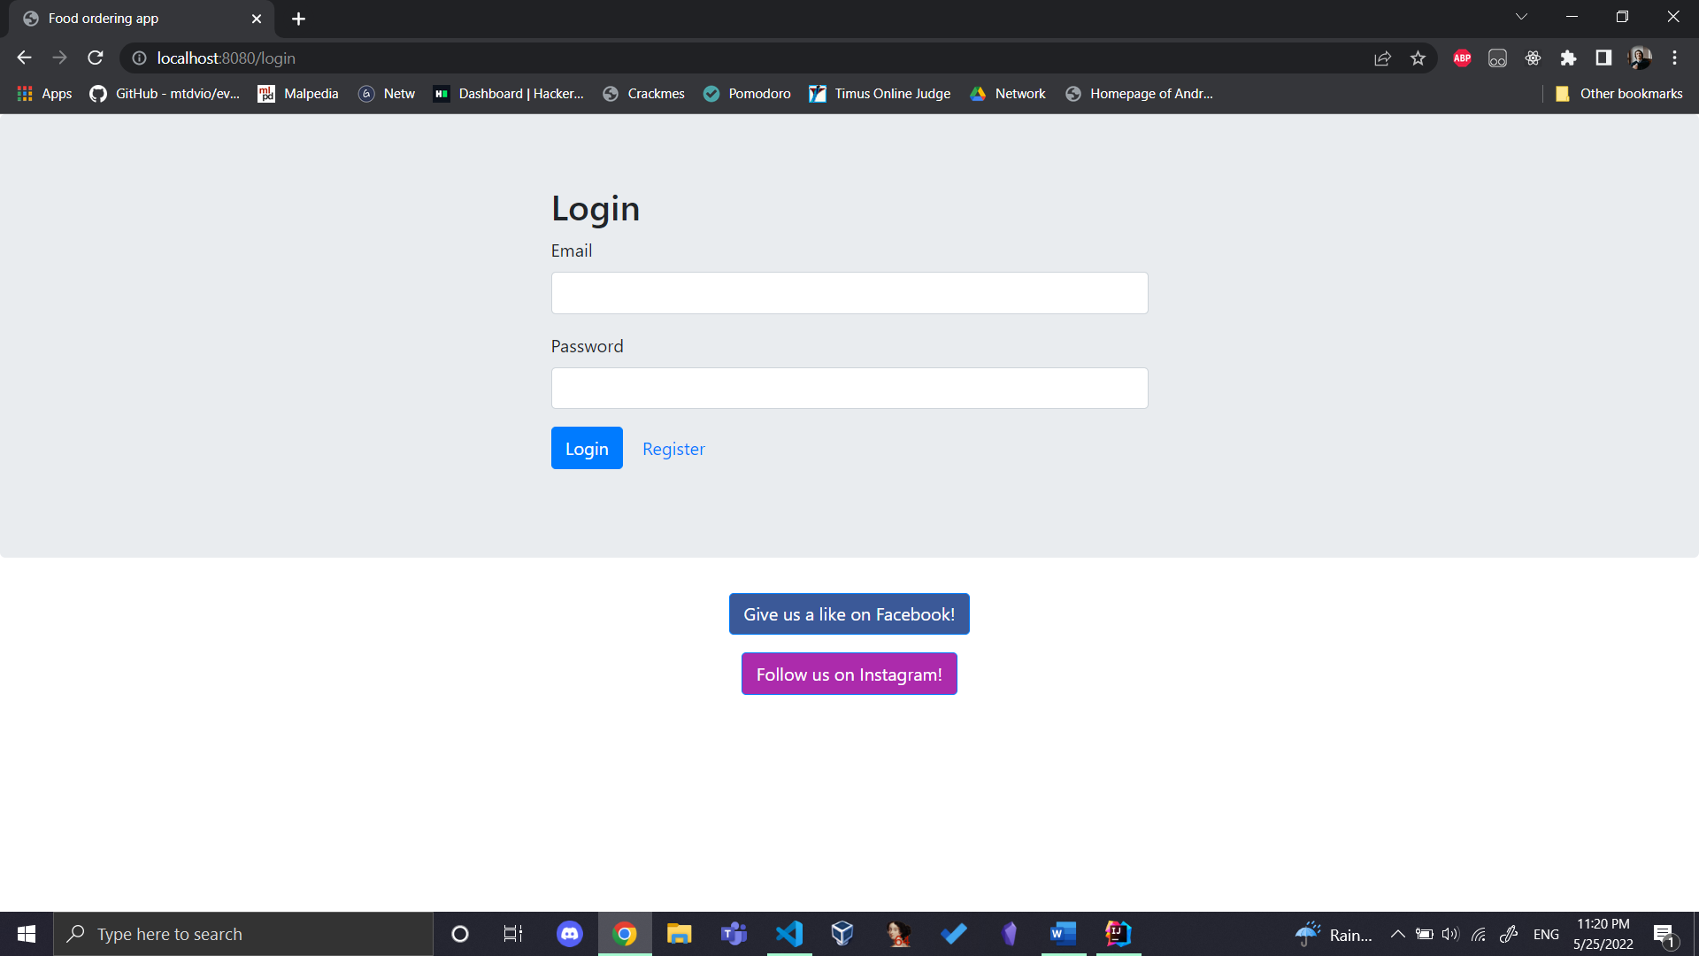

Front-end consists of several components, which will be briefly described:

LoginPage.vue: Main component of the application ( the root node of the web app is here, meaning that each “not found” http code will redirect to this component. It is also rooted at “/”. This component, as all the components, are wrapped in a template which sets dimension boundaries on the content and also displays two nice social media buttons on the bottom of the page (for fun, they don’t redirect to anything of use ). The login panel is encapsulated in a form tag, which has the v-on-click directive to point to a function which will be created only when the component renders. This function will send the data to a wrapper function in the account.service class which will call another function in the user.service.js file. This is were the request is sent to java, so, this front-end tries to reflect a layered architecture design pattern. This can be also said about the register screen which follows the exact same concepts.
HomePage.vue: This component is instanciated after the log in operation was successful and renders two vue-good-table components which will store the simple products and the composite products. The data is fetched by using a “mounted()” method which automatically performs at each render. The fetch API that was used is axios. For selecting each command, we enabled some functionalities of vue-good-table, and for sending the order request, we had to trim the selectedRows variable to display only column data, not other auxiliary data as “lineNr”.

AdminPage.vue : Component that renders if email is administrator@admin.adm. This dashboard contains buttons for linking the backend request operations. It also hosts the only route of adding employees and of managing CRUD operations on the products
The components take full advantage of the declarative instantiation of Vue components, in the sense that each component is part HTML part VUE (hybrid js). These two parts blend together nicely at render time.

Conclusion

This web application has the purpose of simulating an food order management system where users can authenticate, add food to their shopping cart, place orders on these particular selected items. The use of multiple technologies and the short time interval in which this had to be done provided a good challenge. The project is by far not perfect and should be seriously worked upon until it reaches online hosting quality. A list of interesting additions would be: implementing HTTPS on the server, making use of the CSRF tokens that are stored in front-end, sanitise for XSS, SSTI, anything related to OWASP Top 10.

Resources

https://stackoverflow.com/

