Genetic Algorithm for the Evolution of Classifier’s Weights
Abstract. One of the main goals in machine learning is to obtain predictive models with the highest performances for a given problem. Tuning the parameters of classification methods is the most common way to achieve that goal. However, little attention has been paid to weighting the instances of the training data. This paper proposes the use of Genetic Algorithms to improve the efficiency of four classification methods. Individual weights are assigned to each instance of the datasets and a genetic algorithm is employed to find the optimal values of these weights. The results obtained with seven publicly available datasets show the potential of this technique to improve the performance of classifiers.
Keywords: Genetic algorithm, Classifier, Weight assignment, Weight evolution.
- Introduction
This paper proposes a method to improve the accuracy of various classifiers by implementing a Genetic Algorithm (GA) for real value representation. Previous literature work, such as [1], has utilized GAs to enhance the accuracy in the classification of cardiac arrhythmias in electrocardiogram signals. In that study, GAs were applied to optimize features in the classification process of the k-Nearest Neighbors Algorithm (KNN) and Naive Bayes classifiers, both with and without Elitism. The study reported an increase in classification accuracy of up to 79.76%. Additionally, the utilization of Genetic Algorithms led to a reduction of up to 67% in the presence of unnecessary data that acted as noise factors in the classification.
In [2], GAs were employed to reduce the dimensionality of the data by selecting variables with the most significant impact. This approach was used to achieve accurate classification of instances using the Support Vector Machines (SVM) and Naive Bayes algorithms for predicting the level of psychosocial risk among public-school teachers in Colombia. The results showed significant improvements, with Naive Bayes achieving an average accuracy of 94.44% and SVM achieving 96.29%.
On the other hand, in [3], GAs are used as a feature selection method, implementing the logistic regression algorithm to predict the probability of diabetes-related heart disease in patients. This approach involves dividing the data into classes and groups, with GAs responsible for selecting relevant features through cross-validation evaluation of the model. Additionally, in [4] GAs are employed to identify the most significant variables correlated with the development of complications in patients with type 2 diabetes. Subsequently, these variables are utilized as inputs for classification models.
These approaches demonstrate the utility of Genetic Algorithms (GAs) in improving the accuracy and precision of classifiers across different problem domains. In this study, we employ individual weights assigned to samples in a dataset, enabling the classifier to focus on certain instances that are more challenging to classify by giving them greater importance during training. This technique has the potential to enhance classifier performance on diverse datasets. However, each dataset is unique, making it laborious and time-consuming to manually determine an ideal weight list through expert intervention. In contrast, implementing a GA facilitates the evolution and adaptation of a weight list that can approach optimality. It is important to note that not all classifiers support the assignment of individual weights to instances. However, some classifiers that do support this feature include Naive Bayes, Logistic Regression, and Perceptron among others.
- Classification algorithms
Classification algorithms are machine learning techniques that use pattern analysis and features to estimate the classes or categories to which an instance belongs. Among the numerous classifiers available, this study will specifically focus on the following: Naïve Bayes, Logistic Regression, Perceptron, and Support Vector Machines (SVM). These classifiers belong to the supervised learning category, which leverages labeled data for learning purposes. Each of these classifiers possesses distinct characteristics and settings that make them suitable for various classification tasks.

Naïve Bayes
Naive Bayes is a probabilistic method used for classification. This classifier is based on Bayes' theorem and assumes conditional independence between the predictor variables or features. The operation of the classifier follows these steps: Firstly, data are collected to calculate the a priori probabilities for each class. Secondly, conditional probabilities are calculated for each class. Finally, when a new unknown sample is presented, Bayes' theorem is applied to determine its class membership, as shown in Eq. (1).
P(A|B) = (P(B|A)* P(A))/ P(B) . | ()
P(A|B) represents the a posteriori probability of A given B, while P(B|A) corresponds to the probability of B occurring given that A has occurred. Additionally, P(A) and P(B) are used as the a priori probabilities of A and B, respectively.

Logistic Regression
Logistic regression is a method used to predict the probabilities of belonging to a specific class. This classifier is based on the logistic model, which utilizes the logistic function to transform the linear combination of features into a probability. Logistic regression models the relationship between the independent variables and the dependent variable, enabling classification predictions based on estimated probabilities. Equation (2) depicts the general form of the logistic function.
f(x) = 1/( 1+e ^ (-x)) . | (2)
Where x is the input value, and e is the Euler's number.

Perceptron
The perceptron is a learning algorithm designed to classify instances that are linearly separable. Due to this limitation, it is best suited for small datasets and simple binary classification problems. The operation of the perceptron is based on a set of input features and a corresponding set of weights. The goal of the classifier is to find the optimal set of weights that can accurately classify all instances. This is achieved by adjusting the weights based on classification errors using a learning algorithm. The decision boundary is then generated using the equation of a line.
f(x) = w x + b . | (3)
Where w represents the slope, x denotes the input value to the perceptron, and b represents the point where the perceptron intersects the Y-axis in the Cartesian plane. It is important to note that in the case of the perceptron, the weight connecting the input x to the respective perceptron is represented by the variable w.

Support Vector Machine
The Support Vector Machine (SVM) classifier is a widely used algorithm for classifying and regressing data. Its primary objective is to find an optimal hyperplane that effectively separates different classes. The operation of the classifier is based on the search for a separation hyperplane that maximizes the margin between instances of the classes. The margin is defined as the minimum distance between the hyperplane and the closest instances of each class. During the training process, optimization is performed to find the appropriate weights and coefficients of the support vectors, which define the optimal hyperplane. This process involves using mathematical functions that minimize the penalty cost of classifier errors while simultaneously maximizing the margin between classes.

Genetic Algorithms
GAs are a type of Evolutionary Algorithm that operate with binary strings to represent individuals. They use genetic operators such as selection, crossover, and mutation in each generation. In each generation, individuals are evaluated to obtain their fitness value and identify the best individual. If the best individual is not found, the selection operator is applied. This operator selects individuals based on their fitness value or randomly. Subsequently, the crossover operator is used on the selected individuals, combining their genes to create offspring and generate a new generation. Finally, the mutation operator introduces random modifications to the genes of individuals in the generation. This process is repeated until the individual with the most optimal solution is found.
Figure 1 illustrates the general diagram of a GA (Genetic Algorithm). Initially, an initial solution is generated, which consists of a population of individuals typically chosen randomly. Subsequently, the fitness of each individual is evaluated using the fitness function to determine how well-suited each individual is to solve the problem at hand. The next step involves establishing a stopping criterion to determine whether the evolution should continue or if a desired solution has been reached. If the evolution does not stop, the selection, crossover, and mutation operators are applied to generate the new population (offspring population), which replaces the parent population (current population).
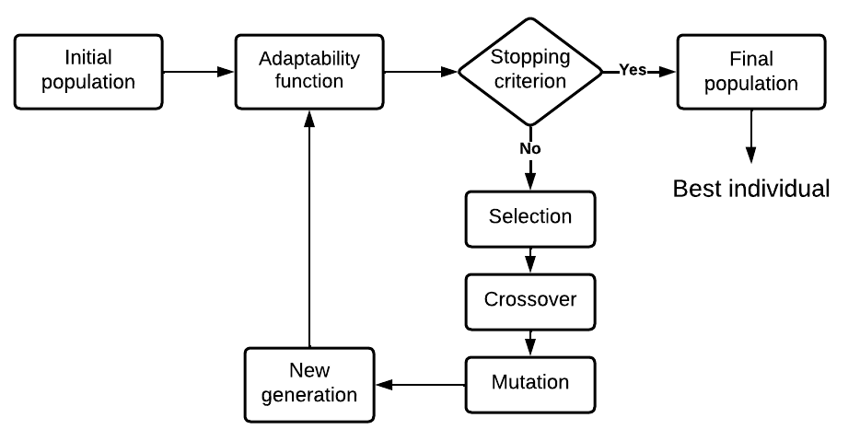
Fig. 1. General Diagram of a GA
Thus, a population is a set of individuals that potentially represent the solution to the problem.

Genotype Representation
In a conventional Genetic Algorithm, the genotype utilizes binary numbers to represent each of its constituent genes. However, for the purpose of this work, a real-valued representation will be employed for each weight. This is because the aforementioned classifiers use numerical formats for classification, and the objective is to assign higher weight values (thus, greater importance) to instances that are more challenging to classify. As a result, each run of the GA will generate individuals with varying genome sizes, as different classification tasks involve different instances.
Logistic Regression, Perceptron, and Support Vector Machine algorithms support both positive and negative weights, whereas only Naive Bayes supports positive numbers in the weights. For instance, Figure 2 depicts the genome representation with N instances, which can be referred to as a weight’s list.

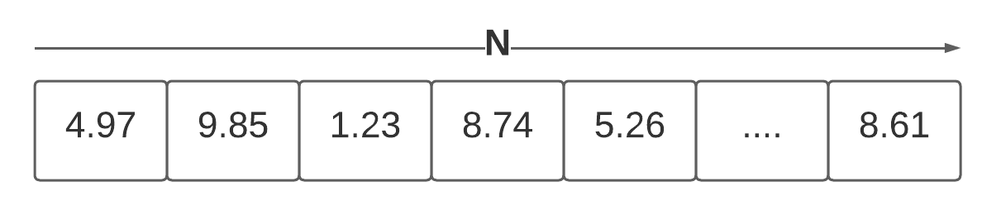
Fig. 2. Chromosome representation (weight’s list of an individual)
In this way, the weight’s list will have a dimension equal to the size of the instances in the test data set.

Operators
Initialization is the process by which an individual is randomly created. If there is knowledge or any indication of how to initialize the individuals, it can help accelerate the convergence of the algorithm. For the present study, the focus of initialization will be on randomly generating the list of weights for each individual in the population.

The Selection operator allows for the selection of parents who will form the new offspring of the population. In this case, Rank base selection is used, where the population is ordered in increasing order based on their fitness value [5].

An Arithmetic Crossover will be used as the crossover operator since the weight lists are evolving with real values. To create a new child, parent_1 and parent_2 are combined using an Alpha value (α) as follows, where α ∈ [0,1].

child = α * parent_1 + (1 - α) * parent_2 . | (4)

The Mutation operator allows one to escape from local minima and explore other areas of the search space. For the present study, given a list of weights, there will be a 30% probability for each gene to mutate, and a modification will be applied accordingly. Equation 4 illustrates this process.
gen = gen + mutation_value . | (5)
where the mutation_value is a randomly generated real number between -1 to 1. For example, Figure 3 shows that the third gene was selected to be mutated. A random number of 0.58 was generated, which was then added to the third gene, resulting in a value of 1.81. This produced a new individual, the bottom part of Figure 3.
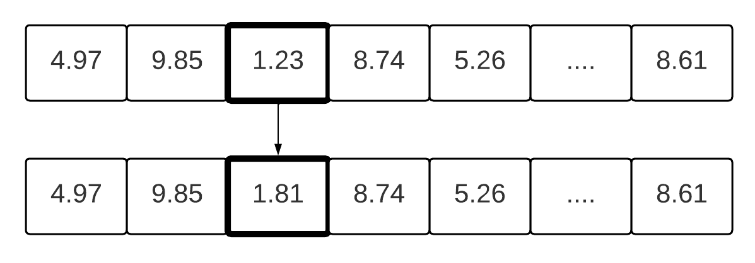
Fig. 3. Mutation Operator
Finally, the elitism operator will select the most well-adapted individuals and pass them to the next generation without any alterations. This helps ensure that the best solution found in early generations is preserved and carried forward. The recommended percentage for this operator is to use a maximum of 10% of the total population.

Assigning weights to instances
Assigning weights to instances during the training of a machine learning algorithm is a valuable technique for handling imbalances in datasets or for the model to prioritize specific samples. This allows the model's learning to adapt to the characteristics of the problem being solved. The datasets used for this work are as follows:
Table 1. Datasets characteristics.
Datasets | Number of instances | attributes
Breast-cancer [6] | 286 | 9
Diabetes [7] | 768 | 9
Hepatitis [8] | 155 | 19
Ionosphere [9] | 351 | 34
Lymphography [10] | 148 | 18

- Experimental setup
The genetic algorithm was implemented in Python, using the scikit-learn library for implementing the different classifiers. The parameters used for the genetic algorithm are as follows:
For each classifier, 80% of the dataset instances were used for model fitting, while the remaining 20% were used for testing. Only the instances from the training dataset were weighted using the genetic algorithm. Once the predictor model was fitted, its performance was measured using the test dataset. The results shown ahead correspond to the average of ten independent repetitions for each experiment. On the other hand, the classification was performed with each classifier (without the GA and without weights) as a baseline experiment to be compared with the GA. It is important to note that the accuracy is used as a fitness measure of each individual to guide the evolution.

Classifiers
Implementing the classifiers has the default characteristics without modifying the classifier's parameters, which could improve its efficiency.
- Naive Bayes: priors=None, var_smoothing=1e-09
- Logistic Regression: penalty='l2', * , dual=False, tol=0.0001, C=1.0, fit_intercept=True, intercept_scaling=1, class_weight=None, random_state=None, solver='lbfgs', max_iter=10000, multi_class='auto', verbose=0, warm_start=False, n_jobs=None, l1_ratio=None
- Perceptron: penalty=None, alpha=0.0001, l1_ratio=0.15, fit_intercept=True, max_iter=1000, tol=0.001, shuffle=True, verbose=0, eta0=1.0, n_jobs=None, random_state=0, early_stopping=False, validation_fraction=0.1, n_iter_no_change=5, class_weight=None, warm_start=False
- SVM: C=1.0, kernel='rbf', degree=3, gamma='scale', coef0=0.0, shrinking=True, probability=False, tol=0.001, cache_size=200, class_weight=None, verbose=False, max_iter=-1, decision_function_shape='ovr', break_ties=False, random_state=None

This configuration was used with the baseline experiment and when the classifiers were implemented with the GA. The performance of the algorithms were tested using de Precision equation as shown in Eq. 6.

Precision = True positives / (True positives + False positives) . | (6)

where True Positives represent cases correctly classified as positive, while False Positives represent cases incorrectly classified as positive.

Genetic Algorithm
For the case of the GA, the following parameters will be used to perform the experimental setup.
The stopping criteria was established based on a maximum number of generations. In this regard, different experiments were carried out, observing that with 5000 generations, acceptable results were obtained. When using 10,000, it demanded a longer time, and in many cases, it did not have a significant reduction of the error. Hence, this parameter was set at 5000 generations. Also, ten individuals were used for each generation, with a value of 80% for crossover, a 30% probability to determine if a gene is mutated, and a random value generated from -1 to 1 when the gene is mutated. For elitism, 10% of the total population was used. Also, each gene in the weight list was randomly generated from 0 to 10.
- Results
This section presents the experimental analysis of the Precision obtained in the data sets, both without applying the GA (baseline experiment) and with the proposed Genetic Algorithm. When the classifiers were trained and tested with each data set without assigning individual weights, the results shown in Table 1 were observed.

Table 2. Baseline experiment. Precision value for classifiers used without weights.
 | Naïve Bayes | Logistic Regression | Perceptron | SVM
Breast-cancer | 61.94 | 56.72 | 60.58 | 65.85
Diabetes | 66.5 | 71.3 | 49.4 | 71.82
Hepatitis | 62.93 | 79.46 | 75.33 | 62.93
Ionosphere | 89.68 | 91.62 | 91.62 | 96.88
Lymphography | 46.21 | 58.33 | 41.47 | 58.73

As it can be observed in Table 2, the SVM perform better in the Breast-cancer, Diabetes, Ionosphere and Lymphography data set, whereas Logistic Regression gives the best result for the Hepatitis data set. On the other hand, when assigning weights to the instances optimized with the GA, an average increase in Precision can be observed in all experiments, as shown in Table 3.
Table 3. Average Precision over ten independent runs with evolved weights.
 | Naïve Bayes | Logistic Regression | Perceptron | SVM
Breast-cancer | 76.7 | 90.6 | 87.4 | 93.2
Diabetes | 77 | 78.1 | 83.7 | 80
Hepatitis | 88.3 | 96.8 | 97.9 | 94.4
Ionosphere | 98.8 | 98.5 | 98.1 | 98.9
Lymphography | 54.9 | 93.8 | 97.6 | 66.5

Table 3 reports the average Precision of the entire population after the completion of the evolutionary processes, while Table 4 shows the best results (best individual) from ten independent runs for each experiment. Comparing Table 2 and Table 3, it can be observed that in all cases the average Precision values with evolved weights performed better than the baseline results, where Perceptron and SVM dominate over Naïve Bayes and Logistic Regression. Comparing the best individual found against the average Precision values (with evolved weights - Table 3) and the baseline results (Table 2), it is observed that in all cases it performs better. This indicates that assigning a weight’s list and evolving them with a GA provides optimized values for each weight.

Table 4. Best individual Precision over ten independent runs with evolved weights.
 | Naïve Bayes | Logistic Regression | Perceptron | SVM
Breast-cancer | 80.39 | 92.55 | 90 | 94.4
Diabetes | 84.9 | 79.06 | 84.12 | 80.16
Hepatitis | 88.33 | 97.91 | 97.91 | 96
Ionosphere | 98.9 | 98.9 | 98.9 | 98.9
Lymphography | 60.41 | 98.03 | 98.03 | 98.03

Table 4 shows that the Ionosphere dataset has the same accuracy with all classifiers. Meanwhile, Naïve Bayes and SVM are the worst performers on the Hepatitis data set. Similarly, Naïve Bayes does not have the best performance on the Lymphography data set compared to the other classifiers. For the Diabetes and Cancer data sets, Naïve Bayes and SVM have the best accuracies, respectively.

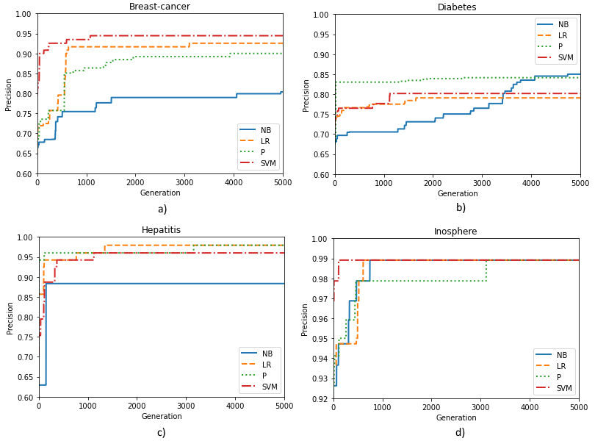
Fig. 4. Precision performance for the best individual results with weight’s list evolution during 5000 generations.
As an example, the precision performance of all classifiers using the GA is depicted in Figure 4. Where NB, LR, and P stand for Naive Bayes, Linear Regression, and Perceptron, respectively. Figure 4(a) shows the Breast Cancer dataset, where it can be observed that the Naive Bayes classifier does not achieve high precision values throughout the evolution process, compared to the other classifiers. Additionally, most of the classifiers reach their peak performance around 4000 generations.
Figure 4(b) displays the results for the Diabetes data set. It is observed that the Perceptron exhibits a gradual increase in the precision value, while Logistic Regression and SVM show a nearly parallel increase. On the other hand, Naïve Bayes steadily improves throughout all generations. On the other hand, Figure 4(c) corresponding to the Hepatitis data set, highlights the behavior of the Naïve Bayes classifier, which achieves its highest performance early on in the initial generations. In contrast, the other classifiers experience a progressive increase until approximately 3000 generations, after which no significant changes are observed. The other classifiers are better than the Naïve Bayes algorithm at the end of the evolutionary stage, for this dataset.
In Figure 4(d), the results for the Ionosphere data set are presented. Most of the classifiers reach their peak value around 1000 generations. After 3000 generations, all classifiers reach their maximum performance. In the case of the Lymphography dataset (figure not presented here), it is observed that most classifiers reach their peak performance within the first 1000 generations and do not exhibit significant changes over time, with a similar behavior to the other datasets presented in Figure 4. To analyze the behavior of the GA during evolution, the Diabetes data set was selected in combination with the Naïve Bayes classifier. A sample of 5000 generations was taken, and the results are presented in Figure 5, showing the best, average, and worst individual for the Precision value.

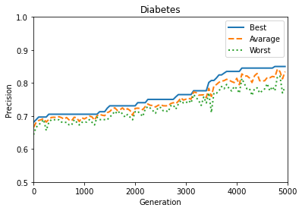
Fig. 5. Best, average, and worst individual evolution for the Diabetes data set, using the Precision performance.
As can be observed in Figure 5, the average Precision value and the worst individual in the population obtain a higher value in previous generations, and sometimes they get worse, decreasing performance, and improving them aging in further generations. This may be due to diverse factors, such as the rank-based selection method that is used, with an arithmetic crossover, taking 80% from the first parent and 20% from the second parent. It is also important to note that the offspring resulting from the crossover have a 30% probability of undergoing modifications in their genes. These modifications can lead to improvements or, in some cases, a deterioration of the individual. The mutation operator is helpful to explore new areas of the search space, which may lead to worse individuals from time to time. However, improvements are guaranteed to be preserved through the Elitism operator as the generations progress. Additionally, it is assumed that the best individual in one population may be crossed with others (worse than him), and this may cause, in some cases, that the resulting offspring obtain better performance than their parents. That is corroborated by the gradual improvement in the Precision of the average and worst individuals throughout generations, as Figure 5 shows.
Figure 6 illustrates this oscillation of improvements and precision deterioration along generations more clearly by zooming in on Figure 5 for 2000 generations. Note that only Figure 5 was subsampled for a clear graphical representation.

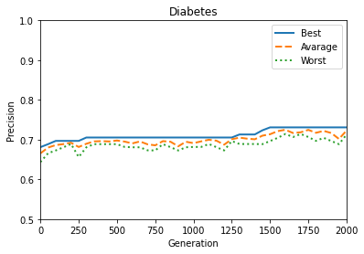

Fig. 6 Zooming Figure 5 in the first 2000 generations.
- Discussion
In terms of the results obtained, significant improvements are observed in all classifiers when using the Genetic Algorithm to adapt the weights of each instance.
It is important to note that the execution time varies considerably for each dataset, ranging from a couple of hours to approximately 10 hours per experiment. This wide range is due to the large number of instances and features present in each dataset. The Genetic Algorithm approach proves particularly beneficial, comparing with a manually finding the optimal weights for each instance, which would be highly complex and time-consuming for a specialist.
Regarding Precision value, it is observed that a rapid adaptation of the values for each data set occurs in the first few generations, typically around 2,000 generations. From that point onwards, the accuracy gradually improves as the generations progress.
Making a comparison among the literature, as far as the authors know, no similar performance has been reported for the Lymphography data set. In [10], also no previous citation for this dataset is reported. In [11], the Least Squares Anomaly Detection (LSAD) algorithm achieved an AUC (Area Under the Curve - ROC) score of 0.978 for the Ionosphere data set. Note that the ROC AUC is a value between 0 and 1. In [12], the AUC for the same dataset was 0.958 using the OCSVM (one-class SVM) algorithm. In the present study, a value of 98.9 was obtained for the best individual found evolving the weight’s list (Table 4), using all 4 classifiers. This supports the importance of weight assignments and evolution.
- Conclusion
In this work, it was proposed a Genetic Algorithm to improve the efficiency of four classifiers by assigning a weight’s list to the instances of different data sets. The evolved weight’s list helps to classify difficult instances more accurately than when the same classifier is used without weights. Therefore, it can be concluded that assigning individual weights to each instance effectively improves model Precision by utilizing a Genetic Algorithm to adapt these weights based on the classifier and data set. In this sense, Genetic Algorithms become a valuable tool for finding an optimal weight’s list, compared to hand-designed weight adjustment, which is infeasible for an expert to do. This is because each weight must be optimized according to each instance, of each data set, and each classifier used. Considering the performance improvement achieved by evolving the weight’s list, more experimental studies are needed to extend this work, e.g., using more data sets and classifiers. In the case of the Perceptron algorithm, a single perceptron was used in this work, but a multilayered perceptron network may perform better.
Acknowledgment
Authors acknowledge the computing time provided by the Cluster of the University Center UAEM Mexico Valley (CLU-CUUAEM-VM), at the Autonomous University of the State of Mexico (UAEMex), for conducting the experiments in this study.

References
1. Padilla-Navarro, C., González-Reyna, S., Aguilera-González, G., Ortega-Yepez, M., Bombela-Jiménez, S., Rangel-Huerta, M., Lino-Ramírez, C. Algoritmos genéticos aplicados a la optimización de características en la clasificación de arritmias cardiacas utilizando los clasificadores KNN y naive Bayes. vol. 134, pp. 55-68. Research in Computing Science (2017).
2. Mosquera, R., Castrillón, O. D., Parra, L. Máquinas de Soporte Vectorial, Clasificador Naïve Bayes y Algoritmos Genéticos para la Predicción de Riesgos Psicosociales en Docentes de Colegios Públicos Colombianos. vol. 29, no. 6, pp. 153 – 162. Información Tecnológica (2018).
3. Aparicio-Montelong, I., Celaya-Padilla, J. M., Luna-García, H., Galván-Tejada, C. E., Galván-Tejada, J. I., Gamboa-Rosales, H. Predicción de enfermedades cardíacas derivadas de diabetes, mediante algoritmos genéticos: caso de estudio. vol. 151, pp. 159-172. Research in Computing Science (2022).
4. Cervantes-Guerrero, M. D., Cruz, M., Valladares-Salgado, A., Galván-Tejada, J. I., Gutiérrez-García, T. A., Galván-Tejada, C. E. Clasificación de complicaciones en diabetes mellitus mediante algoritmos genéticos. vol. 150, pp. 401-411. Research in Computing Science (2021).
5. Valencia, P. E. Optimización meidante algoritmo genético. vol. 109, no. 2, pp. 83-92. Anales del Instituto de Ingenieros de Chile (1997).
6. Zwitter, M., Soklic, M. Breast Cancer. UCI Machine Learning Repository (1988). https://doi.org/10.24432/C51P4M.
7. Kelly, M., Longjohn, R., Nottingham, K. The UCI Machine Learning Repository, https://archive.ics.uci.edu.
8. Hepatitis. UCI Machine Learning Repository. (1988). https://doi.org/10.24432/C5Q59J.
9. Sigillito,V., Wing,S., Hutton,L., Baker,K. Ionosphere. UCI Machine Learning Repository (1989). https://doi.org/10.24432/C5W01B.
10. Zwitter, M. and Soklic, M. Lymphography. UCI Machine Learning Repository (1988). https://doi.org/10.24432/C54598.
11. Goix, N., Drougard, N., Brault, R., & Chiapino, M. One Class Splitting Criteria for Random Forests. Asian Conference on Machine Learning (2016).
12. Quinn, J. A., Sugiyama, M. A least-squares approach to anomaly detection in static and sequential data. vol. 40, pp. 36-40. Pattern Recognition Letters (2014).

