A Comparison of System Dynamics-based Simulators for Project Management Training
Authors Name/s per 1st Affiliation¹, Authors Name/s per 2nd Affiliation² , Authors Name/s per 3th Affiliation³ Authors Name/s per 4th Affiliation⁴
¹ Dept. name of organization, name of organization, acronyms acceptable, City, Country
² Dept. name of organization, name of organization, acronyms acceptable, City, Country
³ Dept. name of organization, name of organization, acronyms acceptable, City, Country
Abstract. Nowadays, the constant pressure on the industrial workforce to achieve the project’s scope within the budget, time, and resources is increasing because of the Project Management (PM) paradigm acquired by organizations. PM facilitates the control and tracking of delivering value to the customers. However, managers with no experience are struggling to complete the customer expectations of high-quality outcomes. Teaching in a context based on 'real life' is possible because of System Dynamics (SD). SD allows simulating alternatives to compute the decisions and results, which can help managers to know immediately the possible consequences. Therefore, Simulation as a training method proposed a stochastic way to fill the gap of knowledge, and skills. This paper applies State-of-the-Art Matrix (SAM) analysis with PRISMA-P protocol to recognize the benefits and disadvantages of the current Simulator approaches to training managers to identify opportunity areas for future research work.
Keywords: Systematic Literature Review, Project Management, Simulation, System Dynamics
1 Introduction
A project is a set of activities to complete a specific objective with defined dates, funding limits, and limited resources, they abound in industry and different areas [1]. The projectification of the industry requirements allows for completing the demands according to the plan.
This approach focuses on delivering value within the budget, time, and human resources, which are common constraints in projects.
However, the current demand for deliverables of the projects in the market is increasing fast and the industry needed to aim for other approaches to achieve de expectations. The agile method as a solution selected improves productivity and defect prevention, but the effectiveness has been harmed by the inadequacy of training [2]. Besides, depending on the area, the success of the projects is underrated. Areas like software development just have the 30% of the projects concluded successfully [3].
To manage projects, Project Management (PM) rises to help people in charge to keep control and track through the project execution to reach the goals inside the scope.
PM is an approach to completing the projects within parameters of budget, resources, and time and came as a solution, but the training methods to prepare the project managers are commonly at risk. Preparing the “On the job” can cause failures, which can be translated to business losses.
To provide efficient training to reduce cost and avoid troubles the answer is the simulation. This technique evaluates the quality, cost, and delivery instantly [3].
System Dynamics (SD) is a framework to simulate the possible issues in a system, getting results about the causes and consequences chosen by the user. This simulation allows getting a “real life” perspective to practice without cost, or schedule delays in projects [4]. Besides, the use of simulators is an opportunity to emulate human conditions to train effective professional knowledge and competencies.
SD in PM works in parallel or in series based on a set of tasks to be performed to know the level of completion and take decisions taking into account the results. From 2007 to the present, more than fifty organizations used SD in one hundred projects in different areas to know possible issues [1].
2 Methodology
The methodology selected to conduct this research work was in the first step a scoping review to map in general context the state of the art to know gas in, clarify concepts and find evidence related [5]. This step uses the search string “Project Management Simulators” through five digital libraries, which are mentioned below to allow continuing with the second step of this systematic research with PRISMA-P Protocol implementation.
2.1 PRISMA-P Protocol
PRISMA-P is the first stage of two to conduct this Systematic Literature Review (SLR). This stage facilitates the manipulation of the information found, It has a checklist categorized into administrative, introduction, and methods sections [6]. Those sections filter the collected literature according to the seventeen tasks proposed.
Figure 1. displays the four applied phases (Identification, Screening, Eligibility, and Included) of PRISMA-P to identify the possible records and ends with the production of data and metadata based on the excluded and included criteria applied to the literature [7].

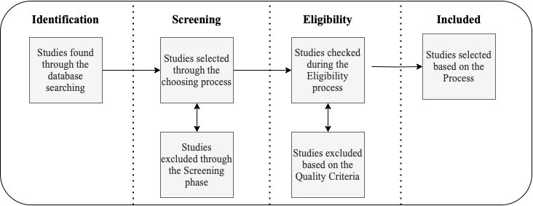
Fig. 1. PRISMA-P Protocol Phases explained
2.2 Research Questions Composition
The following Research Questions (RQs) are critical for this SLR to be accurately based on the conditions and information required according to the scoping review performed previously [8]. The RQs about the Project Management Simulation are the following:
- RQ1. What are the advantages of the current Project Management Simulators in the industry and academia?
- RQ2. What are the current simulators proposed by Academia or the industry to enhance the competencies based on training?
- RQ3. What are the disadvantages of using Project Management Simulators to train project managers to be in charge of a project in an average workplace?
2.3 Search String Creation
According to the three RQs previously stated, a set of keywords were selected to create a proper search string used as input in the digital libraries.
Table 1 shows those keywords related and combined in several ways to expand the search through the digital libraries to get as many primary studies candidates as possible. Besides, the keywords were selected based on the set of results of the first scoping review performed.
Table 1. Search String composition
RQs | Keyword | Synonym or related word | Search String
1, 3 | Project Management |  | Project Management AND Training AND (Simulator OR System Dynamics) AND ((Advantage OR Benefits) OR (Disadvantage OR Problems))
1,2,3 | Simulator
1 | Advantage | Benefits
1,3 | Disadvantage | Problems
3 | Train | Training

2.4 Digital Libraries Selected
The data sources chosen were based on the engineering area to scour through extant literature. The search string was adapted in the following databases. Those digital libraries were limited depending on the author’s institutions.
- SpringerLink
- Elsevier Science
- IEEE Xplore
- Google Scholar
- ERIC
2.5 Inclusion and Exclusion Criteria
The Inclusion criteria determined for this research were the following.
- Studies written in English.
- The time window of 2017 to 2022.
- Studies containing a minimum of three keywords of the search string on the title, abstract, and keywords.
- Studies presenting a PM Simulator.
- Studies with Simulators to train engineering roles.
- Studies with advantages or disadvantages of Simulation usage.

The exclusion criteria used were.
- Studies found in more than one library were removed.
2.6 Protocol Execution
The execution of this SLR was divided into two Stages. The first one uses PRISMA-P protocol according to the four phases (Figure 1) and the second one is based on the State-of-the-Art (SAM).
The SLR was carried out between May and June 2023 where the research was guided by the suggestions of [7], and the search string was used in the digital libraries.
The followed protocol illustrates a filter of the studies to get primary studies (Figure 2).

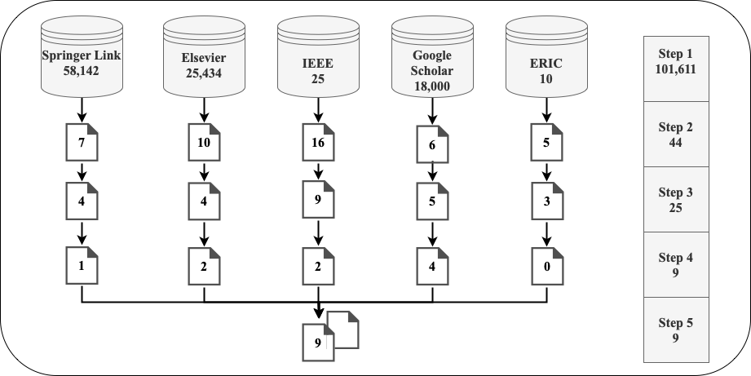
Fig. 2. Screening phase used to filter the results

Figure 2 shows the steps to execute, which are the following.
- The search string was adapted through the digital libraries.
- The studies were filtered based on the criteria.
- The filtered studies were further evaluated for content, searching in the title, abstract, and conclusions.
- Those studies were checked to know if they were either Simulators and/or Training to PM.
  - Studies that did not meet these inclusion and exclusion criteria were discarded.
- The remaining studies were evaluated against a quality filter, as discussed below.
  - The studies determined as “primary studies,” were then further analyzed.
9 primary studies were selected (see Appendix A), meeting the objective of this SLR. Those studies were evaluated against the following question of quality criteria.
- Does the primary study selected have information related to Simulator used in the engineering area?
A total of 9 primary studies completed the quality criteria.
2.7 State-of-the-Art Matrix (SAM)
The primary studies obtained were introduced into a Spreadsheet editor (Google Sheets) to manage the information. Each paper was considered according to the following metadata. Serial Number (ID), Digital Library Source, Authors, Title, Year, Type, Main Topic, Area of Application, Limitations, Citations, SJR Journal, H Index, Country, Journal. Besides, attributes such as Case Study, Industry, and Method were considered as Boolean values to check the presence of some information.
3 Results
The primary studies compiled in the SAM were further analyzed for trends. The results are presented as follows.
3.1 Primary Studies Trends
The primary studies which were qualified then were analyzed to detect according to the metadata possible similarities among them.
Figure 3 displays the distribution of the author’s origin of the nine studies. Australia and Iran have more contributions being combined 40%.

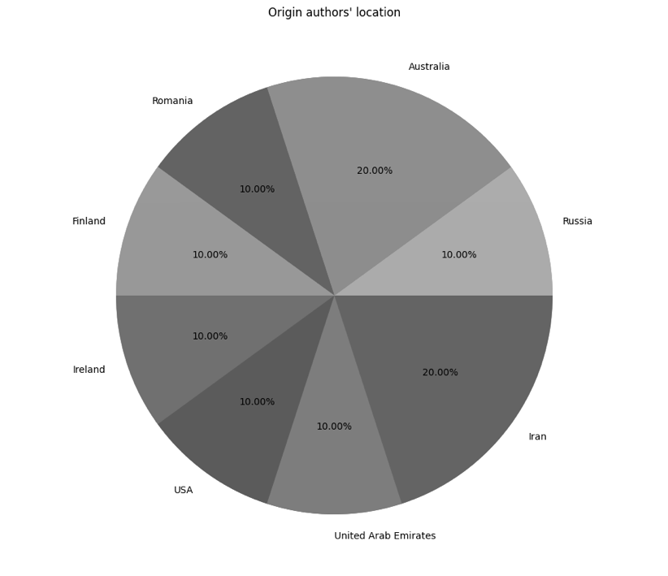
Fig. 3. Origin of main authors of Simulators

Figure 4 shows the distribution of the chief editors of each Journal of the nine primary studies. It highlighted that the chief editors are from the United States and Austria mostly.

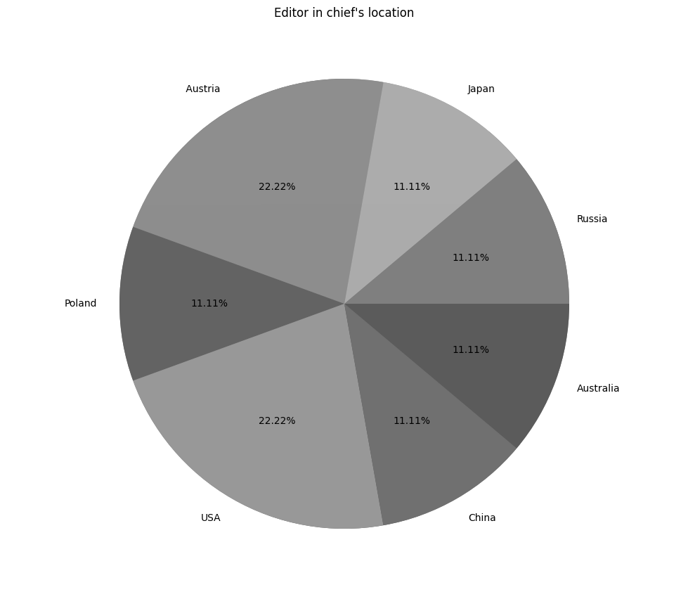
Fig. 4. Origin of chief editors of the selected Journals

Looking at the time when primary studies were published, Figure 5 shows that there is a constant interest in the Simulator's performance, five of the nine primary studies have an approach to a case study of a Simulator implemented in an engineering environment.

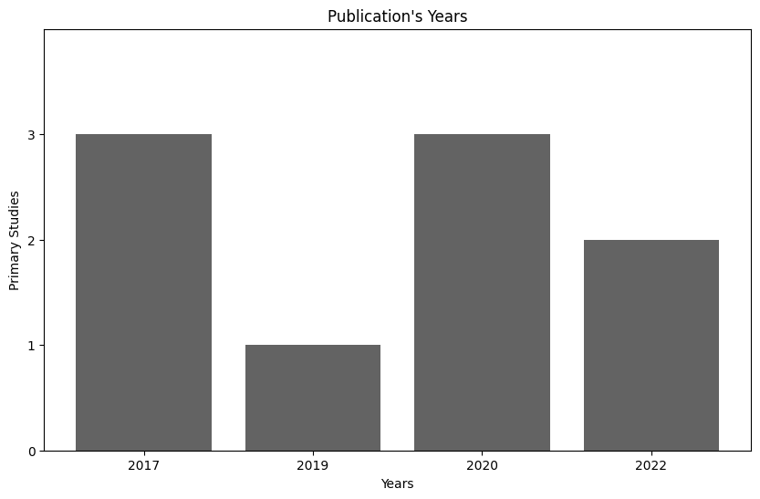

Fig. 5. Primary Studies publication over the years

Nevertheless, the Industry is the area most interested to prepare professionals to deal with PM. Six of the nine contributions are focused on the training of people working in different workplaces. Academia just has three contributions. However, this information is about Simulators' contributions, but [9] shows a different perspective about institutions that train undergraduate students to manage projects in the industry.

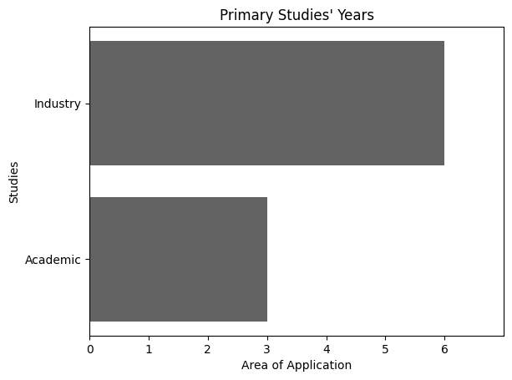
Fig. 6. Interested Area to train project managers
3.2 Analysis Information and Results
The following sections present how the primary studies obtained answer the three research questions. Six of the nine studies were concerned with RQ1, five with RQ2, and another five with RQ3. RQ2 has information about the main features of the simulator proposal. Those can consider some similar aspects, but for this evaluation, their main value was analyzed.

3.3 RQ1. What are the advantages of the current PM Simulators in the industry and academia?
According to the results got it from the primary studies, the following list presents the main advantages of PM Simulators in the industry and academia.
- The continuous use of a simulator in the training process during a long period produces positive results according to the simulation expectation [10].
Methods during the training on the simulator are adapted to work together such as
  - Twin. Students and a teacher work together to perform a specific job.
  - Training manual. Students investigate how it works.
  - Mentoring. Graduate student conducts classes.
  - Experienced training. The simulator works as a job description.
Those methods teach the students relevance with the activities performed, perception, motivation, confidence to do the things, repetitions to consolidate new knowledge, and feedback to adjust the behavior according to the results.
- Besides, the identification of common practices done by the project managers helps to compare possible improvements based on the operation frequencies during a sprint. This means that the Simulator allows getting an analysis of a better precision rate about the decisions made by the users to improve their skills [3].
- The impact of Simulation on the student occurs when it is identified the distinct theme between the performance and the execution to associate the terms and take the correct decisions to improve the user [11].
- Students feel motivated because of the influence of the distinct way to learn. It is interesting to “play” with a random experience providing an engagement between practitioners and Simulator. Besides, the student can learn without risks reducing the feeling of disappointment to understand and experiment with possible results [12].
- The effect of the Simulation implies that the students get deep learning about the different variables used to enhance their abilities and skills into normal participation [13].
- Most of the projects manage the use of traditional tools through the projects to deliver value. SD can model those tools like work breakdown structures, or critical paths to estimate. This helps to create a perspective to describe the process of the project and predict a possible behavior [1].
- The advantage of getting immediate feedback about performance is one of the most important contributions of Simulation to PM training. It is possible to solve any issue and understand the meaning of each decision. Furthermore, this gives the opportunity to take high-risk decisions in a safe place to learn about mistakes without punishment [14].
- SD has a controlled environment to replicate unexpected changes, which affects the planned work. The information collected by the application gives a perspective to adjust the structure and process. This predictive position has a positive impact on future implementations [15]
3.4 RQ2. What are the current simulators proposed by Academia or the industry to enhance the competencies based on training?
Table 2 displays the current simulators in the engineering industry, which aims to train practitioners to improve their competencies in the workplace.
Table 2. Simulators Found in Primary Studies
Paper ID | Name | Description
A1 | ASKTV | Simulator to train and knowledge verification, working with a textbook with theoretical problems and operations, and finally evaluating by an exam with two possible pools. Mini simulators are integrated to cover the primary skills and master the technique individually. This simulator works in the environment of energy [10].
A2 | PM Skill-up | Simulator to train based on the project model to check the outcomes using a Gantt Chart according to event rules. Every event has tasks with different levels of difficulty and specific rules to apply [3].
A3 | Engineering Office | Engineering Office Simulator to train engineers with an approach to real jobs considering organizational requirements, quality, documentation, efficiency, time, and responsibility [11].
A7 | SimulTrain | This simulator offers different scenarios to control tools to track the project considering aspects such as leadership, changes, risks, and human resources. Those parameters aim at the outcomes, quality, and performance decisions [14].
A7 | Cesim Project | This focuses on communication between people to complete the requirements to achieve the goals. The project manager must identify the available team members to match with the task to get an effective result [14].
A7 | Versatile’s PM Simulation | This Simulator has realistic challenges such as scope, communication, and random behavior of stakeholders to understand the different levels of requirements according to the different stages of PM [14].
A7 | Harvard PM Simulation | Harvard PM Simulation simulates a single player to the role of the project manager to execute a plan to deliver a product project in time with enough budget. It has six scenarios to train according to different unanticipated events to enhance the skills of the user [14].
A9 | SD-ABM | Hybrid Simulator to two different paradigms. SD and Agent-Based Modelling were considered to examine the patterns in this area. This aims to train construction workers to improve their safety [16].

3.5 RQ3. What are the disadvantages of using PM Simulators to train project managers to be in charge of a project in an average workplace?
Not only simulation has perks of its implementation, but also negative part is evaluated.
The budget considered to be used to conduct the classes in a Simulation environment is huge. Having multiple computers for each student to work via the Internet is expensive. It requires a complex system as a server to provide services to everyone [10].
However, the Simulator will be a complementary resource to the school because of the fundamental skills acquired there, but the absence of the school raises questions for the practitioners [11].
Also, for some students, the activity of working with a Simulator can be frustrating because the sessions could be time-consuming. However, if they do not have enough technical skills, also can be confusing and they can feel stressed [12].
Despite the Simulator could comprehend all the topics needed, if it does not have a user-friendly interface to interact with the user, it will not work as expected. Also, the continuous change in PM must be considered to create new requirements and adapt to the current practices [14].
Furthermore, not all the possible situations can be replicated in a Simulator, the results are uncertain, and comparing with “real life” sometimes is not able to make it practical. Also, it is expensive to use this kind of technique to train, time as well as cost are key factors, which sometimes cannot be afforded by the organizations [14].
3 Conclusions and Future Work
Technology is advancing constantly and rapidly, many different types are applied in the preparation of professionals to make learning more efficient [17]. Simulation, Virtual Environments, Moodles, and more are part of the proposal. However, the effectiveness of those methods depends on the practitioners’ results and the outcomes produced by their performance.
Depending on the environment is the possible problem, like Software development where they used a rigid, linear process based on a Waterfall causing inflexibility and working in silos, which produces problems according to the demanding of the industry. Scrum as a method to solve this problem using iteration and making improvements has been a technique selected to face this situation [2]. Nevertheless, approaches like Waterfall or Agile are not the general solution if they are not handled appropriately. Lack of experience probably causes constant constraints to achieving the project goals even with the usage of those approaches.
Simulation as a technique to quantify the uncertainties of the projects, is an effective method to through a random proposition of inputs and outputs produce a similar environment to the average workplace. The perspective of the real world provided by the SD approach allows improving model structures to add value [1].
However, the uncertainty has a high influence on the complexity of the projects. This is caused by different sources and requirements. Therefore simulators are recommended to estimate the unknown risks, and each component that can affect the outcomes got after performing a project [18].
Since 1989, it has been a contribution of simulators. Most of them are not available or are deprecated to the current market demands. That is the main reason to filter the search to five years to get the current working simulators and aims to check the up-to-date application. Through the years based on different solutions have been many kinds of simulators, with different costs or working alongside a teacher, survey, or other methods. Those demonstrate the importance of a solution to avoid further costs to organizations because of the lack of experience of the project managers.
Each of the Simulators got by the primary studies requires a minimum level to use and comprehend the different tools to manage the project. If there is no previous experience or someone to guide the student, the application will not work for the candidate, and the experience could be stressful.
After evaluating each current simulator available to PM practitioners. Some main points were detected. One of them is for a specific institution, most of them are fee-paying, and others are not available to use it. Also, the advantages and disadvantages make a perspective of what is needed to be considered to propose a PM Simulator to prepare undergraduate students and practitioners to work in an average place.

References
[1] David N. Ford y James M. Lyneis, «System Dynamics Applied to Project Management: A Survey, Assessment, and Directions for Future Research», 2020, doi: https://doi.org/10.1007/978-1-4939-8790-0_658.
[2] P. M. Ching y J. E. Mutuc, «Modeling the Dynamics of an Agile Scrum Team in the Development of a Single Software Project», en 2018 IEEE International Conference on Industrial Engineering and Engineering Management (IEEM), Bangkok: IEEE, dic. 2018, pp. 386-390. doi: 10.1109/IEEM.2018.8607430.
[3] M. Otsuki, M. Akiyoshi, y M. Samejima, «Identification Method of Improvements in User Operations on Project Manager Skill-Up Simulator», IEEE Access, vol. 5, pp. 5811-5818, 2017, doi: 10.1109/ACCESS.2017.2673019.
[4] N. Tiruvengadam, A. Elizondo-Noriega, D. Gemes-Castorena, y M. G. Beruvides, «Opportunities for System Dynamics Implementation in Project Management Evaluation», en 2022 Portland International Conference on Management of Engineering and Technology (PICMET), Portland, OR, USA: IEEE, ago. 2022, pp. 1-8. doi: 10.23919/PICMET53225.2022.9882860.
[5] A. B. R. Shatte, D. M. Hutchinson, y S. J. Teague, «Machine learning in mental health: a scoping review of methods and applications», Psychol. Med., vol. 49, n.º 09, pp. 1426-1448, jul. 2019, doi: 10.1017/S0033291719000151.
[6] D. Moher, L. Shamseer, y M. C. y, «Preferred reporting items for systematic review and meta-analysis protocols (PRISMA-P», Syst Rev, vol. 4, 2015, doi: 10.1186/2046-4053-4-1.
[7] S. Pahlevan, M. Saeed, W. Paolo, y S., «Systematic Reviews in Asia: Introducing the “PRISMA” Protocol to Tourism and Hospitality Scholars: Current Status and Future Directions». 2019.
[8] M. Muñoz, M. Negrete, y J. Mejía, «Proposal to Avoid Issues in the DevOps Implementation: A Systematic Literature Review», en New Knowledge in Information Systems and Technologies, Á. Rocha, H. Adeli, L. P. Reis, y S. Costanzo, Eds., en Advances in Intelligent Systems and Computing, vol. 930. Cham: Springer International Publishing, 2019, pp. 666-677. doi: 10.1007/978-3-030-16181-1_63.
[9] Mario Negrete, A. Elizondo-Noriega, N. Tiruvengadam, Mirna Muñoz, y David Gúemes-Castorena, «A literature review of simulation-based approaches to train managers in Waterfall and Agile Project management», 2023, doi: Accepted.
[10] E. K. Arakelyan, V. A. Rubashkin, A. V. Andriushin, y S. V. Mezin, «The Use of Modern Computer-Based Training-Simulator Complexes in the Educational Process», en 2020 V International Conference on Information Technologies in Engineering Education ( Inforino ), Moscow, Russia: IEEE, abr. 2020, pp. 1-4. doi: 10.1109/Inforino48376.2020.9111772.
[11] D. Isoc y T. Surubaru, «Engineering Education Using Professional Activity Simulators», en The Challenges of the Digital Transformation in Education, M. E. Auer y T. Tsiatsos, Eds., en Advances in Intelligent Systems and Computing, vol. 916. Cham: Springer International Publishing, 2020, pp. 520-531. doi: 10.1007/978-3-030-11932-4_50.
[12] E. Jääskä y K. Aaltonen, «Teachers’ experiences of using game-based learning methods in project management higher education», Project Leadership and Society, vol. 3, p. 100041, dic. 2022, doi: 10.1016/j.plas.2022.100041.
[13] S. Elsawah, A. McLucas, y J. Mazanov, «An empirical investigation into the learning effects of management flight simulators: A mental models approach», European Journal of Operational Research, vol. 259, n.º 1, pp. 262-272, may 2017, doi: 10.1016/j.ejor.2016.10.011.
[14] M. E. Khatib, A. Alhosani, I. Alhosani, O. A. Matrooshi, y M. Salami, «Simulation in Project and Program Management: Utilization, Challenges and Opportunities», AJIBM, vol. 12, n.º 04, pp. 731-749, 2022, doi: 10.4236/ajibm.2022.124037.
[15] M. Shafieezadeh, M. Kalantar Hormozi, E. Hassannayebi, L. Ahmadi, M. Soleymani, y A. Gholizad, «A system dynamics simulation model to evaluate project planning policies», International Journal of Modelling and Simulation, vol. 40, n.º 3, pp. 201-216, may 2020, doi: 10.1080/02286203.2019.1596779.
[16] F. Nasirzadeh, M. Khanzadi, y M. Mir, «A hybrid simulation framework for modelling construction projects using agent-based modelling and system dynamics: an application to model construction workers’ safety behavior», International Journal of Construction Management, vol. 18, n.º 2, pp. 132-143, mar. 2018, doi: 10.1080/15623599.2017.1285485.
[17] X. Ye, P.-F. Liu, X.-Z. Lee, Y.-Q. Zhang, y C.-K. Chiu, «Classroom misbehaviour management: an SVVR-based training system for preservice teachers», Interactive Learning Environments, vol. 29, n.º 1, pp. 112-129, ene. 2021, doi: 10.1080/10494820.2019.1579235.
[18] S. Jain, «A Tale of Three Simulations for Project Managers», en 2022 Winter Simulation Conference (WSC), Singapore: IEEE, dic. 2022, pp. 2397-2408. doi: 10.1109/WSC57314.2022.10015482.

Appendix A
Table 2. Font sizes of headings. Table captions should always be positioned above the tables.
Paper ID | Information
A1 | Arakelyan, E. K., Rubashkin, V. A., Andriushin, A. V., & Mezin, S. V. (2020). The Use of Modern Computer-Based Training-Simulator Complexes in the Educational Process. In 2020 V International Conference on Information Technologies in Engineering Education ( Inforino ). 2020 V International Conference on Information Technologies in Engineering Education ( Inforino ). IEEE. https://doi.org/10.1109/inforino48376.2020.9111772
A2 | Otsuki, M., Akiyoshi, M., & Samejima, M. (2017). Identification Method of Improvements in User Operations on Project Manager Skill-Up Simulator. In IEEE Access (Vol. 5, pp. 5811–5818). Institute of Electrical and Electronics Engineers (IEEE). https://doi.org/10.1109/access.2017.2673019
A3 | Isoc, D., & Surubaru, T. (2019). Engineering Education Using Professional Activity Simulators. In The Challenges of the Digital Transformation in Education (pp. 520–531). Springer International Publishing. https://doi.org/10.1007/978-3-030-11932-4_50
A4 | Elsawah, S., McLucas, A., & Mazanov, J. (2017). An empirical investigation into the learning effects of management flight simulators: A mental models approach. In European Journal of Operational Research (Vol. 259, Issue 1, pp. 262–272). Elsevier BV. https://doi.org/10.1016/j.ejor.2016.10.011
A5 | Jääskä, E., & Aaltonen, K. (2022). Teachers’ experiences of using game-based learning methods in project management higher education. In Project Leadership and Society (Vol. 3, p. 100041). Elsevier BV. https://doi.org/10.1016/j.plas.2022.100041
A6 | Ford, D. N., & Lyneis, J. M. (2020). System Dynamics Applied to Project Management: A Survey, Assessment, and Directions for Future Research. In System Dynamics (pp. 285–314). Springer US. https://doi.org/10.1007/978-1-4939-8790-0_658
A7 | Khatib, M. E., Alhosani, A., Alhosani, I., Matrooshi, O. A., & Salami, M. (2022). Simulation in Project and Program Management: Utilization, Challenges and Opportunities. In American Journal of Industrial and Business Management (Vol. 12, Issue 04, pp. 731–749). Scientific Research Publishing, Inc. https://doi.org/10.4236/ajibm.2022.124037
A8 | Shafieezadeh, M., Kalantar Hormozi, M., Hassannayebi, E., Ahmadi, L., Soleymani, M., & Gholizad, A. (2019). A system dynamics simulation model to evaluate project planning policies. In International Journal of Modelling and Simulation (Vol. 40, Issue 3, pp. 201–216). Informa UK Limited. https://doi.org/10.1080/02286203.2019.1596779
A9 | Nasirzadeh, F., Khanzadi, M., & Mir, M. (2017). A hybrid simulation framework for modelling construction projects using agent-based modelling and system dynamics: an application to model construction workers’ safety behavior. In International Journal of Construction Management (Vol. 18, Issue 2, pp. 132–143). Informa UK Limited. https://doi.org/10.1080/15623599.2017.1285485

