Non-technical Factors in Software Engineering within the Context of Industry 4.0
Luz Marcela Restrepo-Tamayo1, Gloria Piedad Gasca-Hurtado¹

1 Universidad de Medellín, Carrera 87 No. 30-65, 50026, Medellín, Colombia
{lmrestrepo, gpgasca}@udemedellin.edu.co
Abstract. Software development is a process influenced by aspects related to teamwork and by requiring high levels of interaction among its members. Both aspects are considered non-technical factors and have been arousing interest both for the software industry and for research. In the framework of Industry 4.0, it is also evident the need to identify the relevant non-technical factors in a discipline such as Software Engineering, given the need to develop software to meet the required digital capabilities. This paper presents an analysis to know the evolving nuances of the proposed research topic and to define emerging issues of interest for this research field, based on a systematic mapping of literature. Twenty-three non-technical factors are identified, among which communication, leadership, teamwork, and innovation stand out. The findings of this analysis contribute to the improvement of the software development process and drive the processes required by Industry 4.0.
Keywords: software development, Industry 4.0, systematic mapping of literature, non-technical factors.
1 Introduction
The arrival of the fourth industrial revolution has generated changes in organizational dynamics in terms of structure and processes, as it promotes the integration of digital industrial ecosystems [1]. This integration requires creating digital capabilities and making decisions based on good data management [2], which implies adapting the business, technology, and information systems to the new requirements of the industrial context [3]. Software is a key element for smart companies [4], so the software industry is consolidating as a fundamental support to materialize the transformations that organizations are demanding to meet the challenges of Industry 4.0.
Resource management for companies in the software industry and the digital economy is fundamental for the development of their products and the success of their business [5]. Managing resources, mainly those related to human talent, is critical [5] since software development is a social process centered on people [6]. In addition, it is characterized by the fact that its execution is team-based and requires high levels of communication among its members [7]. However, in 2020, 50% of software projects had changed, and 19% failed, and most of the projects that fail do so for non-technical reasons [8]. In addition, about 80% of people who fail in their work do so for lack of non-technical skills rather than a lack of technical skills [9], which generates low productivity rates.
Productivity is one of the key aspects of the resource management of software development projects and is influenced by technical and non-technical factors [10, 11]. However, there is a tendency to focus on measuring technical rather than non-technical factors [12], as the latter entail complexities related to their quantification and control [13, 14].
Non-technical factors or soft skills can be defined like “abilities that are largely independent of software development and are relevant for other disciplines, too” [15]. Non-technical skills are the cognitive, personal, and social skills that complement technical skills, and therefore contribute to people's performance [16]. Non-technical factors, also called soft factors [17], can be classified into five categories: corporate culture, team culture, individual skills and experiences, work environment, and project [12]. Regarding this topic, literature reviews have been made related to the skills and competencies required in the framework of Industry 4.0 [18–21]. Emphasis has been placed on managerial competencies [22] and those of the project manager [23]. In addition, the competency requirements of Industry 4.0 in the engineering profession have been studied [24]. These literature reviews agree on the importance of soft skills such as leadership or communication.
Based on the preceding information, a systematic literature mapping, complemented by a bibliometric analysis, offers valuable insights into the research outcomes concerning the explicit requirements in Software Engineering within the context of Industry 4.0. This approach aims to identify the crucial non-technical factors associated with the software development process among the wide array of existing factors. By primarily focusing on non-technical elements, this investigation sheds light on the essential aspects necessary for successful software development in the Industry 4.0 landscape. Therefore, the analysis proposed in this article is justified.
After the introduction, section 2 presents the systematic literature mapping protocol as a research methodology. Section 3 presents the results, which are discussed in section 4. Finally, section 5 presents the conclusions and future work.
2 Method
Given that the objective of this article is to identify, analyze and interpret the information available in primary studies related to a specific research question, a systematic literature mapping [25] was used. This study adopts the protocol used by Brereton et al. [26], which includes three phases: study planning, study execution, and report writing.
2.1 Phase 1: Study Planning
Study planning involves defining the research questions and the protocol that will be used to obtain the relevant studies from which data will be extracted.
2.1.1 Definition of Research Questions. According to the object of study, this systematic mapping is focused on summarizing the scientific production in Software Engineering that addresses non-technical factors considering the context of Industry 4.0. Therefore, the following research question is established: what are the non-technical factors required in Software Engineering to meet the challenges of Industry 4.0?
2.1.2 Preparation of the mapping protocol. The mapping protocol defined in this study considers the following elements.
Search String. ("industry 4.0" OR "fourth industrial revolution" OR "i4.0") AND ("software engineering" OR "software developer" OR "software development" OR "software engineer") AND ("non-technical" OR "capabilities" OR "competences" OR "competencies" OR "human aspects" OR "human factors" OR "skill" OR "social aspects" OR "social factors"). The search for terms is done in the whole body of the document and not only in the most common search sections, such as the title, keywords, and introduction, to address as many results as possible. Using the term 'skill' in the search string will capture studies that use this term to refer to "soft skills".
Specialized Databases. IEEE Xplore, ACM, Science Direct, and Springer since they are electronic sources of relevance in Software Engineering [25].
Exclusion Criteria. studies with unavailable file (C1), that are not written in English (C2), that are literature reviews (C3), that are not related to factors required in Software Engineering (C4), that mention only technical factors (C5), that are not related to soft-ware engineering (C6), that are duplicated (C7), or that are not properly scientific articles, such as supplements, event notices, business news, interviews, prefaces, among others (C8) are not considered.
Inclusion Criteria. studies written in English that explain non-technical factors required in Software Engineering in the context of Industry 4.0 are considered. A specific period of time to include articles was not defined, because the "Industry 4.0" concept began to be evidenced in articles published from 2012 [27], therefore, the period of time is limited by this concept, so it is expected to find studies between 2012 and 2023.
Classification Procedure. read each study's title, keywords, abstract, and conclusions captured in each database. During the classification procedure, the title of each of the selected articles is entered into an Excel format database. This will enable us to identify and eliminate duplicated studies.
Quality Assessment. the included studies are submitted to five Yes/No questions. Each 'Yes' answer is rated with a score of 1. If the answer is 'No', then the score is 0. The quality questions are QQ1: do the authors specify a hypothesis or research question? QQ2: do the authors define the context (academia/industry) under which the study was conducted? QQ3: do the authors specify the number of individuals who participated in the study? QQ4: do the authors define the study method they followed to obtain the results they present? QQ5: do the authors specify lines of future work? Only studies with average quality ratings of 4 and 5 are considered. This quality assessment allows to identify false positives.
Data Extraction Strategy. once the studies included in this mapping have been identified, a complete reading of the document allows the extraction of general data (title, authors, year of publication, keywords, DOI, and journal), data related to the research methodology (type of research, context, sample size) and, finally, non-technical factors related to the study. Data storage will be done in a spreadsheet. To define the context of the research, which can be educational or industrial, it is necessary to identify whether the research was carried out meeting the requirements of an academic course or a software project in a company.
Synthesis of Data Extraction. this will be done descriptively to prioritize the non-technical factors identified in the selected studies.
2.1.3 Mapping Protocol Evaluation. The research team and independent experts should critically evaluate the mapping protocol. The review by the research team was done through a pilot search test in each database to verify the consistency between the results and the objective of the study. The independent expert review reviewed the consistency between the research question, the search string, the inclusion and exclusion criteria, and the data to be extracted.
2.2 Phase 2: Study Execution
The execution of the study involves carrying out the search according to the defined chain in the selected databases and, based on the inclusion and exclusion criteria, selecting the studies, and then extracting the data required to answer the research question.
2.2.1 Identification of Relevant Studies. The search in ACM was done using the "Anywhere" filter and only "Research Article" type documents were selected. In Science Direct the following search string was used due to the limitation of this database with connectors: ("Industry 4.0" OR "fourth industrial revolution") AND ("non-technical" OR "capabilities" OR "competenc ?" OR "human factors" OR "skill") AND ("software engineer?" OR "software develop?") and filtered the Document type by Research articles and Book chapters. In Springer it was only filtered by articles, to ensure that they were finished investigations. Finally, in IEEE the 'All metadata' filter was used. In this way, the execution of the search string in the identified databases yielded an initial capture of 833 studies. The application of the established inclusion and exclusion criteria and the review of the general elements of each document led to the selection of 10 studies (Table 1).
Table 1. Table captions should always be positioned above the tables.
Specialized Databases | ACM | Science Direct | Springer | IEEE | Total
Captured studies - initial | 183 | 163 | 470 | 17 | 833
C1 | 166 | 10 | 2 | - | 178
C2 | - | - | 8 | - | 8
C3 | 2 | 17 | 62 | - | 81
C4 | 9 | 114 | 323 | 15 | 461
C5 | 4 | 3 | 5 | - | 12
C6 | 1 | 8 | 34 | - | 43
C7 | - | - | - | - | 0
C8 | 1 | 7 | 32 | - | 40
Selected studies - final | 0 | 4 | 4 | 2 | 10

55.34% of the studies were excluded for not addressing the identification of relevant non-technical factors within the framework of Industry 4.0 (461 studies). 21.37% were excluded because they did not have the complete file available (178 studies), while 9.72% were excluded because they were literature reviews (81 studies). Considering that the search for the terms of interest was done in the entire body of the document, 5.16% of the studies not framed in Software Engineering (43 studies), 4.80% (40 studies) were documents of a nature unlike scientific papers, 1.44% (12 studies) focused only on technical factors and 0.96% (8 studies) were not written in English.
The number of documents not available in ACM may be due to user access limitations, which constitutes a threat to the validity of the results. Precisely for this reason other databases were included. The fact that few studies were available in the ACM database led to a zero number of selected studies, which is a limitation. On the other hand, the search string in the Science Direct and Springer databases yielded several studies, 114 and 323, respectively, whose objective was not oriented toward identifying or presenting non-technical factors required in Software Engineering.
2.2.2 Quality analysis of selected studies. Considering the quality assessment questions defined in Phase 1, the ten studies were analyzed by three experts external to the research. The results are presented in Table 2.
Table 2. Quality assessment of identified studies.
# | Title | Reference | E1 | E2 | E3 | Average
1 | Aspect-Based Emotion Analysis on Speech for Predicting Performance in Collaborative Learning | [28] | 5 | 5 | 5 | 5.00
2 | The Ability of Project Managers to Implement Industry 4.0-Related Projects | [29] | 4 | 4 | 4 | 4.00
3 | An exploratory study of digital workforce competency in Thailand | [30] | 5 | 5 | 5 | 5.00
4 | Are engineering graduates ready for R&D jobs in emerging countries? Teaching-focused industry-academia collaboration strategies | [31] | 5 | 5 | 5 | 5.00
5 | Perceptions of the human and social factors that influence the productivity of software development teams in Colombia: A statistical analysis | [32] | 4 | 4 | 4 | 4.00
6 | Requirements for Education and Qualification of People in Industry 4.0 | [33] | 1 | 1 | 1 | 1.00
7 | Impact of Big Data and Artificial Intelligence on Industry: Developing a Workforce Roadmap for a Data Driven Economy | [34] | 4 | 4 | 4 | 4.00
8 | Design of the required tasks of industrial security experts based on job openings | [35] | 4 | 4 | 4 | 4.00
9 | Knowledge and Skills of Industrial Employees and Managerial Staff for the Industry 4.0 Implementation | [36] | 4 | 4 | 4 | 4.00
10 | Integrating career development into an undergraduate IT curriculum at an Australian University | [37] | 4 | 5 | 4 | 4.33

The chosen experts are highly qualified professionals with postgraduate degrees and are currently employed in academia. The first two experts possess valuable experience in leading software development teams, while the third expert specializes in gamification. Additionally, all three experts are familiar with and have utilized the systematic literature review protocol.
According to the evaluation of the experts, study 6, entitled "Requirements for Education and Qualification of People in Industry 4.0" obtained an average rating of 1 because it only meets one (QQ2) of the five quality requirements and is therefore not considered in the analysis sample. Additionally, the study entitled "Knowledge and Skills of Industrial Employees and Managerial Staff for the Industry 4.0 Implementation" surveys selected companies based on a literature review. Since the results were taken from the survey and not directly from the literature review, it was decided to retain this study in the mapping. Thus, this systematic mapping contemplates the analysis of the remaining nine studies.
2.3 Phase 3: Report Writing
The report writing phase is based on the relevant studies identified and data extracted to answer the research question posed in Phase 1. Phase 3 is formalized with the peer review of the resulting article, prepared, and reviewed by the research team.
3 Results
The nine studies considered in this systematic mapping were published between 2019 and 2022, suggesting this is a recent topic of interest. Of these studies, five were conducted in the software industry context [29, 30, 32, 35, 36], two in the academic context [28, 37], and two in both industry and educational contexts [31, 34].
Examining the data extracted from the nine studies, it was possible to identify 23 non-technical factors listed in Table 3, organized from highest to lowest frequency. The authors referred to the non-technical factors marked with the symbol * as Social and Human Factors - SHF [32].
Table 3. Non-technical factors identified in captured studies.
Non-technical factor | References
Communication* | [30] [32] [34] [35]
Problem solving | [30] [31] [34] [36]
Teamwork / cohesion | [30] [31] [34] [36]
Innovation* | [30] [32] [36]
Leadership* | [32] [35]
Critical thinking | [30] [31]
Personal attitude | [30] [35]
Happiness | [28]
Adaptability | [30]
Ethics | [30]
Trustworthiness | [30]
Collaboration* | [32]
Commitment* | [32]
Motivation* | [32]
Job-satisfaction* | [32]
Emotional intelligence* | [32]
Autonomy* | [32]
Empathy * | [32]
Team cohesion* | [32]
Creativity | [36]
Self-discipline | [36]
Openness to change | [36]
Self-efficacy | [37]
4 Discussion
The findings in the studies selected to answer the research question posed in Phase 1 are expanded and contrasted with another research. In addition, the implications of these findings for practice and research are also presented. Finally, the limitations of the study are mentioned.
4.1 RQ: What are the non-technical factors required in Software Engineering to meet the challenges of Industry 4.0?
The identification of the non-technical factors presented in Table 3 was mainly based on questionnaires addressed to university students related to the Information Technology discipline [37], project managers [29], Information Technology experts [30], members of software development teams [32], and members of companies that have implemented Industry 4.0 solutions [36]. A couple of studies were based on analyzing data from job portals reviewing the profile required in vacancies related to industrial security [35] and in vacancies associated with Big Data and Artificial Intelligence [34]. One research obtained its results from a case study [28], and finally, another investigation was based on interviews and secondary data from companies in the information and communication technologies sector [31].
Considering the results presented in the previous section, the most frequently reported non-technical factors are communication, teamwork, and problem-solving. Although Saniuk et al. [36] do not report communication as part of their results, they mention the importance of this factor and collaboration and interpersonal relationships, especially at the managerial level.
A threat to the validity of the results obtained is related to the limited number of studies captured, whose evidence is qualitative, and the factors have low frequencies, in some cases unitary. One strategy to minimize the impact of this threat is to compare with existing literature.
One of the articles captured and excluded is a literature review related to the competencies that should be developed in professional education to cover the requirements of Industry 4.0 [38]. By verifying that the studies selected in this mapping were not included in that review, it was possible to identify those non-technical factors or soft skills such as flexibility, interdisciplinarity or self-management are essential in today's work environments.
It is helpful to compare the results obtained in this mapping with reports that mention workforce trends [39], particularly in the framework of the digital era [40, 41] and the vocational training process [42]. Table 4 compares the identified non-technical factors in Table 3 and the four reports, considering that the latter's references do not include the captured studies.
Table 4. Table captions should always be positioned above the tables.
Non-technical factors identified in reports | World Economic Forum [39] | Infosys [40] | OCDE [41] | Universities of The Future [42]
Communication |  | X | X | X
Problem solving | X |  | X
Teamwork / cohesion |  | X |  | X
Innovation | X
Leadership | X | X |  | X
Critical thinking | X | X
Adaptability | X | X
Motivation |  |  |  | X
Emotional intelligence | X
Autonomy | X
Empathy |  | X
Creativity | X | X

The relationship between the non-technical factors identified in this mapping, in the captured literature review, and in the reports are presented in Fig. 1, where it is evident that communication, problem-solving, teamwork/cohesion, innovation, leadership, adaptability, and creativity are essential skills in today's work environment, including the Software Engineering context.
The subset of the 11 non-technical factors identified in this mapping but not in the reports or the literature review (the bottom subset of Figure 1) may have relevance in the context of Industry 4.0. Still, Empirical evidence is required to confirm this. This analysis may constitute future work. Similarly, it is possible that factors such as self-address and self-efficacy are closely related, or one is conceptually contained in the other. Due to the above, it is relevant to continue working on characterizing these non-technical factors until a taxonomy is obtained that allows us to delve into this aspect.

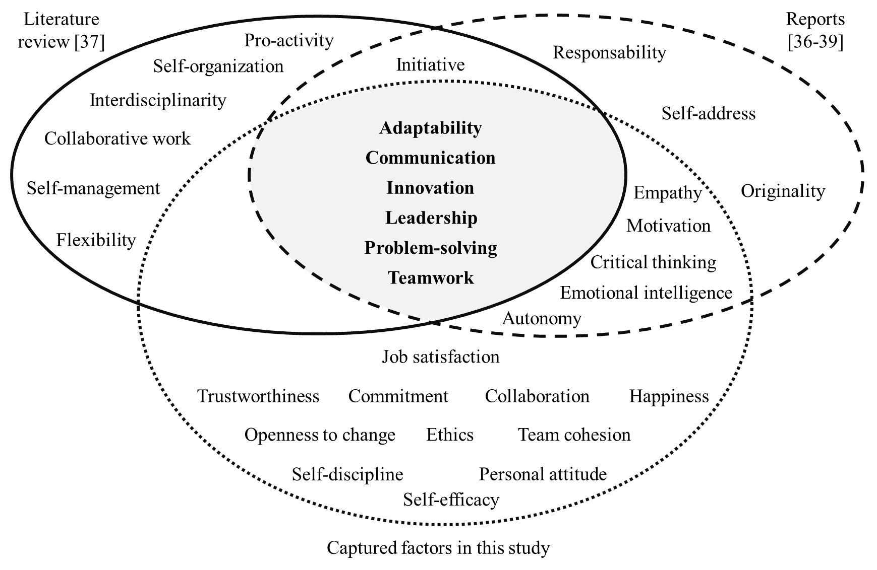
Fig. 1. Non-technical factors required in Industry 4.0.
In a complementary way, a bibliometric analysis of keyword co-occurrences [43] was performed based on reading bibliographic data from Scopus. The search string presented in the planning phase was used. Search in 'All Fields' was selected. The inclusion and exclusion criteria were not applied, but the results were limited to the subject area "Computer Science" and the Document Type was limited to 'Conference paper', 'Article' and 'Book chapter'. The search returned 1,734 results with publications between 2014 and 2023, showing an increasing behavior, specifically between 2018 and 2022.
VOSviewer was used to create a keyword map from the metadata obtained in Scopus. The keyword co-occurrence analysis was made without This resulted in the map shown in Fig. 2.

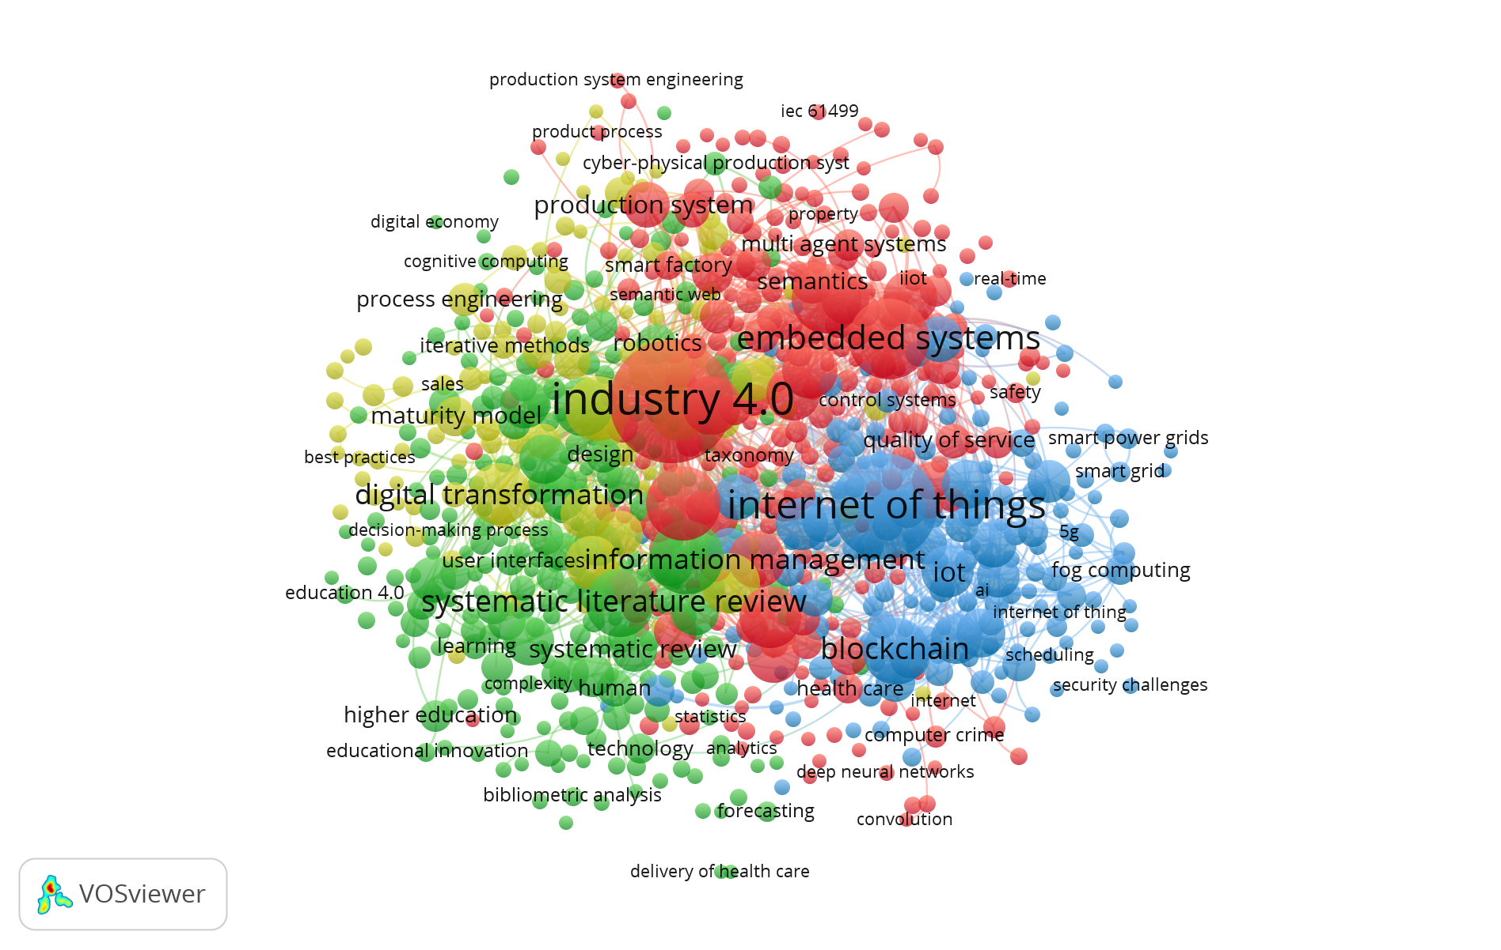
Fig. 2. Map of co-occurrences (Source: VOSviewer).
The four clusters obtained are related to the technical and formal aspects of Industry 4.0, such as the internet of things, embedded systems, or digital transformation related to Software Engineering. However, there is no evidence of significant networks connected to soft skills or human factors, nor is there evidence of networks associated with the non-technical factors presented in Table 3. It is possible that the lack of studies related to non-technical factors is due to the difficulty of measuring them [13, 14].
Software engineering is a fundamental support for this era. Still, although the software development process is considered a people-based social activity [44], studies related to soft skills in this context are still developing. This finding is consistent with the results presented in this study. Thus, it is relevant to continue with research efforts oriented to analyzing non-technical factors in Software Engineering.
4.2 Implications for Practice and Research
The results of this systematic literature mapping suggest that several non-technical factors are relevant in Software Engineering to address the challenges of Industry 4.0. Recognizing their importance in the training process, and identifying which ones are relevant, promotes the design of pedagogical strategies that are transversal to the curriculum so that they cover both technical and non-technical factors. This identification is helpful for team leaders because it strengthens team management by giving value to aspects such as communication, leadership, or creativity.
This mapping contributes to a line of research work oriented towards non-technical factors in Software Engineering. Identifying these factors is the previous step in designing and applying measurement and intervention strategies that facilitate the management of software development teams.
4.3 Limitations of the Study
This study focused on scientific databases Science Direct, Springer, IEEE, and ACM, which represent limitations concerning relevant studies found in other databases of lesser coverage and constraints concerning the number of files available for download. The synthesis that we presented is close to a qualitative metasummary. However, it remains as future work to delve into the use of this or other synthesis methods [45].
The limitation related to the possible exclusion of relevant studies on non-technical factors required in Software Engineering in the context of Industry 4.0 because they are published in other databases is overcome by considering that the four databases were selected for their broad scope in the area of Engineering, Software Engineering and Computer Science, as well as for their frequency of use among the scientific community as a source of recent and reliable information in the area.
The limitation related to the number of files available for download is overcome by analyzing literature reviews related to the topic of interest and, therefore, summarizing those relevant studies that could not be accessed.
5 Conclusions and Future Work
The literature recognizes the importance of non-technical factors in the work environment under Industry 4.0. Nine primary research were found that address the topic of interest of this mapping. After doing the quality analysis and excluding one of the captured studies, 23 non-technical factors were identified, among which communication, leadership, teamwork/cohesion, and innovation/creativity as social and human factors, problem-solving, and adaptability stand out.
Software Engineering is one of the supports of Industry 4.0, and non-technical factors are relevant because it is a people-intensive process. Thus, the non-technical factors identified in this mapping are helpful for those who manage software development teams in the context of Industry 4.0. This is related to principle 2 of the SPI Manifesto [5] since encouraging these skills in team members promotes process improvement and value creation.
Future research may be related to assessing the importance of these non-technical factors in the software industry and investigating their inclusion in decision-making within organizations or work teams.
Additionally, we can continue working on identifying or designing instruments to measure these non-technical factors in the context of Software Engineering and once measured, design intervention strategies in work teams that promote the strengthening of these skills.
References
1. Xu, L. Da, Xu, E.L., Li, L.: Industry 4.0: state of the art and future trends. Int. J. Prod. Res. 56, 2941–2962 (2018). https://doi.org/10.1080/00207543.2018.1444806
2. Schneider, P.: Managerial challenges of Industry 4.0: an empirically backed research agenda for a nascent field. Rev. Manag. Sci. 12, 803–848 (2018). https://doi.org/10.1007/s11846-018-0283-2
3. Kornyshova, E., Barrios, J.: Industry 4.0 Impact Propagation on Enterprise Architecture Models. In: Procedia Computer Science. 24th International Conference on Knowledge-Based and Intelligent Information & Engineering Systems. pp. 2497–2506. Elsevier B.V. (2020)
4. Nakagawa, E.Y., Antonino, P.O., Schnicke, F., Kuhn, T., Liggesmeyer, P.: Continuous Systems and Software Engineering for Industry 4.0: A disruptive view. Inf. Softw. Technol. 135, 106562 (2021). https://doi.org/10.1016/j.infsof.2021.106562
5. Manifesto: Software Process Improvement (SPI), https://conference.eurospi.net/images/eurospi/spi_manifesto.pdf
6. Kirilo, C.Z., Abe, J.M., De Lima, L.A., Lozano, L.C.M., Nogueira, M., De Oliveira, C.C., Nakamatsu, K.: Organizational climate assessment using the paraconsistent decision method. Procedia Comput. Sci. 131, 608–618 (2018). https://doi.org/10.1016/j.procs.2018.04.303
7. Dooley, J.F.: Software Development, Design and Coding. (2017)
8. Krasner, H.: The Cost of Poor Software Quality in the US: A 2020 Report. (2021)
9. Richter, K., Dumke, R.R., Group, F.: Modeling, Evaluating and Predicting IT Human Resources Performance. (2015)
10. Wagner, S., Ruhe, M.: A Systematic Review of Productivity Factors in Software Development. In: 2nd International Workshop on Software Productivity Analysis and Cost Estimation (SPACE 2008) (2018)
11. Trendowicz, A., Münch, J.: Chapter 6 Factors Influencing Software Development Productivity-State-of-the-Art and Industrial Experiences. In: Advances in Computers. pp. 185–241 (2009)
12. Sadowski, C., Zimmermann, T.: Rethinking Productivity in Software Engineering. Springer, New Yotk (2019)
13. Canedo, E.D., Santos, G.A.: Factors affecting software development productivity: An empirical study. In: ACM International Conference Proceeding Series. pp. 307–316. Association for Computing Machinery (2019)
14. Capretz, L.F., Ahmed, F., da Silva, F.Q.B.: Soft sides of software. Inf. Softw. Technol. 92, 92–94 (2017). https://doi.org/10.1016/j.infsof.2017.07.011
15. Sedelmaier, Y., Landes, D.: Software engineering body of skills (SWEBOS). IEEE Glob. Eng. Educ. Conf. EDUCON. 395–401 (2014). https://doi.org/10.1109/EDUCON.2014.6826125
16. Lacher, L., Walia, G., Nygard, K., Fagerholm, F., Pagels, M., Münch, J.: A behavior marker for measuring non-technical skills of software professionals: An empirical study. Int. J. Softw. Eng. Knowl. Eng. 25, 1733–1738 (2015). https://doi.org/10.1142/S0218194015710084
17. Sudhakar, G.P., Farooq, A., Patnaik, S.: Soft factors affecting the performance of software development teams. Team Perform. Manag. 17, 187–205 (2011). https://doi.org/10.1108/13527591111143718
18. Chaka, C.: Skills, competencies and literacies attributed to 4IR/Industry 4.0: Scoping review. IFLA J. 46, 369–399 (2020). https://doi.org/10.1177/0340035219896376
19. Hecklau, F., Galeitzke, M., Flachs, S., Kohl, H.: Holistic Approach for Human Resource Management in Industry 4.0. Procedia CIRP. 54, 1–6 (2016). https://doi.org/10.1016/j.procir.2016.05.102
20. Bongomin, O., Gilibrays Ocen, G., Oyondi Nganyi, E., Musinguzi, A., Omara, T.: Exponential Disruptive Technologies and the Required Skills of Industry 4.0. J. Eng. (United Kingdom). 2020, (2020). https://doi.org/10.1155/2020/4280156
21. Kaur, R., Awasthi, A., Grzybowska, K.: Evaluation of Key Skills Supporting Industry 4.0—A Review of Literature and Practice. Sustain. Logist. Prod. Ind. 4.0. 19–29 (2020). https://doi.org/10.1007/978-3-030-33369-0_2
22. Shet, S. V., Pereira, V.: Proposed managerial competencies for Industry 4.0 – Implications for social sustainability. Technol. Forecast. Soc. Change. 173, (2021). https://doi.org/10.1016/j.techfore.2021.121080
23. Ribeiro, A., Amaral, A., Barros, T.: Project Manager Competencies in the context of the Industry 4.0. Procedia Comput. Sci. 181, 803–810 (2021). https://doi.org/10.1016/j.procs.2021.01.233
24. Maisiri, W., Darwish, H., van Dyk, L.: An investigation of industry 4.0 skills requirements. South African J. Ind. Eng. 30, 90–105 (2019). https://doi.org/10.7166/30-3-2230
25. Kitchenham, B., Charters, S.: Guidelines for performing Systematic Literature reviews in Software Engineering Version 2.3. (2007)
26. Brereton, P., Kitchenham, B.A., Budgen, D., Turner, M., Khalil, M.: Lessons from applying the systematic literature review process within the software engineering domain. J. Syst. Softw. 80, 571–583 (2007). https://doi.org/10.1016/j.jss.2006.07.009
27. Muhuri, P.K., Shukla, A.K., Abraham, A.: Industry 4.0: A bibliometric analysis and detailed overview. Eng. Appl. Artif. Intell. 78, 218–235 (2019). https://doi.org/10.1016/j.engappai.2018.11.007
28. Dehbozorgi, N., Pramasani Mohandoss, D.: Aspect-Based Emotion Analysis on Speech for Predicting Performance in Collaborative Learning. In: 2021 IEEE Frontiers in Education Conference (FIE). IEEE (2021)
29. Marnewick, A., Marnewick, C.: The Ability of Project Managers to Implement Industry 4.0-Related Projects. IEEE Access. 8, (2020). https://doi.org/10.1109/ACCESS.2019.2961678
30. Siddoo, V., Sawattawee, J., Janchai, W., Thinnukool, O.: An exploratory study of digital workforce competency in Thailand. Heliyon. 5, (2019). https://doi.org/10.1016/j.heliyon.2019.e01723
31. Borah, D., Malik, K., Massini, S.: Are engineering graduates ready for R & D jobs in emerging countries ? Teaching-focused industry-academia collaboration strategies. Res. Policy. 48, 103837 (2019). https://doi.org/10.1016/j.respol.2019.103837
32. Machuca-Villegas, L., Gasca-hurtado, G.P., Morillo, S., Restrepo-Tamayo, L.M.: Perceptions of the human and social factors that influence the productivity of software development teams in Colombia: A statistical analysis. J. Syst. Softw. 192, 111408 (2022). https://doi.org/10.1016/j.jss.2022.111408
33. Benešová, A., Tupa, J.: Requirements for Education and Qualification of People in Industry. In: Procedia Manufacturing. pp. 2195–2202 (2017)
34. Johnson, M., Jain, R., Ethne, P.B., Deborah, S., Jessica, S., Johnson, M., Brennan-tonetta, P., Silver, D.: Impact of Big Data and Artificial Intelligence on Industry : Developing a Workforce Roadmap for a Data Driven Economy. Glob. J. Flex. Syst. Manag. 22, 197–217 (2021). https://doi.org/10.1007/s40171-021-00272-y
35. Park, S., Yu, H., Chang, H.: Design of the required tasks of industrial security experts based on job openings. Secur. J. 35, 317–344 (2022). https://doi.org/10.1057/s41284-020-00279-7
36. Saniuk, S., Caganova, D., Saniuk, A.: Knowledge and Skills of Industrial Employees and Managerial Staff for the Industry 4.0 Implementation. Glob. J. Flex. Syst. Manag. (2021)
37. Mckenzie, S., Coldwell, J., Stuart, N.: Integrating career development into an undergraduate IT curriculum at an Australian University. Educ. Inf. Technol. 5971–5990 (2021). https://doi.org/10.1007/s10639-021-10567-3
38. Kipper, L.M., Iepsen, S., Dal Forno, A.J., Frozza, R., Furstenau, L., Agnes, J., Cossul, D.: Scientific mapping to identify competencies required by industry 4.0. Technol. Soc. 64, (2021). https://doi.org/10.1016/j.techsoc.2020.101454
39. World_Economic_Forum: The Future of Jobs Report. (2018)
40. Infosys: Talent Radar How the best companies get the skills they need to thrive in the digital era. (2019)
41. Spiezia, V.: Jobs and skills in the digital economy. (2017)
42. Universities_of_The_Future: Industry 4.0: implications for higher education institutions: State-of-maturity and competence needs. (2020)
43. Donthu, N., Kumar, S., Mukherjee, D., Pandey, N., Lim, W.M.: How to conduct a bibliometric analysis: An overview and guidelines. J. Bus. Res. 133, 285–296 (2021). https://doi.org/10.1016/j.jbusres.2021.04.070
44. Trendowicz, A., Ochs, M., Wickenkamp, A., Münch, J., Ishigai, Y., Kawaguchi, T.: Integrating human judgment and data analysis to identify factors influencing software development productivity. e-Informatica Softw. Eng. J. 2, 47–69 (2008)
45. Cruzes, D.S., Dyb, T.: Research synthesis in software engineering: A tertiary study. Inf. Softw. Technol. 53, 440–455 (2011). https://doi.org/10.1016/j.infsof.2011.01.004

