LinkU: An Academic and Social Schedule Management Software

**Abstract.** Today's society demands a lot of time to carry out activities, but being busy is not synonymous with productivity. This statement has become important at university, where students spend time outside the classroom on activities that do not contribute significantly to their development. This paper presents LinkU, an IT (Information Technology) solution aimed at university schedule management. Identifying the different challenges when the students try to visualize their timetables, LinkU provides an intuitive and easy-to-use platform for quick and organized access to the users’ schedules. In addition to personal schedule management, LinkU allows to add friends, view their schedules, and check classroom availability on campus. This article examines the benefits and importance of adopting LinkU to enhance the academic experience. The results show the potential impact of LinkU in optimizing time management and facilitating social engagement among students, contributing to their overall academic and personal well-being throughout their educational journey.

**Keywords:** university schedules, schedule organization, digital platforms, software solutions, student productivity, time management, social interaction, academic planning.

1 Introduction

Students often face challenges in efficiently visualizing and organizing their schedules, which hinders optimizing time and activities during their university experience. It has become a significant problem as effective time management is associated with better academic performance and lower levels of anxiety in students [1]. In response to these challenges, LinkU emerges as a solution to address the needs and issues faced by students. The objective of this software is to offer students at Universidad del Norte a quick, organized, and dynamic platform for accessing their schedules in an intuitive and user-friendly manner. This innovative software empowers students to make the most of their free time and enhances their planning for studying, socializing with friends, and engaging in extracurricular activities of interest.

Beyond personal schedule management, LinkU offers a unique feature that allows users to add friends, view their schedules, and check classroom availability on campus. This functionality enables students to plan meetings and joint activities, maximizing their shared time and strengthening peer relationships. The significance of social interaction among peers in the university setting has become of tremendous interest, as the peer group plays a considerable role in students' lives [2]. High-quality interpersonal relationships with classmates and friends, characterized by closeness, encouragement, and support, serve as developmental assets for negotiating and adapting during every student's course through the university [3]. Additionally, it's most likely that socially integrated students tend to experience higher levels of satisfaction and success in their university journey [4]. These observations highlight the potential impact of LinkU in improving the university experience for all its users, fostering stronger peer connections, and enhancing overall satisfaction.

This article exposes the methodology to develop the software for schedule management and explores the benefits and significance of utilizing LinkU as an instrument to enhance the life experience of the users at Universidad del Norte. It examines the essential functionalities of the application and presents results from students who used LinkU to optimize their schedule management and improve their day-to-day life at the university. Furthermore, recommendations will be provided for future improvements and expansions to the platform, aiming to continuously elevate the quality of the student experience.

The article is structured into eight sections. The second section examines a variety of bibliographic sources, carefully choosing and examining those that are most relevant to the topic at hand. The subsequent methodological approach made in Section 3 is informed and supported by these sources, which also provide the study's findings legitimacy and depth. Section 4 presents a complete plan, explaining the suggested stages and techniques employed, building on the theoretical framework. Moving forward, Sections 5, 6, and 7 delve into the intricacies of software design, architecture, and implementation, providing a thorough understanding of the technical aspects involved. The main findings and conclusions drawn from the research project are finally summarized in Section 8.

2 Related Work

The impact of digital tools and technology on college students' time management, academic achievement, and social connections has been garnering significant attention and fueling extensive discussions. One key finding is that students who perceive their digital activities as challenges rather than threats tend to exhibit higher productivity levels and experience lower stress levels [5]. These insights shed light on the potential benefits that come from embracing digital tools, emphasizing the importance of adopting a positive mindset towards their use in optimizing student outcomes.

Moreover, research focusing on the influence of social media sites and networking applications on students' academic lives has highlighted the role of social media on behavior, facilitating social learning and interaction, and encouraging the sharing of information. However, students must use responsibly these platforms to avoid any negative effects on their academic performance [6][7].

Another emerging area of interest in educational settings is the integration of artificial intelligence (AI) technologies. AI is increasingly recognized as a strategic asset in education, offering valuable learning tools that can reduce student workloads while fostering engaging and effective learning experiences [8]. Researchers are actively exploring the potential of AI to personalize instruction, provide insights into student progress, and deliver prompt feedback, thereby disrupting conventional educational practices [9]. AI-driven chatbots and virtual assistants, such as the "Link" chatbot implemented in our software, can provide 24/7 support and facilitate interactive learning opportunities, further enhancing the overall learning environment.

Although previous studies have highlighted the advantages of digital tools, social media, and AI in terms of time management, academic performance, and social interactions, further research is needed to investigate their specific effects on university schedules and the overall college experience. In response to this research gap, our proposed solution, LinkU, aims to provide a clear and user-friendly platform that promotes effective schedule management and fosters social engagement among students at Universidad del Norte. By addressing these areas, we contribute to a deeper understanding of the impact of digital tools and AI technologies on the college experience and provide valuable insights for future educational practices.

3 Methodology and requirements analysis

Considering the requirements and desired functionalities, we proposed developing a desktop and mobile application called "LinkU" using modern and appropriate technologies to provide an optimal experience for the students of Universidad del Norte. The crucial aspects of the proposal are detailed below.

3.1 Functional requirements

* Registration: The desktop application allows easy and intuitive registration of the users with the chance to enter their schedules in an agile and efficient way with search filters.
* Timetable visualization: The software allows students to visualize their schedules distinctly through the desktop application, showing relevant information such as courses, class hours, and assigned classrooms.
* Sharing schedules: The software offers to add friends and share schedules, which allows users to view other students' schedules and coordinate joint activities.
* Room Availability Viewing: The mobile application complements the students' experience by allowing them to view, explore, and access updated information about the available rooms at the university during a specific time of the day.
* AI-powered assistant: The desktop application features an AI-powered virtual assistant that answers all users' questions about courses, teachers, and more.

3.2 Non-functional requirements

* Usability: The software is intuitive and easy to use, with a user-friendly interface that allows users to navigate and perform tasks without difficulty.
* Security: Security strategies such as passwords, were implemented to protect the privacy of user data, ensuring secure access to personal information and schedules.
* Performance: The system can obtain information from users efficiently and quickly.

In addition, we adopted the Scrum framework as our agile software development tool. Scrum facilitated effective progress tracking through iterative sprints conducted every 2 weeks [10]. Furthermore, we actively carried out periodic user reviews as an integral part of the development process in Scrum, aimed at gathering user feedback and insights to identify areas in need of urgent improvement and ensure continuous enhancement throughout the project lifecycle.

4 Software design and architecture

The UML class diagram in Fig. 1, represents the structure and relationships between the different classes of the LinkU application. It is separated into modules, each containing the most important classes of our system. Below is an explanation of each module:

1. Databases: This module contains each of the classes that use SQL statements in the database. All the classes in this module inherit from a main one called General Control, which is responsible for making the connection to the database (using a Singleton structure internally) and contains the connection variables, in addition to those that will be used to execute statements (PreparedStatement) and receive results (ResultSet). All the other classes use these variables for optimizing the connections that are made to the database. Also, each of these controls a different table in the database, these tables are determined by the class name. CourseControl controls everything related to the courses’ tables (Courses and CourseProperties), and so on for each of the others.
2. Models: This module contains each of the model classes in which the application's information is internally organized. All of these are simple classes, and their attributes usually coincide with the columns of the database tables since the methods of the classes in the Databases module make use of these models to return the information, and the methods they contain are only Getters and Setters.
3. Web Scrapping: This module contains the classes that make HTTP requests, or that use the web in some way, either through requests or selenium. The classes in this module take the updated information from the university and organize it within models to be able to use it within the application. These classes only have methods to get information, none modify university information.
4. Exceptions: This module contains all the classes that serve as exceptions created by us to indicate errors that occur within the application and to be able to control them.
5. Core: This module contains all the main classes of the application; all other modules are used by the methods of these classes to perform essential functions of the application. An example of this is the Account class which in its methods uses several models and methods from the Databases module to perform all user functions such as login, logout, information modification, etc.
6. Artificial Intelligence: This module contains all the classes that Link (LinkU's chatbot) uses to function correctly. Here, a main class is found which is the core of Link, it is responsible for obtaining messages, processing them using the other classes of this module, sending the request to OpenAI API, executing functions if the user requests it, and returning a response to the chat.
7. GUI: This is just an exemplification module, the only class that can be seen in the UML simplifies and simulates the connections that our various Frames have with the other classes.

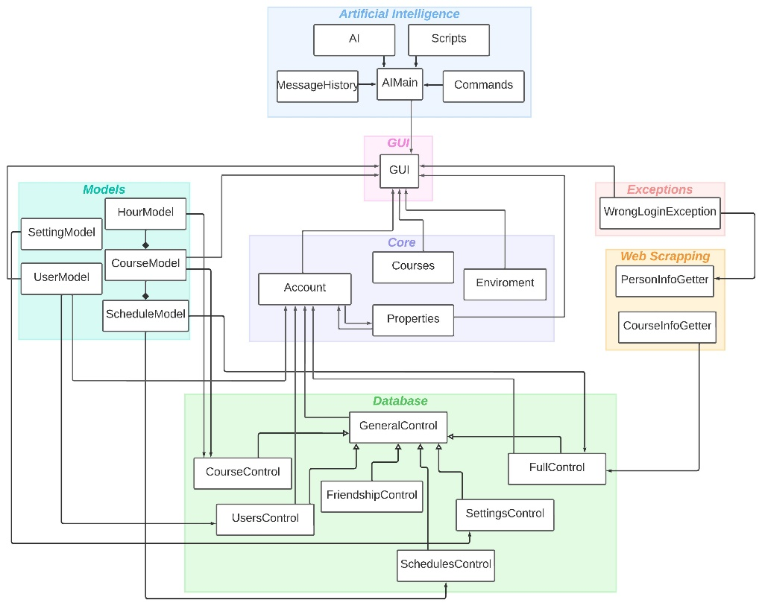

Figure 1 Class diagram for LinkU design

4.1 Architecture and Technologies

We implemented the LinkU application using a client-server architecture, where the client serves as an interface accessible through computers (for the desktop application) and mobile devices with an Android operating system (for the mobile application). The server is responsible for managing the application logic and data storage.

* Frontend: We utilized technologies like NetBeans and Android Studio to develop the user interface, ensuring an appealing and user-friendly visual experience.
* Backend: The application is developed using the Java programming language and organized into several modules that handle the information related to courses, schedules, friends, and other functionalities.
* Course Management Module: This module manages all the information related to the courses offered at Universidad del Norte. It will allow the consultation of details such as the name of the subject/course, the description, the teacher in charge, and the prerequisites.
* Friend Management Module: This module will allow users to add, search and manage their list of friends in the application. Users can send friend requests, accept or reject them, and view their friends' shared schedules.
* Free Rooms Management Module: This module is responsible for managing the information on available rooms. It enables users to check the availability of rooms at their desired time and allows them to reserve rooms for meetings or group studies.
* Database: We utilize a MySQL cloud database to store students' information, schedules, and friends list. The application of this type of tool ensures fast and efficient access to the required data for the application's functionalities.

5 Software implementation

After establishing the methodology and defining the functional and non-functional requirements, we started the development stage of both applications. Throughout this stage, the system underwent rigorous testing, and the results obtained from the implemented test plan were highly satisfactory. As a result, we successfully achieved all the functional and non-functional requirements mentioned above.

Fig. 2 shows the registration interface where the user's personal and academic information must be entered, then Fig. 3 represents the main interface of the software that includes the user's schedule and a side menu with multiple functions, Fig. 4 illustrates the friend search function that displays the information that the user has decided to show to his friends, Fig. 5 shows other functions that the software offers such as the search for free classrooms, free friends and extracurricular courses.

Figure 2 LinkU registration interface

Figure 3. LinkU main interface

Figure 4. LinkU friend’s interface

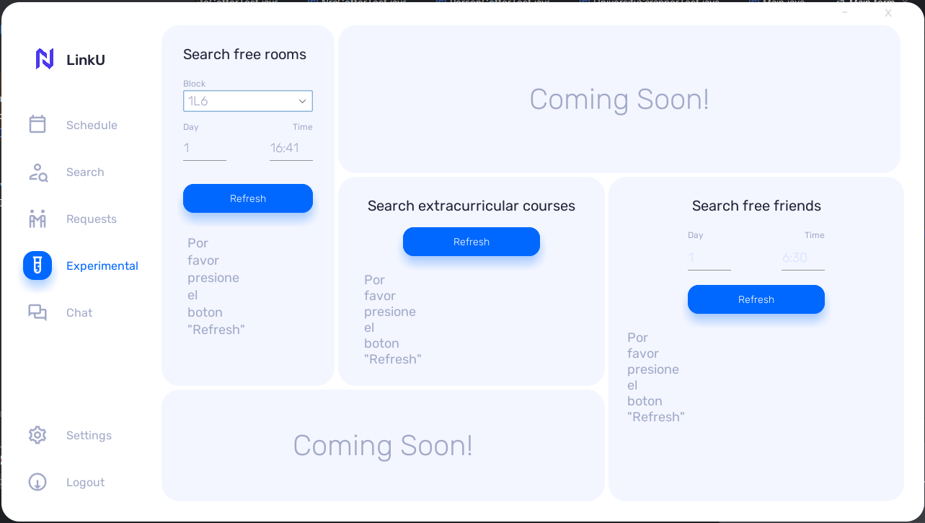

Figure 5. LinkU function menu interface

To evaluate the functionality and usability of the software and gather user feedback, we conducted a survey involving 10 participants. The survey aimed to assess users' impressions, determine the frequency of software usage, and identify their favorite functionalities. The results of this survey are presented in Figures 5 to 9, showcasing valuable insights from the user feedback.

These graphs show general statistics about the user's perception of using LinkU. The graph in Fig. 5 shows that 80% responded that they would use the software more than 15 times during the semester and 20% between 10 and 5 times. The second question inquires about the frequency of use of the applications. The results in Fig. 6 show that most users would use the functions to view their schedule, search for free friends and ask questions to the chatbot.

Questions Q3, Q4, and Q5 are related to the usability of the software. Fig. 7 illustrates the responses from the survey participants regarding the ease of navigating the application. The results indicate that 70% of the surveyed users found the navigation very easy, 20% reported it as easy with rare confusion, and the remaining 10% mentioned that it was somewhat difficult to navigate through the application. Fig. 8 shows the findings regarding the intuitiveness of the application. The results indicate that 90% of the users found the application to be consistently intuitive, while 10% mentioned that it was occasionally intuitive. In Fig. 9, we can see that 50% of the respondents said that the most useful function of the software is to see their available friends, 40% to ask questions to the chatbot, and 10% to see which room is available. Finally, users expressed positive feedback and indicated their willingness to recommend the application. Reasons for recommending it included ease of use, innovation, time optimization, improved interaction with friends, and the application's significance in the daily routine of the average college student.

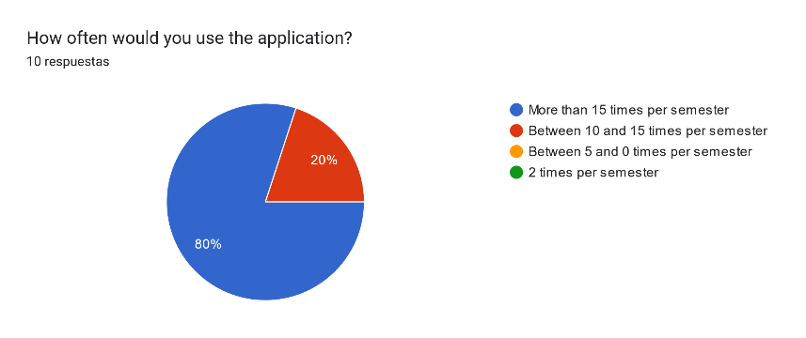

Figure 6. Results of Q1

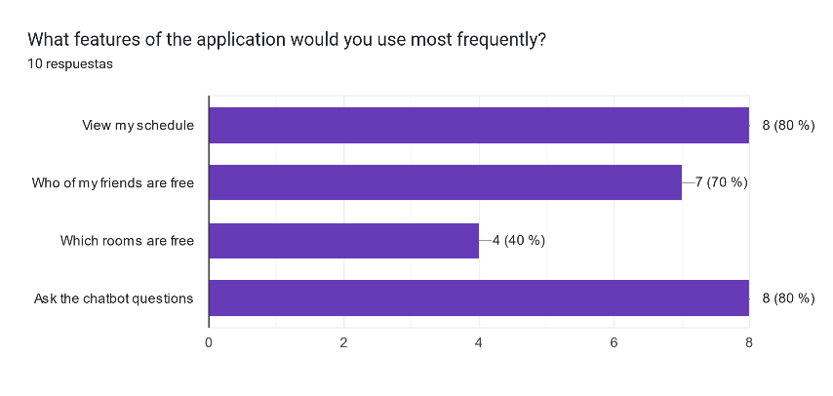

Figure 7. Results of Q2

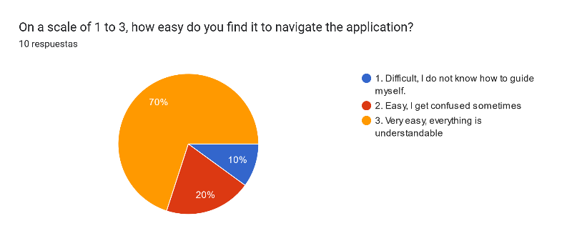

Figure 8. Results of Q3

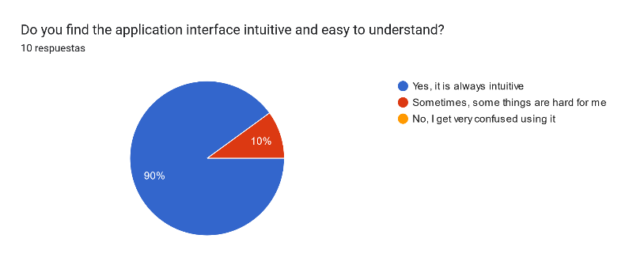

Figure 9. Results of Q4

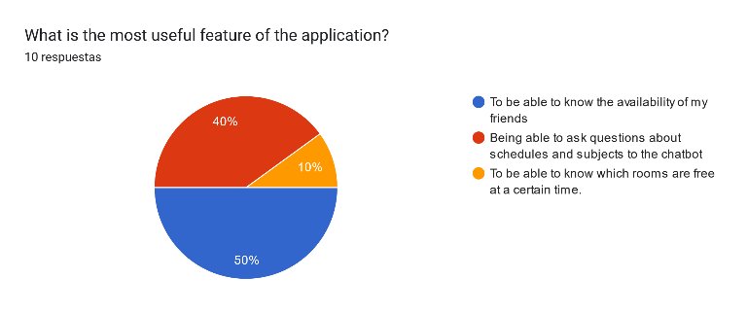

Figure 10. Results of Q5

5 Conclusions

After developing and analyzing LinkU, we have drawn significant conclusions that evaluate the fulfillment of the essential technological and contextual requirements for ensuring its suitable functioning and successful engagement with the target audience.

Regarding the results of the application, we developed a functional and robust technological solution that reaches the established requirements. The potential users (students from Universidad del Norte) will be able to access their schedules in a fast and organized way, manage friends, check room availability, and maximize their time both academically and socially. The implementation of LinkU offers a complete and efficient experience for users, providing them with tools that allow them to optimize their university life.

This application has a high impact on the educational environment, as it fosters greater efficiency in planning and utilizing university resources. LinkU provides students with a comprehensive tool that simplifies the organization of schedules, enhances communication with friends, and facilitates the visualization of available rooms. This, in turn, can lead to improved academic performance, increased opportunities for social interaction, and a more enriching overall experience within the university environment. The contribution of the application to streamline processes, encourage collaboration and optimize the use of resources is essential to create an environment conducive to the success and holistic development of students.

Despite the positive feedback and adequate functionalities, the application still has certain limitations. Notably, the absence of an alternative for users utilizing devices with the iOS operating system is a significant constraint. As part of future enhancements, we will prioritize addressing this limitation to ensure the tool's impact can reach a broader range of students. By expanding compatibility to include iOS devices, we aim to extend the benefits of the application to a vaster user base, promoting inclusivity and accessibility in our solution.

On top of that, there have been suggestions to further improve the application by exploring the implementation of customized notifications or reminders. Additionally, the inclusion of an internal chat feature could be explored, allowing users to communicate with each other seamlessly within the application. These proposed improvements aim to enrich the user experience, enhance productivity, and foster seamless integration with various tools and services.

In summary, LinkU has proven to be a satisfactory technological solution that meets the requirements set out to improve the students' experience at Universidad del Norte. Despite some limitations and technical considerations, its potential impact on the organization of schedules, social interaction, and the use of university resources is relevant. With appropriate improvements and upgrades, LinkU can continue to evolve and contribute positively to the academic and social life of students.

References

1. Adams, R. V., & Blair, E. (2019). Impact of Time Management Behaviors on Undergraduate Engineering Students’ Performance. *SAGE Open*, *9*(1), 215824401882450. <https://doi.org/10.1177/2158244018824506>
2. Adeyemi, F. B. (2019). Peer group influence on academic performance of undergraduate students in Babcock University, Ogun State. *African Educational Research Journal*, *7*(2), 81-87. <https://doi.org/10.30918/aerj.72.19.010>
3. Kiuru, N., Wang, M., Salmela-Aro, K., Kannas, L., Ahonen, T., & Hirvonen, R. (2020). Associations between Adolescents’ Interpersonal Relationships, School Well-being, and Academic Achievement during Educational Transitions. *Journal of Youth and Adolescence*, *49*(5), 1057-1072. https://doi.org/10.1007/s10964-019-01184-y
4. Hudson, T. D., Rockenbach, A. N., Mayhew, M. J., & Zhang, L. (2021). Examining the Relationship Between College Students’ Interworldview Friendships and Pluralism Orientation. *Teachers College Record*, *123*(7), 1-36. https://doi.org/10.1177/016146812112300706
5. Galindo-Domínguez, H., & Bezanilla, M. J. (2021). Promoting Time Management and Self-Efficacy Through Digital Competence in University Students: A Mediational Model. *Contemporary Educational Technology*, *13*(2), ep294. <https://doi.org/10.30935/cedtech/9607>
6. Abbas, J., Aman, J., Nurunnabi, M., & Bano, S. (2019). The Impact of social media on Learning Behavior for Sustainable Education: Evidence of Students from Selected Universities in Pakistan. *Sustainability*, *11*(6), 1683. https://doi.org/10.3390/su11061683
7. Bernard, K. J., & Dzandza, P. E. (2018). Effect of social media on Academic Performance of Students in Ghanaian Universities: A Case Study of University of Ghana, Legon. *Library Philosophy and Practice*, 1. <http://197.255.68.205/handle/123456789/31545?show=full>
8. Zhai, X., Chu, X., Chai, C. S., Jong, M. S., Starčič, A. I., Spector, M. P., Liu, J., Yuan, J., & Li, Y. (2021). A Review of Artificial Intelligence (AI) in Education from 2010 to 2020. *Complexity*, *2021*, 1-18. https://doi.org/10.1155/2021/8812542
9. Hwang, G., Xie, H., Wah, B. W., & Gašević, D. (2020). Vision, challenges, roles and research issues of Artificial Intelligence in Education. *Computers & Education: Artificial Intelligence*, *1*, 100001. https://doi.org/10.1016/j.caeai.2020.100001
10. Hron, M., & Obwegeser, N. (2018). *Scrum in Practice: an Overview of Scrum Adaptations*. https://doi.org/10.24251/hicss.2018.679