*Image recognition system for bird sampling in the city of Zacatecas*

Vania Stephany Sanchéz Lee

Engineering in Computer Systems, National Polytechnic Institute

Zacatecas, México

s.vanialee@gmail.com

Isaul Ibarra Belmonte

Software Engineer, Center for Research in Mathematics

Zacatecas, México

isaul.ibarra@cimat.com

Axel Frederick Félix Jiménez

Engineering in Computer Systems, National Polytechnic Institute

Zacatecas, México

frederick.felix@outlook.com

Ezra Federico Parra González

Computer Science Department, Center for Research in Mathematics

Zacatecas, México

ezra.parra@cimat.com

Abstract — The lack of comprehensive bird monitoring in Zacatecas, Mexico hampers biodiversity conservation efforts. This study addresses this gap by utilizing convolutional neural network models for image recognition of endangered golden eagles, bald eagles, and osprey eagles found in Zacatecas. Datasets were obtained from online sources, and images were pre-processed and organized in a CSV file. Three models (ResNet, Inception, MobileNet) were implemented, trained, and validated. The Inception model achieved the highest accuracy (93.617%), followed by ResNet (85.674%) and MobileNet (78.234%). The Inception model's accuracy establishes it as the most effective for recognizing these bird species. This methodology contributes to bird conservation by providing a reliable identification and monitoring tool. Further integration of these models into comprehensive monitoring programs can aid in assessing conservation status and implementing targeted strategies for bird conservation in Zacatecas.

Keywords – birds, image processing, Zacatecas City, pattern recognition, convolutional neural networks.

1. Introduction

The investigation of urban biodiversity has emerged as a critical aspect in the preservation and management of urban ecosystems. Within this context, the city of Zacatecas, Mexico stands out as a diverse habitat hosting a wide array of avian species across its various areas. Nonetheless, gathering essential data on these species presents challenges, particularly in monitoring bird populations in urban environments. To surmount these obstacles, the development of an image recognition system for avian sampling in Zacatecas has been undertaken. This cutting-edge system enables accurate and efficient data collection, thereby facilitating research efforts and the formulation of conservation strategies for the city's urban fauna. This article delves into the significance of the image recognition system for avian sampling in Zacatecas, elucidating its objectives and operational framework.

The lack of bird monitoring and inventory in the state of Zacatecas poses a significant obstacle to biodiversity conservation in the region, as it limits our capacity to assess the conservation status of bird species and hinders the implementation of effective conservation strategies. Moreover, this lack of information is exacerbated by human pressures faced by the state of Zacatecas, such as urbanization, intensive agriculture, and mining, which can have negative impacts on bird populations.

The absence of information on bird diversity and abundance is a significant limitation to the implementation of effective conservation strategies. According to the National Commission for the Knowledge and Use of Biodiversity (CONABIO), the lack of bird inventories hampers our understanding of the conservation status of birds in Mexico and, consequently, impedes the implementation of effective conservation strategies [1].

Situated in central-northern Mexico, the state of Zacatecas holds importance for biodiversity conservation due to its diverse habitats and the presence of endemic and migratory bird species. However, the lack of information on bird populations in the region hampers the implementation of effective conservation policies and actions. Urbanization, intensive agriculture, and mining are human activities exerting pressure on bird habitats, affecting their quality and quantity. Additionally, these activities can lead to habitat fragmentation, with potential negative consequences for bird diversity in the region [2].

On the other hand, information on bird diversity and distribution can be utilized to design effective conservation strategies. Data gathered through bird monitoring studies can help identify priority conservation areas, assess the effects of land-use changes on biodiversity, evaluate the effectiveness of protected areas, and monitor bird population trends [3].

The absence of bird monitoring and inventory in the state of Zacatecas represents a significant hurdle to biodiversity conservation in the region. It is imperative to conduct long-term research and monitoring programs to better understand bird diversity and distribution in the region. This knowledge will serve as a foundation for designing and implementing effective conservation strategies.

1. Background
   1. Birds

The state of Zacatecas faces a critical challenge in terms of bird monitoring and inventory, which has significant implications for biodiversity conservation in the region. The lack of comprehensive data on bird populations poses obstacles to assessing the conservation status of bird species and implementing effective conservation strategies. This dearth of information is particularly concerning considering the various human pressures that the state of Zacatecas experiences, including urbanization, intensive agriculture, and mining, which can have detrimental effects on bird populations and their habitats.

Bird monitoring and inventory play a crucial role in understanding the ecological dynamics of avian species and identifying potential conservation priorities. These activities enable researchers and conservationists to assess population trends, distribution patterns, and the occurrence of threatened or endangered species. By establishing baseline data and monitoring changes over time, scientists can better evaluate the effectiveness of conservation efforts and make informed decisions to mitigate threats to bird populations.

In the context of Zacatecas, the lack of bird monitoring data inhibits our ability to accurately evaluate the conservation status of local bird species. Without comprehensive inventories, it becomes challenging to identify areas of high biodiversity significance, determine the impact of human activities on bird populations, and design targeted conservation interventions. Furthermore, the state's unique geographical and ecological features make it an important habitat for a diverse range of bird species, heightening the urgency of effective conservation measures.

Human activities, such as urbanization, intensive agriculture, and mining, can significantly impact bird populations and their habitats. Urbanization often results in habitat fragmentation, reducing suitable nesting and foraging areas for birds. Intensive agriculture practices, including the use of pesticides and habitat conversion, can lead to the loss of crucial feeding and breeding grounds. Additionally, mining activities may alter landscapes, disrupt ecosystems, and introduce pollutants that can have adverse effects on bird populations.

To address these challenges, it is imperative to prioritize bird monitoring and inventory efforts in Zacatecas. Establishing long-term monitoring programs, conducting systematic surveys, and collecting comprehensive data on bird species abundance, distribution, and ecological requirements are essential steps in advancing conservation initiatives. This information can inform the development of conservation strategies tailored to the specific needs of the region, including habitat restoration, land-use planning, and the implementation of sustainable practices in agriculture and urban development.

By enhancing our understanding of bird populations and their conservation requirements in Zacatecas, we can take proactive measures to mitigate the impacts of human activities and ensure the long-term survival of avian species. Collaborative efforts among scientists, conservation organizations, local communities, and government agencies are crucial for the successful implementation of monitoring programs and the development of effective conservation actions.

* 1. Neural Network Models

Image classification tasks have become increasingly important in various fields such as computer vision, artificial intelligence, and pattern recognition, as a result, researchers and practitioners have developed numerous deep learning models to tackle this challenge, each with its own unique features and capabilities. Among these models, ResNet34, Inceptionv3, and MobileNet have gained significant attention due to their exceptional performance in image classification tasks. ResNet34, Inceptionv3 and MobileNet are all popular deep learning architectures commonly used in the field of computer vision.

ResNet34, short for Residual net, was a groundbreaking model in the computer vision domain in 2015 [8]. developed by Microsoft Research, is a deep convolutional neural network architecture known for its exceptional performance in large-scale image recognition tasks. ResNet34, as the name suggests, is a variant of the ResNet architecture with 34 layers. Its distinguishing feature lies in the incorporation of residual connections, which effectively address the vanishing gradient problem and enable the network to learn more complex representations by skipping connections between layers. This architectural design enables ResNet-34 to achieve higher accuracy compared to shallower networks, additionally, ResNet-34 is relatively easy to train and implement [16]. However, its deep architecture results in higher computational complexity, slower inference time, and a larger model size. Proper regularization techniques are necessary to prevent overfitting, particularly when working with smaller datasets.

On the other hand, Inceptionv3, developed by Google, introduced the concept of inception modules, which allow for efficient multi-scale feature extraction and comprises parallel convolutional layers of varying kernel sizes. This design allows for efficient resource utilization, resulting in high accuracy on various image recognition tasks. This model has demonstrated remarkable performance in image recognition tasks, particularly with its ability to capture both local and global features simultaneously. Inceptionv3, on the other hand, is another significant model in the computer vision domain [8]. It is an improved version of the Inception architecture. Inceptionv3 performs well even with limited training data and strikes a balance between accuracy and computational efficiency. However, it is not recommended for extremely small datasets due to the risk of overfitting. Training Inceptionv3 may require longer time compared to some other architectures, and it is sensitive to hyperparameter settings. Its complex architecture may pose challenges in understanding and implementation. Deep learning frameworks such as TensorFlow and Keras, along with GPU support, are essential for efficient training of Inceptionv3.

MobileNet, also developed by Google, aims to achieve both high accuracy and computational efficiency for mobile and embedded vision applications. MobileNet is a lightweight convolutional neural network architecture designed specifically for mobile and embedded devices. It utilizes depth wise separable convolutions, which significantly reduce the number of computations required while maintaining satisfactory accuracy. It offers high efficiency and low computational complexity, making it suitable for resource-constrained environments. MobileNet achieves faster inference times compared to deeper architectures while maintaining good performance on mobile and embedded platforms. It allows for trade-offs between model size and accuracy using the width multiplier parameter. However, MobileNet may not attain the same level of accuracy as deeper models on certain tasks, and careful regularization is necessary to avoid overfitting. It is not suitable for large-scale image recognition tasks that demand higher accuracy. MobileNet requires deep learning frameworks like TensorFlow and PyTorch, and GPU support is recommended for faster training. It is worth mentioning that MobileNet is specifically designed for mobile and embedded devices, implying its potential advantages in terms of computational efficiency and model size.

TABLE I SUMMARY OF THE CHARACTERISTICS OF EACH MODEL. COMPARATIVE TABLE OF THE CHARACTERISTICS OF EACH MODEL, AS DESCRIBED ABOVE.

| **Models** | Characteristics | Advantages | Applications |
| --- | --- | --- | --- |
| Resnet-34 | Deep convolutional neural network architecture with 34 layers | Exceptional performance in large-scale image recognition tasks.  Residual connections help with avoiding the vanishing gradient problem. | Large-scale image recognition tasks |
| Inception v3 | Utilizes inception modules with parallel convolutional layers of varying kernel sizes | Efficient multi-scale feature extraction, capturing both local and global features simultaneously.  High accuracy on various image recognition tasks.  Good balance between accuracy and computational efficiency. | Image recognition tasks with moderate to large datasets |
| Mobile Net v3 | Lightweight convolutional neural network architecture designed for mobile and embedded devices | High accuracy and computational efficiency for mobile and embedded vision applications.  Faster inference times.  Adjustable trade-offs between model size and accuracy using the width multiplier parameter. | Mobile and embedded vision applications requiring computational efficiency and smaller model size. |

This research paper aims to provide a comparative analysis of these three models, ResNet34, Inceptionv3, and MobileNet, in terms of their individual features and performance. Specifically, we will examine their computational efficiency and accuracy in various image classification tasks. By conducting a comprehensive evaluation, we hope to shed light on the strengths and weaknesses of each model and provide insights into their suitability for different applications.

The following sections will delve into the individual and important features of ResNet34, Inceptionv3, and MobileNet models, followed by a detailed comparative analysis of their performance. The findings of this study will contribute to the existing body of knowledge in the field of image classification and assist researchers and practitioners in selecting the most suitable model for their specific requirements.

When comparing the performance of different models, it is important to consider their individual features and capabilities. The EfficientNet model has shown superior performance compared to other models such as ResNet, DenseNet, and the Inception series in terms of accuracy, synthesis, and efficiency. On the other hand, MobileNet has achieved comparable performance to these models on smaller datasets, however, it is worth noting that MobileNet does not perform well in extracting key features. In contrast, Inceptionv3 has demonstrated good performance in distinguishing key features [9]. These findings highlight the importance of considering the specific features and strengths of each model when selecting the most suitable one for a particular task. Furthermore, it is essential to validate the results and compare them with existing references to ensure consistency and reliability [9].

When comparing the three models in terms of computational efficiency and accuracy, several factors come into play. One such factor is the use of Factorized Convolutions, which can contribute to maintaining network efficiency. By reducing the number of parameters involved in a network, Factorized Convolutions can help to reduce computational efficiency. In terms of overall performance on the UCSD-AI4H dataset, Inception-v3 outperformed many other models [9]. It is worth mentioning that a larger number of layers in the ResNet, and Inception models does not guarantee better performance in terms of computational efficiency and accuracy. Additionally, ResNet-34 and Inception-V3 achieved good performance on the Italian case dataset [9]. These findings highlight the importance of considering both computational efficiency and accuracy when comparing different models.

TABLE II COMPARISON TABLE OF RESNET34, INCEPTIONV3 AND MOBILENET MODELS

| Models | Characteristics | | |
| --- | --- | --- | --- |
| Advantages | Limitations | Requirements |
| Resnet-34 | Excellent performance in large-scale image recognition tasks.  Can handle deeper networks effectively.  Residual connections help with avoiding the vanishing gradient problem. | Relatively higher computational complexity and memory requirement due to the deep architecture.  Slower inference time compared to shallower networks.  More prone to overfitting on smaller datasets if not properly regularized. | PyTorch deep learning framework  GPU recommended for faster training |
| Inception v3 | Includes parallel convolutional layers of different kernel sizes.  Good performance even with limited training data.  Suitable for scenarios with constrained computing power or memory limitations.  Provides a good balance between accuracy and computational efficiency. | Not suitable for very small datasets due to the risk of overfitting.  Sensitive to hyperparameter settings.  May require longer training time compared to some other architectures.  More complex architecture compared to some other models, making it slightly harder to understand and implement. | Deep learning frameworks such as TensorFlow, Keras.  GPU support for faster training.  Disk space for storing the model parameters and training data. |
| Mobile Net v3 | Lightweight convolutional neural network architecture designed for mobile and embedded devices.  Low computational complexity.  Faster inference time.  Suitable for real-time applications on mobile devices.  Allows for trade-offs between model size and accuracy using width multiplier parameter. | May not achieve the same level of accuracy as deeper and larger models on certain tasks.  Prone to overfitting on smaller datasets if not properly regularized.  Not suitable for extremely large-scale image recognition tasks where higher accuracy is crucial.  Trade-off between model size and accuracy may require experimentation and fine-tuning. | Deep learning frameworks such as TensorFlow, PyTorch.  CPU or GPU (preferably GPU) with sufficient computational power.  Lower memory requirement compared to deeper models. |

The research paper presents a comparative analysis of three popular deep learning architectures, namely ResNet34, Inceptionv3, and MobileNet, for image classification tasks. The study acknowledges the significance of considering both computational efficiency and accuracy when comparing different models in the field of computer vision. ResNet34, an improved version of the ResNet architecture, stands out as a groundbreaking model, demonstrating the importance of residual connections in achieving state-of-the-art performance. Inceptionv3, another significant model in the computer vision domain, is also evaluated in the study. The comparison of these models is crucial in understanding their strengths and weaknesses in image classification tasks. Overall, this research paper contributes to the ongoing advancement of knowledge in the field of image classification by conducting a comparative analysis of ResNet34, Inceptionv3, and MobileNet models.

1. Study Cases

The state of Zacatecas, located in central Mexico, has an important diversity of birds that inhabit different habitats, such as forests, arid and aquatic zones [4]. However, the lack of an efficient system for bird sampling has hindered the collection of accurate and updated data on bird fauna. and updated data on the avian fauna in this region.

According to a study carried out by Bello-Gutiérrez et al. about the biodiversity in Zacatecas, 184 bird species were identified in the state, representing 9.3% of the total number of bird species in Mexico. In addition, it was found that 66% of the species present in the region are permanent residents, while 24% of the species present in Zacatecas are permanent residents, while 24% are migratory and 10% are occasional visitors.

Despite this wealth of avian species in the region, the lack of an automated bird inventory system has hindered the decision-making regarding the conservation and protection of these species. According to Salinas-Melgoza et al. the monitoring of biodiversity is essential for decision making in the management of natural protected areas, as it provides information on the conservation status of the species and their habitat [5].

Hence, the development of a Deep Residual Learning model for image recognition holds great potential in revolutionizing bird sampling practices in Zacatecas. By leveraging this advanced technology, which enables the identification of diverse bird species and their habitats through the analysis of numerous photographic samples, the efficiency and accuracy of bird inventories can be substantially enhanced. Extensive success has been observed in the application of similar models for bird monitoring in various countries [6]. Thus, the adoption of this state-of-the-art approach in Zacatecas could yield invaluable insights into bird biodiversity and foster effective conservation measures in the region.

The problematic situation addressed here is the need to improve the bird inventory system in the city of Zacatecas, Mexico. Currently, biologists and bird experts rely on manual methods to identify and count bird species present in the area, which can be highly limited and prone to errors. Moreover, this Gráfico
task can be laborious and costly in terms of time and resources. Therefore, a more efficient and precise solution is required for the identification and registration of birds in the city.

This will enable a more accurate and detailed identification of bird species present in the city, which can be highly valuable for biologists and other bird experts working on the conservation and study of local fauna.

To support this problematic situation, several studies and publications have emphasized the importance of improving bird inventory and monitoring systems. For instance, a study conducted by Valenzuela-Ceballos highlights the significance of having a bird monitoring system in the central region of Mexico, including the city of Zacatecas. Additionally, a report published by the National Commission for the Knowledge and Use of Biodiversity in 2010 underscores the need to enhance inventory and monitoring systems for fauna, including birds, to inform conservation policies and actions in Mexico.

* 1. Birds in Zacatecas city

Zacatecas, a state located in Mexico, is home to several endemic bird species. These avian treasures are unique to the region, making Zacatecas a significant area for birdwatching enthusiasts and conservation efforts. In this article, we will explore some of the endemic bird species found in the state of Zacatecas, specifically native eagles of this state.

Zacatecas, a region located in central Mexico, boasts a remarkable diversity of bird species. The extensive research conducted to compile this information has allowed for a comprehensive understanding of the avian biodiversity in the area. The data gathered provides valuable insights into the composition, distribution, and abundance of bird species in Zacatecas, contributing to our knowledge of the ecological significance of this region and facilitating conservation efforts.

The birdlife of Zacatecas comprises a total of 353 bird species with confirmed records, categorized into 20 orders and 63 families. This accounts for approximately 31% of the national bird diversity. Additionally, there are 45 species whose presence is considered probable. This means that either precise geographic location data is not available for them within the state or their existence needs to be validated through specimens housed in scientific collections.

A total of 55 bird species in Zacatecas exhibit some level of endemism, representing 16% of the state's, among these species, 16 are endemic to Mexico.[19] Although none of them are exclusively endemic to Zacatecas, some are notable for their endemism within the Altiplano region. For instance, the Worthen's Sparrow (Spizella wortheni) is endemic to this region, while others are primarily endemic to the lowlands and mountains of western Mexico, such as the Beautiful Black-faced Jay (Calocitta colliei) and the Elegant Euphonia (Euptilotis neoxenus).

Figure 1 Number of families and species of birds in Zacatecas.

The diversity and endemism of bird species in Zacatecas underscore the importance of preserving its natural habitats and maintaining the ecological balance necessary for the survival of these remarkable avian populations. Understanding the distribution and abundance of these endemic bird species in Zacatecas provides insights into the ecological uniqueness of the region and aids in the development of targeted conservation strategies. In the state of Zacatecas eagles are an important part of the ecosystem and are one of the easiest birds to recognize, however their importance lies mainly in the fact that most of these species are in some degree of danger of extinction.

As well, the state of Zacatecas, México is home to several species of eagles. One notable species is the Golden Eagle (Aquila chrysaetos) can be found in Zacatecas, Mexico, as many others this species is listed as threatened in Mexico. The Golden Eagle is known for its presence in open mountains, foothills, plains, and open country habitats, particularly in the northern and western parts of the region [11]. As the national bird of Mexico, the Golden Eagle symbolizes the country's identity and holds great importance in its culture.

The population status of golden eagles in North America varies across different regions. In the western half of the continent, from Alaska to central Mexico, golden eagles can be found, indicating a relatively stable population in that area. However, in eastern Canada and the eastern United States, golden eagles are present in small numbers and exist as scattered pairs, suggesting a potentially low population in these regions. One possible reason for the low number of observations of golden eagles could be the lack of overlap between survey routes and eagle territories, making it more difficult to detect them [10]. Additionally, it is important to consider that the low number of observations may be due to a naturally low density of eagles in certain areas. It is worth noting that there is a possibility of seasonal migrations of eagles between summer nesting areas in desert mountains and wintering areas in desert basins, which could further influence the population distribution of golden eagles [10]. Understanding the population status of these native eagles is crucial for conservation efforts and the preservation of their habitats.

The bald eagle, a bird of prey found in North America, is one species that may inhabit this region. Known for its distinct white head and dark brown body, the bald eagle has two known subspecies and is often found near bodies of water. It forms a species pair with the white-tailed eagle. In the past, the bald eagle faced serious endangerment because of pesticides, but conservation efforts have helped restore its population. Interestingly, bald eagles have been observed chasing ospreys and forcing them to drop their catch, exhibiting their predatory behavior [12]. While specific information regarding the presence of eagles in Zacatecas is limited, a checklist of bird species found in the region does include the bald eagle, suggesting its occasional occurrence in the area.

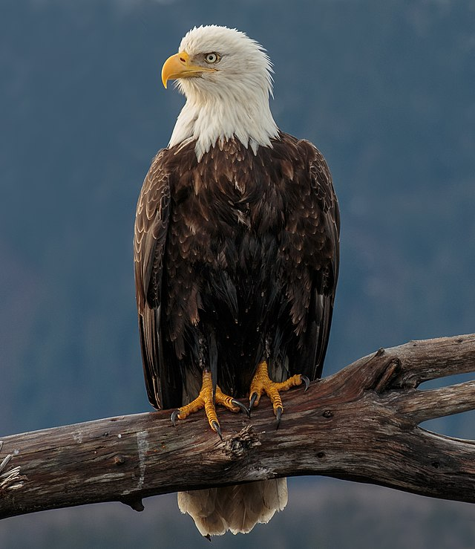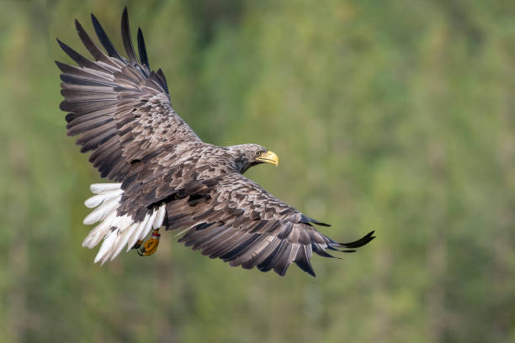

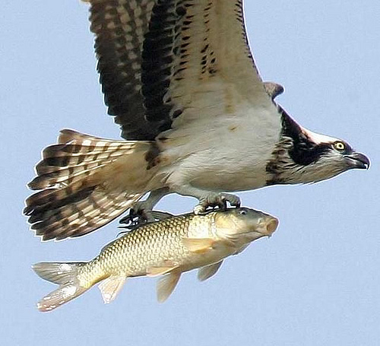 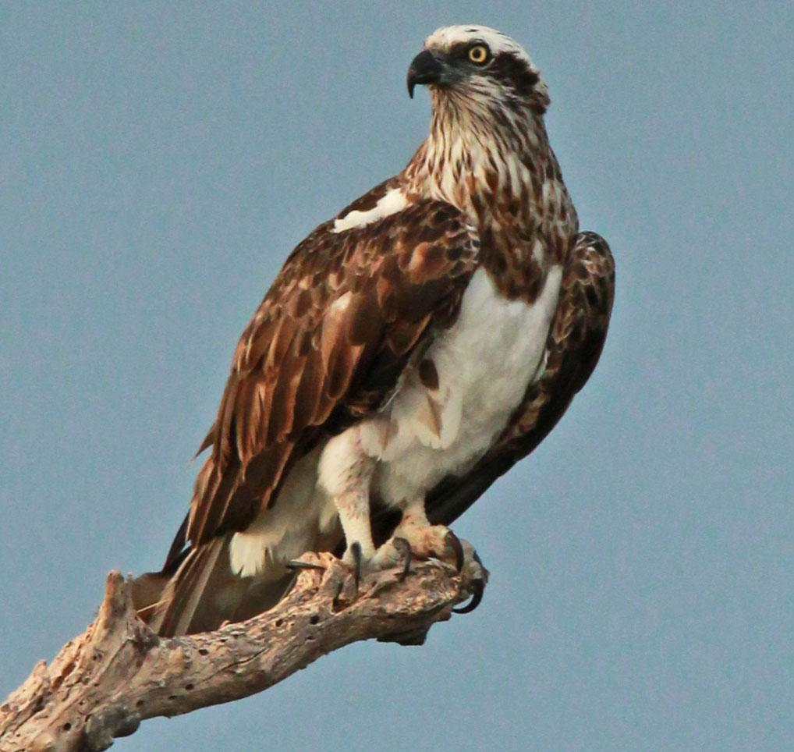

Figure 2 White tailed eagle

Figure 3 Bald eagle

Figure 4 Fishing Eagle Figure 5 Osprey Eagle

Of all the eagle species that inhabit Zacatecas, golden eagles, bald eagles, and ospreys are among the most endangered species, mainly due to the deterioration and usurpation of their habitat by humans. Although efforts to protect the bald eagles and osprey eagles in Zacatecas have been developed through various conservation measures. One significant step taken was the implementation of the Bald and Golden Eagle Protection Act by the government in the 1940s, which aimed to prohibit people from disturbing bald eagles and shooting them [13]. As well, conservation efforts have focused on addressing the effects of pesticides on the population. The use of pesticides seriously endangered the bald eagles between 1946 and 1973, but since then, steps have been taken to ban harmful substances like DDT and protect their nesting areas, leading to a recovery in the bald eagle population [15]. Conservation initiatives have also considered the habitat needs of these eagles. Potential habitat for the bald eagle includes open water lakes and reservoirs, as well as shorelines, which have been identified as important areas for conservation efforts [14]. Furthermore, research published in The Journal of Raptor Research provides valuable insights into the biology and conservation of diurnal and nocturnal raptors, including eagles. This knowledge contributes to understanding their ecology, behavior, and effective conservation strategies [15]. Through these combined efforts, conservationists are working towards ensuring the protection and preservation of the bald eagles and osprey eagles in Zacatecas, Mexico.

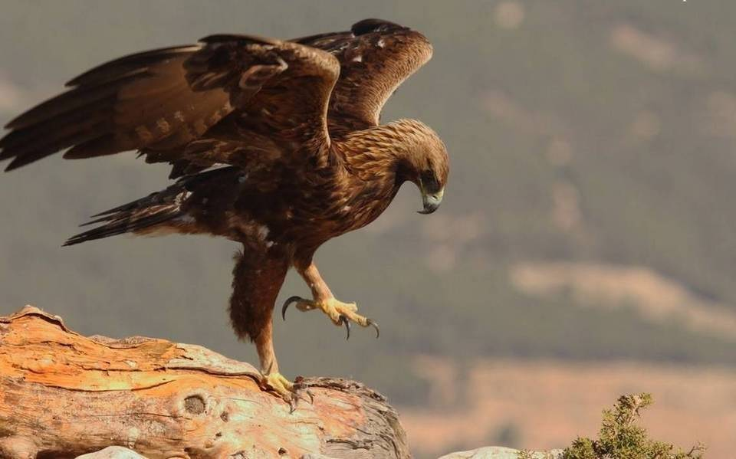

Figure 6 Golden Eagle

Further research is needed to better understand the habitat preferences and breeding patterns of eagles in Zacatecas. Overall, ongoing research and conservation efforts contribute to our understanding and appreciation of these magnificent birds of prey in Zacatecas and beyond.

1. Methodology

The primary objective of this project is to employ a range of transfer learning models and assess their performance on a bird image classification dataset. The project aims to compare the effectiveness of different transfer learning models in accurately classifying bird species based on their images. The models selected for comparison include ResNet34, Inceptionv3 and MobileNet.

Transfer learning allows us to leverage the knowledge and pre-trained weights of these models, which have been trained on large-scale datasets like ImageNet, to enhance the accuracy and efficiency of classifying bird images. By employing transfer learning, we can take advantage of the well-established features learned by these models and adapt them to our specific task of bird classification.

ResNet34, Inceptionv3, and MobileNet are renowned convolutional neural network architectures that have demonstrated exceptional performance in various image recognition tasks. ResNet34 is part of the ResNet family, known for their ability to handle deep network architectures effectively. Similarly, Inceptionv3, with its advanced architecture and sophisticated feature extraction capabilities, has also achieved remarkable success in image classification tasks. Additionally, MobileNet, with its deeper structure, has demonstrated excellent performance in various image recognition and classification tasks.

Through this project, we aim to compare the performance of these transfer learning models by assessing their accuracy, precision, recall, and F1-score on the bird image classification dataset. Additionally, we will analyze their computational efficiency and resource requirements, considering factors such as model size and training time. The findings of this comparative study will provide valuable insights into the suitability of ResNet34, Inceptionv3, and MobileNet for bird image classification tasks and assist in determining the most appropriate model for this specific application.

* 1. Datasets

In this section, we describe the process of selecting, filtering, and generating a dataset specifically designed for image recognition of golden eagles, bald eagles, and osprey eagles in the Zacatecas region. The dataset was compiled to address the conservation concerns of these endangered bird species.

To obtain a relevant dataset, we conducted a thorough search on the internet, with a particular focus on platforms such as Kaggle [17][18][19]. Among the available datasets, three were identified that contained images of various bird species, including golden eagles, bald eagles, and ospreys. These three datasets were chosen for further analysis and refinement. From the collected datasets, we extracted only the images depicting golden eagles, bald eagles, and ospreys. This filtering step ensured that our dataset consisted solely of images relevant to the target bird species, reducing the chances of misclassification during the training and testing phases.

The dataset creation process involved the generation of three distinct sets of images: a training set, a testing set, and an additional set organized by eagle species for improved control.

The training set was created by randomly selecting many images from the filtered dataset. These images represented various poses, backgrounds, and lighting conditions to ensure diversity and enable the convolutional network model to generalize effectively.

For evaluation purposes, a separate testing set was generated. It consisted of a collection of images distinct from the training set, ensuring an unbiased evaluation of the trained model's performance. Similar to the training set, the testing set was randomly selected from the filtered dataset.

To enhance control and performance assessment, an additional set was generated, grouping the same images as the training set but organized by eagle species. This controlled species set allowed for focused analysis and evaluation of the model's ability to differentiate between golden eagles, bald eagles, and osprey eagles.

The dataset selection, filtering, and generation process ensured that our dataset was highly relevant to the target bird species and provided ample data for training, testing, and controlled evaluation. This dataset will serve as a valuable resource in supporting conservation efforts for these endangered bird species in the Zacatecas region.

* 1. Data Pre-processing

In this section, we outline the data pre-processing steps undertaken to prepare the selected dataset for image recognition of golden eagles, bald eagles, and osprey eagles. The pre-processing phase involved renaming the images based on their species and assigning identification numbers. Additionally, each image was saved in a CSV file, facilitating better control and utilization of the dataset with parameters including the image name and its corresponding species.

Once the datasets containing images of the target bird species were obtained, we initiated the pre-processing phase by implementing the following procedures:

1. Renaming Images:

Each image in the dataset was subjected to a renaming process to enhance organization and identification. The new name assigned to each image was based on the type of species it represented, followed by an identification number. This renaming scheme allowed for easy categorization and differentiation of images during subsequent data handling and analysis stages.

2. Saving Data in CSV Format:

To facilitate efficient control and utilization of the dataset, the pre-processed images were saved in a CSV (Comma-Separated Values) file. The CSV file served as a structured data format, containing information related to each image, such as its new given name and the species it belonged to, where for the golden eagles it was identified as 0, the bald eagles as 1 and the osprey eagles as the number 2. This file allowed for easy indexing and referencing during model training, evaluation, and further analysis.

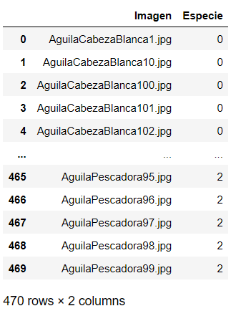

Figure 7 Dataset in CSV format. After manipulation and collection of all the pictures to process.

By implementing the data pre-processing steps we achieved improved organization, identification, and control over the dataset. Renaming the images based on species and assigning identification numbers enhanced the dataset's structure, enabling effective handling and tracking of individual images. Moreover, saving the pre-processed data in a CSV file facilitated streamlined access to image information, ensuring efficient parameterization for subsequent stages of model development and analysis.

* 1. Creation and implementation of learning models

In this section, we describe the process of creating and implementing learning models for the image recognition task of golden eagles, bald eagles, and osprey eagles. The implementation of the models followed relevant literature and involved loading the models and necessary datasets, handling class imbalances, image transformations, as well as adjusting layers and features for each model. Additionally, for the ResNet and Inception models, a dataset function was created to recover images based on the indicated weights.

1. Model Implementation and Dataset Loading:

The implementation of each learning model was guided by the literature specific to that model. The necessary models and datasets, predominantly for training purposes, were loaded accordingly. The datasets were obtained from the pre-processed images, ensuring a representative distribution of the target bird species.

2. Handling Class Imbalances:

To ensure effective learning, it was necessary to address any class imbalances in the training and testing datasets. Calculation of weights was performed to balance the number of instances across all classes. This step aimed to prevent the models from being biased towards overrepresented classes and promoted balanced learning across all species.

3. Image Transformations:

For consistency and compatibility with the chosen models, the images were transformed according to the required specifications. The transformations included resizing the images to a dimension of 512 pixels by 512 pixels, normalization of pixel values, and conversion to tensors. These transformations standardized the input images, enabling the models to process them effectively.

4. Loading Training and Validation Images:

The training and validation images were loaded separately to facilitate the training process. This segregation ensured a clear distinction between the data used for model training and the data used for performance evaluation during validation.

5. Model Loading and Adjustments:

Each respective model was loaded, and necessary adjustments were made to the layers and features based on the literature and requirements of the specific model. This step ensured that the models were appropriately configured for the given image recognition task and the characteristics of the target bird species.

Dataset Function for ResNet and Inception Models:

For the ResNet and Inception models, a dataset function was created to recover the images based on the indicated weights. This function facilitated the retrieval of images according to their assigned weights, ensuring a balanced representation of classes during training and testing.

As we follow the literature specific to each model and implementing the necessary steps outlined above, we ensured the proper creation and implementation of learning models for the image recognition task. The loading of models and datasets, handling class imbalances, image transformations, and adjustments of layers and features were performed systematically, providing a solid foundation for subsequent training and evaluation phases.

* 1. Training

In this section, we outline the training process for the implemented learning models in the image recognition task of golden eagles, bald eagles, and osprey eagles. The training function, optimizer, loss adjustment, and optimization parameters were adjusted to update model weights and achieve lower loss. The training process utilized the training dataset with a batch size of 32 elements and was executed for 50 training epochs.

1. Training Function and Weight Updates:

A training function was created to update the model weights based on the calculated loss. This function iteratively adjusted the model's parameters to optimize its performance in recognizing the target bird species. By continually updating the weights, the model learned to make accurate predictions.

2. Loss Adjustment:

The loss function was adjusted to account for the weights of the classes. This adjustment ensured that the model learned to give appropriate importance to each class, considering any imbalances or variations in the dataset. By adjusting the loss, the model was guided towards accurate classification of the target bird species.

3. Optimization and Learning Rate:

The training process utilized an optimizer with a learning rate of 0.001. The learning rate determined the step size at each iteration during optimization, influencing how quickly the model learned and how effectively it converged towards the optimal solution. The selected learning rate aimed to balance the speed of learning and the stability of the training process.

4. Training with Dataset:

The model was trained using the training dataset, which consisted of a representative collection of images from the target bird species. The training dataset provided the model with the necessary examples to learn the distinctive features and patterns associated with each species. Training with a diverse range of images promoted generalization and robustness in the model's ability to recognize the eagles accurately.

| **Models** | Validation Loss | Accuracy on Validation set | Number of items validated |
| --- | --- | --- | --- |
| Resnet-34 | 1.029040 | 85.674% | 40 / 47 |
| Inceptionv3 | 1.012834 | 93.617% | 44 / 47 |
| MobileNet | 1.033308 | 78.234% | 37 / 47 |

Figure 8 Number of training elements per species. Quantity of images used of each species for training.

5. Batch Size and Training Epochs:

During training, a batch size of 32 elements was used. The batch size determined the number of images processed at once during each iteration of the training process. This approach allowed for efficient memory usage and parallelization. Additionally, the training was performed for 50 training epochs, signifying the number of complete passes through the training dataset. Multiple epochs enabled the model to refine its weights and improve its predictive performance over time.

By employing the training function, optimizing with appropriate learning rate, adjusting the loss, and utilizing the training dataset with specified batch size and training epochs, the learning models were trained to recognize golden eagles, bald eagles, and osprey eagles effectively.

* 1. Clasification

In this section, we describe the classification process for the trained models in the image recognition task of golden eagles, bald eagles, and osprey eagles. The trained models are saved, reloaded, and configured for validation. Test images are classified using the models, and the results are evaluated to determine the accuracy of each model.

1. Saving and Reloading the Trained Model:

Once the models are trained, they are saved to preserve the learned weights and configurations. The saved models can be reloaded later for evaluation and classification purposes. Reloading the models ensures that they are in the same state as they were after the training phase.

2. Validation and Configuration:

The reloaded models are configured for the validation phase. This includes setting up the necessary functions and parameters required for evaluating the performance of the models on unseen data. Validation helps assess the generalization capability of the models and identifies any potential issues or areas for improvement.

TABLE III VALIDATION RESULTS FOR EACH MODEL. SHOWS THE LOSS AND ACCURACY RESULT OF THE VALIDATION FOR EACH MODEL, AS IT WAS USED 47 (10%) IMAGES

3. Classification of Test Images:

The trained and validated models are utilized to classify the test images. Each test image is input into the respective model, and the model predicts the class label for that image. The classification process assigns a new class to each test image based on the model's predictions.

4. Checking Correct Classification:

After the test images are classified, the results are checked to determine whether each image was classified correctly or not. A comparison is made between the predicted class labels and the ground truth labels of the test images. This step helps evaluate the accuracy of the models in correctly identifying the bird species.

5. Accuracy Calculation:

The accuracy percentage of each model is calculated based on the correct classifications. The total number of correctly classified test images is divided by the total number of test images, yielding the accuracy percentage. This metric provides an indication of how well the models perform in recognizing golden eagles, bald eagles, and osprey eagles.

By saving, reloading, and configuring the trained models, followed by classifying the test images and calculating the accuracy percentage, the performance of each model in accurately identifying the bird species is evaluated.

1. Results

In this section, we present the results obtained from the classification process and evaluate the performance of the ResNet, Inception, and MobileNet models in recognizing golden eagles, bald eagles, and osprey eagles. The accuracy percentages achieved by each model were as follows: ResNet - 85.674%, Inception - 93.617%, and MobileNet - 78.234%. Based on these results, we can draw conclusions regarding the methodology used and the selection of the best model.

The accuracy percentages achieved by the ResNet, Inception, and MobileNet models demonstrate the effectiveness of all three models in identifying the target bird species. The Inception model achieved the highest accuracy of 93.617%, followed by the ResNet model with 85.674%, and the MobileNet model with 78.234%. These accuracy percentages provide a measure of the models' precision in correctly classifying the bird species.

TABLE IV. MODEL AND ACCURACIES. 620 IMAGES WERE USED TO TRAIN EACH MODEL, BASED ON WHICH THE ACCURACY WAS OBTAINED.

|  |  |
| --- | --- |
| **Model** | **Accuracy** |
| Inceptionv3 | 93.617% |
| ResNet34 | 85.674% |
| MobileNet | 78.234% |

Considering the methodology employed, it is evident that the implemented approach encompassed crucial steps such as dataset selection, filtering, and generation, data pre-processing, creation and implementation of learning models, training, and classification. Each step was designed with careful consideration to ensure optimal performance and accurate results.

The choice of the best model primarily relied on the precision or accuracy achieved. In this case, the Inception model exhibited the highest accuracy percentage, making it the most suitable model for the image recognition task of golden eagles, bald eagles, and osprey eagles. The Inception model demonstrated superior discriminative capabilities and robustness in distinguishing between the bird species.

Additionally, it is worth noting that all three models took a comparable amount of time to train and classify the test images, suggesting that the training process and computational requirements were reasonably similar for these models.

* 1. Demonstration of the models

TABLE V. EXAMPLE OF THE PERFORMANCE OF EACH MODEL. 2 IMAGES OF EACH SPECIE WERE USED WITH EVERY MODEL TO SHOW ITS PERFORMANCE. WHERE THE CLASS 0 IS BALD EAGLE, CLASS 1 IS GOLDEN EAGLE AND CLASS 2 IS OSPREY EAGLE

| **Image** | Model | Previous class | Predicted class | Correct |
| --- | --- | --- | --- | --- |
| AguilaCabezaBlanca1.jpg | resnet | 0 | 0 | Yes |
| inceptionv3 | 0 | 0 | Yes |
| mobilenet | 0 | 0 | Yes |
| AguilaCabezaBlanca10.jpg | resnet | 0 | 1 | No |
| inceptionv3 | 0 | 0 | Yes |
| mobilenet | 0 | 1 | No |
| AguilaReal1.jpg | resnet | 1 | 1 | Yes |
| inceptionv3 | 1 | 1 | Yes |
| mobilenet | 1 | 1 | Yes |
| AguilaReal10.jpg | resnet | 1 | 1 | Yes |
| inceptionv3 | 1 | 1 | Yes |
| mobilenet | 1 | 2 | No |
| AguilaPescadora1.jpg | resnet | 2 | 2 | Yes |
| inceptionv3 | 2 | 2 | Yes |
| mobilenet | 2 | 2 | Yes |
| AguilaPescadora10.jpg | resnet | 2 | 0 | No |
| inceptionv3 | 2 | 2 | Yes |
| mobilenet | 2 | 1 | No |

In conclusion, the methodology utilized in this study effectively addressed the image recognition task of golden eagles, bald eagles, and osprey eagles. The results obtained demonstrate the success of the implemented approach in achieving accurate classification. Based on the precision achieved, the Inception model was identified as the best model for this specific task. These findings contribute to the conservation efforts of these endangered bird species in the Zacatecas region, providing a reliable means of identifying and monitoring them.

1. Conclutions

In conclusion, this article has addressed the complete process of developing an image recognition system to identify golden eagles, bald eagles, and ospreys using convolutional neural network models. From the selection and creation of the dataset to the implementation of the learning models, various stages have been followed to achieve an effective and accurate system.

Regarding the dataset selection, thorough searches were conducted on platforms like Kaggle to find relevant datasets containing images of various bird species. After careful evaluation, three datasets were chosen that included images of golden eagles, bald eagles, and ospreys. These species were selected due to their presence in Zacatecas and their endangered status in the region.

Subsequently, a filtering process was carried out to extract only the images specifically representing the three target eagle species. This ensured that the dataset was highly relevant to the species of interest and reduced the chances of misclassifications during the training and testing phases.

The dataset generation involved creating three distinct sets of images: a training set, a testing set, and an additional set organized by eagle species. The training set included randomly and impartially selected images, representing various poses, backgrounds, and lighting conditions. This allowed the convolutional neural network model to effectively learn and generalize.

The testing set, separated from the training set, was used to evaluate the performance and accuracy of the trained model. These images were also randomly selected from the filtered dataset to obtain a representative sample and avoid biases in the evaluation.

To improve model control and evaluation, an additional set was generated where images were grouped by eagle species. This allowed for focused analysis and accurate evaluation of the model's ability to differentiate between golden eagles, bald eagles, and ospreys.

Regarding data preprocessing, several stages were undertaken to ensure consistency and compatibility with the selected models. The images were renamed according to the species and assigned an identification number. Additionally, they were saved in a CSV file for better control and use, with parameters including the image name and the corresponding species.

In the section on creating and implementing learning models, the guidelines from the relevant literature for each model were followed. The models and necessary datasets were loaded, and adjustments were made to the layers and features of each model. Class imbalances were addressed by assigning weights to ensure balanced learning. Furthermore, transformations were applied to the images, such as resizing to 512 pixels by 512 pixels, normalization, and conversion to tensors. For the ResNet and Inception models, a dataset function was created to retrieve images based on the specified weights, allowing for balanced class representation during training and testing.

1. Future Work

The proposed project involves the development of a bird sampling system in the city of Zacatecas, which will utilize a cell phone camera to identify the characteristics of birds captured by the user. The main objective of this project is to improve the bird inventory system used by biologists by providing an easy and accessible tool for the identification and data collection of birds present in the city.

The proposed system will work by employing image processing and machine learning techniques. When the user points the cell phone camera at a particular bird, the application will utilize pattern recognition algorithms to identify the bird species and gather relevant data about its size, shape, coloration, among other aspects. This data will be stored in a database and made available for further analysis by biologists.

The application will also feature a user-friendly and intuitive interface that allows the user to record the location and time of the observation, as well as take additional notes on the behavior and habitat of the observed birds. Furthermore, there is consideration for integrating georeferencing functionality to obtain precise data on the birds' location and their relationship with the environment.

It is expected that this system will provide a valuable tool for the identification and monitoring of bird populations in the city of Zacatecas. Additionally, the data collection through this application is expected to enhance biologists' understanding of bird diversity in the city and their distribution patterns, which can greatly assist in making conservation decisions for these species and their habitats.

Bibliographic references

1. Comisión Nacional para el Conocimiento y Uso de la Biodiversidad. (2018). Evaluación del estado de conservación de las aves en México: hacia una política pública para su conservación. México: CONABIO. Recuperado de https://www.biodiversidad.gob.mx/pais/ape/estado_conservacion_aves.html
2. Chávez-León, G., Pérez-Ramírez, M., & Núñez-Pérez, E. (2018). Aves del estado de Zacatecas, México: patrones de riqueza, diversidad y conservación. Acta Universitaria, 28(2), 26-36.
3. Macías-Duarte, A., González-García, F., & Castro-Hernández, J. A. (2020). Composición, riqueza y diversidad de aves en bosques templados de la sierra de Álvarez, Zacatecas, México. Huitzil: Revista Mexicana de Ornitología, 21(2), 163-172.
4. Valdez-Gómez, J., Ríos-Muñoz, C., & Macías-Duarte, A. (2015). Aves del estado de Zacatecas, México. Revista de Biología Tropical, 63(1), 271-296.
5. Bello-Gutiérrez, J., Macías-Duarte, A., & Martínez-Meyer, E. (2014). Diversidad de aves en el estado de Zacatecas, México. Huitzil, 15(1), 15-25.
6. Pérez, R., Gutiérrez, E., & Escobar, F. (2018). A bird’s eye view: Combined use of drone and ground surveys for an efficient and accurate bird monitoring program. Ecological Informatics, 47, 30-35.
7. A. Navarro-Sigüenza, E. García-Trejo, G. Hernández-Alonso, A. Peterson, N. Pérez Valadez, and O. Rojas-Soto, "Aves. La biodiversidad en Zacatecas," 2020.
8. P. Huilgol, “Top 4 Pre-Trained Models for Image Classification | With Python Code,” Analytics Vidhya, Aug. 17, 2020. https://www.analyticsvidhya.com/blog/2020/08/top-4-pre-trained-models-for-image-classification-with-python-code/
9. Y. Yang et al., “A comparative analysis of eleven neural networks architectures for small datasets of lung images of COVID-19 patients toward improved clinical decisions,” Computers in Biology and Medicine, vol. 139, p. 104887, Dec. 2021, doi: https://doi.org/10.1016/j.compbiomed.2021.104887.
10. Naturalist, “Golden Eagle (Birds of Great Basin National Park) · iNaturalist,” iNaturalist. https://www.inaturalist.org/guide_taxa/401914
11. Audubon, “Golden Eagle,” Audubon, Nov. 13, 2014. https://www.audubon.org/field-guide/bird/golden-eagle
12. M. N. Kochert, K. Steenhof, C. L. McIntyre, and E. H. Craig, “Golden Eagle (Aquila chrysaetos),” The Birds of North America Online, Sep. 2020, doi: https://doi.org/10.2173/bna.goleag.02.
13. Audubon, “Osprey,” *Audubon*, Nov. 13, 2014. https://www.audubon.org/field-guide/bird/osprey
14. RODRGUEZ-ESTRELLA, RICARDO. (2002). A survey of Golden Eagles in northern Mexico in 1984 and recent records in central and southern Baja California peninsula. 36.
15. I. MoralesYañez, R. RodríguezEstrella, and A. GaticaColima, “Selección de sitios de anidación por el águila real Aquila chrysaetos (Linnaeus, 1758) (Accipitriformes: Accipitridae) en Janos, Chihuahua, México,” ACTA ZOOLÓGICA MEXICANA (N S ), vol. 39, pp. 15–28, Feb. 2023, doi: https://doi.org/10.21829/azm.2023.3912564.
16. B. Koonce and B. Koonce, “ResNet 34,” in Convolutional Neural Networks with Swift for Tensorflow: Image Recognition and Dataset Categorization, Berkeley, CA: Apress, 2021, pp. 51–61. doi: https://doi.org/10.1007/9781484261682_5.
17. Gerry, “BIRDS 400 - SPECIES IMAGE CLASSIFICATION,” www.kaggle.com, Apr. 30, 2023. https://www.kaggle.com/datasets/gpiosenka/100-bird-species
18. DMCGOW, “Birds 200,” www.kaggle.com, 2020. https://www.kaggle.com/datasets/dmcgow/birds-200?select=birds_train (accessed Jun. 30, 2023).
19. Kedar, “Bird Species Classification 200 Categories,” www.kaggle.com, Jun. 30, 2020. https://www.kaggle.com/datasets/kedarsai/bird-species-classification-220-categories (accessed Jun. 30, 2023).
20. C. Szegedy, V. Vanhoucke, S. Ioffe, and J. Shlens, “Rethinking the Inception Architecture for Computer Vision,” Dec. 2020.
21. Meena, G., Mohbey, K.K., Kumar, S. et al. Image-Based Sentiment Analysis Using InceptionV3 Transfer Learning Approach. SN COMPUT. SCI. 4, 242 (2023). <https://doi.org/10.1007/s42979-023-01695-3>
22. Alvarez-Alvarez, E. A., Rodríguez-Godínez, R., Sierra-Morales, P., Medina-Valdivia, S. A., Vázquez-Salgado, E., Brito-Millán, M., & Almazán-Núñez, R. C. (2020). Patterns of Bird Diversity and Endemism Along an Elevational Gradient in the Southern Mexican Highlands. Zoological Studies, 59. https://doi.org/10.6620/zs.2020.59-69