SADAMLS: Software Architecture for the Development of Adaptive Mobile Learning Systems
Abstract. Adaptive Mobile Learning Systems (AMLS) are software tools designed based on an adaptive learning paradigm in order to generate a personalized teaching-learning process for each student. This fact has motivated various works to propose AMLS; however, its development is often hindered by the poor quality of existing software architectures in terms of coverage and correctness of the desirable requirements to carry out adaptive learning. This work presents a layered software architecture for developing quality AMLS for teaching educational topics. The proposed software architecture was evaluated based on three main aspects: correctness and coverage of desirable requirements, validation and verification of the main elements of a reference architecture, and usability evaluation. The results show that our software architecture provides adequate architectural support for the development of AMLS.
Keywords: Mobile learning, adaptive learning, software architecture, architectural views
1 Introduction
The Internet has boosted the use of mobile devices in students' daily lives in recent years [1]. This fact has contributed to the development of diverse mobile systems in education [2]. These systems aim to create new teaching opportunities that allow students to improve their skills in an interactive and satisfying way [2]. In this context, adaptive mobile learning systems (AMLS) have emerged as an efficient alternative to complement the teaching-learning process. AMLS are software tools that provide students unique teaching experiences to personalize their teaching-learning process [3]. These systems have allowed students to increase interaction with educational resources through mobile devices anywhere and anytime [4,5]. Adaptive learning can be defined as the process of generating a unique learning experience for each student, considering the personality, interests, and performance of a student in order to have a better development of academic skills and more effective learning processes [6]. Diverse works [7-28] have proposed adaptive mobile learning systems with different characteristics and functionalities; however, these works do not consider all the desirable requirements to carry out adaptive learning. Another significant limitation of the proposed works [7-28] is that they lack a reference software architecture that considers the basic technical guidelines and serves as a solid framework for developers seeking to implement quality AMLS. The lack of a reference software architecture limits the implementation and adoption of AMLS proposed in related works in other contexts.
This work presents a reference software architecture called SADAMLS, which considers the desirable requirements for the development of adaptive mobile learning systems for teaching educational topics. The SADAMLS architecture provides a layered architectural style with the necessary components for information extraction, storage, processing, reasoning, providing adaptation services, security, among others. The methodology carried out in this work was divided into four phases: 1) SADAMLS Requirements, 2) SADAMLS Design, 3) SADAMLS Instantiation, and 4) SADAMLS Evaluation. In the first phase, the desirable requirements to be satisfied in AMLS were identified based on the analysis of twenty-two related works. Subsequently, in the second phase, the design of our software architecture was carried out based on the identified requirements. In this phase, four views of our software architecture were created: conceptual view, class view, component view, and deployment view to show a high-level representation of the organization and communication between each layer, modules, and components, and the physical and logical topology of the proposed software architecture. In the third phase, SADAMLS was instantiated based on the generated designs. In our case, a functional prototype of an AMLS was implemented, providing various services to students such as adaptation of the learning path, adaptation of content and format, and presentation of mobile learning objects according to the context and learning style of the student, among others. Finally, the evaluation of SADAMLS was carried out from three perspectives: i) Evaluation of the correctness and coverage of the requirements to verify that the SADAMLS design considers the desirable requirements, ii) Evaluation of SADAMLS applying the RAModel model [29] to validate and verify that the proposed software architecture meets all the main elements of infrastructure, domain, application, and cross-cutting components of a reference architecture, and iii) Usability evaluation of the AMLS developed in phase 3 based on the proposed software architecture in this work. Based on the obtained results, our software architecture is characterized by providing adequate architectural support for the development of AMLS with the required requirements and quality attributes.
2 SADAMLS: Proposed Software Architecture
This section presents a description of the desirable requirements, design, instantiation, and evaluation of the software architecture proposed in this work.
2.1 SADAMLS Requirements
Various desirable requirements that a reference software architecture must consider in its design to develop quality AMLS were identified based on an exhaustive review of various related works proposing AMLS conducted by our research group in [30]. The list of considered requirements is shown below:
- REQ1-Path adaptation.
- REQ2-Content adaptation.
- REQ3-Format adaptation.
- REQ4-Obtaining, managing, and using context information.
- REQ5-Obtaining, managing, and using student information.
- REQ6-Obtaining, managing, and using domain information.
- REQ7-Usability.
- REQ8-Generation of student history.
- REQ9- Generation of student profile.
- REQ10-Management of educational resources.
- REQ11-Management of technological resources.
- REQ12-Heterogeneity.
- REQ13-Robustness against disconnections.
- REQ14-Lightness.
- REQ15-Extensibility.
- REQ16-Modularity.
- REQ17-Ease of verification and maintenance.
2.2 SADAMLS Design
This section presents the design of the proposed software architecture from different views: conceptual view, module view, component view, and deployment view.

2.2.1 Conceptual View. In Fig. 1, the conceptual view of our layered software architecture for the development of adaptive mobile learning systems is presented. This software architecture proposal was designed based on the desirable requirements listed in section 2.2. Our software architecture is composed of eight layers: information acquisition, storage, AMLS model, adaptation, services, application, standards, and security. Below are described each of the layers that make up the proposed software architecture in this work.
Information Acquisition Layer: This layer is responsible for collecting context information from various physical and logical sources such as sensors or modules that obtain user information. This layer also carries out the conversion of the obtained data to a standard format by identifying characteristics and relationships between the data. This layer is composed of two modules:
- Extraction Module: This module was created to automatically extract information or through the user to be used in the sensor module of the layer. At this point, the adapters to be used through physical or logical sensors to obtain the information are implemented.
- Sensorization Module: The module is responsible for obtaining information from the adapters and activating or deactivating plugins to manage data extraction services. This module is composed of two components. The preprocessing component executes actions to convert the received data into a standard information format known by the layers and other systems. The classification component is used to separate the information into classes to identify the components suitable for storing and processing the obtained information.

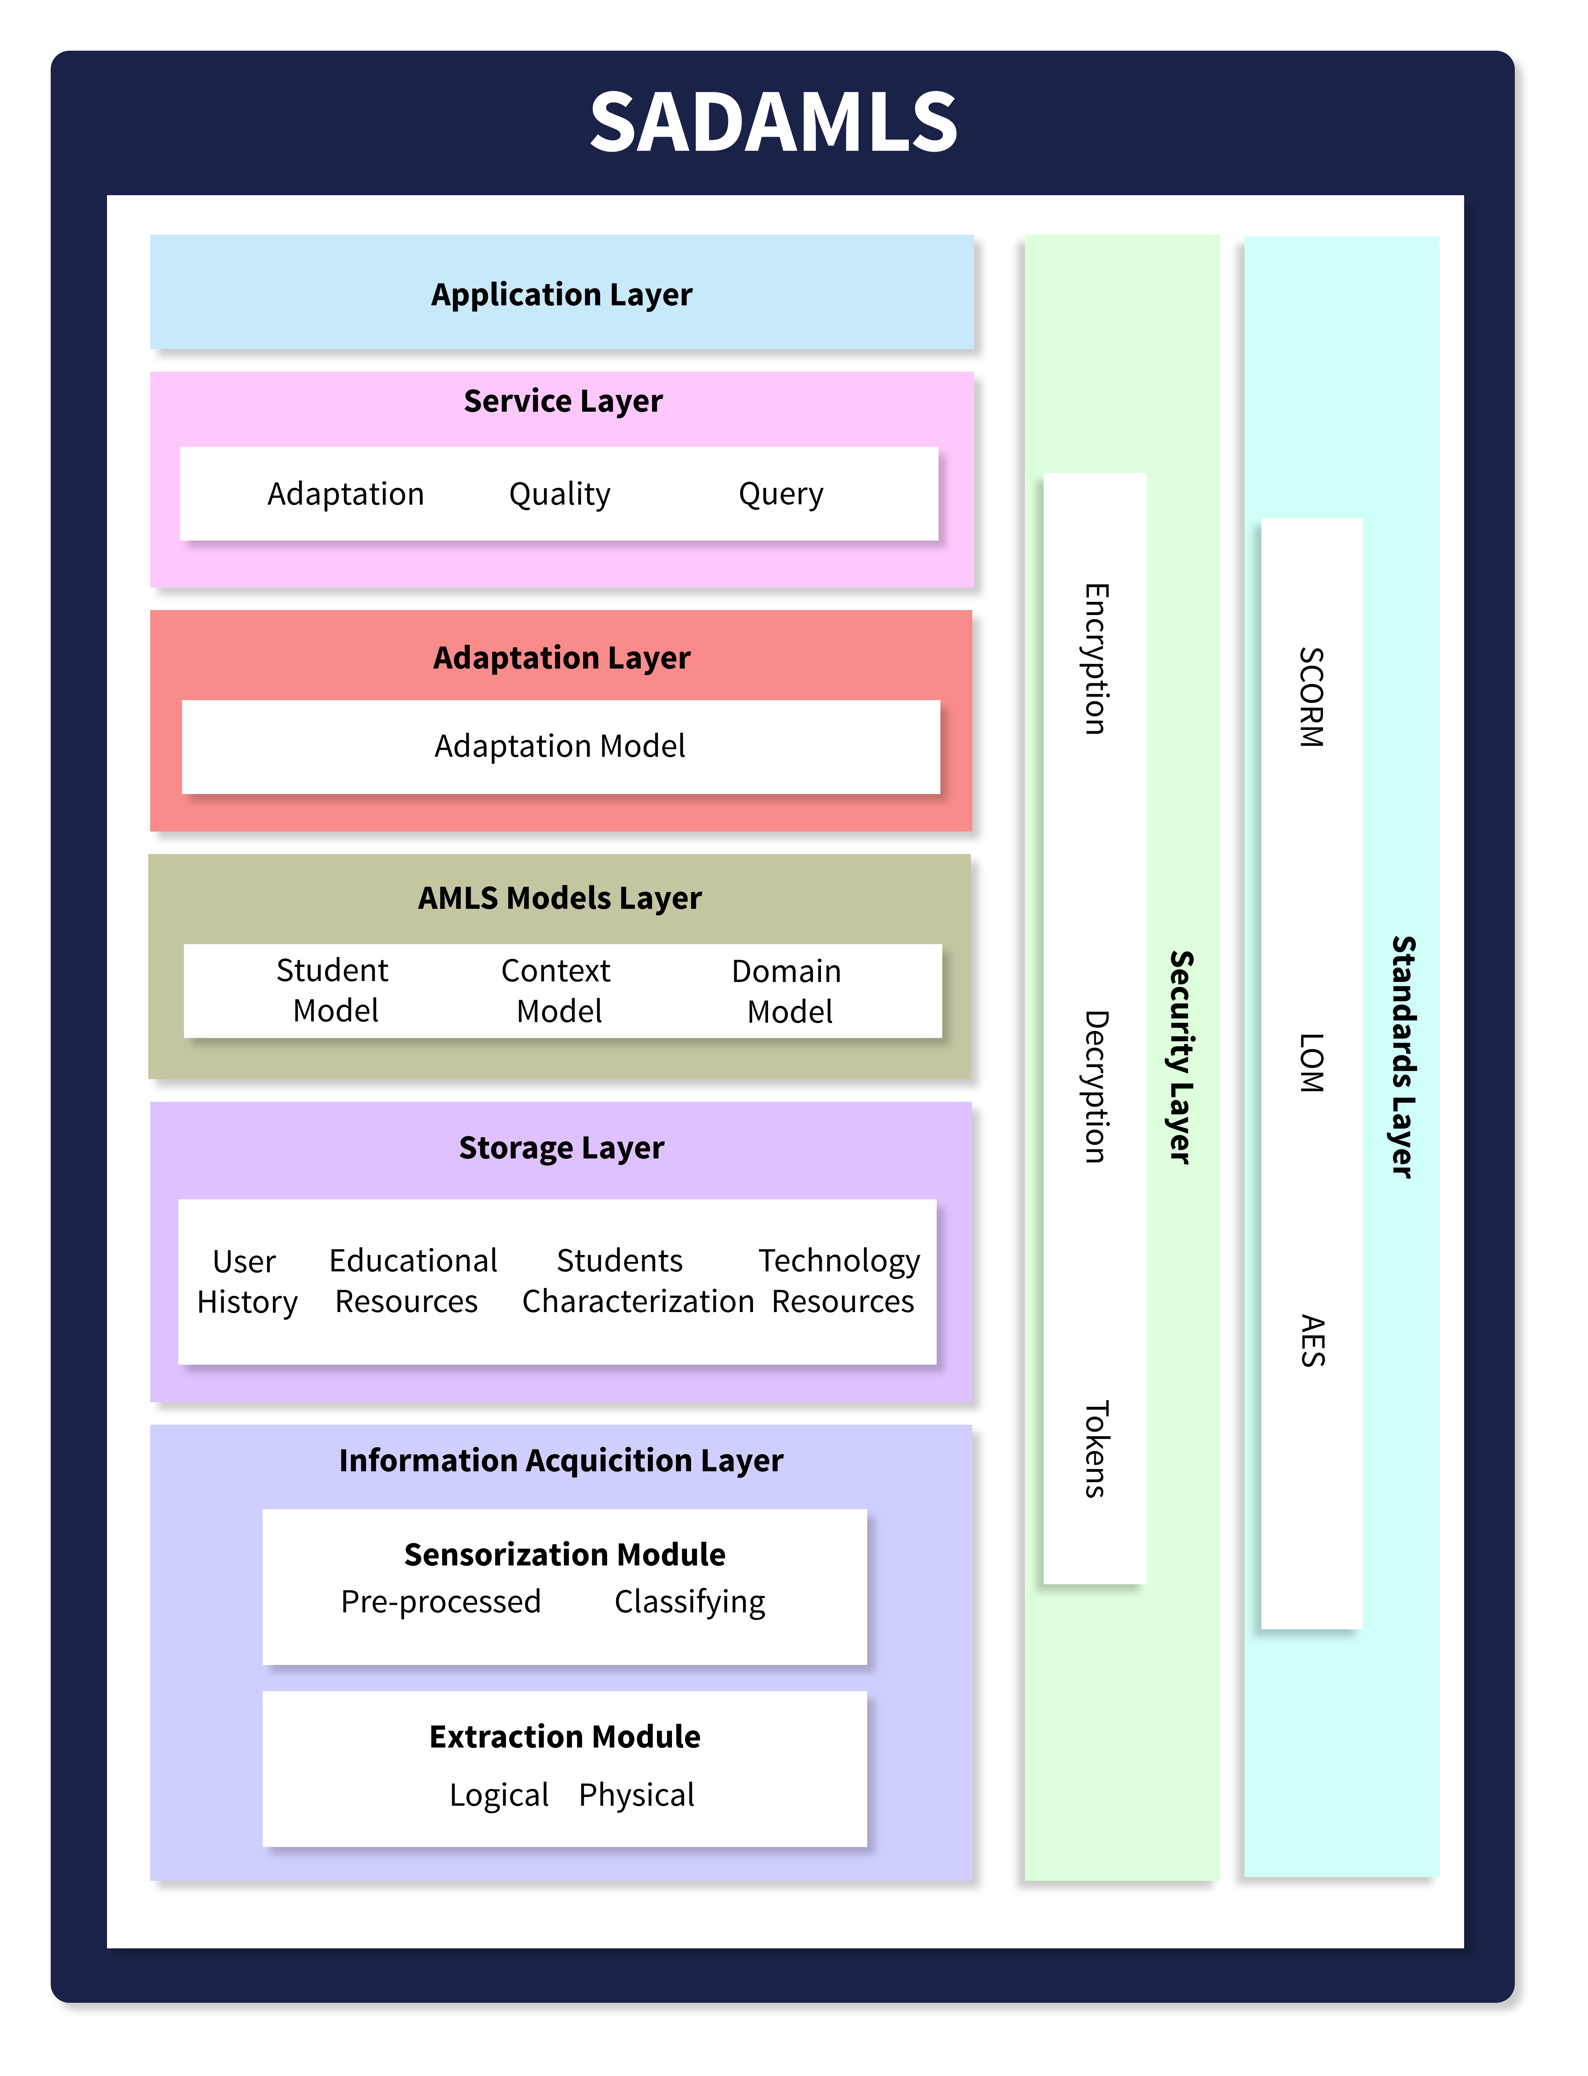
Fig. 1. Conceptual design of the SADAMLS software architecture.

Storage Layer: This layer focuses on storing the collected information, receiving data query requests, and storing information about the types of adaptations performed to be reusable in future functionalities or services. The components that make up this layer are:
- User History: This component generates a history of users with information about the types of adaptations performed, data that help improve the adaptations provided to the student or students with similar learning styles and objectives, among others.
- Educational Resources: Component that inserts and provides interactions, classifications, as well as the ordering of the units of a course available on the platform, which will be used to generate and retrieve a learning path.
- Student Characterization: The component stores user characteristics such as learning style, learning objectives, school levels, among others, to create the file used by the components to configure the student's learning.
- Technological Resources: This component stores information about the characteristics of mobile devices used to access the system to personalize different types of adaptations.
AMLS Models Layer: The objective of this layer is to model and process all the student, context, and domain information collected in the previous layers to provide the adaptation engine with the necessary data to generate a type of adaptation of path, content, and format. The components that make up this layer are:
- Student Model: This component models and processes student information such as personal data, learning style, interactions with the system in real-time or historically, among other aspects.
- Context Model: Component responsible for modeling and processing context information to be used in various scenarios to characterize the environment where the student is immersed.
- Domain Model: Component responsible for modeling and processing the system's domain information to generate structured information about educational materials, courses, tutorials, examples, exams, among others.
Adaptation Layer: This layer carries out content, format, and path adaptation services based on the information obtained from the AMLS Models layer. This layer has the following component:
- Adaptation Model: This component processes the information collected by the student, context, and domain models to generate the appropriate format, content, and path adaptation services for each student.
Services Layer: This layer is a request handler for the adaptation services available at the system's execution time. This layer is composed of three main components:
- Adaptation: This component returns the available types of adaptation based on the context found and the characteristics identified throughout the layers.
- Quality: This component determines the quality of the resources in terms of device capabilities, available educational resources, means of communication of the requests, among others, that will support the services.
- Query: This component collects information on adaptation services that are available in real-time.
Application Layer: This layer displays the relevant information of the requested services to the user based on interactive graphical user interfaces, such as course lists, learning paths, OAM lists, adapted content and format of an OAM, among others.
Standards Layer: This layer uses standards for managing the metadata of educational resources [31]. The components that make up this layer are:
- Sharable Courseware Object Reference Model (SCORM): This is a standard specified by ADL (Advanced Distributed Learning) which serves as a guide for defining the structure of the learning object, its packaging, and distribution.
- Learning Object Metadata (LOM): The LOM standard defined by IEEE is used for defining descriptions of a learning object, providing simple identification of resources when published.
Security Layer: This layer provides various security mechanisms aimed at ensuring the confidentiality, integrity, and availability of system information [32], [33].

2.2.2 Class Diagram. The class diagram of the software architecture proposed in this study is shown in Fig. 2. The design of the components that make up the architecture implements S.O.L.I.D principles [34] to create reusable and maintainable code.

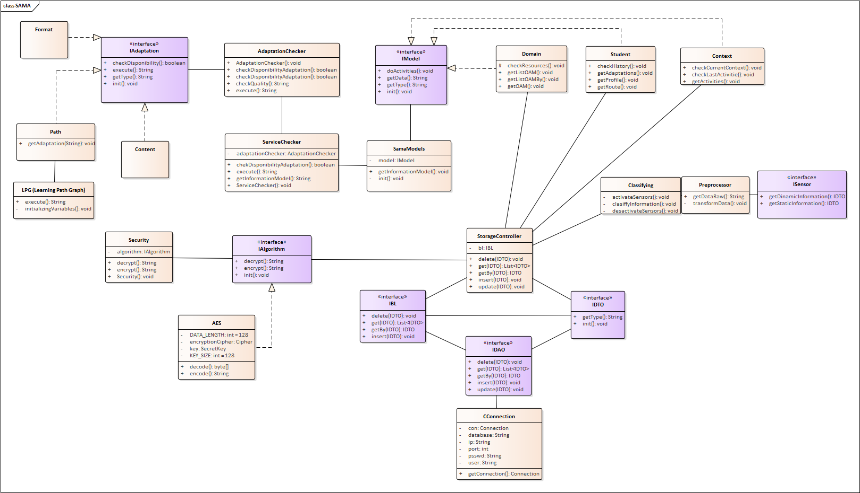
Fig. 2. Class Diagram of SADAMLS
The main classes are described below:
- Context: This class implements mechanisms and operations to carry out the context processing and determine various types of user environments.
- Student: This class implements methods that can provide information corresponding to the user's profile to identify a user profile for use in the adaptation services.
- Domain: This component is responsible for processing and obtaining information on the hierarchy of educational resources that will be shared in the system.
- SamaModels: This class seeks to implement functionalities to serve as an intermediary between components and control requests from the architecture models.
- ServiceChecker: This component is responsible for reviewing and processing requests to the models to determine availability, return information, and more.
- AdaptationChecker: This class is responsible for checking the types or adaptation services implemented in the system where fundamental methods can be invoked to obtain the adapted information.
- Format: This class represents and contains the necessary methods to implement a format adaptation.
- Path: Methods are implemented to perform path adaptation using adaptation algorithms such as LPG.
- LPG (Learning Path Graph): This class represents the methods used by the LPG algorithm to perform path adaptation.
- Content: In this class, methods are implemented to perform content adaptation.

2.2.3 Component View. Fig. 3 shows the component diagram of the proposed software architecture for building AMLS. This diagram illustrates the communication between internal components when receiving a request.

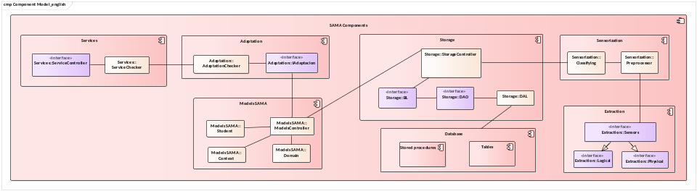
Fig. 3. Component Diagram of SADAMLS
The main components of each layer are described below:
- ServiceController: This consists of defining an interface so that different classes of services can be defined.
- ServiceChecker: This component's main activity is to act as a request handler. This class is responsible for identifying the type of request to redirect it to the appropriate component to provide the requested service.
- AdaptationChecker: This component defines functionalities to execute the type of adaptation required according to the incoming request. In this context, it validates that the components to provide a route, format, or content adaptation service are implemented.
- ModelController: This component is responsible for collecting and returning the necessary information to perform some type of adaptation. The component identifies the required models to obtain the information so that it is redirected to the adaptation engine.
- StorageController: This component acts as an intermediary between requests and database queries. The component identifies the type of incoming request to redirect it to the corresponding class.

2.2.4 Deployment View. Our work extends the Kaanbal learning platform presented in [35] by integrating the proposed software architecture in this work into both tiers of the platform, see Fig. 4. Kaanbal consists of a mobile learning object repository (ROA) that receives and processes user requests from students and teachers and communicates with the database server to store data. The ROA provides various services to teachers to manage learning objects and track their students. The Kaanbal platform also includes a mobile application called PLAAM that students use to interact with mobile learning objects stored in the ROA. The deployment diagram of the Kaanbal platform with the integration of the proposed software architecture in this work is shown in Fig. 4. In the server tier, the ComponentsSAMA module was integrated. This module contains the required layers and components of the proposed software architecture in this work to perform path, content, and format adaptation services in Kaanbal. On the other hand, in the mobile server tier, we also integrated the ComponentsSAMA module with the implementation of the required layers and components in this tier to carry out the respective adaptation services. In this tier, the mobile application communicates with the ComponentsSAMA to provide path, content, and format adaptation services to students.

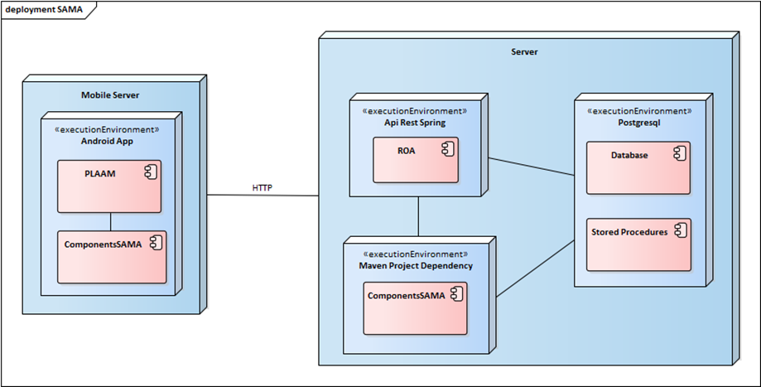
Fig. 4. Deployment Diagram of the Proposed Architecture.
2.3 Instantiation of SADAMLS
The implemented layers and components of the proposed software architecture in this work were integrated into the Kaanbal mobile learning platform proposed in [35] to generate a prototype of an adaptive mobile learning system. Below, the adaptation services provided in Kaanbal to students based on the implemented layers and components of the proposed software architecture in this work are described.

2.3.1 Integrated Adaptation Services in ROA. The ROA provides the teacher with various services such as managing mobile learning objects, checking student progress, among other services. In this system, unit management services, relationship management services, and OAM management services were added. These services allow for obtaining information for the configuration and execution of the LGP learning path adaptation algorithm proposed by Hamada [36], which is implemented in the ComponentsSAMA module. Below, one of the main services integrated into the ROA for the teacher for the configuration and execution of the LGP adaptation algorithm is described.

Relationship Management Service. In this service, the units with which a unit can be related are listed. Based on this service, the teacher can form immediate connections between the units of a course. This allows for configuring the execution of the LGP learning path adaptation algorithm. This service provides the LGP algorithm with information to generate a graph of the connections a course has and consequently define the learning paths for a student.

2.3.2 Integrated Adaptation Services in PLAAM. This section describes the adaptation services provided to students through the PLAAM mobile application and the ROA.
Learning Path Adaptation Service for Course Units. When a student selects a course in their mobile application, this service will present an adapted learning path of the course units based on their context, profile, level of studies, learning style, prior knowledge of the course, among other aspects, see Fig. 5. To achieve this, the mobile application makes a request to the learning path adaptation service of the software architecture component integrated into the Kaanbal platform. This service will respond with a list of ordered course units that make up the adapted learning path for the student based on the information provided by the student, domain, and context models of the model layer of the architecture proposed in this work. The learning path adaptation service, based on a modified version of the LPG algorithm [36] for this work, generates a graph to identify the shortest path among all the course units. Subsequently, this service presents to the student in the mobile application the units that make up the appropriate learning path based on the student's information, domain, and context.
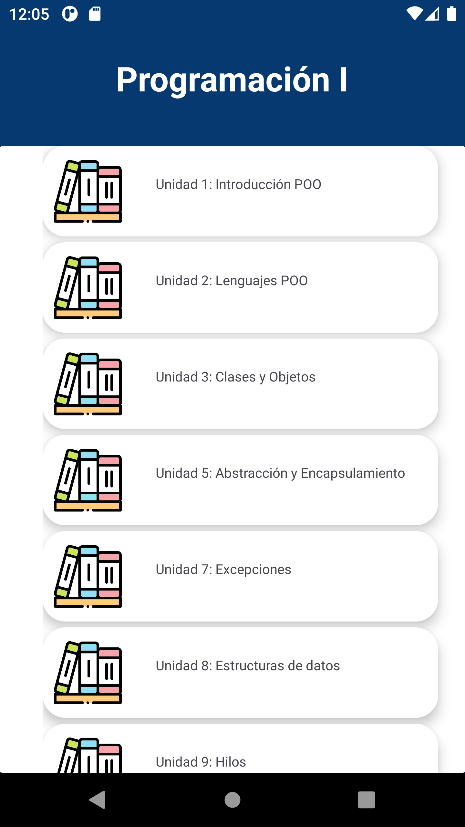
Fig. 5. Adapted learning path of the units presented to the student user based on the information provided by the student, domain, and context models of the proposed software architecture.

Learning Path and Content Adaptation Service for OAMs of Units. In this service, when the student selects a unit from the learning path shown by the mobile application, they are presented with an adapted learning path and content integrated by OAMs that best suit their learning needs and characteristics (see Fig. 6). In this case, the application makes a request to query the OAMs belonging to the unit. The adaptation layer of the proposed software architecture is responsible for querying the user's profile to select the OAMs that match their characteristics and preferences, to present a list of educational resources adapted to the student based on the information provided by the student, domain, and context models.
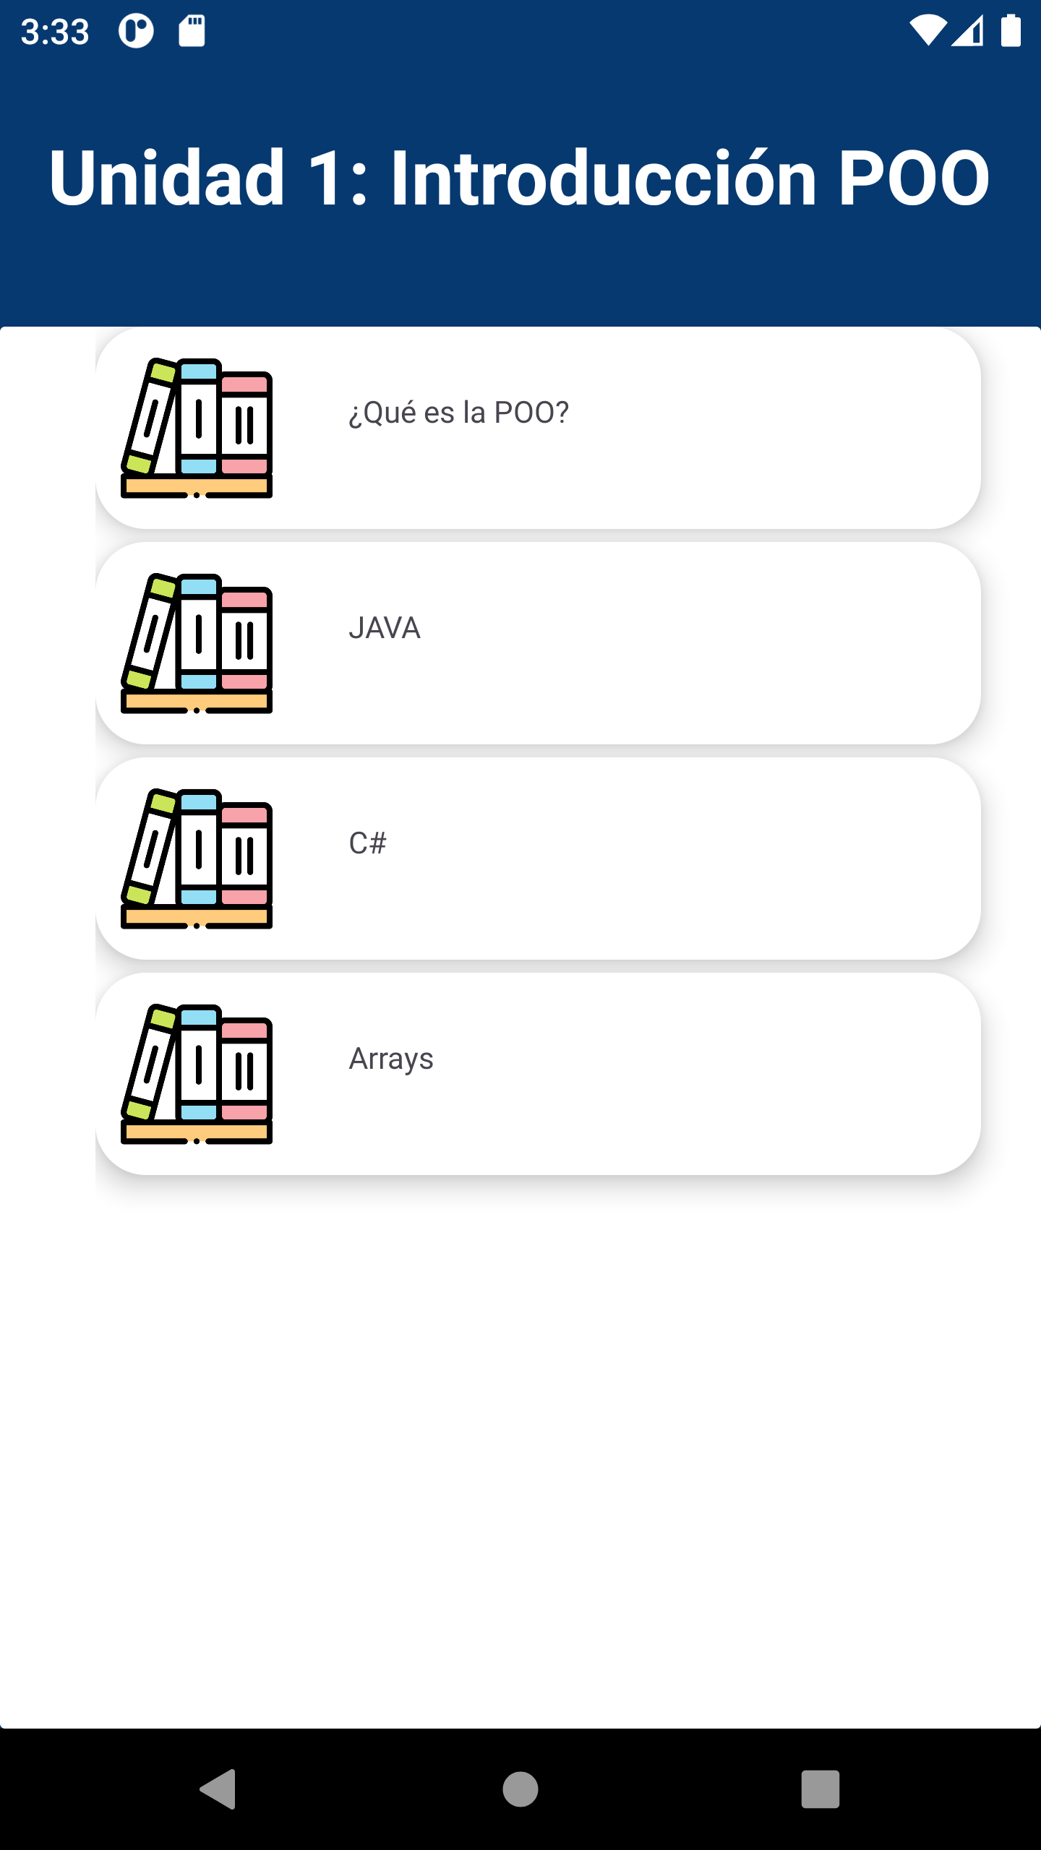
Fig. 6. List of OAMs.

OAM Query and Format Adaptation Services. In this service, the OAM is adapted to the hardware and software characteristics of the mobile device used by the student to take advantage of the device's resources and display the OAM information properly.
2.4 SADAMLS Evaluation
This section describes the three evaluation approaches carried out on the proposed software architecture in this work.

2.4.1 Critical Design Evaluation of the Proposed Software Architecture. The verification of the desirable requirements for the design of AMLS described in section 2.2 is detailed in this section. The requirements considered/attended to in the design of the proposed software architecture in this work are described below according to the proposed layers. The information acquisition layer was designed to consider requirements REQ4 and REQ10. In the storage layer, requirements REQ5, REQ6, REQ7, and REQ8 were mapped. The AMLS model layer was created to address REQ5, REQ6, REQ7, REQ8, and REQ10. Requirements REQ1, REQ2, and REQ3 were mapped in the adaptation layer. The service layer was designed to consider REQ1, REQ2, REQ3, and REQ10. In the application layer, REQ9 was mapped. The standards layer was designed to meet REQ8 and REQ9. Finally, the security layer was designed to address REQ10. Based on this requirements verification, it is concluded that the proposed software architecture in this work meets all the necessary requirements, described in the specialized literature (see section 2.2), for the development of quality AMLS. The design of our SADAMLS software architecture is based on a layered architectural approach. This approach contributes to the identification and grouping of services in different layers, where each layer carries out a set of unique responsibilities. Our SADAMLS architecture in its design considers the S.O.L.I.D principles [34], which help ensure the components are modular, consistent, and have lower development and maintenance costs. Finally, in this work, we show that it is possible to develop an adaptive mobile learning system based on the proposed software architecture design with different architectural views (conceptual view, module view, component view, and deployment view). Developers and research groups based on our software architecture will be able to develop AMLS with the required quality requirements and attributes.

2.4.2 Evaluation of the Proposed Software Architecture Based on the RAModel. The RAModel, proposed by Nakagawa [29], describes the elements and their relationships that a reference software architecture must have. RAModel defines four groups of elements: domain, application, infrastructure, and cross-cutting elements. Domain elements refer to aspects related to legislation, standards, and compliance. Application elements refer to the needs and capabilities of the software architecture. Infrastructure elements address aspects that allow building software applications based on the instantiation of the reference software architecture. Finally, cross-cutting elements extend across the domain, application, and infrastructure elements in terms of domain terminology, external communication, and internal communication. In our work, the evaluation of the proposed software architecture based on the RAModel was carried out using the checklist proposed in [29]. Regarding the domain elements, the proposed software architecture uses standards for structuring and describing the metadata of educational and technological resources, standards to ensure the security of the system's users' personal data, and the quality attributes considered are clearly defined. All domain group elements are considered in the design of the proposed reference software architecture in this work. Regarding the application elements, in this work, the requirements have been fully covered in the design of the proposed software architecture. The objectives, limitations, and scopes have been clearly defined for the proposed software architecture. No potential risks were identified in this domain. In the infrastructure elements, the proposed software architecture was designed and developed based on best practices. The architectural views of conceptual, modules, components, and deployment of the architecture are described in detail. Software and hardware are described in the deployment view and instantiation of the architecture. In the cross-cutting elements, the domain terminology has been included and the communication between the different layers and modules of the proposed software architecture is described. Based on the results obtained, the proposed software architecture meets the various elements that a reference software architecture must have.

2.4.3 Usability Evaluation of the Prototype Developed Based on SADAMLS. This section describes the usability evaluation of the prototype developed based on SADAMLS through a laboratory study. The usability evaluation focused on assessing the following services of the student mobile application: 1) Course query service, 2) Learning path adaptation service for course units, 3) Learning path and content adaptation service for OAMs of units, and 4) OAM query and format adaptation service. Five master's students in applied computing participated in this evaluation. In this case, the students were asked to perform various activities to interact with the learning path, content, and format adaptation services provided by the mobile application. Subsequently, and guided by the ISO/IEC 25022:2016 usability standard [37], the participants conducted a satisfaction evaluation of the adaptation services using the QUIS 7.0 questionnaire [38], [39]. This questionnaire consists of a set of questions classified into the following categories: a) General reaction to the software, b) System screens, c) Terminology and system information, d) Learning, e) System capabilities, and f) Usability of graphical user interface. In this questionnaire, each question is answered based on a Likert scale with conceptual levels of satisfaction ranging from 0 to 9, where 0 is the lowest level of satisfaction and 9 represents the highest level of satisfaction from the users' perspective. Based on the responses obtained, an average is calculated for each category of the questionnaire and then an overall average is calculated. This average is classified into one of the following acceptability ranges proposed in [40]:
0 ≤ Satisfaction ≤ 3: Not Satisfactory
4 ≤ Satisfaction ≤ 6: Acceptable
7 ≤ Satisfaction ≤ 9: Satisfactory
The results obtained in each category of the QUIZ 7.0 from the responses provided by the five students who participated in this usability evaluation are as follows:
- General reaction to the system: 8.47
- Screen: 8.55
- Terminology and system information: 8.27
- Learning capacity: 8.43
- System capabilities: 8.72
- Usability of graphical user interface: 8.64
To obtain the overall user satisfaction level, the following average is calculated:
Satisfaction = (8.47 + 8.55 + 8.27 + 8.43 + 8.72 + 8.64)/6 = 8.51 | ()
The average user satisfaction of students with respect to the evaluated adaptation services was 8.51. Therefore, the satisfaction level of the students is classified as satisfactory. In this evaluation, the median, standard deviation, and average were also calculated based on the results obtained, see Table 1. The results in this case show a positive trend in terms of satisfaction given the closeness between the mean and median values for the evaluated usability categories. Additionally, all values obtained in the standard deviations are less than 1, which shows consistent results across the 6 usability categories evaluated by the students. Therefore, the results generally show a satisfactory level of system usage from the students' point of view.
Table 1. Median, Average, and Standard Deviation of the Evaluated Categories of the QUIZ 7.0 Questionnaire
 | Global reaction to the system | Screen | Terminology and system information | Learning capacity | System capabilities | Usability of graphical user interface
Median | 8.50 | 8.75 | 8.33 | 8.33 | 8.80 | 8.60
Average | 8.47 | 8.55 | 8.27 | 8.43 | 8.72 | 8.64
Standard Deviation | 0.1826 | 0.4809 | 0.3028 | 0.2236 | 0.2280 | 0.2191

According to the analysis conducted in [41], the number of users who participated in our laboratory study likely allowed us to identify approximately 90% of the usability issues in the adaptation services provided to students by the system developed based on the proposed software architecture in this work.
3 Correctness and Coverage of Desirable Requirements in Related Works
This section presents a verification and comparison of the desirable requirements considered in software architectures aimed at the development of AMLS proposed in related works [7-28]. The twenty-two software architectures proposed in the related works cover the requirements of context acquisition and heterogeneity. The requirement for management of educational resources is considered by twenty software architectures proposed in related works ([7], [8], [9], [11], [12], [13], [14], [15], [16], [17], [18], [19], [20], [21], [22], [23], [24], [25], [26], [28]). The student profile requirement is covered by sixteen software architectures proposed in related works ([8], [9], [12], [13], [16], [17], [18], [19], [20], [21], [22], [23], [24], [25], [27], [28]). Related works in [7], [8], [10], [12], [18], [19], [21], [26], [27] consider the content adaptation requirement in the proposed software architectures. Specifically, the format adaptation requirement is considered in the software architectures proposed in [14], [17], [23]. The related work in [28] covers the learning path adaptation requirement. The software architectures described in [9], [15], [16], [20], [22], [24], [25] cover both content and format adaptation requirements. The work proposed in [11] presents a software architecture that addresses the learning path and content adaptation requirements. The software architecture proposed in [13] covers the path and format adaptation requirement. Usability and management of technological resources requirements are considered by ten ([7], [11], [12], [15], [16], [18], [20], [23], [24], [26]) and six ([8], [9], [10], [14], [17], [23]) software architectures proposed in related works, respectively. The student's learning history requirement is considered in three software architectures ([7], [8], [15]). It is noted that none of the proposed software architectures for the development of AMLS cover all the recommended requirements. The lack of attention to requirements in the proposed software architectures has led to suboptimal design decisions. In these cases, imprecise architectural design has led to lack of standardization and low quality of developed AMLS in terms of correctness and requirement coverage. Therefore, these works do not carry out adequate implementation of adaptive learning in the proposed systems. These limitations of proposed software architectures hinder effective and standardized development of quality AMLS.
4 Conclusions and Future Work
In this work, we presented a layered reference software architecture (SADAMLS) for the development of Adaptive Mobile Learning Systems for teaching educational topics. The design of our architecture was based on requirements derived from the analysis of services from related works published in specialized literature. The layers forming our reference software architecture are information acquisition, storage, AMLS models, adaptation, services, application, standards, and security. The evaluation of our architecture was carried out from three approaches. The first approach involved evaluating the correctness and coverage of requirements to verify that the design of SADAMLS meets the necessary requirements for adaptive learning in a distributed mobile system. The results of this evaluation showed that our software architecture stands out from related works by modeling all desirable requirements that an architecture focused on AMLS development must meet. The second approach carried out an evaluation of our software architecture applying the RAModel to validate and verify that our proposal meets all the main elements of infrastructure, domain, application, and cross-cutting components of a reference architecture. The results obtained in this case show that our software architecture proposal considers all the main elements described by the RAModel for reference architectures. The third approach evaluated the usability of a prototype of an AMLS developed based on the proposed reference software architecture in this work. The usability results from the perspective of the participating students showed a satisfactory level of usability. Therefore, our reference software architecture is characterized by providing suitable architectural support for the development of AMLSs with the required requirements and quality attributes. From our point of view, the most important advantages of our reference software architecture are as follows: a) defining the basic technical guidelines that an AMLS should possess; b) streamlining overall development by providing a solid and standardized framework to developers; and c) contributing to meeting the required requirements arising from the specific domain of AMLSs. As future work, we consider integrating artificial intelligence algorithms to improve the quality of the adaptation services for learning path, content, and format in terms of students' academic performance.
References
1. Unión Internacional de Telecomunicaciones, Organización de las Naciones Unidas, https://news.un.org/es/story/2023/12/1526712#:~:text=El%2078%25%20de%20la%20poblaci%C3%B3n,Internacional%20de%20Telecomunicaciones%20(UIT)
2. Pebriantika, L., Wibawa, B., Paristiowati, M.: Adoption of Mobile Learning: The Influence And Opportunities For Learning During The Covid-19 Pandemic. Int. J. Interact. Mob. Technol. 15(5), 222--230 (2021).
3. Mejeh, M., Rehm, M.: Taking adaptive learning in educational settings to the next level: Leveraging natural language processing for improved personalization. Educ. Tech. Res. Dev. 72, 1—25 (2024)
4. Ennouamani, S., Akharraz, L., Mahani, Z.: Integrating ICT in Education: An Adaptive Learning System Based on Users’ Context in Mobile Environments. In: ICBDSDE: International Conference on Big Data and Smart Digital Environment, pp. 15--19. Springer: Cham, Switzerland (2019).
5. Pugliese, L.: Adaptive Learning Systems: Surviving the Storm, EDUCAUSE Review. (2016) https://er.educause.edu/articles/2016/10/adaptive-learning-systems-surviving-the-storm
6. Van-Rosmalen, P., Vogten, H., Van-Es, R., Passier, H., Poelmans, P., Koper, R.: Authoring a full life cycle model in standards based adaptive elearning. J. Educ. Technol. Soc. 9(1), 72--83 (2006).
7. Yao, C.B.: Constructing a user-friendly and smart ubiquitous personalized learning environment by using a context-aware mechanism. IEEE Trans. Learn. Technol. 10, 104--114 (2017).
8. Baccari, S., Neji, M.: Design for a context-aware and collaborative mobile learning system. In: 2016 IEEE International Conference on Computational Intelligence and Computing Research (ICCIC), pp. 1—6. IEEE press, New York (2016).
9. Gomez, S.; Zervas, P.; Sampson, D.G.; Fabregat, R. Delivering adaptive and context-aware educational scenarios via mobile devices. In Proceedings of the 2012 IEEE 12th International Conference on Advanced Learning Technologies, Rome, Italy, 4–6 July 2012; IEEE: New York, NY, USA; pp. 197–201.
10. Zhang, B., Yin, C., David, B., Chalon, R., Xiong, Z.: A framework of context-aware mobile learning system for professionals. In 2013 IEEE 13th International Conference on Advanced Learning Technologies, pp. 23--25. IEEE press, New York (2013).
11. Nguyen, V.A., Pham, V.C.: CAMLES: An adaptive mobile learning system to assist student in language learning. In 2012 IEEE Seventh International Conference on Wireless, Mobile and Ubiquitous Technology in Education, pp. 72–76, IEEE press, New York (2012).
12. Maqsood, S., Shahid, A., Nazar, F., Asif, M., Ahmad, M., Mazzara, M.: C-POS: A context-aware adaptive part-of-speech language learning framework. IEEE Access. 8, 30720–30733 (2020).
13. Liu, X., Du, Y., Sun, F., Zhai, L.: Design of adaptive learning system based on big data. In: 6th International Conference on Information Engineering, pp. 1--5, ACM, New York (2017).
14. Jalal, S.A., Gibbins, N., Millard, D., Al-Hashimi, B., Aljohani, N.R.: Energy-aware adaptation of educational multimedia in mobile learning. In: International Conference on Advances in Mobile Computing & Multimedia, pp. 434–439. ACM, New York (2013).
15. Nimkoompai, A., Paireekreng, W.: Dynamic UX based m-learning using user profile of learning style. In: 3rd International Conference on Communication and Information Processing, pp. 221--225. ACM, New York (2017).
16. Gómez, S., Zervas, P., Sampson, D.G., Fabregat, R.: Context-aware adaptive and personalized mobile learning delivery sup-ported by UoLmP. J. King Saud Univ.—Comput. Inf. Sci. 26, 47--61 (2014).
17. Chorfi, H.O., Sevkli, A.Z., Bousbahi, F.: Mobile learning adaption through a device based reasoning. Procedia—Soc. Behav. Sci. 47, 1707--1712 (2012).
18. Mosquera, D., Guevara, C., Aguilar, J.: Adaptive learning objects in the context of eco-connectivist communities using learning analytics. Heliyon. 5, e02722 (2019).
19. Louhab, F.E., Bahnasse, A., Talea, M.: Towards an adaptive formative assessment in context-aware mobile learning. Procedia Comput. Sci. 135, 441--448 (2018).
20. Ennouamani, S., Mahani, Z., Akharraz, L.: A context-aware mobile learning system for adapting learning content and format of presentation: Design, validation and evaluation. Educ. Inf. Technol. 25, 3919--3955 (2020).
21. Badidi, E., Atif, Y., Sheng, Q.Z., Maheswaran, M.: On personalized cloud service provisioning for mobile users using adaptive and context-aware service composition. Computing. 101, 291--318 (2019).
22. Benlamri, R., Zhang, X.: Context-aware recommender for mobile learners. Hum. Cent. Comput. Inf. Sci. 4, 12 (2014).
23. Louhab, F.E., Bahnasse, A., Talea, M.: Considering mobile device constraints and context-awareness in adaptive mobile learning for flipped classroom. Educ. Inf. Technol. 23, 2607--2632 (2018).
24. Huang, H.C., Wang, T.Y., Hsieh, F.M.: Constructing an adaptive mobile learning system for the support of personalized learning and device adaptation. Procedia—Soc. Behav. Sci. 64, 332--341 (2012).
25. Yin, C., Zhang, B., David, B., Xiong, Z.: A hierarchical ontology context model for work-based learning. Front. Comput. Sci. 9, 466--473 (2015).
26. Morales, R., Igler, B., Böhm, S., Chitchaipoka, P.: Context-aware mobile language learning. Procedia Comput. Sci. 56, 82--87 (2015).
27. Chen, W.: Knowledge-aware learning analytics for smart learning. Procedia Comput. Sci. 159, 1957--1965 (2019).
28. Alshalabi, I.A., Hamada, S.E., Elleithy, K.M., Badara, J.A., Moslehpour, S.: Automated adaptive mobile learning system using shortest path algorithm and learning style. Int. J. Interact. Mob. Technol. 12, 4--27 (2018).
29. Nakagawa, E., Oquendo, F., Becker, M.: RAModel: A Reference Model for Reference Architectures. In: 2012 Joint Working IEEE/IFIP Conference on Software Architecture and European Conference on Software Architecture, pp. 297--301. IEEE Press, New York (2012).
30. Ruiz-Nepomuceno, A., López-Domínguez. E., Domínguez-Isidro, S., Medina-Nieto, M.A., Meneses-Viveros, A., de-la-Calleja, J.: Software Architectures for Adaptive Mobile Learning Systems: A Systematic Literature Review. Applied Sciences. 14(11), 4540 (2024).
31. Prpitsch, C., Veith, P.: Content and management standards: LOM, SCORM and Content Packaging. In: Handbook on Quality and Standardisation in E-Learning. pp. 209-223. Springer, Berlin, Heidelberg (2006).
32. Korać, D., Damjanović, B., Simić, D.: Information Security in M-learning Systems: Challenges and Threats of Using Cookies. In 19th International Symposium INFOTEH-JAHORINA (INFOTEH), pp. 1-6. IEEE press, New York (2020).
33. Heron, S.: Advanced Encryption Standard (AES). Network Security. 2009, pp. 8--12 (2009)
34. Arora, G. K.: SOLID Principles Succinctly. Syncfusion, Inc., Morrisville, USA (2016)
35. Huerta-Guerrero, C., Lopez-Dominguez, E., Hernández-Velázquez, Y., Domínguez-Isidro, S., Cueto-García, A., De-la-Calleja, J., Medina-Nieto, M. A.: Kaanbal: A Mobile Learning Platform Focused on Monitoring and Customization of Learning. International Journal of Emerging Technologies in Learning (iJET), 16, pp. 18--43 (2021).
36. Alkore, I., Hamada, S., Badara, I., Moslehpour, S.: Automated Adaptive Learning using Smart Shortest Path Algorithm for Course Units. In: 2015 Long Island Systems, Applications and Technology, pp. 1—5, IEEE press, New York (2015).
37. ISO/IEC 25022:2016; Systems and Software Engineering—Systems and Software Quality Requirements and Evaluation (SQuaRE)—Measurement of Quality in Use. ISO: Geneva, Switzerland. https://www.iso.org/obp/ui#iso:std:iso-iec:25022:ed-1:v1:en.
38. Chin, J.P., Diehl, V.A., Norman, K.L.: Development of an instrument measuring user satisfaction of the human–computer interface. In: CHI 88 Conference Proceedings: Human Factors in Computing Systems, pp. 213–218. ACM Press, New York (1988)
39. Human-Computer Interaction Lab, http://www.cs.umd.edu/hcil/quis/
40. Jaspers, M.W.M., Steen, T., Van-Den-Bos, C., Geenen, M.: The think aloud method: A guide to user interface design. Int. J. Med. Inform. 73, 781--795 (2004).
41. NN/g Nielsen Norman Group, How Many Test Users in a Usability Study? https://www.nngroup.com/articles/how-many-test-users/

