Maturing an agile software development environment using ISO/IEC 29110 as a reference standard

Abstract. The use of agile methods in software development organizations is well-known. However, many projects fail to meet the required quality standards due to a lack of experience using it within agile approaches. Agile approaches should be strengthened with practices provided by software engineering standards to produce software products that meet the quality requirements. This fact can be a real challenge due to economic feasibility concerns and the lack of confidence. However, using international standards software development in an agile approach can improve in many aspects, such as better requirements management, change requests, and formalization of artifacts that provide value to customers or the team. Implementing ISO/IEC 29110 in agile environments can help Very Small Entities (VSEs) meet the market's quality requirements and ensure their software products meet customer expectations while improving their software engineering practices. This paper presents a case study of a VSE that successfully implemented the guide and offers practical advice and insights related to agile process improvement, including the challenges faced and lessons learned. The results show that the guide reinforces the agile approach and promotes a culture of continuous improvement.
Keywords: Agile software development, ISO/IEC 29110, software process improvement, guideline, Very Small Entities.
1 Introduction
Nowadays, agile methods are acquiring more attention from the software development market than other methodologies [1]. According to the 15th State of Agile Report [2], their use increased from 37% in 2020 to 86% in 2021.
This fact is more evident in Very Small Entities (VSEs), organizations with up to twenty-five people, because of their specific characteristics, such as continuous change in requirements, customer satisfaction, and product delivery frequency [1, 3].
In this context, it is necessary to provide them with practices that help VSEs improve their agile software development approach so that they can reap benefits such as cost reduction, failure reduction, increment in quality and productivity, and customer satisfaction.
Achieving improvement in the VSE development process is crucial; therefore, they need to use practices from international software engineering standards. However, implementing these practices is not easy, mainly because VSEs have personnel, time, and budget limitations for this type of activity [3].
This paper provides an analysis of how a VSE introduced a continuous improvement culture by using ISO/IEC 29110 to reinforce its agile software development approach.
Then, we analyzed the organizational processes of a VSE for two years. This organization has been improving its development approach following two steps: 1) adopting the best practices from an international standard using the guide, and 2) introducing software tools to automate the process execution.
After the introduction, this paper is structured as follows: Section 2 provides the background, including a brief description of the ISO/IEC 29110 standard, the Agile approach, and the guide to reinforce their agile method. Section 3 describes the analysis of the continuous improvement that the VSE has implemented. Section 4 discusses the challenges and lessons learned, and section 5 provides the conclusions.
2 Background
This section introduces two topics that are the basis of this research: ISO/IEC 29110 and agile methods. It also includes an overview of the guide used by the VSE to reinforce its agile environment.
2.1 ISO/IEC 29110
As an effort to provide Very Small Entities (VSEs) without experience in implementing internal software development standards, the WG24 of the ISO/IEC JTC1 SC7 created the ISO/IEC 29110 series of standards.
These series of standards provide a set of engineering standards for developing non-critical software products, gaining advantages in quality, development and delivery time, schedule, and budget [4][5].
Moreover, the standard is structured by profiles, which aim to provide a roadmap that VSEs can select according to their current environment and needs. The following list shows the profiles.
- Entry for those VSEs performing a six-person-month or startups.
- Basic for those VSEs performing one product by a team at a time.
Intermediate for those VSEs performing more than one project in parallel by more than one team, and
- Advanced for those VSEs that aim to sustain and grow as an independent and competitive system or software development products.
Through these profiles, the Project Management (PM) process and the Software Implementation (SI) process remain throughout the four software profiles.
The standard guides are structured based on process elements, i.e., objectives, activities, tasks, roles, and work products [4]. Thus, the standard pretends to provide a recipe for VSEs to implement processes even without experience.
2.2 Agile methods
According to the Agile Alliance, being agile is having the ability to create and respond to changes, in other words, this philosophy pretends to provide a way to deal with uncertain and turbulent environments [6].
As a development approach, agile software development focuses on developing software faster and incrementally. It uses the manifesto agile and its twelve principles as a base to produce satisfied customers [6].
To reduce the time from product conception to delivery, VSEs and SMEs prefer an agile approach to software development. This approach uses one-fourth-week iterations (in Scrum called sprints) to develop better quality software while dealing with the frequently changing requirements in the software project [2],[6],[7].
Besides, it is focused on people working and how they work together, promoting a project management process that encourages teamwork, organization, and self-responsibility [2],[6],[7].
According to studies [1],[2],[6],[7], Scrum is the most popular agile approach. According to the 15th state of agile [1], Organizations use derivations of Scrum (e.g., ScrumBan and Scrum/XP), and other less implemented agile methods are Iterative, Extreme Programming (XP), and Lean Startup.
2.3 Guide to implementing ISO/IEC 29110 (Basic profile) in an agile environment
In [8], the authors provide an overview of how a guide can help reinforce an agile software development approach using International Software Engineering Standard practices. The guide pretends to reduce the problems detected by a set of eight VSEs related to the project management and software implementation processes.
This guide aims to help VSEs who lack experience in implementing software engineering standards identify how they can match the activities provided by the international standard to their current environment without stopping being agile.
Fig. 1 shows an overview of the ISO/IEC 29110 basic profile process (e.g., project management and software implementation) to reinforce an agile environment.
As the figure shows, the guide keeps using the events of an agile approach, specifically Scrum, because it is the most used agile method. Then, using the Scrum events, the guide suggests practices and artifacts related to the activities of control version strategy, agreements, analysis of changes, verification and validation, and test results.
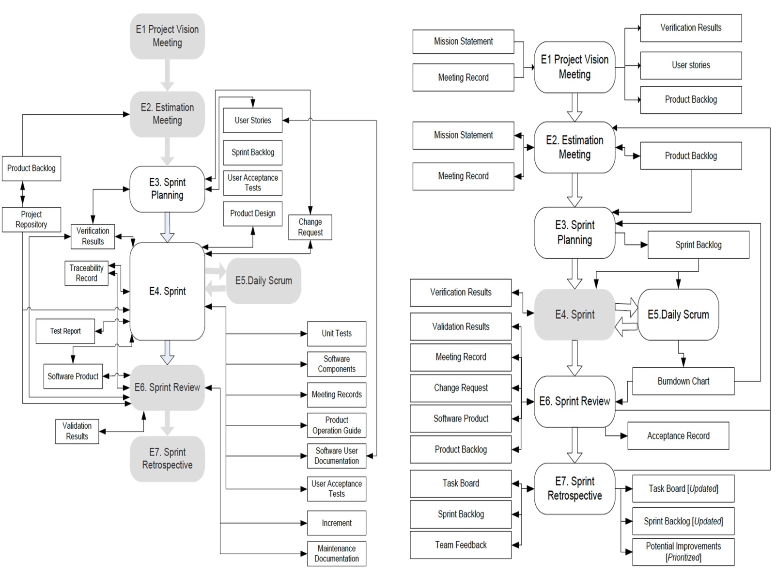
Fig. 1. Agile software development approach reinforced with ISO/IEC 29110 (adapted from [9])
2.4 Related works
Only one paper is related to implementing an agile guide with ISO29110. In [3], the authors provide a previous experience of reinforcing ISO/IEC 29110 in a VSE. This was the first time that the VSE implemented practices from an international standard. According to the results, the benefits detected after using the guide are: 1) The team got new benefits such as better estimation, project planning improvement, following the project progress, and reducing the rework. 2) The team was able to control all items involved in the software development projects, such as tasks, roles, components, events, and responsibilities, from the beginning of the project with the mission statement to the end with the acceptance record. 3) the team handles in a better way the association between roles and tasks. And 4) The Team was able to track the project execution in a better way using tools, techniques, and tactics.
However, the literature also mentions other applications related to Agile Software Development Methods and ISO/IEC 29110. It mentions Scrum +, which was designed using the Artificial Intelligence technique Means-Ends [10]; this solution aims to cover Scrum with the Entry Profile of the ISO/IEC 29110, which is a level down compared with the Basic. The level has fewer tasks, and nowadays, getting a certification at this level is impossible.
The authors of [11] proposed an experimental evaluation of Scrum+ EPG. This solution combines a reconciled agile rigorous software PM process of Scrum with the PM of the ISO/IEC 29110 Entry Profile. The results were about the different aspects considered that using the solution provides easier adoption and implementation. The objective of the case study was to reinforce their agile environment by using the agile guide in a project, which has as its objective to generate a Minimum Viable Product (MVP) of a software product.
The main features of this project and team are a) the project was a development of a web platform to give credit to people based on their economic record and their identity; b) this web platform has multiple roles managing every request and for the user to follow the request, and c) besides, the web platform has another website to show more information about the organization.
Related to the team composition are next provided: a) teams are composed of three engineers and one designer; b) the VSE provides these four members to develop the solution, but the customer wanted to add an external member to recreate the branding of the organization and 3) this external member was not part of the main team. Therefore, the external member was not included in the daily meetings, she/he participated in the first part of the project with a different schedule without responsibilities in the main team.
The benefits obtained from using the guide are: a) The team was able to perform better estimation. They perceived an improvement in project planning and project progress and a reduction in reworking; b) from the beginning of the project to the end of the project, tasks, roles, components, events, responsibilities, etc., have better control; and c) the management activities helped to handle these situations, such as the performance of the tasks many times to minimize errors, by defining roles and tasks.
3 Implementing the guide in a VSE using an agile approach
The Operations Manager, who is responsible for defining the organization's processes, followed the next steps to implement the guide in the VSE.
- Understand the guide to define the software development process of the VSE.
  - The team had some sessions with the operations manager to explain the guidelines and suggestions to adapt them.
- Compare the activities between the guide and the VSE's work product.
  - This VSE has processes defined in a work product called the Technology Area Operations Manual.
- Adopt the terms, conventions, and abbreviations from the Agile Guide.
  - It is important to mention that the adaptation was translated into Spanish because the organization's main language is Spanish.
- Train project managers to understand the changes the process should have.
- Apply the updated process to a new project and check the results by comparing the records of projects executed before.
3.1 Project features
The project used to apply this guide has specific features described in the scope.
- Environment
- The project built was a web platform.
- Make a digital presence on the Internet.
- Main Functionality
- Optimize the time and method for getting the classified information of the users.
- Give credits to the customers related to the organization.
- Keep track of the customers and their payments.
- To create a shared environment for sibling organizations.
- Deliverables
- Landing page, web platform, manual user website based on videos, operation manual, and infrastructure general maintenance manual.
- Time
- The time to complete the project was two months.
- The project was completed in six weeks and delivered on time.
- Team
- The team consisted of 7 members, with the following roles: Scrum Master, Product Owner, and Development Team (development leader, backend developer, frontend developer, designer, and DevOps). Three of the team members are senior software engineers, and one is a designer.
- Every team member has their computer and the programs needed to code and design the software.
- Technology and tools
- The technology used to develop the solution was ReactJS and Gatsby JS, and the site was deployed in Amazon Web Services using Amplify and Lambda services.
- The tools used to manage the project were Google Drive, Google Docs, Visual Studio Code, Adobe XD, Slack, and Daw.io.
3.2 Adaptations to the guide
The adaptations performed to implement the guide in the VSE were the following.
- All the files in the VSE must have an “Introduction” composed of the VSE definition, the proposal, the mission and vision, and the technology department definition.
- Terms and definitions were adapted to reflect the new words added and to identify similarities with previous work.
- This reference document explains the guide components. It defines terms such as work product, proposal, events, roles, tasks, abbreviations, and more.
- The team section has the responsibilities and knowledge needed to fulfill the specific role of any project. This document helps to understand each member's possible role.
- Some work products were changed to follow the control of the VSE.
  - A mission statement could be a contract with the same structure and attributes but with a legal part explaining the payment plan's pros and cons.
  - The change request was changed to Azure DevOps Bugs with the same attributes as the original work product. Azure DevOps is the digital dashboard to track and monitor during the project execution.
  - Defects are reported as Azure DevOps Tasks with the corresponding label.
  - Burndown charts and other charts were made automatically by Azure DevOps. These charts were used in every retrospective meeting (event) to see the advance.
  - The Project Plan and all its attributes, such as product backlog, team integration, user stories, sprints, repositories, wiki, and pipelines, are implemented in Azure DevOps.
- The guide includes tasks related to the Software Implementation process. The variation consists of the adoption of Containers, Architecture as Code, Continuous Integration, Continuous Delivery, Automatic Test Units, and Continuous Deployment.
- The tasks are based on DevOps and XP principles looking for a smooth transition between development environments and production.
3.3 Technology
The technology used in the VSE for every project depends on the kind. The following table describes how it is implemented and used.

The technology used in the VSE for every project depends on its specific requirements and nature. Different types of projects need the use of various technologies to achieve the desired outcomes efficiently and effectively. The following table describes how each technology is implemented and used across different projects within the VSE, detailing the contexts in which they are most beneficial, the specific tools and platforms employed, and the impact they have on project performance and deliverables.
Table 1. Technology used
Tool | Description
Azure [11] | Administration System of software projects that allows carrying out the control of the tasks, generating automatic deployments, and having control of the code repository with version control.
Amazon Web Services [12] | Set of cloud services that provide the necessary infrastructure to deploy the project in the cloud.
Google Drive | File storage tool in the cloud, used to keep track of project documentation.
Google Docs | Google tools used for file management.
Visual Studio Code [13] | Source code editor, used by the development team for the development of applications.
Adobe XD [14] | The application is used to generate interfaces prior to their implementation in applications.
Slack [15] | Collaborative communication tool used by development team members to express ideas and communicate with each other.
Draw.io [16] | Tool for the design of diagrams used by the team used in the conceptualization of the system.
4 Challenges and Lessons Learned
The project execution was completed on time and within the assigned budget. This project was used to get the Basic Profile certification of the ISO/IEC 29110. This project was performed in Mexico, so the certification was issued for NYCE. NYCE is the National Standardization Agency for the Electronics, Telecommunications, Information Technology, Chemicals, and Plastics industries. They provided certification, inspection, and training in Official Mexican Standards (NOM), Mexican Standards (NMX), and ISO/IEC international standards.
The result of implementing the Agile Guide was successful project execution. Besides, the VSE received the ISO/IEC 29110 certification.
The work applied consisted of training sessions, adaptation, and explanation to the VSE team to achieve the correct implementation of the guide.
The challenges faced throughout the guide implementation are the following.
- The operation manager (OM), who is part of the development team, has a software engineer formation. The OM training sessions were also needed to help him understand how the Agile guide works and how to relate it to his process.
- Project Managers' training. The members were unfamiliar with terms like work products and the importance of the respective attributes in achieving the objectives of the Basic profile of ISO/IEC 29110.
- Change the current process to improve it with the agile implementation.
- The misunderstanding of some work product applications.
The lessons learned throughout the guide implementation are the following.
- The most important lesson learned is the investment of time in implementing practices to get a formal software process. This fact provides economic benefits and customer satisfaction, such as improved product quality, faster delivery times, and enhanced reliability and usability of the software.
- According to the VSE's project records, which represent six similar projects performed in the past, none of these projects could have been completed on time and within budget. Besides, those projects had a lack of tracks, releases on the limit, or constant fixes.

5 Conclusion
Implementing the agile guide helped the VSE gain benefits and advantages in the current market. The VSE was able to define a formal process, better understand how to complete a project adequately and obtain a Basic Profile ISO/IEC certification.
The implementation of the practices provided in the guide costs the organization money, but the return on investment is considerably greater than the time and resources spent.
The agile guide contains enough information to be applied in any startup or organization. The VSE, which implemented the guideline, has fifteen people working in different departments, including seven in the technology department. The benefits depend on preparation and dedicated time. This new point of view could be smoothly added to the current operation according to the team's disposition.
The agile guide's basis allows for completing the objectives of ISO/IEC 29110, providing a way to get certification following the VSE’s processes and their respective improvement.
Implementing the agile guide helped the VSE gain benefits and advantages in the current market. The VSE was able to define a formal process, better understand how to complete a project adequately and obtain a Basic Profile ISO/IEC certification.
The implementation of the practices provided in the guide costs the organization money, but the return on investment is considerably greater than the time and resources spent. It led to a more efficient and streamlined process and enhanced the overall quality and reliability of the projects undertaken by the VSE. This, in turn, resulted in higher customer satisfaction and a stronger market position.
The agile guide has enough information to be applied in any startup or organization. The VSE, which implemented the guideline, has fifteen people working in different departments. The technology department has seven people. The benefits can be substantial depending on the preparation and the dedicated time. For instance, it can foster better team collaboration, improve project transparency, and enable quicker adaptation to change, which are critical factors for success in a dynamic market environment.
This new point of view could be smoothly added to the current operation according to the team's disposition. The team's willingness to adopt and integrate these practices plays a crucial role in the successful implementation of the agile guide. Training and continuous support are essential to ensure that all team members are on the same page and can effectively contribute to achieving the desired outcomes.
The agile guide's basis allows for completing the objectives of ISO/IEC 29110, providing a way to get certification following the VSE’s processes and their respective improvement. By adhering to these standards, the VSE ensures compliance and positions itself as a trustworthy and capable entity in the industry. The continuous improvement facilitated by the agile guide aligns with the principles of ISO/IEC 29110, driving ongoing enhancements in process efficiency and project delivery.
References
1. M. Jovanović, A. Mesquida, A. Mas and R. Colomo-Palacios, "Agile Transition and Adoption Frameworks, Issues and Factors: A Systematic Mapping," in IEEE Access, vol. 8, pp. 15711-15735, 2020, Doi: 10.1109/ACCESS.2020.2967839
2. VersionOne. (2021) The 15th State of Agile Report. Retrieved June 9th, 2022, from https://digital.ai/resource-center/analyst-reports/state-of-agile-report
3. Negrete, M., Infante, U., Muñoz, M. (2021). A Case Study of Improving a Very Small Entity with an Agile Software Development Based on the Basic Profile of the ISO/IEC 29110. In: Mejia, J., Muñoz, M., Rocha, Á., Quiñonez, Y. (eds) New Perspectives in Software Engineering. CIMPS 2020. Advances in Intelligent Systems and Computing, vol 1297. Springer, Cham. https://doi.org/10.1007/978-3-030-63329-5_1
4. ISO/IEC: Software engineering- Lifecycle profiles for Very Small Entities (VSEs) - Part 5-1-2: Management and engineering guide: Generic profile group: Basic profile. ISO/IEC TR 29110-5-1-2:2011. Technical report. (2011) Freely available: http://standards.iso.org/ittf/PubliclyAvailableStandards/index.html
5. C. Y. Laporte and R. V. O’Connor, “Systems and software engineering standards for very small entities: Accomplishments and overview,” Computer, vol. 49, no. 8, pp. 84–87, 2016. Doi: 10.1109/MC.2016.242
6. Agile alliance. (2018). Agile 101. https://www.agilealliance.org/agile101/
7. A. R. Chaudhari and S. D. Joshi, "Study of effect of Agile software development Methodology on Software Development Process," 2021 Second International Conference on Electronics and Sustainable Communication Systems (ICESC), 2021, pp. 1-4, doi: 10.1109/ICESC51422.2021.9532842.
8. Galván-Cruz, S., Muñoz, M., Mejía, J., Laporte, C.Y., Negrete, M. (2021). Building a Guideline to Reinforce Agile Software Development with the Basic Profile of ISO/IEC 29110 in Very Small Entities. In: Mejia, J., Muñoz, M., Rocha, Á., Quiñonez, Y. (eds) New Perspectives in Software Engineering. CIMPS 2020. Advances in Intelligent Systems and Computing, vol 1297. Springer, Cham. https://doi.org/10.1007/978-3-030-63329-5_2
9. ISO/IEC. Systems and software engineering - Lifecycle profiles for Very Small Entities (VSEs) - Part 5-4: Guidelines for agile software development using basic ISO/IEC 29110 pr. (To be published).
10. Galván-Cruz, S., Mora, M., O’Connor, R. (2018). A Means-Ends Design of SCRUM+: an agile-disciplined balanced SCRUM enhanced with the ISO/IEC 29110 Standard. In: Mejia, J., Muñoz, M., Rocha, Á., Quiñonez, Y., Calvo-Manzano, J. (eds) Trends and Applications in Software Engineering. CIMPS 2017. Advances in Intelligent Systems and Computing, vol 688. Springer, Cham. https://doi.org/10.1007/978-3-319-69341-5_2
11. Galvan-Cruz, S., Mora, M., Laporte, C.Y. et al. Reconciliation of scrum and the project management process of the ISO/IEC 29110 standard-Entry profile—an experimental evaluation through usability measures. Software Qual J 29, 239–273 (2021). https://doi.org/10.1007/s11219-021-09552-3.
12. Soluciones de DevOps: Microsoft Azure. Soluciones de DevOps | Microsoft Azure. Available at: https://azure.microsoft.com/es-mx/solutions/devops/ (Accessed: January 10, 2023).
13. Cloud computing services - Amazon Web Services (AWS) (2022). Available at: https://signin.aws.amazon.com/ (Accessed: January 10, 2023).
14. Microsoft (2021) Visual Studio code - code editing. Redefined, RSS. Microsoft. Available at: https://code.visualstudio.com/ (Accessed: January 10, 2023).
15. Try Adobe XD free | Adobe XD (2022). Available at: https://www.adobe.com/products/xd/pricing/free-trial.html (Accessed: January 10, 2023).
16. Slack (2022) Slack es tu sede digital, Slack. Available at: https://slack.com/intl/es-mx/ (Accessed: January 10, 2023).
17. Diagrams.net (no date) Google Workspace Marketplace. Google. Available at: https://gsuite.google.com/marketplace/app/drawio_diagrams/671128082532 (Accessed: January 10, 2023).

