Faults Detection in Use Case Modeling Learning
Authors Name 11,, Authors Name 2¹,
Authors Name 3¹

1 Dept. affiliation,
Name organization,
City, Country
{email}@xyz.com
Abstract. With the aim of avoiding faults during the construction of a software product, it is necessary to conduct tests from the early phases of this development. One of these phases is the software modeling. This paper presents a study related with faults detection during the learning process of modeling use case diagrams. To conduct this study. a controlled experiment was developed in which students who were completing their first software design course participated as subjects. The subjects used a proposed faults taxonomy. In this initial study, the effectiveness in fault detection in use case diagrams was evaluated. The result showed that by learning the common faults proposed in use case diagrams, it is possible to achieve slightly significant effectiveness (59.67% observed faults) in faults detection in this type of diagrams.
Keywords: Model review, faults in use case, software testing, learning design.
1 Introduction
One of the phases of the Software Engineering life cycle that occurs at the beginning of the initial phases of this discipline is design (see Figure 1). Although Software Engineering, it is not as old as other engineering fields, such as mechanical or civil engineering, to name a few, it has fortunately made significant progress in just over six decades. It has managed to advance in this topic ―software design―, to the point where software engineers today have a standard for it, this is the Unified Modeling Language (UML). In [1], the authors confirm that the UML for software design is considered a standard for software design and has been widely used in both education and industry.
As can be noted, the development life cycle of a software product has been widely covered by a wide range of knowledge during the brief evolution of software engineering. However, the software construction product, as also occurs in other engineering, it is not exempt from possible errors during construction process, and this is where we can mention another phase of the construction process of a software product: system testing.
From the perspective of Process-Product duality, as shown in Figure 1, the testing phase is located at the end of the model. However, as mentioned earlier, the process models of this engineering have also evolved. In that context, the phases of the model are not implemented in this established order, instead they depend on the problem to be solved [2].

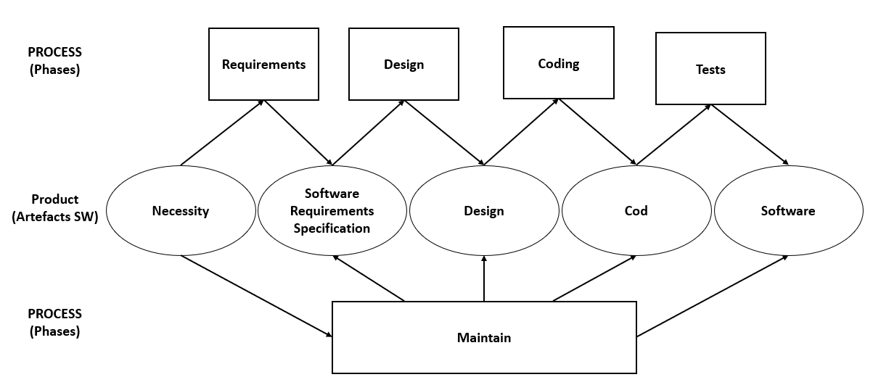
Fig. 1. Process-Product Duality in Software Engineering [2].
In relation to this, and with the objective of avoiding errors during a software construction product, it is necessary that the testing phase be integrated from the early phases of the software product lifecycle.
In the literature there are several reported studies on fault detection during the requirements phase [3][4][5][6][7][8], the coding phase [9][10][11][12][13][14], and design is no exception.
This research is the continue of a project related to fault detection in UML diagrams. This paper presents a controlled experiment for the identification of faults during the learning of use case diagrams. For this study, a fault taxonomy was used which is described in section 3.
2 Related Works
Among the studies related with fault detection in software design, specifically use cases modeling, work [15] is found. In this study a simple case experiment with students is reported. The authors present preliminary research aim at comparing manual fault detection with automated system proposed for fault detection in use case views; the results showed that the efficiency of manual fault detection is slightly lower than the proposed technique.
Another related study is reported in [16]. In this, a similar study to the previous one is presented, proposing a tool for modeling, The authors mention that the objective of the proposed tool is to support and facilitate the learning of the use case diagrams by applying diagram rules. From a controlled experiment for fault detection in use case diagrams, where they compared the results with and without using the proposed tool, they obtained significantly fewer faults in an academic evaluation when applying the diagram rules than those who did not use the proposed modeler.
Finally, in [17], as part of their methodology, the authors conducted a literature review to find recurring faults among students during software modeling in their Software Engineering courses. In an experiment with students from the Requirements Engineering and Systems Analysis courses, they compared the students' faults cases with those found through the literature review and as a result obtained a list of the defects that the authors considered as the most common faults in use case diagrams.
3 Fault Detection in Modeling
When evaluating programming code or modeling, the two words “error” and “fault” are often confused or used casually as if they were the same thing. A similar situation occurs with the other two words, “failure” and “defect”. According to [18], there are four terms that are often used interchangeably, but represent different textures:
- Error: a human action that produces a fault.
- Fault: something is wrong with the product (model, code, document, etc.).
- Failure: the manifestation of a fault.
- Defect: an error, fault or failure.
Similarly, as mentioned in [19], classifying faults in software design, specifically in UML diagrams, is not an easy task. In the literature, it is possible to find a variety of faults and their causes, mainly committed by students who are just beginning with their first modeling. In this study, use case diagrams were used based on the systematic review presented in [20]. Table 1 presents a proposed taxonomy of ten types of faults that were used for this research.
Table 1. Types of faults in the Use Case Diagrams (UCD).
Faults | Description
F1-UCD | Do not start the name of a use case with an infinitive verb.
F2-UCD | Writing the content of the diagram.
F3-UCD | UML symbology is used to represent actors (doll), use cases (eclipses), types of relationships (arrows), etc.
F4-UCD | Different elements to represent similar actions.
F5-UCD | Similar elements to represent different actions.
F6-UCD | Inadequacy in the naming of the elements.
F7-UCD | Incorrect use of generalizations/specializations.
F8-UCD | Recognize recurring actions in use cases – include.
F9-UCD | Recognize subscription actions between use cases: extend.
F10-UCD | Recognize when to reuse information from other diagrams
4 Controlled Experiment Context
In order to evaluate the effectiveness in detecting faults in use case diagrams, a controlled experiment was developed using students who were finishing their first software design course.
The present controlled experiment aims to explore whether the aforementioned study variable presents a significant performance.
Considering the project dimensions proposed in [21], it can be affirmed that the experiment takes into consideration as a controlled variable the types of faults in the use case diagram, maintaining the modeling of said diagram, the conditions of the experimental session, as well as the experience of the experimental subjects as homogeneous parameters, with effectiveness as the dependent variable.
4.1 Hypotheses and Variables
The statistical hypothesis uses the metric linked to the quality as the dependent variable in the individual process. For this study, it was the effectiveness (effectiveness index) in fault identification for use case diagrams modeling.
- H₁: The effectiveness index, measured as the rate of faults detected in use case diagrams modeling is significant.
4.2 Experimental Unit
The experimental unit, also known as the experimental object, is the piece or sample used to generate a value representative of the result of the experiment. In our study, given that the activity is fault detection in use case diagram modeling, the experimental object is the diagram or modeling reviewed by the subjects during the experiment.
For the activity to be performed with the use case diagram, an instrument was designed in which the registration of the information required for identification of the subject is requested, as well as each of the faults detected (see Figure 1) in then mentioned diagram.
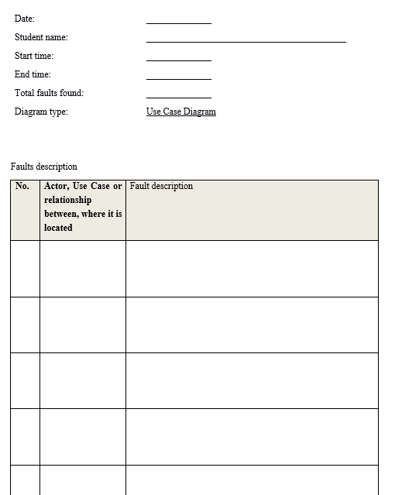
Fig. 1. Data collection instrument.
Figure 2 shows the use case diagram modeling of presented case study.
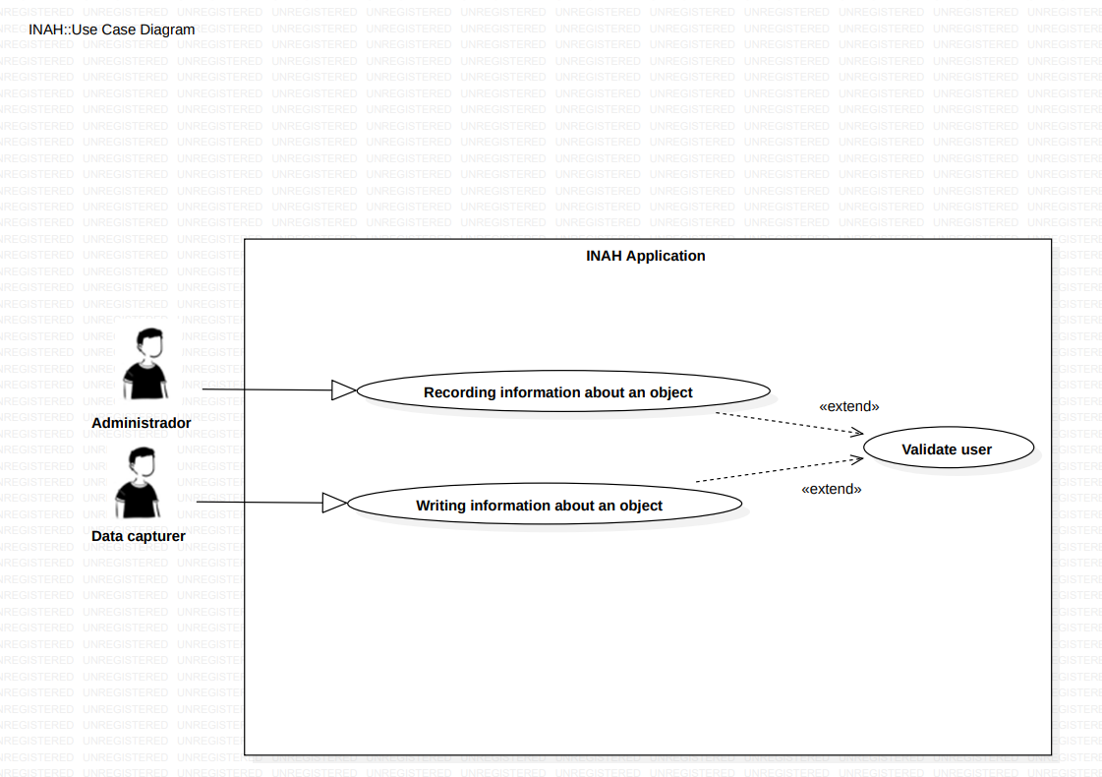
Fig. 2. Use case diagram.
For purposes a first study, 10 faults were injected into the use case diagram used in this experiment. As a reference, 5 faults types were taken from the proposal presented in section 3. The injected faults are presented in Table 2.
Table 2. Faults injected into the Use Case Diagram.
Fault | Position | Description
F1 | Use case: Recording information about an object | The use case name doesn’t begin with an infinitive verb.
F2 | Use case: Writing information about an object | The use case name doesn’t begin with an infinitive verb.
F3 | Relationship between use cases: Recording information for an object and Validate user | Fault to recognize recurring actions in use cases – include.
F4 | Relationship between use cases: Writing information about an object and Validate user | Fault to recognize recurring actions in use cases – include.
F5 | Relationship between actors: Administrator and Data capturer | Incorrect use of generalizations/specializations, no relationship required.
F6 | Relationship between Administrator actor and use case Recording information about an object | UML symbology is not used to represent the correct type of relationship, it must be an association.
F7 | Relationship between Data capture actor and Writing information about an object use case | UML symbology is not used to represent the correct type of relationship, it must be an association.
F8 | Actor: Administrator | UML symbology is not used to represent the actor, it must be a doll of the corresponding standard.
F9 | Actor: Data capturer | UML symbology is not used to represent the actor, it must be a doll of the corresponding standard.
F10 | Use case diagram | The use case diagram does not present a description of its content, that is, what is modeled.
4.3 Experimental Design
For the experimental design to this study, we currently present a summary of the data collected. This is intended to perform an initial analysis and interpretation in a clear and straightforward manner. In this report, the analysis of effectiveness as a dependent variable is presented.
4.4 Statistical Analysis Proposal
For the information analysis, a section on descriptive statistics we will be generated with summary tables of the values obtained for the dependent variables.
In the case of the effectiveness variable, the metric will be obtained by calculating the ratio of the number of faults correctly detected by the experimental subject to the total number of faults.
5 Experiment Execution
According with experiment plan, undergraduate student in Software Engineering offered at the Universidad Autónoma de Yucatán were involved, specifically students enrolled in one of the Software Design course groups taught during the January-May 2024 semester. During the course, one of the authors, as the course instructor, taught and analyzed topics related to software modeling with the group: the Unified Modeling Language and specifically the Use Case Diagrams.
5.1 Experimental Subjects
The convenience sample used in experiment consist of 35 students enrolled in the aforementioned course. These participants were nearing the end of the course and therefore already had the essential knowledge of use case diagrams modeling. Finally, the list was refining to include those students who voluntarily wished to collaborate with the study, resulting 31 students participating in the experimental session. In [13] argues that a student-based sample allows the researcher to obtain preliminary evidence to confirm or refute hypotheses, which can later be tested in an industrial context.
5.2 Experimental Session
The aforementioned course lasted 16 weeks. In a training session on week 14, the group worked with the analysis of the types of faults proposed in section 3. The session consisted of performing a learning activity under fault detection dynamic of in the classroom. In week 15, the experimental session was planned, utilizing the modeling described in section 4. At the beginning of the session, each participant was given the requirements specification of a problem, the data collection instrument presented in Figure 1, as well as the corresponding use case diagram with injected faults presented in Figure 2.
6 Experiment Analysis
This section presents the descriptive statistical analysis of the data collected with the previously described experiment.
6.1 Descriptive Statistics
Table 3 shows the results obtained to evaluate the central tendency and variability of the study data relevant to the effectiveness index. This index corresponds to the percentage of fault detection by the subjects in a use case diagram. It can be observed that, on average, the subjects were able to find more than half of the injected faults, that is, approximately 60%.
Table 3. Statistical summary for the effectiveness index.
Mean | Median | Standard deviation
0.596774 | 0.6 | 0.174133

In Table 2, a symmetrical distribution can also be observed, meaning the mean and median are very similar. Finally, it can be observed that there is less dispersion, indicating that, on average, the number of faults detected in the use case diagrams deviates from the mean by one detected fault.
The recently described results can also be seen graphically in Figure 3.

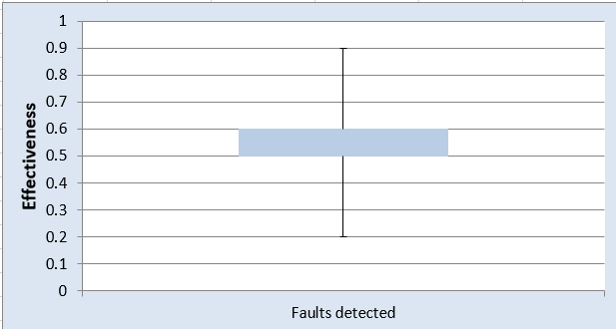
Fig. 3. Box and Whisker plot for effectiveness index.
7 Conclusion and Future Work
This work presented an initial controlled experiment to evaluate the effectiveness in fault detection in use case diagrams. The subjects in this experiment were software engineering students who were completing their first software design course. For the development of the experiment, the subjects were trained with a proposed taxonomy faults based on [20].
The results suggest that, with the proposed learning of common faults in use case diagrams, it is possible to achieve slightly significant effectiveness in detecting faults in use case diagrams.
Future work includes more controlled experiments on fault detection in this type of diagrams, as well as strengthening the analyses with inferential statistics.
Finally, as part of the monitoring of the controlled experiments, it is also planned to compare the studies with other faults classes or taxonomies for the type of diagrams under study.
References
1. Agner, L. T., Lethbridge, T. C., & Soares, I. W.: Student experience with software modeling tools. Softw. Syst. Model., 18(5), 3025–3047 (2019). https://doi.org/10.1007/s10270-018-00709-6
2. Aguilar, R., Oktaba, H., Ramírez, R., Aguilar, J., Fernández, C., Rodríguez, O., & Ucán, J.: Ingeniería de Software. En Pineda, L. (ed.) Computación en México por Especialidades Académicas. 1167-194. Academia Mexicana de Computación (2017).
3. Huang, F.: Software Requirement Criteria based on Human Errors. In 2021 IEEE International Symposium on Software Reliability Engineering Workshops (ISSREW), pp. 77-82. Wuhan, China (2021). https://doi.org/10.1109/ISSREW53611.2021.00047
4. Singh, M., & Walia, G. S.: Automated mapping of fault logs to SRS requirements using key-phrase extraction. In Proceedings of the 2021 ACM Southeast Conference (ACM SE '21). Association for Computing Machinery, pp. 138–145. New York, NY, USA (2021). https://doi.org/10.1145/3409334.3452043
5. Arora, C., Sabetzadeh, M., Briand, L., & Zimmer, F.: Automated Extraction and Clustering of Requirements Glossary Terms. In IEEE Transactions on Software Engineering, vol. 43, no. 10, pp. 918-945 (2017). https://doi.org/10.1109/TSE.2016.2635134
6. Singh, M., Anu, V., Walia, G.S. & Goswami, A.: Validating Requirements Reviews by Introducing Fault-type Level Granularity: A Machine Learning Approach. In Proceedings of the 11th Innovations in Software Engineering Conference (ISEC '18). Association for Computing Machinery, Article 10, pp. 1-11. Hyderabad, India (2018). https://doi.org/10.1145/3172871.3172880
7. Porter, A. A., & Votta, L. G.: An experiment to assess different defect detection methods for software requirements inspections. In Proceedings of the 16th international conference on Software engineering (ICSE '94). IEEE Computer Society Press, pp.103–112. Washington, DC, USA (1994). https://doi.org/10.1109/ICSE.1994.296770
8. Singh, M., & Walia, G. S.: Automating Key Phrase Extraction from Fault Logs to Support Post-inspection Repair of Software Requirements. In Proceedings of ACM Innovations in Software Engineering Conference (ISEC'21), Association for Computing Machinery, Article 3, pp. 1–12. New York, NY, USA (2021). https://doi.org/10.1145/3452383.3452386
9. Dutta, S.: Localizing Faults Using Verification Technique. In Proceedings of the 15th Innovations in Software Engineering Conference (ISEC '22). Association for Computing Machinery, Article 17, pp. 1–11. New York, NY, USA (2022) https://doi.org/10.1145/3511430.3511445
10. Klinik, M. Koopman, P. & Wal, R.: Personal Prof: Automatic Code Review for Java Assignments. In Proceedings of the 10th Computer Science Education Research Conference (CSERC '21). Association for Computing Machinery, pp. 31–38. New York, NY, USA (2022). https://doi.org/10.1145/3507923.3507930
11. Watanabe, M., Kashiwa, Y., Lin, B., Hirao, T., Yamaguchi, K., & Iida, H.: On the Use of ChatGPT for Code Review: Do Developers Like Reviews By ChatGPT? In Proceedings of the 28th International Conference on Evaluation and Assessment in Software Engineering (EASE '24). Association for Computing Machinery, pp. 375–380. New York, NY, USA (2024). https://doi.org/10.1145/3661167.3661183
12. Vahabzadeh, Fard, A. M. & Mesbah, A.: An empirical study of bugs in test code, 2015 IEEE International Conference on Software Maintenance and Evolution (ICSME), pp. 101-110. Bremen, Germany (2015) https://doi.org/10.1109/ICSM.2015.7332456
13. Basili, V., & Perricone, B.: Software errors and complexity: an empirical investigation. Communicatons of the ACM, 27(1), 42-52 (1984).
14. Authors Names.
Publication.
Publication ID.
15.Tianual, P. & Pohthong, A.: Defects Detection Technique of Use Case Views during Requirements Engineering. In Proceedings of the 2019 8th International Conference on Software and Computer Applications (ICSCA '19). Association for Computing Machinery, pp. 277–281. New York, NY, USA (2019). https://doi.org/10.1145/3316615.3316631
16. Borrego, G., Palacio, R. R., Portela, L. T. & Cruz, J.: Easing the Learning of the Robustness Diagram by Using an Assisted Modeler Tool: An Empirical Study with Ungraduated Students. 2022 10th International Conference in Software Engineering Research and Innovation (CONISOFT), pp. 68-77. Ciudad Modelo, San José Chiapa, México, (2022) https://doi.org/10.1109/CONISOFT55708.2022.00019
17.Chourio, P. Azevedo, R., Castro, A. & Gadelha, B.: Most common errors in software modeling using UML. In Proceedings of the XXXIII Brazilian Symposium on Software Engineering (SBES '19). Association for Computing Machinery, pp. 244–253. New York, NY, USA (2019). https://doi.org/10.1145/3350768.3353820
18.Juristo, N., Moreno, A. M., & Vegas, S.: Técnicas de evaluación de software. Universidad Politécnica de Madrid (2006).
19. Authors Names.
Publication. Publication ID.
20 Authors Names.
Publication.
Publication ID.
21 Weigers, K.: Creating a Software Engineering Culture. Dorset House Publishing. New York: USA (1996).

Please note that the LNCS Editorial assumes that all authors have used the western naming convention, with given names preceding surnames. This determines the structure of the names in the running heads and the author index.

