Evaluating the Integrity of the Data Used to Measure Scientific Production in Colombia
Abstract. Information systems on researcher curricula have become a source of data for governments to be able to make strategic decisions regarding the investments to be made. However, these systems are insufficient when the information is incorrect or incomplete. This work presents a tool that aids in the process of validating the research information metadata stored in the Colombian researcher curriculum vitae system (CvLAC). To this effect, a work focused on extracting, manipulating, and cleaning the data in the system was carried out, in order to perform analyses, studies, and validations with international systems such as Crossref, finding notable errors in the form of inconsistent or misreported data, such as authors and data that do not correspond to existing articles or products. Identifying these errors will contribute to enhance research evaluation processes and therefore to better target investments.
Keywords: science measurement, scientific productivity, data quality, interoperability, metadata.
1 Introduction
At the international level, particularly in Latin America, there are different systems, both governmental and from organizations, for creating a researcher’s curriculum vitae (CV). To ensure a correct management and registry of information, these systems should include features such as i) the use of metadata: information storage should be performed while following some sort of standard (Dublin Core, ecite, among others); ii) validation: the platform registered in the platform must undergo a verification of existence or an evaluation; iii) integration with international systems: integration should be sought with ORCID, SciELO, LILACS, Scopus, or other duly recognized systems with validated data; iv) exporting: allowing to export the information available in a digital format for later study and analysis [14].
However, this issue has not been addressed in the best way possible. As stated by Riggio [12], “the international databases used to measure and compare the scientific performance and impact of countries, [the Web of Science and Scopus citation indices] have low coverage regarding Latin American journals and Spanish publications, which […] influences the visibility of the scientific results of this region as well as the low production indices they obtain when analyzing data from these sources”. This evinces the limitation of or the bias in assessing the quality or impact of research in the region in comparison with European or North American systems.
Specifically in the Colombian case, Currículum Vitae de Latinoamérica y el Caribe (Curriculum Vitae for Latin America and the Caribbean, CvLAC) is the system in which the resumes of both national and foreign researchers residing in Colombia are registered [8]. The platform is managed by the Colombian Ministry of Science, Technology, and Innovation, and it includes information on conference presentations, papers, projects, and other research activities conducted. After exploring this system, the only one used in Colombia for registering the national scientific production, an issue with its information structure was identified, as well as difficulties in verifying the quality and truthfulness of the registered data.
This work aims to contribute to the process of validating the data registered in the aforementioned system and cross- checking their truthfulness with international sources through the development of an automatized tool. To this effect, a review of the systems in Latin America was carried out, as well as of their features regarding information integrity. This review is synthesized in the second section of this article.
Next, the implemented methodology is presented, starting with an ETL process (extraction, transformation, and loading) of the system data, especially those on scientific articles, as they are the easiest to cross-check in international sources. Then, the architecture of the developed tool is presented, in addition to the algorithms and elements necessary for analyzing and validating it.
This work shows the need to carry out activities associated with evaluating the quality and integrity of the data in national systems, with a focus on CvLAC-Colombia.
To be able to validate the aspects contemplated by different researcher CV systems in Latin America, the systems of each country were characterized, including the entities in charge of control and information sources. Table 1 presents a comparison of these systems.

Table 1. Latin American Researcher Cv Systems.
 | Metadata standard | Validation | Integration with international systems | Exporting  format | National repository
Argentina (SIC) | -- | Automatic (External database) | -- | PDF | National digital repository system
Brazil (Lattes) | Dublin Core | Automatic (DOI) | SciELO LILACS  Scopus  Crossref | PDF XML | --
Colombia  (CvLAC) | -- | Manual (InstituLAC) | -- | PDF | --
Ecuador (CVN) | -- | -- | -- | -- | Open-Access Repositories of Ecuador
Mexico  (SNI) | -- | -- | -- | -- | CTI national repository
Panama  (SNI) | -- | -- | ORCID | -- | Open-Access Scientific Repository of Portugal
Paraguay  (PIP) | Dublin Core | -- | -- | PDF | CONACYT institutional repository
Peru  (DINA) | Dublin Core | -- | -- | PDF RTF  RefWorks | National repository of the CONCYTEC
Venezuela (CvLAC) | -- | -- | -- | -- | --

This comparison, which was carried out based on the available information on the website and by exploring each system, evidences an obsolescence in the availability, management, and validation of most systems, except in the case of Brazil, which has a comprehensive system with robust characteristics. This system offers more reliable data thanks to its validation process and its interoperability with international systems (e.g., Crossref or Scopus). It is common for Latin American System to exhibit a lack of integration with international sources of information or databases such as Crossref [2], which would allow governments to validate part of the registered information, thus obtaining real data in measuring their installed research capabilities.
In addition, note that Brazil, Peru, and Paraguay apply metadata standards like Dublin Core, which facilitates the extraction of reported data for later study and analysis. On the other hand, there are countries, such as Ecuador and Venezuela, that have no governmental systems focused on managing research information.
2 Methodology
To conduct this work, a methodology comprising six phases was defined:
2.1 Bibliographical Review
Bibliographic sources such as Scopus, Web of Science (WoS), and Google Scholar were consulted to collect information on the work conducted regarding the validation of scientific information. Additionally, the tools and techniques used for data extraction were studied and analyzed in order to identify those that were suitable for the project.
2.2 Data Extraction
This stage involved an evaluation of the structure with which the CV information is presented in the CvLAC platform. The scenarios that could arise during data extraction were classified. In addition, given the amount of information registered in the CVs, only the following information was considered: author information, identifiers, and work experience. Finally, a specific tool for automatic data extraction was developed using Python and the scrapy framework, which was named CvLAC Scraper [5].
2.3 Data Cleaning and Standardization
Once the process and the extraction tool had been developed, a data representation standard was defined in the JSON format. Then, during the cleaning process, regular expressions were used to eliminate any inconsistencies present in the extracted data (e.g., unwanted characters), as well as to correct inconsistent formats and normalize the information.
2.4 Verifying the Reliability of the Data
An exploratory analysis of the extracted data was conducted, and metrics were defined in order to evaluate their consistency and completeness. This validation process was carried out by verifying the reported ORCIDs and DOIs as well as their related information, with the purpose of comparing the information extracted from the CVs with regard to international sources.
2.5 Implementing the Tool
The software lifecycle stages were employed to develop the author information search and verification tool. This resulted in a three-layer application in Angular, Flask, and MongoDB with the necessary functionalities to perform searches, verifications, and analysis regarding author information.

3 Development
3.1 Existing Tool
Previous research works on the Colombian case have used tools such as CvLAC-GrupLAC Extractor [9] or Sistema Recomendador de Productos (Product Recommender System) [4], which offer functionalities focused on extracting information reported in CvLAC or GrupLAC, albeit with the inherent difficulties of the system, such as the lack of a validation process, i.e., the tools extract or analyze the information just as it was registered by the researchers, perpetuating the lack of integrity and truthfulness of the data, since the existence of products cannot be assured, nor is their duplicity prevented.
At the international level, there are tools similar to those proposed, albeit founded upon robust and truthful databases, as is the case of scriptLattes [6], a system that allows creating reports on groups of researchers according to the data available in the Lattes database (the Brazilian equivalent of CvLAC). This database is one of the most robust in Latin America, as shown in Table 1. More specific cases include the development of platforms that only assess productivity in the Scopus and WoS databases, thus hindering a correct analysis of institutions’ productivity [3], [10], [13]. The above does not contemplate all the products included in researcher CV systems.
3.2 CV Data ETL Process
One of the main challenges in this process corresponded to the amount of CVs and data registered in CvLAC, which shows one of its flaws: the lack of registration control. There were registries with inconsistent numbers pointing to non-existent documents (e.g. “00000”), or names such as “Prueba Uno” (Test 1). Therefore, it was necessary to allow individual access to profiles, which was facilitated by the fact that the URL of each CV contains a researcher ID in the cod_rh parameter. Thus, it is only necessary to change said code in the base URL to gain access to a researcher’s information.
During the data extraction process, the HTML structure used in the CV’s web pages was analyzed. Table 2 contains the information on each search carried out in XML Path Language, as well as the name used to identify it. With the purpose of explaining the employed notation, in order to simplify the searches, note that the term BASE_XPATH refers to the beginning of each search, and the subsequent ones, labeled with ellipses at the start, refer to the rest of the search.
Table 2. Xpath Searches to Access Information.
Name | Xpath Description
BASE_XPATH | It is used to access CV information with no restricted data
BASE_XPATH | /html/body/div/div[3]/table/tbody
AUTHOR_INFO | It selects the section of the table with general information
AUTHOR_INFO | …/tr[2]/td/table/tbody
AUTHOR_IDS | It is used to navigate between the rows of the table containing identifiers
AUTHOR_IDS | …/tr[4]/td/table/tbody/tr/td/a
SOCIAL_MEDIA | It is used to navigate between the rows of the table containing social networks
SOCIAL_MEDIA | …/tr[3]/td/table/tbody/tr/td/a
ARTICLES | It selects the table containing the articles
ARTICLES | …/tr[45]/td/table/tbody
ARTICLE_TYPE | It is used to obtain the headers of the articles, i.e., the verification mark and the type of article
ARTICLE_TYPE | …/tr[45]/td/table/tbody/tr[position() mod 2 = 0]/td/li
ARTICLE_INFO | This search allows accessing the internal HTML of each article
ARTICLE_INFO | …/tr[45]/td/table/tbody/tr/td/blockquote
ARTICLE_SECTION_INFO | It is used, together with the previous XPATH, to access the different fields of an article. Between brackets is the number containing each field: 1) name, authors, country; 2) journal name; 3) ISSN; 4) publisher; 5) volume; 6) issue, starting page, final page, year; 7) DOI;  8) keywords; 9) sectors; 10) acknowledgements
ARTICLE_SECTION_INFO | text()[{}]
NAME_WORK_PLACES | It is used to access the name of the institution or places where the researcher has worked
NAME_WORK_PLACES | …/tr[8]/td/table/tbody/tr/td[2]/b/text()
TIME_WORK_PLACES | It allows obtaining the start and end of the period shown in the work information
TIME_WORK_PLACES | …/tr[8]/td/table/tbody/tr/td[2]/i[contains(text(),"Dedicación:")/following-sibling::text()[1]
CHECK_RESTRICTED_INFO | It is used to obtain the following text: “The information in this curriculum is not available at the researcher’s request”.
CHECK_RESTRICTED_INFO | /html/body/table/tbody/tr[3]/td/blockquote/text()
AUTHOR_RESTRICTED_INFO | This search allows accessing the table with the general information of a researcher who has restricted their information
AUTHOR_RESTRICTED_INFO | /html/body/table/tbody/tr[2]/td/blockquote/table/tbody

Even though the CV data were successfully extracted through the searches shown in Table 2, due to the lack of standardization regarding the input of information, especially in the case of data on scientific publications and work experience, it was necessary to use regular expressions designed to work with the HTML structure of the web pages, thus allowing to effectively process the data. Table 3 shows some o the expressions used in the data cleaning, standardization, and extraction process.

Table 3. Regular Expressions Used in Data Extraction and Cleaning.
Name | Regular Expression | Description
REMOVE_SPECIAL_SPACE_CHARACTERS | ([\n\r\t]| +|\xa0) | It removes the line breaks, tabs, and special characters that appear in the HTML structure of the curriculum
GET_ARTICLE_TITTLE | ".+" | It obtains the complete name of an article
GET_PAGES_STRING | p\. *\w+-?\w* - +\w+-  ?\w* | It obtains the starting and final page of an article
GET_PAGES | \w+-?\w* | It obtains the starting and final page of a specific text string
GET_YEARS | \d{4} | It obtains the years corresponding to a specific period in the work experience
GET_AUTHOR_ID | \d+$ | It extracts the identifier or cod_rh of a curriculum’s URL
HTML_TAGS | <\/?\w+> | It extracts the HTML labels contained in a text string or document

Now, to design the data presentation scheme, we decided to use the JSON format, as it allows sending data via HTTP requests between web browsers and other applications. Figure 1 shows the scheme for the collected CV information. It should be clarified that, when some fields are left unspecified, it is likely that there are null or absent values in the scheme.

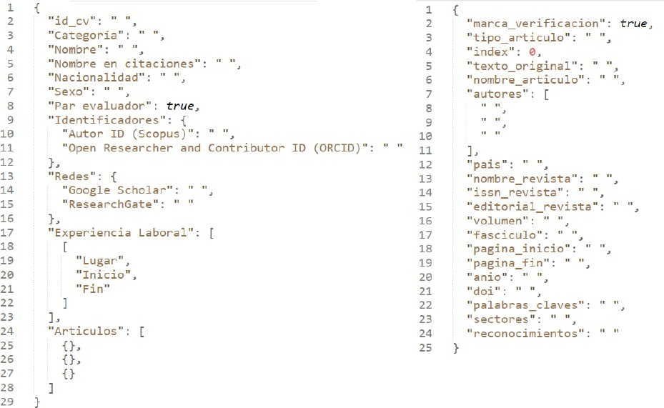
Fig. 1. JSON Author an Article Representation Scheme.

Finally, as mentioned in the Methodology section, the CvLAC Scraper tool was developed. Figure 2 presents the general architecture defined for its configuration, execution, and data output.

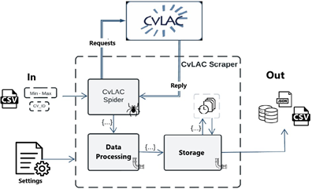
Fig. 2. CvLAC Scraper Architecture.

CvLAC Scraper has an initial configuration file to extract information from the CV sites. It defines aspects such as the URL of the CvLAC curricula, the input type of each CV’s identifiers, and the persistence of the data, among others (Figure 3).

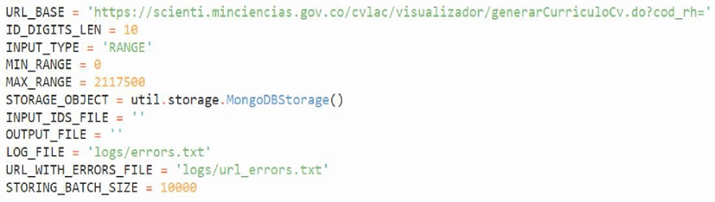
Fig. 3. CvLAC Scraper Configuration File.

The data processing pipeline is in charge of extracting data from an author’s CV through regular expressions XPATH searches, and the defined structure. Once the CV data extraction is complete, this pipeline sends the processed data to the next pipeline in the form of items or dictionaries.
After processing the data in a CV, the item with structured data goes on to the storage pipeline. Here, the items are stored in the memory until a determined number is reached. Then, the persistence process is initiated, freeing the memory of these items in order to store the next ones.
Finally, upon reaching the number of items to be stored per batch, the tool carries out the persistence process, which may vary depending on the specified configuration, as the data can be stored in any previously determined format or database.

3.3 Evaluating the Integrity of the Data
Upon examining the data extracted from CvLAC and comparing them via the APIs of platforms such as Crossref – a feature that sets the platform apart from other developments found – a total of 2.117.500 profile identifiers was evidenced (https://cvlac-verifier.onrender.com/home), with only 995.822 of them linked to a curriculum, meaning that the remaining profiles are empty or contain restricted information. Likewise, the data of interest obtained are presented in Figure 4, highlighting that, from the entirety of the registered articles, less than 50% are linked to a DOI, which is even more critical considering that a lower percentage of these DOIs is not valid.
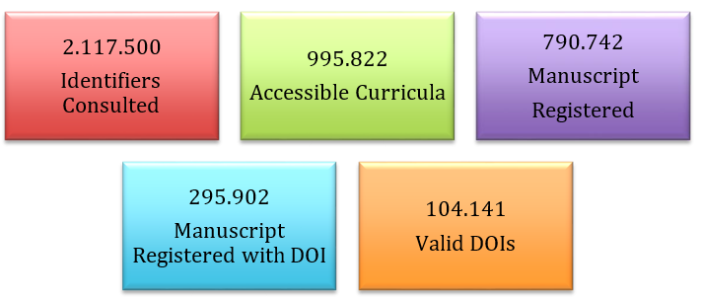
Fig. 4. Results of Data Extraction.

While analyzing these data, a registration issue could be identified in the platform: the recorded identifier may not correspond to the one expected in the field. For example, in the field established for their ORCID, researchers enter their ScopusID, or vice versa.
With the purpose of evaluating the validity of the registered ORCIDs, the API provided by the system was used. This API determines whether the registered data correspond to existing ORCIDs, and, if they exist, it determines whether they correspond to the authors who registered them.
Despite the fact that there were 56.918 records for the ORCID field, it was only possible to evaluate 39.792 after eliminating records of inconsistent data (e.g., hyphens or other characters). Among these records, 1.994 did not have the structure defined for the ORCID, particularly regarding the 16-digit composition of the suffix, which is why they could not be verified. Out of the remaining 37.798, 86% (34.290) were found to be valid. The rest did not return a valid or active registry in the portal.
For the validation process, a similarity function was designed which examined the characters that make up the researchers’ names reported in CvLAC and ORCID. This was done after a prior data cleaning that involved removing

punctuation and accent marks. For a record to be taken as valid, a coincidence percentage of 80% was established. In this vein, it must be clarified that there may be registries falsely included as valid due to homonyms or common names.
From the CvLAC curriculum data extraction, information on 790.742 registered articles was obtained, out of which 37,42% have an associated DOI, but only 20,63% have one that is valid and verified via the DOI Foundation API. Moreover, 13,15% have a valid and unique DOI (Figure 5). In this regard, it was found that different articles were entered into CvLAC with the same associated DOI, which is not right.

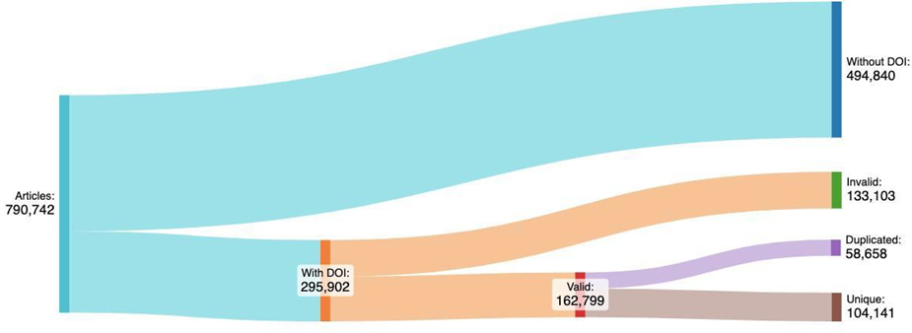
Fig. 5. Validating the Existence of Articles Through DOIs.

Although the first basic data evaluation phase shows a significant amount of erroneous information, which affects the country’s indicators, analyzing the productivity registered by researchers shows a worrying landscape.
3.4 Verification with Crossref
Using the Crossref API, it was possible to validate the authenticity of the data registered in the articles by means of their identifier (DOI), which was done by accessing their information in the database. First, we verified the coincidence percentage between the article titles reported in CvLAC with respect to that registered in Crossref, mostly showing a high level of agreement (Figure 6). However, in some cases, a difference was observed. Even though it can be underrated, this difference requires attention in order to correctly validate the data.

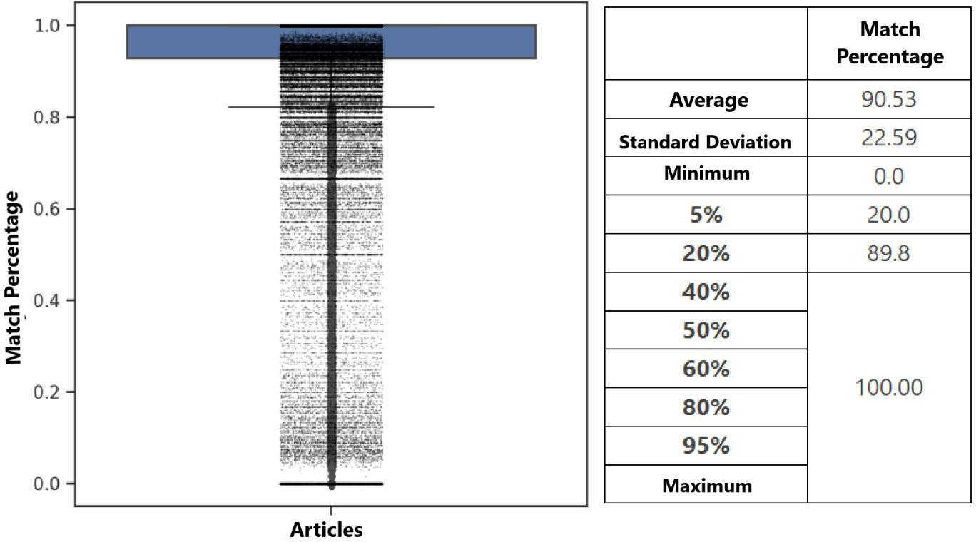
Fig. 6. Coincidences in Article Titles: Crossref vs. CvLAC.

Furthermore, Table 4 summarizes the results of the validation process regarding the author names registered per article in CvLAC vs. those in Crossref. Given the way in which author names are entered for an article in CvLAC (full name, only initials, only a name and a surname), it was necessary to generate several combinations for each author name. This is mainly due to the fact that the data in Crossref mainly have one citation format, wherein the name of an author is often abbreviated.

Table 4. Validation of Authors Per Article.
% of articles | Authors in CvLAC | Authors in Crossref | Validated authors (%)
5 % | 1 | 2 | 5.26
20 % | 1 | 2 | 20.0
40 % | 1 | 3 | 50.0
50 % | 2 | 4 | 66.67
60 % | 2 | 4 | 100
80 % | 4 | 7 | 100
95 % | 6 | 14 | 100

Based on Table 4, it can be deduced that 40% of the verified articles exhibit a 100% agreement between the data of both systems, but it is worrying that there is a difference of at least one author in 60% of the articles, as this affects the cooperation and collaboration figures used by the Ministry of Science to determine the research capabilities of the country. Studying collaboration networks provides insights that helps improve productivity of research [11]. In some particular cases, such as that of CovidSurg [7], there are articles with 16.148 authors registered in Crossref and only one in CvLAC. Upon verifying this figure, it was found to be related to products from organizations with thousands of collaborators worldwide.

3.5 Evaluating the Truthfulness of the Curricula
To evaluate the quality and integrity of the data, the Dublin Core metadata standard [1] was taken into account, assigning a score for each field in said standard (Table 5), except for the description and relation fields.
Table 5. Metadata Evaluation Metrics.
Item | Total Score | Criteria | Individual Score
Title | 8 | Don’t Have | 0
Title | 8 | Contains | 2
Title | 8 | Verified | 6
Author or Creator | 8 | Don’t Have | 0
Author or Creator | 8 | Contains | 2
Author or Creator | 8 | Verified | 6
Subject and Keywords | 4 | Don’t Have | 0
Subject and Keywords | 4 | Contains | 4
Publisher | 8 | Don’t Have | 0
Publisher | 8 | Contains | 2
Publisher | 8 | Verified | 6
Other Contributor | 4 | Don’t Have | 0
Other Contributor | 4 | Contains | 4
Date | 8 | Don’t Have | 0
Date | 8 | Contains | 2
Date | 8 | Verified | 6
Resource Type | 4 | Don’t Have | 0
Resource Type | 4 | Contains | 4
Format | 4 | Don’t Have | 0
Format | 4 | Contains | 4
Resource Identifier | 20 | Don’t Have | 0
Resource Identifier | 20 | Contains | 4
Resource Identifier | 20 | Verified | 8
Resource Identifier | 20 | Verified and unique | 8
Source | 24 | Journal Volume Inicial page  Final Page | 12 (3 for each field)
Source | 24 | Contains ISSN | 4
Source | 24 | Verified ISSN | 8
Language | 4 | Don’t Have | 0
Language | 4 | Contains | 4
Coverage | 4 | Don’t Have | 0
Coverage | 4 | Contains | 4
Total | 100 |  | 100

During this evaluation, it was found that 60,31% of the articles had a score of 32-36. In addition, no article reached a score of 100, with 61 being the maximum value obtained. This is due to CvLAC’s difficulties regarding the language and format fields, which cannot be obtained via web scraping, as well as to the fact that there are fields such as other contributor and coverage which are not requested through the platform.
Upon analyzing the score percentage reached in each field (Figure 7), resource identifier showed to be the metadata item with the lowest fulfillment percentage, given the large number of articles with no DOI, which also did not allow verifying their truthfulness. In the case of metadata such as subject and keywords, as they are not mandatory in the platform, they are not registered by the authors.

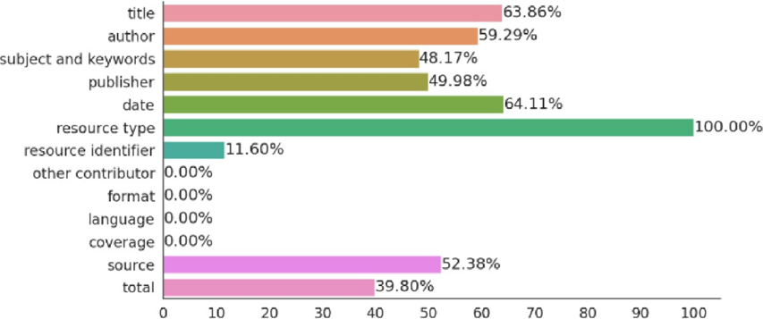
Fig. 7. Score Obtained for Each Dublin Core Metadata Item.

4 Conclusions
CvLAC, as a large part of the information systems for scientific production and researchers in Latin America, allows consulting and registering information. However, there are opportunities to improve its functionality, such as the implementation of a metadata standard (e.g., Dublin Core) in order to standardize the data structure, the application of author identifier validation criteria, and the use of external APIs to ensure the existence of any reported products.
The purpose of a country’s information system for scientific production is to provide indicators related to a real landscape of research capabilities and regional potentials. This type of systems become unreliable if the registered information is not correctly validated.
In the case of CvLAC, we evidenced the way in which the absence of international standards and connections to external databases can generate information gaps, which may entail inadequate decision-making at the national level, investing in strategic areas that do not correspond to the real landscape of the country. The research carried out helps detect errors and contributes to improving government research support systems.
References
- COVIDSurg Collaborative, & GlobalSurg Collaborative: SARS-CoV-2 infection and venous thromboembolism after surgery: An international prospective cohort study. Anaesthesia, 77(1), 28-39 (2022). https://doi.org/10.1111/anae.15563
- CrossRef, https://www.crossref.org/about
- Dattolo, A., Corbatto, M.: Assisting researchers in bibliographic tasks: A new usable, real-time tool for analyzing bibliographies. Journal of the Association for Information Science and Technology 73(6), 757-776 (2022). https://doi.org/10.1002/asi.24578
- Galeano, D.F., Prada, L.C.: Diseño de un sistema inteligente para estimación de categorización de grupos de investigación a partir de lineamientos definidos por COLCIENCIAS (2020). http://hdl.handle.net/11349/22537
- Martínez, R., Rodríguez, R., Vera, P., Parkinson, C.: Análisis de técnicas de raspado de datos en la web aplicado al Portal del Estado Nacional Argentino. In: XXV Congreso Argentino de Ciencias de la Computación (2019).
- Mena-Chalco, J.P., Junior, R.M.C.: scriptLattes: An open-source knowledge extraction system from the Lattes platform. Journal of the Brazilian Computer Society 15(4), 31-39 (2009). https://doi.org/10.1007/BF03194511
- Ministerio de Ciencia, Tecnología e Innovación: Convocatoria Nacional para el Reconocimiento y Medición de Grupos de Investigación, Desarrollo Tecnológico o de innovación y para el reconocimiento de investigadores del Sistema Nacional de Ciencia (2020). https://minciencias.gov.co/sites/default/files/upload/convocatoria/anexo_1_-_documento_conceptual_2021.pdf
- Ministerio de Ciencia, Tecnología e Innovación-Glosario de términos: CvLAC, https://minciencias.gov.co/glosario/cvlac
- Mosquera-Perdomo, A., Salazar Galindez, J., Ramirez-Gonzalez, G., Figueroa, C.: Software for the extraction of bibliographic information registered in CvLAC and GrupLAC applied in the Department of Cauca. RIINN 11(2), e3464 (2023). https://doi.org/10.21897/rii.3464
- Patil, V.H., Bhavsar, S.A., Patil, A.H.: An efficient author information retrieval tool for bibliographic record analysis. Journal of Intelligent and Fuzzy Systems 39(1), 341-353 (2020). https://doi.org/10.3233/JIFS- 191289
- Razzaq, S., Malik, A.K., Raza, B., Khattak, H.A., Moscoso Zegarra, G.W., Díaz Zelada, Y.: Research Collaboration Influence Analysis Using Dynamic Co-authorship and Citation Networks. International Journal of Interactive Multimedia and Artificial Intelligence 7(3), 103-116 (2022). https://doi.org/10.9781/ijimai.2022.03.001
- Riggio, G.: Indicadores bibliométricos de la actividad científica de la República Dominicana [Unpublished doctoral thesis]. Universidad Carlos III de Madrid (2017).
- Ruiz-Rosero, J., Ramirez-Gonzalez, G., Viveros-Delgado, J.: Software survey: ScientoPy, a scientometric tool for topics trend analysis in scientific publications. Scientometrics 121(2), 1165-1188 (2019). https://doi.org/10.1007/s11192-019-03213-w
- Valles-Coral, M.A.: Modelo de gestión de la investigación para incrementar la producción científica de los docentes universitarios del Perú. Revista de Investigación, Desarrollo e Innovación 10(1), 67-78 (2019). https://doi.org/10.19053/20278306.v10.n1.2019.10012

