Time Trek: Odyssey videogame – Bridging the gap between Gaming and Historical Learning

*Abstract* — Educational methods today have changed compared to traditional ones, there are many more effective learning proposals for the intellectual development of young people. This is how digital alternatives such as video games are created to facilitate the teaching of academic concepts. This is how Time Trek: Odyssey was born. The proposal’s focus is learning history, focusing on prominent events of the past. Time Trek: Odyssey is designed to be used primarily by high school students. This tool provides, through selected historical scenarios and objects, the appropriate space for interaction between students and history. It seeks to provide an interactive, fun, and engaging learning experience that stimulates interest and understanding. The results demonstrate great potential as a teaching method: Usability test results show that the game is easy to navigate and play, significantly helps to retain historical information, and motivates students to learn. The proposal seeks to combine learning and fun through a video game for students interested in history.

Keywords — Methods; high school; history; learning; student; video game

# Introduction

Today, the lack of knowledge and appreciation of history is concerning. Many people, especially young ones, find themselves disconnected from the events that have shaped our present, compromising our understanding of the world we live in [1]. The future generations must remain aware of their origins, not only to avoid the same past mistakes but also to use them as a guide for their future. However, new generations are aiming their visions only towards the latest technological advancements, and the integration of our reality into virtuality. This is how traditional methods of education have been compromised in effectively teaching today’s students.

Considering this situation, the implementation of educational video games emerges as a promising tool to awaken and encourage interest in history. Through these video games, the aim is to combine the main entertainment of today’s young people with playful and educational elements, and thus, to captivate the users’ attention and transmit historical information in a fun and interactive manner. In this way, educational video games appear as an innovative tool to combat the lack of historical knowledge today, considering that data from evaluations indicate that employing a game-based teaching method has shown better results in comparison to the conventional approach [2].

This proposal seeks to create a video game that helps or facilitates the understanding of academic concepts. Video games turn out to be highly interactive, which can involve students more actively in their learning process. This can increase their level of engagement and motivation to acquire knowledge. Educators who teach students who tend to be diverse in prior knowledge and motivation have discovered that integrating video games into their classes is beneficial for these differences and enhancing the learning experience of their students. Video games have been shown to make easier those areas that seem to be difficult and promote interest, and cultivate lifelong learning, then, they are certainly worth including [3]. In addition, video games represent a safe environment to experiment and make mistakes without serious repercussions for the student. Likewise, these spaces allow the concepts to be transmitted in a visual and much more attractive way for user’s eyes, facilitating their retention and understanding.

Taking this into account, the focus intended for the proposal is to create an interactive game that makes learning the subject of history easier. It is intended that young users acquire knowledge about historical facts or events, as this proves to be a dense topic that covers political, social, economic, and cultural aspects necessary to understand the reality of each era. Historical video games offer an attractive and stimulating way to approach these dense topics, as they actively involve students in the exploration and understanding of historical events, which can make learning more enjoyable and meaningful. In addition, these video games present detailed scripts that cover significant historical facts, processes, and developments [4], thus offering a more complete learning experience in the subject of History.

Thus, we endeavor to create Time Trek: Odyssey. An immersive and interactive tool that allows the player to have fun and learn simultaneously. The main idea revolves around a time traveler seeking to repair his ship. This is achieved by collecting objects from different historical eras or events. Each of these spaces or contexts represents a level or a world that enables the character to become part of each era and visually and auditorily receive the necessary elements to understand better the situation of the period in which they find themselves. Each era is composed of collection elements and objects that provide the player with a context of their importance and role within the historical context. A desire has been established to transcend the monotony of the subject through gaming and its expressive possibilities [5].

This game is designed with a user-centric approach, considering the student's needs and preferences. Additionally, limitations that some users may have were considered, which is why the project has an inclusive component: voice features useful for those with reading or visual difficulties. The entertainment provided by this game is not only enjoyable but also offers learning benefits, promoting cognitive skills and improving information retention in a fun and engaging way.

This article is structured into five sections. The second section research multiple bibliographic sources, examining and choosing those existing proposals that closely align with the idea of Time Trek: Odyssey and its educational and entertainment objectives. The third section presents the methodology, outlining the processes and strategies for game development, as well as the implemented functional and non-functional requirements. The fourth section includes product samples, along with reviews and evidence of its effectiveness on a group of students. In the fifth section, conclusions are drawn from reflection and analysis of the product´s impact on the development of the target audience.

# Related Work

The exponential growth of computers and technological advancements that have been occurring around the world have had a huge impact on students and their way of learning. Technologies have caused attention problems and conflicts with traditional teaching for students. This is why we must seek new solutions that follow the same path that society is taking because education is not just what the teacher gives, it is a natural process of humans facing the environment and situations. This is how video games have begun to become a natural medium for learning: they serve as a tool that keeps young people attracted and at the same time educates them. The idea is to use new alternatives so that society continues to acquire knowledge, learning games may become the main means for progressive pedagogy [6].

Students at the Pontificia Universidad Católica del Perú (PUCP) used an educational video game, "1814: La rebelión de Cusco," to recreate the main events of the 1814 rebellion in Peru. The game was used by three groups of students: the experimental group, which used the game as a supplement to a history class taught by a teacher; the control group 1, which only received the class taught by the teacher; and the control group 2, which was only given the video game to learn about Peru’s history in 1814. All three groups of students were given a pre-test (before the experiment) and a post-test (after the experiment) on the topic to assess their knowledge. The results showed that the group that received the class and used the video game in addition had the greatest improvement between the pre-test and post-test, followed by the group that only received the game as a learning tool. This is an important finding that indicates that technologies or software work much better when they are incorporated or supplemented by the work of the teacher in the classroom [7].

Students at the Universidad Nacional de Educación a Distancia (UNED) in Spain used "MinecraftEdu," the educational version of the popular video game "Minecraft," to learn about ancient civilizations and their architecture. The game was used by two groups of students from schools in Spain and the USA: one group consisted of only students and the other group consisted of students, teachers, and parents. Both groups were assigned to use the game in the unit "History and Architecture." After using the game and analyzing all the resources and elements it offered, the students took a test on the topic, completed a questionnaire about their opinion of the game, and participated in a message analysis between the students and teachers. Finally, the results showed that while there was no significant improvement in the students' historical knowledge, the participants felt that "MinecraftEdu" enhances creativity, improves learning, is fun, enables discovery, and facilitates learning of historical content [8].

All these studies discussed highlight the potential benefits of video games as digital tools for education and underscore the importance of adopting new technologies to enhance traditional learning methods.

Time Trek: Odyssey emerges as a historical video game with an educational focus, which represents an innovative proposal to explore different periods, spaces, and historical events through the interaction and direct participation of young people with their environment through the collection of objects. However, this is not the first game to present these development or functionality parameters. Young people use Minecraft Education, which focuses on the learning of its players, specifically, it allows trips to ancient cities, the construction of historical monuments, and the representation of ancient civilizations with characters. Similarly, there is the "Assassins Creed" franchise, which, although its main objective is not to teach, is well-known for allowing players to insert themselves, via the player-characters, in different - well-known or increasingly more obscure and underrepresented - historical periods as Egypt or the French Revolution. Additionally, there are games focused on teaching in general, not just one topic, such as "Preguntados" composed of rounds of trivia on different topics of general culture, with specific questions. Or the well-known "Duolingo" that allows you to learn a wide variety of languages, through a gamified platform that provides interactive exercises, quizzes, and challenges daily. With these examples, the need to provide a video game inclined to historical topics, entertaining, visually attractive, user-friendly, and at the same time, didactic and educational for the cognitive development of young people is evident. One of the greatest motivations is the distinct possibility that much of what students today know about the past may come not from teachers, textbooks, or tests but from popular-culture media, such as video games [9]. Table 1 provides a comparison between our proposal and other applications.

1. Comparative table Time Trek: Odyssey against other applications

|  |  |  |  |  |  |
| --- | --- | --- | --- | --- | --- |
| **Features** | **Similar games/applications** | | | | |
| Time Trek: Odyssey | Minecraft Education  [10] | Assassin’s Creed  [11] | Preguntados  [12] | Duolingo [13] |
| Historic elements | ✔️ | ✔️ | ✔️ | ✔️ |  |
| Educative purposes | ✔️ | ✔️ |  | ✔️ | ✔️ |
| Entertaining purposes | ✔️ | ✔️ | ✔️ | ✔️ |  |
| Didactic | ✔️ | ✔️ |  | ✔️ | ✔️ |
| Motivational | ✔️ |  | ✔️ |  | ✔️ |
| Inclusive | ✔️ | ✔️ |  |  | ✔️ |
| Storytelling | ✔️ |  | ✔️ |  |  |
| Competitive |  |  | ✔️ | ✔️ | ✔️ |
| Multiplayer |  | ✔️ | ✔️ | ✔️ |  |

Historical games, like any cultural product, are shaped by a network of cultural representations—from adventure novels to comic books—that mold the collective imaginary of the past, often for the sole purpose of entertainment and profit, and with a focus on global audiences. This factor is very important to offer a very good graphic representation, with visual elements that are known and that are attractive to young students. This goes hand in hand with the functional development of the game since it is intended to present an interesting story or plot, which follows a timeline, events, and actions to complete the goal of this product to 100%. This is achieved through design choices and game "affordances", such as the preselection of certain geographic spaces, remarkable objects, and NPCs (non-playable characters), that allow or restrict player actions. These affordances reflect not just commercial and technological concerns, but, in the case of historical games, the history that is being represented [14][15].

# Methodology

Taking into consideration all the requirements, desired functions, and main objective of the initiative, we proposed to develop *Time Trek: Odyssey*, a desktop game that utilizes simple yet effective technologies that aims to provide a different experience by combining entertainment with learning elements, targeting high school students. Fig. 1 shows the proposed methodology for achieving the proposal’s goals including the functional and non-functional requirements, which define the program's functionalities and quality attributes, respectively.

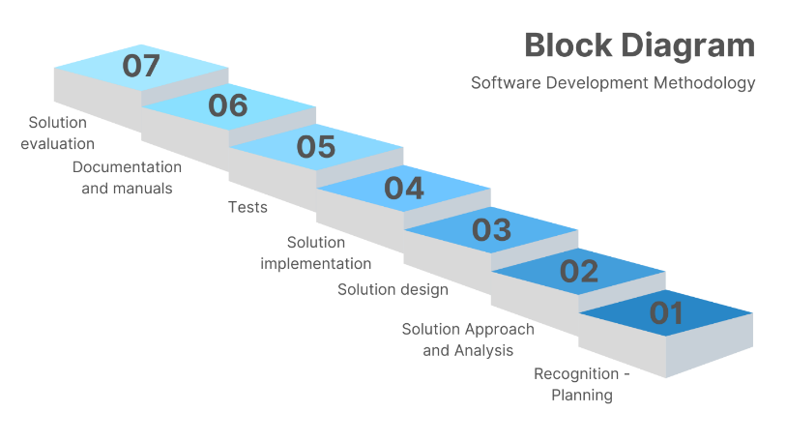

**Fig. 1** Time Trek: Odyssey methodology block diagram

The proposal is divided into seven steps:

### Recognition—planning: Investigate and identify the problem in an interesting area of learning to be solved and the potential solution.

### Solution approach and analysis: Identify and establish each of the requirements and technical specifications of the program.

### Solution design: Clear design of the game interface and communication between the different modules that make up the software. Clear interaction between the game and the user.

### Implementation of the solution: The development of the program is carried out, the necessary tests are performed and the identified bugs are corrected.

### Tests: The necessary usability tests are carried out with the help of users to identify and fix existing bugs in the program/game.

### Documentation and manuals: Comprehensive documentation is written detailing the game's architecture, functionality, and usage guidelines.

### Evaluation of the solution: Review of each step of the methodology and its correct execution.

The requirements implemented in Time Trek: Odyssey are defined under the FURPS+ method.

F stands for Functionality, U for Usability, R for Reliability, P for Performance, S for Supportability, and + for additional requirements implemented [16].

## **F**unctionality

* Random Component: Our game brightens up the visual experience with a system that generates clouds in random positions in the background. This esthetic detail adds a sense of movement and life to the game environment, creating a more immersive and enjoyable atmosphere for all players. Furthermore, there is a range of attacking sounds generated randomly to provide a varied experience to players.
* Inclusive Component: To promote a more inclusive gaming experience, we have incorporated a voice feature that narrates each text that appears on the screen. This feature is especially useful for our users with reading or visual difficulties, just as the text is for those with hearing difficulties, allowing all players to enjoy the game on an equal term.
* File management: Linked lists are used to generate the animations for each of the visual components of the game. Files are used to search, save, sort, and load all the level images of the game.
* GUI: The video game has a user-friendly graphical interface, which allows them to identify the different options and navigate within the game in the way they consider. Similarly, each level of the game is esthetically designed according to its time, including collectibles, enemies, and backgrounds.
* Character attributes: The character can move along the map within the limits. He runs, jumps, and attacks enemies that block his path. It should be noted that each action performed by the character is linked to its respective animation.
* Collection of historical objects: The main objective of the video game is the collection of historical objects alluding to different periods. Each historical object marks a degree of importance for the era in which it was created or discovered. Therefore, the user receives a description of the origin or importance of the object, to enrich his knowledge about history.

## **U**sability

The game includes a HELP tool in which the player can find the instructions.

## **R**eliability

The system must run perfectly without any bugs in every device compatible. The system must keep running even in case of wrong entries.

## **P**erformance

The system response time cannot be longer than 2 seconds. The system runs at 120 frames per second (FPS) and 200 updates per second (UPS).

## **S**upportability

The system supports mouse and keyboard inputs, as well as outside input.

## **+** extras

* Interface: The system does not require an external item for it to function, only the keyboard and mouse inputs entered by the player.

The UML class diagram in Fig. 2 represents the structure and relations between the different classes of the game. It is separated into packages that are taken as general modules that represent the main idea of the different classes by which they are composed.

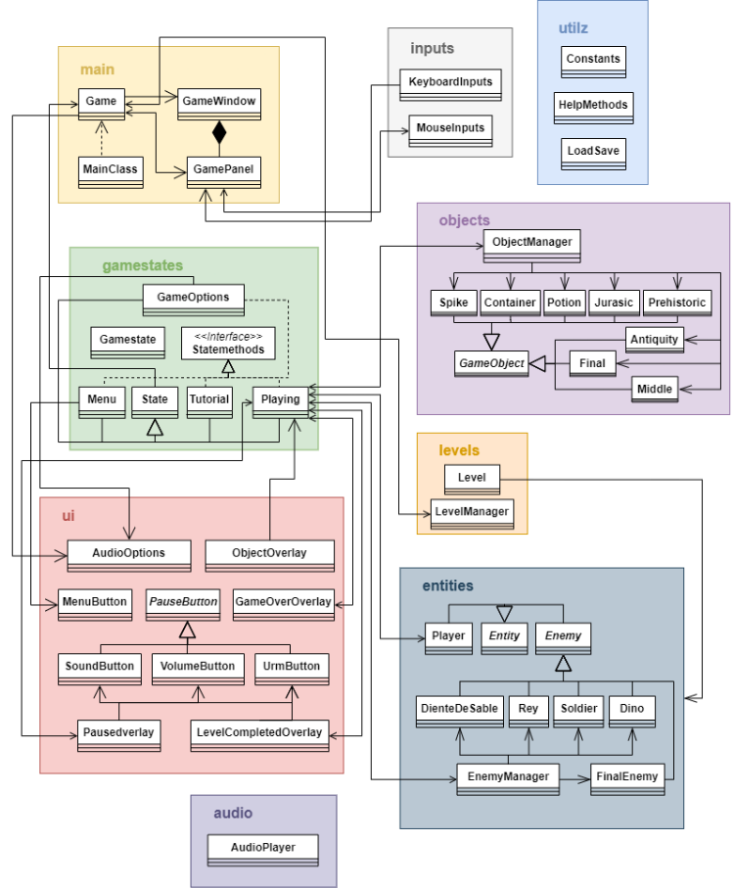

**Fig. 2** Class diagram for Time Trek: Odyssey design

Each module has its own purpose and explanation below:

### Main: This module houses the primary classes of the game. All other modules reference these classes to execute essential functions and enable the player to view the graphics.

### Game states: This module encompasses classes responsible for managing what is displayed on the screen and altering the player’s possible interactions with the game based on the current state.

### Levels: This module includes all classes that oversee the displayed level and every associated component.

### Entities: This module comprises classes tasked with creating, managing, and controlling all game characters, including both enemies and the player.

### Objects: This module holds the classes responsible for creating and managing objects that appear in each level, including traps, collectibles, player aids, rewards, and more.

### Inputs: This module contains classes that handle keyboard and mouse inputs, enabling players to interact with game components.

### UI: This module incorporates all classes related to the game’s visual aspects, facilitating a rewarding interaction for the player.

### Utilz: This module contains auxiliary classes designed to enhance code organization and reusability.

### Audio: This module holds the single class responsible for all the sounds and music used in the game.

Time Trek: Odyssey architecture for the desktop game, its software design, and modules are conducted by:

* Frontend: We utilized NetBeans to develop the game’s interface, looking for an interactive, easy, and user-friendly visual and auditive experience.
* Backend: The game is developed using the Java programming language. It is organized into different modules that have information related to every character and object, their attributes, and other functions of each level.
* Hardware: In addition to the standard keyboard and mouse, an external controller can be used to enhance the gameplay experience.

After the methodology was defined and the functional and non-functional requirements were established, we proceeded to the next stages: solution design and implementation of our game. The game was meticulously designed to incorporate engaging gameplay mechanics, intuitive user interfaces, and robust backend support. Consequently, all the requirements mentioned were achieved ensuring to provide an immersive and enjoyable experience for users.

The following figures illustrate the game’s user interface. Fig. 3 shows the main menu of the game, which helps players navigate through the other sections of the game. Fig. 4 shows the option menu, which allows players to customize settings and preferences for a better game experience. Fig. 5 shows a tutorial screen of the basic controls and mechanics of the game. Fig. 6 shows the basic gameplay screen with its immersive environment and interactions. Fig. 7 shows an example of the information given when the player collects a historical object.

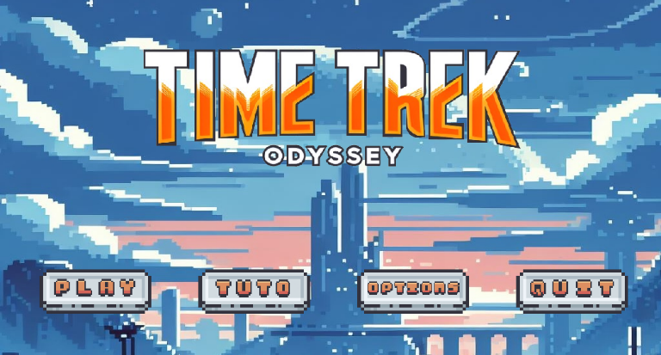

**Fig. 3** Main menu of Time Trek: Odyssey

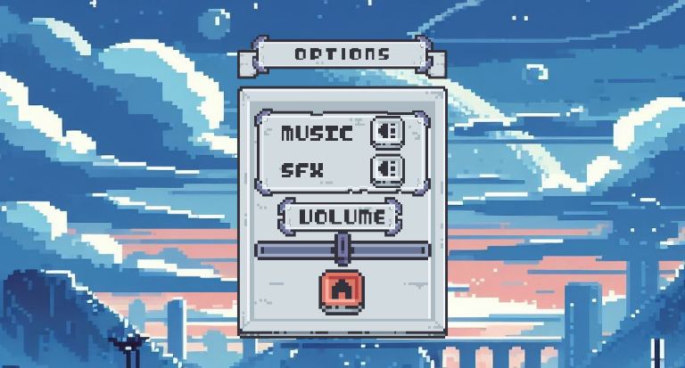**Fig. 4** Options menu of Time Trek: Odyssey

**Fig. 5** Time Trek: Odyssey’s tutorial

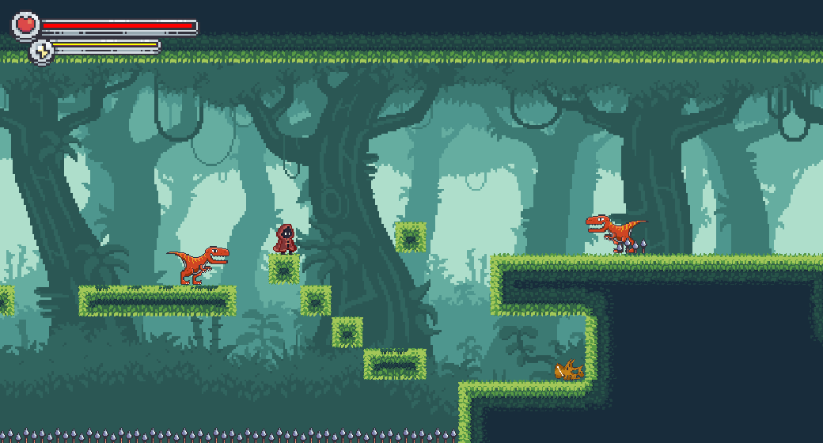

**Fig. 6** Time Trek: Odyssey’s basic gameplay screen

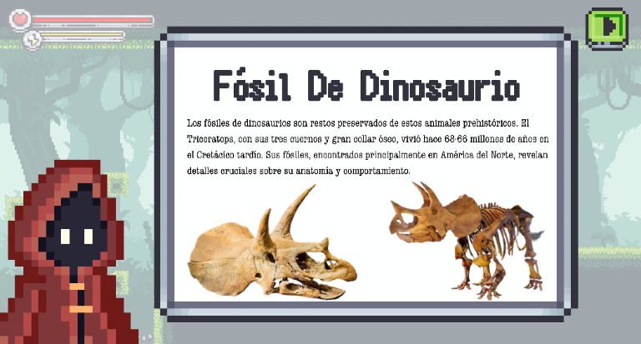

**Fig. 7** Historical object example

# Results

To evaluate the functionality and usability of the video game, a usability test was conducted with a group of 10 high school students between 8th and 9th grade (between 13 and 15 years old) and a history teacher from a school in Barranquilla, Colombia. After they finished playing, navigating, and completing various tasks in the game they provided us qualitative information that we analyzed to improve the user experience.

The questions were designed to assess the degree of user satisfaction and comfort with the interface, design, and dynamics of the game. In addition, we also aimed to determine if the students were able to understand the historical content shown in the game and if they acquired new knowledge about the subject.

The questionnaire has the following questions:

1. Did you find the historical content presented in the game interesting and relevant?

a) Yes, it is very interesting and relevant. b) No, it isn't interesting and relevant. c) It could be better

2. How would you rate the difficulty of the game (very easy, easy, adequate, difficult, very difficult)?

Very easy, easy, adequate, difficult, very difficult.

3. "The game helped me learn historical facts in a fun way." Yes/No

4. Did you feel motivated to investigate more on any historical topic after playing? Yes/No

5. On a scale of 1 to 5, how innovative and attractive did you find the dynamic of collecting historical objects for learning history? (1-5)

6. Would you recommend this game to your classmates?

a) Of course b) Not really

The results obtained from this study were crucial for adjusting and refining the pedagogical approach of the video game. Several areas for improvement were identified, including modifications to the game mechanics, the difficulty of the challenges, the feedback provided, and other key elements. Figures 8, 9, 10, 11, 12, 13 expose these results.

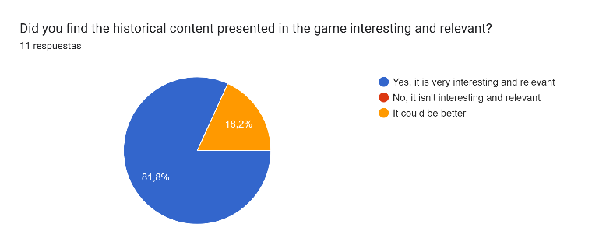

**Fig. 8** Results question 1

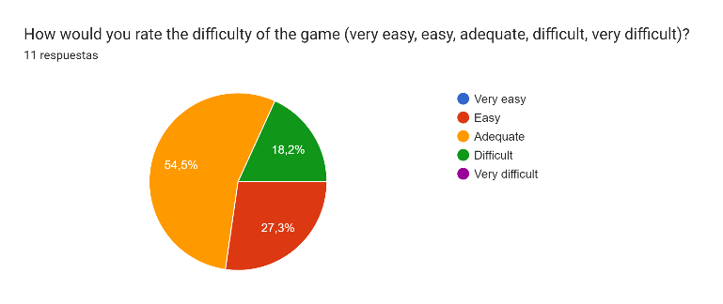

**Fig. 9** Results question 2

Gráfico de respuestas de formularios. Título de la pregunta: "The game helped me learn historical facts in a fun way."
. Número de respuestas: 11 respuestas.**Fig. 10** Results question 3

Gráfico de respuestas de formularios. Título de la pregunta: Did you feel motivated to investigate more on any historical topic after playing?
. Número de respuestas: 11 respuestas.

**Fig. 11** Results question 4

Gráfico de respuestas de formularios. Título de la pregunta: On a scale of 1 to 5, how innovative and attractive did you find the dynamic of collecting historical objects for learning history?
. Número de respuestas: 11 respuestas.

**Fig. 12** Results question 5

Gráfico de respuestas de formularios. Título de la pregunta: Would you recommend this game to your classmates?
. Número de respuestas: 11 respuestas. **Fig. 13** Results question 6

Considering the results obtained from each survey, a positive response from a sample of the target audience is evident. While they suggest implementing new elements and mechanics in the game, as well as moderating the difficulty of the levels, the students also showed curiosity, engagement, and enjoyment when using the software.

# Conclusions

The study conclusively demonstrates the effectiveness and benefits of implementing the Time Trek: Odyssey video game to improve the knowledge of high school students. Through an attractive design, the video game manages to increase students' engagement, motivation and interest in learning. The dynamics of the game are educationally interesting, and there are clear signs of an improvement in users' concentration and attention. The data collected and analyzed from the students evaluated empirically demonstrate the positive impact that the video game has on their learning. This demonstrates the success in meeting the established requirements, both functional and non-functional.

Despite the good test results, the game still has certain limitations. To improve Time Trek, it is suggested that the range of students involved in the tests be broadened to include students from different high school grades. This will allow incorporating elements and correcting errors to offer a more detailed and comprehensive experience for the target audience. In addition, it would be beneficial to have the help and supervision of teachers and experts in History, who could guide the relevance of each era and object of the game, as well as contribute innovative ideas to cover more topics and learning dynamics. Similarly, for the game it is possible to implement new forms of gameplay, checkpoints, different abilities for each enemy, and even new customizations.

In conclusion, the application of Time Trek: Odyssey in the high school educational context has successfully achieved its main objective: to teach history in a fun and engaging way. Although some limitations are evident, it is hoped that these will be overcome with constant changes in the future to develop an even better product. It is noticeable that this idea has had a positive impact on student life; there has been an increase in attention to the topics, greater engagement with homework, and increased motivation to continue learning and researching history. With the necessary updates to the game, is hoped that these results will increase and serve as evidence for more teachers to implement this innovative way of teaching. This proposal seeks to open doors to new learning methods for young people and motivate others to promote changes in the future of education.

##### References

[1] D. Lahera Prieto and F. A. Pérez Piñón, “La enseñanza de la historia en las aulas: un tema para reflexionar,” *Debates por la Historia*, vol. 9, no. 1, pp. 129–154, Jan. 2021, doi: 10.54167/debates-por-la-historia.v9i1.629.

[2] J. Jackson, “Game-based teaching: What educators can learn from videogames,” *Teaching Education*, vol. 20, no. 3, pp. 291–304, 2009, doi: 10.1080/10476210902912533.

[3] J. Carenys, S. Moya, and J. Perramon, “Is it worth it to consider videogames in accounting education? A comparison of a simulation and a videogame in attributes, motivation and learning outcomes,” *Revista de Contabilidad-Spanish Accounting Review*, vol. 20, no. 2, pp. 118–130, Jul. 2017, doi: 10.1016/j.rcsar.2016.07.003.

[4] J. F. Jiménez Alcazar, “La interacción del videojuego en las aulas universitarias: educación e Historia.,” *REIRE*, 2019, doi: 10.1344/reire2020.13.129124.

[5] Vinicius Marino Carvalho, “Videogames as Tools for Social Science History,” *The Historian*, vol. 79, no. 4, pp. 784–819, Jan. 2020.

[6] C. Steinkuehler, “Videogames as a serious medium,” *On the Horizon*, vol. 24, no. 2, pp. 175–178, 2016, doi: 10.1108/OTH-06-2015-0028.

[7] I. S. Evaristo Chiyong, M. V. Vega Velarde, R. Navarro Fernandez, and T. Nakano Osores, “Uso de un videojuego educativo como herramienta para aprender historia del Perú,” *RIED. Revista Iberoamericana de Educación a Distancia*, vol. 19, no. 2, p. 35, Jun. 2016, doi: 10.5944/ried.19.2.15569.

[8] J. M. Sáez-López, J. Miller, E. Vázquez-Cano, and M. C. Domínguez-Garrido, “Exploring Application, Attitudes and Integration of Video Games: MinecraftEdu in Middle School,” 2015.

[9] L. Gilbert, “‘Assassin’s Creed reminds us that history is human experience’: Students’ senses of empathy while playing a narrative video game,” *Theory Res Soc Educ*, vol. 47, no. 1, pp. 108–137, Jan. 2019, doi: 10.1080/00933104.2018.1560713.

[10] Mojang Studios, “Minecraft Education.” 2016.

[11] Ubisoft, “Assassin’s Creed.”

[12] Etermax, “Preguntados.” 2013.

[13] Luis Von Ahn, “Duolingo,” 2011.

[14] E. Wright, “On the promotional context of historical video games,” *Rethinking History*, vol. 22, no. 4. Routledge, pp. 598–608, Oct. 02, 2018. doi: 10.1080/13642529.2018.1507910.

[15] P. J. B. J. Van Den Heede, “‘Experience the Second World War like never before!’ Game paratextuality between transnational branding and informal learning (‘¡Experimenta la Segunda Guerra Mundial como nunca antes!’ La paratextualidad de los videojuegos entre el branding transnacional y el aprendizaje informal),” *Infancia y Aprendizaje*, vol. 43, no. 3, pp. 606–651, Jul. 2020, doi: 10.1080/02103702.2020.1771964.

[16] M. A. Constanzo, “Comparacion de modelos de calidad, factores y metricas en el ambito de la ingeneria de software,” 2014.