Validation of a low-cost myoelectric prosthesis prototype developed with Arduino and 3D printing

José Caicedo-Ortiz1, Nefer Blanchar-García1, Juan Gomez-Betancourt1, Javier Jiménez-Cabas1, Johan Mardini-Bovea1, Yadira Quiñonez2, and Javier Vargas-Duque3

1 Dpto. Ciencias de la computación y electrónica, Universidad de la Costa, Barranquilla, Colombia

2 Facultad de Informática Mazatlán, Universidad Autónoma de Sinaloa, Mazatlán, México

3 Grupo de Investigación en Diseño, Fabricación y Materiales 3D Ingeniería BQ S.A.S, Barranquilla, Colombia

jcaicedo1@cuc.edu.co, nblancha1@cuc.edu.co, jgomez57@cuc.edu.co, jjimenez41@cuc.edu.co, jmardini@cuc.edu.co, yadiraqui@uas.edu.mx, [sr11jvargas@gmail.com](mailto:sr11jvargas@gmail.com),

**Abstract.** This study presents a low-cost, 3D-printed myoelectric prosthetic hand prototype developed in collaboration with 3D Ingeniería BQ and the Universidad de la Costa in Barranquilla, Colombia. The objective is to enhance the quality of life for individuals with amputations. The prototype comprises an Arduino Nano, a Myoware Muscle sensor, MG996 servomotors, and a mobile application created in Xamarin for selecting the functions of the prosthetic hand. The document encompasses an analysis of analogous studies, the selection and integration of components, and trials with end users who validated the prototype's functionality by detecting muscular signals and activating the defined grasping or typing functions within the mobile application. The results highlight the feasibility of utilizing open-source hardware and software to develop accessible prostheses, suggesting system robustness and electromyographic (EMG) signal processing enhancements to improve durability and optimize functionality.

**Keywords:** Myoelectric Prosthesis, Upper Limb, Arduino, 3D printing, Xamarin.

1 Introduction

The World Health Organization (WHO) estimates that 1.3 billion people, or 16% of the global population, have a significant disability. This figure is expected to increase due to the aging of the population and the rising prevalence of noncommunicable diseases, such as diabetes and cardiovascular disease [1]. In Colombia, the DANE reported in 2020 that 7.1% of the population has some disability, including upper limb amputations [2]. Myoelectric prostheses represent an advanced solution for these individuals, allowing natural movements by detecting electrical signals generated by residual muscles [3]. However, these prostheses are expensive and not accessible to many.

To address this need, 3D Ingeniería BQ and Universidad de la Costa in Barranquilla, Colombia, developed a low-cost myoelectric prosthesis prototype using free hardware and software technologies, including Arduino and Xamarin [4], along with 3D printing, to activate the prototype through EMG signals [5]. This project aims to provide an accessible and functional alternative that will improve the quality of life of individuals with upper limb disabilities. The main innovation lies in the communication between the prosthesis hardware and a mobile application, which allows for intuitive and personalized control. This paper presents a comprehensive analysis of similar studies, describes the methodology employed in developing the prototype, outlines the component selection and system implementation process, and presents the results of functional and end-user tests. It concludes with a series of proposals aimed at enhancing the robustness and functionality of the system.

2 Related works

Several studies have investigated the development of low-cost myoelectric prostheses utilizing free hardware technologies, free software, and EMG signal acquisition to trigger movement [6] [7]. In a notable example of low-cost prosthetic development, Fuentes-Gonzalez et al. (2021) created a prosthesis controlled by EEG signals using Neurosky Mindwave 2 and Arduino [8]. The prosthesis is customizable, uses 3D printing, and can make binary movements. However, it is limited to binary movements and dependent on the user's concentration. Similarly, in Wu et al. (2020), an Arduino-based myoelectric system was implemented with OYMotion EMG sensors and a Robo-limb prosthetic hand. This system is notable for its affordability and modularity [9]. However, the evaluation tests were limited to one volunteer, and only two control algorithms were implemented.

Rodrigo Oporto-Tejerina and Tapia-Siles developed a body-powered hand prosthesis using a syringe hydraulic system and accessible materials. The prosthesis has been validated for basic tasks, although its lateral and precision grip performance is limited [10]. Conversely, Canizares et al. (2017) investigate the viability of 3D printing for fabricating cost-effective robotic prostheses, emphasizing rapid customization and accessibility [11]. However, enhancements in motors and control are necessary. Similarly, Nilwong et al. (2019) present the design of a myoelectric robotic hand created using 3D printing and Arduino MEGA, which has been validated in grasping tasks [12]. However, challenges remain in manipulating small objects. In their study, Valadez Palacios et al. (2019) present a 3D-printed prosthetic hand equipped with MG996R servo motors [13]. They highlight the device's low cost and functionality while noting the necessity for improvements in durability and EMG signal accuracy. In the study by Reddy et al. (2023), a low-cost myoelectric arm prosthesis was developed, with 3D printing being its main advantage [14]. However, challenges remain in terms of the durability of materials and the accuracy of EMG sensors. Finally, in [15] a preliminary study for a low-cost bionic hand controlled by EMG signals is presented. The hand is designed using 3D printing and fuzzy logic to improve grip accuracy. The LabVIEW platform is used for real-time EMG data processing, enabling precise movement control. However, challenges remain in latency and hardware configuration.

At the commercial level, Ottobock [16] and Össur [17] have developed advanced prostheses, such as the Michelangelo and the i-Limb Ultra, which offer high functionality. However, the high costs associated with these prostheses limit their accessibility.

In the analysis of these studies, significant limitations were identified in the functionality and durability of low-cost prostheses, as well as the high cost and complexity of commercial prostheses. In this sense, the present proposal places emphasis on the utilization of 3D printing, with the Arduino Nano serving as the central data processing system and a mobile application in Xamarin facilitating intuitive and customized control. This innovative integration of accessible technologies and a focus on customization offers a viable and economical solution for individuals with upper limb disabilities, distinguished by its equilibrium between functionality, cost, and accessibility.

3 Methodology

The methodology employed in this project was structured in several phases, from initial prototype evaluation to final user testing. Each phase was designed to address and solve specific challenges, thereby ensuring the systematic and efficient development of myoelectric prostheses.

3.1 Component selection

Due to its compact size and processing power, the open hardware platform selected for the prototype was the Arduino Nano [18]. Additional options that were considered included the Arduino Uno, Mega, Raspberry Pi [19], and Beagleboard [20]. The Myoware Muscle Sensor [21] was selected for its high accuracy in capturing muscle signals, which converts muscle electrical activity into a voltage signal [22]. Three actuators were evaluated for suitability: the PQ12-R Micro Linear Servo, MG996 Servomotor, and L16-R Linear Servo. The MG996 was selected for its high torque, low cost, and availability. The Bluetooth HC-05 module was selected for its versatility and ability to operate in master and slave modes, facilitating wireless connection with the mobile application.

3.2 Implementation

The integration of the Myoware Muscle Sensor with the muscles of the amputated limb was achieved by establishing a connection between the two, thereby enabling the capture of electromyogram (EMG) signals. Then, these signals were processed by the Arduino Nano, which controlled the MG996 servo motors. The libraries Servo.h and Filters.h were employed to minimize noise and improve accuracy in muscle signal interpretation. Furthermore, a mobile application was developed in Xamarin to control the prosthesis via Bluetooth. The application provides an intuitive interface that allows the user to adjust the intensity of the grip force, change operating modes, and receive real-time feedback (see Fig. 1).

**Fig. 1.** Myoelectric prosthesis connection - Source: own.

3.3 Xamarin

The Xamarin platform was selected for its capacity to facilitate the development of efficient cross-platform applications. The application was designed to ensure ease of use and high responsiveness, enabling optimal user interaction with the prosthesis.

According to the above, the fundamental hand actions were analyzed [23], focusing on the gripping and typing actions, which are paramount for users' daily activities (Fig. 2).

**Fig. 2.** Functions in the app: A. Grasp function - B. Type function - Source: own.

The grasping function was designated as the default when the prosthesis was activated, enabling users to grasp and manipulate objects of varying sizes and shapes (see Fig. 3). The mobile application, developed in Xamarin, allows users to switch between the grasping and typing functions according to their needs. The typing function facilitates typing on keyboards by detecting and processing EMG signals, activating the servomotors in precise and rapid movements.

**Fig. 3.** Execution of functions: A. Grasp function - B. Type function - Source: own.

4 Tests

4.1 Functional tests

Initial tests were conducted with the development team to identify and rectify anomalies in the prosthesis. Hardware and software were integrated to ensure the accurate capture of myoelectric signals and actuator response. The adjustments made in the programming of the Arduino and the configuration of the mobile application optimized the system's performance, demonstrating precision in replicating desired movements.

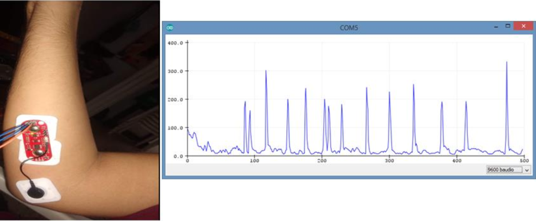

**Fig. 4.** Myoelectric signals person without upper limb amputation - Source: own.

4.2 End-user testing

A total of 50 users with varying degrees of amputation participated in the study, designed to comprehensively evaluate the prosthesis's functionality and usability. The evaluation was primarily based on the prosthesis's functionality and usability as accessed through the mobile application developed in Xamarin. Qualitative and quantitative user experience data were collected and described below:

1. **Accuracy of movements**: This metric assesses the capacity to replicate natural hand movements, with a score of 10 indicating optimal accuracy and a score below 6 indicating the presence of significant errors.
2. **Ease of use of the application**: This criterion assesses the degree of intuitiveness and ease of use, with a rating of 10 indicating a high degree of intuitiveness and a rating of less than 6 indicating a need for assistance.
3. **Overall satisfaction**: This measure assesses the overall satisfaction with the device on a scale 10, with 10 indicating complete satisfaction and a score below 6 indicating areas that require improvement.
4. **System robustness**: This criterion assesses the system's durability and reliability, with a rating of 10 indicating a highly robust system and a rating of less than 6 indicating a system that is prone to frequent failures.
5. **Effectiveness of replicated movements**: This instrument assesses the capacity to perform fundamental motor actions, with a rating of 10 indicating optimal effectiveness and less than 6 indicating suboptimal effectiveness.

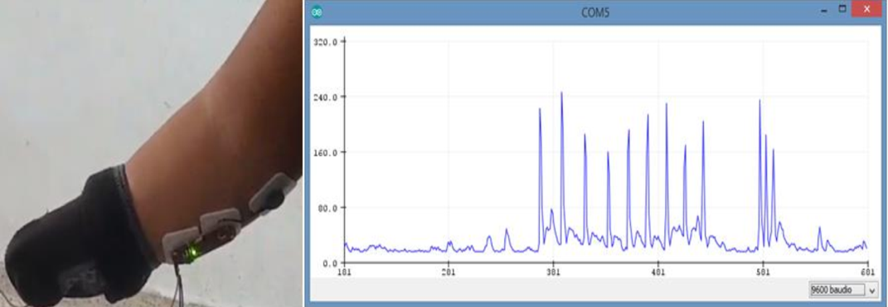

**Fig. 5.** Myoelectric signals for upper limb amputee - Source: own.

5 Analysis of results

The results demonstrated high satisfaction among the 50 users who participated in the tests. They particularly highlighted the movements' accuracy and the mobile application's ease of use. The mean scores obtained were as follows: The mean scores for the variables mentioned above were as follows: 8.2 for movement accuracy, 8.4 for ease of use of the app, 8.3 for overall satisfaction, 7.0 for system robustness, and 8.3 for effectiveness in replicating movements. For a visual representation of these findings, please refer to Fig. 6. These results demonstrate that the prosthesis is generally effective and well-received by users, offering precise control and an intuitive user experience. The high scores for ease of use of the application and overall satisfaction reflect the success of designing an accessible and functional user interface. Furthermore, the scores for motion accuracy and effectiveness in replicating movements suggest that the prosthesis can accurately perform the essential functions required, reliably replicating the movements of the human hand.

**Fig. 6.** Usability evaluation of the myoelectric prosthesis - Source: own.

The data collected substantiate the evaluations and outcome analyses, demonstrating the overall effectiveness and satisfaction with the developed prosthesis. Concurrently, they identify areas for future improvements, such as system robustness and EMG signal processing optimization, which will direct the continued development and optimization of the device to enhance the user experience further.

5 Discussion and Conclusion

4.1 Discussion

This low-cost prototype has demonstrated that creating a functional and cost-effective prosthesis using commercially available components and technologies is feasible. The selection of open-source platforms, such as Arduino and Xamarin, was instrumental in maintaining low costs and enabling substantial flexibility in the system's design and implementation. These components facilitated programming and integration, providing a robust and scalable foundation for future enhancements.

4.1.1 Main advantages

1. Reduced cost: The utilization of accessible components and open-source technologies has created a prosthesis that is significantly more affordable than commercial alternatives, facilitating greater accessibility for individuals with economic limitations.
2. User-centric design: The mobile application developed in Xamarin provides users with straightforward and efficient control of the prosthesis, thereby enhancing their experience regarding the customization of movements.
3. Design flexibility: 3D printing enables the customization of prosthesis design to individual requirements, enhancing comfort and functionality and facilitating rapid and cost-effective iteration.

4.1.2 Improvement areas

1. System robustness: It is imperative to enhance the durability of components to guarantee dependable functionality in diverse environmental and operational contexts. This necessitates the utilization of more resilient materials and construction methodologies [15].
2. Latency: The Arduino's latency and the servo motor's speed can impact the system's overall speed.
3. EMG signal optimization: Enhancing EMG signal filtering and processing will augment the precision and responsiveness of actuators, thereby facilitating more natural and efficacious movements [24][25].
4. Expansion of functionalities: The prosthesis is being enhanced with additional functions and movements, extending its adaptability to encompass a broader spectrum of daily activities.
5. Clinical trials and long-term evaluation: Conducting long-term clinical studies to evaluate the prosthesis's impact on the users' quality of life is crucial. This will provide valuable insights for continuously improving the design based on the results.

This prototype demonstrates that the integration of accessible and low-cost technologies can result in a functional myoelectric prosthesis that improves users' quality of life. To maximize the project's impact and sustainability, it is crucial to continue researching and improving the system's robustness and signal processing accuracy. Continued collaboration between researchers, developers, and end users will be essential to advancing more advanced and accessible prosthetic solutions.

4.1 Conclusion

The development of a low-cost myoelectric prosthesis using free hardware and software technologies has demonstrated the feasibility and efficacy of this approach and the potential to significantly enhance the quality of life for individuals with upper limb disabilities. The results obtained validate the effectiveness of the implemented system, demonstrating the accuracy of the myoelectric sensors and the actuators' capacity to replicate the human hand's natural movements. The integration with an intuitive mobile application developed in Xamarin facilitates the control of the prosthesis and marks a significant leap in enhancing the user experience.

This project establishes a noteworthy precedent in the advancement of accessible and customizable prostheses. Nevertheless, areas for improvement were identified, including system robustness and optimization of EMG signal processing [26]. Future research should concentrate on enhancing component durability, developing more sophisticated algorithms for EMG signal processing [27], and expanding the capabilities of the prosthesis to encompass a broader range of functions and movements. Sustained collaboration between researchers, developers, and end users will be pivotal to propel the advancement of more sophisticated and accessible solutions in the domain of prosthetics.

Acknowledgments

The authors would like to thank the Universidad de la Costa and the company 3D Ingeniería BQ for their invaluable collaboration in developing this low-cost myoelectric prosthesis prototype. Their support and commitment to technological innovation have been fundamental to the success of this project. Furthermore, the authors would like to extend their gratitude to the users who participated in the tests, whose feedback was essential to validate and improve the functionality of the prosthesis.

References

1. WHO. (2024). Disability. Retrieved July 1, 2024, from <https://www.who.int/news-room/fact-sheets/detail/disability-and-health>
2. DANE. (2020). Panorama general de la discapacidad en Colombia. Retrieved from <https://dane.gov.co>
3. Nawrocka, A., Nawrocki, M., & Kot, A. (2021). Implementation of EMG Signal Measurement for the Control of the 3D Hand Prototype. In 2021 22nd International Carpathian Control Conference (ICCC) (pp. 1-4). IEEE. <https://doi.org/10.1109/ICCC51557.2021.9454628>
4. Microsoft. (2024). Xamarin. Retrieved July 1, 2024, from <https://dotnet.microsoft.com/es-es/apps/xamarin>
5. Snajdarova, M., Barabas, J., Radil, R., & Hock, O. (2018). Proof of Concept EMG-Controlled Prosthetic Hand System - An Overview. In 19th International Conference Computational Problems of Electrical Engineering (pp. 1-4). IEEE, Banska Stiavnica, Slovakia. <https://doi.org/10.1109/CPEE.2018.8506896>
6. M Seo, M., Yoon, D., Kim, J., & Choi, Y. (2015). EMG-based prosthetic hand control system inspired by missing-hand movement. In 2015 12th International Conference on Ubiquitous Robots and Ambient Intelligence (URAI) (pp. 290-291). IEEE. <https://doi.org/10.1109/URAI.2015.7358955>
7. Ayachi, M., & Seddik, H. (2021). Design and Control of Multifunctional, Multiarticulate Prosthetic Hand. In Advances in Information and Knowledge Processing (pp. 3-29). Springer. <https://doi.org/10.1007/978-3-030-14939-0_1>
8. Fuentes-Gonzalez, J., Infante-Alarcon, A., Asanza, V., & Loayza, F. R. (2021). A 3D-Printed EEG based prosthetic arm. In 2020 IEEE International Conference on E-Health Networking, Application & Services (HealthCom) (pp. 1-5). IEEE. <https://doi.org/10.1109/HEALTHCOM49281.2021.9399035>
9. Wu, H., Dyson, M., & Nazarpour, K. (2020). Arduino-based embedded system for myoelectric hand prostheses. In 2020 27th IEEE International Conference on Electronics, Circuits and Systems (ICECS) (pp. 3-6). IEEE. <https://doi.org/10.1109/ICECS49266.2020.9294843>
10. Oporto-Tejerina, F. R., & Tapia-Siles, S. C. (2023). Design and Prototyping of Low Cost, 3D Printed Body Powered Hand Prosthesis for Transradial Amputees in Bolivia. In 2023 11th International Conference on Control, Mechatronics and Automation (ICCMA) (pp. 386-391). IEEE. <https://doi.org/10.1109/ICCMA59762.2023.10374745>
11. Canizares, A., Pazos, J., & Benitez, D. (2017). On the use of 3D printing technology towards the development of a low-cost robotic prosthetic arm. In 2017 IEEE International Autumn Meeting on Power, Electronics and Computing (ROPEC) (vol. 2018-Janua, pp. 1-6). IEEE. <https://doi.org/10.1109/ROPEC.2017.8261579>
12. Nilwong, S., Hossain, D., Petoku, E., & Capi, G. (2019). Development of Myoelectric Robotic Hand using 3D Printer. In 1st International Conference on Advanced Science, Engineering and Robotics Technology (ICASERT) (pp. 1-4). IEEE. <https://doi.org/10.1109/ICASERT.2019.8934505>
13. Valadez Palacios, A., Luviano Cruz, D., Garcia Luna, F. J., & Garcia Villalba, L. A. (2019). Diseño y Construcción de una Prótesis de Mano Controlada por Medio de un Sensor Mioeléctrico. Sinergia Mecatrónica, 28, 350-362.
14. Reddy, B. N., Raj, M. B., Reddy, B. P., & Shwetha, G. (2023). Prosthetic Arm for Amputees. In 2nd IEEE International Conference on Vision Towards Emerging Trends in Communication and Networking Technology (ViTECoN) (pp. 1-5). IEEE. <https://doi.org/10.1109/ViTECoN58111.2023.10157030>
15. Ben Abdallah, H., & Bouteraa, Y. (2023). A new design of a bionic hand controlled by EMG signals: A preliminary study. In 2023 20th International Multi-Conference on Systems, Signals & Devices (SSD) (pp. 318-322). IEEE. <https://doi.org/10.1109/SSD58187.2023.10411297>
16. Ottobock. (2024). Michelangelo hand. Retrieved July 1, 2024, from <https://www.ottobock.com/en-us/product/8E500>
17. Össur. (2024). Prótesis de mano biónica i-Limb® Ultra. Retrieved July 1, 2024, from <https://www.ossur.com/es-es/protesica/miembro-superior/i-limb-ultra>
18. Arduino. (2024). Arduino Nano. Retrieved July 1, 2024, from <https://store.arduino.cc/products/arduino-nano>
19. Raspberry Pi. (2024). Raspberry Pi. Retrieved July 1, 2024, from <https://www.raspberrypi.com/>
20. BeagleBoard. (2024). BeagleBoard - open hardware computers for makers, educators and professionals. Retrieved July 1, 2024, from <https://www.beagleboard.org/>
21. Advancer Technologies. (2015). Myoware datasheet. Retrieved from <https://github.com/AdvancerTechnologies/MyoWare_MuscleSensor/raw/master/Documents/AT-04-001.pdf>
22. Roy, R., & Udupa, G. (2022). Design and Analysis of Soft Prosthetic Hand based on Asymmetric Flexible Hydraulic Actuator. In International Conference on Computational Communication & Security and Intelligent Systems (IC3SIS) (pp. 1-7). IEEE. <https://doi.org/10.1109/IC3SIS54991.2022.9885620>
23. Amparo, L., López, A., Segundo, M., & Departamento, H. (2012). Biomecánica y patrones funcionales de la mano. Sinergia Mecatrónica, 4(1), 14-24.
24. Salman, A., Iqbal, J., Izhar, U., Khan, U. S., & Rashid, N. (2012). Optimized circuit for EMG signal processing. In 2012 International Conference on Robotics and Artificial Intelligence (ICRAI) (pp. 208-213). IEEE. <https://doi.org/10.1109/ICRAI.2012.6413390>
25. Kamal, M. S., Efaz, E. T., Alam, M. F., Rana, M. M., Sakib, S. N., & Islam, S. M. M. (2020). Development of A Low-Cost Real-Time Bioelectrical Signal Acquisition Module. In 2020 2nd International Conference on Sustainable Technology in Industrial 4.0 (STI) (pp. 19-20). IEEE. <https://doi.org/10.1109/STI50764.2020.9350473>
26. Raurale, A. (2014). Acquisition and processing real-time EMG signals for prosthesis active hand movements. In IEEE International Conference on Green Computing, Communication and Electrical Engineering (ICGCCEE) (pp. 1-6). IEEE. <https://doi.org/10.1109/ICGCCEE.2014.6922225>
27. Huaman Levano, L. A., & Huamanchahua, D. (2022). Biomechanical Prosthesis with EMG Signal Acquisition for Patients with Transradial Amputation. In 2022 IEEE International IOT, Electronics and Mechatronics Conference (IEMTRONICS) (pp. 1-5). IEEE. <https://doi.org/10.1109/IEMTRONICS55184.2022.9795779>