Optimization project with Artificial Intelligence for Quality Control in Measurement Equipment: Aeronautical Sector

*Abstract* **— Context: Manufacturing in Industry 4.0 of the Aerospace Sector.**

**Objective: Improvement of Efficiency in assembly line in manufacturing in industry 4.0 using Artificial Intelligence Models.**

**Method: Apply Scrum to design data acquisition through smart sensors and in test stations for storage in a database to control and optimize the efficiency of measurement in production lines in industry 4.0.**

**Results: There is already stored part record information in the SQL database to determine and classify the causes of failures, to take actions to improve efficiency. With the development in Python, the units are classified according to the type of failure using a “k-means” AI algorithm for automatic classification and finding the root causes of these failures. With this information it is intended to improve the efficiency of the First Pass Yield by at least 5%.**

**Conclusions: The automation of data capture and measurements by intelligent sensors and test equipment on the assembly line helps us to have a real time data for determining improvement actions for efficiency and continuous improvement of this Efficiency metric.**

**Keywords – Industry 4.0, BIG DATA, Artificial Intelligence, Smart Sensors, Machine Learning.**

# I. INTRODUCTION

1. PROBLEM

In the manufacturing company of the aeronautical sector, under analysis of this project, it does not have a Process control system that helps to analyze and control the efficiency of a manufacturing line in real time and that can, in turn, quickly select the type of failure that occurs to carry out quick and efficient actions.

1. PURPOSE

To analyze, controlling, and clustering the types of failures in an assembly line to determine actions through AI to make the production line more efficient in context of the industry 4.0. Thus, this system will improve efficiency and also improve the quality of the product in its manufacture, reduction of waste in time, parts, energy, and costs related to the operator's work. To achieve this, this AI-based development project is proposed, formulated, as well as this application to an Alpha test level.

1. JUSTIFICATION

The line of research is focused on non-linear control (Industrial Computing and Robotics), Machine Learning and Neural Networks, since in an industrial environment there are many variables that affect the correct performance of production efficiency. In the case of research, it is proposed to implement a control system for the following variables (Figure 1):

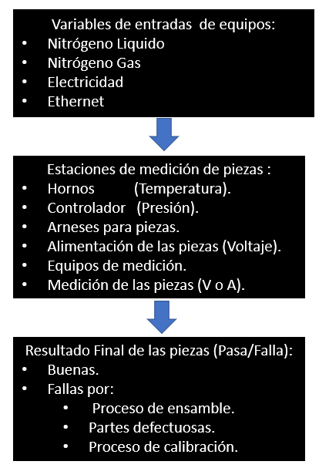

Figure 1. Variables of the measurement with the IA system.

When the manufacturing process gets out of control, a lot of waste is generated because the products must be reworked, many products are sealed and metallic, so rework is very expensive. Efficiency, production and material capacities are impacted by these process failures, not to mention delays in deliveries to the end customer that also cause penalties for late delivery.

Currently, there is no exact data on low efficiency, since there is not yet all the information available in the database, so only a projection of this metric is made. As there is not enough data to analyze , it is very difficult to determine the root cause of the problem, so it would be intended to obtain the necessary information and adapt it to [1] parameters of the field of artificial intelligence, which is based on techniques and methods that allow solving problems, individually or in combination with other similar methods. Consequently, for those tasks of classification, identification and/or diagnosis, in which the balance of data/knowledge leans towards the data and their relationships.

Using artificial intelligence techniques, a comprehensive vision is established between aspects of behavior and human intelligence. [2] It is intended to structure and give the control system the ability to learn from data according to Machine Learning tasks as shown in Figure 2.

[2] Figure 2. ML structure.

[3] Machine learning techniques are evolving and are being applied in algorithms for intelligent decision-making, [4] explores how AI has evolved from games and [5] illustrates how the impact of AI is evolving for social good.

With this type of task, it is proposed to give the system the ability to learn from the data so that it knows how to react to changes in variables and intelligently react to these variations and carry out an effective and efficient control of the system. With this new trend, autonomous learning is enriched by data tasks of classification, regression, and clustering, in essence machine learning. The following image in Figure 3 explains the activities related to Machine Learning that will be used for the management of information. Likewise, in Figure 4 it is shown how an application of a control system in a production line is:

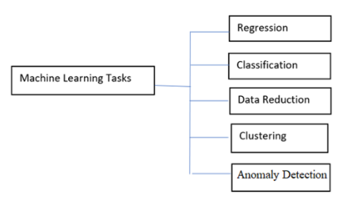

Figure 3. Tasks associated with ML.

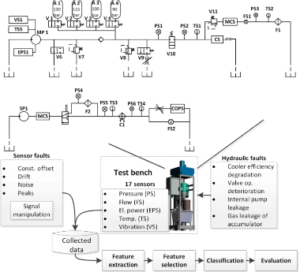

Figure 4. Application in production under control system.

[6] Industry 4.0 is the era of robots and data management, case studies and methods of this type of industry 4.0 are mentioned in [7] and [8].

D) GENERAL OBJECTIVE

Design a system that can replace traditional feedback systems with improved feedback and feedforward systems. Optimize a quality control system based on artificial intelligence, BIG DATA and IoT technology that drives the improvement of operation efficiency over traditional systems.

E) SPECIFIC OBJECTIVES

1. *Determine the operating requirements for current quality control systems and their measurement mechanisms.*
2. *Identify alternatives for improvement and optimization based on intelligent systems and BIG data applied to industry 4.0 (such as sensors).*
3. *Select the best option of the general efficiency control system for all equipment (intelligent monitor), to formulate the development project.*
4. *Formulation of the project specifications to develop the application of categorization of failures and errors in the system through AI decision-making.*

F) HYPOTHESIS

With the new efficiency control system, the quality of manufacturing will improve, reduce waste of materials, machine time, labor time and improve the delivery of products to our customers in a manufacturing industry and will enhance the new trend of industry 4.0.

# II. THEORETICAL FRAMEWORK

It is proposed to create a total efficiency control system to analyze the information in real time, to anticipate/predict if the process gets out of control and take immediate actions to avoid and/or reduce waste. This program/algorithm will have interaction between all the component equipment of the system as if it were a local information network. All this information will be stored in a database (data mart) so that the system can learn and make decisions on actions efficiently [21]. It is intended that the efficiency control system has the ability to interact with all the equipment in real time, to categorize each efficiency failure and could associate it to a cause defined by previous cases, by all the information that is entered from the same system. Figure 5 illustrates a graphical version of a possible control system in machine learning.

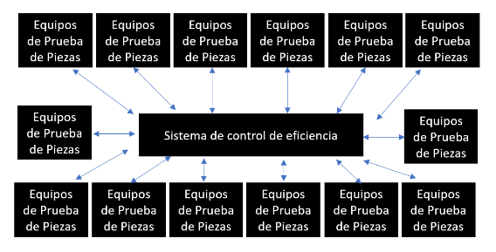

Figure 5. Interaction of the system with the measuring equipment.

Some guides on how to apply machine learning are mentioned in [9], all this leads to a decentralized information process as mentioned in [10] and we are shown some examples and developments of blockchain platforms in [11] and [12].

With this information stored from the production devices, it is intended to complement it with a Statistical Process Control, which allows diagnosing, controlling as well as correcting problems within the manufacturing lines themselves.

[13] BIG DATA can access techniques for converting raw information into real business results, so these techniques (e.g. data mining) can support the effective use of the information, so that it can be used for the effective control of the production line process. Likewise, in [14] BIG DATA is useful for information evaluation processes and information analysis models. In fact, these models can be applied in the measurements of environmental control or environments of continuous organizational improvement [15], and even to carry out automation of these same systems as mentioned in [16] and [17]. Indeed, the purpose of all these algorithms is to support predictive control methods.

1.- Analysis and Structure of the information

The structuring of the information of the variables that would influence the proposed control system is intended to be carried out, according to neural network techniques, which according to [18], neural networks are simplified models of the functioning of the nervous system. The basic units are neurons, which are usually organized in layers, as shown in Figure 6:

Figure 6. [18] Structure of a neural network.

A neural network is a more understandable model that emulates the way the human brain processes information: It works by simulating many interconnected processing units that look like abstract versions of neurons. Processing units are organized into layers. There are three parts typically in a neural network: an input layer, with units representing the input fields; one or more hidden layers; and an output layer, with a unit or units representing the target field(s).

The units are connected with weighted connection forces. The input data is presented in the first layer, and the values are propagated from each neuron to each neuron in the next layer. At the end, a result is sent from the output layer.

In the input layer all the data of the control variables will be stored, in the hidden layers the necessary processing will be carried out to obtain in the output layer; the necessary actions to gradually improve efficiency through improvement actions for each case categorized by the control system.

2.- Optimization of measurement equipment

Optimize and redesign the measurement equipment individually so that, as a whole, they are able to control the variables of the system effectively and prevent them from getting out of control and in the event that an out-of-control variable occurs, the measurement equipment can make the correct decision of the action to take in real time and avoid the crash of the test (Figure 7).

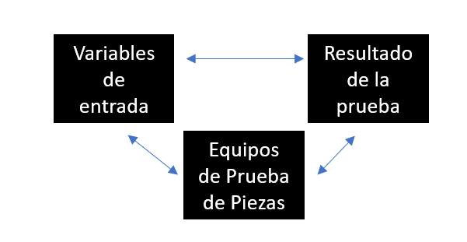

Figure 7. Information on the measuring equipment.

To improve the control process of the measurement equipment, intelligent sensors will be used to improve the response time, resolution and accuracy to make the measurements of the variables in question. By carrying out a real-time control of the variables involved in the measurement of the output of the product, it is intended to carry out an effective measurement of the products themselves, mishaps of falls due to out-of-control variables in the measuring equipment. In fact, in some cases there is no appropriate control method in some equipment, since only the conditions of temperature, voltage and pressure are applied in the case of study, but without an effective control method, so the performance of these equipment is very low.

With the use of intelligent sensors for decision-making in an industrial problem as in this case, the decision will be made in real time supported by automatic identification, to activate and improve the decision-making of the dynamic scheduling of tasks in the industrial environment and quality control [19].

3.-Generation of intelligent monitor

It is proposed to develop an intelligent reporting program so that possible recommendations are sent by mail to production line support so that they can take the required actions and corrections more quickly, thus minimizing latency, which increases the risks of low efficiency.

4.-Definition of medium and long-term actions

It is proposed with the information obtained by the smart monitor to establish monthly actions to improve the metric.

5.-Generation of a daily report of the effectiveness metric by mail.

It is proposed to generate a daily report by mail of the effectiveness metric with the information obtained to inform the management of the progress of this metric.

6.- Control the efficiency of the production line in terms of quality.

It is proposed to establish real limits of efficiency for the production line and to define the plan to achieve that level.

# III. DEVELOPMENT METHODOLOGY

[20] Scrum is a framework through which people can address complex adaptive problems, while efficiently and effectively delivering products with maximum value. Specifically, Scrum has the following features:

* Light and simple to understand, which is due to its perfectly defined structure.
* Difficult to master, since its practice requires a lot of effort and perseverance at all stages of development.

Its techniques and processes can be used interchangeably to achieve project objectives (effectiveness). With Scrum, continuous improvement will be achieved both in processes and in the team and their work. In summary, the components of the Scrum framework are:

* The Scrum team and their respective roles.
* Events.
* Artifacts.
* Associated rules.

These components are a series of people with assigned roles, who use tools according to the appropriate techniques (soft skills), in different periods of time or events and who are guided by specific rules of action (know where, know when), to complete a project. In other words, each component must fulfill its function and must relate in the right way with the rest of the team, to achieve the success of the framework.

Scrum Pillars:

The Scrum framework is based on process control theory, empirical or empiricism, which means that it is based on knowledge from experience and based on this acquired knowledge, makes the relevant decisions. There are three pillars that support the full weight of empirical process control implementation:

* Transparency: The significant aspects of the process must be visible to everyone who is responsible for the result. These aspects must always be defined around the same standard, so that all the people involved understand the same thing. Both the people in charge of performing the work and those inspecting the increment should also share a common definition of "Done." (This term will be defined later.)
* Inspection: The purpose is to detect anomalies in the process, so users who use Scrum must frequently perform inspections on the artifacts and progress towards the goal. These inspections should not interfere with the work of the team, so it is recommended that they be carried out by professionals within the work environment.
* Adaptation: The adaptation process will take place when inspectors determine that one or more aspects of the process do not meet accepted tolerances. Therefore, the material or process that is being carried out will have to be adjusted/adapted to achieve the final goal.

[20] These pillars will be visible throughout the development process of a project that is carried out using the Scrum framework. They can be found in the events and artifacts used by the team at all times, and their correct application is essential to achieve the success of the work. Table 1 specifies the steps of the methodology.

Table 1. SCRUM activities of the project.

|  |
| --- |
| SCRUM |
| 1. Define what you want to achieve |
| * Gathering information from the teams and processes involved. |
| * Use smart sensors to monitor variables that affect the measurement process. |
| * Store all information in an electronic medium. |
| * Manage information to determine defined patterns of the system. |
| * Feeding the system of possible causes of the defined patterns. |
| * Implementation of the control system to warn of incidents and provide containment actions. |
| 2. Organize a team. Support Team |
| 3. Organize by priorities Staff |
| 4. Plan the first sprint. Engineering |
| 5. Develop and execute. Engineering |
| 6. Review the first results. Staff |
| 7. Make a retrospective of the project. Staff |
| 8. Start the next cycle of sprints immediately. Staff |

# IV. THE PROJECT SUBSTANTIVE ACTIVITIES

* Definition and analysis of measurement equipment.
* Definition of all the variables involved in the control system.
* Analysis of the infrastructure necessary to carry out the project.
* Creating a GANTT with activities defined with dates.
* Purchase of equipment necessary for the project in case sensors are needed.
* Implementation and programming of the pilot system for monitoring and control of equipment.
* Validation of the effectiveness of the system.
* Release to the production area.

#### SCOPE OF THE PROJECT

This project is focused on monitoring and controlling the measurement data from all workstations in a production environment focused on industry 4.0, so that artificial intelligence algorithms/programs know how to react to changes in measurements and can take the necessary actions to control the system.

#### DELIVERABLE SPECIFICATION

* Analysis and compilation of current system.
* Proposal of changes in the measurement equipment and the definition of the control system.
* Documentary evidence on the development of a control system.
* Operating methodology.

#### SCHEDULE OF ACTIVITIES

The following schedule of activities in table 2 was defined for the implementation of this project:

Table 2. Schedule of activities.

#### DEVELOPMENT REQUIREMENTS

The project will be implemented in the production area with the current equipment infrastructure, to which the new smart sensors and the modification of the software for their control will be added.

#### RESOURCES AND INFRASTRUCTURE FOR THE EXECUTION OF THE PROJECT

The project will be implemented with the company's internal resources and infrastructure where the prototype control system will be developed.

A server with a SQL database will be used to store the data of the measurements of the measuring equipment and each workstation will have a computer that will feed this data from this database. The monitoring and control system will be housed on the same server as shown in Figure 8.

Figure 8. System proposal.

#### PROJECT IMPLEMENTATION

Currently, the project has already implemented smart sensors in the production area of the manufacturing company. As shown in Figure 9.

Figure 9. Implementation of smart sensors.

The SQL database already has records of tested units, as illustrated in Table 3.

Table 3. Registration of units in the database.

|  |  |  |  |
| --- | --- | --- | --- |
| Test Station | Units tested | | |
| Bad | Good | Total |
| PT_01 | 2,070 | 4,607 | 6,677 |
| PT_02 | 328 | 652 | 980 |
| PT_03 | 715 | 1,813 | 2,528 |
| Grand Total | 3,113 | 7,072 | 10,185 |

Work is being done on the categorization of the type of failures to be able to train the AI to perform the process automatically, using a Python application for this implementation. Specifically, It has been applied the k-mean algorithms to clustering the groups for the categorization purpose (Alpha test), Using the measurements of temperature, supply voltage, Unit output voltage and pressure, a group of categorization of the failures can be carried out to determine a possible improvement action in the process by production line, as it shown below in the figure 10.

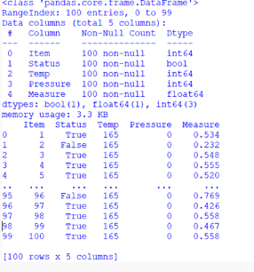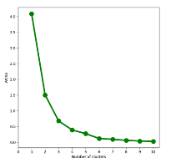

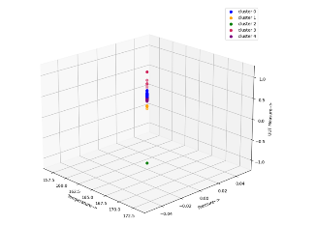

Figure 10. Python application results.

In this first phase, 5 categories were identified corresponding to common failures due to repair of units in Table 4:

Table 4. Parts failure categories.

|  |  |
| --- | --- |
| FAILURE DESCRIPTION | CLUSTER |
| CALIBRATION | 1 |
| PWA SENSOR SIGNAL CONDITIONING | 2 |
| SENSOR/PRESSURE FITTING ASSEMBLY | 3 |
| EMI FILTER | 4 |
| SOLDERING ISSUES. | 5 |

The categorization information is intended to group faults according to their parts’ repairment history so that the algorithm can predict what type of repair the system will recommend for the repair of the unit. As more information is entered into the system, the application will be trained to make the repair more efficient.

# V. CONCLUSIONS

This project aims to provide an alternative for continuous improvement of measurement processes in industry 4.0, since, with an intelligent control method, with the ability to learn from the information that the same system stores as raw data from the measurement variables and/or smart sensors. Consequently, this knowledge-base system tends to improve actions based on the experience acquired by the information and this develops a better decision making of actions to make them more assertive and efficient as a whole, it is intended to improve the metric of efficiency in the company's production manufacturing.

With the information obtained by the smart sensors during these months, it was found that variables such as ambient temperature, nitrogen pressure and supply voltage directly affect the quality of the measurement of the products so they must be controlled automatically. The improvement that is intended during this project is an automatic control of the variables to avoid affecting the quality and in addition, the system of categorization of failures will be carried out automatically using this information (BIG DATA) and the decision making of the AI will be carried out with the information fed by the diagnostic technicians of the parts and by the engineering department. So, the more the system is fed, the more efficient this determination will be and the better the control actions of the system will be.

#### BIBLIOGRAPHIC REFERENCES

1. Rivas Asanza/ Bertha Mazón Olivo. "Artificial Neural Networks Applied to Pattern Recognition." Editorial Utmach. 2018
2. Roiman Balbuena "Artificial Intelligence Advanced Scientific Research Focused on Data". 2021
3. Cruz-Benito, A. Vázquez-Ingelmo, J. C. Sánchez-Prieto, R. Therón, F. J. García-Peñalvo y M. Martín-González, "Enabling adaptability in web forms based on user characteristics detection through A/B testing and machine learning," IEEE Access, 2018.
4. Hansen Hsu. “AI and Play, part 1: How Games Have Driven two Schools of AI Research, Computer History Museum”. https://computerhistory.org/blog/ai-and-play-part-1-how-games-have-driven-two-schools-of-ai-research/ 2020.
5. Tomašev, N., Cornebise, J., Hutter, F. et al. “AI for Social Good: Unlocking the Opportunity for Positive Impact”. Nat Commun 11, 2468, 2020.
6. Bayram B., İnce G. “Advances in Robotics in the Era of Industry 4.0\: Managing the Digital Transformation”, Springer, Cham pp. 187-200. 2018
7. Lee, H. Davari, J. Singh, V. Pandhare, “Industrial Artificial Intelligence for industry 4.0-based manufacturing systems,” Manuf. Lett., vol. 18, pp. 20–23, 2018.
8. Karacay G., Aydın B. “Internet of things and new value proposition Industry 4.0: Managing the Digital Transformation”, Springer, Cham , pp. 173-185. 2018
9. Mehrabi, Ninareh, et al. “A Survey on Bias and Fairness in Machine Learning”. arXiv preprint, 2019
10. Fraga-lamas, “A Review on Blockchain Technologies for an Advanced and Cyber-Resilient Automotive Industry,” IEEE Access, vol. 7, doi:10.1109/ACCESS.2019.2895302. 2019.
11. Teslya, I. Ryabchikov, “Blockchain Platforms Overview for Industrial IoT Purposes,” 22nd Conference of Open Innovations Association (FRUCT), Jyvaskyla, pp. 250-256, 2018.
12. Zhai et al. “Research on the Application of Cryptography on the Blockchain,” J. Phys.: Conf. Ser.1168 032077, doi: 10.1088/1742-6596/1168/3/032077. 2019
13. Bernard Marr.” BIG DATA” Tell Editorial S.L. 2017.
14. Cañete, José, Gabriel Chaperón, Rodrigo Fuentes, y Jorge Pérez. “Spanish pre-trained Bert Model and Evaluation Data”. PML4DC at ICLR 2020.
15. Gawankar S.A., Gunasekaran A., Kamble S. “A study on investments in the big data-driven supply chain, performance measures and organizational performance in Indian retail 4.0 context International Journal of Production Research”, 58 (5), pp. 1574-1593, 2020.
16. Javier Miranda, Rob Sesmans “Data Measures Automation in U.S. Businesses United states Census Bureau” November 03. 2020.
17. Wassouf W.N., Alkhatib R., Salloum K., Balloul S. “Predictive analytics using big data for increased customer loyalty: Syriatel Telecom Company case study Journal of Big Data”, 7 (1), pp. 1-24, 2020.
18. IBM "The Neural Network Model. https://www.ibm.com/docs/es/spss-modeler/SaaS?topic=networks-neural-model." 2021
19. Coito.; Firme, B.; Martins, M.S.E.; Vieira, S.M.; Figueiredo, J.; Sousa, J.M.C. “Intelligent Sensors for Real-Time Decision-Making.Automation.” 2021.
20. Tania Fernández "Study of agile methodologies in the management of industrial projects.", 2021.
21. AWS "What is a data mart?". https://aws.amazon.com/es/what-is/data-mart/ 2024.