Enhancing Electric Network Solutions: A Comparative Study of Homotopy and Accelerated Gauss-Seidel Methods

Yadira Quiñonez1, Oscar Zatarain1, Carmen Lizarraga1, and Juan C. Elizondo-Leal2,

1 Facultad de Informática Mazatlán, Universidad Autónoma de Sinaloa, Mazatlán, México

2 Facultad de Ingenieria y Ciencias, Universidad Autonoma de Tamaulipas, Ciudad Victoria, Mexico

{yadiraqui@uas.edu.mx, oscarzatarain@uas.edu.mx, carmen.lizarraga@uas.edu.mx, jcaelizondo@docentes.uat.edu.mx

**Abstract.** This article proposes a homotopy method to solve an electric network. This homotopy method works hand in hand with the Gauss-Seidel method to generate trajectories that converge to the solution of the electric network system at its via point while forming a loop within an interval of the homotopy parameter as iterations continue. Finally, this method is compared to the accelerated Gauss-Seidel method to draw conclusions and suggest possible future works.

**Keywords:** Trajectory generation, numerical iterations, via point, Gauss-Seidel method, power flow systems, homotopy.

1 Introduction

Power system network analysis is crucial for ensuring an efficient and reliable electricity supply in our daily lives. One of the most essential tools in this field is the state estimator, which is vital in optimizing the electricity supply, ensuring its quality and efficiency at the lowest possible cost.

Also, the load flow is a calculation used in electrical power systems to determine how electricity moves from power plants to consumers through transmission lines and transformers. It helps to understand the system’s voltage levels, current flows, and power losses, ensuring that electricity is delivered efficiently and reliably. It is crucial and fundamental for analyzing every power system because it is used in the operational and planning stages [1].

Various methods exist to carry out state estimation in electrical power systems, providing essential tools for efficient management. This technique is used in electrical energy control centers for tasks such as energy dispatch planning, maintenance scheduling, and anticipating future growth of the electrical network, considering the demographic increase experienced in recent years [2].

Various approaches for state estimation in electrical power systems have been developed to obtain optimal and reliable responses. One of the most used methods are load-forecasting methods [2,3]. However, erroneous data and high uncertainty can negatively affect its performance [3].

The Newton-Raphson method deserves special mention as one of today’s most widely used approaches in solving electrical power systems. This method stands out due to several advantages that significantly contribute to the solution of these systems. For example, its ability to converge to the solution in a reduced number of iterations has been demonstrated, which implies less calculation time and minimal computational cost [4]. Furthermore, the Newton-Raphson method is highly accurate and is not affected by factors such as the selection of the reference bus or the presence of regulating transformers [4]. Additionally, the number of iterations required by this method is practically independent of the size of the system [5]. However, it should be noted as a disadvantage that the high number of calculations required by this method can significantly increase the computational cost per iteration and the memory demand during its execution.

On the other hand, the Gauss-Seidel method is another widely used approach to solve electrical power systems. Although this algorithm is practical and straightforward to implement, its main limitation lies in its convergence speed, necessitating acceleration factors to speed up the process. However, the pronounced increase in these factors in each iteration can lead to the divergence of the system [6]. This limitation precisely motivates the opportunity to combine the Gauss-Seidel method with the proposal of the present study by constructing a homotopic function in [7].

In this work, the inherent advantages of the Gauss-Seidel method are capitalized on by integrating it with the homotopic function developed in this research. Homotopy, in simple terms, is a concept in mathematics where one function can be continuously transformed into another function. The objective is to offer a robust alternative for addressing the resolution of electrical power systems (EPS), ensuring convergence towards the desired solution.

One of the main advantages of this methodology is its ability to simplify complex tasks. The Gauss-Seidel method, known for its accessibility, significantly reduces the calculation time required to obtain an accurate solution when combined with the developed homotopic function. This reduction in complexity can decrease the finding of solutions.

Furthermore, this approach offers remarkable flexibility. Adjusting the parameters of the homotopic function allows for even faster convergence to the desired solution, resulting in considerable time savings in practical applications. Additionally, this homotopic function provides a valuable indication of a solution for a given system, facilitating informed decision-making in situations where convergence is uncertain.

2 Related works

This study adopts an innovative approach by choosing an estimation method based on homotopic functions. These functions have been the subject of study and application in various problems, highlighting their usefulness in estimation by seeking the function that best fits a set of data, as demonstrated in the work of [8]. In addition to their versatility, homotopic functions can deform one function to another or from one point to another using one or more parameters, at least one of which is defined in the interval [0,1]. Their implementation in numerical methods is justified by their ability to simplify complex problems using mathematical tools such as series convergence, which facilitates the resolution of systems [8].

A practical example of the effectiveness of homotopic functions can be found in the work of [9], where a homotopic function was used to ensure system convergence regardless of the number of nodes. Another example is in [8], where a homotopic function was employed to find solutions in contingency scenarios, achieving global solutions with multiple alternatives.

3 Gauss-Seidel method in power flow system analysis

The power flow problem in a network of nodes involves solving a system of nonlinear equations that represent the connections between nodes (an example of this system can be found in Figure 1) as well as device models, load, generation, and other characteristics such as device limits and the control of transformers and capacitors/reactors. In this sense, it is necessary to interpret the equations of an electrical power system with N nodes and R generators, so there must be $2(N-1)-(R-1)$ equations that do not include any new unknown variables. It is also essential to know that the power factor, which is presented in the following paragraphs, is defined as the true power (the ideal power that should flow at the network node) divided by the apparent power (the power that is flowing at the network node), forming an angle between these two quantities. Therefore, the equation to use is called the power balance equation, which is written using each node’s real and reactive power. The real power part is written as follows [6]:

|  |  |
| --- | --- |
|  | (**1**) |

The reactive power balance equation is:

|  |  |
| --- | --- |
|  | (**2**) |

where the active power at the network bus is $P_{i}$ ​ at node $i$, $G_{ik}$ ​ represents the real part of the admittance matrix $Y_{Node}$ ​ at the row iii and column $k$ node, $B_{ik}$ ​ is the imaginary part of this, and the voltage angle difference is $α_{ik}$ ​. The reactive power injected at the node is $Q_{i}$ ​, the voltage at the bus is $V_{i}$ ​, the phase angle of the voltage is $δ_{i}$ ​, the admittance matrix is $Y_{Node}$ ​, where $i$ represents the row and $k$ the column, the total number of nodes is $N$, and the voltage angle difference between node $i$ and node $k$ is $α_{ik}$ ​.

The admittance matrix, generally denoted as $Y$, is a square matrix describing how the electrical network’s currents and voltages at each node (bus) are related. Each element of the matrix $Y_{ik}=G_{ik}+jB_{ik}$ ​ represents the admittance between node $i$ and node $k$ [12]. From this, the Gauss-Seidel method is used to calculate the voltage of the last node by using successive steps in each iteration as follow:

|  |  |
| --- | --- |
|  | (**3**) |

where $p$ represents the iteration number or the number of steps performed.

It is known that this algorithm, as mentioned in the introduction, converges slowly, but it is very easy to implement. This is why it was chosen for use in this work, as there is an opportunity for improvement. However, this method can achieve faster convergence by using an acceleration factor, as shown in the following equation:

|  |  |
| --- | --- |
| $$x^{p+1}=x^{p}+α∆x$$ | (**4**) |

where $α$ is the acceleration factor, and $x^{p}$ represents the solution obtained in iteration $p$. The disadvantage of implementing this technique is that if $x^{p+1}$ increases too much, the system diverges or could lead to an incorrect result. This is where the proposal presented in this work comes to address this disadvantage [6].

3.1 Homotopy method in the context of Power system network analysis

Homotopy is a concept in topology that refers to the process of mapping one continuous function to another. This mapping is achieved through a continuous deformation using homotopic parameters, typically defined in the interval [0,1]. The conventional homotopic function is defined as follows: Let $f_{1}$ and $f_{2}$ be two continuous functions. The homotopic function h from the space $χ$ to the space $ψ$ is defined as follows: $h: χ × [0,1] → ψ$

|  |  |
| --- | --- |
| $$f_{1},f_{2} λ→h\left(f_{1},f_{2}\right)$$ | (**5**) |

Such that the following conditions are met:

|  |  |
| --- | --- |
| $$\begin{aligned}h\left(f_{1},f_{2},0\right)=f_{1}, \\ h\left(f_{1},f_{2},1\right)=f_{2}\end{aligned}$$ | (**6**) |

In this work, the homotopic function is constructed using the definition of path homotopy and basepoint homotopy. They are defined as follows:

Path homotopy: Two functions $f$ and $f´$, mapped over the interval $I=[0,1]$ within $X$, are called path homotopies if they have the same initial point $x_{0}$ ​ and the same endpoint $x_{1}$ ​, and if there exists a continuous function $F:I×I→X$ such that:

|  |  |
| --- | --- |
| $$\begin{aligned}F\left(s,0\right)=f\left(s\right) \\ F\left(0,t\right)=x_{0} \\ F\left(s,1\right)=f´\left(s\right) \\ F\left(1,t\right)=x_{1}\end{aligned}$$ | (**7**) |

This definition was obtained from [10].

Basepoint homotopy: Let $f,g:(X,x0)→(Y,y0)$. It happens that there exists $F:I×X→Y$ such that $F(I×\{x0\})=\{y0\}$ [11]. Thus, using these two definitions, the homotopy is constructed with the following characteristics:

1. The homotopic function should converge to a trajectory for some point $x_{0}$ ​ using the definition of basepoint homotopy. This ensures a solution for the system that a trajectory must approximate and passes through while the appropriately adjusting the parameters in each iteration.
2. Parameters of the homotopy that principally change the shape of the trajectories are calculated through a sequence during iteration.
3. The homotopic function can be deformed with various characteristics to generate the trajectory through two continuous functions $ϕ_{1}$ and $ϕ_{2}$. This feature will be used to obtain different results and to accelerate convergence to the desired trajectory.

Firstly, the nomenclature is presented for the proper use of this homotopic function: $t$ and $t'$ are the homotopic parameters where $t, t' ∈ [0,1]$.

$\left(n + ϕ_{1}\left(t∙t_{s}\right)\right)$ is a modification operator where $n$ is any constant satisfying $(n + ϕ_{1}\left(t∙t_{s}\right)) > 1$ for all $t$, and $ϕ_{1}\left(t_{s}∙t\right)$ is continuous in $t_{s}∙t$.

$\left(n_{v} + ϕ_{2}\left(t_{v}∙t\right)\right)$ is a modification operator where $n_{v}$ is any constant satisfying $\left(n_{v} + ϕ_{2}\left(t_{v}∙t\right)\right) > 1$ for all $t$, and $ϕ_{2}\left(t_{v}∙t\right)$ is continuous in $t_{v}∙t$.

$t_{s}$: Factor adjusting the duration of trajectory representation in the interval [0,1].

$t_{v}$: Factor less than $t_{s}$ ($t_{v} < t_{s}$) adjusting the duration of trajectory representation in the interval $[0,s]$, where $s = \frac{t_{v}}{t_{s}} < 1$.

$a$: Parameter modifying the first, second, and third derivatives directly of trajectories obtained for $t ∈ [s,1]$.

$a_{v}$: Parameter modifying the first, second, and third derivatives directly of trajectories obtained for $t ∈ [0,s]$.

$S_{f}:$ Final solution or final function.

$θ_{v}$: Base of the homotopic function to which convergence is desired at the base point s of the trajectory.

$q_{0}$: Initial point or initial function.

$ζ$: Acceleration factor.

$ζ_{v_{i}}:$ Acceleration factor at the base point s.

$k$: Iteration number.

$I = [0,1]$.

Mathematically defining the sequence $S_{v_{k}}$ as follows that helps to find the trajectory with the solution of the system and constraints in general ​: let $ϕ_{1}$ ​ and $ϕ_{2}$ be continuous functions on the intervals $t_{s}⋅[0,1]$ and $t_{v}⋅\left[0,1\right]$ respectively.

|  |  |
| --- | --- |
|  | (**8**) |

Defining $ζ_{k}$ ​ and $ζ_{v_{k}}$, it follows that:

|  |  |
| --- | --- |
|  | (**9**) |

Regarding $ζ_{v_{k}}$ ​​, it follows that:

|  |  |
| --- | --- |
|  | (**10**) |

The conditions to consider are as follows:

**First condition.** If $q_{0}≤S_{v_{k}}≤S_{f}$ holds for some $i=0,1,2,3,…$ then the function $S_{i}(t,t')$ is defined as:

|  |  |
| --- | --- |
|  | (**11**) |

**Second condition**. If $q_{0}<S_{v_{i}}$ ​​ and $S_{f}<S_{v_{i}}$ holds for some $i=0,1,2,3,…$, then the function $S_{i}(t,t')$ is defined as:

|  |  |
| --- | --- |
|  | (**12**) |

**Third condition.** If $S_{v_{i}}<q_{0}$, $S_{v_{i}}<S_{f}$ ​ holds for some $i=0,1,2,3,…$, then the function $S_{i}\left(t,t^{'}\right)$ is defined as:

|  |  |
| --- | --- |
|  | (**13**) |

**Fourth condition.** If $S_{v_{i}}<q_{0}$, $S_{f}<S_{v_{i}}$ ​ holds for some $i=0,1,2,3,…$, then the function $S_{i}(t,t')$ is defined as:

|  |  |
| --- | --- |
|  | (**14**) |

This function truly satisfies the conditions of path homotopy, as mentioned in equations (11), (12), (13), and (14). This can be easily demonstrated as follows: First, for when $t≤0$, then ${HS}_{i}\left(0,t^{'}\right)=q_{0}$ ​; this holds by definition. Now, if $t=1$, then:

|  |  |
| --- | --- |
|  | (**15**) |

Substituting $ζ_{i}$ as in (9) and $ζ_{v_{i}}$ as in (10), it can be seen that:

|  |  |
| --- | --- |
| $$\begin{aligned}1st condition:\left(S_{f}-S_{v_{i}}\right)+\left(S_{v_{i}}-q_{0}\right)+q_{0}=S_{f}; donde q_{0}≤S_{v_{i}}≤S_{f} \\ 2nd condition: -\left(S_{v_{i}}-S_{f}\right)+\left(S_{v_{i}}-q_{0}\right)+q_{0}=S_{f}; donde q_{0}<S_{v_{i}},S_{f}<S_{v_{i}} \\ 3rd condition: \left(S_{f}-S_{v_{i}}\right)-\left(q_{0}-S_{v_{i}}\right)+q_{0}=S_{f}; donde S_{v_{i}}<q_{0}, S_{v_{i}}<S_{f} \\ 4th condition: -\left(S_{v_{i}}-S_{f}\right)-\left(q_{0}-S_{v_{i}}\right)+q_{0}=S_{f}; donde S_{v_{i}}<q_{0}, S_{v_{i}}<S_{f}\end{aligned}$$ | (**16**) |

Therefore, indeed $HS_{i}\left(t,t´\right)$ is a homotopy. To apply the homotopic function and accelerate the convergence of the system, it is necessary to first select a convergence method, in this case, the Gauss-Seidel method, which helps us find the solution to the electrical power system. For example, as mentioned earlier, the Gauss-Seidel method is used. Then, the following procedure is performed:

An initial solution can be chosen as $q_{0}=S_{f}^{\left(0\right)}$ ​, and $q_{0}$ remains fixed in all iterations and taking any value of $S_{v_{0}}$ ​ different from $S_{f}^{\left(0\right)}$ ​. One can take $S_{v_{0}}=S_{f}^{\left(0\right)}-ϵ$, where $ϵ≠0$. Using the equations of the Gauss-Seidel method, $S_{v_{k}}$ ​ in iteration $k$ is defined as follows:

|  |  |
| --- | --- |
|  | (**17**) |

since $θ_{v}^{\left(k\right)}$ ​ is the value, we want to reach, $θ_{v}^{\left(k\right)}$ is then chosen as:

|  |  |
| --- | --- |
| $$θ_{v}^{\left(k\right)}=\frac{1}{Y_{ii}}\left[\frac{P_{i}-jQ_{i}}{V_{i}^{\left(k-1\right)}}-\sum_{j=1}^{i-1}{Y_{ij}V_{j}^{\left(k\right)}}-\sum_{j=i+1}^{N}{Y_{ij}V_{j}^{\left(k-1\right)}}\right]$$ | (**18**) |

From here, we have the following equality:

|  |  |
| --- | --- |
|  | (**19**) |

And it is solved to find the parameters $n$ and $a$, thus having that:

|  |  |
| --- | --- |
| $$n^{\left(k\right)}=\sqrt[t_{s}∙s-ζ_{k-1}]{S_{v_{k}}Y_{ii}V_{i}^{\left(k-1\right)}-\left[\left(P_{i}-jQ_{i}\right)+V_{i}^{\left(k-1\right)}\left(-\sum_{j=1}^{i-1}{Y_{ij}V_{j}^{\left(k\right)}}-\sum_{j=i+1}^{N}{Y_{ij}V_{j}^{\left(k-1\right)}}\right)\right]}-ϕ_{1}\left(t_{s}∙s\right)$$ | (**20**) |

And

|  |  |
| --- | --- |
| $$a^{\left(k\right)}=\frac{\ln\left(\frac{\left(±Y_{ii}V_{i}^{\left(k-1\right)}-{\left(n^{{\left(k\right)}^{*}}+ϕ_{1}\left(t_{s}∙s\right)\right)}^{t_{s}\left(s+\frac{1-s}{s}\right)}\right)}{±\left(1-t´\right)}\right)}{\ln\left(n^{{\left(k\right)}^{*}}+ϕ_{1}\left(t_{s}∙s\right)\right)}, taking+Y_{ii}V_{i}^{\left(k-1\right)} for 1st and 3rd condition and-Y_{ii}V_{i}^{\left(k-1\right)} for the 2nd and 4th condition.$$ | (**21**) |

Taking $n_{v}$ ​ and $a_{v}$ such that $\left(n_{v}+ϕ_{2}\left(t_{v}⋅t\right)\right)>1$ for all $t∈\left[0,s\right]$ and $a_{v}<t$ ​, all parameters are thus defined to calculate $ζ_{k}$ and $ζ_{v_{k}}$ ​​ using equations (9) and (10) and generate trajectories that will converge to a path passing through the solution of the system.

So far, it is known that any value of $V_{i}^{\left(k\right)}$ ​ and $V_{i}^{\left(k-1\right)}$ ​ will have $S_{v_{k+1}}$ ​​ and $S_{v_{k}}$ ​​. It is also known that any value close to or between $S_{v_{k+1}}$ ​​ and $S_{v_{k}}$ ​​ will generate a homotopic path to the path that has the solution (or desired approximation). To significantly reduce the number of iterations, the midpoint (or average) between these last two solutions is taken as the solution to use in a new iteration, thus having:

|  |  |
| --- | --- |
| $$S_{v_{k+1}}=\frac{S_{v_{k}}+S_{v_{k-1}}}{2}≥\sqrt{\left(S_{v_{k}}\right)\left(S_{v_{k-1}}\right)}≥\frac{2S_{v_{k}}S_{v_{k-1}}}{S_{v_{k}}+S_{v_{k-1}}}$$ | (**22**) |

4 Simulation and results

This section addresses one electrical network using the proposed method to contrast it with the Gauss-Seidel method in its accelerated form. Through this analysis, the aim is to highlight the advantages and disadvantages of each method, emphasizing their effectiveness in solving electrical systems. The three selected electrical networks present different configurations and conditions, allowing the evaluation of the algorithms' robustness and versatility in different scenarios.

The electrical network, consisting of 4 nodes in total, will be the starting point for comparing the proposed and Gauss-Seidel methods. Additionally, to enrich the analysis, various functions $ϕ_{1}$ and $ϕ_{2}$ are employed in the proposed method that characterizes the deformation of the trajectories. This choice broadens the spectrum of evaluated situations and provides insights into how the selection of trajectories can impact the number of iterations required to obtain an accurate solution. Through this comprehensive approach, the aim is to offer a complete and detailed view of the effectiveness and applicability of the proposed method to obtain results quickly with an innovative approach.

4.1 Electrical network

Using example 9.2 from the book Power System Analysis [12], the voltage of nodes 2, 3, and 4 are calculated, with admittance values $Y_{22}=8.985190-j44.835953$, $Y_21=-(3.815626-j19.078144)$, and $Y_{24}=-(5.169561-j25.847809)$, and a load value of $P=170 MW$ and $Q=105.35$, as stated in Table 1:

**Table 1.** Table with initial data for electrical network 1 of energy generation and load at its different buses.

|  |  |  |  |  |  |  |  |  |  |
| --- | --- | --- | --- | --- | --- | --- | --- | --- | --- |
| Node | $P, MW$ (Generation) | | $Q, Mvar$ (Generation) | | $P, MW$ (Load) | | $Q, Mvar$ (Load) | | $V$ per unit |
| 1 | -- | | -- | | $$50$$ | | $$30.99$$ | | $$1.00/0^{°}$$ |
| 2 | $$0$$ | | $$0$$ | | $$170$$ | | $$105.35$$ | | $$1.00/0^{°}$$ |
| 3 | $$0$$ | | $$0$$ | | $$200$$ | | $$123.94$$ | | $$1.00/0^{°}$$ |
| 4 | 318 | -- | | $80$ | | $49.58$ | | $1.02/0^{°}$ | | |

The electrical network is shown in the following Figure 1:

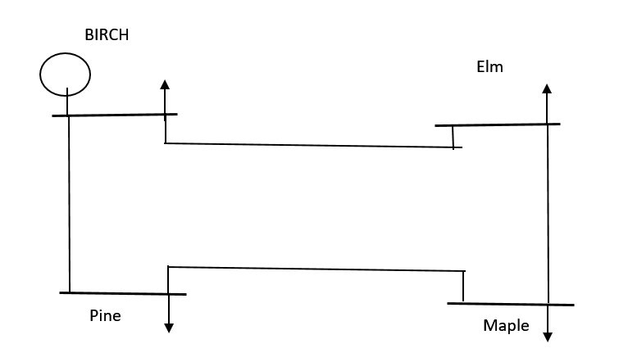

**Fig. 1.** The image extracted from [12] shows an electrical or circuit diagram with four important points, each labeled with the name of a different tree. The points are: • Birch: Labeled as circle and Generators are connected in this bus 1. • Elm and Pine: This buss is a load bus where the net scheduled values $P_{i}$ and $Q_{i}$ are negative. • Maple: Labeled as a node where a Generator is connected.

Based on the information from Table 1, the admittance matrix is calculated:

|  |  |
| --- | --- |
| $$Y=\left(\begin{matrix}8.985190-j44.835953 & -3.815629+j19.078144 & -5.169561+j25.847809 & 0 \\ -3.815629+ j19.078144 & 8.985190-j44.835953 & 0 & -5.169561+j25.847809 \\ -5.169561+j25.847809 & 0 & 8.193267-j40.863838 & -3.023705+j15.118528 \\ 0 & -5.169561+j25.847809 & -3.023705+j15.118528 & 8.193267-j40.863838\end{matrix}\right)$$ | (**23**) |

Calculating $V_{2}$ (Voltage of node 2), with $Y_{22}=\left(-Y_{21}\right)+j0.05125+\left(-Y_{24}\right)+j0.03875=8.985190-j44.835953$. Using the Gauss-Seidel method, a better approximate value is obtained with $V_{2}^{\left(0\right)}=1.02$, then:

|  |  |
| --- | --- |
| $$V_{2}^{\left(1\right)}=\frac{1}{Y_{22}}\left[\frac{-1.7+j1.0535}{1.02+j0.0}-1.00\left(-3.815629+j19.078144\right)-1.02\left(-5.169561+j25.847809\right)\right]=0.984150438630388 -j 0.031690284944853$$ | (**24**) |

The initial value of $1.02 + j0.0$ is then used to generate results for $V_{2}$ using the accelerated Gauss-Seidel method and the proposed method. The parameters $q_{0}=0.1$, $S_{f}^{\left(0\right)}=0.1$, $S_{v_{0}}=1$, $n_{v}=n^{\left(0\right)}=9.5$, $s=t_{v}=0.5$, $t_{s}=1$, $a_{v}=a^{(0)}=0.249$, and $-\left(1-t^{'}\right)$ with $t'=0$ are chosen without any particular reason. The functions $ϕ_{1}\left(t\right)=S_{v_{k}}*t^{4}*cos(100*t)$ and $ϕ_{2}\left(t\right)=S_{f}^{k}*t^{2}*cos\left(8*t\right)$ are also chosen without any reason. The results obtained are shown in Table 2, where each iteration shows the value of $V_{2}^{\left(k\right)}$ in each iteration $k$, and each method stops at the iteration where it has reached an absolute error value less than ${10}^{-5.3}$. Using the homotopy method to get a better approximation, then, with the initial data, $n^{\left(1\right)}$ and $a^{\left(1\right)}$ can be calculated by calculating $ζ_{1}$ using (8), obtaining $ζ_{0}≈-0.027788498615792$, then:

|  |  |
| --- | --- |
| $$n^{\left(1\right)}=\sqrt[\left(1\right)∙\left(0.5\right)-ζ_{0}]{S_{v_{0}}Y_{22}\left(0.1\right)-\left[\left(P_{i}-jQ_{i}\right)+V_{i}^{\left(k-1\right)}\left(-\left(1.00\left(-3.815629+j19.078144\right)\right)-\left(1.02\left(-5.169561+j25.847809\right)\right)\right)\right]}-ϕ_{1}\left(0.5\right)=1.907434633598808 - 3.023278682092488i$$ | (**25**) |

Then, using (17), $a^{\left(1\right)}=2.443894442871418 + 0.838759253855776i$. Calculating $ζ_{k}$ with $n^{\left(k-1\right)}$ and $a^{\left(k-1\right)}$ and using it to calculate $n^{\left(k\right)}$ and $a^{\left(k\right)}$, the solution of the system is found at $t=s=0.5$ by calculating these parameters sequentially. The approximation of the $V_{2}$ solution is illustrated in Table 2.

Also, calculating $V_{3}$ by putting these two methods with a significant disadvantage, placing on these with an initial value of 1250 units, so it follows that:

|  |  |
| --- | --- |
| $$V_{3}^{\left(1\right)}=\frac{1}{Y_{33}}\left[\frac{-2+j1.2394}{1250+j0.0}-1.00*\left(-5.169561+j25.847809\right)-\left(1.00\right)*\left(-3.023705+j15.118528\right)\right]=-7.483843532184282*{10}^{+02} - 8.320632807459205*{10}^{-04}$$ | (**26**) |

The following parameters are used, chosen without any particular reason: $q_{0}=1250-j1250$, $S_{f}^{\left(0\right)}=1250-j1250, S_{v_{0}}=1$, $n_{v}=n^{\left(0\right)}=0.02$, $s=t_{v}=0.5$, $t_{s}=1$, $a_{v}=a^{(0)}=0.05$, and $-(1-t')$ with $t'=0.4$. The functions are also chosen without any particular reason: $ϕ1(t)=t^{8}-4t^{7}+7t^{6}-8t^{5}+6t^{4}-4t^{3}+3t+1$ and $ϕ2(t)=t^{4}-t^{3}+7t^{2}-5t$. The results of $V_{3}$ in each iteration to compare these two methods are shown in the Table 2.

**Table 2.** Results in each iteration to calculate the value of $V_{2}$ and $V_{3}$ using the accelerated Gauss-Seidel method and the homotopy method proposed in this work, comparing, and showing the number of iterations required for each method.

|  |  |  |  |  |
| --- | --- | --- | --- | --- |
| Iteration | Values of $V_{2}$ ​ using the accelerated Gauss-Seidel method | Values of $V_{2}$ ​ using the method proposed in this work | Values of $V_{3}$ ​ using the accelerated Gauss-Seidel method | Values of $V_{3}$ ​ using the method proposed in this work |
| 0 | $$0.962640701808620 - j0.050704455911765$$ | $$0.989358396389588 - j0.012690285909550$$ | $$-7.483843532184282*{10}^{+02} - j8.320632807459205*{10}^{-04}$$ | $$2.348206297851 - j1.710445016477$$ |
| 1 | $$0.997186774325362 - j0.025728843865442$$ | $$0.987190056218197 - j0.022825838013653$$ | $$4.506463906169020*{10}^{02} - j1.919881283102943*{10}^{-04}$$ | $$1.981144720424 - j1.609764091268$$ |
| 2 | $$0.976608517066843 - j0.037615523796862$$ | $$0.985692628736148 - j0.028043927228374$$ | $$-2.687722752093169*{10}^{+02} - j8.104253187135857*{10}^{-04}$$ | $$1.381955188258 - j0.779171714924$$ |
| 3 | $$0.988676193515266 - j0.032166320225211$$ | $$0.984944663628120 - j0.030779266978268$$ | $$1.628792910416925*{10}^{+02} - j4.777088754973129*{10}^{-05i}$$ | $$1.190813526786 -j0.156041583318$$ |
| 4 | $$0.981679570324587 - j0.034508991203719$$ | $$0.984577462252421 - j0.032220798444191$$ | $$-96.112257541177783 - j0.001155427225534$$ | $$1.096963090149 - j0.050446713292$$ |
| 5 | $$0.985689453771876 - j0.033600367931325$$ | $$0.984398302657747 - j0.032978838277015$$ | $$59.283693156202531 + j0.000599881411617$$ | $$1.010446455074 - j0.041817324212$$ |
| 6 | $$0.983415509262387 - j0.033879492646807$$ | $$0.984310943581599 - j0.033380279326083$$ | $$-33.955561273252385 - j0.002251323962503$$ | $$0.987878018456 - j0.040666981033$$ |
| 7 | $$0.984691856983467 - j0.033851814888045$$ | $$0.984269456517536 - j0.033593111214176$$ | $$21.990851529851820 + j0.002512965092820$$ | $$0.976870312845 -j0.041992458165$$ |
| 8 | $$0.983982697177198 - j0.033795743152704$$ | $$0.984250215940177 - j0.033705847165769$$ | $$-11.581622920382108 - j0.005284776083153$$ | $$0.971125650455 -j0.043141785159$$ |
| 9 | $$0.984372736581128 - j0.033866484625649$$ | $$0.984241496095591 - j0.033765475935082$$ | $$8.570003971156611 + j0.008081622323200$$ | $$0.968019168359 -j0.043850147081$$ |
| 10 | $$0.984160451809485 - j0.033805447545908$$ | $$0.984237638978172 - j0.033796971512673$$ | $$-3.533518438978073 - j0.013314431544886$$ | $$0.966360501578 -j0.044267308840$$ |
| 11 | $$0.984274732847533 - j0.033851159910846$$ | $$0.984235978207641 - j0.033813591771463$$ | $$3.753351882502885 + j0.025801266380818$$ | $$0.965504533058 - j0.044524840964$$ |
| 12 | $$0.984213930670370 - j0.033819424490080$$ | $$0.984235288143229 - j0.033822361169252$$ | $$-0.652886014640044 -j0.033711405043667$$ | $$0.965012222865 -j0.044697707749$$ |
| 13 | $$0.984245865477253 - j0.033840419718167$$ | $$0.984235018108889 - j0.033826990175326$$ | $$2.106951611360513 +j0.115288799142363$$ | $$0.964749784245 - j0.044800604508$$ |
| 14 | $$0.984229334616872 - j0.033826993546369$$ |  | $$0.320599408473164 - j0.099551342480826$$ | $$0.964552557773 - j0.044836694621$$ |
| 15 | $$0.984237748667910 - j0.033835361787228$$ |  | $$1.305915445263097 -j0.183151095311818$$ | $$0.964542794990 -j0.044940320296$$ |
| 16 | $$0.984233551824030 - j0.033830251714032$$ |  | $$0.792720358457969 + j0.053097347656140$$ | $$0.964515140398 - j0.044959385959$$ |
| 17 |  |  | $$1.056973847820118 - j0.110239687428246$$ | $$0.964497371197 - j0.044966045810$$ |
| … |  |  |  |  |
| 19 |  |  | $$0.991399252130586 - j0.070406765330767$$ | $$0.964480074754 - j0.044971948447$$ |
| 20 |  |  | $$0.963585730962712 - j0.029102971978653$$ | $$0.964476614819959 - j0.044973436127760$$ |
| … |  |  | ... |  |
| 33 |  |  | $$0.972147757722362 - j0.044596837707552$$ |  |

The obtained trajectories concerning the homotopic parameter are shown separately in Figure 2. The evolution of the real and imaginary parts of the system’s solution values is illustrated:

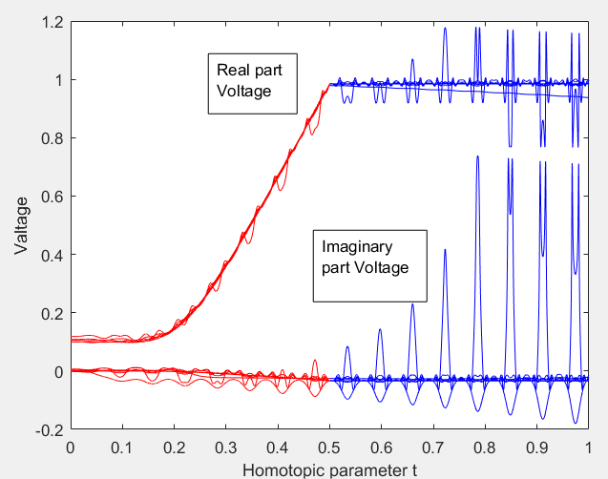

**Fig. 2.** This graph illustrates the evolution of the voltage´s real and imaginary parts regarding the homotopic parameter $t$. The red curves show the evolution of the solution from when $t∈\left[0,0.5\right]$ and the blue curves show the evolution of the solution from when $t∈\left[0.5,1\right]$, and when $t=0.5$, indicates the via point where the trajectories converge to a trajectory that passes through the solution of the system at $t=0.5$.

Figure 3 shows the evolution of the system´s solution in the complex plane:

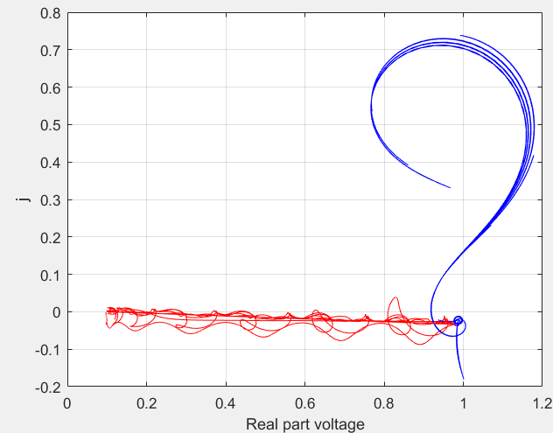

**Fig. 3.** This graph illustrates the evolution of the voltage’s real and imaginary parts in the complex plane. A notable feature of this graph is the accumulation point where the trajectories converge, indicated by the dense clustering of lines near $Real part voltage≈1$\ and $j≈0$. This accumulation point suggests a region where many trajectory paths intersect or accumulate, indicating the potential stability or equilibrium state of the system’s solution in the complex plane.

Figure 4 provides a zoomed-in view of the accumulation point where the system’s solution is located, highlighting the convergence of the trajectories shown in Figure 3:

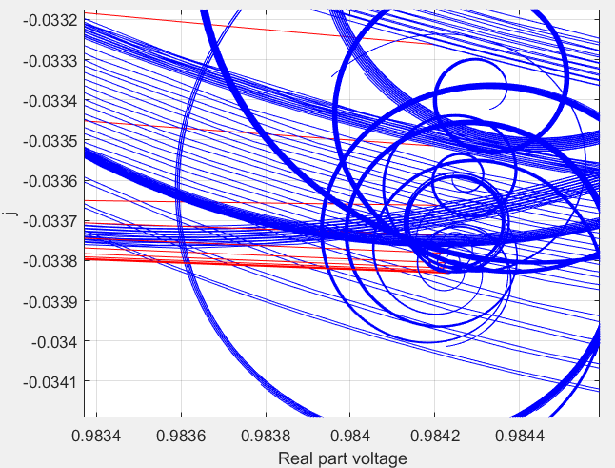

**Fig. 4.** This is a zoomed-in view of the graph’s accumulation point in the complex plane where the system’s solution is located. A figured pattern shows that it converges as a loop.

The trajectories obtained in this simulation are illustrated in Figure 5:

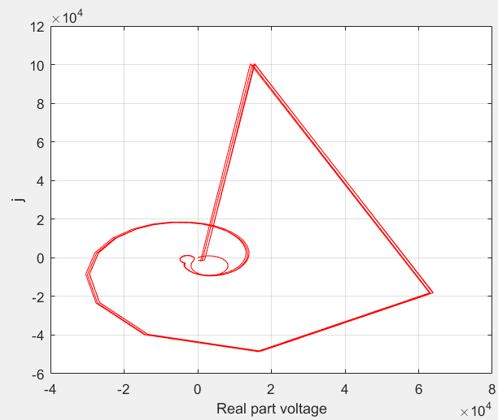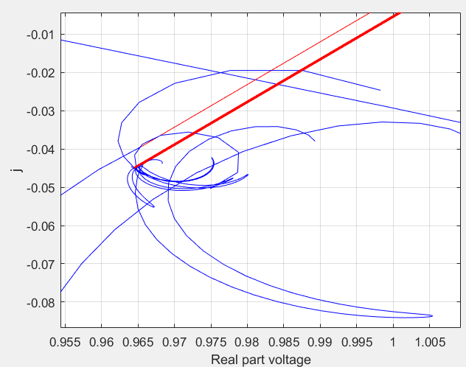

**Fig. 5.** The left graph shows the trajectories obtained that pass through the solution of $V_{3}$, converging to a loop in the interval $t∈\left[s,1\right]$. The right graph is a zoomed-in view of the accumulation point of the graph in the complex plane where the system’s solution is located.

Now, calculating the voltage $V_{4}$ ​, starting with an initial proposed value of $V_{4}^{\left(0\right)}=1.02 - j0.0$ ​, and using the Gauss-Seidel method, we have the following:

|  |  |
| --- | --- |
| $$V_{4}^{\left(1\right)}=\frac{1}{Y_{44}}\left[\frac{2.38-j1.654151}{1.02-j0.0}-\left(-5.573066+j40.059398\right)\right]=\frac{1}{8.193267-j40.863838}\left[\frac{2.38-j1.654151}{1.02-j0.0}-\left(-5.573066+j40.059398\right)\right]=1.017874-j0.010604$$ | (**27**) |

Iterations are generated to obtain the solution for $V_{4}$ ​ using the two methods being compared. The following parameters are also used without any particular reason: $q_{0}=1$, $S_{v_{0}}=1.02$, $S_{f}^{\left(0\right)}​=1,$ $n_{v}=n^{\left(0\right)}=4$, $s=t_{v}=0.5$, $t_{s}=1$, $a_{v}=a^{\left(0\right)}=0.25$, and $-(1-t')$ with $t'=0.89$. The functions are also chosen without any particular reason: $ϕ_{1}(t)=cos\left(t\right) + \left(\frac{1}{2}\right)cos\left(2t\right) + \left(\frac{1}{3}\right)cos\left(3t\right)$ and $ϕ_{2}\left(t\right)=sin\left(t\right) + \left(\frac{1}{2}\right)sin\left(2t\right) + \left(\frac{1}{3}\right)sin\left(3t\right)$. The results of each iteration are provided in Table 3:

**Table 3.** Results in each iteration to calculate the value of $V_{4}$ using the accelerated Gauss-Seidel method and the homotopy method proposed in this work.

|  |  |  |
| --- | --- | --- |
| Iteration | Values of $V_{4}$ ​ using the accelerated Gauss-Seidel method | Values of $V_{4}$ ​ using the method proposed in this work |
| 0 | $$1.016598258071199 - 0.016966135945892i$$ | $$1.009690996188317 - 0.005371757001843i$$ |
| 1 | $$1.017615115673635 - 0.005237951739977i$$ | $$1.014058003077701 - 0.007721926339863i$$ |
| 2 | $$1.017821446478973 - 0.013242430010548i$$ | $$1.016131950704688 - 0.008858697056300i$$ |
| 3 | $$1.017074990956532 - 0.007846363788603i$$ | $$1.016917222116891 - 0.009387955800353i$$ |
| 4 | $$1.017989975428065 - 0.011436948315498i$$ | $$1.017275053239156 - 0.009766204934923i$$ |
| 5 | $$1.017098815263229 - 0.009078982355596i$$ | $$1.017444878025250 - 0.009961811984322i$$ |
| 6 | $$1.017880420720248 - 0.010605137904069i$$ | $$1.017507709324226 - 0.009985247604071i$$ |
| 7 | $$1.017236117436672 - 0.009632775719431i$$ | $$1.017518227579832 - 0.009992654942856i$$ |
| 8 | $$1.017745534966448 - 0.010241115220721i$$ | $$1.017524216693837 - 0.009996398209904i$$ |
| 9 | $$1.017354947778670 - 0.009868566763533i$$ | $$1.017529207223068 - 0.010001312803910i$$ |
| 10 | $$1.017647284515949 - 0.010090730699369i$$ | $$1.017529280122285 - 0.010007459502061i$$ |
| 11 | $$1.017432784753677 - 0.009962755274882i$$ | $$1.017526780300213 - 0.010010249200348i$$ |
| 12 | $$1.017587507954284 - 0.010032970020260i$$ | $$1.017525507414044 - 0.010009281393491i$$ |
| 13 | $$1.017477580195321 - 0.009997259263514i$$ | $$1.017524230473239 - 0.010008730462044i$$ |
| 14 | $$1.017554604067075 - 0.010013048291980i$$ | $$1.017523436281361 - 0.010008658250181i$$ |
| 15 | $$1.017501336297753 - 0.010008226565871i$$ | $$1.017523116530720 - 0.010008726644160i$$ |
| 16 | $$1.017537711556644 - 0.010007439225597i$$ |  |
| … | … |  |
| 32 | $$1.017523007234028 - 0.010008710008111i$$ |  |

The trajectories obtained in the complex plane are shown in Figure 6:

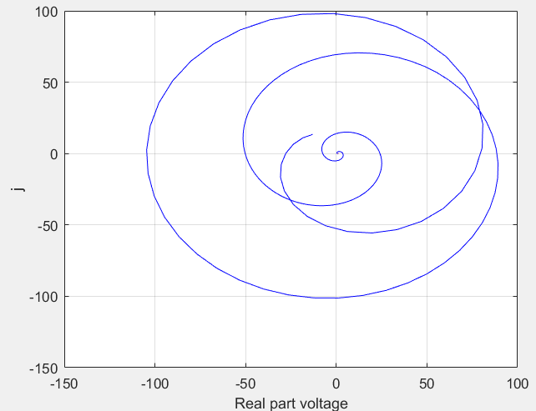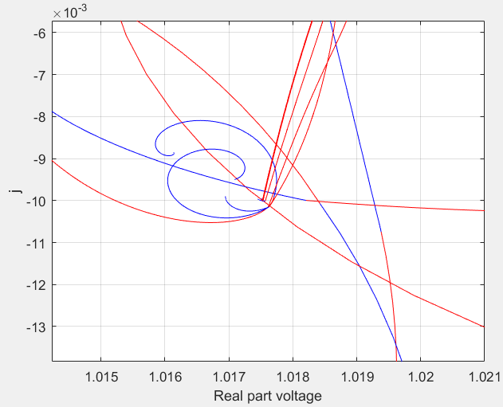

**Fig. 6.** The left graph shows the trajectories obtained that pass and approximates to the solution of $V_{4}$ at $t=0.5$, converging to a loop in the interval $t∈\left[s,1\right]$. The right graph is a zoomed in view of the accumulation point of the graph in the complex plane where the system´s solution is located.

Taking the same values of the homotopy to calculate $V_{4}$ but taking $t´=0.1,0.09,0.08,0.07,…,0$ to deform these trajectories and help explain the function of these parameter in this context. First, taking $t´=0.1$, the next trajectory is obtained in Figure 7:

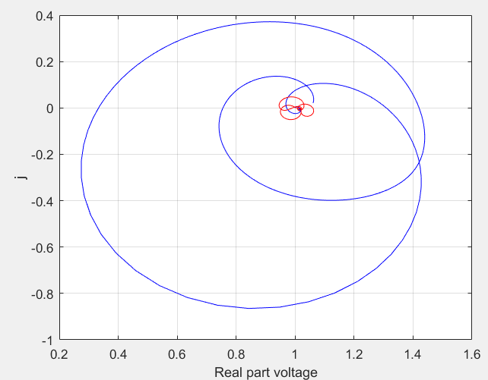

**Fig. 7.** The graph shows the trajectories obtained that pass and approximate to the solution of $V_{4}$ at $t=0.5$, with a $t´=0.1$.

Deforming these trajectories by taking $t´=0.1, 0.09, 0.08, 0.07$, there are four trajectories deformed that are shrunk while $t´$ increases (in this case), as shown in Figure 8:

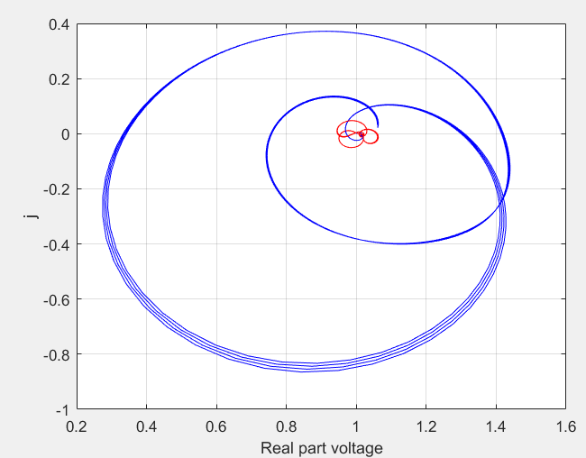

**Fig. 8.** Shrinking trajectories by taking $t´=0.1, 0.09, 0.08, 0.07$ and converging to form a loop in $t∈\left[s,1\right]$.

Getting a smaller $t´$, then $-\left(1-t´\right)$ increases, having a more shrunken trajectory, as shown in Figure 9:

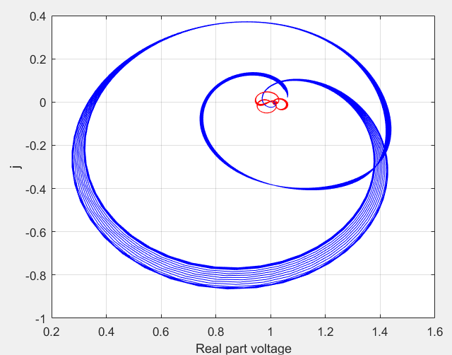

**Fig. 9.** Trajectories obtained by changing the value of $t´$ in $\left[0,0.1\right]$.

In this case, using these values of $t´$ resulted in shrinking the trajectories. However, there are instances where these trajectories can stretch significantly. This occurs because, at iteration $k$, the parameters $a$ and $n$ are calculated using values from the previous iteration k−1k-1k−1 and depend on $ζ_{k-1}$. Consequently, the homotopy $HS_{l}(1,t')$ can change abruptly when transitioning from one condition to another, as $a^{\left(k\right)}$ and $n^{\left(k\right)}$ use past values from iteration $k-1$ to generate updated trajectories.

This abrupt change can be disadvantageous because, for certain values of $t'$, $ϕ_{1}\left(t⋅t_{s}\right)$ and $ϕ_{2}\left(t⋅t_{s}\right)$, the homotopy $HS_{k}(1,t')$ can vary suddenly. As a result, the method may add more iterations to approximate the solution of the system.

5 Conclusion and further works

5.1 Conclusion

The approach used in this work combines concepts from homotopy theory, sequences, and numerical methods to solve power systems. Homotopic function definitions are employed to construct a homotopy that guides the solution search process. This homotopy is designed so that, by using the Gauss-Seidel method, it converges towards a path that passes through the solutions of the power system. This approach leverages the topological structure of the solution space of the power system and combines it with the efficiency of the Gauss-Seidel method to iteratively find solutions. Using the constructed homotopy in [7] ensures robust convergence towards the system solutions, providing an effective tool for analyzing and optimizing power systems, as observed in the results of the iterations in each simulated network presented in this work.

This methodology offers an innovative and powerful way to address complex problems in power systems, combining advanced theoretical techniques with efficient numerical methods to obtain precise and reliable results. Compared to the Gauss-Seidel method, as seen in the results listed in the tables, this new approach stands out for its ability to generate solutions quickly and accurately, even starting from suboptimal initial assumptions, as evidenced in $V_{3}$ of the power grid. Each simulation shows a notable reduction in the number of iterations required, accompanied by a graphical representation that illustrates the evolution of the paths the user selects. This method provides abundant information simultaneously during its operation, offering a new dynamic for solving power systems. This adaptability and efficiency translate into mitigating the limitations of the Gauss-Seidel method.

The research reveals a clear advantage regarding iterative efficiency and functional versatility. Therefore, the need to deepen this study becomes evident, given its promising nature as a practical, adaptable, and easy-to-apply tool. Its potential to address various challenges in engineering and related disciplines suggests a horizon of extensive and significant applications.

5.1 Further works

The homotopy presented in [7], different via points are added to reshape and generate different trajectories, aiming to achieve faster convergence and introduce characteristics that could lead to potential future applications. This aspect should be explored in future research. Meanwhile, investigating a possible method that could generate trajectories with different via points to solve the entire system in parallel may lead to a much faster method for solving larger systems.

References

1. Teng, J.-H. (2002). A modified Gauss–Seidel algorithm of three-phase power flow analysis in distribution networks. *International Journal of Electrical Power & Energy Systems*, 24(2), 97-102. <https://doi.org/10.1016/S0142-0615(01)00022-9>.
2. Granada, M. (2003). Estimación de estado en sistemas eléctricos de potencia: Parte I Detección de errores grandes. *Scientia Et Technica*, *2*(22), 7-12. <https://revistas.utp.edu.co/index.php/revistaciencia/article/view/7409>
3. 4 Wang, Y., Guo, P., Ma, N., & Liu, G. (2023). Robust Wavelet Transform Neural-Network-Based Short-Term Load Forecasting for Power Distribution Networks. *Sustainability, 15*(1), 296. <https://doi.org/10.3390/su15010296>.
4. 5 Nur, A., & Kaygusuz, A. (2023). Load Flow Analysis With Newton–Raphson and Gauss–Seidel Methods in a Hybrid AC/DC System. *IEEE Transactions on Power Systems*, 38(3), 2393-2401. <https://doi.org/10.1109/TPWRS.2022.3054062>.
5. 6 Freitas, F. D., & Silva, A. L. (2022). A hybrid approach for short-term load forecasting using wavelet transform and artificial neural networks. *Journal of Cleaner Production*, 341, 130822. <https://doi.org/10.1016/j.jclepro.2020.130822>.
6. 7 Chatterjee, S., & Mandal, S. (2018). A novel comparison of Gauss-Seidel and Newton-Raphson methods for load flow analysis. *IEEE Transactions on Power Systems*, 33(3), 3084-3092. <https://doi.org/10.1109/TPWRS.2017.2764465>.
7. 13 Quiñonez, Y., Zatarain, O., Lizarraga, C., Aguayo, R., & Mejía, J. (2021). Numerical Method Using Homotopic Iterative Functions Based on the via Point for the Joint-Space Trajectory Generation. Applied Sciences, 13(2), 1142. doi: 10.3390/app13021142.
8. 8 Park, S., Glista, E., Lavaei, J., & Sojoudi, S. (2022). An efficient homotopy method for solving the post-contingency optimal power flow to global optimality. *IEEE Access*, 10, 124960-124978.
9. 9 Freitas, F. D., Silva, A. L., Zhang, Y., Wang, J., & Li, Y. (2022). Flat start guess homotopy-based power flow method guided by fictitious network compensation control. International Journal of Electrical Power & Energy Systems, 134, 107056. <https://doi.org/10.1016/j.ijepes.2021.107056>.
10. Munkres, J. R. (2000). Topology (2nd ed.). Upper Saddle River, NJ: Prentice Hall, Inc.
11. Bauer, K., Deloup, F., & Zvengrowski, P. (2009). Base points in homotopy theory and the Fundamental Theorem of Algebra. University of Calgary Contacts. Recuperado el 2 de septiembre de 2023, de https://contacts.ucalgary.ca/info/math/research/publications/view/1-5967970.
12. Grainger, J. J. (1999). *Power system analysis*. McGraw-Hill.