Zoolingua: An Educational Application to Support Reading and Writing Skills in Children Through Gamified Learning and Concentration Improvement.

María Gutiérrez1, Lucia Montoya1, Zahir Acosta1, Alejandro Alonso1

and Margarita Gamarra1

1 Department of Systems Engineering, Universidad del Norte, Barranquilla 081007, Colombia

{mariaig, limontoya, zdelaasuncion, aalonsod, [mrgamarra} @uninorte.edu.co](mailto:mrgamarra%7d@uninorte.edu.co)

**Abstract.** Zoolingua is an educational application developed for children of an average age between 4 and 7 years old, aimed at supporting the learning of reading and writing in an engaging way. Based on a progressive method, this app guides children through distinct levels of difficulty, helping them practice basic and advanced reading and writing skills. Each level includes activities and exercises designed to strengthen specific aspects, from letter and word recognition to the composition of complete sentences and paragraphs. At the end of each level, children are rewarded with games designed not only to provide them with a playful break but are also designed to enhance cognitive skills and attention, complementing the learning process, and thus helping children in the prevention of attention deficit hyperactivity disorder (ADHD). The integration of educational activities with interactive games not only motivates children to continue learning, but also provides them with practical tools to face real-world challenges with confidence and skill.

**Keywords:** Progressive method, Educational, Reading, Writing, ADHD, Attention, Cognitive skills.

1 Introduction

Currently, the use of technology in education has become an indispensable tool to improve and enrich learning processes, especially in the context of early childhood education [3]. In this sense, the development of educational applications aimed at children has become a growing trend, driven by the need to provide more dynamic, interactive, and engaging learning experiences.

Learning to read and write in childhood is a fundamental aspect of children's cognitive and social development. These skills not only allow them to communicate effectively but also form the foundation for future academic and professional success. However, the process of buying reading and writing skills can be challenging for many children, especially when faced with traditional teaching methods that can be monotonous and unstimulating.

It is crucial for this work to address the topic of connecting with children, given the growing concern about attention issues today. According to a study conducted in Barranquilla, Colombia, the prevalence of attention deficit hyperactivity disorder (ADHD) in school-age children was found to be 15% [7]. This percentage was distributed among subtypes, with 7.3% combined type, 5% inattentive type, and 3.1% hyperactive type. Additionally, it was seen that ADHD presented a gender ratio of 2:1, with a higher prevalence in boys than in girls. These findings support the idea that ADHD is a common disorder in the child population of Barranquilla and suggest the importance of adequately addressing this disorder in educational and clinical contexts [7].

These findings highlight the importance of early intervention in cases of ADHD to prevent possible repercussions in adolescence and adulthood. Given this scenario, the need arises to develop new educational strategies and tools that can capture the attention and interest of children, making learning to read and write a fun, meaningful and relevant experience for their personal and academic development. In response to this need, our project provides important support in the field of early childhood education through the development of user-centered educational software adapted to children's preferences. This app is based on a progressive method, allowing children to gradually advance through various levels of difficulty as they build and refine their reading and writing skills. Each level of the app features a variety of activities and exercises carefully designed to address specific aspects of the learning process, from recognizing letters and words to understanding text and producing written content.

In addition to focusing on academic learning, Zoolingua also integrates playful and motivational elements in its design, to keep children's interest and participation throughout their learning experience. In this app, children have the freedom to be whatever they wish. Therefore, they can personalize their avatar, choosing any animal with which they feel identified. These avatars do not include gender symbols, as our goal is to break gender stigmas and promote inclusivity. Moreover, at the end of each level of the app, children are rewarded with interactive games designed to stimulate their attention, concentration and memory, while having fun and actively learning. The playful part of Zoolingua not only serves as an educational tool, but also enhances learning through active participation and intrinsic motivation. We used a design method that balances teaching and play. The digital application was developed so that children feel part of it and the platform becomes an effective tool for children's education.

2 Related Work

The integration of ICT (Information and Communication Technology) and assistive technologies in education has proved significant benefits for students with learning challenges. For example, the study in [8] showed improvements in attention, impulsivity, organization, and social skills for a twelve-year-old with ADHD, though memory was not enhanced, showing the need to reassess strategies targeting memory improvement.

Similarly, the study [4] revealed that incorporating video games into education can enhance focus and cognitive functions in elementary students. Using a mixed-method approach, researchers found that video games not only increase motivation but also play a crucial role in improving essential cognitive skills for learning.

Another study, [2] found that educational software significantly improved early literacy skills among preschoolers. Employing a quasi-experimental design, the results showed notable advantages for the experimental group compared to the control group, highlighting the effectiveness of integrating educational technology and constructivist teaching methods.

The project developed in [1] also showed that digital tools effectively enhanced Spanish comprehension and engagement for young learners. This study involved creating and evaluating an online educational resource, with positive feedback from both students and teachers about its effectiveness and adaptability.

The research in [11] suggests that incorporating playful and technological elements into educational tools could be crucial for the effective development of fundamental skills such as reading and writing, especially in contexts where preventing difficulties like ADHD is a concern. Integrating these aspects could enhance dynamic learning and student motivation, key aspects to consider in the design of a web application aimed at these educational goals

Overall, these studies highlight the positive impact of ICT, educational software, and gamified environments on student learning. They emphasize the importance of integrating innovative technologies into educational frameworks to boost motivation, engagement, and academic performance. The evidence suggests that these tools not only enrich the educational process but also offer new opportunities to address individual student needs, fostering more inclusive and effective learning.

3 Methodology

Zoolingua is proposed as a technological solution for educational purposes, offering a blend of educational and entertaining features to enhance learning and cognitive skills. The application's design follows a hybrid approach, combining elements of the Scrum agile development model [14] with the Waterfall development model to ensure adaptability and flexibility. Continuous updates are essential for this application, leading to potential variations in requirements during the development process. The Waterfall model [13], on the other hand, focuses on refining each phase of the application to streamline the final development process.

**Fig. 1** Waterfall Development Application Diagram

This application was developed using the Flutter framework, incorporating the Dart and Python programming languages, in conjunction with Visual Studio Code and Android Studio tools. Flutter, in combination with Dart, enables the creation of top-notch native interfaces for both iOS and Android platforms from a unified code base. This approach is helpful for mobile app development due to its versatility and adaptability across different platforms and operating systems, easing the design of engaging and seamless interfaces crucial for captivating and motivating children. Moreover, Python played a key role in executing specific backend tasks such as data processing and managing function logic, using its user-friendly nature and robustness. Visual Studio Code, a lightweight yet potent source code editor, proved to be instrumental for coding and debugging tasks related to Flutter and Python, supported by tailored extensions for both languages. Android Studio gave essential features for emulation and testing within an Android environment, ensuring the proper functionality of the application across various devices.

4 Proposed Approach

Zoolingua's proposal is based on the implementation of interactive and gamified educational activities to support the practice of children's reading and writing skills of children from four to seven years of age. The app offers progressive difficulty levels designed to keep children motivated and ease continuous and effective learning. It includes a variety of games that not only help in learning but are also designed to help concentration and attention, which could help to reduce the possibility of children developing ADHD.

**4.1 Preliminary study about the context**

Recognizing the limitations of traditional teaching methods that often disengage young learners, Zoolingua was developed to address these challenges by integrating play into education. Zoolingua offers a gamified learning experience designed to support children's attention, enhance cognitive abilities, and support reading and writing skills. Created in collaboration with experienced teachers, the application incorporates activities that aim to mitigate ADHD symptoms while promoting academic performance.

**4.2 Functional requirements of the application**

• User Registration: The application enables users (parents or legal guardians) to register and access their profile and progress within the application.

• Progressive Difficulty Levels: Zoolingua offers a range of difficulty levels that advance gradually based on topics, enabling children to progress as they enhance their skills.

• Letter and Sound Recognition: The app features exercise to aid children in finding alphabet letters and linking them to their respective sounds.

• Syllable and Word Formation: The application offers games and exercises enabling children to create syllables and words with the letters they have learned.

• Zoolingua offers the opportunity to read phrases and short texts, featuring escalating levels of difficulty to enhance and test the child's reading abilities.

• Letter, Syllable, and Word Writing: The application features exercise for children to enhance their writing and spelling abilities by practicing writing letters, syllables, and words.

• Gamified Rewards: Upon finishing each level or achieving specific milestones, the application provides incentives in the shape of games or enjoyable activities to keep the child's motivation and deter ADHD.

**4.3 Non-functional application requirements**

• The application highlights an aesthetically pleasing and vibrant design that appeals to children and encourages their engagement in educational activities. Moreover, the user interface is straightforward and accessible for children, featuring clearly labeled icons and buttons, as well as a logical organization of on-screen elements.

• Performance: The application efficiently manages quick loading times on various devices and perfects internet connection usage across different speeds, reducing wait times and enhancing user experience.

• Support: The application accommodates a range of screen sizes and resolutions, along with diverse operating systems and many devices, guaranteeing a uniform and best user experience across mobile devices and computers.

5 Software design and architecture

The Zoolingua application was developed using the Flutter framework, incorporating Dart and Python as the main programming languages, in conjunction with Visual Studio Code and Android Studio tools. Flutter, in combination with Dart, enables the creation of top-notch native interfaces for both iOS and Android platforms from a unified code base.

This approach is helpful for mobile app development due to its versatility and adaptability across different platforms and operating systems, easing the design of engaging and seamless interfaces crucial for captivating and motivating children. Moreover, Python played a key role in executing specific backend tasks such as data processing and managing function logic, using its user-friendly nature and robustness.

Visual Studio Code proved to be instrumental for coding and debugging tasks related to Flutter and Python, supported by tailored extensions for both languages. Android Studio gave essential features for emulation and testing within an Android environment, ensuring the proper functionality of the application across various devices.

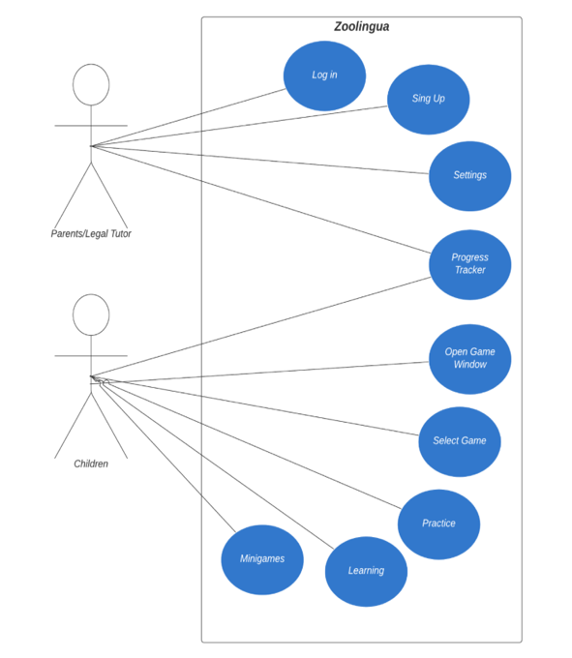

**Fig. 2** The use case diagram

The use case diagram for the Zoolingua application illustrates interactions between two types of users, parents/legal tutors and children. Both user types can log in, sign up, change settings, track progress, open the game window, select games, practice, access learning materials, and play minigames. Overall, the diagram illustrates Zoolingua’s functions and provides a set of features accessible to both parents/legal tutors and children, emphasizing user engagement in educational and recreational activities.

6 Software implementation

Once the planning and creation stages were completed, we moved on to the most important part: the children's feedback. We visit a public school in the city of Barranquilla, where we presented our application preliminarily. Our goal was to evaluate the intuitiveness of the application. To do this, 30 kindergarten children used it, and then we asked them about their experience. Upon discovering that 37.9% of the children found it difficult to understand certain instructions provided by the application and understanding that learning was much easier through sounds and visual activities, we were able to find areas for improvement.

With the insights gained from the first feedback, we created a broad experience for our users, especially children. Our color palette of blues and greens promotes concentration and tranquility, enhancing the learning environment. Avatar customization ensures every child feels valued. Zoolingua's structured levels guide children through thematic environments like Junglengua, Oceánolex, Desiertopía, and Tundraling, offering progressively challenging activities that stimulate cognitive development. Each level starts with a captivating story introducing key themes, with children earning virtual coins by answering related questions as they progress.

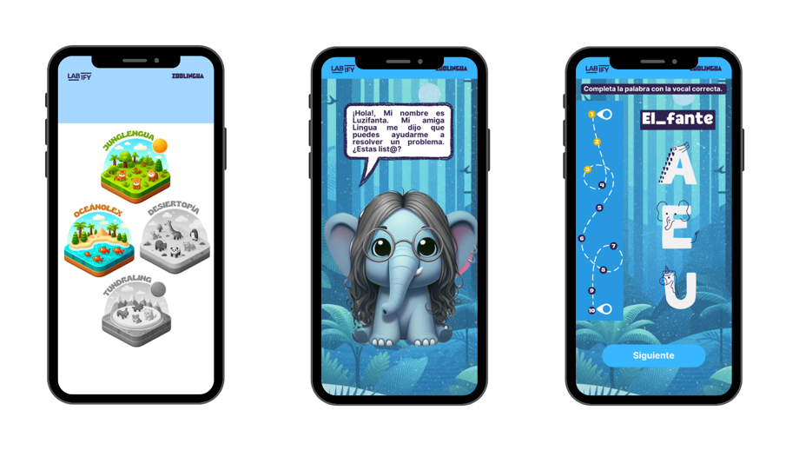

**Fig. 3** Screens of levels, some stories and activities presented to children

As children answer questions related to these themes to advance and earn virtual coins, these coins allow them to access an arcade consisting of 4 games: BrickBreak, a puzzle game, memory cards, and a maze. These games are designed to stimulate concentration in children, helping them stay focused and potentially reducing the likelihood of developing attention deficit disorder.

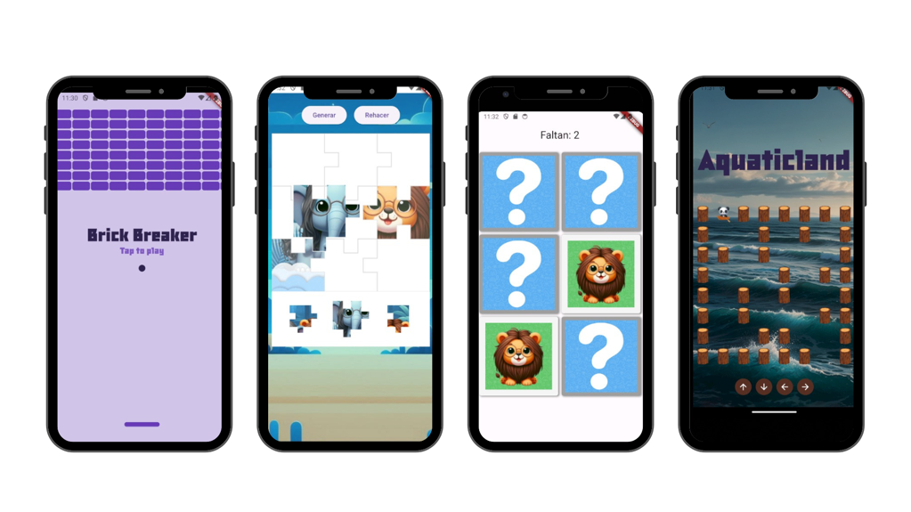

**Fig. 4** Games designed to stimulate children's attention and concentration

In addition to the first survey, we chose to re-interview children who met challenges with the application. From the original 30 participants, we selected 15 children (8 girls and 7 boys). These children, having seen the recent changes implemented based on their earlier feedback, answered the following questions:

1. Did you find the app easy to navigate?

2. Was it easy to understand the instructions and activities?

3. Was there ever a time when you felt confused or lost while using the app?

4. If the answer was YES, when was it?

5. What level do you find most fun or interesting?

6. Was there any activity that you found uninteresting?

7. If the answer was YES, which one?

8. Do you enjoy customizing your avatar?

9. How do you feel about unlocking new levels or achievements as you progress through the app?

10. Did you like the colors and images used in the app?

11. Was there anything about the design of the app that you found annoying or difficult to read?

12. On a scale of 1 to 5, how would you rate Zoolingua in terms of fun and learning?

13. Will you recommend this app to your friends?

Based on the responses from the surveyed children, Zoolingua has had a highly positive reception. 100% of the children found it easy to navigate the application and understand the instructions and activities presented. Additionally, the majority (13 out of 15) showed that they did not feel confused or lost at any point during its use, highlighting the clarity and consistency of the user experience provided by the application.

About the levels, Level 3 was identified as the most fun and interesting by most children, followed by Level 2 and Level 4. Although one child mentioned finding some activities without images boring in Level 4, this suggests an opportunity to enhance the diversity and visual appeal of the activities. Additionally, avatar customization was widely enjoyed by all children, highlighting it as a popular feature.

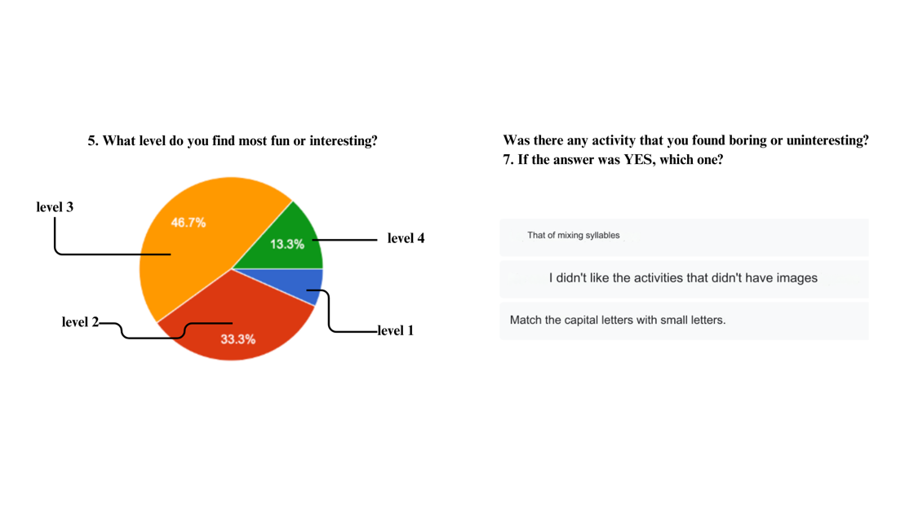

**Fig. 5** Results for Question 5 and 7

The majority of Zoolingua users (86.7%) felt excited when unlocking new levels or achievements, showing enthusiasm and motivation in their experience with the app. However, a small percentage (13.3%) were indifferent to this aspect. These results highlight the effectiveness of the rewards and progression system in keeping user engagement with the application.

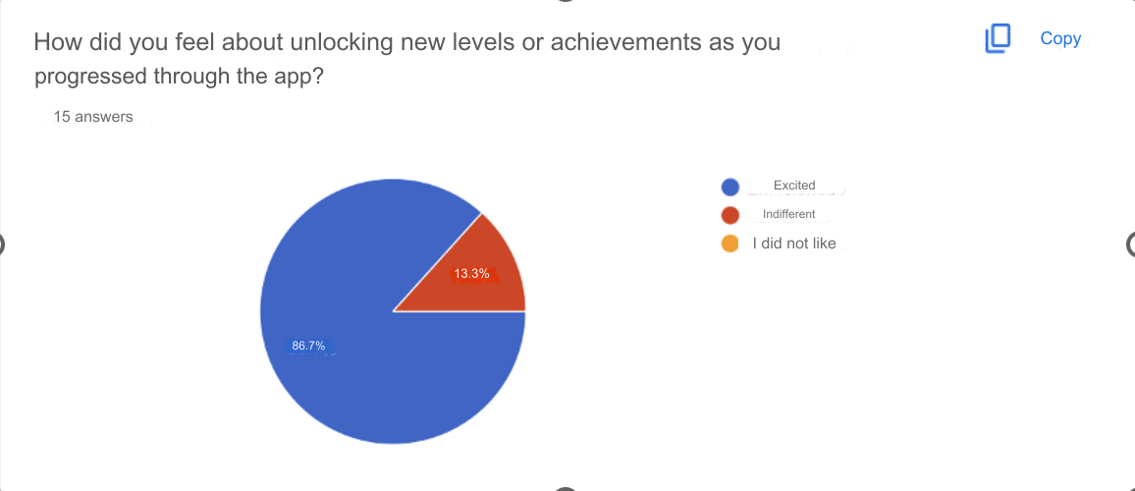

**Fig. 5** Results Question 9

Users liked the colors and images in the Zoolingua app (100% positive response), showing high satisfaction with its visual appeal. Most users (93.3%) found the app's design easy to read, though a small percentage (6.7%) had minor issues. Addressing these concerns can enhance readability and accessibility for all users.

Children show high satisfaction in fun and learning, with the majority (93%) rating the app with a 4 or 5. Only a small percentage (6.7%) gave a rating of 3, showing room for minor improvements. These results underscore Zoolingua's success in providing a positive and educational experience for children.

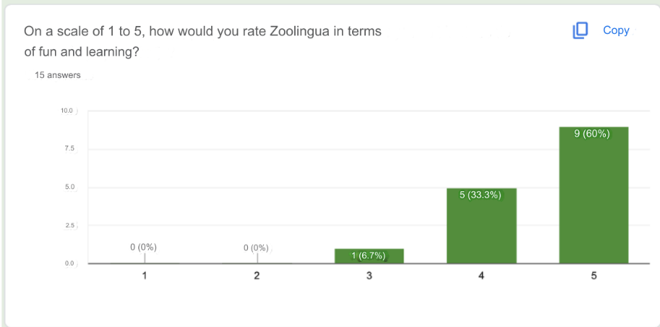

**Fig. 6** Results Question 12

When asked if they would recommend the app to their friends, all users (100%) responded "Yes." This shows high satisfaction and writes down Zoolingua's success as a valuable choice for fun and effective children's learning tools

7 Conclusion

Zoolingua is an approach in educational technology, specifically tailored for children between the ages of 4 and 7. By employing a progressive learning method enriched with interactive gamification, the application nurtures the foundational skills of reading and writing. This dynamic method of learning ensures that children are not only buying essential academic skills but are also doing so in an engaging and enjoyable manner, which significantly enhances their motivation and cognitive development. The positive feedback from users, who are children and their tutors, highlights Zoolingua's success in delivering educational experiences. Parents and children have noted the application's ability to foster the taste for learning in young children, as it combines educational content with elements of play. This combination helps to sustain children's interest and curiosity, making the learning process both fun and effective. The application's design is crafted to ease seamless navigation and comprehension, ensuring that even the youngest users can easily interact with the platform. The user interface is designed with bright, vibrant visuals and intuitive controls that make it accessible and enjoyable for young children. These design elements play a crucial role in enhancing user engagement, making the learning process visually appealing and easy to understand. The application's aesthetic appeal is complemented by its functional design, which ensures that educational content is presented in a manner that is both engaging and understandable for young minds. By integrating playful elements into its educational content, Zoolingua not only enriches the learning experience but also addresses potential challenges such as attention deficit hyperactivity disorder (ADHD). The activities designed within the app promote concentration and attention, helping children keep focus while learning. This is particularly important for children who may struggle with traditional learning methods, as Zoolingua provides a stimulating environment that caters to their specific needs. The inclusion of interactive games and activities ensures that children are actively engaged in the learning process, which can help to improve their attention span and overall cognitive abilities.As educational paradigms continue to evolve with technological advancements, Zoolingua aspires to stand out as a valuable tool in early childhood education. Looking forward to continuous updates and enhancements based on user feedback will further refine Zoolingua's capabilities. These improvements will reinforce its role as a supportive companion in children's educational journeys, ensuring that the app is still and effective in an ever-changing educational landscape.

References

1. Balanta Zamora, Carlos Andrés. (2020). Diseño, desarrollo y evaluación de material didáctico web para la enseñanza del español como lengua extranjera a niños de siete años. (Tesis de maestría). <https://doi.org/10.35537/10915/99578>
2. Calderón Guerrero, G., & Pohls Díaz, E. (2021). La influencia de un recurso informático en el proceso de alfabetización inicial: Un estudio con niños de tercero de preescolar. IE Revista de Investigación Educativa de la REDIECH, 12(diciembre), e1176. <https://doi.org/10.33010/ie_rie_rediech.v12i0.1176>
3. Cloete, A. L. (2017). Technology and education: Challenges and opportunities. *HTS: Theological Studies*, *73*(3), 1-7.
4. Fernández-Menor, I. (2021). Evaluación de un estudiante con TDAH tras una intervención con recursos tecnológicos. Educación, 14(2), 121–131. <https://doi.org/10.22235/pe.v14i2.2565>
5. García, J. G., & Calleros, J. M. G. (2018). Mejorar la atención con videojuegos: Un estudio de caso. Revista Española de Orientación y Psicopedagogía, 29(3), 94 <https://doi.org/10.5944/reop.vol.29.num.3.2018.23323>.
6. García, J. G., & Calleros, J. M. G. (2021). Videojuegos en educación especial: niños con TDAH. Revista de la Asociación Interacción Persona Ordenador (AIPO), 2(1), 48–59. <http://revista.aipo.es/index.php/INTERACCION/article/view/35>
7. Gómez Díaz, R., García Rodríguez, A., & Cordón García, J. A. (2015). Aprender a leer y escribir: aplicaciones para el aprendizaje de la lectoescritura. Education in the Knowledge Society (EKS), 16(4), 118–137. <https://gredos.usal.es/handle/10366/127210>
8. Llanos Lizcano, L. J., García Ruiz, D. J., González Torres, H. J., & Puentes Rozo, P. (2019). Trastorno por déficit de atención e hiperactividad (TDAH) en niños escolarizados de 6 a 17 años. Pediatría Atención Primaria, XXI (83), e101-e108.
9. Máñez-Carvajal, C., & Cervera-Mérida, J. F. (2022). Desarrollo de aplicación móvil para niños con dificultades de aprendizaje de la lectura y escritura. CIT Información Tecnológica, 33(1), 271–278. <https://doi.org/10.4067/s0718-07642022000100271>
10. Mendieta Toledo, L., Bermeo Muñoz, S. V., & Vera Reyes, J. E. (2018). Técnicas lúdicas en el aprendizaje de la lectoescritura. Espirales revistas multidisciplinaria de investigación, 2(23). <https://doi.org/10.31876/re.v2i23.388>
11. Moreno, J., & Valderrama, V. (2015). Aprendizaje Basado en Juegos Digitales en Niños con TDAH: un Estudio de Caso en la Enseñanza de Estadística para Estudiantes de Cuarto Grado en Colombia. Revista brasileira de educação especial, 21(1), 143–158. <https://doi.org/10.1590/s1413-65382115000100010>
12. Patiño-Quizhpi, D. A., Alvarez Lozano, M., & Erazo Álvarez, J. C. (2020, noviembre). Estrategias lúdicas para desarrollar la lecto-escritura mediante la plataforma Liveworksheets. CIENCIAMATRIA, 6(3), 408-427. <https://doi.org/10.35381/cm.v6i3.408>
13. Petersen, K., Wohlin, C., & Baca, D. (2009). The waterfall model in large-scale development. In *Product-Focused Software Process Improvement: 10th International Conference, PROFES 2009, Oulu, Finland, June 15-17, 2009. Proceedings 10* (pp. 386-400). Springer Berlin Heidelberg.
14. Schwaber, K., & Sutherland, J. (2020). La guía definitiva de Scrum: las reglas del juego.