Perfect Driver: A Simulation Environment for Learning to Drive

**Abstract.** With globalization, various transportation methods have become established, with the automobile being one of the most common. As cities and urban areas grow, it is increasingly necessary to develop driving skills. Additionally, amaxophobia, a fear of driving among younger drivers, has emerged. This issue prompted the development of interactive software that accurately simulates a driving environment on a realistic map. The software aims to provide users with the necessary knowledge to enhance their driving skills effectively. Designed for individuals aged 16 to 30, it uses a video game format for better comprehension. The software seeks to meet the theoretical and practical needs for proper driving education while offering an entertaining experience. Additionally, it provides detailed information on traffic rules and driving techniques to reinforce these skills.

**Keywords:** Simulation, Driving, Amaxophobia, Video game.

1 Introduction

Each day technological advances increase and they are involved in several aspects of daily life. Transportation and urban mobility are areas that need technological support to evolve and improve service quality. The city of Barranquilla, Colombia currently has 171,395 registered vehicles, including cars, motorcycles, trucks, SUVs, buses, lorries, minibuses, and more [1]. This is due to the significant economic and territorial growth the city has experienced in recent years, making personal transportation increasingly seen as a necessity. According to the graph in Figure 1, the most common vehicle is the car [1].

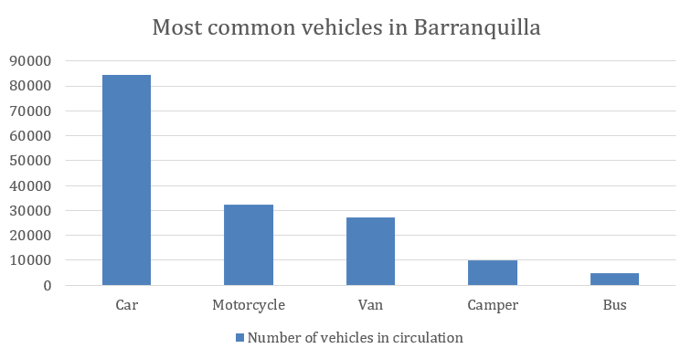

**Fig. 1.** Chart of the most common vehicles in the city of Barranquilla. Taken from: <https://www.elheraldo.co/barranquilla/preocupacion-por-elevado-numero-de-vehiculos-con-placa-foranea-en-barranquilla-343863>

Among younger drivers, there is talk of amaxophobia, better known as fear of driving. This is characterized by irrational and disproportionate fear that some people experience when faced with the possibility of driving [2]. Common causes include lack of practice, fear of risk, fear of making mistakes, fear of responsibility, or irrational fear [3]. Those affected fear accidents, traffic jams, collisions, criticism from other drivers, panic attacks, heart problems, and fainting [4]. Another significant characteristic is the development of avoidance responses [5]. This greatly affects drivers, so action is needed to create a support system for them.

This proposal develops a simulation environment aimed at potential users with amaxophobia to enhance their driving skills in a controlled setting. The program also features an inclusive keyboard-only system for individuals with upper limb disabilities. Additionally, it includes a points system to motivate and foster competitiveness among users, thereby improving their driving skills and practical knowledge.

This article is structured into five sections. In Section 2, related works are exposed to support the development of the methodological proposal and software design presented in Sect. 3. Afterward, Sect. 4 addresses the software implementation. Finally, Sect. 5 presents the conclusions reached in this research.

2 Related works

One of the studies most closely related to the project's purpose also involved a simulation environment, but it utilized virtual reality. In 2018, a study was conducted with adults aged 22 to 54 suffering from driving anxiety [6]. This study used virtual reality to reduce anxiety and fear levels during driving. Participants attended between 11 and 14 sessions, during which interviews and functional tests were conducted to identify the causes of their anxiety. Participants were divided into three groups (Group 1: P2 and P6, Group 2: P3 and P5, Group 3: P1 and P4) and underwent 3 to 5 baseline sessions that included emotional interviews and exposure to neutral scenarios to familiarize themselves with the simulator. They were asked to keep a "Diary of Bordo," and functional assessments were conducted to analyze driving episodes and anxiety levels.

During the sessions, participants were exposed to selected virtual scenarios, starting with the least anxiety-inducing and progressing to the most feared scenarios. The main scenarios used were the "Urban Driving Simulator" and the "Virtual Highway." At the end of each session, questionnaires and surveys were conducted regarding the simulator experience. Follow-up sessions were conducted one to three months after the study. The study demonstrated a significant decrease in driving-related anxiety levels. Participants reported increased confidence and comfort while driving after completing the program, indicating that the combination of therapy with virtual reality exposure and functional assessment was effective in addressing both the emotional and behavioral symptoms of driving phobia.

The article [3] investigated the use of mindfulness techniques and cognitive-behavioral therapy (CBT) to treat amaxophobia or driving anxiety. Mindfulness includes meditation, conscious breathing, and mindfulness exercises, helping individuals accept their thoughts and emotions without automatically reacting, thereby reducing anxiety. CBT focuses on changing negative thought patterns and behaviors through techniques like cognitive restructuring and gradual exposure to feared situations. Participants were initially assessed and received mindfulness training sessions, practicing daily exercises and learning coping strategies. The sessions integrated mindfulness and CBT, encouraging conscious breathing during driving. Periodic evaluations showed that the combination of mindfulness and CBT is effective in treating amaxophobia, improving confidence and managing driving anxiety.

The article [7] presents the development of immersive 3D virtual environments with an educational focus. In the article, they designed a methodological framework that guides the creation process of immersive 3D virtual environments. They used specific design and programming tools and techniques to develop these virtual educational environments. They introduced a set of specific heuristics to evaluate the usability and effectiveness of virtual environments in educational contexts. These heuristics were developed based on a review of existing literature and case studies. The study concluded that immersive 3D virtual environments can significantly enhance the educational experience, making learning more dynamic and participatory. These environments allow students to interact more effectively with educational content.

In article [8], the authors explored the implementation of virtual simulations as an educational tool for teaching Environmental Education. They used software and design tools to develop virtual environments that simulate complex environmental phenomena. These virtual simulations were integrated into the educational curriculum as supplementary resources. They were used in practical sessions and as supportive tools during classes, facilitating the understanding of abstract concepts and promoting active learning among students.

The study concluded that implementing virtual simulations in Environmental Education can significantly enhance the learning process. The simulations provided students with a more immersive and practical experience, enabling a deeper understanding of environmental concepts. Additionally, the simulations fostered students' interest and motivation in the subject, promoting more active and meaningful learning in the classroom.

Finally, article [9] explores the use of virtual reality as an innovative tool for language teaching to immigrants. Virtual reality technology can enhance language skills acquisition and cultural integration by creating specific virtual environments that simulate everyday situations such as shops, offices, public transportation, and social settings. These interactive environments provide immediate feedback. Participants attended regular sessions using virtual reality headsets to interact with these environments, focusing on specific language aspects like vocabulary, grammar, pronunciation, and listening comprehension. Assessment tests were conducted at the beginning and end of the program to measure progress in language skills.

Thanks to virtual reality and interactive simulations, participants showed significant improvement in their language skills, including increased vocabulary, improved pronunciation, and smoother language comprehension. Additionally, virtual environments helped participants familiarize themselves with cultural and social situations in the host country, facilitating their integration.

3 Methodology

"Perfect Driver" is the name assigned to this program, which allows users to test their theoretical driving knowledge through racing circuits, focusing on skills such as road safety, defensive driving, and knowledge of traffic laws and regulations [10]. Additionally, a list of requirements will be fulfilled as shown in Table 2.

**Table 2.** Table of functional and non-functional requirements of the program

|  |  |
| --- | --- |
| Requeriments | List of requeriments |
| Functional | * Control and profile configuration. * Game tutorial * Points system |
| Non-functional | * Randomly generated traffic signs and elements on the map * Game optimization and low resources comsumption * Sound system to capture user attention * Driving knowledge tests for the user |

3.1 FURPS model

Considering the project requirements, Unity was chosen as the development tool for the video game due to its wide variety of assets suitable for creating a realistic 3D experience for the player, along with development in C# language. Table 3 shows the requirements of the project using a (Functionality, Usability, Reliability, Performance, and Supportability) FURPS approach.

**Table 3.** FURPS model for understanding the final project.

|  |  |
| --- | --- |
| Factors | Attributes |
| Functionality | * Displays the points obtained by the user within the game. * Utilizes basic car knowledge such as starting and using the handbrake. |
| Usability | * Includes a tutorial for controls. * Simple interface for the user. * Control configuration. |
| Reliability | * Data remains securely stored locally. * Settings remain defaultin case of failures |
| Performance | * Does not consume a large amount of resources. * Own terrain loading system for improved performance. * Video and audio configuration. |
| Supportability | * Compatibility with peripherals. * Easy installation. |

The fulfillment of these requirements guarantees the user-oriented design of our environment, with help tools, adaptable configuration, and quality requirements related to reliability, performance, and supportability.

3.2 UML class diagram

For the development of the program, the Scrum methodology is applied, defined as a working model focusing on agility and adaptability, involving constant product deliveries for enhanced development or production effectiveness [11].

To expedite development, task distribution was managed through shorter sprints than those typically suggested by the Scrum methodology. These sprints range from one to two weeks, during which the product quality is assessed, reflections are made, and feedback is provided. This iterative sprint process continues throughout the project's development. A class diagram based on UML (Unified Modeling Language) was designed to aid the understanding of the program and its procedures. The diagram in Fig. 4 provides a graphical representation of the classes and their methods.

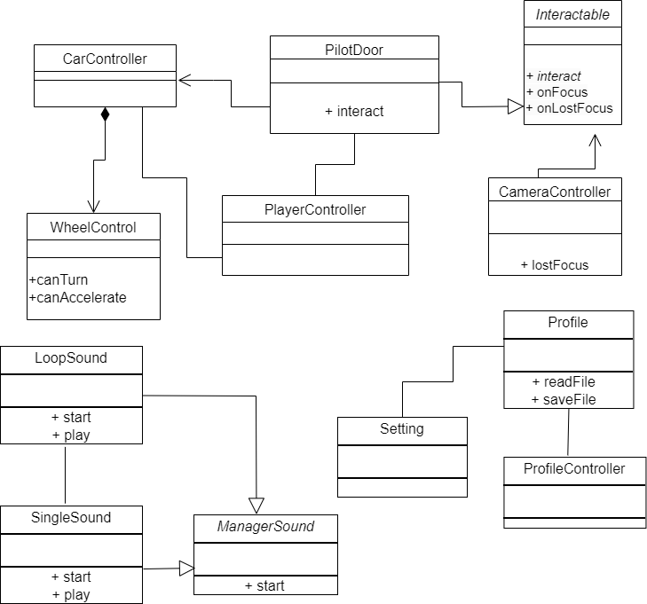

**Fig 4**. UML class diagram of Perfect Driver.

It is worth noting that certain functions originate from Unity, several of which have been consulted in Unity's user manual and library [12]. Additionally, the vehicle features sounds that are not our property; they are publicly and freely available, but we do not claim ownership of them [13].

4 Results

Regarding user functions, we can observe practical examples of the light functions when the user moves (see Figure 5), where the car activates the rear lights when reversing to provide visibility and activates the red lights when stopping. Additionally, we can see the operation of the vehicle's turn signals.

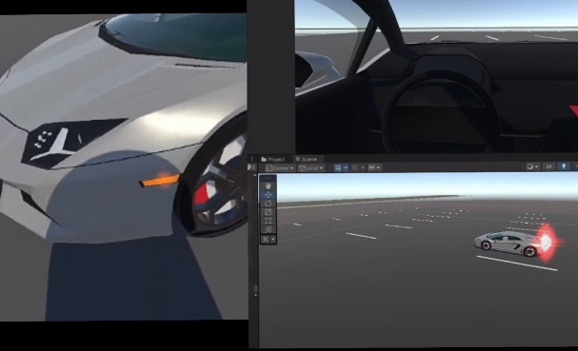

**Fig 5.** Vehicle lights working.

Similarly, we can see the interior view inside the vehicle (Figure 6) and the operation of the camera, where the red line indicates the direction the user is currently viewing. The red line is only visible when we are debugging in Unity, it is simply to have a reference to where we are looking.

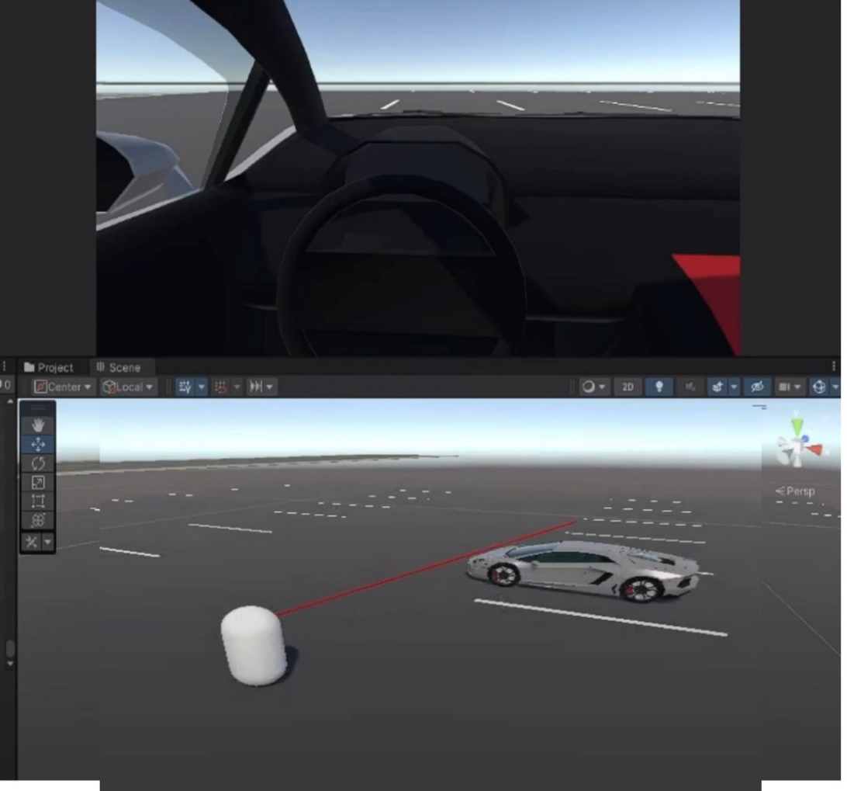

**Fig 6.** Internal view of the vehicle and camera sensor.

Finally, in Figure 7, we see the circuits of the map where the user's knowledge and skills are tested. The environment also includes parking areas, turns, inclines, and declines, in addition to the upcoming implementation of signage and traffic lights.

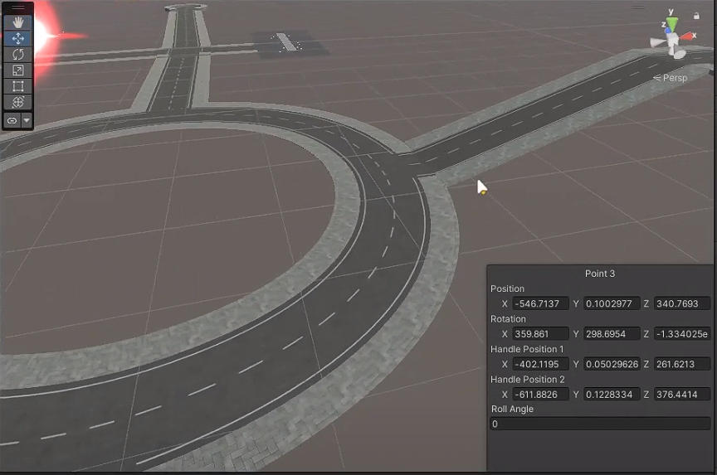

**Fig 7.** Base model of the map circuits.

Also, a usability test was conducted (see Fig. 8 and 9) with 10 people aged between 17 and 41, where the expected responses were mostly positive regarding the application. The aspect they liked most was driving the vehicle through the map. Therefore, this could indicate that the program is both enjoyable and rewarding for users in their learning experience.

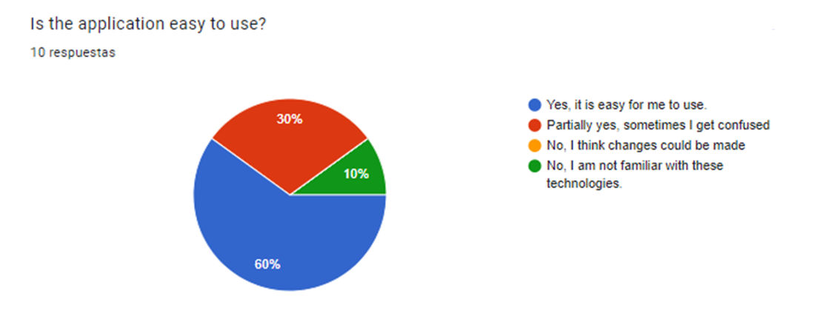

**Fig. 8**. Usability test regarding the application and its comfort.

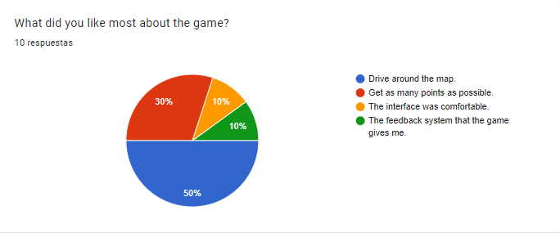

**Fig 9.** Usability test regarding the aspects that users liked the most.

5 Conclusions

During the development of the Perfect Driver program, awareness has been raised about amaxophobia and how it affects people. Efforts have been made to create an interactive environment that does not trigger the main factors of this phobia, such as fear of risk, fear of making mistakes, fear of responsibility, or irrational fear. The focus has been on young adults when driving, recognizing how this phobia can hinder progress in transportation, especially in a context where owning a personal vehicle is considered a necessity rather than a luxury, contrasting with past perceptions.

Perfect Driver is not a program capable of reducing amaxophobia, nor does it have a way to prove such capability. However, it is focused on addressing amaxophobia by designing its features around the factors that most affect people with this phobia. Perfect Driver is a virtual environment that provides users with the knowledge they need to practice driving, adhering to traffic rules and promoting a commitment to road safety. The program challenges users with tasks such as using turn signals, adjusting lights, vehicle movement, and internal controls. Additionally, it offers a visually appealing 3D environment to maintain engagement, with the potential for further development by introducing more real-life interactions such as handling in-game events like festivals, unexpected situations, or changes in environment.

Most of the functional and non-functional requirements are fulfilled, with the following highlights: there is a tutorial space to clarify player doubts about the program's operation, a simple and intuitive interface for users, a points system to make users aware of their interactions and actions within the game. The game is optimized, requiring minimal resources from the user, and features graphics that attract users. The sound system allows users to audibly recognize the vehicle's situation, position, and changes happening around them, functioning pragmatically like a real-life personal vehicle. Program stability is also ensured, with errors that may arise not significantly impacting the user experience or halting the program in the midst of the experience itself.

Perfect Driver provides a safe, entertaining, practical, and inclusive environment for users. It helps users learn, practice, and understand driving while fostering competitiveness and motivation to improve driving skills in a virtual setting.

References

1. A. De La Hoz, "Preocupación por elevado número de vehículos con placa foránea en Barranquilla," El Heraldo, Available: <https://www.elheraldo.co/barranquilla/preocupacion-por-elevado-numero-de-vehiculos-con-placa-foranea-en-barranquilla-343863>

2. S. S. Marín, "Evaluation of fear of driving in students of driver license," Secur. Vialis, vol. 3, no. 2, pp. 53-62, Jul. 2011. doi: 10.1007/s12615-012-9040-5.

3. A. Hernández Gómez, "Mindfulness y terapia cognitivo conductual aplicados para el tratamiento de la amaxofobia," vol. 5, 2017. Available: <https://dialnet.unirioja.es/servlet/articulo?codigo=6201739>

4. A. Bados, "Fobias específicas," 2005. Available: http://diposit.ub.edu/dspace/bitstream/2445/360/1/113.pdf. Accessed: 13/05/2024.

5. American Psychiatric Association, DSM-5: manual diagnóstico y estadístico de los trastornos mentales, Editorial Médica Panamericana, 2014, Madrid, España; Bogotá, Colombia.

6. E. Borloti, A. dos Santos, and V. B. Haydu, "Therapy with exposure to virtual reality and functional assessment for driving phobia: An intervention program," Avances en Psicologia Latinoamericana, vol. 36, pp. 235-251, 2018. doi: 10.12804/revistas.urosario.edu.co/apl/a.5329. Available: <https://revistas.urosario.edu.co/index.php/apl/article/view/5329/5922>

7. J. C. Monroy Osorio and H. Trefftz Gómez, "Ambientes Virtuales Inmersivos en 3D con Énfasis Educativo: Una Propuesta para el Proceso de Creación y Nuevas Heurísticas en la Evaluación," Universidad EAFIT, 2012. Available: <http://hdl.handle.net/10784/1411>

8. E. Solano-Tenorio, E. Pérez-Puche, and A. Caballero-Guevara, "Implementación de simulaciones virtuales en la enseñanza y el aprendizaje para la Educación ambiental," Educación y Sociedad, vol. 20, no. 3, pp. 130-145, Universidad de Ciego de Ávila Máximo Gómez Báez, Cuba, 2023. Available: <https://doaj.org/article/dcd0fe0b1df44cfe9bec1fc7c9188e07>

9. M. Burgos, A. González, and E. Sánchez, "Realidad virtual en enseñanza lingüística a inmigrantes," CITAS, vol. 8, no. 2, 2022. Available: <https://doi.org/10.15332/22563067.7948>

10. PODER PÚBLICO - RAMA LEGISLATIVA DE COLOMBIA, "Ley 769 de 2002," 2006. Available: <https://www.funcionpublica.gov.co/eva/gestornormativo/norma.php?i=5557>

11. E. M. Valencia Betancur, B. A. Uribe Ochoa, and F. J. Salazar Gómez, "Diseño de Marco de Trabajo SCRUM para los proyectos de transformación digital de INCOLMOTOS YAMAHA en Colombia," Universidad EAFIT, 2021. Available: <http://hdl.handle.net/10784/30160>

12. Unity Technologies, "Manual de Usuario de Unity," 2024. Available: https://docs.unity3d.com/Manual/index.html. Accessed: 28/04/2024.

13. J. R. Meyer, "Metal Bang 1," Freesound, 2020. Available: https://freesound.org/people/jrmeyer/sounds/537272/. Accessed: 13/05/2024.