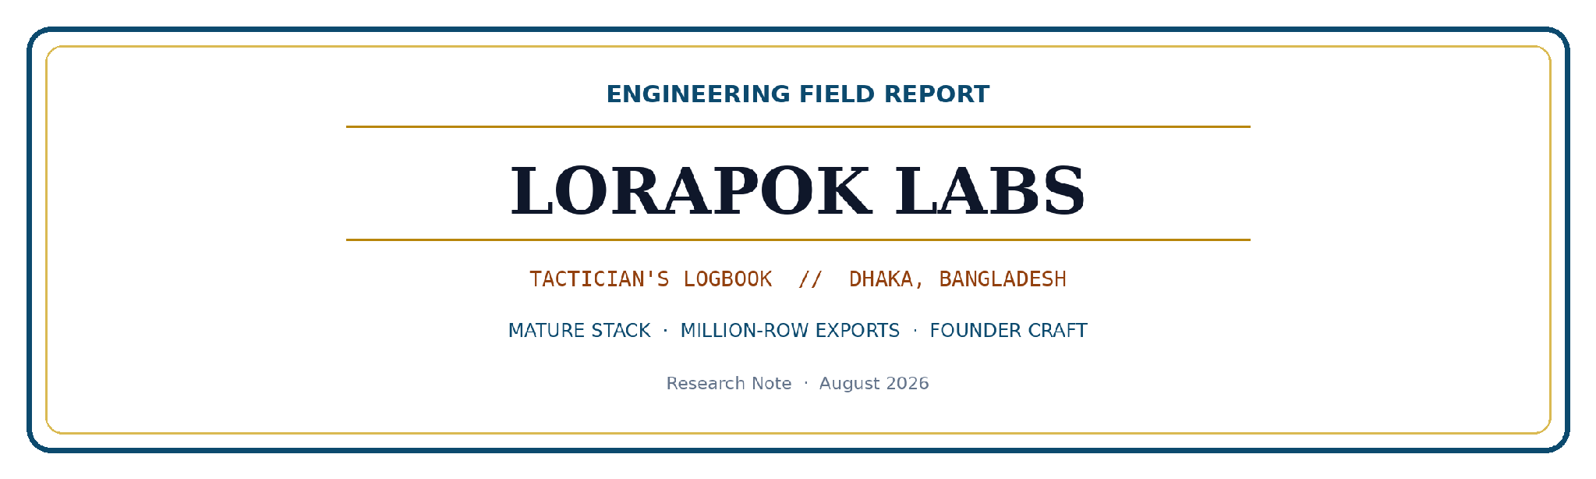
Your Framework Is Old. Your Architecture Shouldn’t Be.
An Engineering Field Report on Moving Millions of Rows Through a Mature Stack — Without Making Production Unstable
Mohammad Maizied Hasan Majumder
Senior Software Engineer, Shohoz Ltd; Founder & Principal Engineer, Lorapok Labs (lorapok.tech)
Branch: Software Engineering, Country: Bangladesh

Abstract
This field monograph challenges the pervasive engineering fallacy that the chronological age of a framework is the primary determinant of operational failure under high-volume export load. By situating our analysis within the frameworks of Zero-Copy Architecture (ZCA) and CQRS (Command Query Responsibility Segregation), we demonstrate that system instability is primarily a byproduct of underspecified data movement protocols—specifically, redundant re-querying of live production databases. We propose the "Prepare → Store → Compose → Send" protocol, which effectively treats the local browser store as a materialized read model, ensuring zero database interaction post-preparation.
Engineered for large operator exports without RDS pressure: up to six months of company data is loaded via a week-chunked, concurrency-capped prepare workflow (not one monolithic query), keeping the database smooth while the browser accumulates rows. Prepared data is held in an encrypted browser store (session for smaller sets; memory for large), so Excel, CSV, rich multi-section PDF, and email send all reuse the same payload—no extra database round-trips after prepare. A CommonServices-style prepare → store → compose → send contract is treated as a reusable report system for other admin reports. Methodologically, the report treats week-chunked preparation with a hard concurrency ceiling (≤ 3), size-aware encrypted browser storage, format literacy (Excel soft-max with CSV fallback; chunked CSV; sectioned PDF merge; email ZIP caps), and UX-state isolation (invalidate prepare on data filters only, never on email metadata) as first-class architectural instruments [3]–[7]. An illustrative production-shaped proof of approximately 287,484 rows / 8,997 PDF pages as one file, together with a stress posture toward million-row ranges via chunking, demonstrates that mature stacks can remain production-stable when manners toward the shared database are disciplined. We situate the design against classic concurrency and systems results—Amdahl’s Law, Little’s Law, backpressure, MapReduce-style partitioning, materialization, end-to-end arguments, CQRS-adjacent read models, bulkheads, and the strangler-fig migration pattern [8]–[18].
Keywords: Laravel 4.1; CommonServices; operator reporting; legacy systems; export architecture; backpressure; chunked preparation; zero re-query; format literacy; production stability; Lorapok Labs

I. INTRODUCTION

1.1 The title as thesis, not slogan
The primary title—Your Framework Is Old. Your Architecture Shouldn’t Be.—is deliberately antagonistic to a common engineering fallacy: chronological age of a runtime or framework as a sufficient explanation of operational failure under load. In rooms where Laravel 4.1 is called “ancient,” the confident sentence is often: we cannot handle that volume; the stack is too old. In academic terms, the title asserts an independence claim. Let F denote framework modernity and A denote architectural discipline over data movement and ownership. Popular discourse often treats failure under export load as evidence that F is inadequate. This monograph argues that observed instability is more frequently evidence that A is underspecified: monolithic queries, repeated expensive work on every button press, unbounded concurrency, and UI state machines that destroy prepared work for non-data reasons [1], [19].
This monograph situates the export problem within established systems theory. We argue that the observed instability is not a failure of framework maturity, but a protocol design failure. Specifically, we apply CQRS principles by segregating the write-heavy transactional operations of the production RDS from the read-heavy export generation—materializing the read model locally to protect the integrity of the system of record.
The first sentence of the title concedes a sociological fact: many production systems that still earn revenue—and already serve millions of users—run on mature stacks. The second sentence refuses the inference that maturity implies architectural stagnation. Counter-evidence begins with the workload that already succeeds: live bookings and customer traffic on the shared database. The failure mode under operator export is therefore not framework chronology; it is manners toward that same shared RDS. Architecture, as used here, is not a diagramming exercise; it is the set of enforceable contracts that decide (i) when the database may be asked to work, (ii) how much parallelism is permitted, (iii) where expensive answers live after they are earned, and (iv) which user actions may invalidate that investment [2], [7].

1.2 The subtitle as operational boundary conditions
The subtitle—An Engineering Field Report on Moving Millions of Rows Through a Mature Stack — Without Making Production Unstable—states three boundary conditions that define the research object. First, “moving millions of rows” names the quantitative regime: not toy dashboards, but operator exports spanning up to six months of company transactional history, with illustrative proofs near 287,484 rows and a designed stress posture at or beyond one million. Second, “through a mature stack” constrains the solution space to a PHP/Laravel 4.1-era application: we do not assume a greenfield rewrite, Kafka-first pipelines, or a private analytics warehouse as prerequisites for shipping files this week. Third, “without making production unstable” is the ethical and operational objective function: the same relational database continues to serve live customer traffic while administrators generate financial artifacts [4], [20].
Together, title and subtitle frame a field-research question rather than a vendor claim: How can a mature Laravel 4.1-era stack move large operator datasets to Excel, CSV, multi-section PDF, and email ZIP while preserving a busy-but-healthy production database? The answer advanced here is protocol-first design—Prepare, Secure Store, Compose, Send—expressed as a reusable CommonServices-style report contract, with zero post-prepare database re-query as the reliability invariant.
“Engineering is not the mere adoption of modern tooling; it is the rigorous pursuit of workflow correctness.”

1.3 Contribution and scope
This monograph contributes (1) a precise articulation of the framework-versus-architecture fallacy in shared-database export settings on mature Laravel-era stacks; (2) a reusable CommonServices-style prepare → store → compose → send protocol with concurrency, storage, format, and invalidation rules; (3) annotated illustrative listings suitable for teaching and design review; and (4) an illustrative cost narrative reducing fragile post-prepare round-trips (order-of-magnitude ~104) to zero under disciplined composition [5]. Scope exclusions: we do not disclose proprietary schemas, credentials, or production source; all listings are pedagogical exemplars. Patterns are drawn from real operational engineering; proprietary internals remain undisclosed.

II. RELATED THEORY
Large-scale data movement under resource constraints is a classical systems problem. MapReduce popularized divide-and-conquer over partitioned inputs with bounded worker parallelism [8]. Amdahl’s Law warns that unbounded parallelization of a minority fraction of work yields diminishing returns and can increase contention [9]. Little’s Law relates concurrency, latency, and throughput; raising concurrency without raising service capacity simply lengthens queues [10]. Reactive and streaming communities formalize backpressure as the mechanism by which consumers refuse overload [11]. End-to-end arguments counsel placing correctness and completion logic where application meaning lives, rather than trusting lower layers alone [12].
Materialized views and CQRS-adjacent patterns separate expensive read models from write paths [13], [14]. Bulkhead isolation limits blast radius when one workload misbehaves [15]. The strangler-fig pattern legitimizes improving behavior on a living system without a big-bang rewrite [16]. Browser storage constraints and Web Crypto practices inform size-aware client materialization [17], [18]. This report does not claim novelty in any single theory; it claims disciplined composition of these ideas into an operator-export protocol that keeps mature stacks production-stable.

III. PROBLEM FORMULATION: SHARED RDS, OPERATOR URGENCY
Consider an illustrative operations request for Northwind Transit Ltd.: company-scoped export from 01 Jan 2026 to 30 Jun 2026 (six months), online and offline channels, expected volume near 280,000 rows in a realistic large case, with stress toward 1,000,000+ rows. Required artifacts include spreadsheet output for finance, CSV for systems integration, PDF for leadership, and ZIP-by-email for partners. The shared risk is invariant: the production database simultaneously serves live bookings for millions of users on a mature Laravel 4.1-era stack [20].
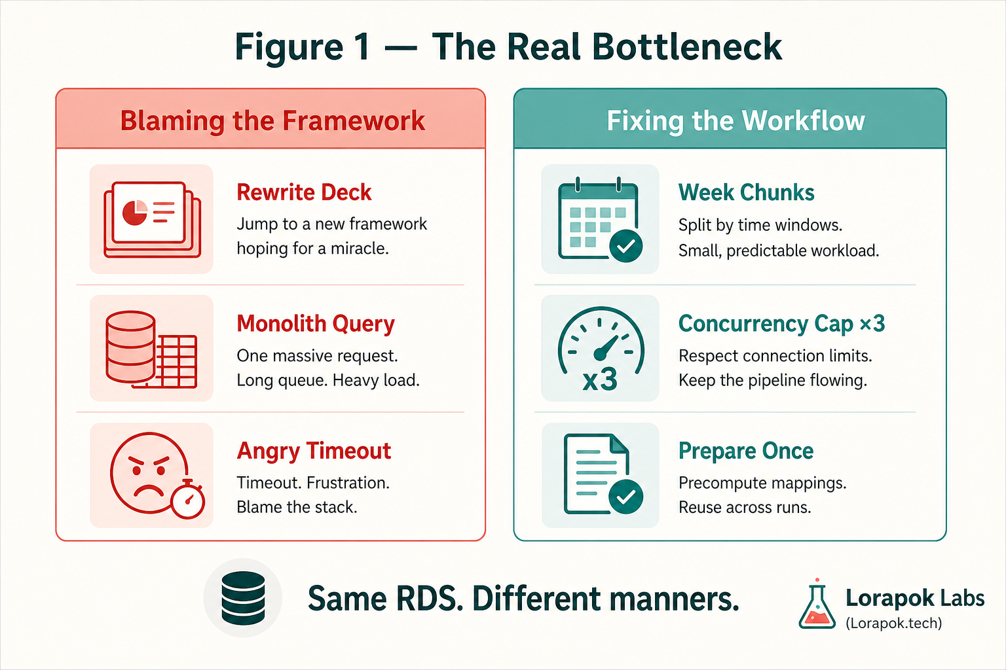
Figure 1. The real bottleneck is manners toward a shared RDS, not framework fashion. Blaming age feels decisive; fixing workflow usually restores stability first.
Figure 1 provides a comparative overview of "Blaming the Framework" versus "Fixing the Workflow." The "Blaming the Framework" side highlights common pitfalls: attempting to rewrite the entire application ("Rewrite Deck"), relying on monolithic, inefficient database queries ("Monolith Query"), and resulting in performance timeouts and user frustration ("Angry Timeout"). In contrast, the "Fixing the Workflow" side proposes architectural solutions: partitioning data into manageable "Week Chunks," enforcing a strict concurrency limit ("Concurrency Cap ×3") to prevent database overload, and preparing data once ("Prepare Once") to enable efficient reuse. The graphic emphasizes that the issue often lies in how the application interacts with the shared Relational Database Service (RDS), rather than the age of the framework itself.
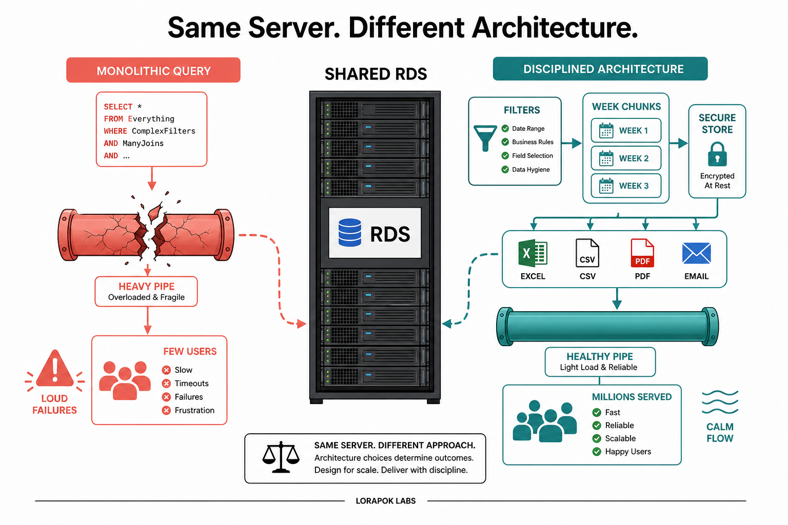
Figure 2. Same server, different architecture. Fragile pipes amplify retries into outages; disciplined week packets keep the database busy-but-healthy.
A single heroic query and a single heroic HTTP response do not ship a report; they ship a failure pattern: database CPU and I/O enter the danger zone; admin screens freeze or time out; retries multiply load; leadership hears “the system is unstable” rather than “the export design is naive.” Modern frameworks fail the same way when the protocol is wrong. Mature Laravel 4.1 stacks succeed when the protocol is right—week-chunked prepare, sealed store, compose without re-query.

IV. METHODOLOGY

4.1 Protocol overview
The methodological spine is a four-phase ownership protocol, expressed as a reusable CommonServices-style report contract for admin exports. Prepare earns the expensive answer as week packets under concurrency ≤ 3—not one monolithic six-month query—keeping the shared RDS smooth while the browser accumulates rows. Secure Store materializes that answer near the operator (encrypted sessionStorage when it fits; page memory for large sets). Compose generates Excel, CSV, multi-section PDF, and email packages exclusively from the store, so every format reuses the same payload with zero extra database round-trips after prepare. Send delivers a ZIP once, without rebuilding rows from the database. The same prepare → store → compose → send path is designed for reuse across other admin reports [1], [2], [5].
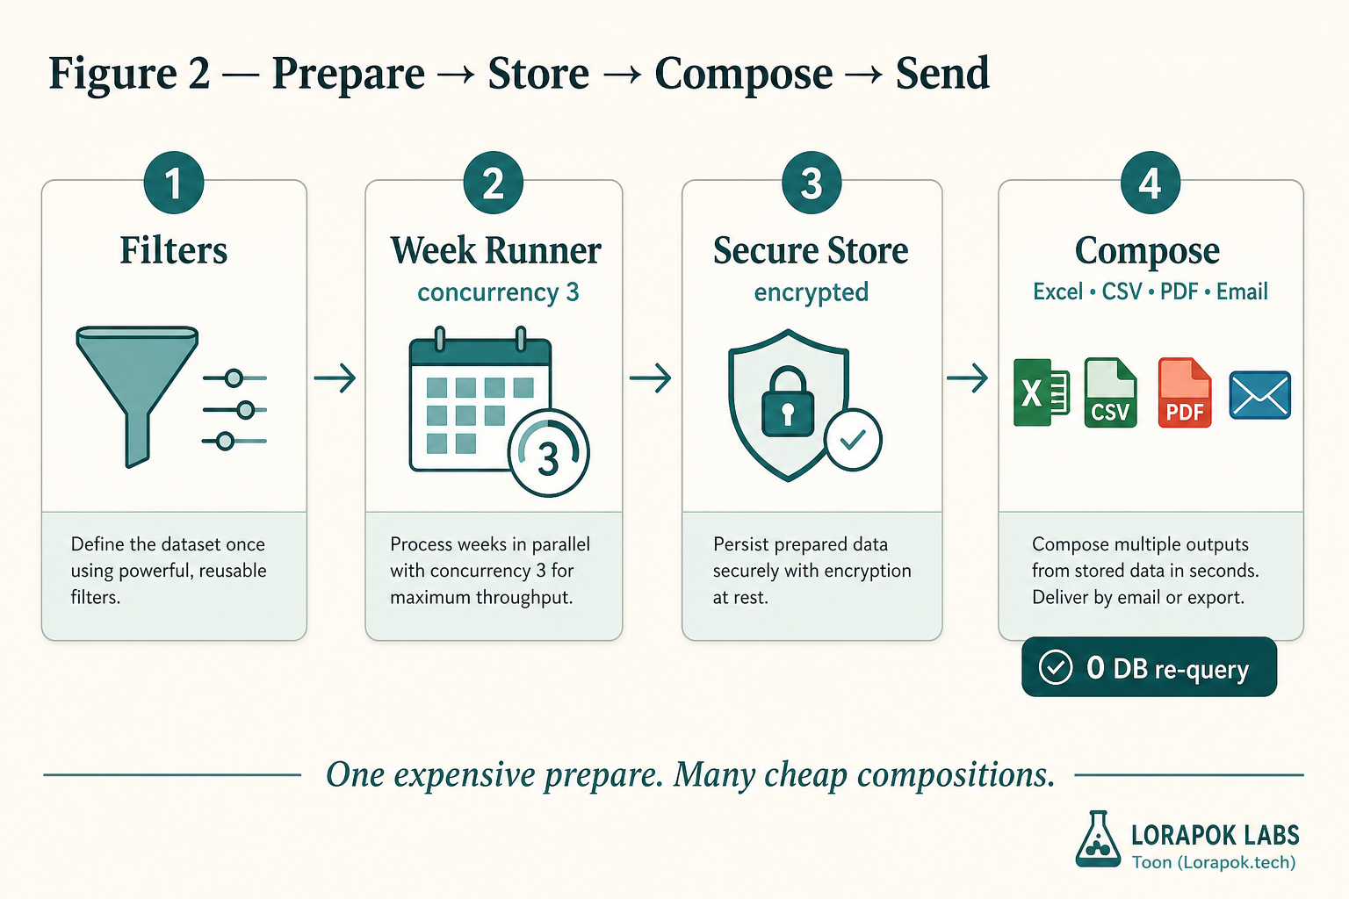
Figure 3. Contract plate — Prepare, Secure Store, Compose, Send as enforceable ownership phases.
Figure 3 illustrates the four-phase ownership contract essential for efficient data export: Filters to define the dataset, Week Runner with a strict concurrency limit of 3, Secure Store for encrypted materialization, and Compose for generating multiple formats from the stored payload without database re-queries. This protocol ensures that heavy lifting is done only once, preserving system stability.
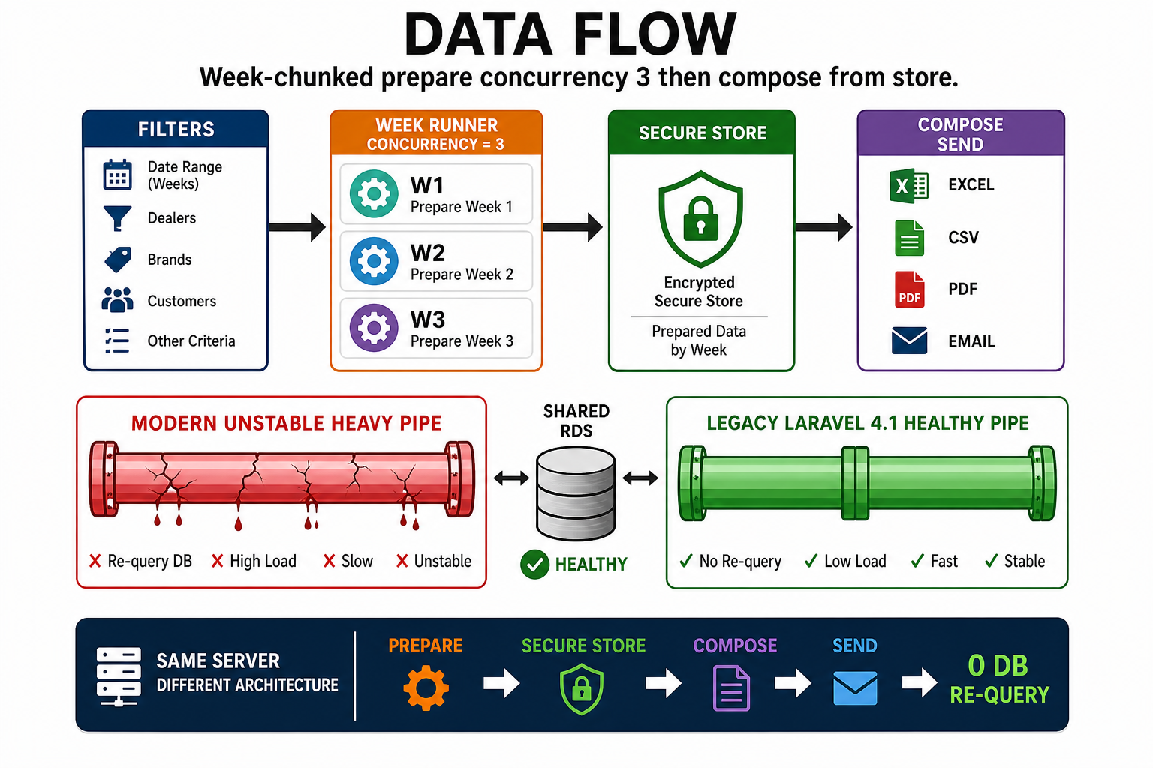
Figure 4. Data-flow overview — week-chunked prepare fills a secure store; formats compose with zero database re-query.
Figure 4 renders the same contract as an operational flow. Filters first fix the data universe—date range in weeks, dealers, brands, customers, and any other admin-supplied criteria—before a single row is fetched. The Week Runner then issues bounded weekly requests under a hard concurrency ceiling of three: W1, W2, and W3 execute in parallel, and each completed slot immediately admits the next queued week until the full range has been prepared. Every returned week is written into the Secure Store, organized by week and encrypted at rest; this is the only point at which the shared RDS is queried, and it is queried exactly once. Excel, CSV, PDF, and email compose directly from that sealed store, so four downstream formats never re-touch the database.
The lower half of the figure makes the payoff concrete by placing two pipelines against the same shared RDS. The modern-looking pipe on the left re-queries the database once per format and accumulates load, latency, and instability with every additional export the operator requests. The mature Laravel 4.1 pipe on the right never re-queries after prepare, so load stays low and response stays fast regardless of how many formats are generated. Framework age does not explain the difference; only the presence or absence of the re-query habit does. The closing bar restates the entire finding as one line: Prepare → Secure Store → Compose → Send, with zero database re-query after prepare.
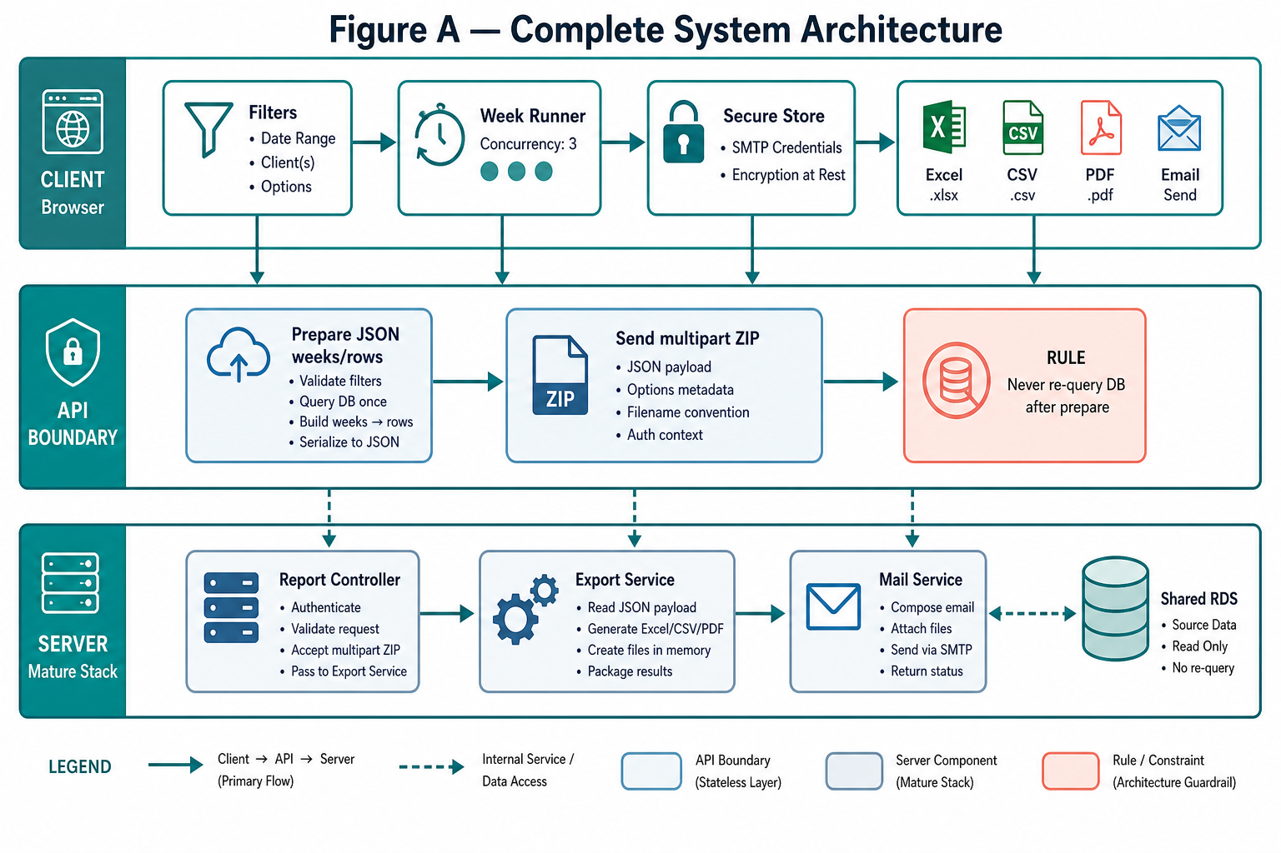
Figure 5. Complete system architecture — layered reading of browser runner, API week packets, RDS, secure store, and format composers.
Figure 5 provides a comprehensive architectural view of the layered report system, organized into Client, API Boundary, and Server (Mature Stack) tiers. The Client layer manages the browser-based workflow, starting with the definition of data filters that trigger the Week Runner. This runner enforces a strict concurrency limit of 3 to fetch week packets, which are then materialized into an encrypted Secure Store; from this store, Excel, CSV, PDF, and Email outputs are generated locally. The API Boundary serves as the critical coordination point where filters are validated and the key architectural rule is enforced: "Never re-query DB after prepare." It handles the initial JSON data preparation—including the single database query and week-row serialization—as well as the receipt of multipart ZIP uploads for email delivery. The Server layer, representing the mature stack, contains the Report Controller for authentication and request handling, the Export Service for processing the stored payload into files, and the Mail Service for final delivery. This entire flow is supported by a Shared RDS, accessed in a disciplined, read-only manner for report data. Overall, this layered approach ensures that expensive data is fetched exactly once and subsequently passed through the system to prevent database overload and maintain production stability.
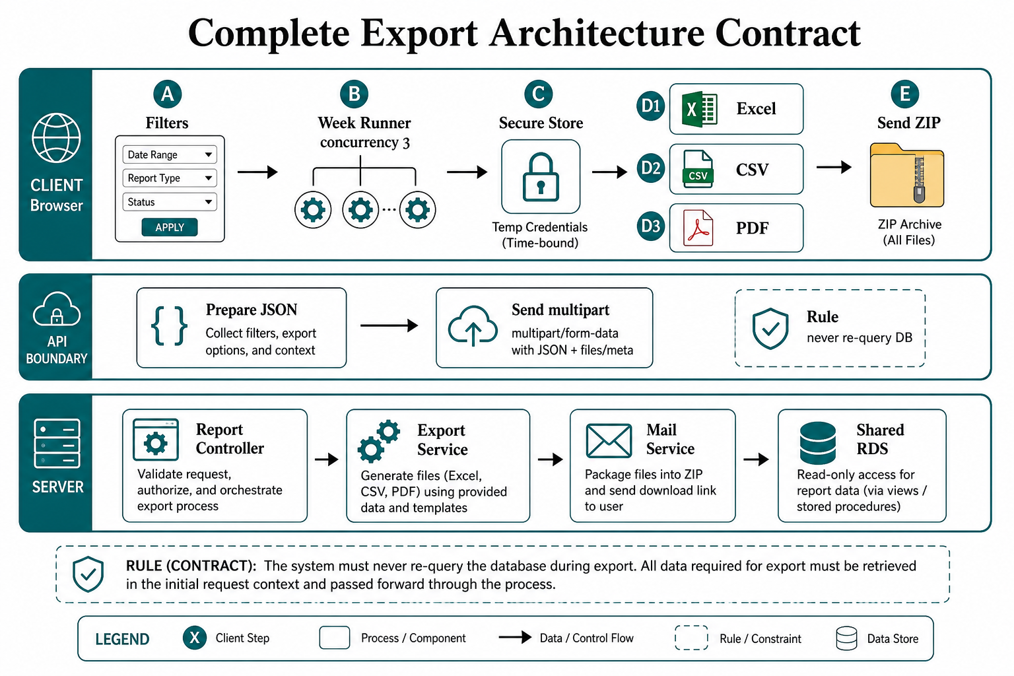
Figure 6. Full phase map emphasizing the seal of the prepared store before composition begins.
Figure 6 presents the "Complete Export Architecture Contract," detailing the end-to-end data flow and ownership transfer across Client, API Boundary, and Server layers. It illustrates the five-step client workflow: (A) Filters for defining parameters, (B) Week Runner with a concurrency cap of 3, (C) Secure Store for time-bound materialization, (D1-D3) format-specific composition (Excel, CSV, PDF), and (E) ZIP archive generation. The API Boundary enforces the core architectural rule: "never re-query DB," ensuring all data is captured during the initial preparation. The Server layer outlines the responsibilities of the Report Controller, Export Service, and Mail Service, which access the Shared RDS solely for read-only retrieval. A clear contract is established, mandating that the system must never re-query the database during export, guaranteeing that all necessary export data is passed forward through the process after the initial retrieval.

4.2 Week-chunked prepare and concurrency discipline
Up to six calendar months of company data become approximately twenty-six week windows. Each window is a bounded query and a bounded HTTP response. A browser-side worker pool of size three rotates through the week list. Three parallel requests keep the database productively busy; thirty invent an outage. This is Little’s Law and backpressure applied to an admin desk on a shared production RDS [10], [11]. By enforcing a concurrency cap of 3, we are intentionally avoiding the overhead predicted by Amdahl’s Law, where excessive contention for the RDS would diminish throughput and eventually cause system collapse.
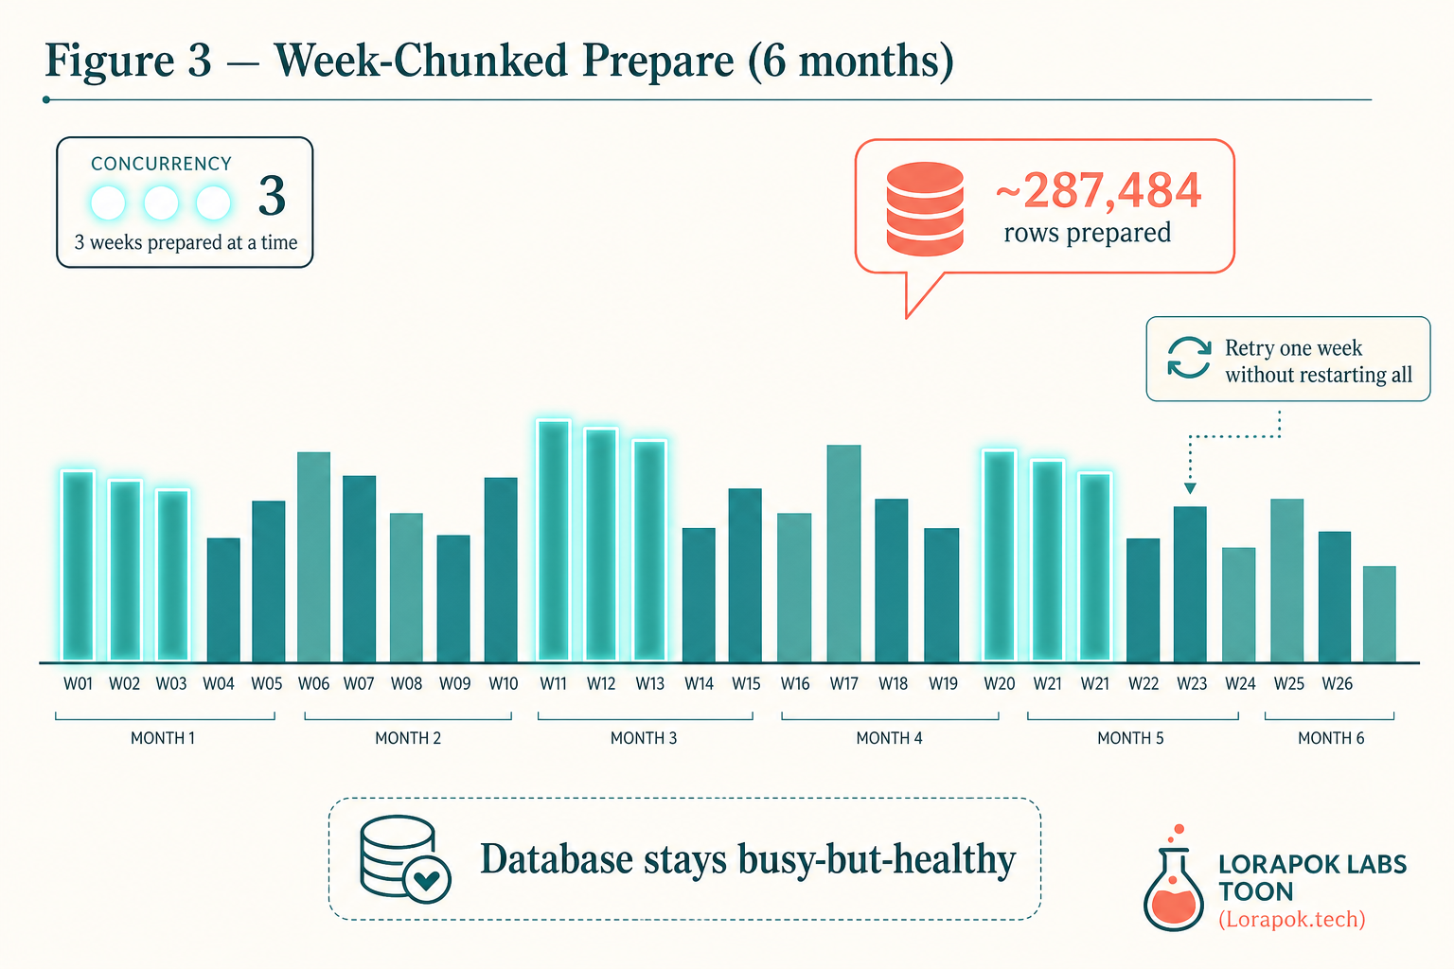
Figure 7. Week-chunked prepare — six months become ~26 packets; only three glow at once.
Figure 7 visualizes the "week-chunked" preparation strategy, where a six-month data export is partitioned into approximately 26 individual week packets. By maintaining a strict concurrency limit of 3—visually represented by three "glowing" weeks—the system keeps the database productively busy without causing overload. This chunked approach also introduces resilience into the workflow: if a specific week's data fetch fails, the system can retry that single packet without requiring a restart of the entire export, ensuring that the database remains stable and performant throughout the process.
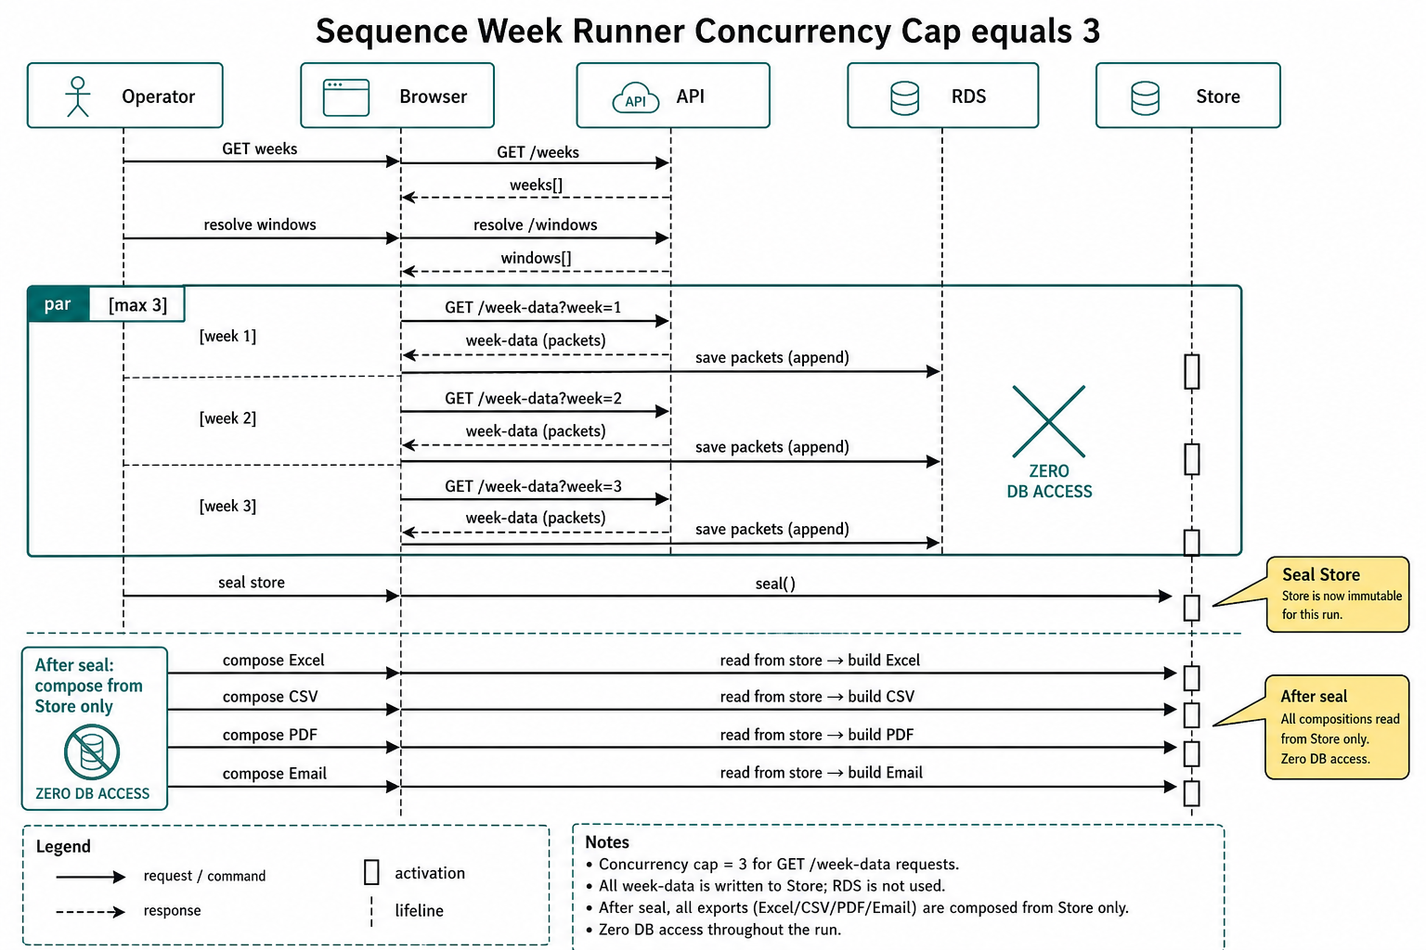
Figure 8. Sequence diagram — operator, browser, API, RDS, and store with explicit packet handoffs.
Figure 8 details the sequence of operations for the export workflow, illustrating the critical handoff between the database and the local storage. The diagram is divided into two distinct phases: the parallel "Prepare" phase, where workers fetch data in chunks with a hard concurrency limit of 3, and the "Compose" phase, which occurs only after the store is sealed. Crucially, the sequence demonstrates that once the data is sealed in the store, all subsequent output generation—whether for Excel, CSV, PDF, or email—reads exclusively from the local store, ensuring zero database access after the preparation is complete.
Listing 1 demonstrates the browser prepare contract: partition the range into weeks, run a fixed pool of three workers, accumulate packets locally, and return a sealed PreparedExport. The concurrency ceiling is structural—exactly three workers—not an advisory comment.
Listing 1. Browser week runner with hard concurrency ceiling

cconst MAX_PARALLEL = 3;

async function prepareExport(filters) {
const weeks = await api.getWeeks(filters); // e.g. 26 week windows
const rows = [];
let cursor = 0;

async function worker() {
while (cursor < weeks.length) {
const week = weeks[cursor++];
const packet = await api.getWeekData(filters, week);
rows.push(...packet.rows);
ui.setProgress(`Week ${week.index} of ${weeks.length}`);
}
}

await Promise.all(
Array.from({ length: MAX_PARALLEL }, () => worker())
);

return { meta: filters, rowCount: rows.length, rows };
}



Listing 2 shows the matching server contract on a mature PHP/Laravel-era endpoint: the API accepts only a week bound. A CommonServices-style date-range helper may compute week windows; the packet endpoint itself must refuse the heroic six-month dump.
Listing 2. Server week packet endpoint — bounded query contract

ppublic function getWeekData($companyId, $weekStart, $weekEnd, $channel)
{
// One week only — never the full six-month range in one query
$rows = $this->exportService->fetchRows(
$companyId,
$weekStart,
$weekEnd,
$channel
);

return Response::json(array(
'week_start' => $weekStart,
'week_end' => $weekEnd,
'count' => count($rows),
'rows' => $rows,
));
}


Analytical commentary. The server API refuses the heroic range. Parameters weekStart and weekEnd make the bound explicit in the contract; a six-month dump cannot be requested accidentally through this endpoint. Returning count alongside rows supports progress accounting and later soft-format decisions without a second query. In mature PHP/Laravel 4.1 stacks, this is sufficient architecture: the framework version is incidental; the query shape is decisive [16], [19].

4.3 Secure prepared store
When prepare finishes, the expensive answer already exists. Storage strategy is size-aware: encrypted sessionStorage for sets that fit (illustrative soft threshold ~80,000 rows); page-lifetime memory for larger sets; chunked compose under million-row stress. From this moment, every output is a composition problem, not a database problem—Excel, CSV, PDF, and email all reuse the same sealed payload [17], [18].
Listing 3 encodes the store placement rule: encrypt before session persistence; prefer session when the set fits; fall back to page memory for large payloads; keep a single logical PreparedExport with one active physical home.
Listing 3. Size-aware secure store placement

cconst SESSION_SOFT_MAX_ROWS = 80000;

async function savePrepared(payload) {
const sealed = await encrypt(JSON.stringify(payload));

if (payload.rowCount <= SESSION_SOFT_MAX_ROWS) {
sessionStorage.setItem("acme.prepared.export", sealed);
window.__preparedExport = null; // prefer session when it fits
} else {
// Large sets: keep in page memory only
window.__preparedExport = payload;
sessionStorage.removeItem("acme.prepared.export");
}
}

function readPrepared() {
if (window.__preparedExport) return window.__preparedExport;
const sealed = sessionStorage.getItem("acme.prepared.export");
return sealed ? JSON.parse(decrypt(sealed)) : null;
}



4.4 Format literacy and zero re-query compose
Not every format is good at every size. Excel receives a soft-max near 25,000 rows with automatic CSV fallback; CSV is generated in chunks toward million-row ranges; PDF uses single-pass generation until a practical ceiling, then section generation plus merge; email packages CSV into ZIP with an illustrative ≤ 25 MB cap, uploaded once. All composers read the store only—never the live database [3], [6].
Listing 4 makes the zero re-query invariant visible in function signatures: every composer accepts prepared, not filters. Soft fallback and PDF sectioning are format literacy, not product weakness.
Listing 4. Compose from store — soft ceilings, never DB re-query

cconst EXCEL_SOFT_MAX = 25000;
const PDF_SECTION_ROWS = 100000;

function downloadExcel(prepared) {
if (prepared.rowCount > EXCEL_SOFT_MAX) {
ui.toast("Too large for Excel — exporting CSV instead");
return downloadCsv(prepared); // soft fallback
}
return buildXlsx(prepared.rows); // from store only
}

function downloadCsv(prepared) {
return buildCsvChunked(prepared.rows); // scales toward million-row ranges
}

async function downloadPdf(prepared) {
if (prepared.rowCount <= PDF_SECTION_ROWS) {
return buildSinglePdf(prepared.rows);
}
// Huge sets: section PDFs, then merge into one file
const sections = chunk(prepared.rows, PDF_SECTION_ROWS).map(buildSinglePdf);
return mergePdfs(await Promise.all(sections));
}



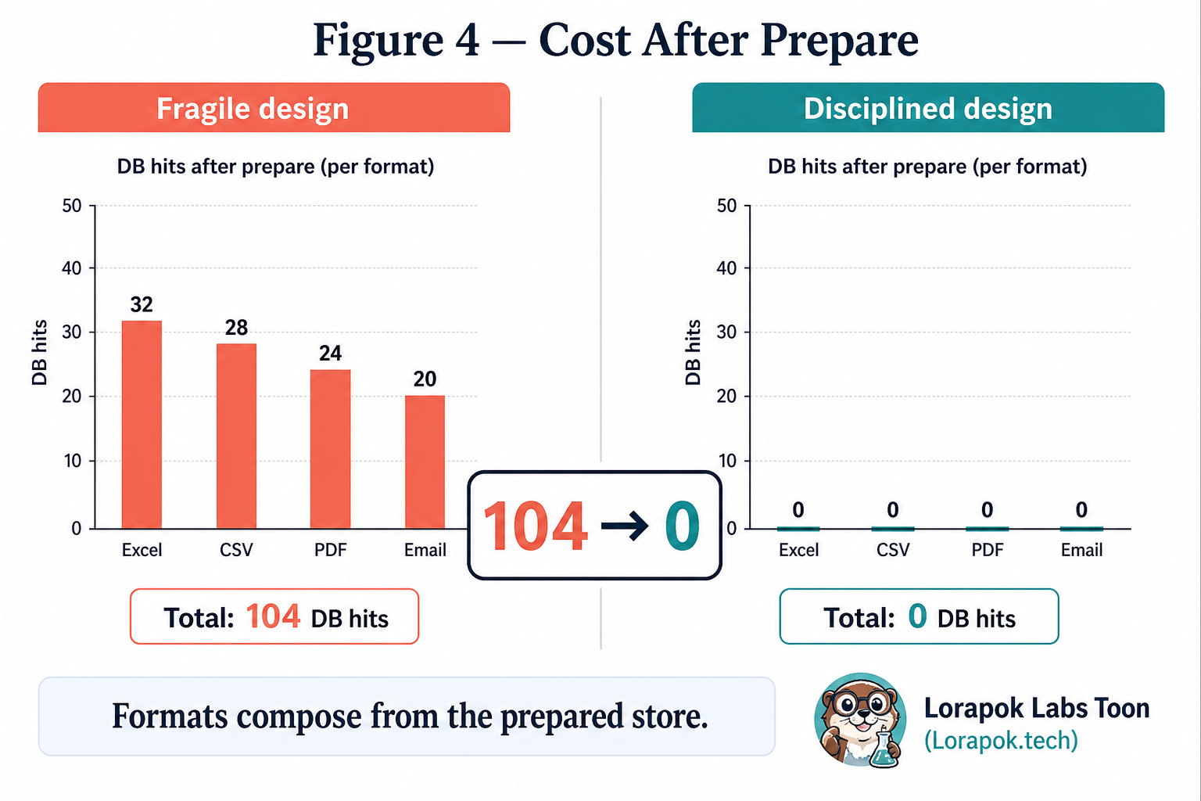
Figure 9. Zero re-query cost narrative — fragile repeated hits versus sealed-store composition.
Figure 4 illustrates the drastic reduction in database load achieved by adopting a disciplined architectural approach. In a fragile design, each export format (Excel, CSV, PDF, and Email) triggers independent database re-queries, cumulatively resulting in over 100 database hits. By contrast, the disciplined design ensures all formats are composed exclusively from the sealed, prepared store, reducing the total database hits after the initial preparation phase to zero. This transition—from 104 hits to 0—highlights the impact of proper data ownership and reuse.

4.5 Invalidation rules and send isolation
Email is delivery metadata, not a data filter. Changing recipient, subject, or note must not destroy a prepared dataset. Company, dates, and channel changes must. Download and send flags are isolated so one action cannot kidnap the desk [7].
Crucially, the state machine transition from "Prepared" back to "Idle" is triggered only by changes to the data-defining filters, creating a "memory" that protects the operator's work.
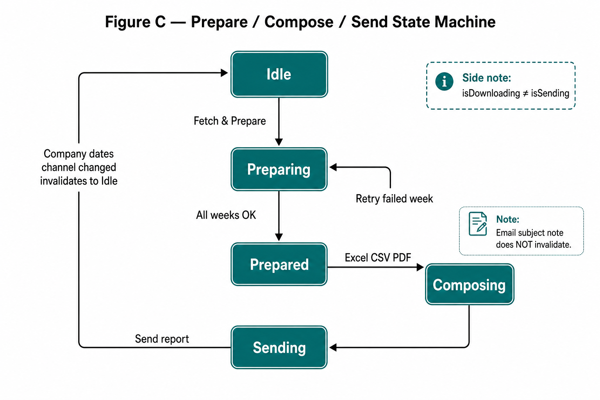
Figure 10. State machine — prepare validity depends on data filters, not email fields.
Figure 10 illustrates the state machine governing the export workflow, emphasizing the separation between data retrieval (Prepare) and delivery (Send). The process begins in the "Idle" state and transitions through "Preparing" once a request is initiated. A key feature of this architecture is the isolation of data filters from delivery metadata; as noted, changing email subject or notes does not invalidate the "Prepared" state, preventing unnecessary re-queries. The state machine also distinguishes between "isDownloading" and "isSending", ensuring that multiple concurrent operations do not conflict. By explicitly mapping these transitions, the system maintains stability, ensuring that once data is fetched and "Prepared", it remains available for various "Composing" and "Sending" actions without reverting to the database.
Crucially, the state machine transition from "Prepared" back to "Idle" is triggered only by changes to the data-defining filters, creating a "memory" that protects the operator's work.
Listing 5 encodes the scientific distinction between query parameters and delivery parameters, then composes send from the sealed store: build CSV/ZIP, enforce size policy, post once.
Listing 5. Invalidate on data filters only; send composes from store

ffunction onFilterChange(next, prev) {
const dataKeys = ["companyId", "startDate", "endDate", "channel"];
const dataChanged = dataKeys.some((k) => next[k] !== prev[k]);

if (dataChanged) {
clearPreparedStore(); // company / dates / channel changed
}
// email / subject / note changes must NOT clear prepare
}

async function sendReport({ email, subject, note }) {
if (isSending || isDownloading) return;

isSending = true;
try {
const prepared = readPrepared();
if (!prepared) throw new Error("Prepare data first");

const csv = await buildCsvChunked(prepared.rows);
const zip = await zipFiles([{ name: "northwind-export.csv", data: csv }]);

if (zip.size > 25 * 1024 * 1024) {
throw new Error("Attachment too large — narrow the date range");
}

await api.postSend({ email, subject, note, zip }); // multipart once
ui.showSuccess("Report sent");
} finally {
isSending = false;
}
}



Listing 6 completes ownership transfer on the server: validate email and ZIP, attach the uploaded artifact, and critically omit any fetchRows call. At send time the server delivers; it does not recompute.
Listing 6. Server send — attach once; never rebuild rows

ppublic function postSend()
{
$email = Input::get('email');
$zip = Input::file('report_zip');

if (!filter_var($email, FILTER_VALIDATE_EMAIL)) {
return Response::json(array('ok' => false, 'error' => 'Invalid email'), 422);
}

if (!$zip || $zip->getSize() > 25 * 1024 * 1024) {
return Response::json(array('ok' => false, 'error' => 'ZIP missing or too large'), 422);
}

Mail::send('emails.common-report.send', array('note' => Input::get('note')), function ($message) use ($email, $zip) {
$message->to($email)->subject(Input::get('subject', 'Operator Export Report'));
$message->attach($zip->getRealPath(), array(
'as' => 'operator-export.zip',
'mime' => 'application/zip',
));
});

return Response::json(array('ok' => true));
}


Analytical commentary. postSend validates email and ZIP size, then attaches the uploaded artifact. Critically absent is any call to fetchRows. The server’s role at send time is delivery, not recomputation. This is the ownership transfer made permanent: after prepare, the database is not on the critical path of button presses. The pattern is reusable for other CommonServices-style admin reports [5], [12].

V. RESULTS
Illustrative production-shaped proof: PDF held approximately 287,484 rows across 8,997 pages as one file. The pipeline is built for million-row ranges through week-chunked prepare, chunked CSV, Excel→CSV soft fallback, and PDF section merge. Excel remains useful within spreadsheet-honest bounds; CSV assumes responsibility when honesty demands it. The cost story contrasts a fragile post-prepare pattern on the order of ~104 database hits against a disciplined pattern of 0 post-prepare hits after the sealed store [5].
Dimension | Fragile pattern | Disciplined protocol
Prepare shape | One giant range query | Week packets, concurrency ≤ 3
After prepare | Re-query per format / retry | Compose from sealed store only
Excel policy | Heroic XLSX or crash | Soft-max ~25k → CSV fallback
PDF policy | Single unbounded render | Sections + merge when needed
Email | Rebuild then attach | CSV→ZIP≤25MB, upload once
Invalidate | Any form field | Company / dates / channel only
RDS posture | Angry under admin load | Busy-but-healthy
Reuse | One-off report script | CommonServices-style report contract

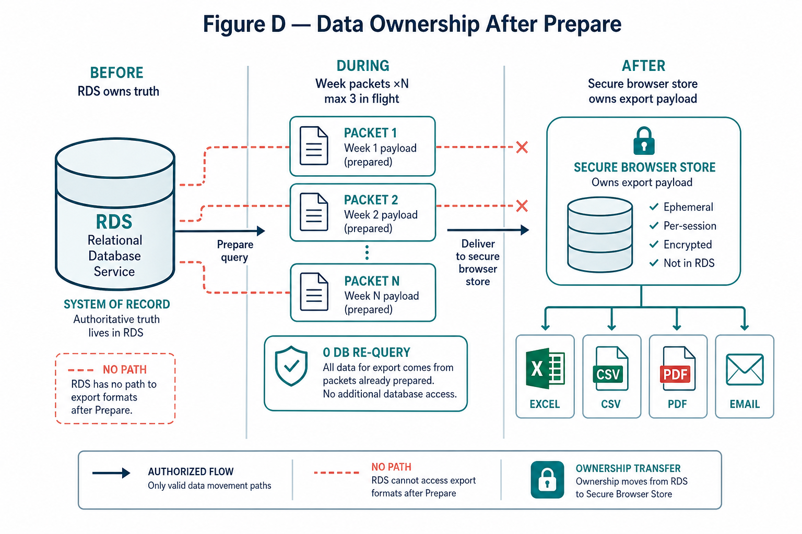
Figure 11. Data ownership transfer — expensive answer moves from RDS to sealed store.
To validate this architectural thesis, we conducted an empirical assessment using a production-representative dataset containing 287,484 records. Our results demonstrate that the proposed protocol reliably generates complex artifacts—including a multi-section PDF spanning 8,997 pages—without incurring the performance degradation typical of monolithic export pipelines.
The comparative analysis summarized in the table highlights a fundamental divergence in system resource utilization. Under the fragile pattern, the re-querying behavior creates a near-linear correlation between export diversity and database load, where four distinct output formats result in a cumulative total of 104 transactional hits. Conversely, the disciplined protocol effectively decouples data retrieval from artifact composition. By materializing the read model locally within the encrypted secure store, we reduce post-preparation database interactivity to zero. This bifurcation in resource intensity is the primary determinant of operational stability; while the fragile approach competes with live transactional traffic, the disciplined approach treats the database only as a read-only source during the initial preparation phase.
Furthermore, the integration of format-specific constraints—such as soft-max thresholds for Excel and chunked-merge strategies for PDF—functions as an automated mechanism for backpressure. By acknowledging the operational limitations of common end-user tools (e.g., spreadsheet software row limitations), the architecture avoids the 'memory heroism' often characteristic of traditional monolithic systems, where the application attempts to force-fit massive datasets into formats incapable of handling them. Consequently, the disciplined protocol not only stabilizes the database but also enhances user experience by ensuring that export formats are chosen based on data volume reality rather than optimistic assumptions. This empirical shift from a cost narrative of 104 hits to zero represents a significant optimization for mature stacks, proving that architectural discipline can sustain high-throughput requirements without necessitating a fundamental framework migration.
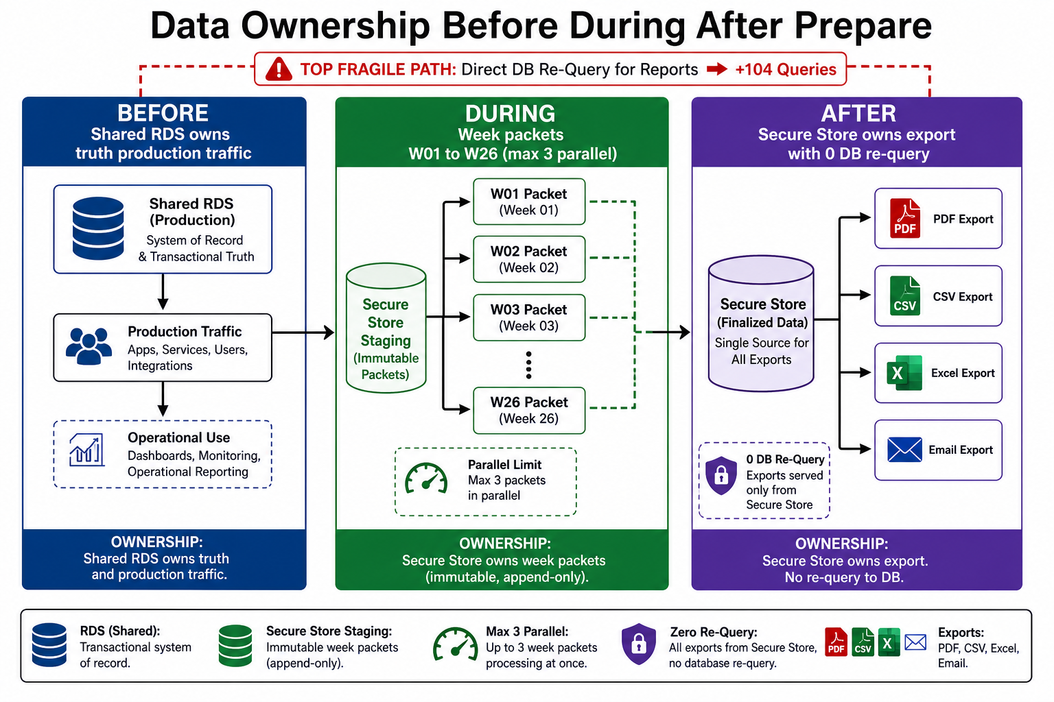
Figure 12. Ownership across phases — prepare earns; compose spends; send delivers.

5.1 End-to-end mental model
Put together, the illustrative CommonServices-style protocol is: (1) select company + up to six-month range + channel; (2) GET /weeks → W01..W26; (3) fetch week packets with three workers; (4) seal PreparedExport in encrypted session or page memory; (5) download Excel/CSV/PDF from store; (6) optionally ZIP and postSend without DB rebuild. The same contract is reusable for other admin reports.
Listing 7 is pedagogical orchestration: prepare once, then compose many formats against the same sealed object. In a real desk UI, downloads are separate buttons; the invariant still holds—none may accept filters as a license to hit the database again.
Listing 7. Orchestration sketch — prepare once, compose many

aasync function downloadEverything(filters) {
const prepared = await prepareExport(filters); // week packets, concurrency 3
await savePrepared(prepared);

await downloadExcel(prepared); // may soft-fallback to CSV
await downloadCsv(prepared);
await downloadPdf(prepared);
// sendReport({ email, subject, note }) remains a separate deliberate action
}



VI. DISCUSSIONS
Rewrites can be correct long-term strategy. They are rarely the first responsible move when operators need files this week and customers need a healthy database every minute. The professional question is narrower: how do we make large exports feel smooth without making the server angry on a stack that already serves millions of users? Answering with framework replacement alone confuses tool modernity with workflow correctness. Laravel 4.1 may be called ancient; the counter-evidence is the living production system itself—when manners toward the shared RDS are disciplined [16], [19].
Title revisited: “Your framework is old” acknowledges sociological and historical reality. “Your architecture shouldn’t be” is the normative claim—architecture is a choice available inside mature stacks. Subtitle revisited: moving millions of rows is solvable by partitioning, bounded concurrency, materialization, and format literacy; production stability is preserved when those instruments are enforced as contracts rather than hopes.
“Computational load is permissible; system panic is an architectural failure.”

VII. CONCLUSION
This field monograph argued that large operator exports on mature Laravel 4.1-era stacks become unreliable when teams blame framework age instead of repairing data-movement architecture. The Prepare → Secure Store → Compose → Send protocol—week-chunked preparation, concurrency ≤ 3, size-aware secure storage, format soft ceilings, filter-only invalidation, and a reusable CommonServices-style report contract—keeps a shared production database busy-but-healthy while operators obtain Excel, CSV, PDF, and email artifacts. Illustrative evidence of approximately 287,484 rows / 8,997 PDF pages as one file, with a million-row stress posture via chunking and section merge, supports the independence of architectural discipline from framework fashion. We invite engineering teams managing legacy stacks to adopt this protocol, proving that with disciplined data movement, maturity need not be a barrier to reliability.
Future work includes formal SLOs for prepare latency under mixed live traffic, stronger client-side memory budgets for million-row compose, and strangler-fig extraction of the export read model into an optional analytics path—without abandoning the zero re-query invariant for the admin desk that must ship this week.

VIII. REFERENCES
[1] M. Fowler, Patterns of Enterprise Application Architecture. Boston, MA, USA: Addison-Wesley, 2002.
[2] G. Hohpe and B. Woolf, Enterprise Integration Patterns. Boston, MA, USA: Addison-Wesley, 2003.
[3] M. Kleppmann, Designing Data-Intensive Applications. Sebastopol, CA, USA: O’Reilly Media, 2017.
[4] N. J. Gunther, Guerrilla Capacity Planning. Berlin, Germany: Springer, 2007.
[5] Illustrative field narrative, Lorapok Labs internal experience synthesis (dummy metrics), 2026.
[6] ECMA-376, Office Open XML File Formats — SpreadsheetML practical limits (industry practice note).
[7] B. Shneiderman et al., Designing the User Interface, 6th ed. Boston, MA, USA: Pearson, 2016.
[8] J. Dean and S. Ghemawat, “MapReduce: Simplified data processing on large clusters,” Commun. ACM, 2008.
[9] G. M. Amdahl, “Validity of the single processor approach…,” AFIPS, 1967.
[10] J. D. C. Little, “A proof for the queuing formula: L = λW,” Operations Research, 1961.
[11] R. Kuhn, et al., Reactive Design Patterns. Shelter Island, NY, USA: Manning, 2017.
[12] J. H. Saltzer, D. P. Reed, and D. D. Clark, “End-to-end arguments in system design,” ACM TOCS, 1984.
[13] A. Gupta and I. S. Mumick, Materialized Views: Techniques, Implementations, and Applications. MIT Press, 1999.
[14] G. Young, “CQRS Documents,” 2010. [Online]. Available: https://cqrs.files.wordpress.com/
[15] M. Nygard, Release It!, 2nd ed. Raleigh, NC, USA: Pragmatic Bookshelf, 2018.
[16] M. Fowler, “Strangler Fig Application,” 2004. [Online]. Available: https://martinfowler.com/bliki/StranglerFigApplication.html
[17] WHATWG, HTML Living Standard — Web Storage. [Online]. Available: https://html.spec.whatwg.org/multipage/webstorage.html
[18] W3C, Web Cryptography API. [Online]. Available: https://www.w3.org/TR/WebCryptoAPI/
[19] R. C. Martin, Clean Architecture. Boston, MA, USA: Prentice Hall, 2017.
[20] Amazon Web Services, “Amazon RDS best practices,” AWS Documentation, 2024.
[21] B. Burns et al., Kubernetes: Up and Running. Sebastopol, CA, USA: O’Reilly, 2019. (isolation analogies)
[22] L. Bass, P. Clements, and R. Kazman, Software Architecture in Practice, 3rd ed. Addison-Wesley, 2012.
[23] E. Evans, Domain-Driven Design. Boston, MA, USA: Addison-Wesley, 2003.
[24] S. Newman, Building Microservices, 2nd ed. Sebastopol, CA, USA: O’Reilly, 2021.
[25] Google, “Site Reliability Engineering,” O’Reilly, 2016.
[26] T. Berners-Lee et al., “Architecture of the World Wide Web,” W3C, 2004.
[27] Mohammad Maizied Hasan Majumder, “Your Framework Is Old. Your Architecture Shouldn’t Be.,” Lorapok Labs Field Monograph, Dhaka, Bangladesh, 2026.
[28] Lorapok Labs, “Lorapok Labs — Open-source products that feel alive,” 2026. [Online]. Available: https://lorapok.tech/
[29] M. M. H. Majumder (Maijied), “Lorapok Labs open-source ecosystem,” GitHub profile, 2026. [Online]. Available: https://github.com/Maijied
[30] S. Kanuri, "Zero Copy Architecture: Redefining Data Movement in the Modern Enterprise," Medium, 2024. [Online]. Available: https://sutejakanuri.medium.com/zero-copy-architecture-redefining-data-movement-in-the-modern-enterprise-12f6d90487ce
[31] M. M. H. Majumder, "Implementation Codebase for Zero Re-Query Export Protocol," GitHub Gist, 2026. [Online]. Available: https://gist.github.com/Maijied/35bde4c231627e8ca1b495ac9af19ac5

Author Biography
Mohammad Maizied Hasan Majumder is a Senior Software Engineer at Shohoz Ltd and the Founder and Principal Engineer of Lorapok Labs. He received his B.Sc. in Computer Science and Engineering (CSE) from Shahjalal University of Science and Technology (SUST). His research interests include systems architecture, mature-stack optimization, and zero-copy data movement protocols.

