Recreating Figure Showing Relation Between Speed and Body Mass

Maike Morrison1,✉

30 November, 2021

Text of abstract

1 Stanford University Department of Biology

✉ Correspondence: [Maike Morrison <[maikem@stanford.edu](mailto:maikem@stanford.edu)>](mailto:maikem@stanford.edu)

Keywords: body mass; speed; animals

Highlights: Animals go zoooom.

# 1 Introduction

This is a replication of figure 2A from1 (fig.(**ref?**fig:fig2a)).

# 2 Background

# 3 Methods

# 4 Results

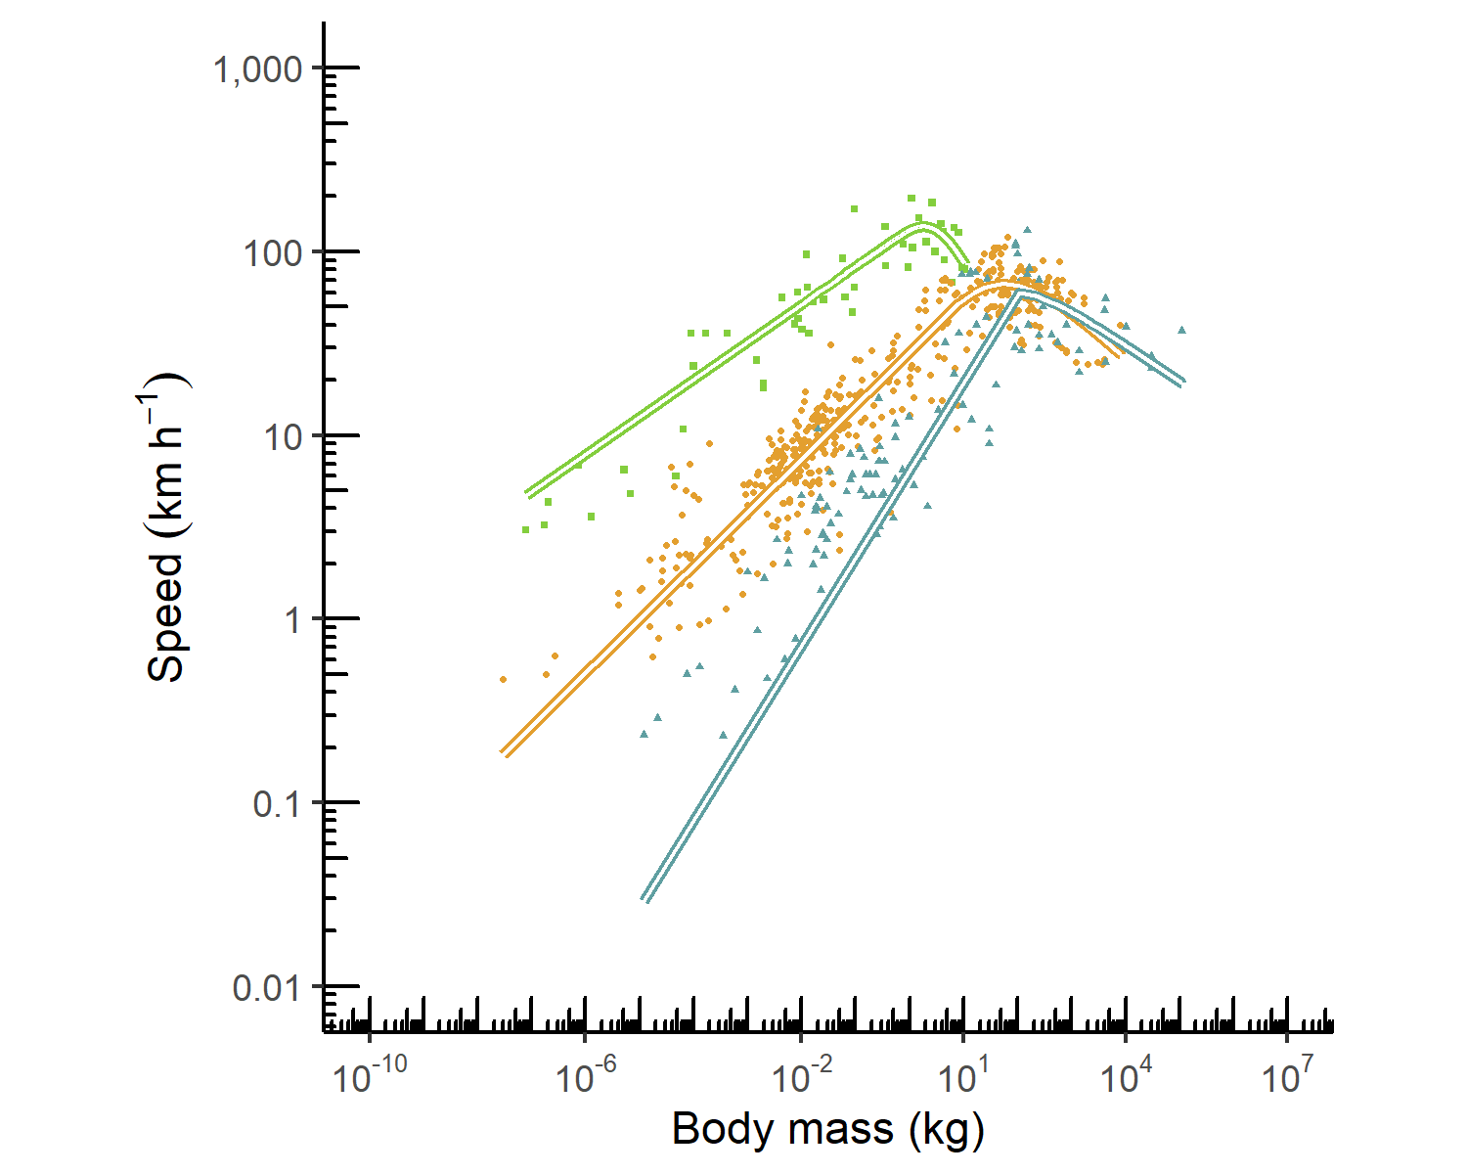

Figure 4.1: Replication of figure 2a from1

# 5 Discussion

# 6 Conclusion

# 7 Acknowledgements

# 8 References

1. Hirt, M. R., Jetz, W., Rall, B. C. & Brose, U. A general scaling law reveals why the largest animals are not the fastest. *Nature Ecology & Evolution* **1**, 1116–1122 (2017).

### 8.0.1 Colophon

This report was generated on 2021-11-30 10:26:02 using the following computational environment and dependencies:

#> - Session info ---------------------------------------------------------------  
#> setting value   
#> version R version 4.0.2 (2020-06-22)  
#> os Windows 10 x64   
#> system x86_64, mingw32   
#> ui RTerm   
#> language (EN)   
#> collate English_United States.1252   
#> ctype English_United States.1252   
#> tz America/Los_Angeles   
#> date 2021-11-30   
#>   
#> - Packages -------------------------------------------------------------------  
#> package * version date lib source   
#> assertthat 0.2.1 2019-03-21 [1] CRAN (R 4.0.2)  
#> bookdown 0.24 2021-09-02 [1] CRAN (R 4.0.5)  
#> cachem 1.0.6 2021-08-19 [1] CRAN (R 4.0.5)  
#> callr 3.7.0 2021-04-20 [1] CRAN (R 4.0.5)  
#> cli 3.0.1 2021-07-17 [1] CRAN (R 4.0.5)  
#> colorspace 2.0-2 2021-06-24 [1] CRAN (R 4.0.5)  
#> crayon 1.4.1 2021-02-08 [1] CRAN (R 4.0.5)  
#> DBI 1.1.1 2021-01-15 [1] CRAN (R 4.0.5)  
#> desc 1.4.0 2021-09-28 [1] CRAN (R 4.0.5)  
#> devtools 2.4.2 2021-06-07 [1] CRAN (R 4.0.5)  
#> digest 0.6.28 2021-09-23 [1] CRAN (R 4.0.5)  
#> dplyr * 1.0.7 2021-06-18 [1] CRAN (R 4.0.5)  
#> ellipsis 0.3.2 2021-04-29 [1] CRAN (R 4.0.5)  
#> evaluate 0.14 2019-05-28 [1] CRAN (R 4.0.2)  
#> fansi 0.5.0 2021-05-25 [1] CRAN (R 4.0.5)  
#> farver 2.1.0 2021-02-28 [1] CRAN (R 4.0.5)  
#> fastmap 1.1.0 2021-01-25 [1] CRAN (R 4.0.5)  
#> fs 1.5.0 2020-07-31 [1] CRAN (R 4.0.2)  
#> generics 0.1.0 2020-10-31 [1] CRAN (R 4.0.5)  
#> ggplot2 * 3.3.5 2021-06-25 [1] CRAN (R 4.0.5)  
#> glue 1.4.2 2020-08-27 [1] CRAN (R 4.0.5)  
#> gtable 0.3.0 2019-03-25 [1] CRAN (R 4.0.2)  
#> highr 0.9 2021-04-16 [1] CRAN (R 4.0.5)  
#> htmltools 0.5.2 2021-08-25 [1] CRAN (R 4.0.5)  
#> knitr 1.36 2021-09-29 [1] CRAN (R 4.0.2)  
#> lifecycle 1.0.1 2021-09-24 [1] CRAN (R 4.0.5)  
#> magrittr 2.0.1 2020-11-17 [1] CRAN (R 4.0.5)  
#> maxspeed * 0.0.0.9000 2021-11-30 [1] local   
#> memoise 2.0.0 2021-01-26 [1] CRAN (R 4.0.5)  
#> munsell 0.5.0 2018-06-12 [1] CRAN (R 4.0.2)  
#> pillar 1.6.3 2021-09-26 [1] CRAN (R 4.0.5)  
#> pkgbuild 1.2.0 2020-12-15 [1] CRAN (R 4.0.5)  
#> pkgconfig 2.0.3 2019-09-22 [1] CRAN (R 4.0.2)  
#> pkgload 1.2.2 2021-09-11 [1] CRAN (R 4.0.5)  
#> prettyunits 1.1.1 2020-01-24 [1] CRAN (R 4.0.2)  
#> processx 3.5.2 2021-04-30 [1] CRAN (R 4.0.5)  
#> ps 1.6.0 2021-02-28 [1] CRAN (R 4.0.5)  
#> purrr 0.3.4 2020-04-17 [1] CRAN (R 4.0.2)  
#> R6 2.5.1 2021-08-19 [1] CRAN (R 4.0.5)  
#> remotes 2.4.1 2021-09-29 [1] CRAN (R 4.0.5)  
#> rlang 0.4.11 2021-04-30 [1] CRAN (R 4.0.5)  
#> rmarkdown 2.11 2021-09-14 [1] CRAN (R 4.0.5)  
#> rprojroot 2.0.2 2020-11-15 [1] CRAN (R 4.0.5)  
#> rstudioapi 0.13 2020-11-12 [1] CRAN (R 4.0.5)  
#> scales 1.1.1 2020-05-11 [1] CRAN (R 4.0.2)  
#> sessioninfo 1.1.1 2018-11-05 [1] CRAN (R 4.0.5)  
#> stringi 1.7.4 2021-08-25 [1] CRAN (R 4.0.5)  
#> stringr 1.4.0 2019-02-10 [1] CRAN (R 4.0.2)  
#> testthat 3.0.4 2021-07-01 [1] CRAN (R 4.0.5)  
#> tibble 3.1.4 2021-08-25 [1] CRAN (R 4.0.5)  
#> tidyselect 1.1.1 2021-04-30 [1] CRAN (R 4.0.5)  
#> usethis 2.0.1 2021-02-10 [1] CRAN (R 4.0.5)  
#> utf8 1.2.2 2021-07-24 [1] CRAN (R 4.0.5)  
#> vctrs 0.3.8 2021-04-29 [1] CRAN (R 4.0.5)  
#> withr 2.4.2 2021-04-18 [1] CRAN (R 4.0.5)  
#> xfun 0.26 2021-09-14 [1] CRAN (R 4.0.5)  
#> yaml 2.2.1 2020-02-01 [1] CRAN (R 4.0.0)  
#>   
#> [1] C:/Users/maike/Documents/R/win-library/4.0  
#> [2] C:/Program Files/R/R-4.0.2/library

The current Git commit details are:

#> Local: master G:/My Drive/Second Year/Just Enough Software Engineering/maxspeed  
#> Remote: master @ origin (https://github.com/MaikeMorrison/maxspeed.git)  
#> Head: [0fd8cf5] 2021-11-30: Add figure reference