Replication of Figure 2: Time-varying interspecific interactions in a subset of the Maizuru fish community

Chih-Fu Yeh1,✉, Maike Morrison1, and Shirley SerranoRojas1

10 December, 2021

Ecological theory suggests that large-scale patterns such as community stability can be influenced by changes in interspecific interactions that arise from the behavioural and/or physiological responses of individual species varying over time. Although this theory has experimental support, evidence from natural ecosystems is lacking. Here, using tools for analysing nonlinear time series and a 12-year-long dataset of fortnightly collected observations on a natural marine fish community in Maizuru Bay, Japan, the authors show that short-term changes in interaction networks influence overall community dynamics.

1 Ecology and Evolution, Department of Biology, Stanford University, USA

✉ Correspondence: [Chih-Fu Yeh <[yehcf@stanford.edu](mailto:yehcf@stanford.edu)>](mailto:yehcf@stanford.edu)

Keywords: Interaction networks; seasonal patterns; community dynamics

Highlights: Figure 2 shows that interactions in the Maizuru Bay fish community are not static; this contradicts a common assumption of ecological research. Instead, they change over time, as expected for a system with nonlinear dynamics. .

# 1 Introduction

The dynamics of ecological communities are influenced by interspecific interactions occurring at multiple temporal and spatial scales. Earlier studies have focused mainly on long-term effects.1–4 However, more recent theoretical and experimental studies have revealed that temporally variable ecological and/or biological responses (including physiological and behavioural responses) can have considerable effects on community dynamics.1,5 In this paper, they look instead at a measure that accounts for nonlinear dynamics and that tracks community stability as it varies through time. Relating fluctuating interaction networks to community stability is crucial for understanding how natural ecological communities are maintained.

This is a replication of figure 2A from6

# 2 Methods

Long-term time-series data of the fish community were obtained by underwater direct visual census conducted approximately once every two weeks along the coast of the Maizuru Fishery Research Station of Kyoto University (Nagahama, Maizuru: 35° 28′ N, 135° 22′ E) from 1 January 2002 to 2 April 2014 (285 time points during approximately 12 years). This high-frequency census enables the detection of short-term interspecific interactions.

## 2.1 Reproducibility

The data and code used in this analysis were packaged as a research compendium (R package rrtools).**marwickPackagingDataAnalytical2018?**,**rrtools2019?** The research compendium was written as an R package so other researchers can read, run, and modify the methods described here.

# 3 Results

## 3.1 Extract causality and interactions

#> Process 1 / 29 completed: 4.558 sec  
#> Process 2 / 29 completed: 0 sec  
#> Process 3 / 29 completed: 3.08 sec  
#> Process 4 / 29 completed: 0.589 sec  
#> Process 5 / 29 completed: 0.937 sec  
#> Process 6 / 29 completed: 0 sec  
#> Process 7 / 29 completed: 3.156 sec  
#> Process 8 / 29 completed: 0 sec  
#> Process 9 / 29 completed: 0 sec  
#> Process 10 / 29 completed: 3.167 sec  
#> Process 11 / 29 completed: 0.892 sec  
#> Process 12 / 29 completed: 0 sec  
#> Process 13 / 29 completed: 0 sec  
#> Process 14 / 29 completed: 1.405 sec  
#> Process 15 / 29 completed: 0 sec  
#> Process 16 / 29 completed: 0 sec  
#> Process 17 / 29 completed: 0.466 sec  
#> Process 18 / 29 completed: 2.825 sec  
#> Process 19 / 29 completed: 0 sec  
#> Process 20 / 29 completed: 0 sec  
#> Process 21 / 29 completed: 0.706 sec  
#> Process 22 / 29 completed: 0 sec  
#> Process 23 / 29 completed: 1.236 sec  
#> Process 24 / 29 completed: 0 sec  
#> Process 25 / 29 completed: 1.071 sec  
#> Process 26 / 29 completed: 0.525 sec  
#> Process 27 / 29 completed: 0 sec  
#> Process 28 / 29 completed: 2.375 sec  
#> Process 29 / 29 completed: 0 sec

## 3.2 Figure 2

And here’s a cross-reference to figure 3.1.

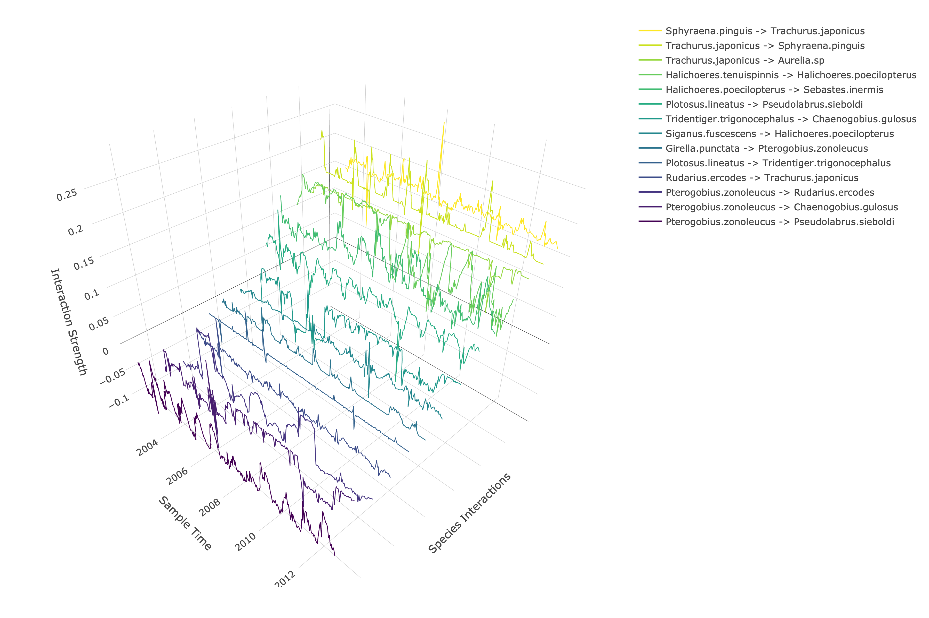

Figure 3.1: Time-varying interspecific interactions in a subset of the Maizuru fish community.

# 4 Conclusion

Here we present a framework based on attractor reconstruction from observational time series that quantifies the dynamic nature of the community interaction network and provides an estimate of dynamic stability. Although the exact individual-level behaviour that gives rise to the interspecific effect cannot be addressed by this analysis, the analysis does enable quantitative identification of the essential interactions that influence community dynamics. Further applications of this framework to ecological time series in different geographical regions—for example, Arctic and tropical regions3—will enable tests of the generality of the present results, and aid in identifying other critical patterns in the dynamic stability of natural ecological communities. Such applications of empirical dynamic modelling could also clarify the relationships between interaction strengths, properties of the distribution (for example, the dominance of weak interactions, skewness and standard deviations), network structure (for example, arrangements and topologies) and community dynamics (such as the relationship between dynamic stability and population variation observed in this study), enabling a more in-depth investigation of the mechanisms by which dynamic interactions and species diversity govern the behaviour of a wide range of natural ecosystems.

# 5 Acknowledgements

# 6 References

1. Kondoh, M. Foraging Adaptation and the Relationship Between Food-Web Complexity and Stability. *Science* **299**, 1388–1391 (2003).

2. Mougi, A. & Kondoh, M. Diversity of Interaction Types and Ecological Community Stability. *Science* **337**, 349–351 (2012).

3. Reynolds, P. L. & Bruno, J. F. Multiple predator species alter prey behavior, population growth, and a trophic cascade in a model estuarine food web. *Ecological Monographs* **83**, 119–132 (2013).

4. Allesina, S. *et al.* Predicting the stability of large structured food webs. *Nature Communications* **6**, (2015).

5. Gratton, C. & Denno, R. F. Seasonal shift from bottom-up to top-down impact in phytophagous insect populations. *Oecologia* **134**, 487–495 (2003).

6. Ushio, M. *et al.* Fluctuating interaction network and time-varying stability of a natural fish community. *Nature* **554**, 360–363 (2018).

### 6.0.1 Colophon

This report was generated on 2021-12-10 10:40:06 using the following computational environment and dependencies:

#> ─ Session info 🇱🇨 👨🏾‍🌾 🚲 ─────────────────────────────────────────────────  
#> hash: flag: St. Lucia, man farmer: medium-dark skin tone, bicycle  
#>   
#> setting value  
#> version R version 4.1.1 (2021-08-10)  
#> os macOS Big Sur 10.16  
#> system x86_64, darwin17.0  
#> ui X11  
#> language (EN)  
#> collate en_US.UTF-8  
#> ctype en_US.UTF-8  
#> tz America/Los_Angeles  
#> date 2021-12-10  
#> pandoc 2.14.0.3 @ /Applications/RStudio.app/Contents/MacOS/pandoc/ (via rmarkdown)  
#>   
#> ─ Packages ───────────────────────────────────────────────────────────────────  
#> package * version date (UTC) lib source  
#> assertthat * 0.2.1 2019-03-21 [1] CRAN (R 4.1.0)  
#> backports * 1.3.0 2021-10-27 [1] CRAN (R 4.1.0)  
#> bookdown * 0.24 2021-09-02 [1] CRAN (R 4.1.0)  
#> broom * 0.7.10 2021-10-31 [1] CRAN (R 4.1.0)  
#> cachem 1.0.6 2021-08-19 [1] CRAN (R 4.1.0)  
#> callr 3.7.0 2021-04-20 [1] CRAN (R 4.1.0)  
#> cellranger * 1.1.0 2016-07-27 [1] CRAN (R 4.1.0)  
#> cli * 3.1.0 2021-10-27 [1] CRAN (R 4.1.0)  
#> codetools * 0.2-18 2020-11-04 [1] CRAN (R 4.1.1)  
#> colorspace * 2.0-2 2021-06-24 [1] CRAN (R 4.1.0)  
#> crayon * 1.4.2 2021-10-29 [1] CRAN (R 4.1.0)  
#> crosstalk 1.2.0 2021-11-04 [1] CRAN (R 4.1.0)  
#> data.table * 1.14.2 2021-09-27 [1] CRAN (R 4.1.0)  
#> DBI * 1.1.1 2021-01-15 [1] CRAN (R 4.1.0)  
#> dbplyr * 2.1.1 2021-04-06 [1] CRAN (R 4.1.0)  
#> desc 1.4.0 2021-09-28 [1] CRAN (R 4.1.0)  
#> devtools 2.4.2 2021-06-07 [1] CRAN (R 4.1.0)  
#> digest * 0.6.29 2021-12-01 [1] CRAN (R 4.1.0)  
#> doParallel * 1.0.16 2020-10-16 [1] CRAN (R 4.1.0)  
#> doRNG * 1.8.2 2020-01-27 [1] CRAN (R 4.1.0)  
#> dplyr * 1.0.7 2021-06-18 [1] CRAN (R 4.1.0)  
#> ellipsis * 0.3.2 2021-04-29 [1] CRAN (R 4.1.0)  
#> evaluate * 0.14 2019-05-28 [1] CRAN (R 4.1.0)  
#> fansi * 0.5.0 2021-05-25 [1] CRAN (R 4.1.0)  
#> farver 2.1.0 2021-02-28 [1] CRAN (R 4.1.0)  
#> fastmap * 1.1.0 2021-01-25 [1] CRAN (R 4.1.0)  
#> forcats * 0.5.1 2021-01-27 [1] CRAN (R 4.1.0)  
#> foreach * 1.5.1 2020-10-15 [1] CRAN (R 4.1.0)  
#> fs * 1.5.0 2020-07-31 [1] CRAN (R 4.1.0)  
#> generics * 0.1.1 2021-10-25 [1] CRAN (R 4.1.0)  
#> ggplot2 * 3.3.5 2021-06-25 [1] CRAN (R 4.1.0)  
#> glue * 1.5.0 2021-11-07 [1] CRAN (R 4.1.0)  
#> gtable * 0.3.0 2019-03-25 [1] CRAN (R 4.1.0)  
#> haven * 2.4.3 2021-08-04 [1] CRAN (R 4.1.0)  
#> here * 1.0.1 2020-12-13 [1] CRAN (R 4.1.0)  
#> highr 0.9 2021-04-16 [1] CRAN (R 4.1.0)  
#> hms * 1.1.1 2021-09-26 [1] CRAN (R 4.1.0)  
#> htmltools * 0.5.2 2021-08-25 [1] CRAN (R 4.1.0)  
#> htmlwidgets * 1.5.4 2021-09-08 [1] CRAN (R 4.1.0)  
#> httr * 1.4.2 2020-07-20 [1] CRAN (R 4.1.0)  
#> iterators * 1.0.13 2020-10-15 [1] CRAN (R 4.1.0)  
#> jsonlite * 1.7.2 2020-12-09 [1] CRAN (R 4.1.0)  
#> knitr * 1.36 2021-09-29 [1] CRAN (R 4.1.0)  
#> lattice * 0.20-45 2021-09-22 [1] CRAN (R 4.1.0)  
#> lazyeval * 0.2.2 2019-03-15 [1] CRAN (R 4.1.0)  
#> lifecycle * 1.0.1 2021-09-24 [1] CRAN (R 4.1.0)  
#> lubridate * 1.8.0 2021-10-07 [1] CRAN (R 4.1.0)  
#> magrittr * 2.0.1 2020-11-17 [1] CRAN (R 4.1.0)  
#> Matrix * 1.3-4 2021-06-01 [1] CRAN (R 4.1.1)  
#> memoise 2.0.1 2021-11-26 [1] CRAN (R 4.1.0)  
#> modelr * 0.1.8 2020-05-19 [1] CRAN (R 4.1.0)  
#> munsell * 0.5.0 2018-06-12 [1] CRAN (R 4.1.0)  
#> pforeach * 1.3 2021-12-06 [1] Github (hoxo-m/pforeach@2c44f3b)  
#> pillar * 1.6.4 2021-10-18 [1] CRAN (R 4.1.0)  
#> pkgbuild 1.2.0 2020-12-15 [1] CRAN (R 4.1.0)  
#> pkgconfig * 2.0.3 2019-09-22 [1] CRAN (R 4.1.0)  
#> pkgload 1.2.3 2021-10-13 [1] CRAN (R 4.1.0)  
#> plotly * 4.10.0 2021-10-09 [1] CRAN (R 4.1.0)  
#> png * 0.1-7 2013-12-03 [1] CRAN (R 4.1.0)  
#> prettyunits 1.1.1 2020-01-24 [1] CRAN (R 4.1.0)  
#> processx 3.5.2 2021-04-30 [1] CRAN (R 4.1.0)  
#> ps 1.6.0 2021-02-28 [1] CRAN (R 4.1.0)  
#> purrr * 0.3.4 2020-04-17 [1] CRAN (R 4.1.0)  
#> R6 * 2.5.1 2021-08-19 [1] CRAN (R 4.1.0)  
#> Rcpp * 1.0.7 2021-07-07 [1] CRAN (R 4.1.0)  
#> readr * 2.0.2 2021-09-27 [1] CRAN (R 4.1.0)  
#> readxl * 1.3.1 2019-03-13 [1] CRAN (R 4.1.0)  
#> rEDM * 0.4.4 2016-03-05 [1] CRAN (R 4.1.1)  
#> remotes 2.4.1 2021-09-29 [1] CRAN (R 4.1.0)  
#> reprex * 2.0.1 2021-08-05 [1] CRAN (R 4.1.0)  
#> reticulate * 1.22 2021-09-17 [1] CRAN (R 4.1.0)  
#> rlang * 0.4.12 2021-10-18 [1] CRAN (R 4.1.0)  
#> rmarkdown * 2.11 2021-09-14 [1] CRAN (R 4.1.0)  
#> rngtools * 1.5.2 2021-09-20 [1] CRAN (R 4.1.0)  
#> rprojroot * 2.0.2 2020-11-15 [1] CRAN (R 4.1.0)  
#> rstudioapi * 0.13 2020-11-12 [1] CRAN (R 4.1.0)  
#> rvest * 1.0.2 2021-10-16 [1] CRAN (R 4.1.0)  
#> scales * 1.1.1 2020-05-11 [1] CRAN (R 4.1.0)  
#> sessioninfo 1.2.1 2021-11-02 [1] CRAN (R 4.1.0)  
#> stringi * 1.7.6 2021-11-29 [1] CRAN (R 4.1.1)  
#> stringr * 1.4.0 2019-02-10 [1] CRAN (R 4.1.0)  
#> testthat 3.1.0 2021-10-04 [1] CRAN (R 4.1.0)  
#> tibble * 3.1.6 2021-11-07 [1] CRAN (R 4.1.1)  
#> tidyr * 1.1.4 2021-09-27 [1] CRAN (R 4.1.0)  
#> tidyselect * 1.1.1 2021-04-30 [1] CRAN (R 4.1.0)  
#> tidyverse * 1.3.1 2021-04-15 [1] CRAN (R 4.1.0)  
#> tzdb * 0.2.0 2021-10-27 [1] CRAN (R 4.1.0)  
#> usethis 2.1.3 2021-10-27 [1] CRAN (R 4.1.0)  
#> ushio2018 * 0.0.0.9000 2021-12-09 [1] local  
#> utf8 * 1.2.2 2021-07-24 [1] CRAN (R 4.1.0)  
#> vctrs * 0.3.8 2021-04-29 [1] CRAN (R 4.1.0)  
#> viridisLite * 0.4.0 2021-04-13 [1] CRAN (R 4.1.0)  
#> withr * 2.4.2 2021-04-18 [1] CRAN (R 4.1.0)  
#> xfun * 0.28 2021-11-04 [1] CRAN (R 4.1.0)  
#> xml2 * 1.3.2 2020-04-23 [1] CRAN (R 4.1.0)  
#> yaml * 2.2.1 2020-02-01 [1] CRAN (R 4.1.0)  
#>   
#> [1] /Library/Frameworks/R.framework/Versions/4.1/Resources/library  
#>   
#> ─ Python configuration ───────────────────────────────────────────────────────  
#> python: /Users/serranoj/Library/r-miniconda/envs/r-reticulate/bin/python  
#> libpython: /Users/serranoj/Library/r-miniconda/envs/r-reticulate/lib/libpython3.6m.dylib  
#> pythonhome: /Users/serranoj/Library/r-miniconda/envs/r-reticulate:/Users/serranoj/Library/r-miniconda/envs/r-reticulate  
#> version: 3.6.15 | packaged by conda-forge | (default, Dec 3 2021, 18:49:43) [GCC Clang 11.1.0]  
#> numpy: /Users/serranoj/Library/r-miniconda/envs/r-reticulate/lib/python3.6/site-packages/numpy  
#> numpy_version: 1.19.5  
#>   
#> NOTE: Python version was forced by RETICULATE_PYTHON  
#>   
#> ──────────────────────────────────────────────────────────────────────────────

The current Git commit details are:

#> Local: main /Users/serranoj/Desktop/Important Disc D Mac/Stanford University/Courses/Software course/ushio2018  
#> Remote: main @ origin (https://github.com/ShirleyJenniferSerranoRojas/ushio2018)  
#> Head: [ea750b4] 2021-12-10: adding citations