大作业设计报告
设计题目：100.(A 类)快递公司人员信息管理
学生姓名：邓杰湧
专 业：物联网工程
班 级：物联网工程1班
学 号：2023212351
指导教师：于磊
完成日期：2023年11月1号

合肥工业大学计算机与信息学院

需求和规格说明
100 (A 类)快递公司人员信息管理
实现快递公司人员信息管理。人员信息包括：编号、姓名、性别、年龄，联系电话，负责片
区，所在部门等，功能要求如下：
（1）添加功能：程序能够任意添加人员的记录，可提供选择界面供用户选择所要添加的人员，
要求员工的编号要唯一，如果添加了重复编号的记录时，则提示数据添加重复并取消添加。
（2）查询功能：可根据编号、姓名等信息对已添加的记录进行查询，如果未找到，给出相应的
提示信息，如果找到，则显示相应的记录信息。
（3）显示功能：可显示当前系统中所有记录，每条记录占据一行。
（4）编辑功能：可根据查询结果对相应的记录进行修改，修改时注意编号的唯一性。
（5）删除功能：主要实现对已添加的人员记录进行删除。如果当前系统中没有相应的人员记录，
则提示“ 记录为空！” 并返回操作；否则，输入要删除的人员的编号或姓名，根据所输入的信息
删除该人员记录，如果没有找到该人员信息，则提示相应的记录不存。
（6）统计功能：能根据多种参数进行人员的统计。能统计四类人员数量以及总数，统计男、女
员工的数量。
（7）保存功能：可将当前系统中各类人员记录存入文件中，存入方式任意。
（8）读取功能：可将保存在文件中的人员信息读入到当前系统中，供用户进行使用。

二. 设计

设计思想：
根据上述需求，设计一个Employee类，和一个EmployeeManager类，Employee包含string id;string name;string gender;int age;string contact;string responsibleArea;string department;等属性。
而EmployeeManager类为Employee类提供了功能接口，如bool addEmployee(const Employee& employee);bool findEmployeeById(const string& id, Employee& employee);等函数。
同时采用了unordered_map容器，其特点在于通过使用哈希表支持平均常数时间复杂度的快速访问。换句话说，可以通过键快速查找、插入和移除元素，而不需要遍历容器。
该程序实现了该题的要求，同时还对输入的数据进行合理性判断，将功能函数以及容器封装在一个EmployeeManager类中，便于维护和添加功能。使用system("cls");将每一次操作后重新显示菜单

系统类图
Employee
string id;
string name;
string gender;
int age;
string contact;
string responsibleArea;
string department;

EmployeeManager
private:
std::unordered_map<std::string, Employee> employee_map;
public:
bool addEmployee(const Employee& employee);
bool findEmployeeById(const string& id, Employee& employee);
bool findEmployeeByName(const string& name, std::vector<Employee>& employees);
void displayAllEmployees();
bool editEmployeeById(const std::string& id, const Employee& employee);
bool deleteEmployeeById(const std::string& id);
void genderStats();
void saveToFile(const std::string& filename);
void loadFromFile(const std::string& filename);
void findwork(EmployeeManager& emanager, Employee& employee);
bool isExist(string &id);

用户手册
打开时会在界面上显示菜单，根据提示输入数字完成操作，如加入职工，修改职工等。

四. 调试及测试
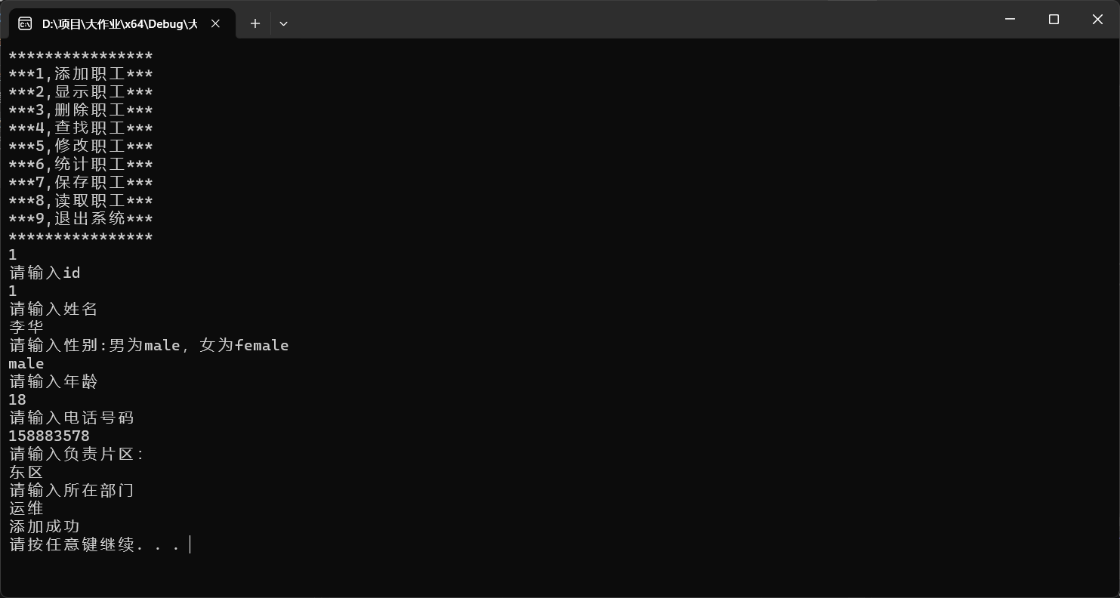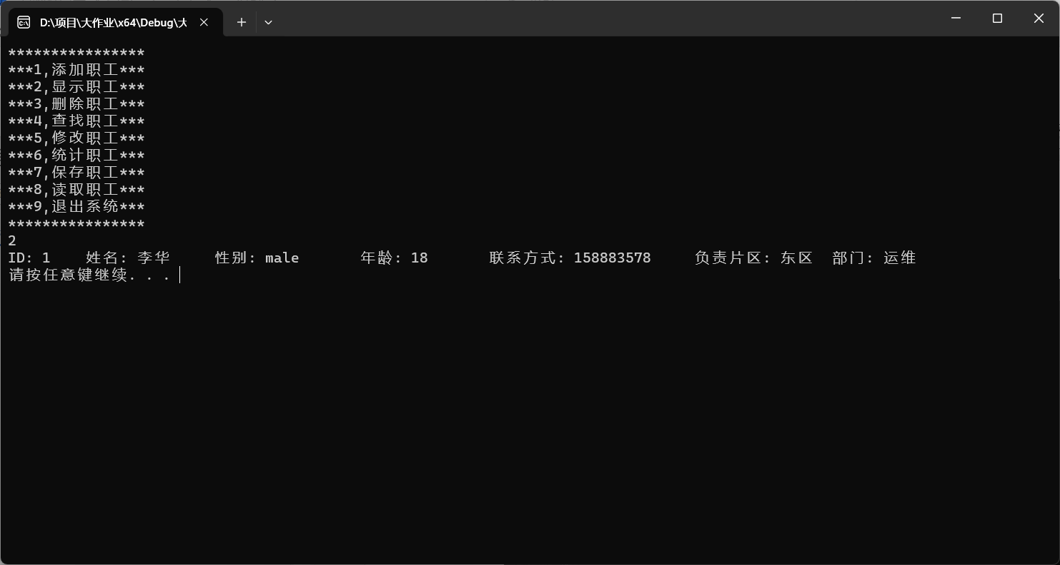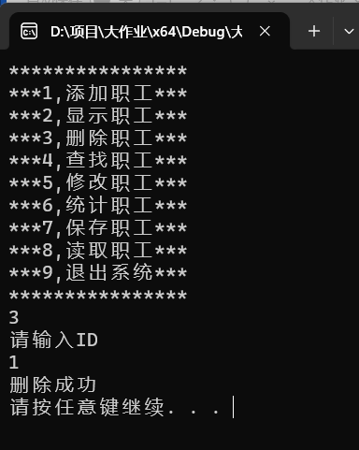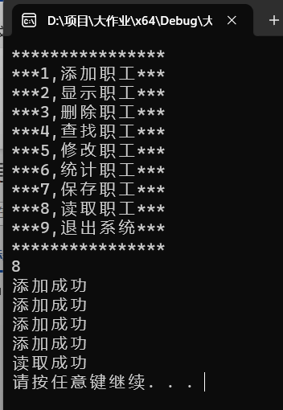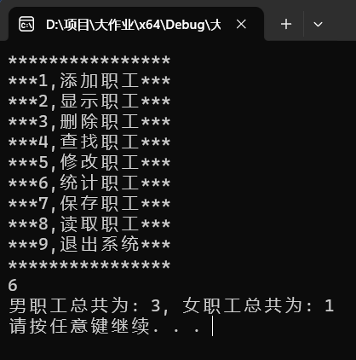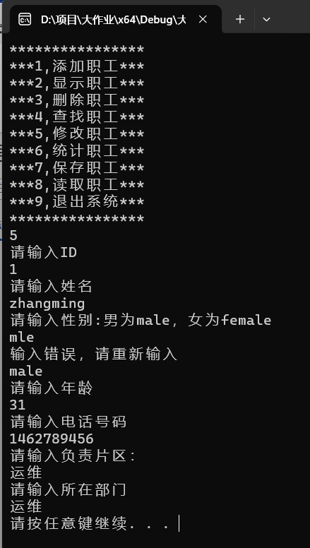 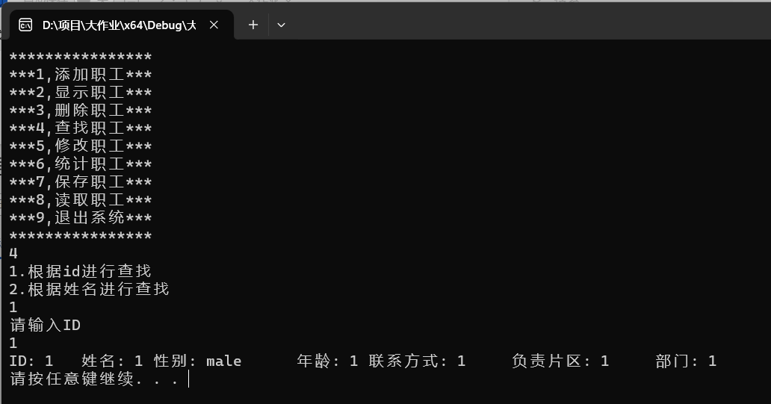

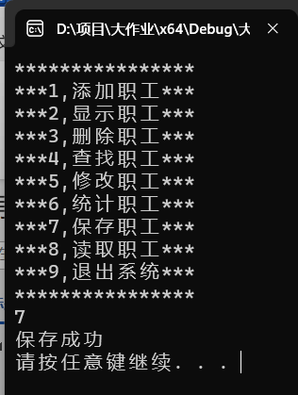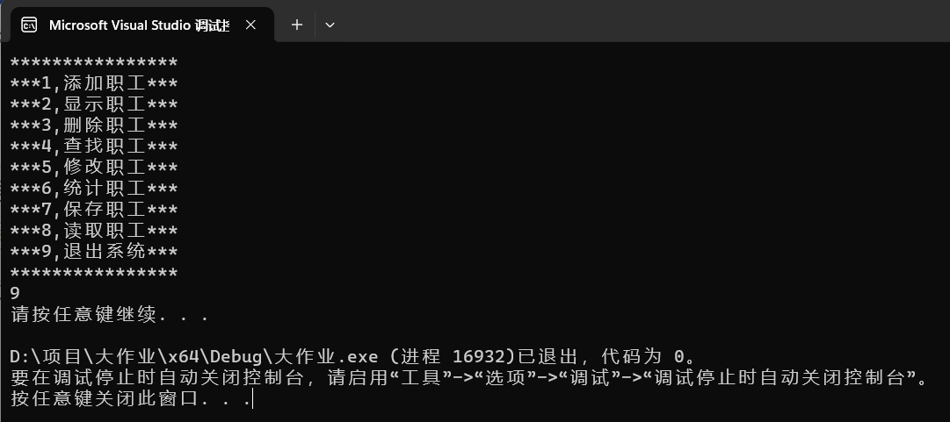

附录

源代码（共383行）
#include <iostream>
#include <fstream>
#include <vector>
#include <string>
#include <unordered_map>
using namespace std;
struct Employee {
string id;
string name;
string gender;
int age;
string contact;
string responsibleArea;
string department;
};

class EmployeeManager {
private:
std::unordered_map<std::string, Employee> employee_map;
public:
bool addEmployee(const Employee& employee);
bool findEmployeeById(const string& id, Employee& employee);
bool findEmployeeByName(const string& name, std::vector<Employee>& employees);
void displayAllEmployees();
bool editEmployeeById(const std::string& id, const Employee& employee);
bool deleteEmployeeById(const std::string& id);
void genderStats();
void saveToFile(const std::string& filename);
void loadFromFile(const std::string& filename);
void findwork(EmployeeManager& emanager, Employee& employee);
bool isExist(string &id);
};

bool EmployeeManager::addEmployee(const Employee& employee) {
if (employee_map.count(employee.id) == 0)
{
employee_map.insert({ employee.id, employee });
cout << "添加成功" << endl;
return true;
}
else {
cout << "添加失败" << endl;
return false;
}
}
void addPerson(string & Id,Employee&employee)
{
employee.id = Id;
string name;
cout << "请输入姓名" << endl;
cin >> name;
employee.name = name;
cout << "请输入性别:男为male，女为female" << endl;
string sex;
while (1)
{
cin >> sex;
if (sex == "female" || sex == "male")
{
employee.gender = sex;
break;
}
cout << "输入错误，请重新输入" << endl;
}
cout << "请输入年龄" << endl;
int age = 0;
cin >> age;
employee.age = age;
cout << "请输入电话号码" << endl;
string num = "";
cin >> num;
employee.contact = num;

cout << "请输入负责片区：" << endl;
string responsiblearea;
cin >> responsiblearea;
employee.responsibleArea = responsiblearea;

cout << "请输入所在部门" << endl;
string dep;
cin >> dep;
employee.department = dep;
}
bool EmployeeManager::findEmployeeById(const string& id, Employee& employee)
{
if (employee_map.count(id))
{
employee = employee_map[id];
cout << "ID: " << employee.id
<< "\t姓名: " << employee.name
<< "\t性别: " << employee.gender
<< "\t年龄: " << employee.age
<< "\t联系方式: " << employee.contact
<< "\t负责片区: " << employee.responsibleArea
<< "\t部门: " << employee.department << endl;
return true;
}
else {
cout << "查无此人" << endl;
return false;
}
}

bool EmployeeManager::findEmployeeByName(const string& name, vector<Employee>& employees) {
bool found = false;
for (const auto& element : employee_map) {
if (element.second.name == name) {
employees.push_back(element.second);
found = true;
for (vector<Employee>::iterator it = employees.begin(); it != employees.end(); it++)
{
cout << "ID: " << it->id
<< "\t 姓名: " << it->name
<< "\t性别: " << it->gender
<< "\t 年龄: " << it->age
<< "\t联系方式: " << it->contact
<< "\t负责片区: " << it->responsibleArea
<< "\t部门: " << it->department << endl;
return 1;
}
}
else
{
cout << "查无此人" << endl;
return 0;
}
}
return found;
}
void EmployeeManager::findwork(EmployeeManager &emanager, Employee &employee)
{
int judge;
cout << "1.根据id进行查找" << endl << "2.根据姓名进行查找" << endl;
cin >> judge;
switch (judge)
{
case 1:
{
string ID;
cout << "请输入ID" << endl;
cin >> ID;
emanager.findEmployeeById(ID, employee);
break;
}
case 2:
{
vector<Employee>employees;
string name;
cout << "请输入姓名" << endl;
cin >> name;
emanager.findEmployeeByName(name, employees);
break;
}
default:
break;
}
}
void EmployeeManager::displayAllEmployees()
{
if (employee_map.size() != 0) {
for (const auto& employee : employee_map)
{
cout << "ID: " << employee.second.id
<< "\t 姓名: " << employee.second.name
<< "\t性别: " << employee.second.gender
<< "\t 年龄: " << employee.second.age
<< "\t联系方式: " << employee.second.contact
<< "\t负责片区: " << employee.second.responsibleArea
<< "\t部门: " << employee.second.department << endl;
}
}
else
{
cout << "记录为空" << endl;
}
}

bool EmployeeManager::editEmployeeById(const string& id, const Employee& employee) {
if (employee_map.count(id)) {
employee_map[id] = employee;
return true;
}
else {
cout << "查无此人" << endl;
return false;
}
}
bool EmployeeManager::isExist(string& id)
{
if (employee_map.count(id)) {
return 1;
}
else {
return 0;
}
}
bool EmployeeManager::deleteEmployeeById(const string& id) {
if (employee_map.count(id)) {
employee_map.erase(id);
cout << "删除成功" << endl;
return true;
}
else {
cout << "查无此人" << endl;
return false;
}
}

void EmployeeManager::genderStats() {
int male = 0;
int female = 0;

for (const auto& employee : employee_map) {
if (employee.second.gender == "male") {
male++;
}
else if (employee.second.gender == "female") {
female++;
}
}

cout << "男职工总共为: " << male
<< ", 女职工总共为: " << female << endl;
}

void EmployeeManager::saveToFile(const string& filename) {
ofstream file(filename);
if (file.is_open()) {
for (const auto& employee : employee_map) {
file << employee.second.id << ","
<< employee.second.name << ","
<< employee.second.gender << ","
<< employee.second.age << ","
<< employee.second.contact << ","
<< employee.second.responsibleArea << ","
<< employee.second.department << endl;
}
file.close();
cout << "保存成功" << endl;
}
else {
cout << "Couldn't save to file." << endl;
}
}

void EmployeeManager::loadFromFile(const string& filename) {
employee_map.clear();
ifstream file(filename);
string line;
vector<string> tokens;

if (file.is_open()) {
while (getline(file, line)) {
Employee new_employee;
size_t pos = 0;
size_t next_pos = -1;

while ((next_pos = line.find(",", next_pos + 1)) != string::npos) {
tokens.push_back(line.substr(pos, next_pos - pos));
pos = next_pos + 1;
}
tokens.push_back(line.substr(pos));
new_employee.id = tokens[0];
new_employee.name = tokens[1];
new_employee.gender = tokens[2];
new_employee.age = stoi(tokens[3]);
new_employee.contact = tokens[4];
new_employee.responsibleArea = tokens[5];
new_employee.department = tokens[6];
addEmployee(new_employee);

tokens.clear();
}
file.close();
cout << "读取成功" << endl;
}
else {
cout << "Couldn't load from file." << endl;
}
}
void shoumenu1()
{
cout << "****************" << endl;
cout << "***1,添加职工***" << endl;
cout << "***2,显示职工***" << endl;
cout << "***3,删除职工***" << endl;
cout << "***4,查找职工***" << endl;
cout << "***5,修改职工***" << endl;
cout << "***6,统计职工***" << endl;
cout << "***7,保存职工***" << endl;
cout << "***8,读取职工***" << endl;
cout << "***9,退出系统***" << endl;
cout << "****************" << endl;
}
int main()
{
EmployeeManager emanager;
int select = 0;
cout << "请输入数字" << endl;
while (1)
{
Employee employee;
shoumenu1();
cin >> select;
switch (select)
{
case 1: {
cout << "请输入id" << endl;
string Id;
cin >> Id;
if (!emanager.isExist(Id)) {
addPerson(Id,employee);
emanager.addEmployee(employee);
}
else
{
cout << "添加失败" << endl;
}
system("pause");
system("cls");
break;
}
case 2:
emanager.displayAllEmployees();
system("pause");
system("cls");
break;
case 3:
{
string ID;
cout << "请输入ID" << endl;
cin >> ID;
emanager.deleteEmployeeById(ID);
system("pause");
system("cls");
break;
}
case 4:
emanager.findwork(emanager, employee);
system("pause");
system("cls");
break;
case 5:
{
string ID;
cout << "请输入ID" << endl;
cin >> ID;
if (emanager.isExist(ID)) {
addPerson(ID,employee);
emanager.editEmployeeById(ID, employee);
}
else cout << "查无此人" << endl;
system("pause");
system("cls");
break;
}
case 6:
emanager.genderStats();
system("pause");
system("cls");
break;
case 7:
emanager.saveToFile("text.txt");
system("pause");
system("cls");
break;
case 8:
emanager.loadFromFile("text.txt");
system("pause");
system("cls");
break;
case 9:
system("pause");
return 0;

default:
system("cls");
break;
}
}
system("pause");
return 0;
}

