实验五：作用域、结构和联合类型
<1> 在某系的成绩登记册中，每个班最多有40个学生，每份成绩表中的成绩信息包括：学号（9位字符），姓名（8位字符），成绩（百分制），备注（20位字符）。设计程序以处理一个班级的成绩信息，包括输入、输出、查询（给定分数以上或以下的学生信息）、按分数排序等。
#include <iostream>
#include <iomanip>
#include <vector>
#include <algorithm>
using namespace std;

struct Student {
string id;
string name;
int score;
string comment;
};

bool compareByScore(const Student& s1, const Student& s2) {
return s1.score < s2.score;
}

void addStudent(vector<Student>& students) {
if (students.size() >= 40) {
cout << "班级已满，无法添加更多学生。" << endl;
return;
}

Student student;
cout << "请输入学生信息：" << endl;
cout << "学号：";
cin >> student.id;
cout << "姓名：";
cin >> student.name;
cout << "成绩：";
cin >> student.score;
cout << "备注：";
cin >> student.comment;
students.push_back(student);
cout << "学生信息添加成功。" << endl;
}

void printStudents(const vector<Student>& students) {
if (students.empty()) {
cout << "没有学生信息。" << endl;
return;
}
cout << setw(10) << "学号" << setw(10) << "姓名" << setw(10) << "成绩" << setw(20) << "备注" << endl;
for (const auto& student : students) {
cout<< "学号：" << setw(10) << student.id << endl
<< "姓名：" << setw(10) << student.name << endl
<< "成绩：" << setw(10) << student.score << endl
<< "备注：" << setw(20) << student.comment << endl;
}//控制了学号9位字符，姓名8位字符，备注20位字符 setw函数控制输出长度
}

void printStudentsAboveScore(const vector<Student>& students, int score) {
bool found = false;
cout << setw(10) << "学号" << setw(10) << "姓名" << setw(10) << "成绩" << setw(20) << "备注" << endl;
for (const auto& student : students) {
if (student.score >= score) {
cout << "学号：" << setw(10) << student.id << endl
<< "姓名：" << setw(10) << student.name << endl
<< "成绩：" << setw(10) << student.score << endl
<< "备注：" << setw(20) << student.comment << endl;
found = true;
}
}
if (!found) {
std::cout << "没有分数大于等于 " << score << " 的学生。" << endl;
}
}

void printStudentsBelowScore(const std::vector<Student>& students, int score) {
bool found = false;
cout << setw(10) << "学号" << setw(10) << "姓名" << setw(10) << "成绩" << setw(20) << "备注" << endl;
for (const auto& student : students)//遍历整个容器
{
if (student.score <= score) {
cout << "学号：" << setw(10) << student.id << endl
<< "姓名：" << setw(10) << student.name << endl
<< "成绩：" << setw(10) << student.score << endl
<< "备注：" << setw(20) << student.comment << endl;
found = true;
}
}
if (!found) {
cout << "没有分数小于等于 " << score << " 的学生。" << endl;
}
}

int main() {
vector<Student> students;
int choice;

do {
cout << "---------------------------------------------------------" << endl;
cout << "请选择操作：" << endl;
cout << "1. 添加学生信息" <<endl;
cout << "2. 查看所有学生信息" << endl;
cout << "3. 查询分数大于等于指定值的学生信息" << endl;
cout << "4. 查询分数小于等于指定值的学生信息" << endl;
cout << "5. 按分数排序并显示所有学生信息" << endl;
cout << "0. 退出程序" << endl;
cout << "---------------------------------------------------------" << endl;
cin >> choice;

switch (choice) {
case 1:
addStudent(students);
break;
case 2:
printStudents(students);
break;
case 3:
int scoreAbove;
cout << "请输入分数阈值：";
cin >> scoreAbove;
printStudentsAboveScore(students, scoreAbove);
break;
case 4:
int scoreBelow;
cout << "请输入分数阈值：";
cin >> scoreBelow;
printStudentsBelowScore(students, scoreBelow);
break;
case 5:
sort(students.begin(), students.end(), compareByScore);
printStudents(students);
break;
case 0:
cout << "退出程序。" << endl;
break;
default:
cout << "无效选择，请重新输入。" << endl;
break;
}
} while (choice != 0);

return 0;
}

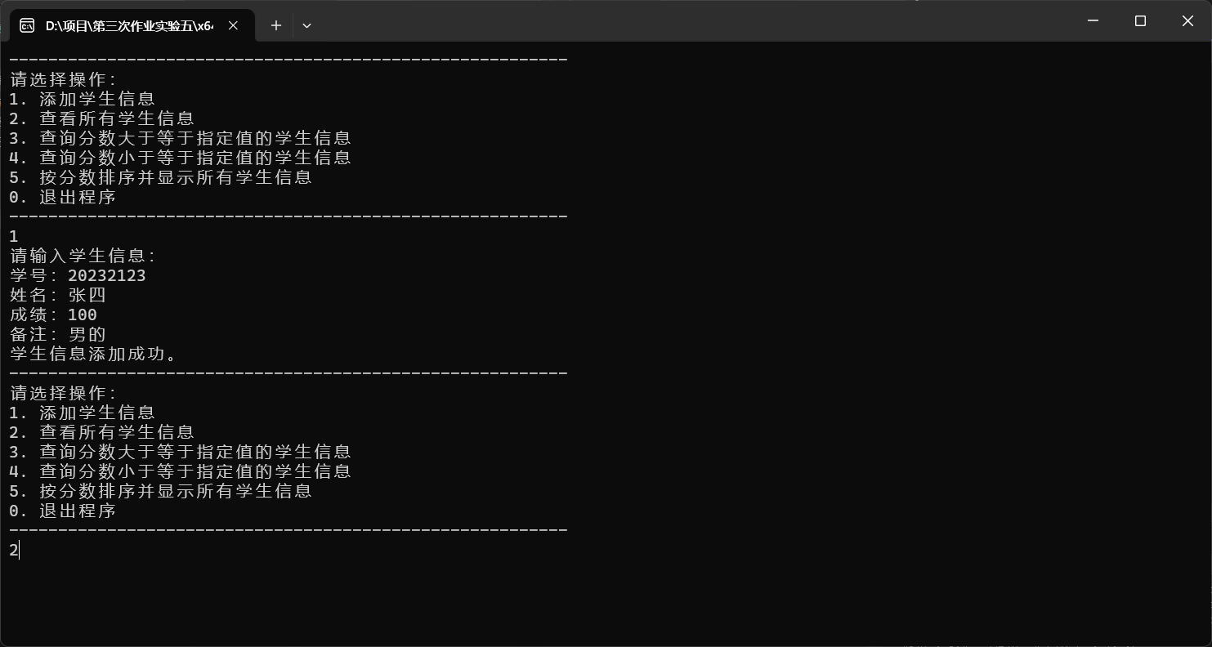
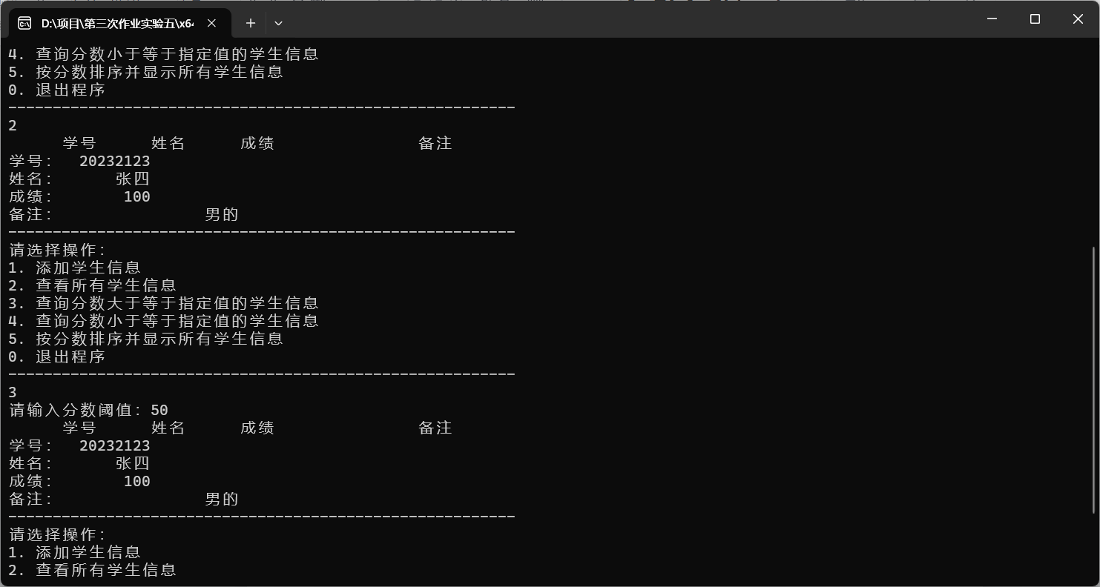
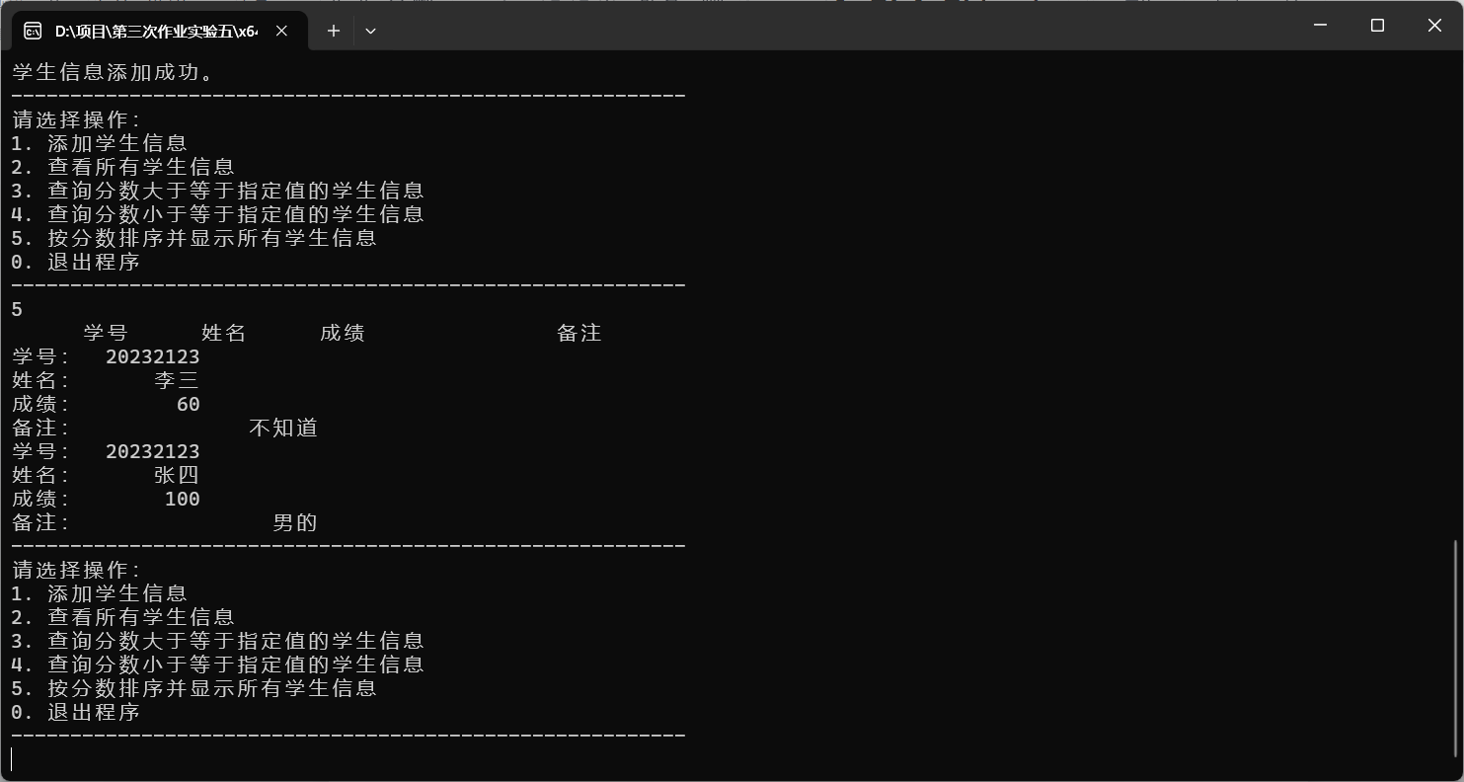
实验六
<2> 编程实现数组的排序：将有15个元素的整型数组按从小到大的次序排序。
#include <iostream>
using namespace std;
//算法为折中插入排序
void binary_insertion_sort(int arr[], int n) {
for (int i = 1; i < n; ++i) {
int key = arr[i];
int left = 0;
int right = i - 1;

// 使用折半查找法找到插入位置
while (left <= right) {
int mid = (left + right) / 2;
if (arr[mid] > key) {
right = mid - 1;
}
else {
left = mid + 1;
}
}

// 移动元素，为插入位置腾出空间
for (int j = i - 1; j >= left; --j) {
arr[j + 1] = arr[j];
}

// 插入元素
arr[left] = key;
}
}

int main() {
int array[15] = { 9, 7, 5, 3, 1, 2, 4, 6, 8, 0, 10, 11, 12, 14, 13 };
int n = sizeof(array) / sizeof(array[0]);

binary_insertion_sort(array, n);

for (int i = 0; i < n; ++i) {
cout << array[i] << " ";
}

return 0;
}
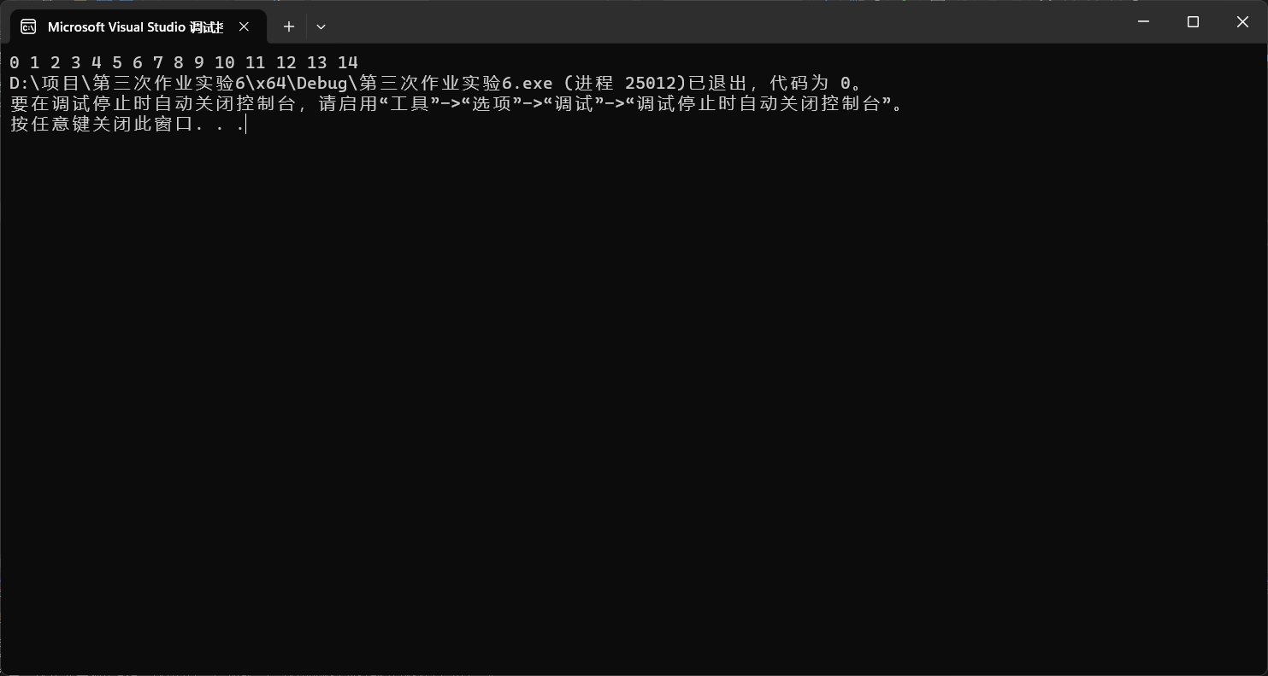
<4> 随机输入一组数组元素值，利用题<2>使一个数组有序。然后随机输入一个数，用折半查找法在数组中查找，如在数组中，则输出元素在数组中的位置；如不在，则输出提示。
#include <iostream>
using namespace std;
//算法为折中插入排序
void binary_insertion_sort(int arr[], int n) {
for (int i = 1; i < n; ++i) {
int key = arr[i];
int left = 0;
int right = i - 1;

// 使用折半查找法找到插入位置
while (left <= right) {
int mid = (left + right) / 2;
if (arr[mid] > key) {
right = mid - 1;
}
else {
left = mid + 1;
}
}

// 移动元素，为插入位置腾出空间
for (int j = i - 1; j >= left; --j) {
arr[j + 1] = arr[j];
}

// 插入元素
arr[left] = key;
}
}
int binary_search(int arr[], int n,int target)
{
int low = 0;
int high = n - 1;
int mid = (low + high) / 2;
while (low <= high) {
if (target > arr[mid])
{
low = mid + 1;
mid = (low + high) / 2;
}
else if (target == arr[mid])
{
return mid;
}
else
{
high = mid - 1;
mid = (low + high) / 2;
}
}
return -1;
}

int main() {
int array[15] = { 9, 7, 5, 3, 1, 2, 4, 6, 8, 0, 10, 11, 12, 14, 13 };
int n = sizeof(array) / sizeof(array[0]);

binary_insertion_sort(array, n);

for (int i = 0; i < n; ++i) {
cout << array[i] << " ";
}
while (1) {
cout << "请输入目标数" << endl;
int target;
cin >> target;
if (binary_search(array, n, target) != -1)
{
cout << "该数的位置在" << binary_search(array, n, target)<<endl;
}
else
{
cout << "不存在该数" << endl;
}
}
return 0;
}
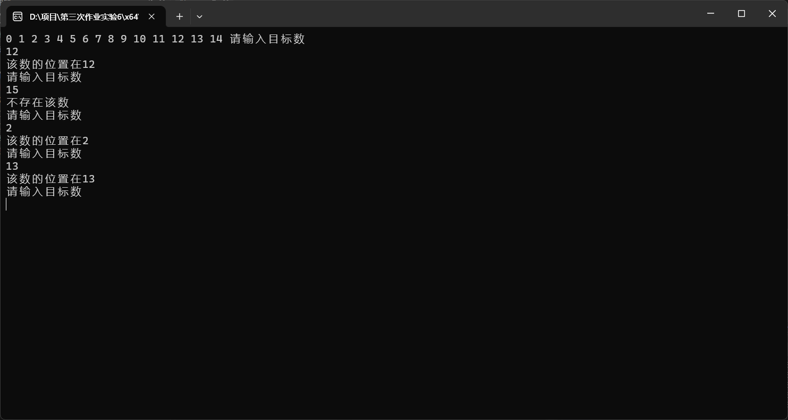
- 分析与思考
<2> 判断一个二维数组是否有“鞍点”，即该位置上的元素在该行上最大，在该列上最小。如有，输出其行列号和值；若无，给出提示。（数组元素的值用scanf输入）
#include <iostream>
#include <vector>
using namespace std;

// 函数用于找鞍点
void findSaddlePoint(vector<vector<int>>& matrix) {
int rows = matrix.size();
int cols = matrix[0].size();
bool saddlePointExists = false;

for (int i = 0; i < rows; ++i) {
// 找到第i行的最大值
int rowMax = matrix[i][0];
int colIndex = 0;
for (int j = 1; j < cols; ++j) {
if (matrix[i][j] > rowMax) {
rowMax = matrix[i][j];
colIndex = j;
}
}

// 检查这一列中是否这是最小值
bool isMinInColumn = true;
for (int k = 0; k < rows; ++k) {
if (matrix[k][colIndex] < rowMax) {
isMinInColumn = false;
break;
}
}

// 如果是最小值，则找到了一个鞍点
if (isMinInColumn) {
cout << "鞍点位于 [" << i << ", " << colIndex << "] 值为: " << rowMax << endl;
saddlePointExists = true;
}
}

if (!saddlePointExists) {
cout << "二维数组中不存在鞍点。" << endl;
}
}

int main() {
int m, n;
cout << "请输入行数" << endl;
cin >> m;
cout << "请输入列数" << endl;
cin >> n;
vector<vector<int>> matrix(m, vector<int>(n));

// 读取9个元素的值
cout << "请输入一个"<<m<<"*"<< n<<"的二维数组元素, 每输入一个数请按下回车继续:" << endl;
for (int i = 0; i < m; ++i) {
for (int j = 0; j < n; ++j) {
cin >> matrix[i][j];
}
}

// 找鞍点
findSaddlePoint(matrix);

return 0;
}
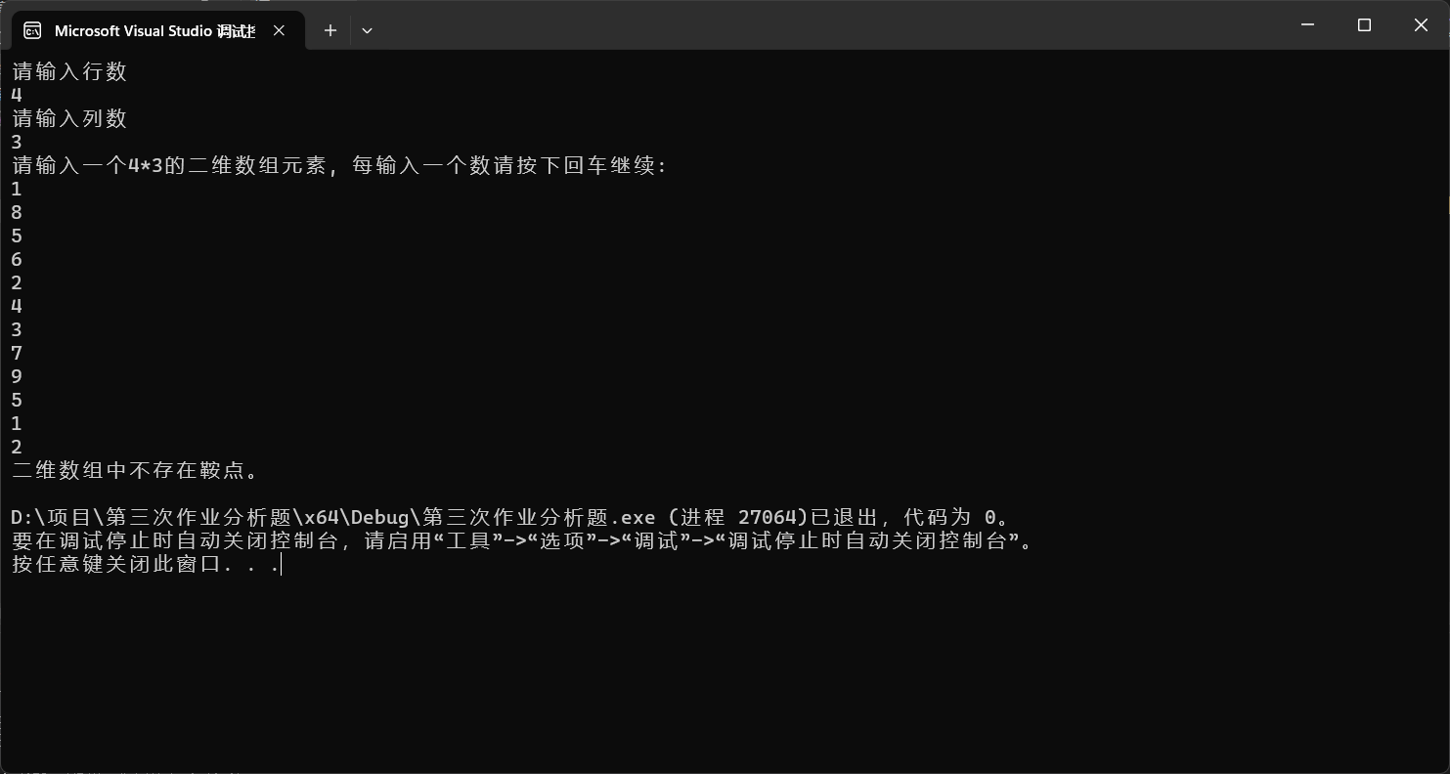
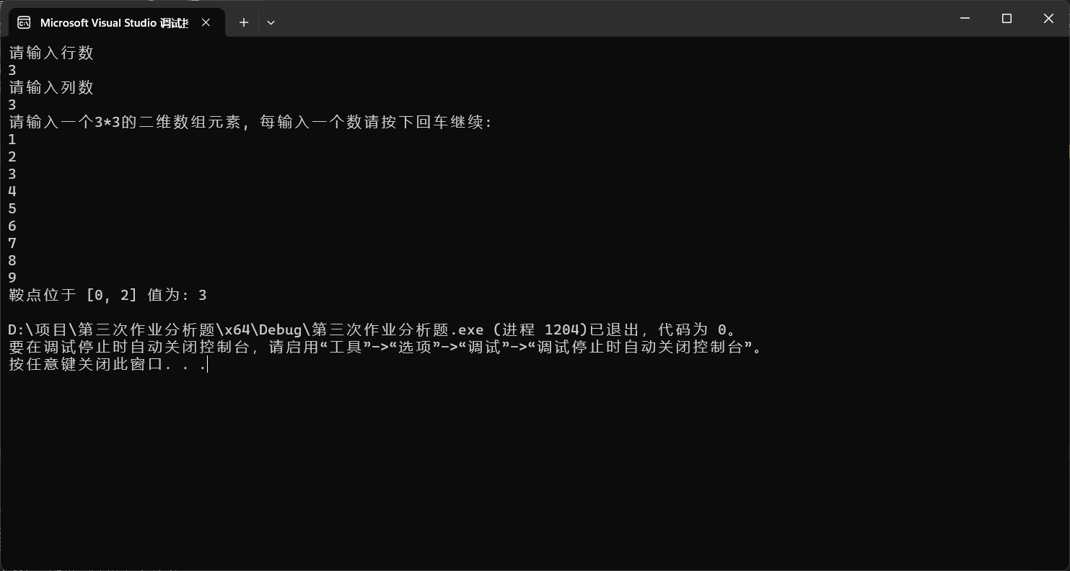

实验七
〈1〉 输入三个整数，按由小到大的顺序输出，然后将程序改为：输入三个字符串，按由小到大的顺序输出（可以使用库函数strcmp函数，要求不使用string，使用指针指向字符串）。
#include <iostream>
#include <cstdio>
using namespace std;
void sort_str(char** s1, char** s2, char** s3) {
char* temp;
if (strcmp(*s1, *s2) > 0) {
temp = *s1;
*s1 = *s2;
*s2 = temp;
}
if (strcmp(*s1, *s3) > 0) {
temp = *s1;
*s1 = *s3;
*s3 = temp;
}
if (strcmp(*s2, *s3) > 0) {
temp = *s2;
*s2 = *s3;
*s3 = temp;
}
}
int main() {
char str1[50], str2[50], str3[50];
char* p1 = str1, * p2 = str2, * p3 = str3;
cin >> p1;
cin >> p2;
cin >> p3;
sort_str(&p1, &p2, &p3);
cout << p1 << endl << p2 << endl << p3 << endl;
return 0;
}
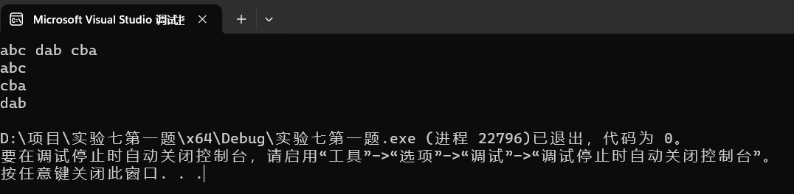
〈3〉 自己写一个_strcmp函数，实现两个字符串的比较。两个字符串s1,s2由main函数输入，_strcmp函数的返回值也在main函数中输出，_strcmp原型：
int _strcmp(const char* s1,const char* s2);，s1大于s2返回1，s1等于s2返回0，s1小于s2返回-1。(提示：两个字符串的大小比较规则：从第一个字符开始逐一比较字符大小，如果s1的字符大返回1，s2的字符大则返回-1，两者相同继续比较，如果到字符串结束一直相同，则返回0。)
#include <iostream>
using namespace std;

int _strcmp(const char* s1, const char* s2) {
while (*s1 && (*s1 == *s2)) {
s1++;
s2++;
}

if (*s1 > *s2) {
return 1;
}
else if (*s1 < *s2) {
return -1;
}
else {
return 0;
}
}
int main() {
char str1[50], str2[50];
cin.getline(str1, 50);
cin.getline(str2, 50);
int result = _strcmp(str1, str2);
cout << result << endl;
return 0;
}
