第三章作业
第一题
#include<iostream>
#include<cmath>
#include<cstdio>
using namespace std;
int main()
{
while (1) {
double a, b, c, dval;
double x1, x2;
cin >> a >> b >> c;
dval = b * b - 4 * a * c;
if (dval > 0)
{
x1 = (-b + sqrt(dval)) / (2 * a);
x2 = (-b - sqrt(dval)) / (2 * a);
cout << "x1=" << x1 << "x2=" << x2 << endl;
}
else if (dval == 0)
{
x2 = x1 = (-b) / (2 * a);
cout << "x1=" << x1 << "x2=" << x2 << endl;
}
else
{
double m, n;
m = (-b) / (2 * a);
n = sqrt(-dval) / (2 * a);
printf("x1=%.3lf+%.3lfi x2=%.3lf-%.3lfi\n", m, n, m, n);
}
}
return 0;
}
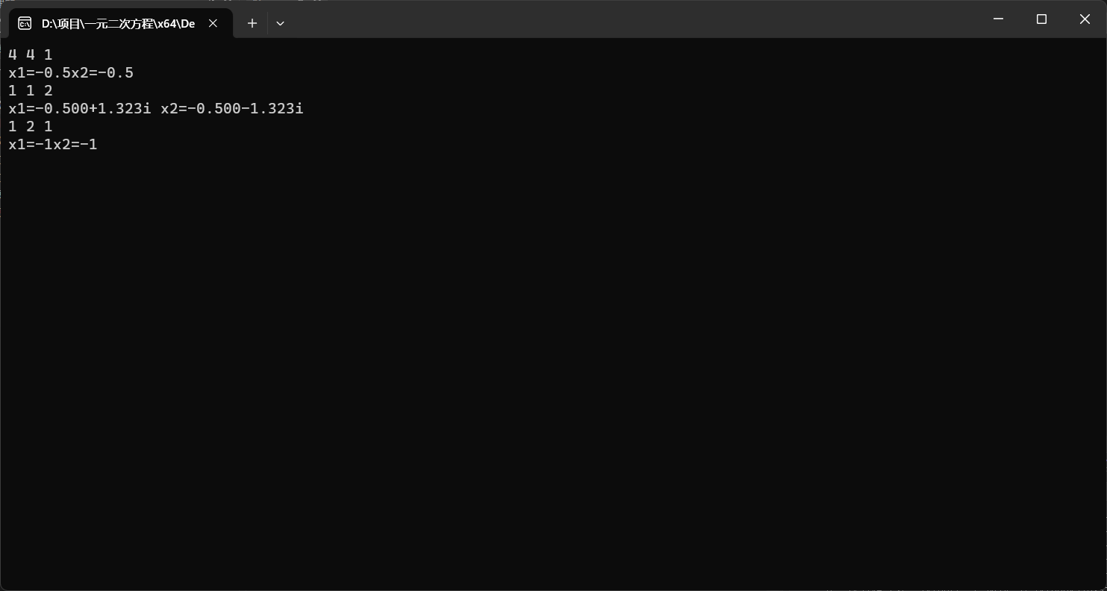
第二题
#include<iostream>
#include<vector>
using namespace std;
int main(){
while (1) {
string str = "0123456789ABCDEF";
vector<char>v;
int n;
cin >> n;
while (n != 0) {
v.push_back(n % 16);
n /= 16;
}
for (int i = v.size() - 1; i >= 0; i--) {
cout << str[v[i]];
}
}
return 0;
}
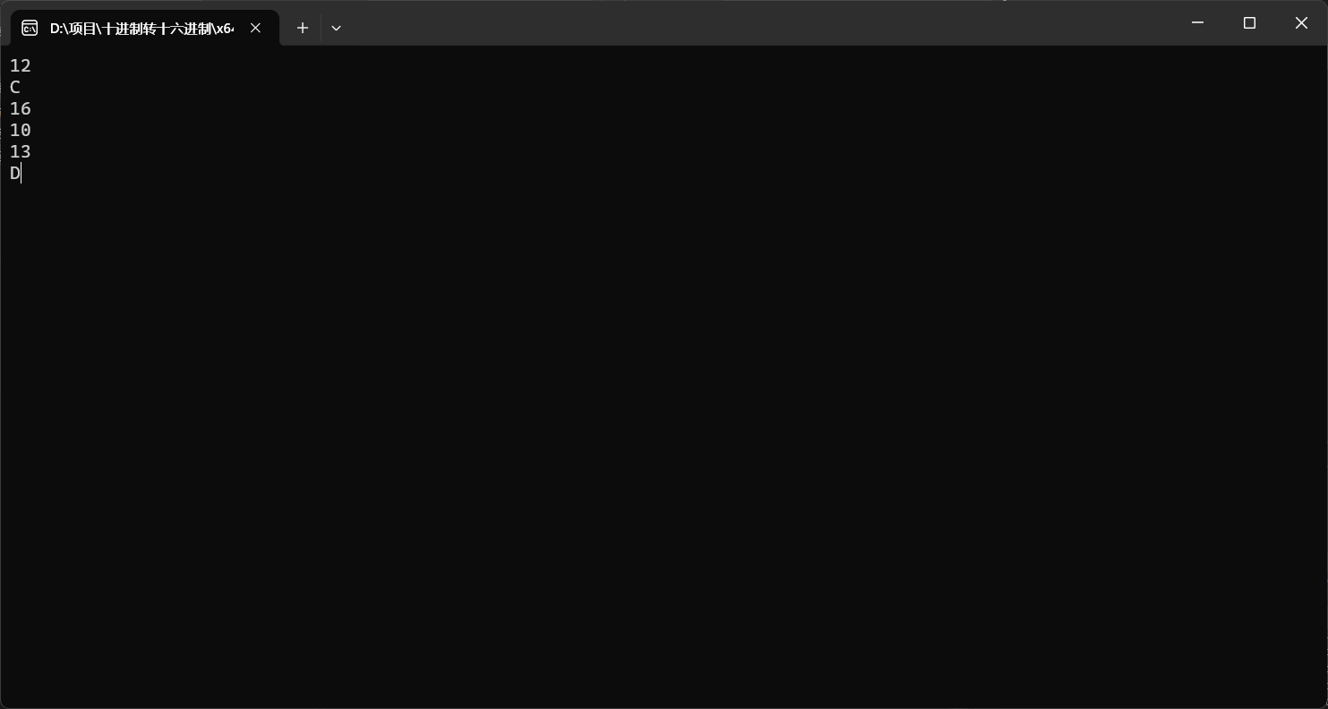
第三题
递归形式
#include<iostream>
using namespace std;
//递归函数
int test(int n, int x)
{
if (n == 0){
return 1;
}
else if (n == 1){
return 2*x;
}
else{
return 2 * x * test(n - 1, x) - 2 * (n - 1) * test(n - 2, x);
}
}
int main()
{
while (1) {
int n, x;
cout << "请输入n值和x值" << endl;
cin >> n >> x;
cout << test(n, x)<<endl;
}
return 0;
}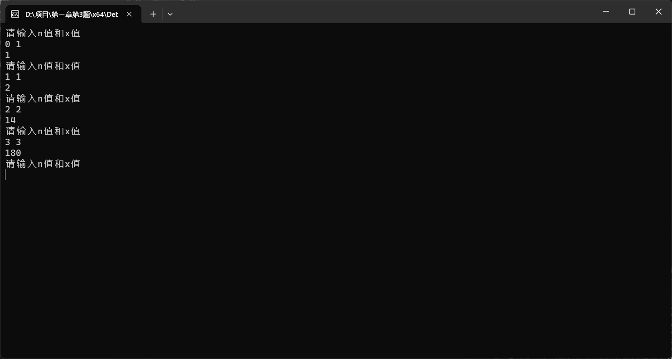
递推形式
#include<iostream>
using namespace std;
int main()
{
while (1) {
int arr[50] = {};
int n, x;
cout << "请输入n和x的值" << endl;
cin >> n >> x;
arr[0] = 1;
arr[1] = 2 * x;
for (int i = 2; i < 51; i++)
{
arr[i]=2 * x * arr[i - 1] - 2 * (i - 1) * arr[i - 2];
}
cout << arr[n]<<endl;
}
return 0;
}
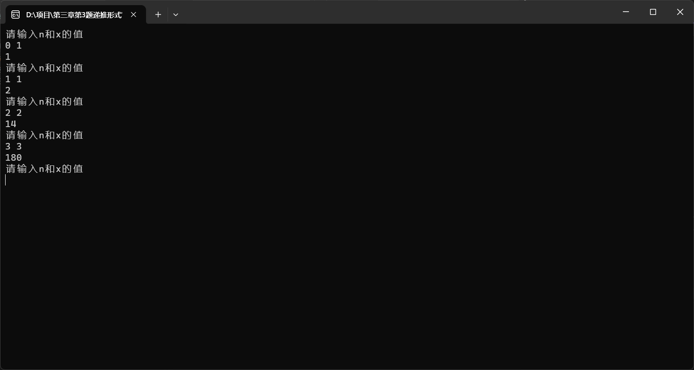
第四章
#include <iostream>
using namespace std;
class Time
{
private:
int hours, minutes, seconds;
public:
Time(){};//默认构造函数
Time(int H, int M, int S) :hours(H), minutes(M), seconds(S) {};//初始化，有参构造函数
void display_time()
{
cout << hours << ':' << minutes << ':' << seconds << endl;
}
void add_time(Time& t1, Time& t2)
{
hours = t1.hours + t2.hours;
minutes = t1.minutes + t2.minutes;
seconds = t1.seconds + t2.seconds;
if (seconds >= 60)
{
while (seconds >= 60)
{
seconds -= 60;
minutes++;
}//用循环直至seconds小于60
}
if (minutes >= 60)
{
while (minutes >= 60)
{
minutes -= 60;
hours++;
}//用循环直至minutes小于60
}
}
};

void main()
{
int Hour, Minute, Second;
cout << "\nEnter the first time(hours minutes seconds):";
cin >> Hour >> Minute >> Second;
Time one(Hour, Minute, Second);
cout << "\nEnter the second time(hours minutes seconds):";
cin >> Hour >> Minute >> Second;
Time two(Hour, Minute, Second);
Time three;
three.add_time(one, two);
cout << "the result is:" << endl;
three.display_time();
}
