1.1 实验目的
（1）掌握图的存储结构的设计与实现，基本运算的实现；
（2）掌握图的两种遍历算法、遍历生成树及遍历算法的应用；
（3）掌握基于图的关键路径、最短路径等实际问题求解的算法实现。
2、实验任务
设计算法实现下列问题的求解。
1> 设计一个无向图的类，并基于此图类实现以下功能：
（1）求给定图中的边的个数；
（2）判断一个该图是否是一棵树；
（3）用户自定义迷宫、入口和出口，设计算法寻找一条出入口之间最短
的路径；
要求：给出测试案例验证相关运算求解结果。
<2>设计一个有向图的类，基于此类设计算法求解图6.1的关键路径 ；
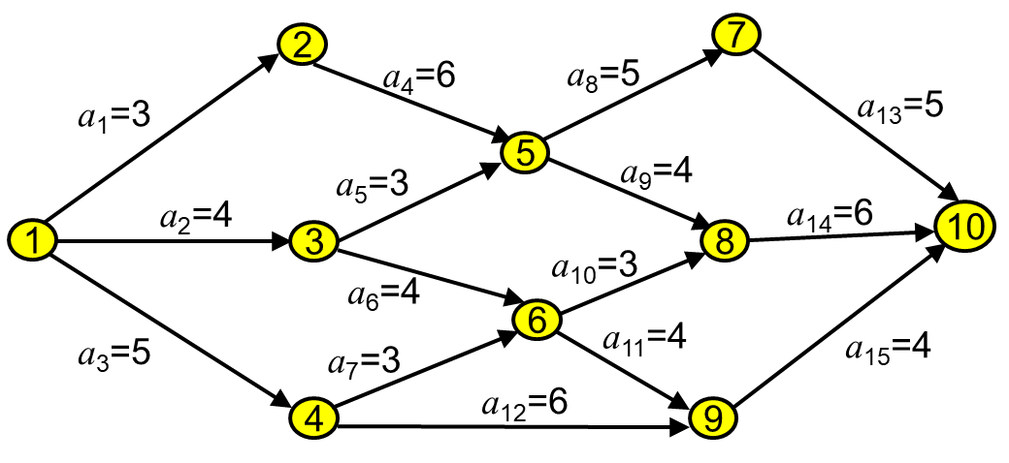

源码

6.1
#include <iostream>
#include <vector>
#include <queue>
#include <unordered_map>
#include <unordered_set>
using namespace std;

class UndirectedGraph {
private:
unordered_map<int, vector<int>> adjList; // 邻接表表示图
int edgeCount; // 边的数量

public:
UndirectedGraph() : edgeCount(0) {}

// 添加顶点
void addVertex(int vertex) {
if (adjList.find(vertex) == adjList.end()) {
adjList[vertex] = vector<int>();
}
}

// 添加边
void addEdge(int vertex1, int vertex2) {
adjList[vertex1].push_back(vertex2);
adjList[vertex2].push_back(vertex1);
edgeCount++;
}

// 获取边的个数
int getEdgeCount() {
return edgeCount;
}

// 判断图是否为树
bool isTree() {
if (adjList.empty()) return true; // 如果图为空，则是树

unordered_set<int> visited; // 已访问顶点集合
int start = adjList.begin()->first;

// 如果存在环或者不是连通图，则不是树
if (hasCycle(start, -1, visited) || visited.size() != adjList.size()) {
return false;
}
return true;
}

// 查找迷宫中从入口到出口的最短路径
vector<int> shortestPath(int start, int end) {
unordered_map<int, int> parent; // 记录路径
queue<int> q; // 广度优先搜索队列
unordered_set<int> visited; // 已访问顶点集合

q.push(start);
visited.insert(start);
parent[start] = -1;

while (!q.empty()) {
int current = q.front();
q.pop();

if (current == end) {
vector<int> path;
for (int at = end; at != -1; at = parent[at]) {
path.push_back(at);
}
reverse(path.begin(), path.end());
return path;
}

for (int neighbor : adjList[current]) {
if (visited.find(neighbor) == visited.end()) {
visited.insert(neighbor);
q.push(neighbor);
parent[neighbor] = current;
}
}
}

return {}; // 无法找到路径
}

private:
// 检查是否有环
bool hasCycle(int vertex, int parent, unordered_set<int>& visited) {
visited.insert(vertex);

for (int neighbor : adjList[vertex]) {
if (neighbor == parent) continue;
if (visited.find(neighbor) != visited.end() || hasCycle(neighbor, vertex, visited)) {
return true;
}
}

return false;
}
};

// 测试用例
int main() {
UndirectedGraph graph;
graph.addVertex(1);
graph.addVertex(2);
graph.addVertex(3);
graph.addVertex(4);

graph.addEdge(1, 2);
graph.addEdge(1, 3);
graph.addEdge(3, 4);

cout << "边的个数: " << graph.getEdgeCount() << endl;
cout << "该图是树吗? " << (graph.isTree() ? "是" : "否") << endl;

graph.addEdge(2, 4); // 添加会形成环的边

cout << "添加环之后，该图是树吗? " << (graph.isTree() ? "是" : "否") << endl;

vector<int> path = graph.shortestPath(1, 4);
cout << "从1到4的最短路径: ";
for (int vertex : path) {
cout << vertex << " ";
}
cout << endl;

return 0;
}

6.2

#include <iostream>
#include <vector>
#include <unordered_map>
#include <queue>
#include <stack>
using namespace std;

class DirectedGraph {
private:
unordered_map<int, vector<pair<int, int>>> adjList; // 邻接表表示图，包含边的权重
int verticesCount; // 顶点的数量

public:
DirectedGraph(int verticesCount) : verticesCount(verticesCount) {}

// 添加边
void addEdge(int from, int to, int weight) {
adjList[from].push_back({ to, weight });
}

// 拓扑排序
vector<int> topologicalSort() {
vector<int> inDegree(verticesCount + 1, 0); // 计算每个顶点的入度
for (auto& adj : adjList) {
for (auto& edge : adj.second) {
inDegree[edge.first]++;
}
}

queue<int> q;
for (int i = 1; i <= verticesCount; ++i) {
if (inDegree[i] == 0) {
q.push(i);
}
}

vector<int> topoOrder;
while (!q.empty()) {
int current = q.front();
q.pop();
topoOrder.push_back(current);

for (auto& edge : adjList[current]) {
inDegree[edge.first]--;
if (inDegree[edge.first] == 0) {
q.push(edge.first);
}
}
}

return topoOrder;
}

// 关键路径算法
vector<int> criticalPath() {
vector<int> topoOrder = topologicalSort();
if (topoOrder.size() != verticesCount) {
cout << "图中存在环，无法找到关键路径。" << endl;
return {};
}

vector<int> earliest(verticesCount + 1, 0); // 最早开始时间
vector<int> latest(verticesCount + 1, INT_MAX); // 最晚完成时间

// 计算最早开始时间
for (int vertex : topoOrder) {
for (auto& edge : adjList[vertex]) {
int to = edge.first, weight = edge.second;
earliest[to] = max(earliest[to], earliest[vertex] + weight);
}
}

// 计算最晚完成时间
latest[topoOrder.back()] = earliest[topoOrder.back()];
for (auto it = topoOrder.rbegin(); it != topoOrder.rend(); ++it) {
int vertex = *it;
for (auto& edge : adjList[vertex]) {
int to = edge.first, weight = edge.second;
latest[vertex] = min(latest[vertex], latest[to] - weight);
}
}

vector<int> criticalPath;
for (int vertex : topoOrder) {
for (auto& edge : adjList[vertex]) {
int to = edge.first, weight = edge.second;
if (earliest[vertex] == latest[to] - weight) {
criticalPath.push_back(vertex);
}
}
}

return criticalPath;
}
};

// 测试用例
int main() {
DirectedGraph graph(10);

graph.addEdge(1, 2, 3);
graph.addEdge(1, 3, 4);
graph.addEdge(1, 4, 5);
graph.addEdge(2, 5, 6);
graph.addEdge(3, 5, 3);
graph.addEdge(3, 6, 4);
graph.addEdge(4, 6, 3);
graph.addEdge(4, 9, 6);
graph.addEdge(5, 7, 5);
graph.addEdge(5, 8, 4);
graph.addEdge(6, 8, 3);
graph.addEdge(6, 9, 4);
graph.addEdge(7, 10, 5);
graph.addEdge(8, 10, 6);
graph.addEdge(9, 10, 4);

vector<int> criticalPath = graph.criticalPath();
cout << "关键路径: ";
for (int vertex : criticalPath) {
cout << vertex << " ";

}

cout << endl;
system("pause");

return 0;
}

