 | 

合肥工业大学
计算机与信息学院
课程设计

课 程：嵌入式系统课程设计

专业班级：物联网工程23-1班

学 号：2023212360

姓 名：柳希直

一、设计题目及要求
【课题 4】中断方式识别组合按键 - 十六进制数（选题人数不超过 6 人，申优名额：2 人）
设计要求：
通过中断方式识别多个按键组合的输入情况，并根据比较结果控制 LED 灯和蜂鸣器按不同模式工作。具体控制规则如下：
① 以按键 K1、K2、K3 的组合状态表示一个两位十六进制数。K2 对应高位，K3 对应低位，K1 用于辅助完成 “A~F” 的输入。即 K1 保持按下时，K2 (K3) 的按下次数 “1~6” 分别对应 “A~F”。
② 在通过按键完成该十六进制数设置后（★应通过程序判断数字何时输入完成，不能使用其他按键作为确认信号），四个 LED 按 1 秒（定时器中断实现）的间隔闪烁该十六进制数的高位对应的次数。
③ 以当前星期作为比较值。K4 短按时，若输入的十六进制数对应十进制数的个位≥比较值，则蜂鸣器按 “一长一短” 的方式鸣叫十六进制数对应十进制数的十位对应的次数，同时四个 LED 灯（LED1~LED4）按 1 秒（定时器中断实现）的间隔持续闪烁；否则，则蜂鸣器按 0.5 秒（定时器中断实现）的间隔鸣叫比较值对应的次数，同时四个 LED 灯按相同的频率从 LED1 开始按单向跑马灯显示（同一个时刻只有一个灯亮），并循环显示比较值对应的次数后熄灭。
④ K4 长按时，所有 LED 灯熄灭，蜂鸣器停止鸣叫，系统进入初始状态。
■ 说明：LED 灯亮 1 次 + 灭 1 次视为闪烁 1 次。未特别要求定时器中断实现的时间间隔，均可通过软件延时实现。蜂鸣器通过 GPF14 作为输出口进行控制，输出高电平鸣叫，输出低电平关闭。如何以中断方式识别按键的组合操作，以及如何使用一段延时时间（≥3 秒）作为两位十六进制数输入完成的确认信号，而非使用其他按键作为确认键，是设计时应考虑的重点问题。同时需要对按键进行软件消抖。
二、设计思想
通过中断方式识别和判断。根据来源主要分为两类中断，第一部分按键中断，实现对各按键的功能处理，第二部分时钟中断，实现定时和时间条件判断。按键中断部分，K1未被按下时，K2，K3输入在0-9,识别K1被按下，将K1_pressed标志为1，之后输入K2，K3在A-F，K4通过延迟再读的方式判断长按和短按，短按开始比较，长按reset。
时钟中断部分使用0.5s时钟，并分阶段，第一阶段输入部分，输入值改变时重置计数，在输入值没有改变时，每周期计数，计数到6终止，进入第二阶段，闪烁展示高位对应次数（通过计数）。K4短按进入第三阶段，根据比较结果分别实现全部灯1s闪烁、蜂鸣器一长一短鸣叫其十进制十位对应次数或走马灯、0.5s间隔鸣叫星期数。K4长按进入第四阶段，重置参数及状态等。
三、功能流程图
按键中断：
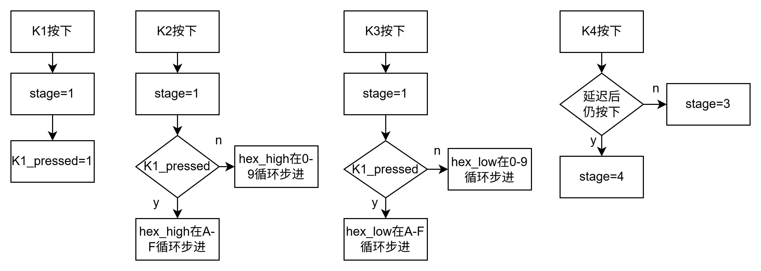
时钟中断：
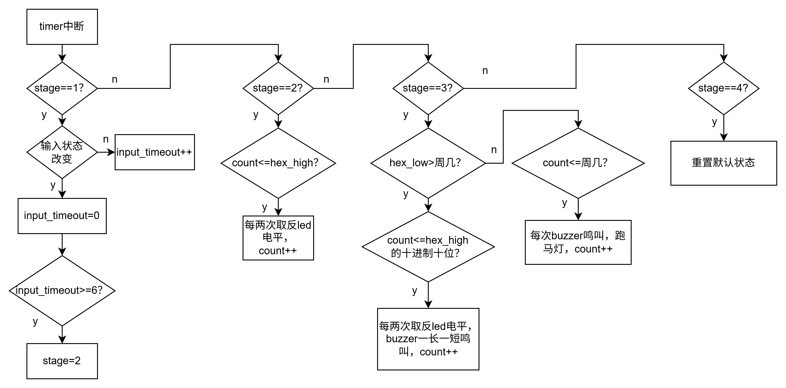
- 结果讨论

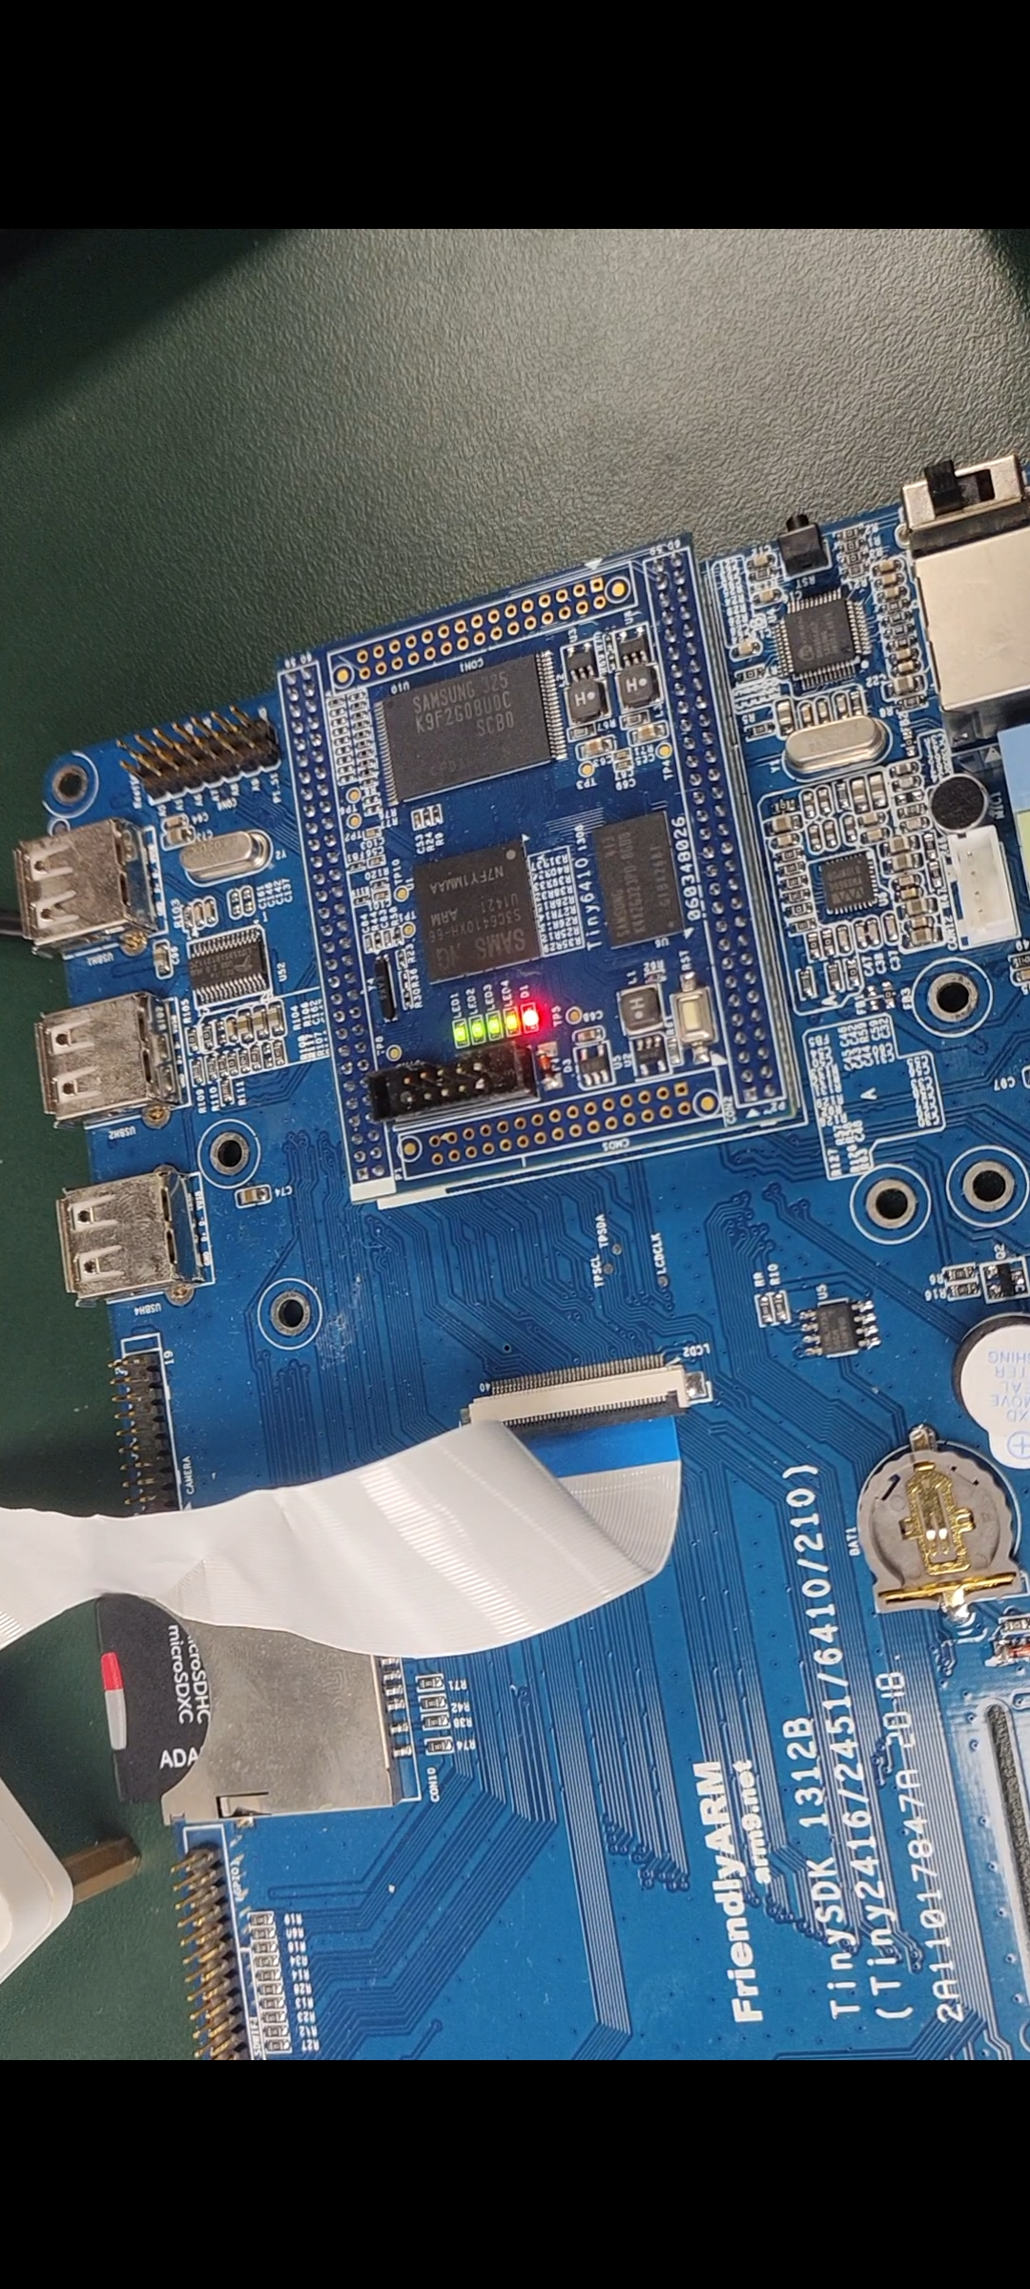
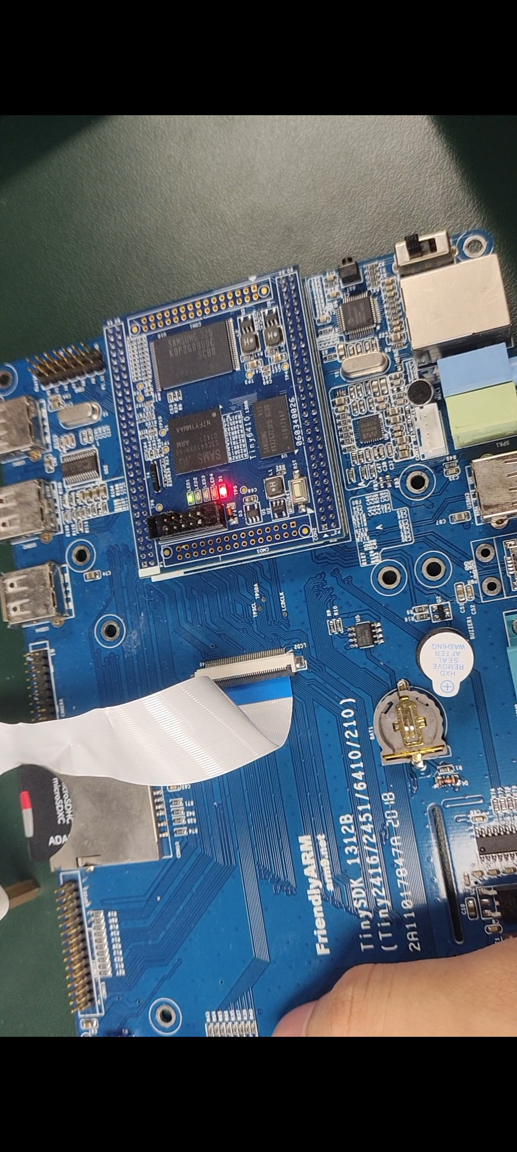
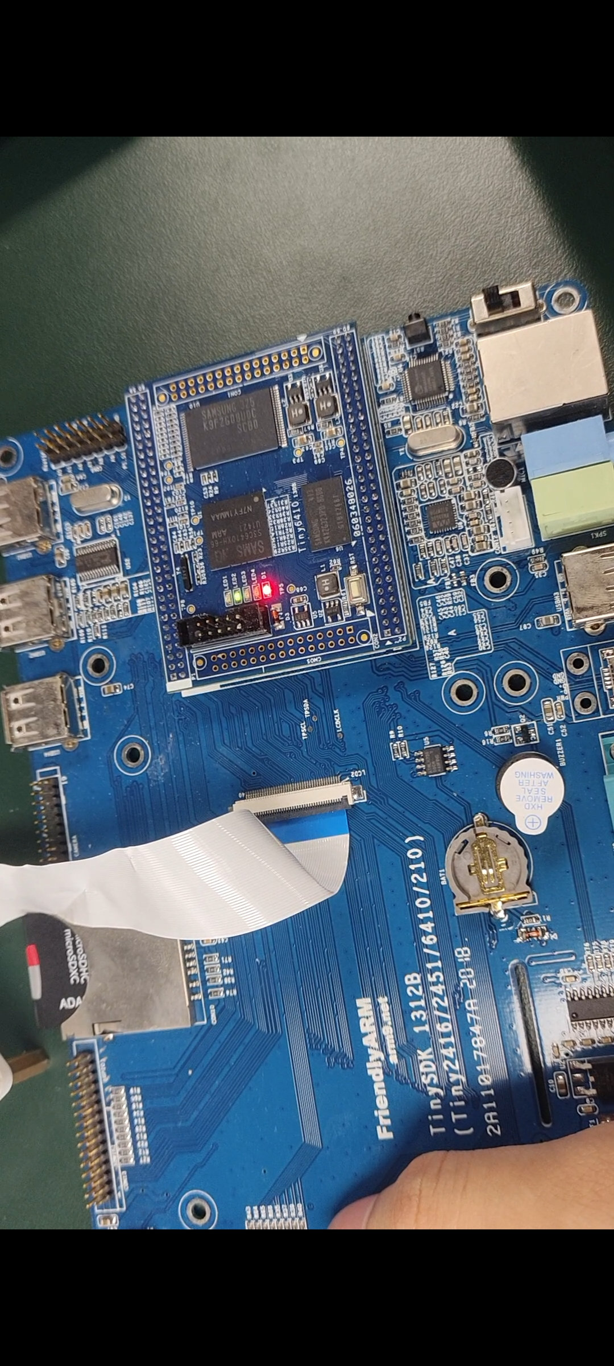
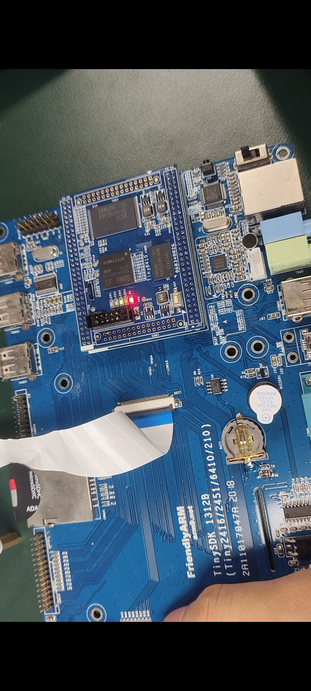
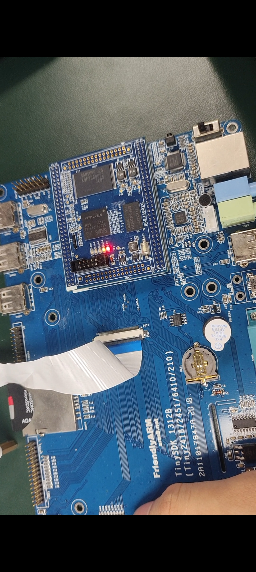
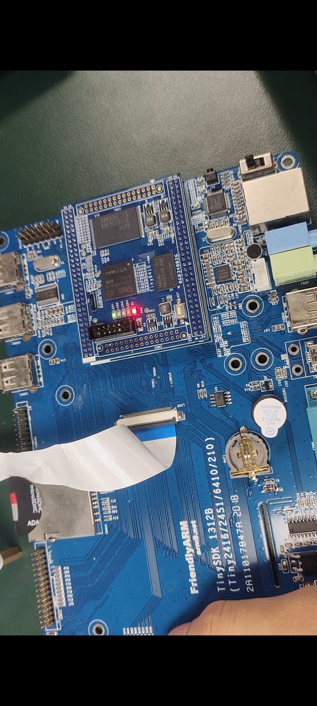
如图分别为led闪烁和跑马灯的演示图。
该课设在原有基础上还实现了在K1、K2、K3输入时的反馈，按K2或K3会使led2或led3亮起，同时如果按过K1，led1也会同时亮起。
我们小组在验收时由于U盘拷错代码，存在bug，将1A输入统一按K1按下处理，识别成AA，170，导致结果错误，同时我个人在验收修改以十进制个位和十位之和与星期数比较时虽修改了代码，但貌似忘记拷贝，导致结果仍按个位与星期比较，0<3走向走马灯分支。

附录：实验代码：（完整的源程序）
irq.c:
#include "stdio.h"
#include "buzzer.h"
#define GPKCON0 (*((volatile unsigned long *)0x7F008800))
#define GPNCON (*((volatile unsigned long *)0x7F008830))
#define GPNDAT (*((volatile unsigned long *)0x7F008834))
#define PRIORITY (*((volatile unsigned long *)0x7F008280))
#define GPKDATA (*((volatile unsigned long *)0x7F008808))
#define EINT0CON0 (*((volatile unsigned long *)0x7F008900))
#define EINT0MASK (*((volatile unsigned long *)0x7F008920))
#define EINT0PEND (*((volatile unsigned long *)0x7F008924))
#define SERVICE (*((volatile unsigned long *)0x7F008284))
#define SERVICEPEND (*((volatile unsigned long *)0x7F008288))
#define VIC0IRQSTATUS (*((volatile unsigned long *)0x71200000))
#define VIC0FIQSTATUS (*((volatile unsigned long *)0x71200004))
#define VIC0RAWINTR (*((volatile unsigned long *)0x71200008))
#define VIC0INTSELECT (*((volatile unsigned long *)0x7120000c))
#define VIC0INTENABLE (*((volatile unsigned long *)0x71200010))
#define VIC0INTENCLEAR (*((volatile unsigned long *)0x71200014))
#define VIC0PROTECTION (*((volatile unsigned long *)0x71200020))
#define VIC0SWPRIORITYMASK (*((volatile unsigned long *)0x71200024))
#define VIC0PRIORITYDAISY (*((volatile unsigned long *)0x71200028))
#define VIC0ADDRESS (*((volatile unsigned long *)0x71200f00))
#define PWMTIMER_BASE (0x7F006000)
#define TCFG0 ( *((volatile unsigned long *)(PWMTIMER_BASE+0x00)) )
#define TCFG1 ( *((volatile unsigned long *)(PWMTIMER_BASE+0x04)) )
#define TCON ( *((volatile unsigned long *)(PWMTIMER_BASE+0x08)) )
#define TCNTB0 ( *((volatile unsigned long *)(PWMTIMER_BASE+0x0C)) )
#define TCMPB0 ( *((volatile unsigned long *)(PWMTIMER_BASE+0x10)) )
#define TCNTO0 ( *((volatile unsigned long *)(PWMTIMER_BASE+0x14)) )
#define TCNTB1 ( *((volatile unsigned long *)(PWMTIMER_BASE+0x18)) )
#define TCMPB1 ( *((volatile unsigned long *)(PWMTIMER_BASE+0x1C)) )
#define TCNTO1 ( *((volatile unsigned long *)(PWMTIMER_BASE+0x20)) )
#define TCNTB2 ( *((volatile unsigned long *)(PWMTIMER_BASE+0x24)) )
#define TCMPB2 ( *((volatile unsigned long *)(PWMTIMER_BASE+0x28)) )
#define TCNTO2 ( *((volatile unsigned long *)(PWMTIMER_BASE+0x2C)) )
#define TCNTB3 ( *((volatile unsigned long *)(PWMTIMER_BASE+0x30)) )
#define TCMPB3 ( *((volatile unsigned long *)(PWMTIMER_BASE+0x34)) )
#define TCNTO3 ( *((volatile unsigned long *)(PWMTIMER_BASE+0x38)) )
#define TCNTB4 ( *((volatile unsigned long *)(PWMTIMER_BASE+0x3C)) )
#define TCNTO4 ( *((volatile unsigned long *)(PWMTIMER_BASE+0x40)) )
#define TINT_CSTAT ( *((volatile unsigned long *)(PWMTIMER_BASE+0x44)) )
typedef void (isr) (void);
extern void asm_k1_irq();
extern void asm_timer_irq();
volatile int hex_high = 0;
volatile int hex_low = 0;
volatile int actual_hex_high = 0;
volatile int actual_hex_low = 0;
volatile int k1_pressed = 0;
volatile int state = 0;
volatile int input_timeout = 0;
volatile int confirm_hex = 0;
volatile int led_flash_count = 0;
volatile int led_flash_target = 0;
volatile int led_state = 0;
volatile int comparison_result = 0;
volatile int buzzer_pattern = 0;
volatile int buzzer_count = 0;
volatile int buzzer_target = 0;
volatile int buzzer_state = 0;
volatile int buzzer_timer = 0;
volatile int led_running_pos = 0;
volatile int led_running_count = 0;
volatile int timer_500ms_count = 0;
volatile int xinqi = 3;
volatile int last_hex_high = 0;
volatile int last_hex_low = 0;
void delay(volatile unsigned int n)
{
while(n--){
volatile unsigned int m=0x7ff;
while(m--){}
}
}
void irq_init(void)
{
GPNCON &= ~(0xff);
GPNCON |= 0xaa;
EINT0CON0 &= ~(0xff);
EINT0CON0 |= 0x33;
EINT0MASK &= ~(0x0f);
VIC0INTENABLE |= (1 << 23);
VIC0INTENABLE |=(0x3);
VIC0INTSELECT = 0;
isr** isr_array = (isr**)(0x71200100);
isr_array[0] = (isr*)asm_k1_irq;
isr** isr_timer_array = (isr**)(0x7120015C);
isr_timer_array[0] = (isr*)asm_timer_irq;
GPKCON0 = 0x11110000;
GPKDATA = 0xf0;
}
void timer_init(void)
{
unsigned long utimer=0;
unsigned long uprescaler=65;
unsigned long udivider=4;
unsigned long utcntb=31250;
unsigned long utcmpb=0;
unsigned long temp0;
temp0 = TCFG0;
temp0 = (temp0 & (~(0xff00ff))) | (uprescaler<<0);
TCFG0 = temp0;
temp0 = TCFG1;
temp0 = (temp0 & (~(0xf<<4*utimer))& (~(1<<20))) |(udivider<<4*utimer);
TCFG1 = temp0;
TCNTB0 = utcntb;
TCMPB0 = utcmpb;
TCON |= 1<<1;
TCON &= ~(1<<1);
TCON |= (1<<0)|(1<<3);
temp0 = TINT_CSTAT;
temp0 = (temp0 & (~(1<<utimer)))|(1<<(utimer));
TINT_CSTAT = temp0;
}
int get_hex_value(int count, int k1_assist)
{
if (k1_assist && count >= 1 && count <= 6) {
return count + 9;
}
return (count > 9) ? my_mod(count, 10) : count;
}
int my_div(int dividend, int divisor)
{
if (divisor == 0) return 0;
int quotient = 0;
int temp_dividend = dividend;
while (temp_dividend >= divisor) {
temp_dividend -= divisor;
quotient++;
}
return quotient;
}
int my_mod(int dividend, int divisor)
{
if (divisor == 0) return 0;
int temp_dividend = dividend;
while (temp_dividend >= divisor) {
temp_dividend -= divisor;
}
return temp_dividend;
}
void do_irq(void)
{
if (EINT0PEND & 0x1)
{
delay(50);
if (!(GPNDAT & (1<<0)))
{
k1_pressed = 1;
state = 1;
}
else
{
k1_pressed = 0;
}
}
if (EINT0PEND & 0x2)
{
delay(50);
if (!(GPNDAT & (1<<1)))
{
state = 1;
if (k1_pressed)
{
hex_high++;
if (hex_high > 6) hex_high = 1;
actual_hex_high = hex_high + 9;
GPKDATA = 0xc0;
delay(300);
GPKDATA = 0xf0;
}
else
{
hex_high++;
if (hex_high > 9) hex_high = 0;
actual_hex_high = hex_high;
GPKDATA = 0xd0;
delay(300);
GPKDATA = 0xf0;
}
}
}
if (EINT0PEND & 0x4)
{
delay(50);
if (!(GPNDAT & (1<<2)))
{
state = 1;
if (k1_pressed)
{
hex_low++;
if (hex_low > 6) hex_low = 1;
actual_hex_low = hex_low + 9;
GPKDATA = 0xa0;
delay(300);
GPKDATA = 0xf0;
}
else
{
hex_low++;
if (hex_low > 9) hex_low = 0;
actual_hex_low = hex_low;
GPKDATA = 0xe0;
delay(300);
GPKDATA = 0xf0;
}
}
}
if (EINT0PEND & 0x8)
{
delay(50);
if (!(GPNDAT & (1<<3)))
{
delay(1000);
if (!(GPNDAT & (1<<3)))
{
state = 4;
/* k4_click_count = 0;
k4_click_timer = 0;*/
}
else
{
if (state == 2)
{
state = 3;
}
/* if (state == 2)
{
k4_click_count++;
k4_click_timer = 0;
if (k4_click_count >= 2)
{
state = 3;
k4_click_count = 0;
k4_click_timer = 0;
}
*/
}
}
}
EINT0PEND = 0x3f;
VIC0ADDRESS = 0;
}
void do_timer_irq()
{
timer_500ms_count++;
if (state == 1 && (timer_500ms_count % 2 == 0))
{
if (hex_high == last_hex_high && hex_low == last_hex_low)
{
input_timeout++;
if (input_timeout >= 3)
{
confirm_hex = actual_hex_high * 16 + actual_hex_low;
led_flash_target = actual_hex_high;
led_flash_count = 0;
state = 2;
input_timeout = 0;
}
}
else
{
input_timeout = 0;
last_hex_high = hex_high;
last_hex_low = hex_low;
}
}
else if (state == 2 && (timer_500ms_count % 2 == 0))
{
if (led_flash_count < led_flash_target)
{
if (led_state == 0)
{
GPKDATA = 0x00;
led_state = 1;
}
else
{
GPKDATA = 0xf0;
led_state = 0;
led_flash_count++;
}
}
else
{
GPKDATA = 0xf0;
}
}
else if (state == 3)
{
int decimal_value = confirm_hex;
int ge_wei = my_mod(decimal_value, 10);
int shi_wei = my_mod(my_div(decimal_value, 10), 10);
if (ge_wei > xinqi)
{
if (timer_500ms_count % 2 == 0)
{
if (led_state == 0)
{
GPKDATA = 0x00;
led_state = 1;
}
else
{
GPKDATA = 0xf0;
led_state = 0;
}
}
if (buzzer_count < shi_wei)
{
if (buzzer_state == 0)
{
buzzer_on();
buzzer_state = 1;
buzzer_timer = 0;
}
else if (buzzer_state == 1)
{
buzzer_timer++;
if (buzzer_timer >= 2)
{
buzzer_off();
buzzer_state = 2;
buzzer_timer = 0;
}
}
else if (buzzer_state == 2)
{
buzzer_timer++;
if (buzzer_timer >= 2)
{
buzzer_on();
buzzer_state = 3;
buzzer_timer = 0;
}
}
else if (buzzer_state == 3)
{
buzzer_timer++;
if (buzzer_timer >= 1)
{
buzzer_off();
buzzer_state = 4;
buzzer_timer = 0;
}
}
else
{
buzzer_timer++;
if (buzzer_timer >= 2)
{
buzzer_state = 0;
buzzer_timer = 0;
buzzer_count++;
}
}
}
else
{
buzzer_off();
}
}
else
{
if (buzzer_count < xinqi)
{
if (buzzer_state == 0)
{
buzzer_on();
buzzer_state = 1;
}
else
{
buzzer_off();
buzzer_state = 0;
buzzer_count++;
}
}
else
{
buzzer_off();
}
if (led_running_count < xinqi)
{
switch(led_running_pos)
{
case 0: GPKDATA = 0xe0; break;
case 1: GPKDATA = 0xd0; break;
case 2: GPKDATA = 0xb0; break;
case 3: GPKDATA = 0x70; break;
}
led_running_pos++;
if (led_running_pos >= 4) led_running_pos = 0;
if (led_running_pos == 0)
{
led_running_count++;
}
}
else
{
GPKDATA = 0xf0;
}
}
}
else if (state == 4)
{
buzzer_off();
hex_high = 0;
hex_low = 0;
actual_hex_high = 0;
actual_hex_low = 0;
k1_pressed = 0;
state = 0;
input_timeout = 0;
confirm_hex = 0;
led_flash_count = 0;
led_flash_target = 0;
led_state = 0;
comparison_result = 0;
buzzer_count = 0;
buzzer_target = 0;
buzzer_state = 0;
buzzer_timer = 0;
led_running_pos = 0;
led_running_count = 0;
last_hex_high = 0;
last_hex_low = 0;
timer_500ms_count = 0;
GPKDATA = 0xf0;
}
unsigned long uTmp = TINT_CSTAT;
TINT_CSTAT = uTmp;
VIC0ADDRESS = 0x0;
}

start.S:
.global _start
.global asm_k1_irq
.global asm_timer_irq
.extern do_irq
.extern do_timer_irq
_start:

reset:

ldr r0, =0x70000000
orr r0, r0, #0x13
mcr p15,0,r0,c15,c2,4

ldr r0, =0x7E004000
mov r1, #0
str r1, [r0]

mrc p15,0,r0,c1,c0,0
orr r0,r0,#(1<<24)
mcr p15,0,r0,c1,c0,0

ldr sp, =8*1024
bl clock_init
bl sdram_init
bl nand_init
bl irq_init
bl timer_init
mrs r0,cpsr
bic r0,r0,#0x80
msr cpsr_c,r0

adr r0, _start
ldr r1, =_start
ldr r2, =bss_start
sub r2, r2, r1
cmp r0,r1
beq clean_bss
bl copy2ddr
cmp r0, #0
bne halt

clean_bss:
ldr r0, =bss_start
ldr r1, =bss_end
mov r3, #0
cmp r0, r1
beq on_ddr
clean_loop:
str r3, [r0], #4
cmp r0, r1
bne clean_loop

on_ddr:

ldr pc, =main

asm_k1_irq:
b irq
asm_timer_irq:
b irq1
irq:

ldr sp, =0x54000000
sub lr, lr, #4
stmfd sp!, {r0-r12, lr}

bl do_irq

ldmfd sp!, {r0-r12, pc}^
irq1:
ldr sp, =0x55000000
sub lr, lr, #4
stmfd sp!, {r0-r12, lr}
bl do_timer_irq
ldmfd sp!, {r0-r12, pc}^
halt:
b halt

main.c:
#include "stdio.h"
#include "buzzer.h"
#define GPKCON0 (*((volatile unsigned long *)0x7F008800))
#define GPNCON (*((volatile unsigned long *)0x7F008830))
#define GPNDAT (*((volatile unsigned long *)0x7F008834))
#define PRIORITY (*((volatile unsigned long *)0x7F008280))
#define GPKDATA (*((volatile unsigned long *)0x7F008808))
void init_uart(void);
int main()
{
init_uart();
buzzer_init();
while (1)
{
}
return 0;
}

附表1. 成绩评定表
 | 评价内容 |  | 权重 | 得分
验收 | 程序能否正常运行；运行结果是否正确；设计任务是否全部完成；开发操作是否熟练；回答提问是否正确。 |  | 0.55
设计报告 | 1 | 报告格式是否规范，语言使用是否规范，行文是否流畅，是否图文并茂； | 0.45
设计报告 | 2 | 设计原理和设计思想描述是否正确、详实，程序流程图是否规范，代码实现是否正确； | 0.45
设计报告 | 3 | 设计结果的分析和讨论是否充分，设计体会是否正确，是否提出了自己独到见解。 | 0.45
合计
指导教师（签章）： 2024 年 月 日

