Bias, Variance, Underfitting, and Overfitting
The goal of machine learning is not to memorize training data. The goal is to learn patterns that also work on new, unseen data. This ability is called generalization.
In Notebook 1, we split the tumor dataset into a training set and a test set. The reason is exactly this: training performance alone is not a reliable measure of how well a model will perform on new patients.
In this notebook, we study three closely related ideas:
- Bias — is the model too simple?
- Variance — is the model too sensitive to the training data?
- The bias-variance tradeoff — why you cannot minimize both at the same time

Bias
Bias measures how much the model's predictions systematically differ from the true values because the model is too simple or makes overly strong assumptions.
High bias occurs when a model cannot capture the true pattern in the data. For example, if the true relationship is curved but the model can only fit a straight line, it will make similar systematic errors again and again — on training data and on new data alike.
Low bias means the model is flexible enough to capture the main pattern in the data.
High bias → Underfitting. The model is too simple to learn the true pattern.

Variance
Variance measures how sensitive the model is to the specific training data it sees.
High variance occurs when the model fits not only the real pattern but also the random noise in the training data. Such a model may look excellent on the training set but perform poorly when the data changes even slightly.
Low variance means the model is more stable. Its predictions do not change too much from one training sample to another.
High variance → Overfitting. The model is too flexible and memorizes the training data, including its noise.

A Visual Intuition: The Target Board
The target board below shows all four combinations of bias and variance. Think of each dot as one prediction. The red centre is the correct answer.
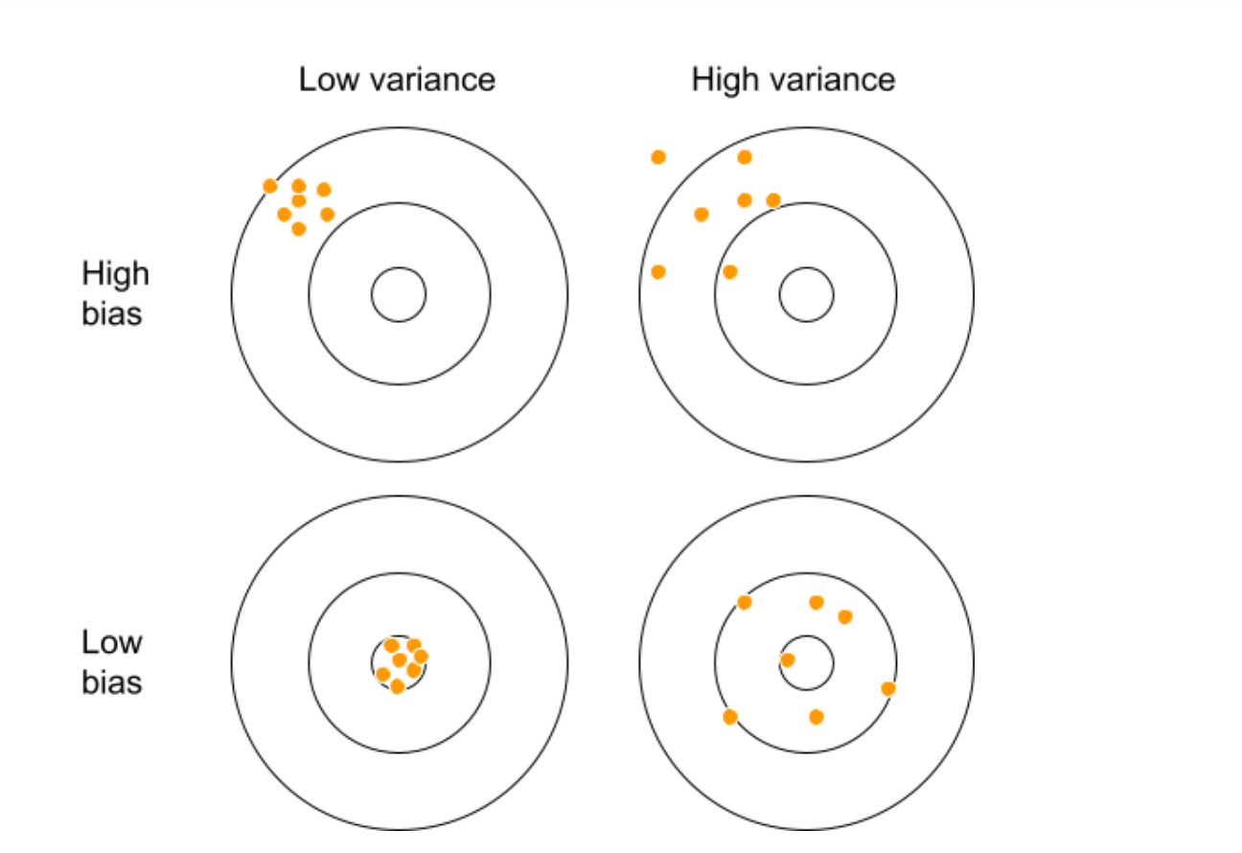
Figure 1. Bias and Variance: Target-Board Intuition
- High bias, low variance (top left) — consistently off in the same direction. Stable but wrong.
- High bias, high variance (top right) — both off-centre and spread out. The worst case.
- Low bias, low variance (bottom left) — predictions cluster tightly around the true answer. This is the ideal.
- Low bias, high variance (bottom right) — centred on average, but spread out widely.

Underfitting and Overfitting
Before looking at how different models fit the data, let us first look at the raw dataset. The blue dots are training data points and the green dots are test data points.
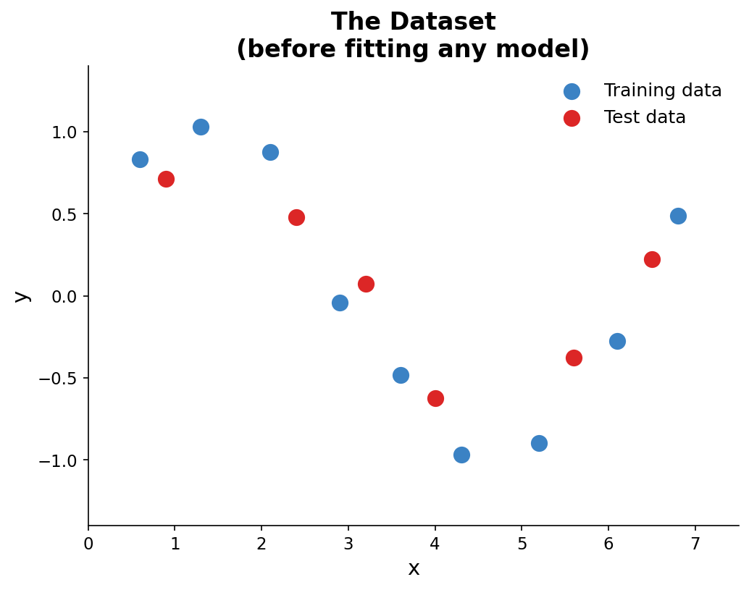

Figure 2a. The raw dataset — blue dots are training data, green dots are test data

Now let us see what happens when we fit models of different complexity to this data.
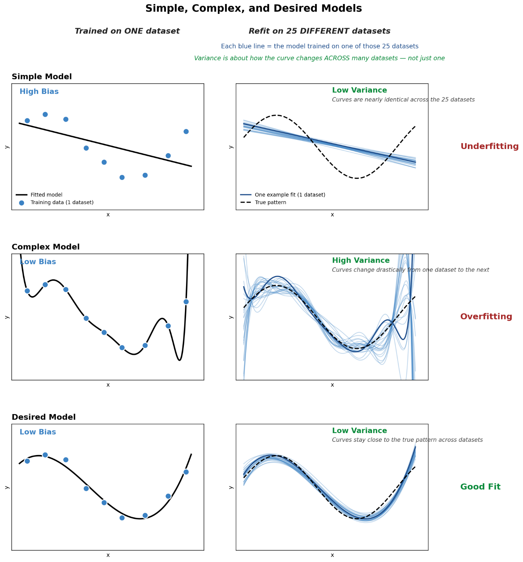

Figure 2b. Simple, Complex, and Desired Models

Reading Figure 2b. The figure has two columns. The left column shows each model trained on a single dataset — what you would normally see if you fit the model once. The right column shows the same model refit 25 times, each time on a different dataset drawn from the same underlying pattern. Each thin blue line in the right column is the curve produced from one of those 25 datasets; the dashed black line is the true pattern we are trying to recover.
This second view is what makes variance visible. Variance is not a property of a single fit — it is how much the fitted curve changes when you retrain the model on a different dataset. A model with low variance produces nearly the same curve every time. A model with high variance produces wildly different curves depending on which data points it happened to see.
With that in mind, look at the three rows:
- Simple Model (top). The straight line misses the wave entirely (high bias), but the 25 retrained lines lie almost on top of one another (low variance). The model is stable, but consistently wrong.
- Complex Model (middle). The degree-12 polynomial threads through the training points and on average tracks the true pattern (low bias), but the 25 retrained curves fan out drastically — especially near the edges. Any single fit could be far off (high variance).
- Desired Model (bottom). The 25 curves cluster tightly and hug the true pattern. Both bias and variance are low. This is the goal.

Seeing It with Polynomial Regression
The three panels below show the same idea using real data and polynomial models of increasing complexity.
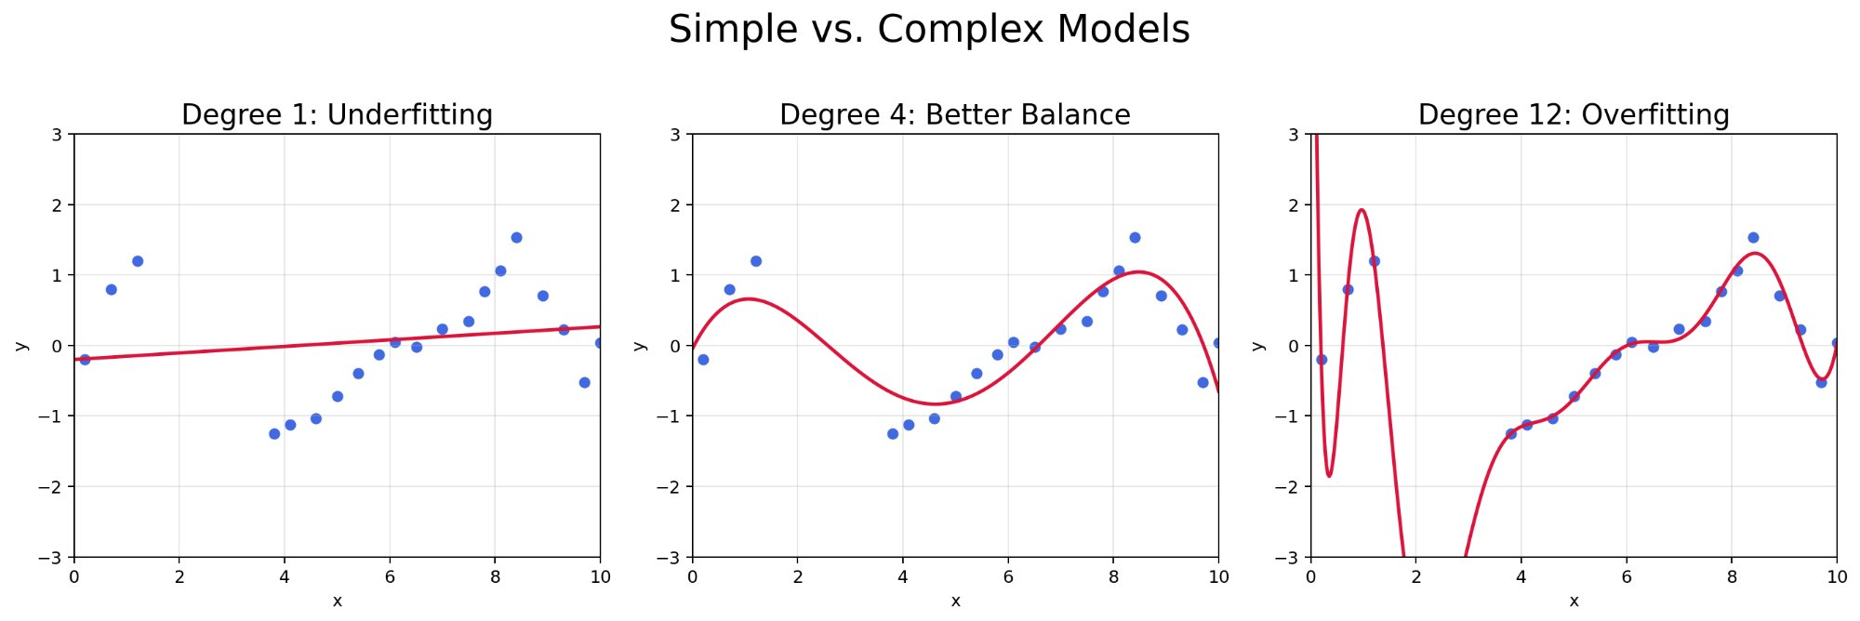
Figure 3. Degree 1 (Underfitting), Degree 4 (Better Balance), Degree 12 (Overfitting)
- Degree 1 (left) — a straight line. Too simple to follow the sine curve. Underfitting.
- Degree 4 (middle) — flexible enough to follow the general shape without chasing noise. A better balance.
- Degree 12 (right) — passes through almost every training point. On new data it will likely perform poorly. Overfitting.

Underfitting vs. Overfitting
Situation | Bias | Variance
Underfitting | High | Low
Balanced fit | Relatively Low | Relatively Low
Overfitting | Low | High

Key ideas:
- If the model has high bias, it fails on both training and test data — it never learned the pattern in the first place
- If the model has high variance, it looks great on training data but fails on new data — it memorized the noise
- This is why we always evaluate on a separate test set

The Bias-Variance Tradeoff
Bias and variance move in opposite directions as model complexity changes:
- As complexity increases → bias usually decreases, variance usually increases
- As complexity decreases → bias usually increases, variance usually decreases

The total prediction error can be written as:
Total Error ≈ Bias² + Variance + Irreducible Noise
Irreducible noise is the natural randomness in the data that no model can remove, no matter how complex. The goal is not to minimize bias alone or variance alone. The goal is to find the complexity where their combined effect — total error — is smallest.
Why is Bias squared?
Bias is a signed quantity — it can be positive (model consistently overestimates) or negative (model consistently underestimates). Squaring it converts the signed value into a magnitude that is always positive, so it can be added meaningfully to variance. Without squaring, a bias of +0.5 and a bias of −0.5 would cancel each other out, which makes no sense as a measure of error.
This is the same reason MSE uses squared differences rather than raw differences — squaring measures the size of the error, not its direction. The Bias² term also falls out naturally from the formal mathematical derivation of total expected prediction error.
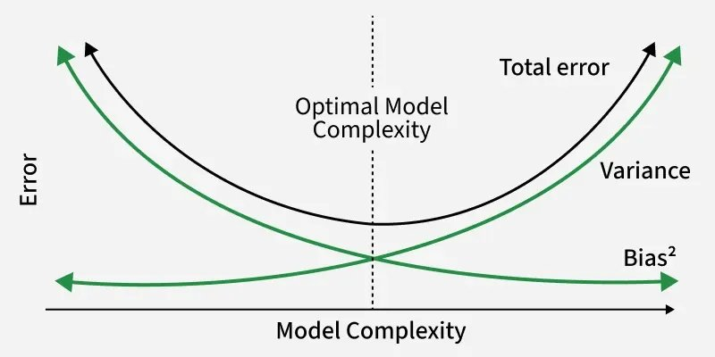
Figure 4. The Bias-Variance Tradeoff Curve
The black curve shows total error. On the left, bias dominates — the model is too simple. On the right, variance dominates — the model is too complex. The lowest total error sits at the optimal model complexity, marked by the dashed vertical line.

Connection to Notebook 1
In Notebook 1, we trained a logistic regression model on the tumor dataset and kept a separate test set. The reason for that split is exactly what we studied here: a model can memorize training data and still fail on new patients. We need the test set to check whether the model generalizes.
In Notebook 3, we will open the tumor test set and evaluate the model properly — using the confusion matrix, recall, and precision.

Practice Problems
Question 1. What does it mean for a model to generalize well?
Answer: A model generalizes well when it performs well not only on the training data, but also on new, unseen data that was not used during training.
Question 2. A model achieves 96% accuracy on the training set but only 61% on the test set. What is this problem called, and what does it say about bias and variance?
Answer: This is overfitting. The large gap between training and test accuracy means the model memorized the training data. This suggests low bias (fits training data very well) and high variance (too sensitive to the specific training examples, performs poorly on new data).
Question 3. A model achieves 63% accuracy on the training set and 61% on the test set. What is the likely problem, and what does it say about bias and variance?
Answer: This is underfitting. When both training and test performance are low and similar, the model is too simple. This suggests high bias and low variance.
Question 4. In the target board diagram, which panel represents the ideal situation, and why?
Answer: The top-left panel — low bias, low variance. The predictions cluster tightly around the true answer (low bias) and are consistent across different training samples (low variance).
Question 5. Why can you not simply make a model as complex as possible to minimize bias?
Answer: Because increasing complexity also increases variance. A very complex model memorizes the training data including its noise, and performs poorly on new data. The total error — bias² plus variance — rises again when the model becomes too complex.
Question 6. Why do we need a separate test set rather than just reporting training accuracy?
Answer: Because training error is not a reliable measure of generalization. A very complex model can achieve near-zero training error simply by memorizing the data. The test set gives an honest estimate of how the model performs on truly new data.

Summary
Concept | Key Idea
Generalization | The ability to perform well on new, unseen data
Bias | Error from a model being too simple; causes underfitting
Variance | Error from a model being too sensitive to training data; causes overfitting
Underfitting | High bias, low variance — model too simple, fails on both training and test data
Overfitting | Low bias, high variance — model memorizes noise, fails on new data
Bias-variance tradeoff | As complexity increases, bias falls and variance rises; the goal is to minimize their sum
Why we use a test set | Training error alone does not measure generalization

