英语
时间:60分钟 分值：100分
- 选择(单选) （10分）
- “一个苹果”的英语是？
A an apple B apple C the apple D apple
- 下列哪句话是正确的？
A China is a good country
B she set her chair
C she set Tom chair
D I love your
- 下列哪句短语是正确的？
A an hour
B an university
C an book
D an car
- “__”中应该填？ I like this book and __ book is good.
A a
B an
C the
D 不填
- “__”中应该填？He __homework every day
A do B does C did D go
- 翻译 （10分）
- 这是Jason的足球 football足球
- 她坐在Tom的汽车 car汽车
- 我每天吃饭
- 我在2019年不喜欢他
- 她上一年没见我 meet见
- 填空（共80分）
（1）（共21空 对21 10分 对20 9分 对18 5分 对15 1分 对10 0分 ）
1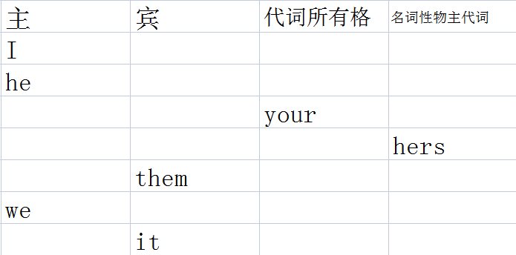
- 单三谓语变化（共29空 对27以上10分 对25以上8分 对20以上5分
对15以上3分 对10以上1分 对10以下0分 向下取）
buy______worry______fly______study_______like_______make______take__
love_______come_______drive_______leave_____wake_______ride_______write______
give______see______swim___cut_______run_______forget_______begin_______wash_____watch_______finish______teach_____fish_______reach_______go_______do_____

- ”__”上填单词适当形式.（10分）
1. He often ________(have) dinner at home.
2. Daniel and Tommy _______(be) in Class One.
3. We _______(not watch) TV on Monday.
4. Nick _______(not go) to the zoo on Sunday.
5. ______ they ________(like) the World Cup?
6. _______ your parents _______(read) newspapers every day?
7. The girl _______(teach) us English on Sundays.
8. She and I ________(take) a walk together every evening.
9. Mike _______(like) cooking.
10.They _______(have) the same hobby.
（4）（10分）
1.Tom and Mary ___________ (come) to China last month.
2.Mike _________________(not go) to bed until 12 o’clock last night. So I
_______ (get ) up late.
3.Mary __________ (read) English yesterday morning.
4.There _________ (be) no one here a moment ago.
5.I ___________ (call) Mike this morning.
6.I listened but ___________ (hear) nothing.
7.Tom ___________ (begin) to learn Chinese last year.
8.Last week we _________ (pick) many apples on the farm.
9.My mother ________________ (not do) housework yesterday.
10.She watches TV every evening. But she _______________ (not watch)
TV last night.
(5)（10分）
1.The boy __________________ ( draw)a picture now.
2. Listen .Some girls __________( sing)in the classroom .
3. My mother ____________ ( cook )some nice food now.
4. What _____ you ______ ( do ) now?
5. Look . They _____________( have) an English lesson .
6.They ____________(not ,water) the flowers now.
7.Look! the girls ____________(dance )in the classroom .
8.What is our granddaughter doing?She _________(listen ) to music.
9. It's 5 o'clock now. We ___________(have)supper now
10.______Helen__________(wash )clothes? Yes ,she is
(6)The boy is playing basketball. (10分)
否定句：____________________________
一般疑问句：_________________________
肯定回答：__________________________
否定回答：__________________________
对The boy提问：__________________________

- 单词检查（写出词性 汉语 名词n 动词 v 形容词adj ）（20分）
（共43个单词 对40 20分 对37 18分 对35 15分 对30 12分 对25 8分 对20 5分
对15 3分 对10 1分 对5 0分）
Yes
Is
This
Handbag
It
Thank you
Very much
Pen
Pencil
Book
Watch
Coat
Dress
Skirt
Shirt
Car
House
Umbrella
Please
Here
Ticket
Number
Five
Sorry
Sir
Cloakroom
Suit
School
Teacher
Son
Daughter
Good
Morning
Miss
New
Student
French
German
Nice
Meet
Japanese
Korean
Chinese

