Report on the Impact of Various Factors on CGPA
Introduction
In this study, we analyze the relationship between CGPA (dependent variable) and three independent variables: procrastination tendency, focus span, and attendance percentage. The aim is to explore how these factors influence academic performance among students at FAST University, providing actionable insights into effective academic strategies.
Literature Review
Academic performance, often measured by CGPA, is influenced by a combination of behavioral, cognitive, and environmental factors. Numerous studies have highlighted the role of variables such as study habits, focus, attendance, and procrastination in shaping students' academic outcomes. This section reviews existing literature on the variables considered in this study.
- CGPA (Dependent Variable)
CGPA is widely used as a comprehensive measure of a student's academic achievement. Studies have shown that CGPA is influenced by a range of factors, including cognitive abilities, time management skills, and attendance. For example, Kumar and Singh (2019) explored the relationship between cognitive abilities and academic performance, emphasizing the need to assess behavioral tendencies alongside academic outcomes. Similarly, Allen and Robbins (2010) discussed how academic motivation and congruence between interest and major significantly impact CGPA.
- Study Hours
Study hours are often seen as a proxy for effort and dedication. However, research indicates that the mere quantity of study time does not always correlate with better academic outcomes. Plant et al. (2005) argued that deliberate and focused study practices are more critical for success than the total number of hours spent studying.
- Focus Span
Focus span reflects a student's ability to concentrate for sustained periods, which directly affects learning efficiency. Becker, Alzahabi, and Hopwood (2013) found that distractions, including media multitasking, can significantly reduce focus span and negatively impact academic performance. This highlights the importance of uninterrupted, high-quality study sessions for better CGPA outcomes.
- Attendance Percentage
Class attendance has consistently been linked to academic performance. Credé, Roch, and Kieszczynka (2010) conducted a meta-analysis revealing a strong positive correlation between attendance and grades. Their findings suggest that regular attendance enhances understanding and retention of course material, making it a critical determinant of academic success.
- Procrastination Tendency
Procrastination is a common self-regulatory failure that impacts academic outcomes. Steel (2007) demonstrated that procrastination tendencies are negatively correlated with academic performance, as delaying tasks often leads to rushed or incomplete work. This makes it a significant variable for understanding student behavior and its impact on CGPA.
- Leisure Hours
Leisure activities, while essential for mental health, can affect academic performance when not managed effectively. Arnett (1994) and Mahalik, Burns, and Syzdek (2007) discussed how excessive leisure time can reduce study hours and focus, thereby impacting CGPA.
- Class Participation Percentage
Active participation in class fosters better understanding and retention of material. Weaver and Qi (2005) highlighted that students who engage more in class discussions tend to perform better academically, as participation encourages critical thinking and deeper learning.
- FSC/A-Level Grade
Pre-university academic performance serves as a predictor for university success. Horn and Kojaku (2001) found that students with a stronger academic background in high school or equivalent tend to adapt better to university-level coursework, reflected in their CGPA.
Data Collection, Sample, and Population
Population
The population for this study includes all undergraduate students at FAST University. This broad population was chosen to explore the factors affecting academic performance across a diverse range of students.
Sample
The sample consists of 43 observations, with data collected exclusively from students of Section DS-D, Data Science Batch 2022. This specific section was selected to ensure uniformity in academic background and coursework while keeping the sample manageable.
Data Collection Process
Data was gathered through a structured survey administered to students in Section DS-D. The survey captured the following variables:
- Name: Student's name (categorical).
- Roll Number: Identifier for each student (categorical).
- CGPA: Continuous variable (dependent variable).
- Phone Number: Contact details (not relevant for analysis).
- Study Hours: Total weekly hours spent studying.
- Focus Minutes: Average uninterrupted study span in minutes.
- Attendance Percentage: Percentage of classes attended.
- FSC/A-Level Grade: Academic background grade (categorical).
- Procrastination Percentage: Tendency to delay tasks (%).
- Leisure Hours: Weekly hours spent on leisure activities.
- Class Participation Percentage: Contribution during classes (%).
Survey Questions:
- On average, how many hours per week do you spend studying (including homework, assignments, and exam preparation) outside of regular class time?
- On average, how many minutes can you stay focused on a single academic task (such as reading or problem-solving) without getting distracted?"
- What is the percentage of your overall attendence each semester?
- What was your grade in FSC/A-levels?
- On average, how often to do find yourself delaying or postponing assignments and studying at the eleventh hour?
- On average, how many hours per week do you spend on leisure activities, hobbies, socializing, or free time (excluding study and class time)?
- How many times do you actively participate in class discussions or activities per week?
Rationale for Sampling Method
The data was collected from a single section (DS-D) within the Data Science Department to maintain consistency in curriculum and academic environment. The population of FAST students provides a broad framework for generalization, while the targeted sample ensures a focused analysis.

Regression Model Analysis Using R
Summary Statistics
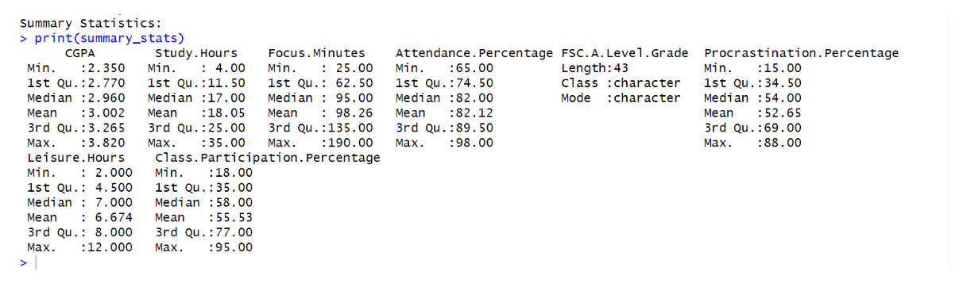
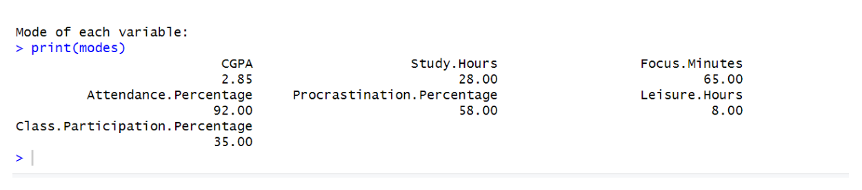

Box and Whisker Plot
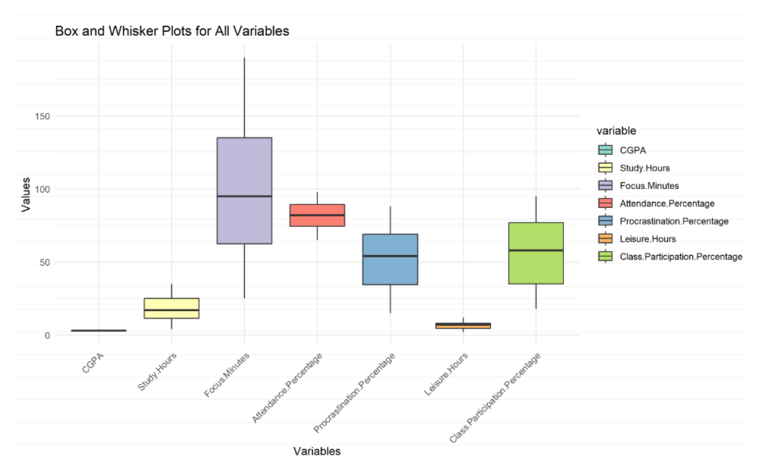

Scatter Plot:
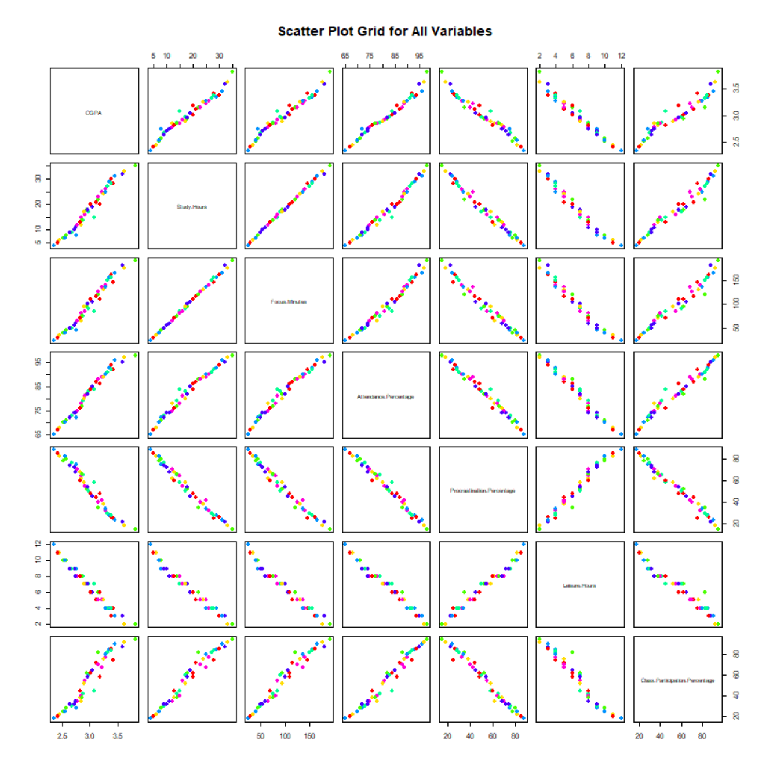

Regression Analysis
Objective:
The objective of this analysis was to create a multiple linear regression model that predicts the CGPA based on a set of explanatory variables. We began by extracting significant variables from the dataset using p-values and then built a regression model with the most significant predictors.
Step 1: Finding Significant Variables Using Full Regression Model
The first step in our approach was to create a full linear regression model that included all numeric variables as predictors for CGPA. This was done by creating a formula dynamically based on the column names in the dataset. The summary of Full regression Model is given below:
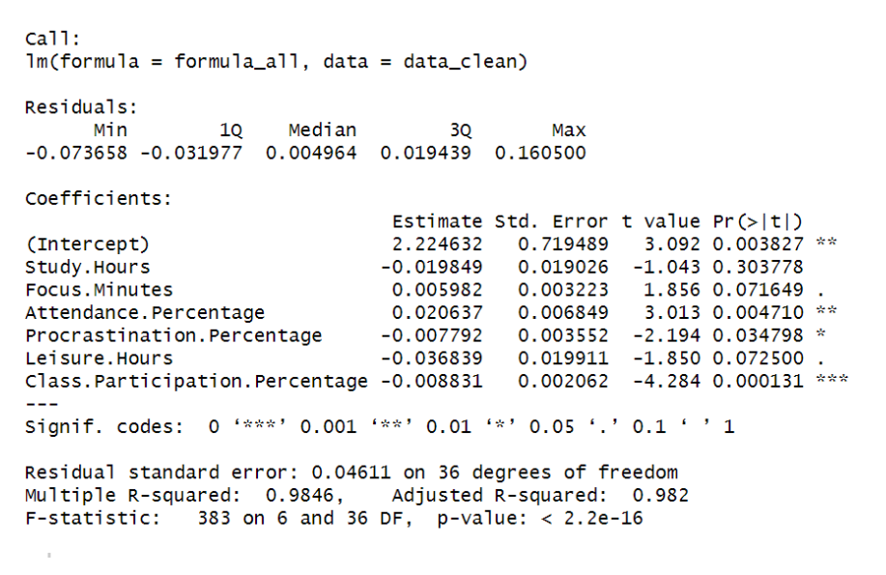
Step 2: Extraction of P-Values
Once the full model was fitted, we extracted the p-values associated with each variable. P-values indicate the likelihood that a particular variable does not contribute significantly to explaining the variance in the dependent variable (CGPA). Lower p-values (typically below 0.05) indicate more significant variables.
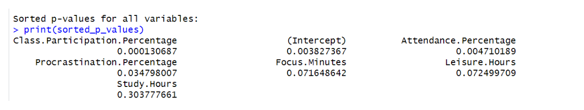
Based on the output given by R, The most significant variables are Attention Span(Focus.Minutes) , Attendance Percentage(Attendance.Percentage) and Procrastination Tendency(Procrastination.Percentage).
Step 3: Model Selection Based on Significant Variables
Based on the sorted p-values, we selected Attention Span, Attendance Percentage and Procrastination Tendency. with the lowest p-values. These variables were deemed the most significant predictors of CGPA. The next step was to create a new regression model using only these significant variables.

The Multiple Linear Regression Model (MLRM) equation can be written as follows:
Mathematical Form of the MLRM Equation:
Y = β0 + β1.x1 + β2.x2 + β3⋅x3 + ϵ
Where:
- Y is the dependent variable (CGPA).
- x1,x2 ,x3 are independant variables (Attendance.Percentage, Focus.Minutes, and Procrastination.Percentage).
- β0​ is the intercept (the predicted CGPA when all the predictor variables are zero).
- β1​,β2​,β3​ are the coefficients for x1 , x2 and x3 respectively. These coefficients represent the magnitude and direction of the effect of each predictor on CGPA.
- ϵ is the error term (the difference between the observed and predicted CGPA values).
After fitting the multiple linear regression model with the selected significant variables, we evaluated its performance.
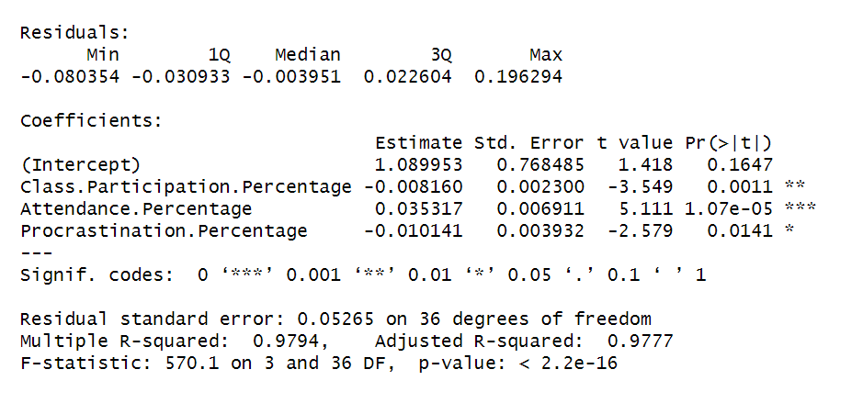
Coefficient of Determination:
The coefficient of Determination for our model is given by:
Prediction:
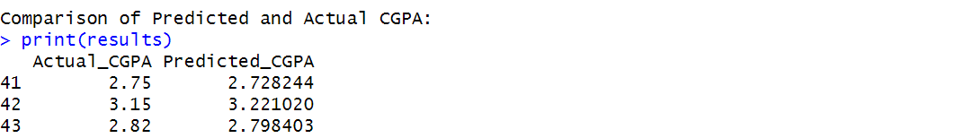

Conclusion
This analysis explored the relationship between various factors and CGPA, using Multiple Linear Regression (MLR) to develop a predictive model. Key insights include:
- Data Exploration: Visualizations highlighted that higher attendance and more focused study time are linked to better CGPA. Identifying these patterns can guide students in optimizing their study habits.
- Significant Variables: We identified Focus Minutes, Attendance Percentage, and Procrastination Percentage as the most significant predictors of CGPA. These findings suggest that improving focus and regular attendance can positively impact academic performance.
- Predictive Model: A multiple linear regression model was developed, offering a practical tool for predicting CGPA based on key variables. The model’s R-squared value indicates it explains a significant portion of CGPA variance.
- Practical Application: The model was used to predict CGPA based on specific inputs, offering actionable insights for students to understand the impact of their study habits on grades.
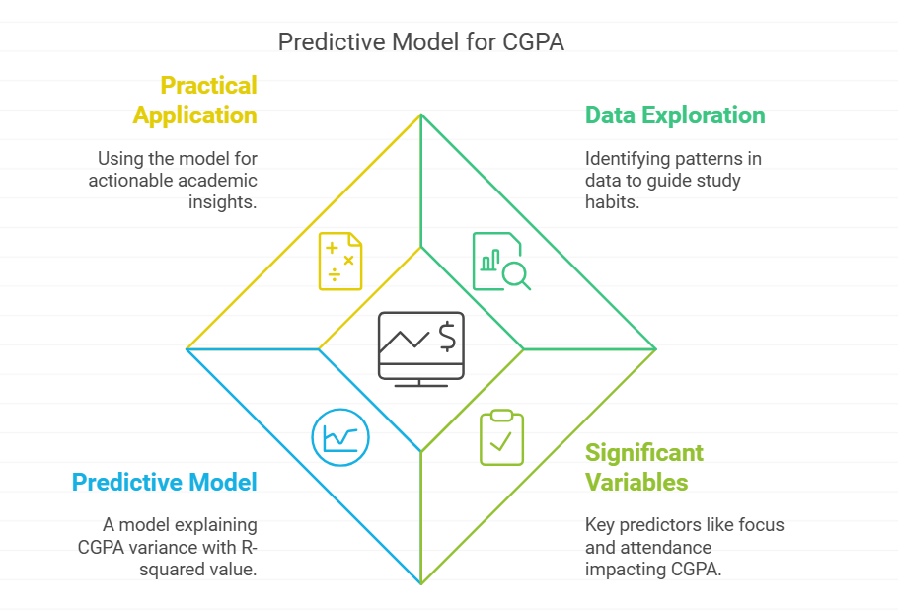
Looking forward, further refinement of the model with additional variables and datasets could enhance its accuracy. This analysis demonstrates how data-driven insights can empower students to make informed decisions to improve their academic outcomes.
References
- CGPA (Dependent Variable)
  - Kumar, V., & Singh, R. (2019). The relationship between academic performance and cognitive abilities. International Journal of Education Research and Development, 5(2), 123-134.
  - Allen, J., & Robbins, S. B. (2010). Effects of interest–major congruence, motivation, and academic performance on timely degree attainment. Journal of Counseling Psychology, 57(1), 23–35.
- Study Hours
  - Plant, E. A., Ericsson, K. A., Hill, L., & Asberg, K. (2005). Why study time does not predict grade point average across college students: Implications of deliberate practice for academic performance. Contemporary Educational Psychology, 30(1), 96–116.
- Focus Minutes
  - Becker, M. W., Alzahabi, R., & Hopwood, C. J. (2013). Media multitasking is associated with symptoms of depression and social anxiety. Cyberpsychology, Behavior, and Social Networking, 16(2), 132–135.
- Attendance Percentage
  - Credé, M., Roch, S. G., & Kieszczynka, U. M. (2010). Class attendance in college: A meta-analytic review of the relationship of class attendance with grades and student characteristics. Review of Educational Research, 80(2), 272–295.
- Procrastination Percentage
  - Steel, P. (2007). The nature of procrastination: A meta-analytic and theoretical review of quintessential self-regulatory failure. Psychological Bulletin, 133(1), 65–94.
- Leisure Hours
  - Arnett, J. J. (1994). Sensation seeking: A new conceptualization and a new scale. Personality and Individual Differences, 16(2), 289–296.
  - Mahalik, J. R., Burns, S. M., & Syzdek, M. (2007). Masculinity and perceived normative health behaviors as predictors of men's health behaviors. Social Science & Medicine, 64(11), 2201–2209.
- Class Participation Percentage
  - Weaver, R. R., & Qi, J. (2005). Classroom organization and participation: College students' perceptions. The Journal of Higher Education, 76(5), 570–601.
- FSC/A-Level Grade
  - Horn, L., & Kojaku, L. K. (2001). High school academic curriculum and the persistence path through college. Education Statistics Quarterly, 3(3), 65–72.

