**DBMS**

**LAB TASK 02 - DDL STATEMENTS.**

INSTRUCTOR: BASIT ALI

1. **Create database system for the simple point of sale system.** There are the relational Tables that you have to implement.

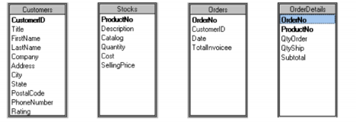

**Instructions.**

1. Create a new database named POS.

CREATE DATABASE POS;

1. The database system should contain the above shown tables with attributes. Write queries for creation of database/tables.

**Table: Customers**

CREATE TABLE Customers

(

CustomerID int Primary Key ,

Title varchar (255) ,

FirstName varchar (255) ,

LastName varchar (255) ,

Company varchar (255) ,

Address varchar (255) ,

City varchar (255) ,

State varchar (255) ,

PostalCode char (5) ,

PhoneNumber int,

Rating int

) ;

CREATE TABLE Stocks

(

ProductNo int primary key ,

Descriptions varchar (255) ,

Catalog varchar (255) ,

Quantity int ,

Cost int ,

SellingPrice int

) ;

CREATE TABLE Orders

(

OrderNo int Primary key ,

CustomerID int ,

Date date ,

TotalInvoicee varchar (255)

) ;

CREATE TABLE OrderDetails

(

OrderNo int UNIQUE ,

ProductNo int UNIQUE ,

QtyOrder int ,

QtyShip int ,

Subtotal int ,

FOREIGN KEY (OrderNo)

REFERENCES Orders (OrderNo) ,

FOREIGN KEY (ProductNo)

REFERENCES Stocks (ProductNo)

);

1. Select appropriate datatype for each attribute.

|  |  |
| --- | --- |
| Data Types | Usage |
| Int | Use for Integer |
| Varchar | Use for variable Length of string. |
| Char | Use for a fixed length String. |
| Date | Date of format: YYYY-MM-DD |

1. Screenshots of tables.

