**Lab Task – 3 – Constraint Declaration**

**Instructor: Basit Ali**

**1. Consider the following database.**

**Schema:**

1. **Movie** ( **mID**, title, year, director ) – Table.

English: There is a movie with ID number mID, a title, a release year, and a director.

2. **Reviewer** ( **rID**, name ) – Table.

English: The reviewer with ID number rID has a certain name.

3. **Rating** ( **rID, mID**, stars, ratingDate ) – Table.

English: The reviewer rID gave the movie mID a number of stars rating (1-5) on a certain ratingDate.

**CONSTRAINTS:**

**Key Constraints**.

1. mID is a key for Movie

2. rID is a key for Reviewer

3. (rID,mID,ratingDate) is a key for Rating but with null values allowed

**Non-Null Constraints**

4. Reviewer.name may not be NULL

5. Rating.stars may not be NULL

**Attribute-Based Check Constraints**

6. Movie.year must be after 1900

7. Rating.stars must be in {1,2,3,4,5}

8. Rating.ratingDate must be after 2000

**Default**

9. Default rating date should be system date.

10. Default rating should be 1.

**Task 1:**

Create Database MovieRating

CREATE DATABASE MovieRating;

**Task 2:** Write queries to create three tables (Movies, Reviewer, Rating) with the above mentioned properties.

**Table: Movie**

CREATE TABLE Movie

(

mID int Primary Key ,

Title varchar (255) ,

Year int,

Director varchar (255),

Check ( Year > 1900 )

) ;

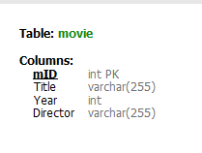

**Table: Reviewer**

CREATE TABLE Reviewer

(

rID int Primary Key ,

Name varchar (255) NOT NULL

) ;



**Table: Rating**

CREATE TABLE Rating

(

rID int NULL ,

mID int NULL ,

Stars int NOT NULL DEFAULT 1,

ratingDate DATE DEFAULT

( DATE( sysdate( ) )),

UNIQUE (rID, mID, ratingDate ),

CONSTRAINT checks

CHECK ( ( Stars in (1,2,3,4,5) ) AND

( YEAR(ratingDate) > 2000 ) )

) ;

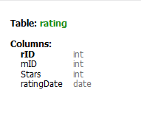

**Task 3:** Run the following SQL commands and Attach output result of these queries.

1. SHOW CREATE TABLE Movie;

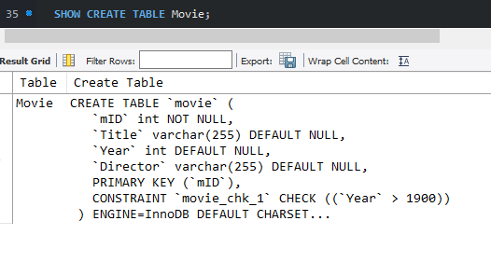

2. SHOW CREATE TABLE Reviewer.

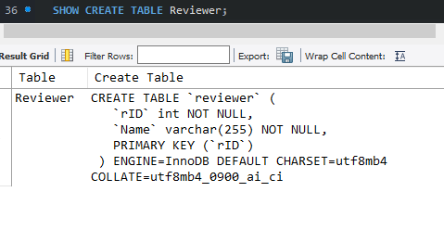

3. SHOW CREATE TABLE Rating;

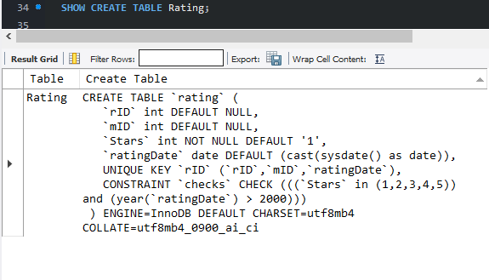

**Task 4:** Insert 3 records in each table.

insert into Movie

values

(1, "Big Hero 6", 2010, "XYZ" ),

(2, "Smurf", 2011, "HYZ" ),

(3, "Zootopia", 2014, "AYZ" );

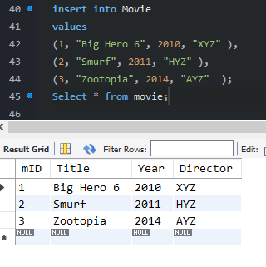

insert into reviewer

values

(01, "ABC"),

(02, "DEF"),

(03, "GHI");

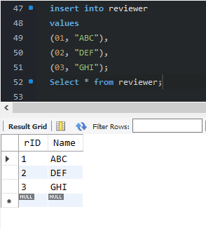

insert into rating

values

( 1, 03, 3,"2020-10-13 "),

( 2, 02, 4, "2001-05-13 "),

(3, 01, 5, "2015-04-12 ");

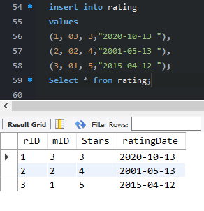

**Task 5:** Consider the following record in Rating table, Write a delete query to delete the following record only.

|  |  |  |  |
| --- | --- | --- | --- |
| **rID,** | **mID** | stars | ratingDate |
| 305 | 101 | 3 | 2020-05-10 |

DELETE FROM rating where rID=3;

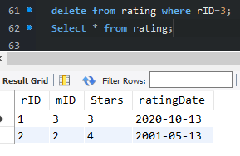

**THE END**