**Lab Submission**

**Instructor: Basit Ali**

**Assignment-07**

1. Write query to display Employee id, Last Name,Department id and department name from table employees & department.

**Code:**

SELECT employee_id, Last_name, department_id, department_name

from employees natural join departments;

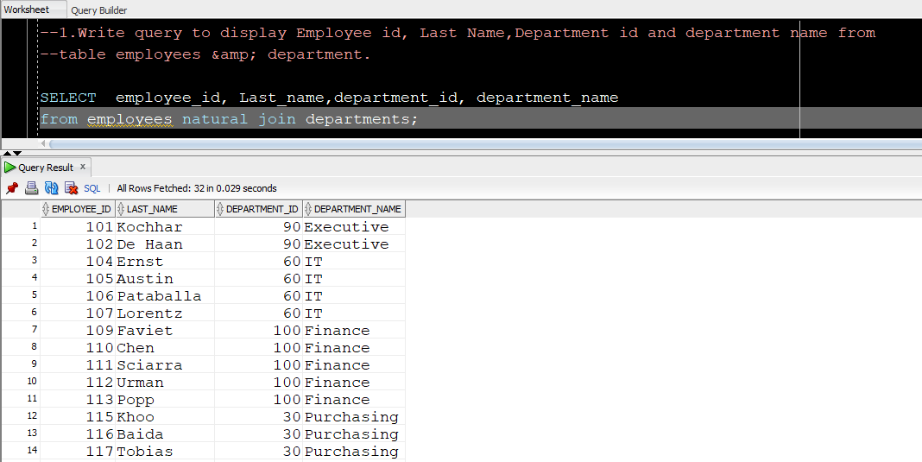

**---------------------------------------------**

1. Write query to display Employee’s last name, salary ,department_id and department name of all those employees who’s last name starts with A from table employees & department.

**Code:**

SELECT Last_name, salary, department_id, department_name

from employees natural join departments

where last_name like 'A%';

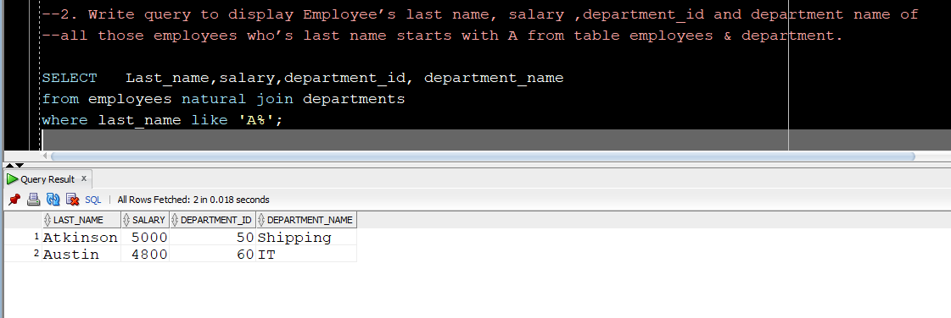

**---------------------------------------------**

1. Write query to display Employee’s last name, department_id, department name and city where department is using employee,department and locations table.

**Code:**

SELECT Last_name, department_id, department_name, city

from departments

join employees using (department_id)

join locations using (location_id);

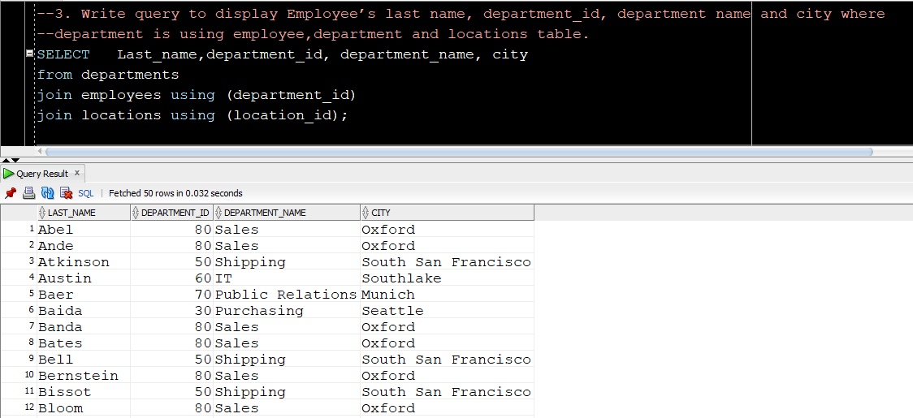

**---------------------------------------------**

1. Write query to display employee first name, his salary and his manager’s first name his salary from table employees.

**Code:**

SELECT employee.first_name Employee_FName, employee.salary Employee_Salary, manager.first_name manager_FName, manager.salary manager_salary

from employees employee

join employees manager

on (employee.manager_id=manager.employee_id);

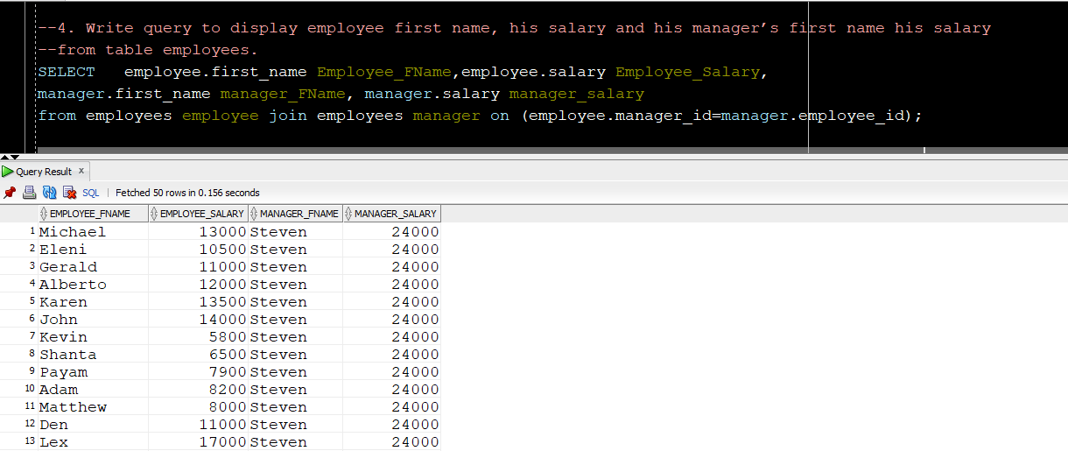

**---------------------------------------------**

1. What is your understanding about full outer join write a query and explain its working.

**Full outer join** is join that includes all the rows from both tables whether their rows are matching or not. In simple words, it is a combination of **left** and **right outer join**.

**Explanation:**

Consider, there are two tables:

**Groups:** This table is consists of **group_id** and **group_name.**

**Members:**  This table is consists of **member_id, member_name** and

**group_id.**

**(Members** belong to one of the group listed in the **Groups** table.**)**

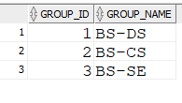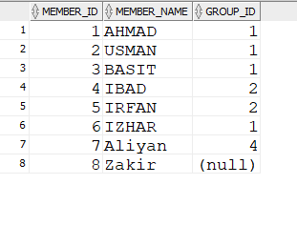

**Table: Groups**

**Table: Members**

**Full Outer Join**

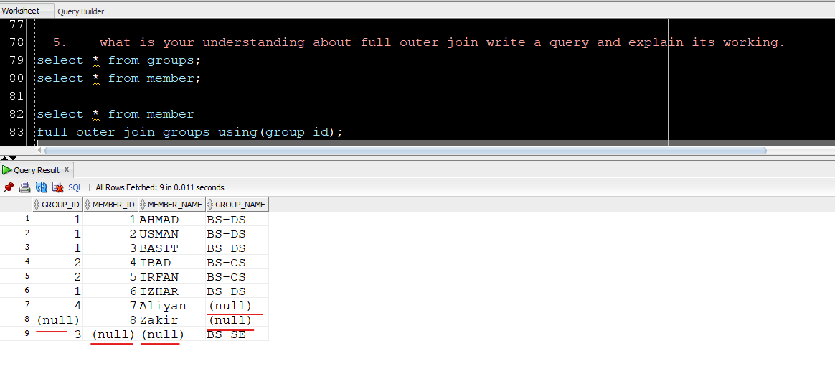

Through full outer join, all the rows including matched and unmatched are displayed.

Like in above example,

* Group_ID =4 have no Group_name
* Member_id=8 doesn’t belong to any group.
* Group_id =3 have zero members.

**Code:**

select * from member

full outer join groups using(group_id);

**---------------------------------------------**

1. What does cross join means in sql write a query and explain it.

**Cross join** is also known as Cartesian product. It multiplies each row of **table** **A** with all rows of **table** **B.**

**Explanation:**

Consider, there are two tables:

**Groups:** This table is consists of **group_id** and **group_name.**

**Instructors:**  This table is consists of **instructor_name**

**(Each Instructor** will supervise the performance of all groups.**)**

**Table: Groups**

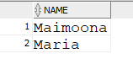

**Table: Instructor**

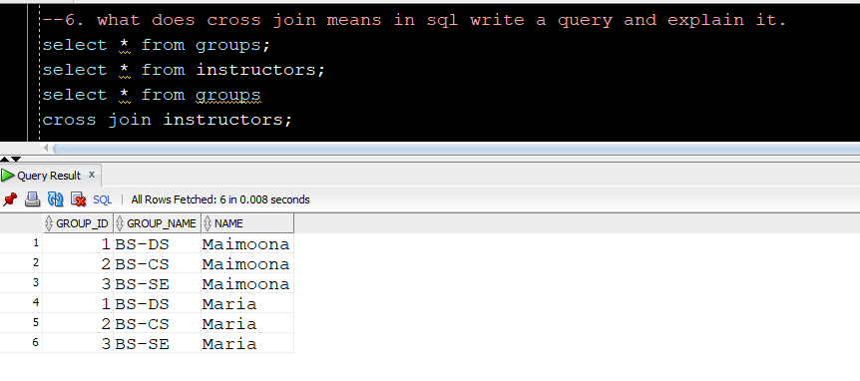

**Code:**

select *

from groups

cross join instructors;

**---------------------------------------------**