MAIMUNNISHA

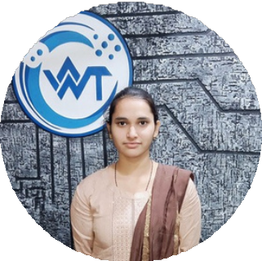

FULL STACK DEVELOPER

EXPERIENCE

**About Me**

I am a dedicated and goal-oriented individual with strong time management skills and a creative approach to problem-solving. My journey into coding was driven by my curiosity and determination, and I have since become a capable Full-Stack Developer. I am passionate about expanding my knowledge and continuously improving my skills to grow in my field.

+91 7238899614

[maimunnisha.ait@gmail.com](mailto:maimunnisha.ait@gmail.com)

# Full Stack Developer Internship

## The One Web Technology Pvt.Ltd December 2023

As a Full Developer. I’m comfortable around both Front-End and Back-End coding languages, development frameworks and third- party libraries. In my internship career i learned various technology like HTML5, CSS3, JavaScript, Angular, and Bootstrap, Sql, C#, Asp.Net Core etc.

1. ACC Property Cleaning Services The One Web Technology Pvt.Ltd Role: Front-End Developer

Developed a responsive front-end interface using HTML,

CSS, JavaScript, and Bootstrap. Created user-friendly layouts and seamless navigation to enhance client interactions and improve the overall user experience.











# Hindi English



LANGUAGE

HTML5 CSS3

JavaScript SQL (SSMS) C#

ASP .Net Core Bootstrap Angular

MS. Office

Project Management Design Process

# Tephra Enterprise

## The One Web Technology Pvt.Ltd Role: Front-End Developer

Developed a platform for managing the delivery of spring water to homes and businesses. Designed user-friendly interfaces and implemented functionality to streamline order processing and enhance customer experience.



SKILLS SUMMARY

# sizzler

## The One Web Technology Pvt.Ltd Role: Front-End Developer

Created a simple, responsive website for wine distribution. Designed a user-friendly interface to showcase products and facilitate basic customer interactions.

# Influencer Marketing

## The One Web Technology Pvt.Ltd Role: Front-End Developer

Developed a full-stack platform connecting brands with influencers. Designed the front-end using HTML, CSS, JavaScript, and Bootstrap.

Management Skills Creativity Negotiation Critical Thinking Leadership

Listening Music Reading Traveling

# Barodian Market

## The One Web Technology Pvt.Ltd Role: Full Stack Developer



EXPERTISE

Developed a platform for managing appointments, services, and client records for a beauty parlour and salon. Designed the front-end with HTML, CSS, and JavaScript to provide a seamless booking experience. Built back-end functionality for managing appointments, customer data, and service details.

# Bakery Shop

HOBBIES

## The One Web Technology Pvt.Ltd Role: Front-End Developer

Developed a front-End platform connecting brands with Bakery Shop. Designed the front-end using HTML, CSS, JavaScript, and Bootstrap.



EDUCATION

Parbhu M I C

Primary Education - First School Leaving Certificate (FSLC) Tarajiwanpur, Chandauli July 2014 - May 2015

Ambition Institute Of Technology

Diploma - Information Technology Parao, Varansi July 2015 - June 2018

Vikram Singh Kanya Mahavidhayalaya

Bachelor Of Commerce - Management Mughalsarai, Chandauli Aughust 2018 - November 2021

