Comparative Analysis of SVM, KNN, and Decision Tree Models for Water Potability Classification

Zarin Tasnim Maimuna
BSc student
Department of Electronics and Telecommunication Engineering.
Chittagong University of Enginnering and Technology u1908048@student.cuet.ac.bd

Israt Jahan Akhi
BSc student
Department of Electronics and Telecommunication Engineering.
Chittagong University of Enginnering and Technology u1908053@student.cuet.ac.bd

Abstract— The most crucial resource for maintaining life is water. It is everyone's right to have access to clean water. There are noticeable health benefits when safe drinking water is achieved. The World Health Organization (WHO) estimates that over 2.5 million people worldwide pass away each year as a result of water-related illnesses. Studying novel applications for evaluating and categorizing safe water quality is crucial as a result. The potability of the drinking water is categorized in this study using the K Nearest Neighbors (KNN), Decision Tree (DT), and Support Vector Machine (SVM) classification algorithms. SVM's 69% accuracy rate was the best performance. At 57.6%, DT has the lowest classifier accuracy.
Keywords—Water, Quality, Potability, Safe, Drinking, Machine, Learning, KNN, DT, SVM.

INTRODUCTION
Public health depends on having access to clean drinking water because water pollutants can cause neurological abnormalities, gastrointestinal illnesses, and in extreme situations, life-threatening conditions. According to the World Health Organization (WHO), drinking tainted water is a major contributor to many diseases globally, and maintaining water quality is essential to lowering avoidable sickness rates. Even if they are accurate, standard techniques for evaluating the quality of water, like laboratory chemical and microbiological studies, are expensive, resource-intensive, and can take a long time to get findings. The scalability and responsiveness of these manual examinations are constrained, especially in resource-poor locations, by the need for specialized equipment and trained workers.

By enabling the automated, quick, and effective classification of water quality based on easily observable factors, machine learning (ML) presents a viable substitute for conventional testing techniques. Machine learning models may identify trends in physicochemical data using sophisticated algorithms, providing very reliable predictions about the potability of water. Preventive action is made possible by machine learning (ML), which uses data-driven insights to detect minute changes in water quality that could be signs of contamination. Three machine learning models—K-Nearest Neighbors (KNN), Support Vector Machine (SVM), and Decision Tree—are evaluated in this study for their capacity to assess water potability based on physicochemical characteristics like pH, turbidity, and mineral content. Finding the most accurate and trustworthy model for classifying the potability of water is the goal. Enabling the possible creation of easily accessible, automated water testing systems that may scale to regions without access to conventional lab resources and enhance water safety in real-time.

LITERATURE REVIEW
The accuracy of traditional field measurements for water quality assessment is very high. However, a lot of workers are needed for these procedures. Traditional procedures cannot meet the efficiency and speed requirements since they take a long time to deliver results [2].
However, water quality can be categorized using machine learning techniques. Numerous papers on water quality forecasting and classification use different approaches to produce different outcomes. Amir's work looks at how well artificial intelligence methods anticipate the Tayra River's water quality components in southwest Iran. To forecast the quality of the water, ANN and SVM were evaluated. The SVM model is the most accurate model, according to the results [3]. Another study that Theyazn[4]conducted . created artificial intelligence algorithms to classify water quality in order to reduce pollution. Three machine learning algorithms—SVM, KNN, and Naive Bayes (NB)—were examined using a data set with seven important parameters. For predicting water quality, the SVM method has the highest accuracy, 97.01%.
Generally speaking, the majority of earlier research concentrated on classifying seawater rather than drinking water. Furthermore, no research was done on the factors' significance. As a result, the most crucial elements will be determined and novel methods for determining the quality of drinking water will be examined.

EXPLORATORY DATA ANALYSIS

Data Collection
The potable drinking water dataset was collected from the machine learning repository of the Kaggle website [5]. TABLE 1 summarizes the variables in the dataset.
TABLE1. DRINKING WATER POTABILITY DATASET VARIABLES DESCRIPTION
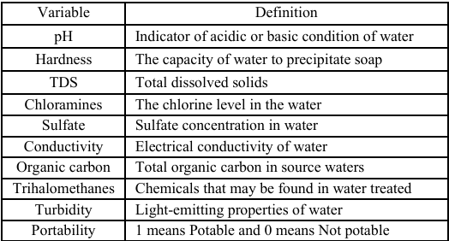

There are 9 variables including the response which is the Potability with 3276 instances. All variables are numerical except the response. There are two categories in the dataset: 0 for not potable and 1 for potable. 60% of the data are potable and only 40% are not potable. There are missing values in the dataset that needs special handling. Each variable has a permissible range to be considered safe drinking water. TABLE 2 shows the permissible range for each variable to be considered safe drinking water according to WHO standards [3].

TABLE 2 PERMISSIBLE RANGE FOR SAFE DRINKING WATER
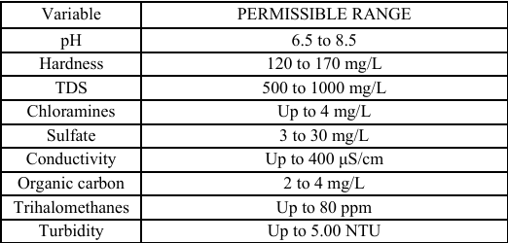

Handling Missing Values:
Missing data for features like pH, Sulfate, and Trihalomethanes were imputed with the median value to maintain data consistency without bias..

Standardization:
All features were standardized to ensure comparability across models, which is crucial for distance-based algorithms like KNN and SVM.

METHODOLOGY
In this section, the conceptual structure used in this analysis will be described. Each learning process includes 4 main processes: planning, data selection and processing, machine learning algorithms, and model evaluation. The figure below shows a summary of the research methodology.
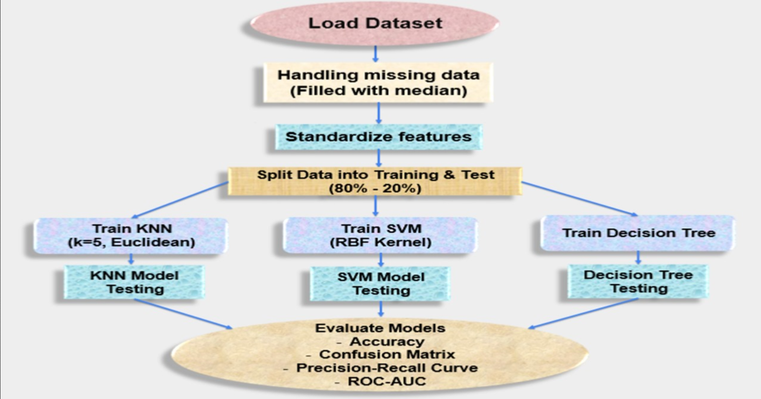

Fig.01:Research methodology.

In this research, the classification algorithms of KNN, DT and SVM were used.

Method 1: K Nearest Neighbors (KNN)
KNN algorithm is easy to implement and easy to understand. Its advantage is to learn nonlinear decision boundaries that can be used in both classification and regression. In addition, the implementation process requires only two parameters, the K value, and the distance function. A very flexible model can be set by controlling the value of K. For distance scales, some common distance scales used are Euclidean, and Manhattan [6]. The most common choice is the Euclidean distance which can be calculated by the following equation:
Euclidean = √∑ (𝑥𝑖 −𝑦𝑖)2 𝑖=1
Where k is the number of the neatest neighbors and x, and y are variables. Here k=5 is taken.

Method 2: Decision Tree (DT)
DT is a supervised learning method for decision support using a tree-like model of decisions. Used to solve classification and regression problems. Typically, specialized techniques for data analysis contain only one type of variable but DT can handle both numerical and categorical data. Also, it can automatically process missing values [7].

Method 3: Support Vector Machine (SVM)
SVM is a supervised ML algorithm mostly used to solve classification problems. The SVM algorithm is very good when there is no idea about the data. Initially, each data element is plotted as a point in space. Then, the superior level that distinguishes the two categories well is found to create the classification process. SVM is characterized by less overfitting risk. In addition, it works well even with data such as text, images, and trees [8].

RESULTS AND DISCUSSION
In order to categorize water samples as drinkable or non-drinkable based on a variety of water quality indicators, including pH, turbidity, and solid content, we compared three machine learning models in this study: K-Nearest Neighbors (KNN), Support Vector Machine (SVM), and Decision Tree. Key performance indicators such as accuracy, precision, recall, ROC-AUC, and confusion matrices were used to assess the models.

TABLE 3 CLASSIFICATION ALGORITHMS RESULTS

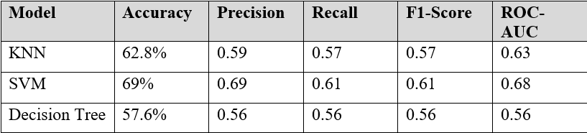

Accuracy, precision, F1 score, and recall were assessed following model construction. The outcomes of the classification algorithms are displayed in Table 3. SVM had the best performance, achieving 69% accuracy. The dataset is not linearly separable, as indicated by DT's lowest classifier accuracy of 57.6%. Finding additional and better features is the remedy for this.

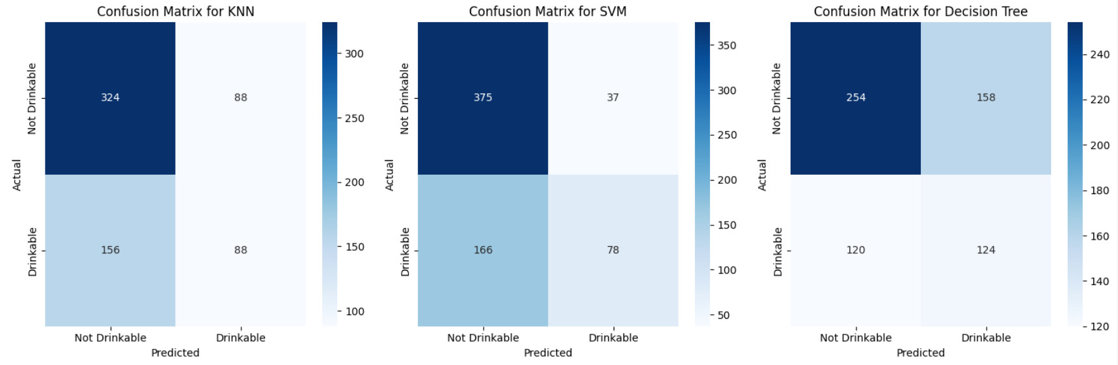

Fig.02: The confusion matrix for KNN, SVM & DT

The confusion matrices display the advantages and disadvantages of each model for water quality classification. Although KNN is good at detecting non-consumable water, it has a high false negative rate, which causes some drinkable water to be incorrectly classified as non-drinkable. The most cautious is SVM, which has a significant number of false negatives but few false positives, or the infrequent misclassification of non-drinking water as drinkable. Despite being balanced, Decision Tree produces more false positives, classifying some samples that shouldn't be drunk as drinkable. Depending on how important it is to reduce false positives or false negatives, the strengths of each model suggest distinct usage.

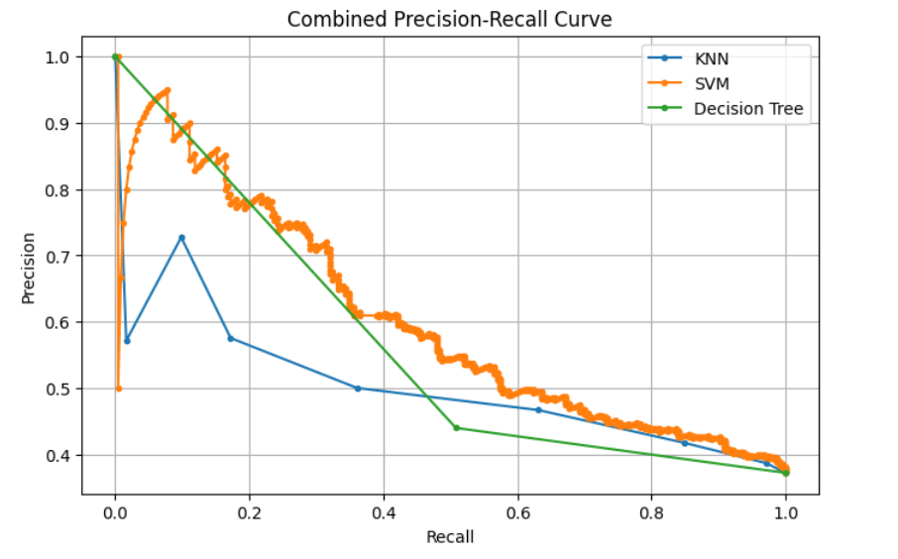
Fig.03: Precision-Recall curve for SVM,KNN & DT

The precision-recall curve shows how well each model balances recall (the capacity to recognize real positives) and precision (the accuracy of positive forecasts).SVM performs the best, retaining greater precision over a wide range of recall values, suggesting that it is more reliable in accurately detecting drinkable water with fewer false positives. Decision Tree performs somewhat well, with precision decreasing as recall rises, indicating that it becomes more difficult to correctly pick positives at greater memory levels. With the lowest curve and higher rates of misclassification, KNN exhibits a poorer balance between precision and recall. This analysis aids in comprehending the efficacy of each model, especially with regard to managing false positives and false negatives, which are crucial for forecasting water quality.

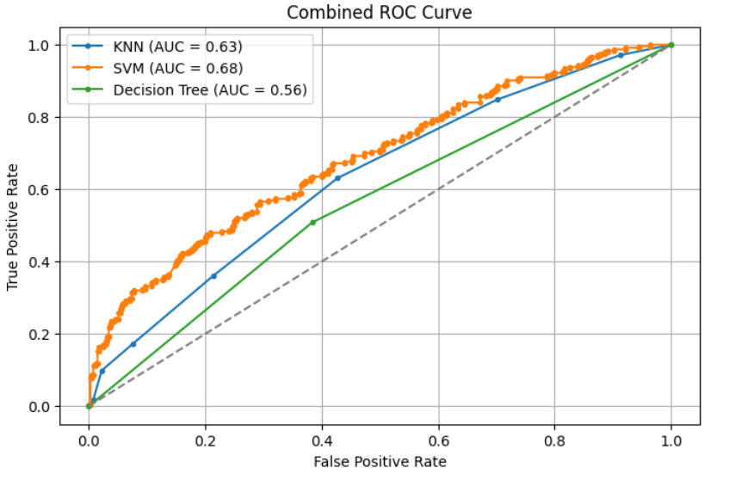
Fig.04: The curve for ROC of SVM,KNN & DT

The ability of each model to differentiate between drinkable and non-drinkable water is compared using the ROC-AUC curve. SVM is the most dependable method for correctly determining the potability of water since it exhibits the highest AUC score, which suggests that it strikes the ideal balance between sensitivity and specificity. KNN performs mediocrely, showing some class separation abilities, but not as precisely as SVM. The Decision Tree model suffers more to accurately classify water samples, as evidenced by its lowest AUC. All things considered, these findings imply that SVM is the best model, KNN and Decision Tree are less accurate, and Decision Tree is the least successful.

CONCLUSION AND FUTURE WORK
In conclusion, this study assessed the potability-based water quality classification algorithms K-Nearest Neighbors (KNN), Support Vector Machine (SVM), and Decision Tree. According to its higher AUC score in ROC analysis, SVM was the most accurate model among those examined, striking the optimum balance between precision and recall. Although KNN showed a reasonable level of effectiveness, it had a greater proportion of false positives, which could cause non-drinking water to be mistakenly classified as potable. Despite being simpler to understand, the Decision Tree model had the largest classification mistakes and the lowest accuracy, which made it less appropriate for accurate water quality evaluation. These results demonstrate SVM's promise as a tool for analyzing water quality and point to its application in automated systems for evaluating water safety and assisting with public health initiatives.
For further improvement, data balancing, new machine learning algorithms can be investigated such as XGBoost, and GradientBoost, to improve the accuracy of the prediction.

ACKNOWLEDGMENT

We would like to express our gratitude to department Electronics and Telecommunication Engineering, CUET for providing us with the resources and support necessary to conduct this research. Our sincere thanks go to Dr. Nursadul Mamun, Assistant Professor of ETE, CUET for his invaluable guidance and constructive feedback throughout the course of this study. We also extend our appreciation to the creators and maintainers of the Kaggle repository for making the dataset used in this research readily available.

REFERENCES
- J. Taruna and C. Alankrita, "Assessment of water quality and its effects on the health of residents of Jhunjhunu district, Rajasthan: A cross-sectional study," Journal of Public Health and Epidemiology, vol. 5, no. 4, pp. 186-191, 2013.
- H. Sidrah, S. Man, C. Hung, N. Majid, N. Janet, A. Sawaid and T. Danling, "Comparison of machine learning algorithms for retrieval of water quality indicators in case-II waters: a case study of Hong Kong," Remote Sens, vol. 10, pp. 1-26, 2018.I. S. Jacobs and C. P. Bean, “Fine particles, thin films and exchange anisotropy,” in Magnetism, vol. III, G. T. Rado and H. Suhl, Eds. New York: Academic, 1963, pp. 271–350.
- A. Hamzeh and N. Ali, "Water quality prediction using machine learning methods," Water Quality Research Journal, vol. 53, no. 1, pp. 3-13, 2018.
- T. Aldhyani, "Water Quality Prediction Using Artificial Intelligence Algorithms," Applied Bionics and Biomechanics, vol. 4, no. 2, pp. 1-12, 2020.
- K. ADITYA, "water-potability," Kaggle , 2020. [Online]. Available: https://www.kaggle.com/datasets/adityakadiwal/wat er-potability.
- Z. Zhongheng, "Introduction to machine learning: k nearest neighbors," Annals of Translational Medicine, vol. 11, pp. 1-7, 2016.
- B. Aashoo, D. Kavita and S. Manish, "Implementation of Decision Tree," International Journal of Engineering and Advanced Technology (IJEAT), vol. 2, no. 2, pp. 30-34, 2012.
- J. Pineda and D. Juan, "A review of Machine Learning (ML) algorithms used for modeling travel mode choice," Universidad Nacional de Colombia, Colombia, 2019.
.

