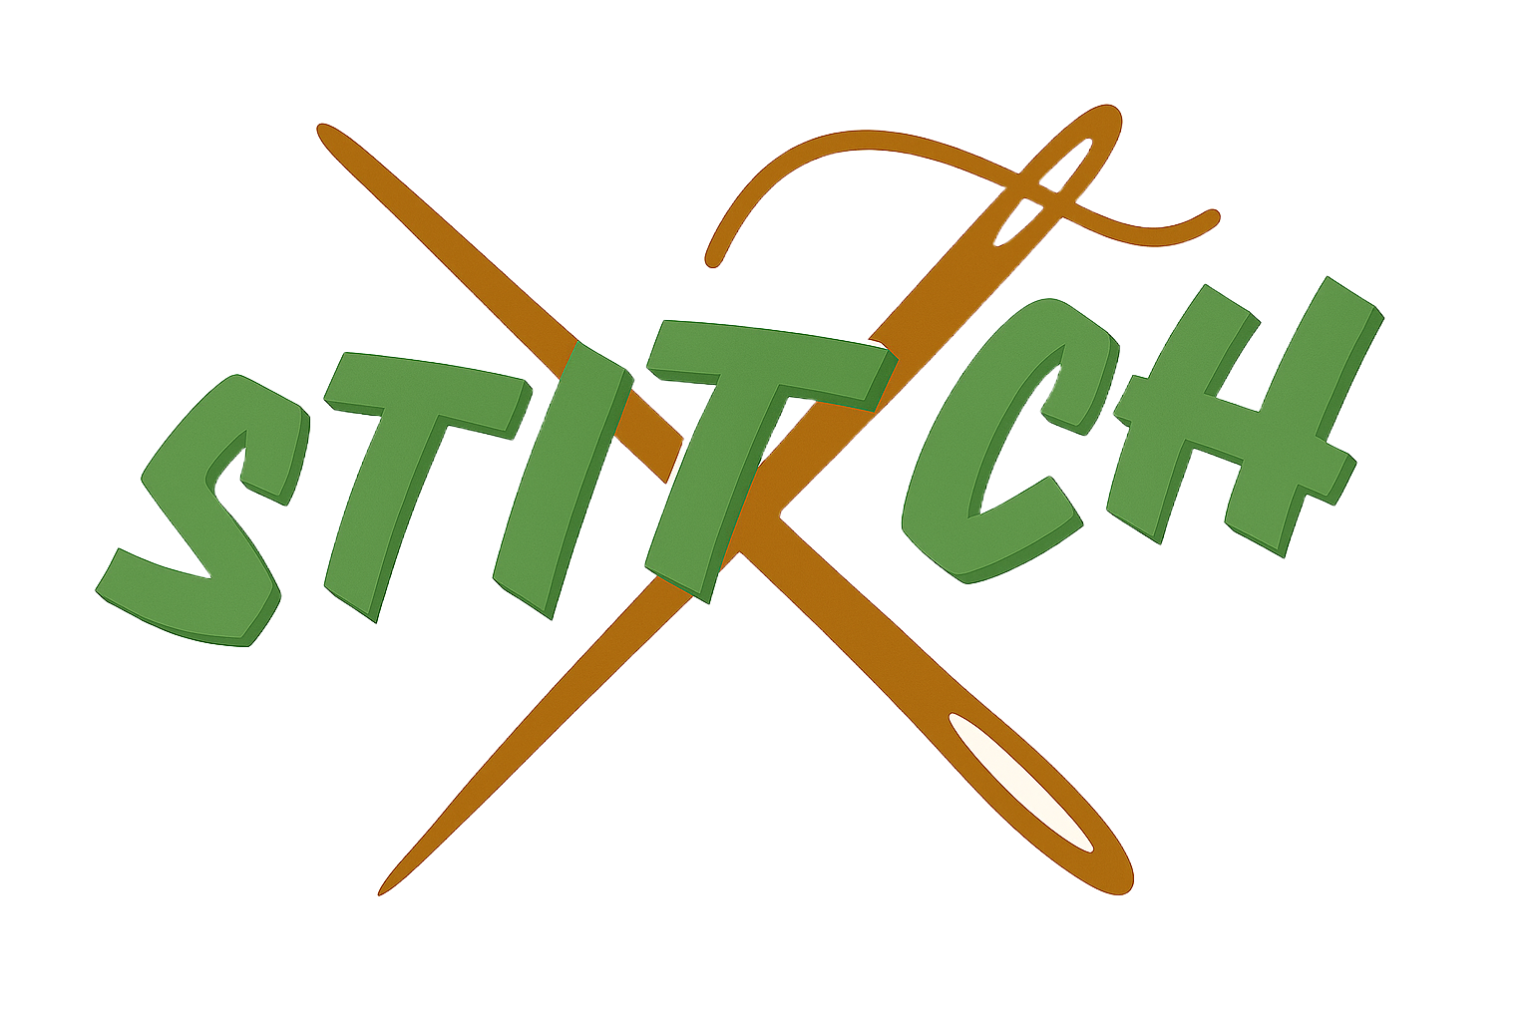
Small Businesses Together
Through Community Events

OUR TEAM:

1. Eva T. 2. Maimuna M. 3. Sunny S.
Software Engineer Software Engineer UI/UX Designer
THE PROBLEM
New small businesses are trying to establish themselves.
Old small businesses are trying to keep up with the changing times.
For all small businesses, finding support, adapting to a new generation, and creating community has been difficult.
SOLUTION OVERVIEW
STITCH uses an AI matching algorithm to allow small businesses to collaborate on events to attract new customers.

NEEDFINDING
We conducted seven interviews across two user groups: small business owners/managers and customers, to look into how we could improve small business communities (based on our studio’s theme: community resilience!). Our participant selection strategy focused on three criteria: recruiting outside of Stanford, targeting small business stakeholders, and ensuring a range of backgrounds and experiences. We recruited participants through in-person visits to local businesses on University Avenue and Town & Country Village in Palo Alto, approaching owners and managers during non-peak hours to request brief conversations about their experiences running small businesses.
Our interview approach was conversational and open-ended, allowing participants to share their stories organically. We conducted interviews both on-site at their businesses and with customers in public spaces. We did not provide monetary compensation, but offered our time and genuine interest in understanding their challenges. Our guiding questions included: "What's your community and support system like as a business owner?", "Tell us about a challenge or crisis you've faced this past year/month," "How do you learn about information relevant to you as a small business owner?", and "How is business now compared to last year?"
We intentionally selected an extreme user spectrum ranging from brand new businesses (hair salon owner Taryn, just starting out) to well-established community staples (bookstore owner Amy, whose store has been open for 90 years). This spectrum allowed us to understand resilience at different stages of business maturity.
For the first round of interviews, we talked to:

a) Mike - preliminary interview(Researcher from New York)
Before focusing specifically on small business resilience, we conducted a preliminary interview with Mike, a researcher, which helped us narrow our domain from broad economic downturn topics to specifically focusing on small business community resilience.
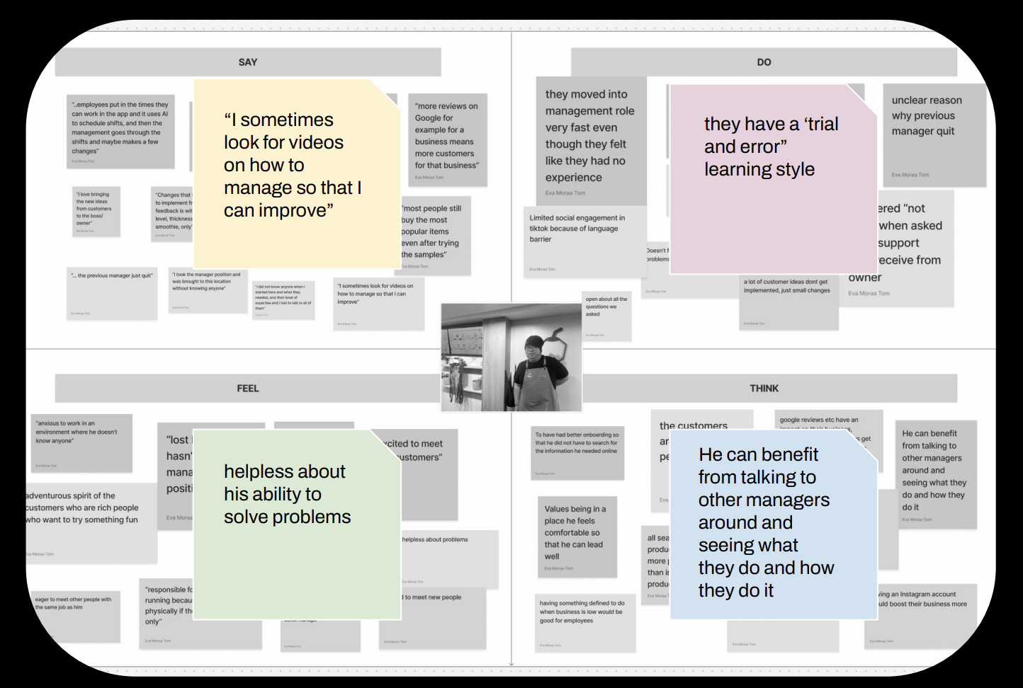
b) Mark – Manager at Bubble Tea Shop
Mark is a relatively new manager who frequently turns to online videos to learn management skills, stating "I sometimes look for videos on how to manage so that I can improve." His main challenges included feeling unsupported in his role and relying heavily on trial-and-error problem solving. Despite stepping into management quickly, he often feels uncertain about where to find solutions, leaving him in a constant cycle of experimentation without guidance.
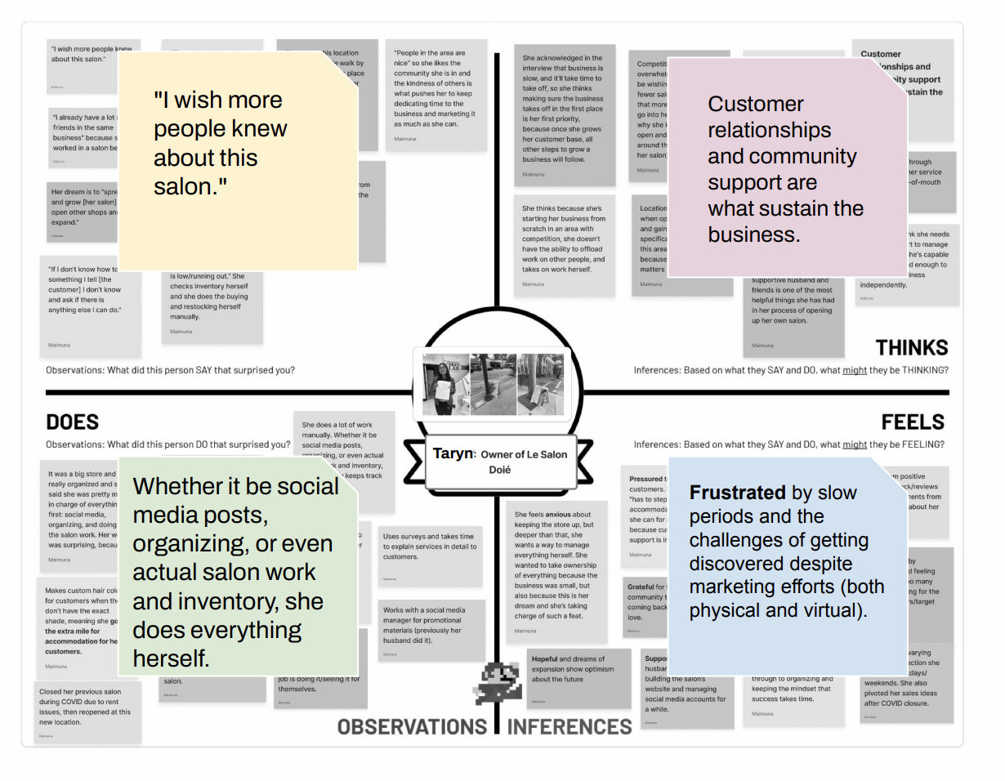
c) Taryn - Owner of Hair Salon (new business)
Taryn represents the extreme user on the "brand new" end of our spectrum. Her main challenge is visibility and customer acquisition: "I wish more people knew about this salon." Despite significant marketing efforts, both physical flyers and virtual social media posts, she struggles with slow periods and getting discovered in a saturated market. She handles everything herself, from social media to inventory to actual salon work. What sustains her business is strong word-of-mouth: "My family drives 30 minutes all the way from San Jose to support the salon," but she needs to expand beyond her immediate network.
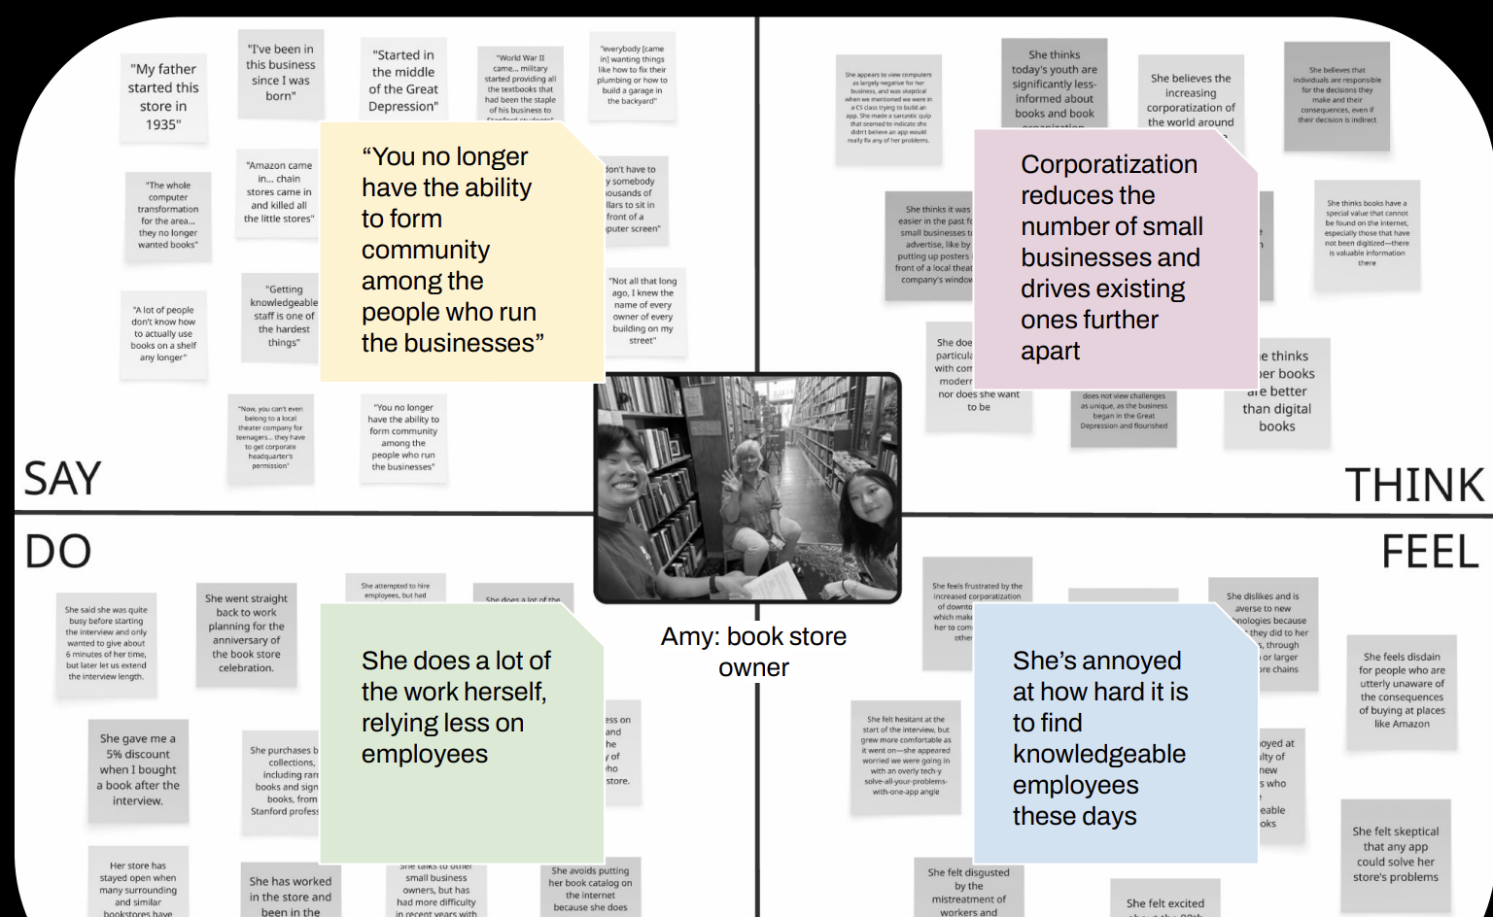
d) Amy - Owner of Bookstore (90 years in business)
Amy owns a bookstore that started during the Great Depression ("very little money, very few resources, little materials you could get a hold of"). Her main insight focused on how corporatization has fundamentally changed small business dynamics: "All the chains came in and killed all the little stores… we're fortunate in having a really loyal following." She observed that "you no longer have the ability to form a community among the people who run the businesses," highlighting how small businesses have evolved from being interconnected communities to isolated entities fighting corporations alone. She does much of the work herself and expressed frustration at the difficulty of finding knowledgeable employees.
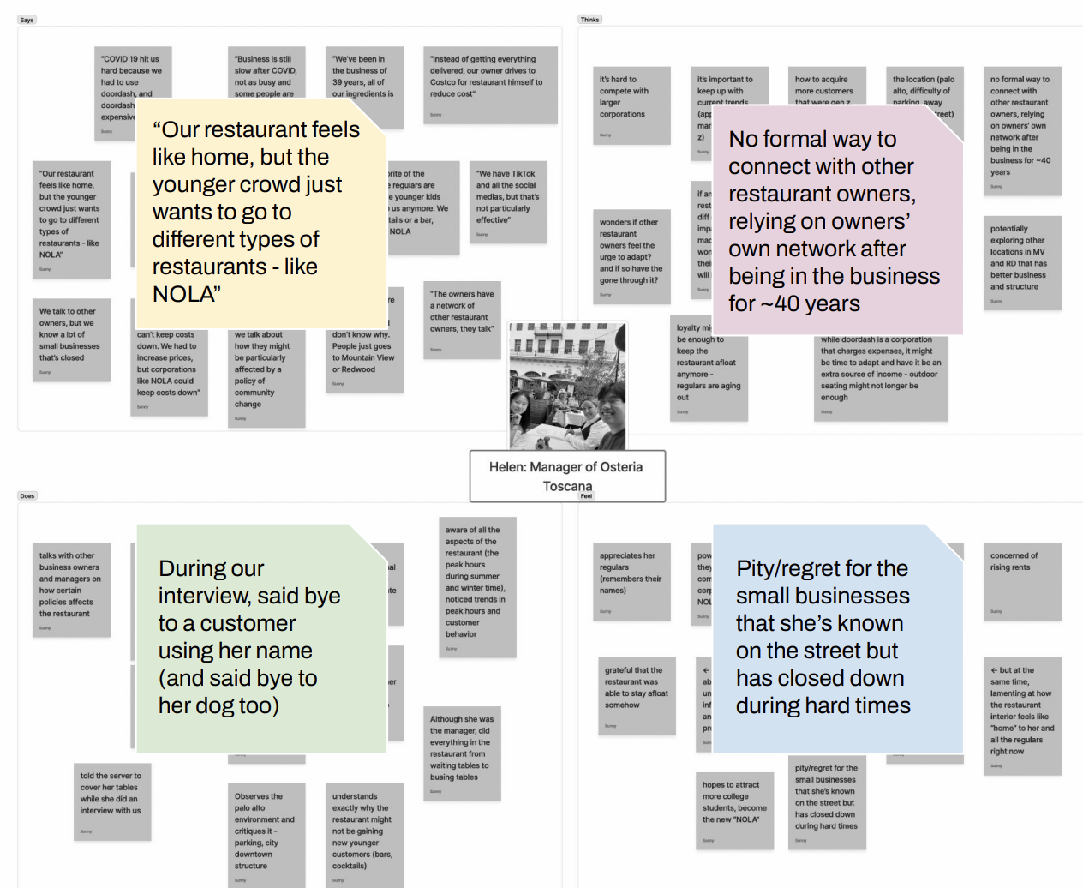
e) Helen - Manager at Italian Restaurant (22 years)
Helen has managed a family-owned Italian restaurant that has been open for over two decades and has deep knowledge of the local business community. Her main concern centered on changing customer demographics: "This was a favorite of the regulars, but the regulars are getting older, the younger kids aren't coming to us anymore. We don't have cocktails or a bar, they're going to NOLA." She emphasized the difficulty of adapting to appeal to younger generations while maintaining the restaurant's traditional identity. Despite decades in the business, she noted there's no formal way to connect with other restaurant owners, and that her network exists only through informal connections built over 40 years.
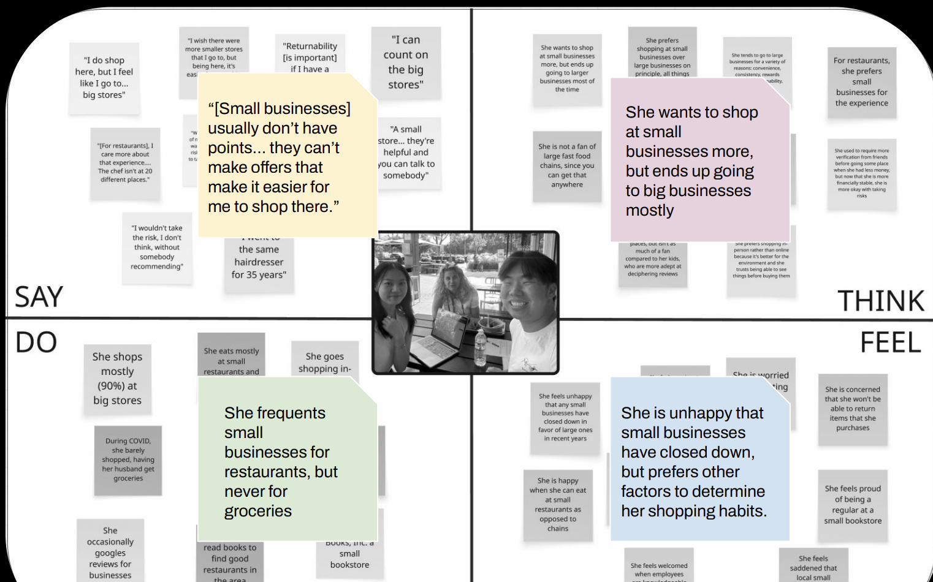
f) Beatrice - Customer (grandmother of 2)
Beatrice provided the customer perspective on small business shopping habits. Her main insight revealed a tension between intention and behavior: "Big stores are probably 90% [of what I buy from]" for most goods, but "I try to avoid the chain [restaurants] almost all the time." She expressed that small businesses "usually don't have points… they can't make offers that make it easier for me to shop there," indicating that while she wants to support small businesses on principle, convenience and incentives ultimately drive her shopping decisions. She frequents small restaurants but never small businesses for groceries, showing that customer preferences vary significantly by sector.
g) Jessie - Customer (high school student)
Jessie represented younger customer perspectives. Her main decision-making process involves peer influence and research: "I try not to name brands, but if I know that a brand has good basics, I'll probably gravitate towards that. [When buying], I ask my friends' opinions and I do my own research." This reinforced Helen's concern about younger generations having different discovery and decision-making patterns than older regulars who built relationships with businesses over decades.
From these initial interviews, our team refined our domain from broad "small business resilience" to specifically "Promoting Collaboration Between Small Businesses For Building Community Resilience." We noticed that across our interviews, from Mark's isolation as a new manager to Amy's observation about lost community connections to Taryn's struggle with visibility, a common thread emerged. Small businesses were operating in silos when they could benefit from working together. This narrower focus felt more actionable and aligned with evidence from our interviews suggesting that collaboration could address multiple pain points simultaneously: customer acquisition, knowledge sharing, and community embedding. To test key assumptions about collaboration and gain expert perspective, we conducted two additional interviews, with one of them being via Zoom.
- Val - Manager at Mini Cat Town (nonprofit cat shelter)
Val manages a nonprofit cat shelter on California Avenue with two business models: cat adoptions and drop-in visits to pet the cats. We selected Mini Cat Town specifically because it operates as a nonprofit, allowing us to understand how operations and collaboration incentives might differ from for-profit businesses. Val's main insight centered on selective partnership: "On Cal Ave, Gamelandia reached out to us to partner with us for board game night + cats. Their owners adopted two of our cats." This collaboration between the board game cafe and cat shelter was mutually beneficial—Gamelandia gained a unique event attraction while Mini Cat Town increased adoption visibility. However, Val was extremely selective about partnerships, explicitly refraining from partnering with other cat shelters or for-profit cat cafes due to concerns about substandard cat health practices. She emphasized that proximity to younger families gives them an advantage in donations (their main revenue source), and that engaging with the community must be done selectively based on shared values. This reinforced our hypothesis that values-aligned collaboration is critical. Businesses won't partner with just anyone, even if financially beneficial.

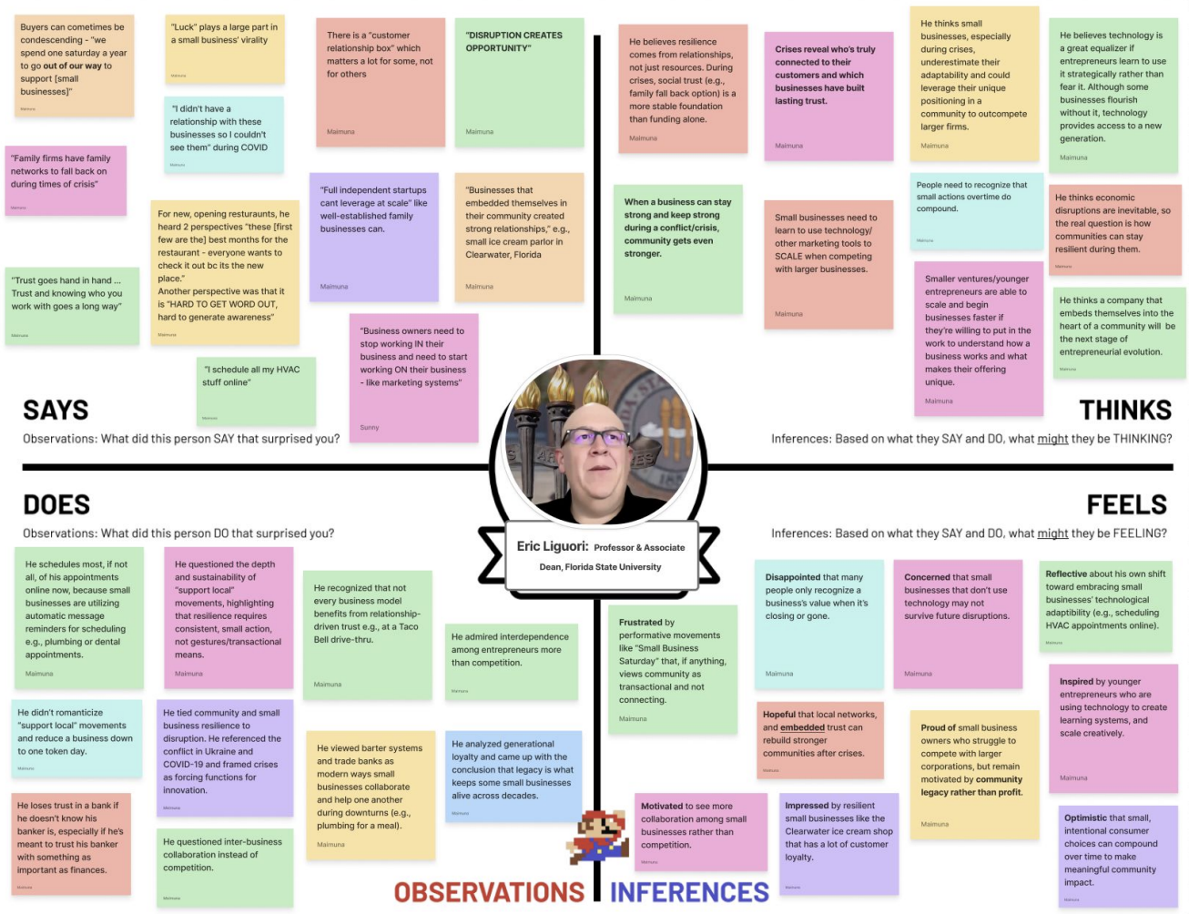
- Eric Liguori - Professor & Associate Dean, Florida State University (Expert Interview)
We conducted a Zoom interview with Professor Liguori, an expert in entrepreneurship and small business resilience, to validate our findings and gain academic perspective. His main advice was that entrepreneurs must "stop working in your business to work on your business," emphasizing that owners get trapped in day-to-day operations rather than strategic growth. He noted that "luck plays a large part in small business vitality" but also that "trust and knowing who you work with goes a long way." He was "inspired by younger entrepreneurs using technology" but "concerned small businesses that don't use technology may not survive." Most relevant to our domain, he emphasized that "resilience comes from relationships, not just resources" and that businesses embedded in communities "stayed stronger during crises like COVID." He shared an example of an ice cream store in Clearwater, Florida that embedded itself in the community by collaborating with local carnivals and showing up at baseball games, demonstrating concrete evidence that collaboration-based community embedding leads to business resilience. This expert validation strengthened our conviction that promoting small business collaboration was the right direction.

SYNTHESIS AND ANALYSIS
To synthesize and analyze our findings, we organized our interview notes into empathy maps using Figma. Each empathy map contained four quadrants, what participants said, thought, felt, and did, allowing us to surface underlying emotions and uncover hidden needs. We created empathy maps for all interviewees across both rounds, then conducted affinity mapping to identify patterns.
Empathy map from our interview with Val - Manager at Mini Cat Town:
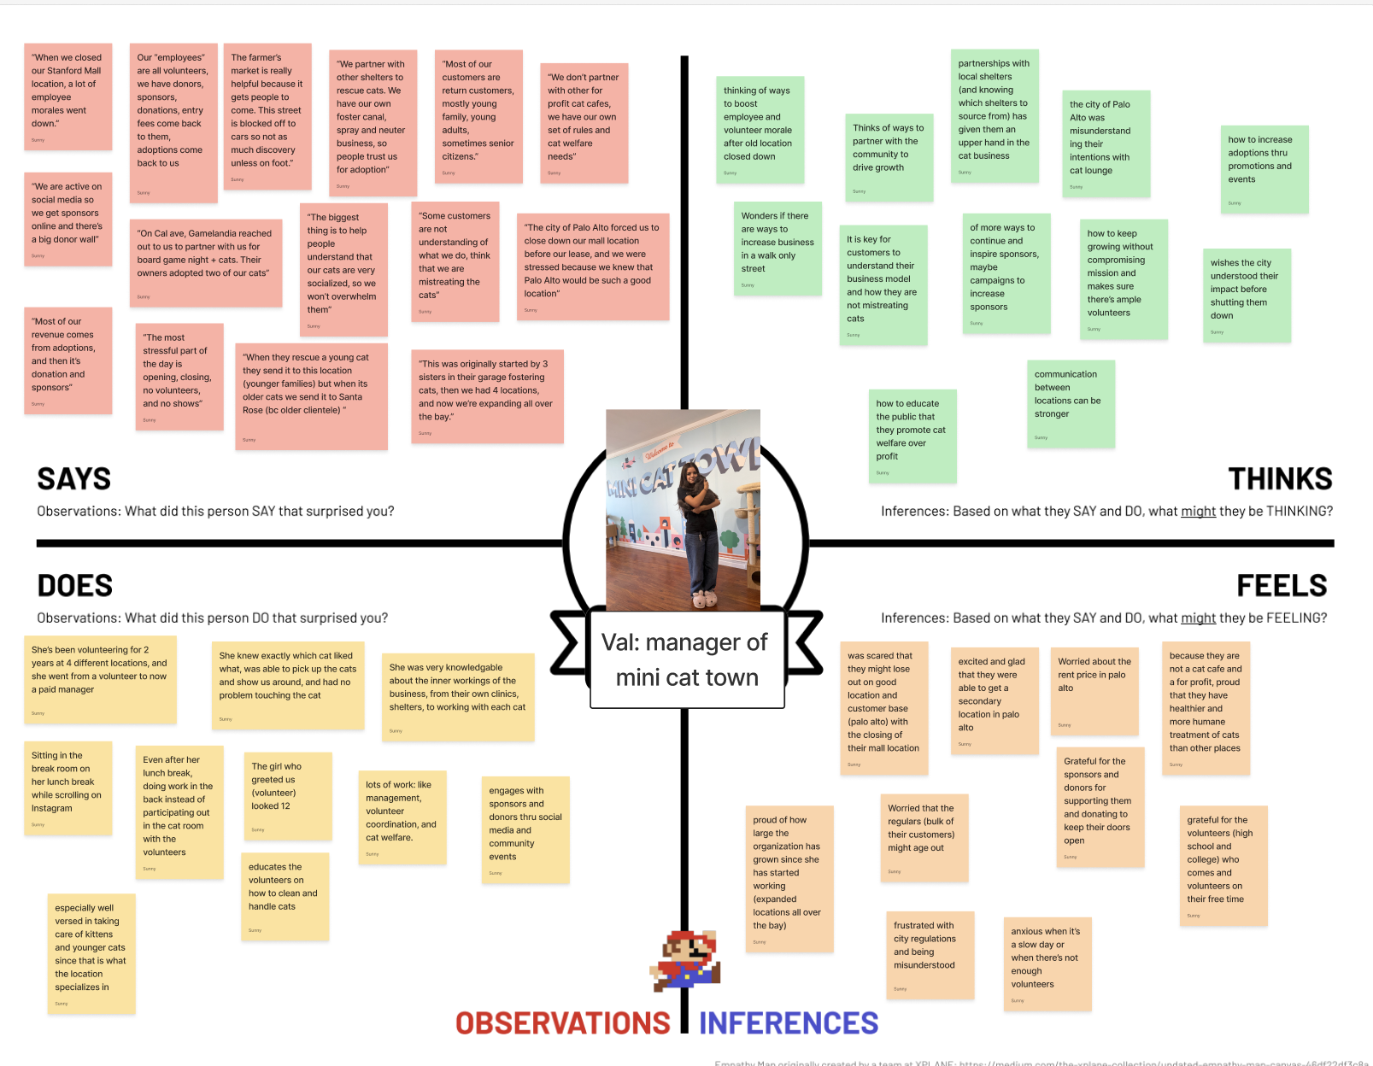
Some of our key insights from round 1 of interviews were:
- Managers feel unsupported and rely on trial-and-error learning → Need: structured support systems for new managers.
- Adapting to new demographics is difficult without formal networks → Need: marketing strategies and formal business-to-business communication channels.
- Corporatization has isolated small businesses → Need: ways to band together against shared threats.
- Discoverability is a major barrier for new businesses → Need: methods to reach local audiences beyond personal networks.
- Customer intentions don't match behaviors → Need: convenience and trust signals that vary by business sector.
Some of our key insights from round 2 of interviews were:
Key insights from Round 2:
- Selective collaboration based on values is essential: Val partnered with Gamelandia but refused others due to animal welfare concerns → Need: values-aligned partnership matching.
- Strategic community embedding builds resilience: Professor Liguori's ice cream store example showed businesses embedded through event collaborations survived crises better → Need: systems to facilitate community event participation.
From these we identified an opportunity. Small businesses need accessible tools to find value-aligned collaboration partners for community event embedding, addressing isolation, discoverability, knowledge gaps, and resilience simultaneously while demonstrating clear financial value.

POVS
We framed our findings into POVs, allowing our team to consider the tensions and emotions behind our interviewees' problems. When analyzing our empathy maps, we found themes of isolation, disconnection from community, and struggles with customer acquisition and business management. To further understand our interviewees, we broke each empathy map and interview notes into POVs.

POV 1: Taryn
We met Taryn, a mid-30s co-salon owner with her husband, who is struggling to attract customers, and was surprised to see us come into her salon.
We were surprised to notice that despite saying that opening the salon was her dream, Taryn doesn't put in any effort into knowing her community or interacting with other salons in the area.
We wonder if this means that Taryn's view of success and achievement of her dream is defined by opening the salon rather than building a community or attracting customers.
It would be game changing if Taryn could envision the potential of her business as an anchor in the community, by seeing competitors as collaborators, and embedding herself in her neighborhood.
Selected HMWs for Taryn:
- HMW convince isolated business owners like Taryn that community connection and collaboration is profitable?
- HMW reduce the sense of competition between similar businesses in one area (like salons) and instead promote collaboration or community support?
- HMW support business owners who currently view competitors as threats, and convince them of the potential personal and business value of viewing them as potential collaborators and community partners?

POV 2: Beatrice
We met Beatrice, a retired grandmother of 2 who was eating at a small chain restaurant next to her home.
We were surprised to notice she exclusively shops in big businesses for groceries, but she likes to support small businesses in the restaurant and clothing sectors.
We wonder if this means she feels conflicted between her moral obligation to support small businesses for the experience and big chains for the quality and convenience.
It would be game changing if Beatrice had a way to get quality assurance and discover small businesses that offer the same level of services as chains.
Selected HMWs for Beatrice:
- HMW make discovering new small businesses feel natural and rewarding for customers who already care about shopping local?
- HMW make the warmth of human connection and community the defining reason people choose small businesses?
- HMW make discovering small businesses feel like finding hidden gems or finding treasures?

POV 3: Mark
We met Mark, a manager at a local bubble tea shop, who had only been working there for 6 months, and it was his first time being a manager.
We were surprised to notice that even as a manager, he has to look up YT videos on how to manage to know how to do certain things and improve the business.
We wonder if this means he feels inadequate as a manager and has to use trial and error to solve current problems he faces instead of drawing from his experience.
It would be game changing if Mark felt validated in his abilities while being encouraged to grow, transforming his lack of preparation into motivation and confidence to succeed in his role.
Selected HMWs for Mark:
- HMW support people in their early career who are learning through trial and error with experienced mentors to provide guidance on their community specific challenges?
- HMW enable managers new to an area to understand the local customer behaviors, competitor landscape, and community dynamics that impact their business success?
- HMW create opportunities for inexperienced managers to learn from peers facing similar challenges in their area?

Top 3 Solutions
After compiling many HMWs, we derived three top solutions to proceed in our design process.

Solution 1: AI Collaboration Matcher
Description: Instead of businesses reaching out manually, AI can match businesses with potential events to embed businesses in their community and raise revenue and community support.
Key Assumption: Small businesses that are struggling with connecting with their community will follow through with the AI-generated collaboration opportunities if the matches are relevant and require minimum effort.

Solution 2: AI Milestone and Tutorial System for Managers
Description: Empower managers to set and track milestones, with AI-driven recommendations that suggest personalized learning videos and unlock new goals as they progress.
Key Assumption: Confidence in management skills increases when small milestones are achieved and achievements are validated.

Solution 3: AI/VR Scavenger Hunt
Description: AI/VR Scavenger Hunt to get to and discover small businesses.
Key Assumption: People can be incentivized to do a scavenger hunt and they have time to explore small businesses in the area.

Experience Prototypes

Experience Prototype 1: Financial Incentive for Collaboration
Assumption being tested: Small business owners are financially incentivized to collaborate with other small businesses.
Prototype setup:
- Props: Sticky notes with various incentives for small business collaboration
- Participant: Benedict, On-Call Cafe manager
- Methodology: We went to On-Call Cafe and asked the manager to choose from 3 cards what incentive would make him collaborate with another small business (TAPs) for an event.
What worked: He validated the assumption that small businesses would collaborate for financial gain.
What didn't work: Unless we tested on many businesses, this can't be a conclusive test.
Implication: Assumption validated. Financial incentive is a primary motivator for collaboration, informing our decision to focus on AI Collaboration Matcher as the most viable solution.

Experience Prototype 2: Milestone-Based Confidence Building
Assumption being tested: Confidence in management skills increases when small milestones are achieved and achievements are validated.
Prototype setup:
- Participant: Toby, On-Call Cafe manager of 1 year, present for interviewing candidates
- Situation: "It's the first night of the quarter, On-Call is having its grand opening. At night, the line goes out the door, students complain about slow service, and your baristas feel rushed. In addition, on opening night, you realized one of your toasters (out of 2) is broken. The university administration has asked you to come up with a plan to reduce average wait time by 30% without hiring more staff or cutting product quality."
- Methodology:
  - Initial calibration: "How would you approach this problem tonight?" → Write down plan → Collect self-assessment (confidence, stress, feasibility on 1-5 scale)
  - AI generates milestones: (1) Assess capacity bottlenecks, (2) Reassign staff and optimize load, (3) Fix toaster or find workaround, (4) Set up pre-order/express pickup
  - Watch personalized tutorial: https://www.youtube.com/watch?v=YWyfA-I9yM4
  - Solve milestone 1 → Self-reflection (did scoring change?)
What worked: His stress level decreased from 4 → 1 after solving one milestone.
What didn't work:
- Feasibility score and confidence did not change
- AI-generated milestones didn't account for business nature: "On-Call would not do milestone 4 because we are focused on the human-centered experience, so we don't want a just pick-up-and-go situation"
- The video wasn't helpful because it focused on restaurants—couldn't find video specific enough, suggesting personalization may not be feasible
Implication: Assumption invalidated. While stress decreased, the core hypothesis about confidence increase didn't hold, and AI struggled to generate contextually appropriate milestones. We decided not to pursue this solution.

Experience Prototype 3: Scavenger Hunt for Discovery
Assumption being tested: People can be incentivized to do a scavenger hunt and they have time to explore small businesses in the area.
Prototype setup:
- Participants: Daniela, Cole, and Max, a friend group that knows about different places on campus but doesn't frequent them
- Situation: It's a weekday afternoon at Stanford. Students walking through Tressider see a QR code: "It's Wednesday, isn't it? I'm feeling musical! I love Alicia Keys too—try to find me!" They follow clues to CoHo (piano clue), then On-Call, then TAPs, with a prize ($15 free meal) waiting at the end.
- Methodology:
  - Read initial clue
  - Go to location and find hidden next clue
  - Explore area to discover clue
  - Repeat until final location reveals prize
  - Redeem free meal at any visited small business
What worked:
- They went to every location and became more engaged as they visited more businesses—they wanted to know what their "prize" was
- At each location, they explored the space when trying to find clues and saw things they hadn't seen before. For example, at On-Call, Daniela said, "I didn't realize how much they revamped this place since when it first opened."
What didn't work:
- They already knew all the businesses they visited and didn't spend time looking at menus. Rather, they explored space.
Implication: Assumption validated. People are motivated by incentives to explore small businesses, though the prototype revealed discovery works better for spaces than for product/service offerings. This informed our decision that while gamification could work for awareness, it wouldn't directly solve the core collaboration problem for business owners.

Design evolution

Final solution
During the initial sketches stage, we brainstormed a variety of design directions, including mobile and laptop applications, robots, AR/VR, and wearables options. After analyzing the novelty and feasibility of each sketch, we decided to proceed with the mobile application, given its accessibility and ease-of-use, especially for our target customers: business owners. We entertained the idea of a VR and AR application, however, since these options were typically less available to the everyday small business owner, we decided against pursuing these applications further.

A mobile application best aligned with our values: transparency, empowerment, accessibility, and inclusivity. While information such as business & location data are a concern, our app can ensure transparency by providing reasoning for pairing 2 businesses together. Considering the limitations on tech savvy skills with other modalities such as AR and VR, we realized that mobile applications are the most convenient and easy to use for all ages. There are no limits on the phone mobile to download an app, whereas other modes such as AR would require newer phones made after 2017. We also found that through a mobile interface, we can have a community social tab, where businesses can post their successful collaboration to empower other small businesses, which would require more effort to find out in VR/AR.

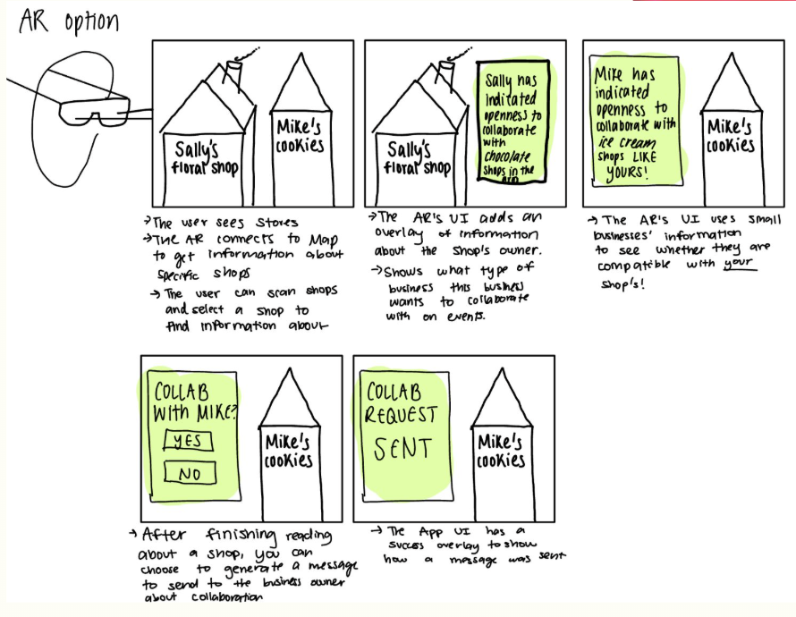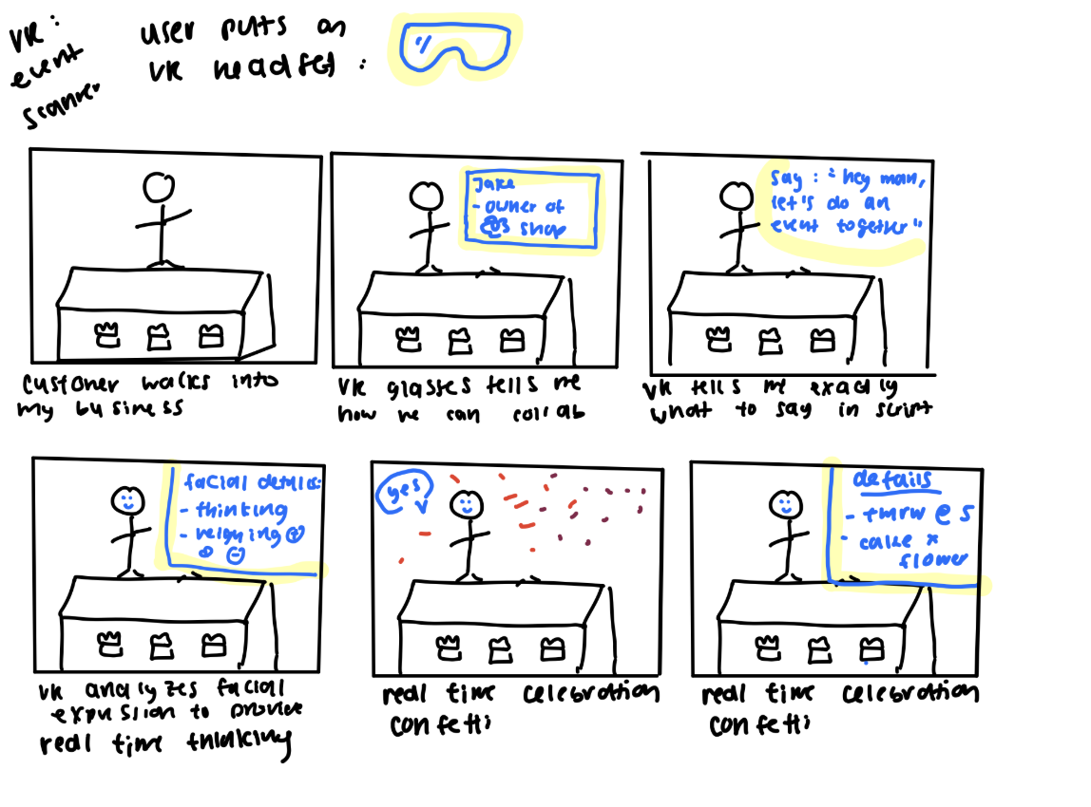
Initial sketches of VR and AR applications for Stitch.

Tasks

Simple task
We want our target audience (small business owners/employees) to easily send a message to another business they want to collaborate with.

Small businesses depend heavily on local relationships and fast coordination. We want messaging on Stitch to feel effortless, so owners can quickly express interest, ask questions, and explore opportunities in real time. This task workflow will help small businesses take immediate action on collaboration ideas generated by the AI recommendations feed or by messaging any business they think they can co-host an event with.
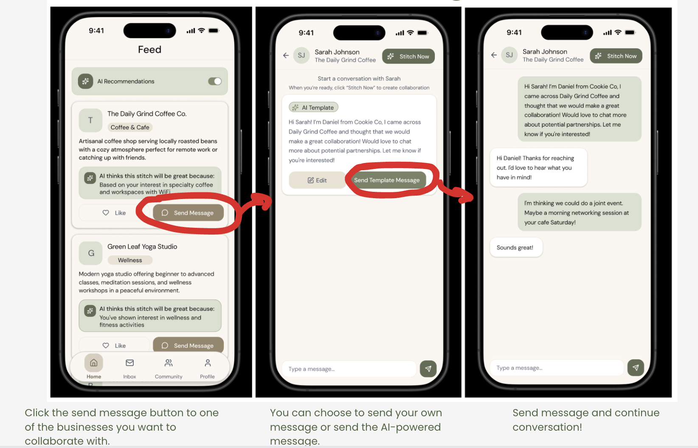
Annotated task-flow for Simple Task.

Moderate task
Creating a formal event in collaboration with another small business on Stitch.

Collaborative events are one of the most effective ways small businesses gain visibility, attract new customers, and share resources. But planning events is usually overwhelming and time-consuming. Stitch simplifies logistics by giving small businesses a structured space to outline details, align on responsibilities, and publish an event that benefits both sides. The two-sided collaboration request is important, so a business must approve or wait for approval from the co-hosting small business of a Stitch event before it can be posted on the Communities page.
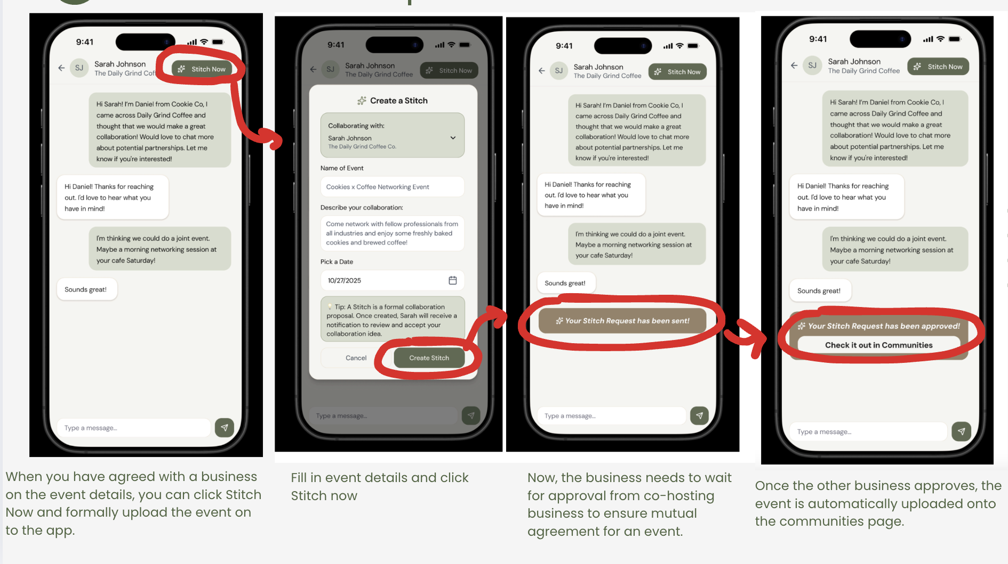
Annotated task-flow for Medium Task.

Complex task
Providing post collaboration feedback and repeating the collaboration at another time in the future.

Long-term partnerships are key to sustainable growth for small businesses, and can even create community among not just business owners but regular, frequent customers of small businesses as well. By capturing feedback and making it easy to re-engage collaborators, Stitch helps businesses strengthen trust, refine their collaboration strategy, and build recurring community events that boost customer loyalty and cross-business visibility.
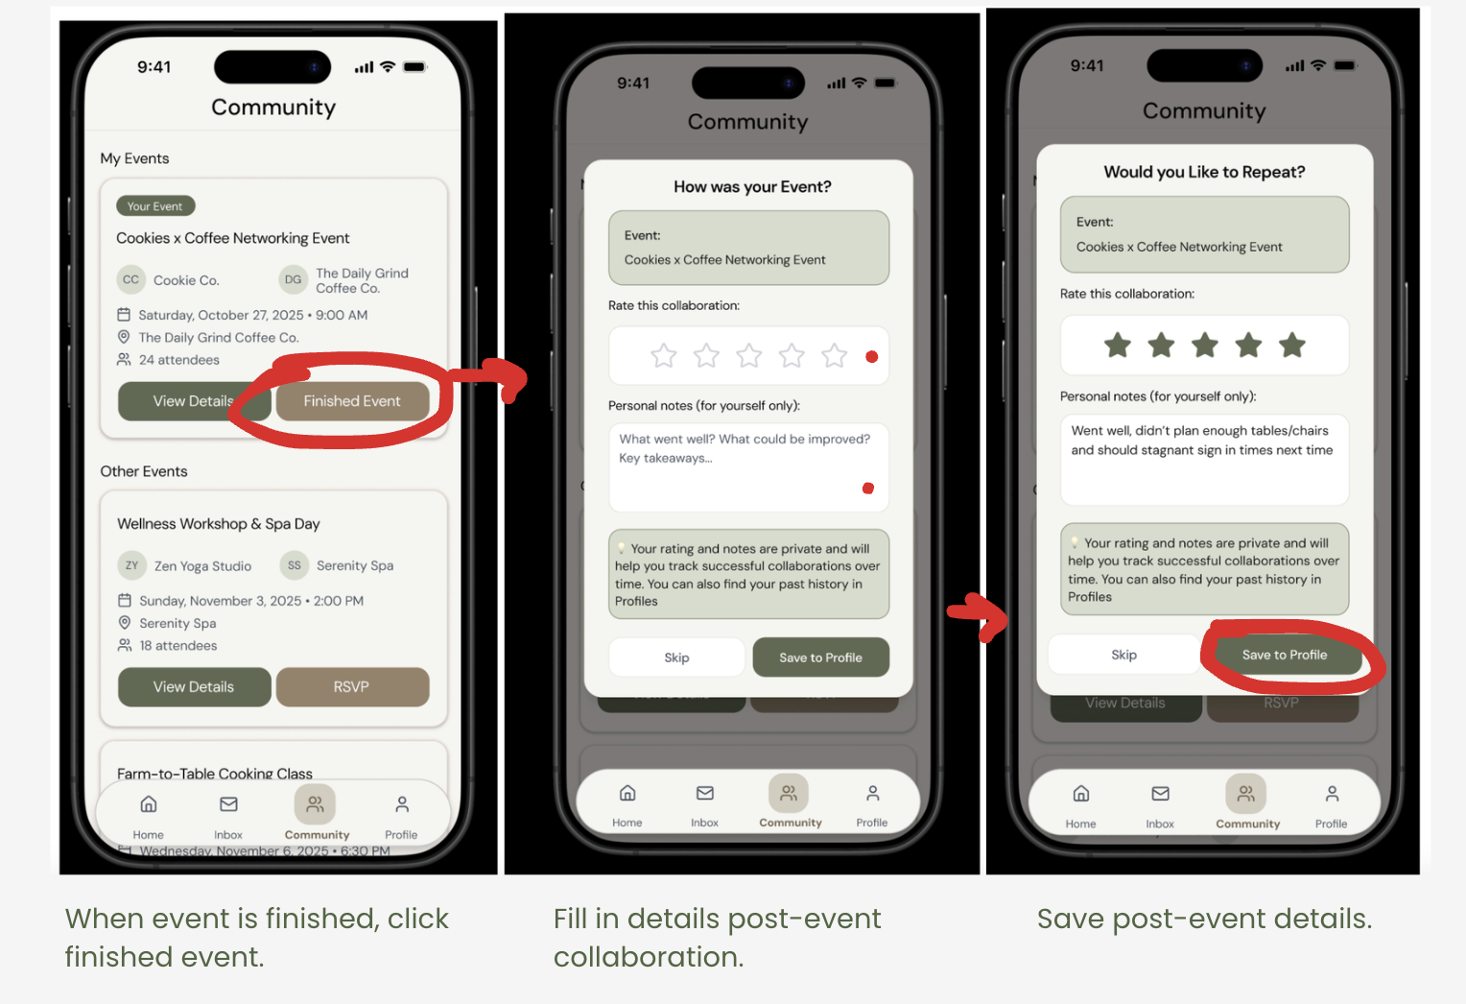
Annotated task-flow for Complex Task.

Design evolution visualization(s) and rationale

Lo-fi Prototype and Evaluation
Once we chose to proceed with our mobile app realization, we began sketching out task flows for our three tasks on a mobile platform. We sketched all our final lo-fi prototype pages digitally on an iPad to make the prototype look as clean as possible for user testing.
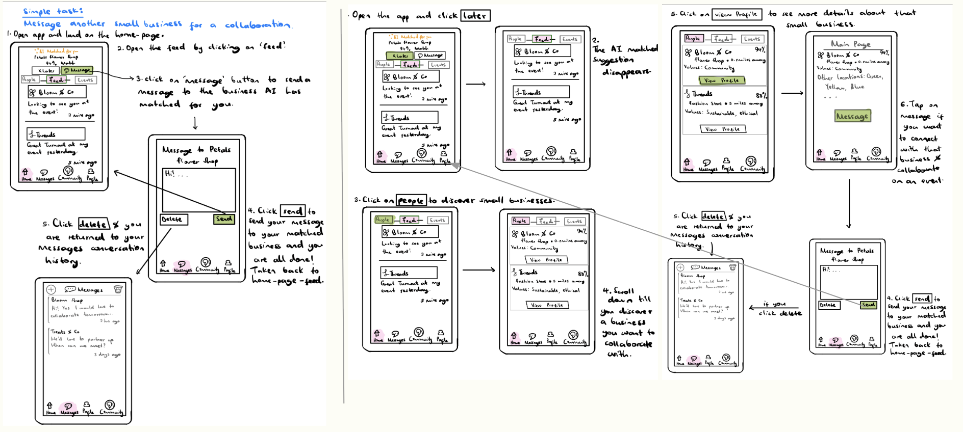
Lo-fi Prototype of Simple Task: Messaging other Businesses, on Stitch.

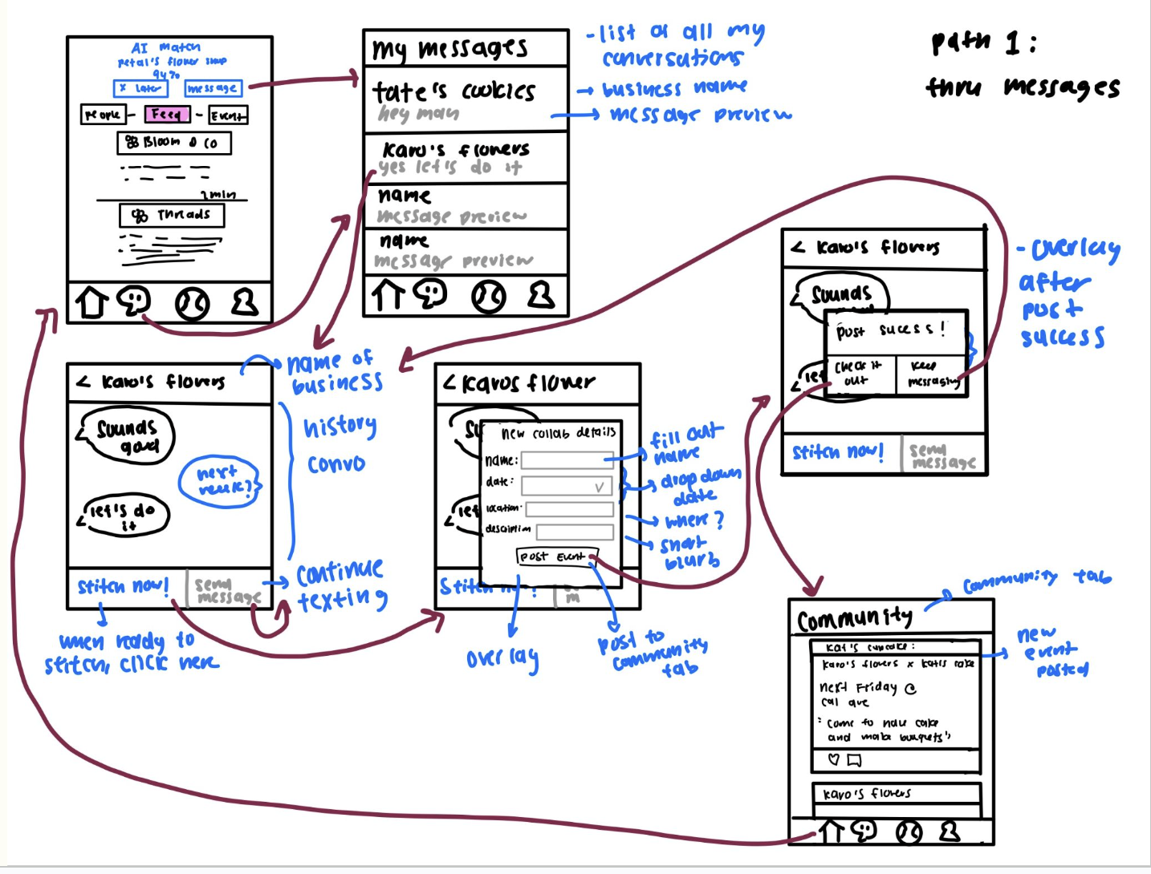
Lo-fi Prototype of Medium Task: Creating a Stitch Event, on Stitch.

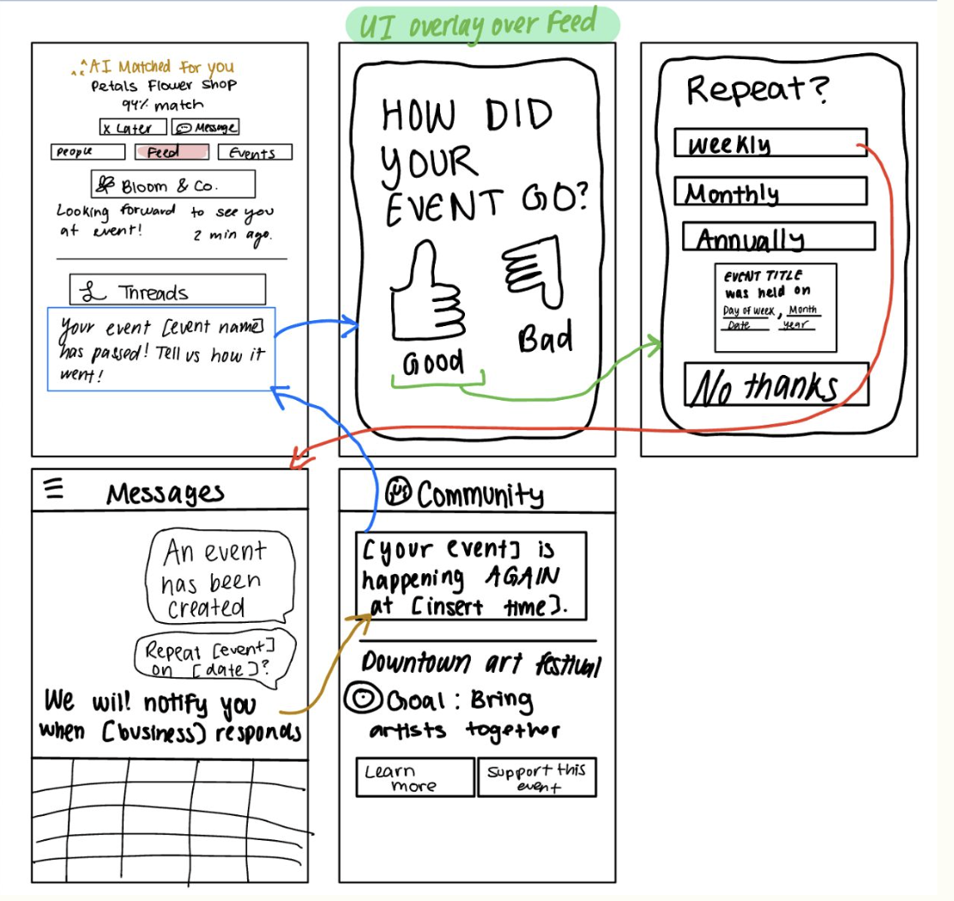
Lo-fi Prototype of Complex Task: Repeating events on Stitch.

User testing was conducted on four participants who were all either small business owners or worked under a small business (to make sure they fit with our target demographic). Each participant was asked to navigate through our simple, medium, and complex task flows on the app and think out loud as they progressed through the app’s screens. We used participants’ comments to gain qualitative feedback, and we also kept track of quantitative metrics such as number of misclicks (to measure ease of navigation), number of steps needed to complete a task (to measure efficiency), and asked them to rate how much they liked the app (to measure eagerness of using app).

Generally, participants were able to complete tasks with few to no misclicks (5 misclicks across all participants), indicating strong navigability (11 clicks on average to navigate workflows) across all the tasks that could be completed on the low-fi prototype. Participants were generally very eager to use the app (9/10 eagerness average rating across all participants).

One general problem we saw during testing was that we could improve our labeling to reduce confusion and support user expectations around how the app facilitates collaboration. Important design changes we found necessary for task navigation was clarifying the difference between “+ Post” and “Stitch” through clearer labels, adding multi-business collaboration support through message templates, and by making the Community page discoverable for event management. Overall, we achieved our usability goals, but identified opportunities to clarify feature meanings.

Med-fi Prototype and Evaluation
From the design changes we discussed after low-fi prototype user testing, we designed our medium-fi prototype accordingly to expand upon our original designs. We designed our prototype on Figma with the same task flows from the low-fi prototype.

Med-fi Simple Task Workflow

Med-fi Annotated task-flow for Simple Task.

The objective of this task is to send an AI-templated message to another small business on the map so that you can collaborate together on an event.
The user starts at the home page, which has the feed. The default state for the feed is that it has the AI recommendations since the toggle button is ON.
The User will see the first AI-recommended business as “Daily Grind Coffee”. The user can click on the ‘send message’ button on the recommendation card of Daily Grind Coffee. The user will be navigated to a page with an auto-populated AI template message and will have two options: “Edit” and “Send Template Message”. For this prototype, the user cannot edit the templated message before sending. The User will then click “Send Template Message”, and the conversation thread will auto-populate showing the message exchange.
The task is then complete.
Available Options After Sending:
- The User can click “Stitch Now” to proceed to Task 2 (creating a collaboration event)
- The user can click the “Back arrow” to return to the message preview screen.

Med-fi Medium Task Workflow

Med-fi Annotated task-flow for Medium Task.
The user creates a Stitch from an existing conversation.
The user navigates to the "Inbox" tab using the bottom navigation bar and sees a scrollable list of past conversations. For this prototype, only the first message in the list (with Sarah Johnson) is clickable. Upon clicking the first message to open the conversation with Sarah, the user reviews the conversation history and clicks the "Stitch Now" button to initiate a formal collaboration event. The user is then taken to the Stitch creation form, which in this prototype must be filled out in order from top to bottom. The user clicks the "Name of Event" text field and it auto-populates, then clicks "Describe your collaboration" which also auto-populates, and finally clicks "Pick a Date" to select a date from the October 2025 calendar. After filling all fields, the user clicks "Create Stitch" to send the collaboration request. After approximately 800ms (simulating real-world processing time), the request is automatically approved using a Wizard of Oz technique. A confirmation message appears with a "Check it out on Communities" button, which navigates the user to the Communities page where they can view their new collaboration under "My Events."
The task is then complete.

Med-fi Complex Task Workflow

Med-fi Annotated task-flow for Complex Task.
This task is a continuation of the Medium Task. After the user has sent a collaboration request via "Stitch Now" and the request is automatically approved, the user receives a notification that their stitch has been approved. The user taps this notification, which navigates them directly to the "Communities" tab. The Communities screen displays two sections: "My Events" (active and past collaborations the user is part of) and "Other Events" (community events the user might join). For this prototype, only events under "My Events" are clickable.
The user sees their newly created collaboration event displayed as a card under "My Events," showing the event name ("Cookies x Coffee Networking Event"), collaborating businesses (Cookie Co. and The Daily Grind Coffee Co.), date/time, location, and attendee count. The user has two primary action options for this event: "View Details" or "Finished Event." If the user clicks "View Details," they are taken to a detailed event screen showing the full event information including time, place, description, guest list, and partner business details. This screen allows users to review event logistics but does not offer editing functionality in this prototype.
If the user clicks "Finished Event" instead, an overlay appears asking "How was your event?" with options to provide a star rating (1-5 stars) and write personal notes about how the event went. These notes are private reminders for the business owner to track what worked well or what could be improved for future events. The user can then either "Save" their feedback or "Skip" to dismiss the overlay. If the user clicks "Save," another overlay immediately appears titled "Repeat Event?" showing the event name and asking, "Would you like to make this a recurring event?" The user has two options: "No thanks" or "Yes, repeat it" If they select "Yes, repeat it," a list of frequency options appears: Weekly (Every week), Bi-weekly (Every 2 weeks), Monthly (Once a month), or Quarterly (Every 3 months). The user selects their preferred frequency by tapping the radio button, then clicks "Save" to confirm. The event card in "My Events" updates to show "Repeat Event" instead of "Finished Event". The user returns to the Communities feed where they can now see this event marked as recurring.
By clicking the back arrow from any screen, the user returns to the Communities feed, where they can see all past, active, and recurring events in one centralized location. This allows business owners to track multiple partnerships simultaneously, maintain records of successful collaborations, and easily set up repeating events without starting from scratch each time.
The task is complete once the user has navigated through the event feedback flow, optionally set up a recurring event, and understands how to manage ongoing collaborations.
From this med-fi testing, we broke down the severity of heuristic violations found during the heuristic evaluation of the med-fi prototype of Stitch. 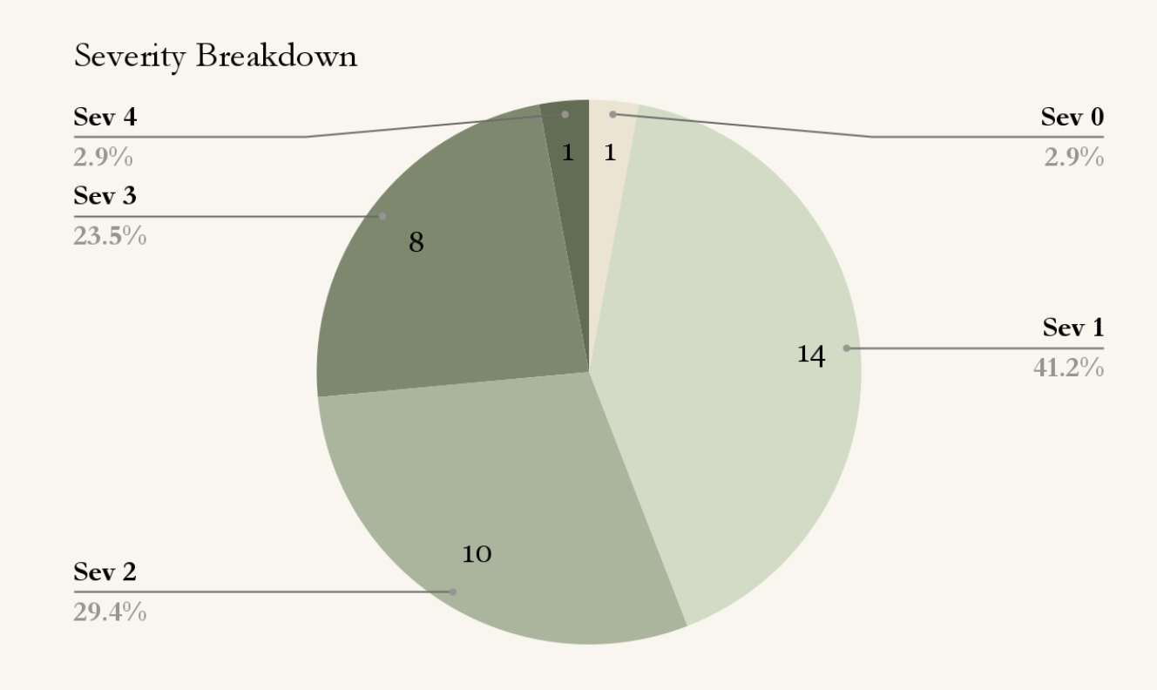
High Level Summary of Results
The most common violations were 10 H4 (Consistency & Standards) violations, 4 H8 (Aesthetic & Minimalist Design) violations, and 4 H3 (User Control & Freedom) violations.

High-fi Prototype and Evaluation
The most severe heuristic violations found by the evaluators were:
- Sev 4: H4: The navigation elements are all different colours
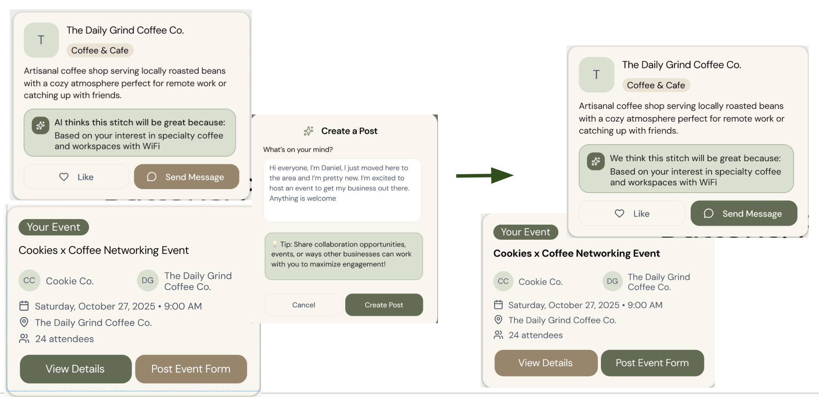
We fixed this violation by using dark green to draw more attention as a consistent call to action whereas beige is used for less important buttons.

- Sev 3: H1: The AI toggle lacks confirmation, so the user will not know if it's off/on.
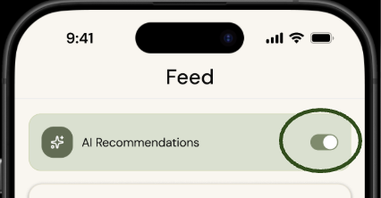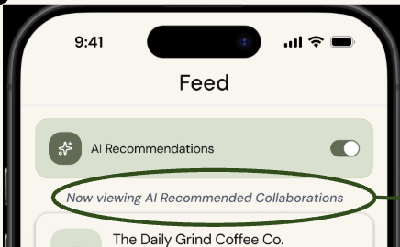
Before, there was simply a green and grey option for AI recommendations, but we changed our design to have explicit texts explaining differences between AI recommendations and community posts: user will understand AI toggle (H1) and understand comment options (H4).

- Sev 3: H4: Inconsistency in "Stitch now" vs "Create Stitch"
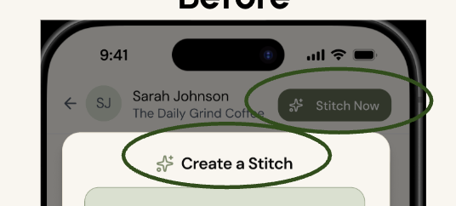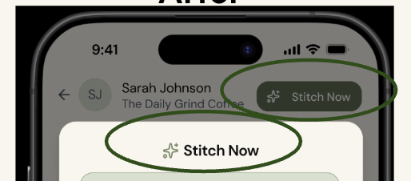
Before, there was simply a green and grey option for AI recommendations, but we changed our design to have explicit texts explaining differences between AI recommendations and community posts: user will understand AI toggle (H1) and understand comment options (H4).

- Sev 3: H3 Once the AI-generated message is sent, there is no way to undo or edit the message.
While we decided to not have a way to edit/undo the message, we are giving users more control by adding a guardrail to make sure they really want to send the AI template message first.
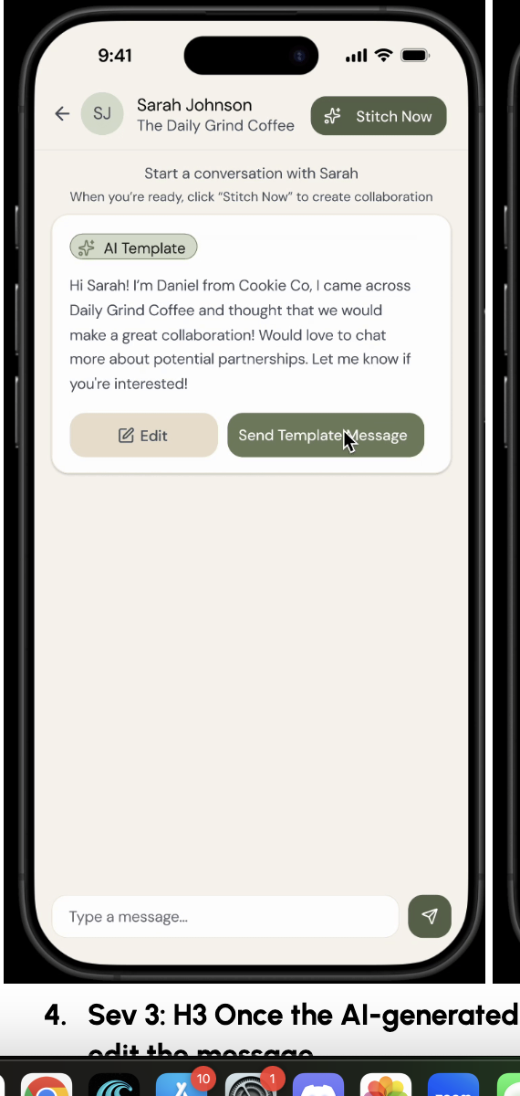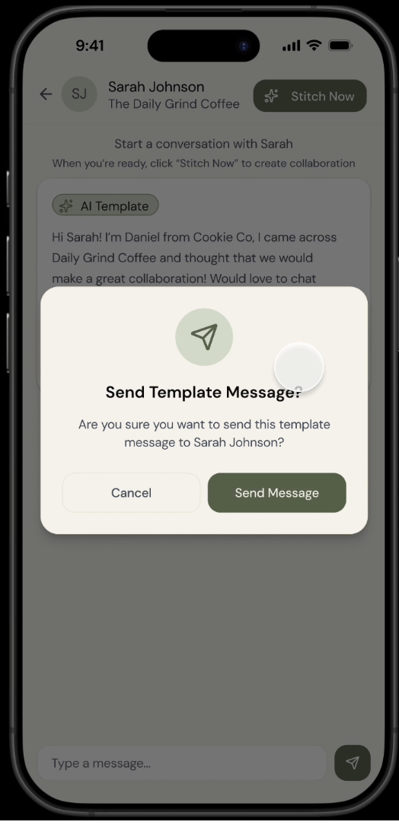

We built our hi-fi prototype by incorporating design changes from our heuristic evaluation. Below are the task flows reflected in our high fidelity prototype along with annotations (in red) listing the new task flows.
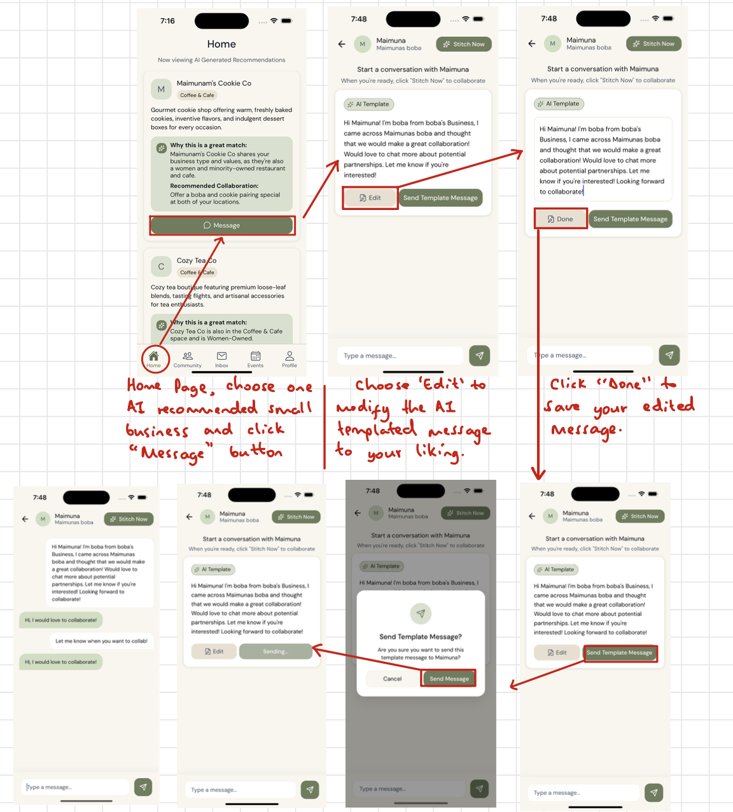
Simple Task Flow Annotation
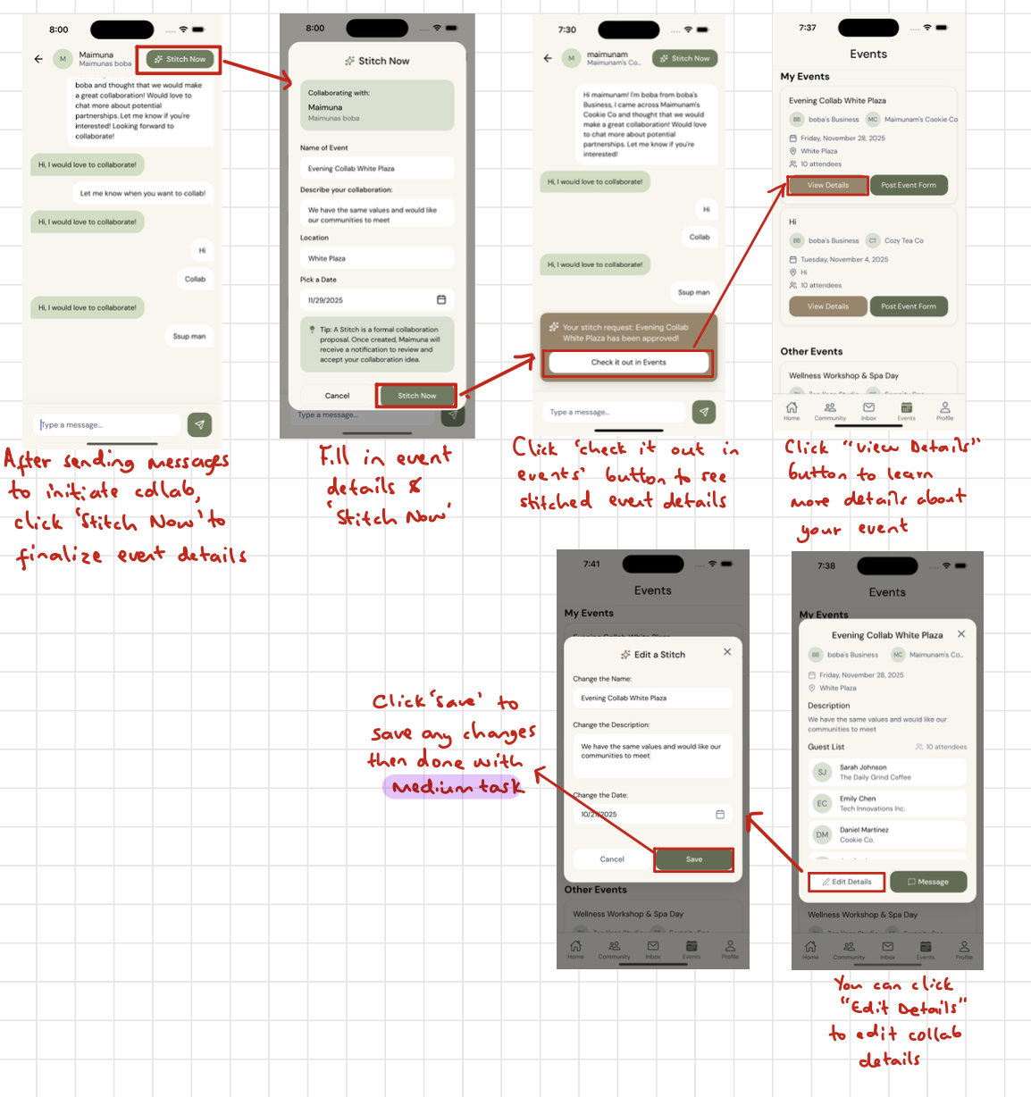
Medium Task Flow Annotation
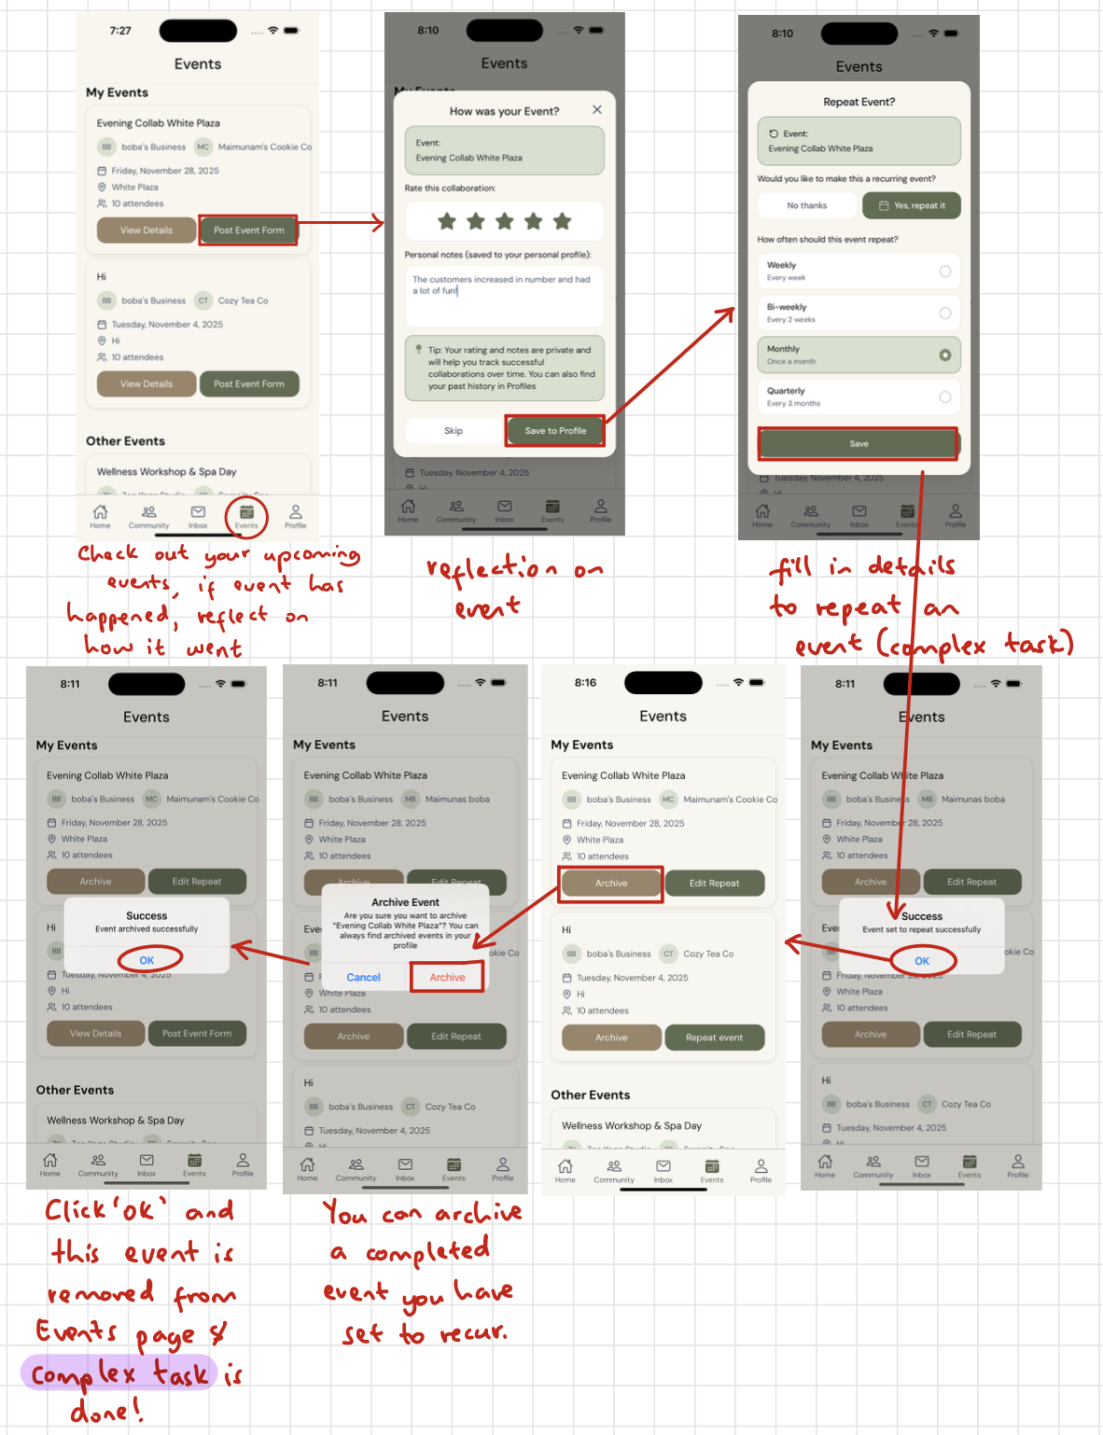
Complex Task Flow Annotation

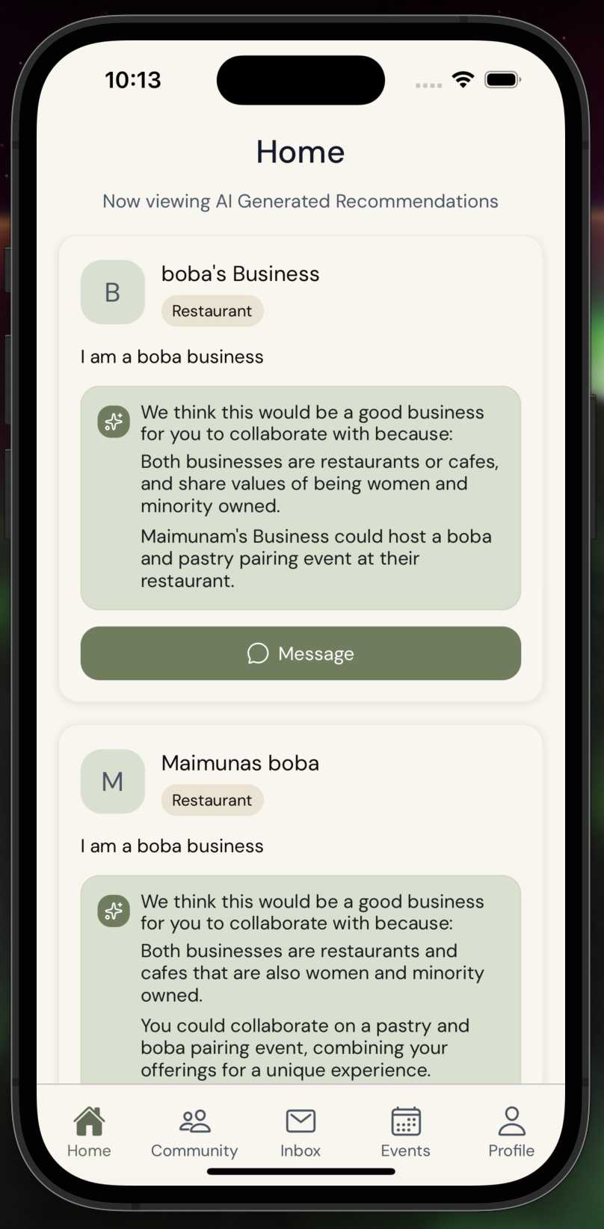
Values in design
Transparency
An important value tension was that users should understand the underlying details behind AI matches.

We embedded this value in our design by having the app explain why certain businesses were paired together. Transparency with AI is important, because users will have to understand how AI will work in Stitch for privacy concerns.

Accessibility
Every user regardless of technical background, can easily navigate and benefit from all platform features.
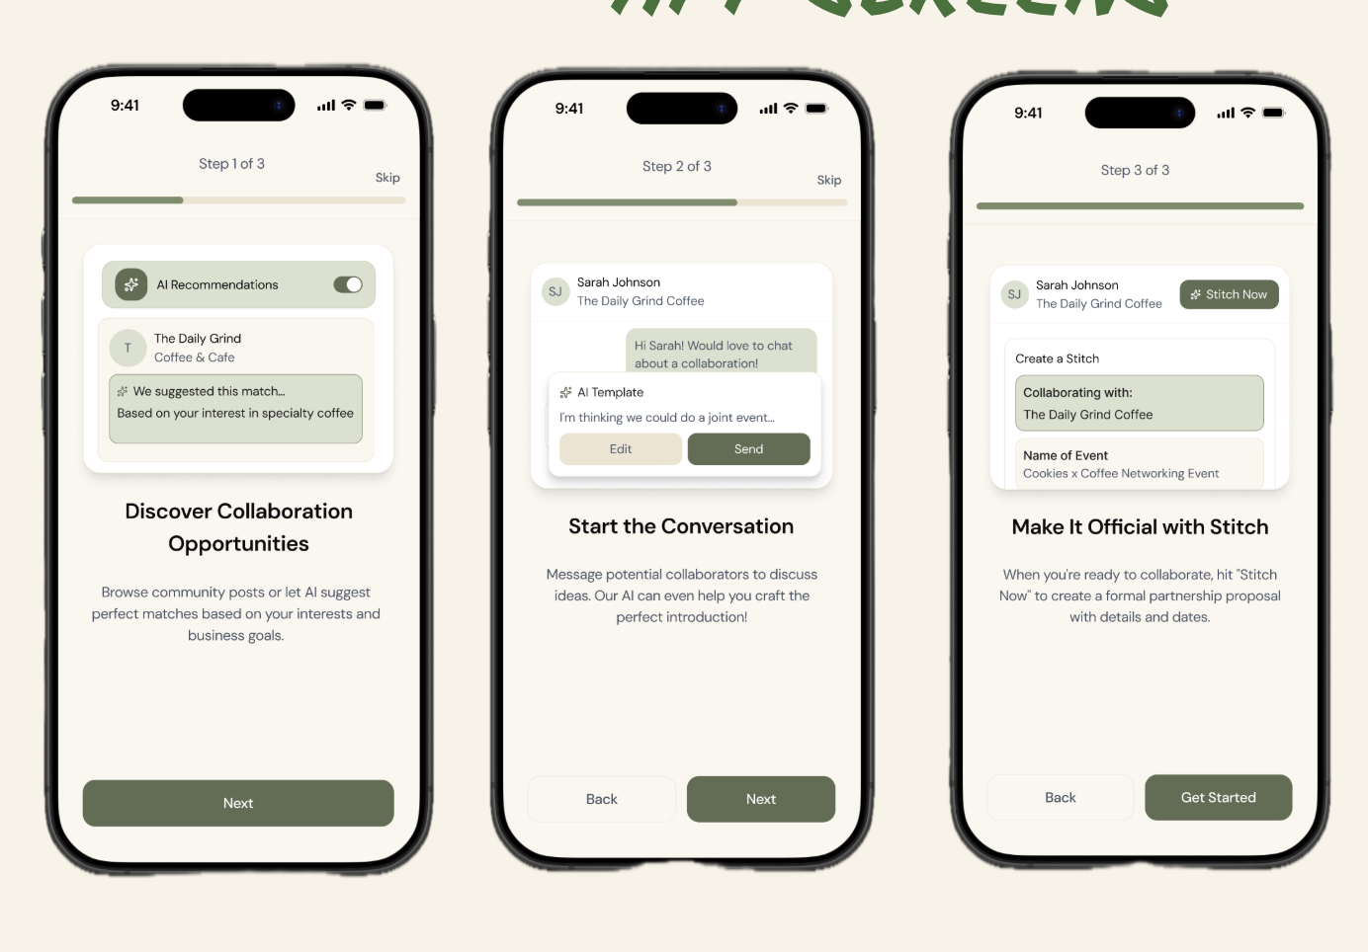
The onboarding process for the app after account creation is a great example of how Stitch teaches users how the app operates through in depth explanation of unique features.
Additionally, Stitch is built to reduce effort to be as accessible as possible for small business owners. We created AI-templated messages and built a quick “Stitch Now” button, but users should still have autonomy over their business interactions .
How we addressed it:
- We kept the AI template message fast to send to preserve momentum.
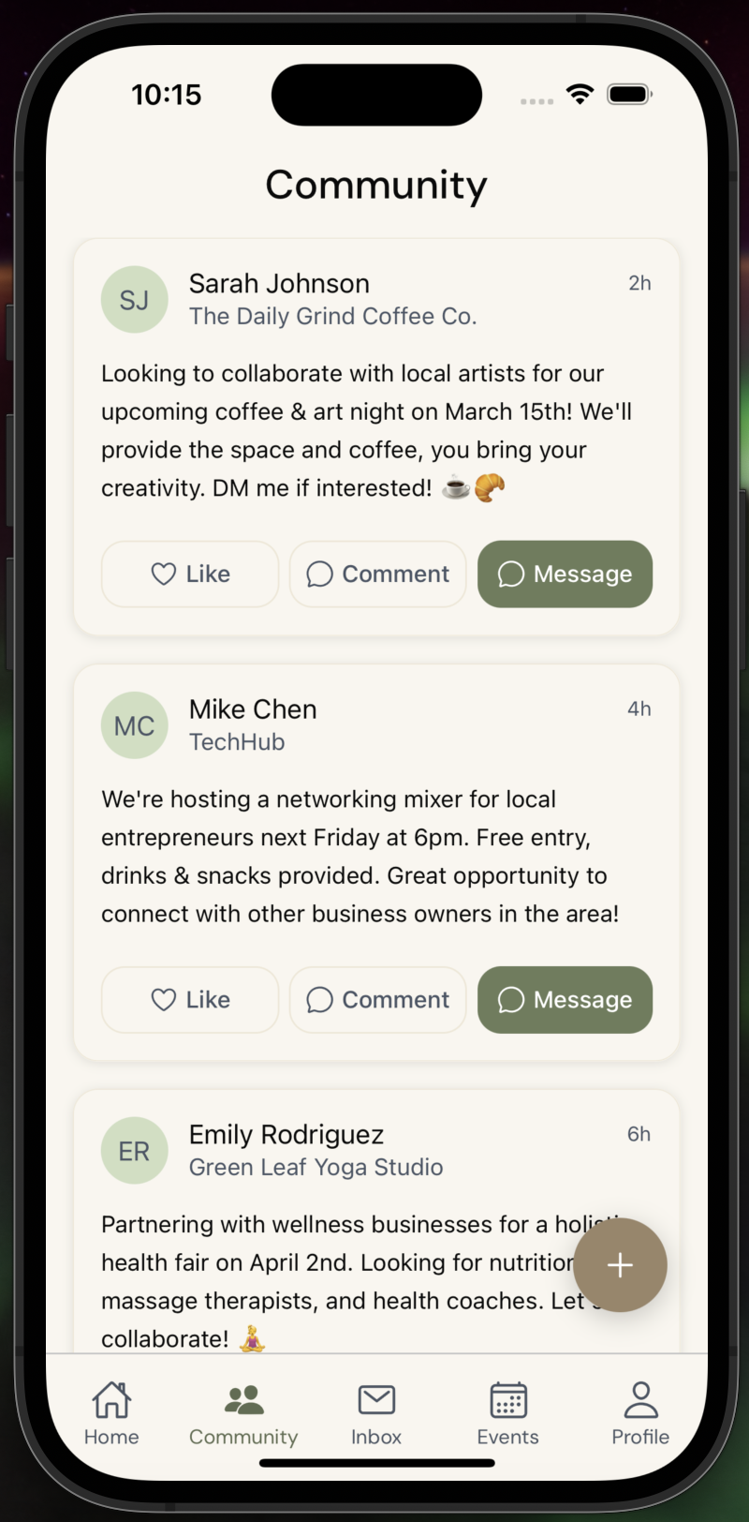
- After heuristic feedback, we added a guardrail step before sending AI messages to reduce accidental or unwanted outreach (H3 control & freedom improvement).
- Event creation requires two-sided approval, preserving user control for both collaborators.
Empowerment
Strengthen community by enabling members to support and uplift each other.

Through the community and events tabs, users can find out about events held by small businesses on Stitch and work with each other to create a safe space where small businesses not just collaborate, but become a community that nurture one another through posts and event support.
Tension: Our interviews surfaced that businesses could benefit from collaborating, but many still instinctively view similar businesses as competitors (POV on Taryn); collaboration can feel risky.
How we addressed this:
- The matching system emphasizes values alignment and complementary goals.
- We designed collaboration to be opt-in and conversational first (message → trust → event), instead of jumping straight to a formal partnership.
- The Communities feed showcases successful collabs, functioning as social proof that collaboration is normal and beneficial.

Final prototype implementation

Tools used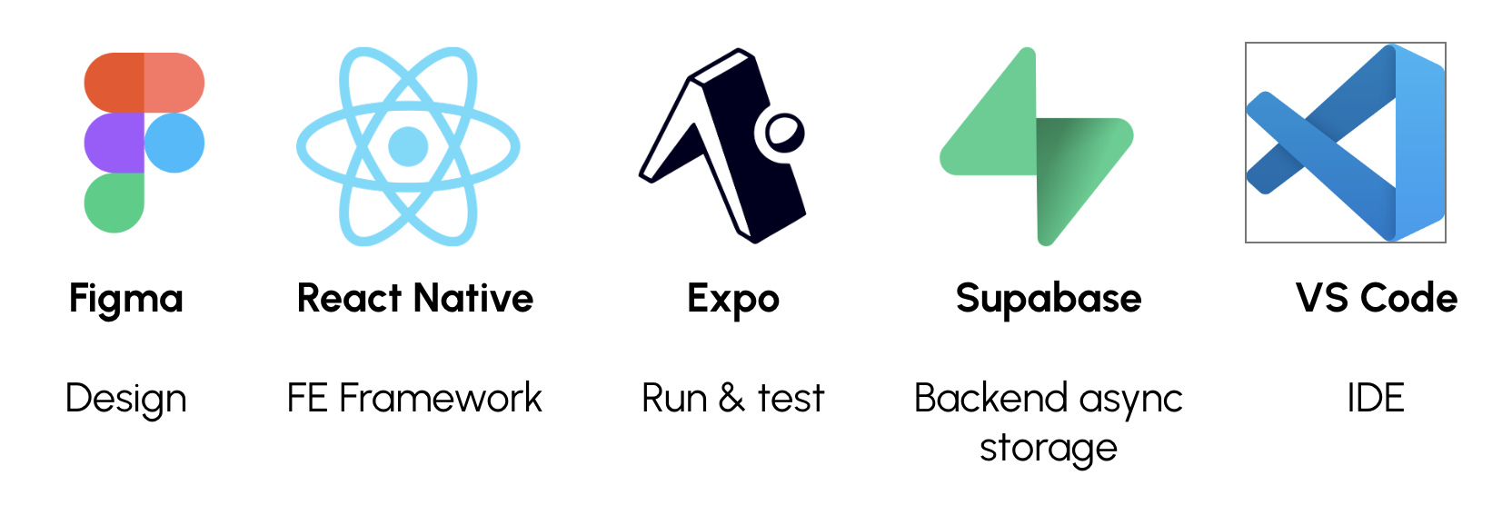
We used Figma to design our med-fi prototype and make changes to it. We then used builder.io, a Figma extension, to turn Figma screens into front end screens in React Native on VS Code. For the backend, we are using Supabase for asynchronous storage of sign ins, profile, event hosted, feed posts, etc. for users. We are running and testing the app on Expo, and we have used Google Gemini’s API to create the AI recommendations feed.

Wizard of Oz techniques used
In expectation, this would be an app built upon by users (real posts, real interactions), but in practice, without other users, we have to “wizard of oz” interactions for the final high-fi prototype.

When a message is sent to someone that contains the string “collab,” the other person will automatically respond “Hi, I would love to collaborate.”

When a Stitch request is sent, it will automatically be accepted.

These Wizard of Oz techniques successfully simulate real world interactions between small businesses that create co-hosted events with businesses they align with.

Hard-coded techniques used
In expectation, this would be an app built upon by users (real posts, real interactions), but in practice, without other users, we have to hard code some posts and messages.

We have hard coded posts with fake small businesses so that whenever a user creates an account, there is a good amount of businesses on the app to start a collaboration with. This is important for our high-fi prototype, because Stitch requires users (small businesses) to already be on the app when they log on. If Stitch has very few to none small businesses on the app, then users will not be as eager to use the app, which is why the illusion of having businesses with events on the app encourages small businesses to message and begin Stitch events.

AI tools used with justification of why
We used builder.io to turn Figma screens into front end screens in React Native on VS Code. This was a very helpful extension because we had 40 Figma screens we had to turn into code for the front end, so we decided to use the extension to quickly develop each screen one by one, and then spend more time refining the AI algorithm and backend asynchronous storage on Supabase.

We also used the Gemini AI to make API calls to create real AI suggestions based on a business’ values and bio descriptions. These API calls help businesses learn which businesses are most compatible with one another alongside generating one sentence potential events with the business.

Reflection & next steps

Main learnings about the design thinking process

Over the quarter, we learned that strong design outcomes depend less on a single good idea and more empathizing with people during needfinding, pivoting from idea to idea or from design to design, and iterating continuously throughout the design process.

In the very first week, we conducted 7 needfinding interviews to get to know a large audience of potential users and their struggles. One of our biggest learnings was how unexpected insights from early interviews can redefine the entire trajectory of a project.

We entered needfinding thinking broadly about small business resilience, but interviews quickly surfaced a more specific and actionable tension: small businesses are increasingly operating in silos despite relying on community for survival:

Mark’s isolation as a new manager
Taryn’s visibility struggles
Amy’s reflection on the lack of inter-business community

All pointed to the same deeper need that small businesses want to thrive, but lack structured ways to support each other.

Professor Liguori’s interview pushed us to recognize that collaboration only works when trust and alignment are built into the system. Throughout our workflows, we wanted to consider how trust played a role in each feature, or more specifically, how we could foster that trust.

The experience prototyping stage taught us how essential it is to test assumptions early and honestly. We validated that financial incentive motivates collaboration, invalidated the milestone tutorial concept because it didn’t translate well to real business constraints, and learned that gamified discovery worked for awareness but didn’t address the core business-to-business collaboration problem. Those prototypes helped us converge on our final direction of business-to-business support.

Key learnings about the studio theme
Our studio theme on community resilience, had us thinking about how we can best support a community that may have been overlooked traditionally. Unlike consumer social apps, small business ecosystems are built on long-term trust, reputation, and shared local norms. Communities are often a resource many rely on, but have trouble accessing. The small business ecosystem was one our team discovered because of the studio’s theme.

We initially struggled with how to make collaboration feel compelling rather than risky, or threatening. Over time, we learned that facilitating collaboration isn’t just about making communication easy; it’s about making connection feel worth it and safe, which is why values-aligned AI matching and two-sided approvals became central to the app. The studio theme pushed us to focus not just on events, but on relationships and repeatability as the core of resilience as demonstrated through our complex task which is to repeat events with a certain business.

Key learnings about Stitch
One of our most important learnings while designing Stitch was to not get attached to the first version of our solution. Early on, we had multiple promising ideas (matching, manager tutorials, scavenger hunts), but the design process made it clear that we have to choose a specific goal and simple, medium, and complex tasks that are the backbone of the app.

Another critical learning was that trust is the product. Small businesses are cautious about who they associate with because reputation is fragile and resources are limited. Val’s interview showed us that even mutually beneficial collaborations won’t happen if values don’t align. Therefore, Stitch’s success depends on making compatibility reasoning visible (AI transparency), making collaboration a two way street, and showing social proof through the Communities tab.

We also learned that simplicity matters even more for professional users than for casual users.
Owners like Taryn are doing everything themselves.
Managers like Helen already feel stretched.

If the path from discovery → messaging → event creation feels even slightly heavy, the collaboration won’t happen.

This insight drove our focus on a clean, low-friction mobile flow, and why we built in AI-generated message templates and made it as easy and safe as possible to create a formal event on Stitch.

Next steps
If we had more time, our first priority would be connecting the high-fi prototype to a real backend and piloting with a small local business network. Right now, many parts of the prototype are hard-coded or Wizard-of-Oz’d to simulate a thriving community; a real deployment would let us observe authentic trust formation, rejection cases, and repeat-collaboration behavior over time.

In the future, we would also add:

- Editable AI messages and tone controls so users can personalize outreach without losing the momentum of templating.
- Stronger value filters (e.g., “not interested in partnering with direct competitors,” “must align on nonprofit/for-profit goals,” etc.).
- Negotiation and rejection flows: real collaborations need counter-proposals, “not this month,” or alternate event ideas.
- Post-event analytics to help owners quantify the value of an event and whether it is worth their time and money to repeat an event and learn what kinds of collaborations improve revenue & community reach.
- A neighborhood-level pilot to test whether Stitch truly increases collaboration frequency and long-term resilience compared to existing informal networks.

Ultimately, we see Stitch as more than a tool, it is a platform for rebuilding the local business community infrastructure that many owners described as missing today.

With iteration and real-world rollout, we believe Stitch has the potential to help small businesses not just survive, but grow together.

