Aleksandar Ivanov

Assignment 1

At first, it seemed like there was a solution, but I forgot that there can not be any negative amount of marbles

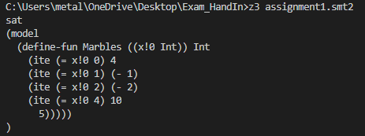

After adding the requirement for there to not be any negative numbers, z3 could not find a solution anymore



My approach was to have a function that takes an Int (a timestamp) and returns another int

This function has to be positive, has an initial and end value and is given an or operator of 3 functions.

Assignment 2

At first this assignment seemed like a lot to write. But I remembered that we did such an exercise before – I reused my solution from week 1 assignment 2 (If I recall correctly) – I only needed to change the statements which needed to be true.

I basically gave them the answer limit – they must be distinct and between 1 and 9, and then proceeded with the statement and that was it.

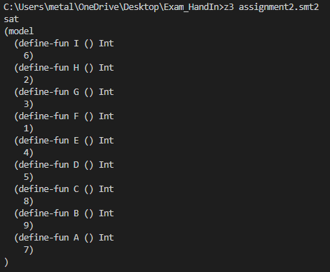

Assignment 3

I decided to express the Items as functions, to which you pass a day (1 to 6) and they return 1 or 0; 1 means they were sold today and 0 means they weren’t sold today. I made sure the answer limits were correct and created 6 functions that determine the day on which an item is sold. Then I put the general conditions in and started the questions.

1. Answer i) is correct. Z3 couldn’t find a model for ii)

i

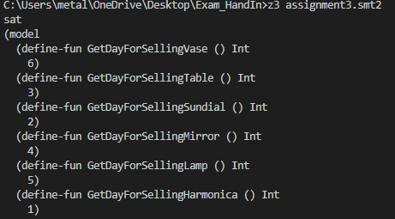

ii

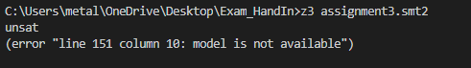

1. Answer ii) is correct. Z3 didn’t find a model for i)

i

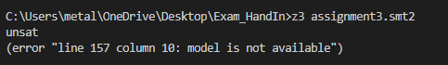

ii – here I also found out I did not implement a limit that makes sure all items get sold – I put it there and retested my previous question, everything still works out

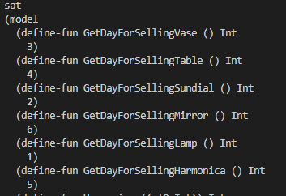

1. I is correct. Ii is wrong (no model found)

I

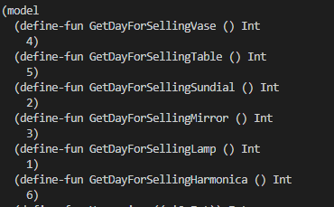

Ii

