

**Whitepaper of PCGP**

**Power Coin Groot & Panda**

**Info@grootpandacoin.com**

**RSHC: Revolutionizing the Green Ecosystem through**

**Crypto-Centric Innovation and blockchain**

**technology v1.0**

**RSHC International FZCO**

**Silicon Oasis, DDP,**

**IFZA Building A 2,**

**Dubai, UAE**

**Project PCGP**

**Power Coin Groot & Panda**

Legal Disclaimer Nothing in this White Paper is an offer to sell, or the solicitation of an offer to buy, any tokens. RSHC is publishing this White Paper solely to receive feedback and comments from the public. If and when RSHC offers for sale any tokens (or a Simple Agreement for Future Tokens), it will do so through definitive offering documents, including a disclosure document and risk factors. Those definitive documents also are expected to include an updated version of this White Paper, which may differ significantly from the current version. Nothing in this White Paper should be treated or read as a guarantee or promise of how RSHC’s business or the coins will develop or of the utility or value of the coins. This White Paper outlines current plans, which could change at its discretion, and the success of which will depend on many factors outside RSHC control, including market-based factors and factors within the data and cryptocurrency industries, among others.

Any statements about future events are based solely on RSHC analysis of the issues described in this White Paper. That analysis may prove to be incorrect.

**Abstract**

The RSHC Foundation aims to revolutionize the green ecosystem by introducing a new system of cryptocurrency, RSHC’s Project PCGP, this white paper outlines the key features, principles, and vision behind the RSHC project, which utilizes a centralized blockchain system to secure clients with credit contracts and ensures a sustainable, prosperous future. The coin, RSHC, is capped at 1 billion units and is designed to appreciate in value as the foundation receives investments.

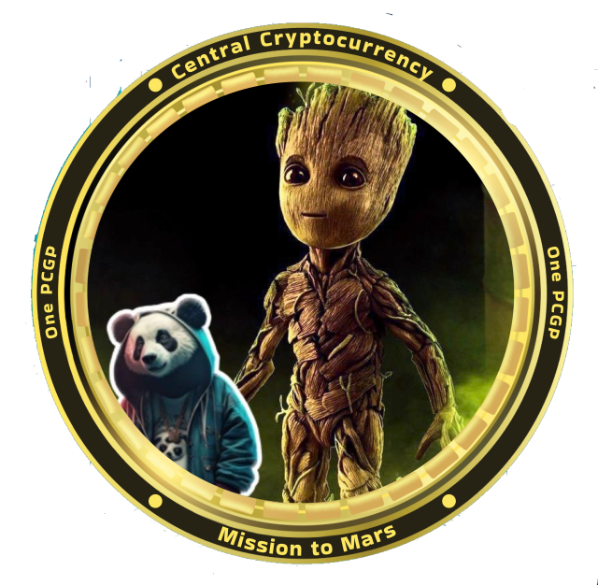

**1. Introduction**

The global push for sustainability and environmental responsibility has led to a surge in renewable energy adoption. The RSHC Foundation recognizes the potential of blockchain technology to catalyze this transition further. Our foundation aspires to create a robust, eco-friendly ecosystem by intertwining blockchain with growing bamboo in many countries to sell it to the industry. This white paper serves as a comprehensive guide, elucidating the features and benefits of the RSHC system and outlining the framework for a prosperous, eco-conscious future.

**2. The PCGP Blockchain**

It is a centralized ledger maintained by a network of nodes operated by the RSHC Foundation. The centralization is chosen for its scalability, speed, and

enhanced security, ensuring a robust infrastructure for the growing green ecosystem.

**2.1. Consensus Mechanism**

To maintain the integrity of the blockchain, the PCGP through RSHC Foundation adopts a hybrid consensus mechanism, combining Proof of Authority (PoA) and Proof of Stake (PoS). PoA ensures swift validation of transactions, while PoS incentivizes coin holders to participate in network maintenance, reducing the risk of centralization.

**3. PCGP Coin ( exclusively from RSHC)**

PCGP is the native cryptocurrency of the RSHC Foundation, serving as a medium of exchange, store of value, and a gateway to green investments. Here are some key aspects of the RSHC coin:

**3.1. Limited Supply**

The total supply of PCGP coins is capped at 1 billion units, ensuring scarcity and potential for value appreciation as demand grows.

**3.2. Initial Price and Value Increase**

The PCGP coin will be initially priced at € 0,11 per unit. The coin's value will increase over time, reflecting the growth of the green ecosystem through investments and contributions to renewable projects.

**3.3. Incentives for Coin Holders**

Holders of PCGP coins will benefit from staking rewards and encouraging long-term participation and commitment to the PCGP ecosystem.

**3.4. Integration with the Resort**

RSHC will be integrated as a primary payment system within the RSHC Foundation's resort. This integration aims to promote the use of PCGP & RSHC and stimulate adoption among users.

**3.5. Trading and Reselling**

PCGP holders can trade the coin on the PCGP Foundation's website and resell it to other customers at the current market rate, promoting liquidity and a healthy trading environment. The foundation will facilitate an exchange platform that provides a secure and user-friendly experience for trading PCGP.

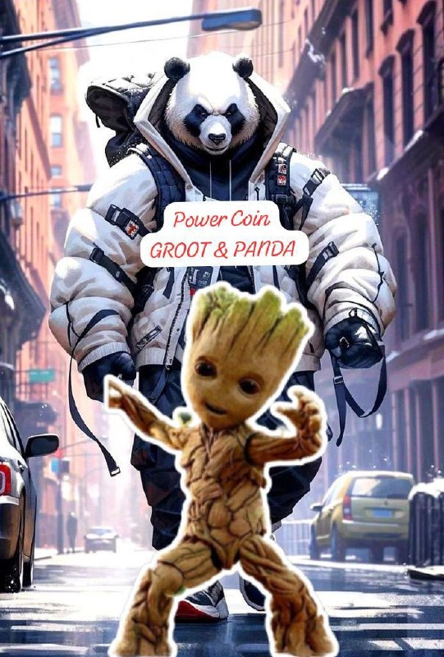

**4. Growth**

Growing bamboo in many countries is helping us to grow quickly in this business.

**4.1. Green Energy Projects**

The PCGP through RSHC Foundation will collaborate with partners to establish solar energy farms, hydrogen generation facilities, and other sustainable energy infrastructure. These projects will be strategically located to maximize energy efficiency and minimize environmental impact.

**4.2. Environmental Impact**

By supporting green energy projects, the PCGP through RSHC Foundation aims to reduce carbon emissions and contribute to a cleaner, greener planet. The foundation will actively measure and report the environmental impact of its initiatives, promoting transparency and accountability.

**4.3. Community Benefits**

Green energy projects will create job opportunities, stimulate local economies, and empower communities to embrace sustainability. The PCGP through RSHC Foundation is committed to engaging with local stakeholders and ensuring that the benefits of renewable energy extend beyond financial gains.

**5. PCGP Wallet**

To facilitate seamless transactions, the PCGP through RSHC Foundation will provide its users with secure and user-friendly PCGP wallets. These wallets will support peer-to-peer coin transfers and payment requests.

**5.1. Features**

PCGP wallets will include features like multi-factor authentication, contactless payments, and transaction history for enhanced user experience. Moreover, the foundation will continue to enhance wallet functionalities based on user feedback and technological advancements.

**5.2. Interoperability**

To promote widespread adoption, PCGP wallets will be compatible with popular devices and platforms, ensuring easy accessibility for users. Additionally, efforts will be made to enable cross-chain compatibility, allowing seamless exchange of RSHC with other cryptocurrencies.

**6. Roadmap**

The PCGP through the RSHC Foundation has laid out a comprehensive roadmap to achieve its vision of a sustainable and prosperous green ecosystem. Key milestones include:

**6.1. Initial Coin Offering (ICO)**

The foundation will conduct an ICO to raise funds for the development of green energy projects and the establishment of the PCGP through RSHC ecosystem. During the ICO, interested participants can acquire PCGP at the initial price, fostering early adoption.

**6.2. Resorts of bamboo everywhere**

**6.3. Renewable Energy Projects**

The foundation will begin investing in and managing renewable energy projects, aiming to power the resort and eventually expand to other locations. These projects will serve as models of sustainable development and demonstrate the efficacy of PCGP in supporting green initiatives.

**6.4. Community Engagement**

The PCGP through RSHC Foundation will actively engage with the crypto and environmental communities to foster a strong network of supporters. Community-driven initiatives, such as hackathons and idea contests, will be organized to encourage active participation and diverse perspectives.

**6.5. Ecosystem Expansion**

As the PCGP through RSHC ecosystem gains momentum, the foundation will explore partnerships and collaborations with other green-focused organizations, amplifying the impact and reach of its initiatives.

**7. Conclusion**

The PCGP through RSHC Foundation's novel approach to merging a centralized blockchain system with growing bamboo plantages demonstrates its commitment to creating a sustainable and eco-friendly future. By introducing the PCGP through RSHC cryptocurrency and establishing green energy projects, the foundation envisions a world where innovation, environmental consciousness, and financial prosperity go hand in hand.

As we move forward on this exciting journey, the PCGP through RSHC Foundation invites the global community to join us in shaping a cleaner and greener future through the transformative power of blockchain and renewable energy technologies.

Note: This white paper is a conceptual document and should be used for informational purposes only. The actual implementation of the PCGP through RSHC Foundation and its associated projects may vary and would require detailed technical, financial, and legal analysis



**RSHC International FZCO**

**Silicon Oasis, DDP,**

**IFZA Building A2**

**Dubai, UAE**

**Project PCGP**

**Power Coin Groot & Panda**

**www.grootpandacoin.com**