SU12 - Medication Policy and Procedure

Last Reviewed: | 18/09/2024 | Reviewed by: | Nicole Whent  Angela Donohue
Scheduled review date: | All policies are reviewed annually or as per relevant legislation.

1. Purpose
- The purpose of this Overarching Policy and Procedure is to outline key points and responsibilities regarding Medication Management.
- To describe the ways in which Service Users may be safely assisted with managing their medication that promotes choice, independence, dignity and respect.
- To comply with regulatory and legislative requirements, best practice recommendations, guidance and professional codes of practice.
- To describe the procedures involved in delivering medication support and the responsibilities of the staff.
- To support Dale Care in meeting the following Quality Statements:

Key Question | Quality Statement
SAFE | QSS8: How does the provider ensure the proper and safe use of medicines?
EFFECTIVE | QSE1 and QSE2: Are people’s needs and choices assessed and care, treatment and support delivered in line with current legislation, standards and evidence-based guidance to achieve effective outcomes?
EFFECTIVE | QSE2 and QSE3: How does the service make sure that staff have the skills, knowledge and experience to deliver effective care and support?
EFFECTIVE | QSE6: Is consent to care and treatment always sought in line with legislation and guidance?
WELL-LED | QSW5: Does the governance framework ensure that responsibilities are clear and that quality performance, risks and regulatory requirements are understood and managed?

To meet the legal requirements of the regulated activities that Dale Care is registered to provide:
- The Human Medicines Regulations 2012, (amended 2014) now replaces -The Medicines Act 1968
- Misuse of Drugs Act 1971 (Amended 2008)
- The Drugs Act 2005
- Control of Substances Hazardous to Health Regulations (as amended) 2002
- Safer Management of Controlled Drugs Regulations 2006 (CDs)
- Health & Safety at Work Act 1974 (Reviewed in 1994)
- Data Protection Act 1998…GDPR
- Customs and Excise Management Act 1979
- Road Traffic Act 1972 and medication Trafficking Act 1994
- The Health and Social care Act 2014
- The Mental Capacity Act 2005 and Safeguarding
- The Mental Capacity Act 2005 Cde of Practice
- NMC Guidelines on Medicines
- The Care Act 2014
- The Care Quality Commission [Registration] Regulations 2009
- The Controlled Drugs [Supervision, Management and use] Regulations 2013
- The hazardous Waste Regulations 2005
- The health and Social Care Act 2008 [Regulated Activities] Regulations 2014
- The Health and Social Care Act 2008 (Regulated Activities) (Amendment) Regulations
- The Pharmacy Order 2010
- Safeguarding Vulnerable Groups Act 2006

2. Scope

The following roles may be affected by this policy:
- All staff, with responsibility for administering medication or supervising medication administration, management of medication administration, and training of staff to administer medication safely.

The following people may be affected by this policy:
- Service Users

The following stakeholders may be affected by this policy:
- Family
- Representatives
- External health professionals
- Local Authority
- NHS
- Commissioners

3. Objectives

- To maintain the health, safety and independence of Service Users by supporting them to take prescribed medication at the correct time and in the correct way as part of an individualised plan of care and support.
- To provide a safe framework for the Carer to work within when assisting the Service User with medication.
- To reduce the risk of medication errors and incidents and to help prevent unnecessary admissions to hospital.

4. Policy

Dale Care understands the importance of providing safe, reliable care including support and treatment in relation to Medication Management and Storage.

- The Service User will be treated as an individual at all times respecting dignity, privacy, independence, choice and control.
- Dale Care recognises the importance of staff training and supervision and will ensure all staff involved in medication management are well trained and competent to perform the activities, and highlight potential risks/changes within the remit of their roles.
- Staff will monitor the safe storage of medications and where there are concerns in relation to the Service Users capacity, this will be reported, risk assessed to ensure the continuous safety of the Service User.
- Medicines remain the property of the Service User to whom they have been prescribed.

- All staff will follow the 6 Rights of Medication Administration to ensure the safety and wellbeing of the Service User.

Roles and Responsibilities of Staff

The Registered Manager/ Compliance/Area Supervisors are responsible for monitoring and assessing conformances to the following:

- Ensuring that a mental capacity assessment forms part of person-centred care planning and that consent to support medication is obtained.
- The care plan and risk assessments are holistic to the Service User needs and clearly outline and agree: does the Service User have capacity to make decisions, agreed place of storage in line with instructions on label, is this accessible to the Service User, does the medication require a locked box and where will this be stored to avoid potential forms of risk to the Service User, and are there children in the home that could access the medication
- An up-to-date list of the Service Users Medication should be recorded, level of support required to assist with medication, where this will be stored including any key codes, to enable carers to also provide information relating to medications with other healthcare professionals i.e. Paramedics if the Service User is unable to do so. It should be detailed: Name of Medication, Strength of Medication, Frequency Taken, and how to take the medication.
- Ensuring that where best interest decisions are required, this is done in collaboration with others involved in the Service User's care and is recorded and shared with relevant staff
- Ensuring that capacity in relation to the management of medication is reviewed regularly or when changes dictate.
- If staff have to prompt a service user on 3 consecutive occasions, this should be reported to the office, and a new medication assessment carried out to ensure that the service users medicines remain safely managed.
- If covert administration of medications is required for a Service User, then this must be carried out in line with a Best Interest Decision, Led by the prescribing DR, Service User, Family, and Dale Care staff. The decision must be recorded in care plan and a copy of the Best Interest Decision must be on record before staff are permitted to administer medication covertly.
- Ensuring that Service Users have a medication assessment undertaken prior to the service starting or as soon as is practically possible. This should form part of their Care Plan to determine the level of support
- Ensuring that medication reviews are part of, and align with, the Service User's care and treatment assessments, plans or pathways and that they are completed and reviewed regularly when their medication changes
- Ensuring that there are regular medication audits
- Ensuring that all staff involved in medication management are trained, assessed and competent to perform the activities required of them within their role
- Ensuring that policies and procedures are in place that comply with current legislation and guidance for medicines administration including:
- Administration
- Disposal
- Recording
- Ensuring there is a culture that allows staff to report incidents. To achieve this, there should be systems to support:
- Clear incident reporting
- Investigations of incident reports to decide whether to offer training to an individual or review existing procedures
- Dip In and regular audits – establish compliance – themes and trends.
- Reporting of serious incidents to the regulatory body and compliance with the Duty of Candour
- Whistleblowing, and knowing that there will be no adverse reaction taken against the staff member for bring this to the attention of Senior staff. Staff to be aware that there is an onwards and upwards chain from the Branch staff, that staff can whistleblow to the Operations Manager, Compliance Manager, Training Manager and Regional Directors.
- Completing spot checks/performance reviews to monitor conformance.
- Monitor and document all controlled drugs

Care Workers are responsible for:

- Ensuring that they only administer medicines that they have been trained and have been assessed as competent to give and refresher training attended and completed as required.
- Monitoring Quantity of medication and re-ordering as per care plan.
- Ensuring medication is available at all times and alerting the relevant person when stock is low/not available.
- Being aware of their responsibilities if a Service User refuses to take their medication on copious occasions.
- Medication deliveries are recorded/stored in the agreed place and checked for accuracy.
- Attend all planned training in line with Skills for Care and all company/CQC/Local Authority requirements.
- Complying to Dale Care’s policies and procedures and to seek guidance if there are any areas of misunderstanding prior to supporting Service Users with medication management.
- Reporting any concerns to their line manager as soon as they arise including errors or omissions.
- Reporting errors of Controlled drugs to: The Standard Operating Procedure for Medication Error Procedure should be detailed that any incident involving controlled drugs should also be reported to the controlled drugs accountable officer via http://www.cdreporting.co.uk
- Attending refresher training as required every year.

Consent and Mental Capacity

- When assessing the Service User's requirements and agreeing their Care Plan, consideration will be given to the Service User's mental capacity and ability to give informed consent
- The Support Worker will be guided by the principles of the Mental Capacity Act and Dale Care’s Policy on Consent and Mental Capacity. SU08 - Mental Capacity Act (MCA) 2005 Policy and Procedure.
- Consent will be obtained for important aspects of Service User care and support, including medication.
- A record of a Service User's informed consent will be made in their care record
- The Service User should be deemed to have mental capacity to make decisions about their care unless there is an indicator that they are unable to make decisions relating to their medication. Where an indicator exists that a Service User may not have the capacity to make decisions about their medication, Dale Care will request an assessment is completed in line with the Mental Capacity Act 2005 and where required, a best interest decision will be recorded in the Service User's care record

Protected Characteristics and Medication Management

Dale Care will ensure that protected characteristics are considered when managing medicines. This includes the Service User's cultural and religious requirements, which will be fully and carefully considered and may include but not be limited to:
- Vegetarians and people from some religious groups who do not want gelatine capsules (made from animal products)
- Having medicines given to them by people of the same gender
- The administration of medicines during religious festivals, including fasting
- Medicines including ‘unclean’ substances

Confidentiality and Information Sharing

- Information regarding a Service User's medication and health must be treated confidentially and respectfully
- All records must be stored securely where they cannot be accessed by unauthorised persons
- Information about a Service User should only be disclosed with that person’s consent, unless Dale Care is legally obliged to share the information
- Any information shared must be relevant, necessary and proportionate
- If the Service User agrees, relevant information about them can be shared with their relatives or nominated representatives
- The agreement for sharing information should be documented in the Care Plan, and a copy uploaded to the Service Users Documents
- Information should be shared with health and social care professionals involved in the direct care of the Service User where it is needed for the safe and effective care of the individual, unless the Service User has refused to share the information
- The Service User's refusal should be documented in their Care Plan and the Carer should ensure that the person is aware that such a refusal may compromise their safety if relevant information is not shared, where possible the service user should sign to say that they are refusing to share the information and they understand the risk to their health if important information is not shared with relevant healthcare professionals.
- If a Service User attends an appointment with a Carer outside of the home, it is important that information is available to that healthcare professional, unless the Service User has refused consent
- This information should be given by the Service User themselves, wherever possible; however, the Carer should ensure that the Service User (or the person accompanying them, if appropriate) has with them a copy of the current medication administration record (MAR) chart / Care Planer Application or is provided with the same details in another written form [Service Users Detail / Hospital Passport]

5. Procedure

Social Services will inform Dale Care what level of support is initially required. Dale Care will complete a full assessment to assess the current needs of the Service Users. Any updates will be provided to Social Service to ensure effective partnership working and sharing of information.

The outcome of the medication assessment will determine:

- The ability to self-manage without assistance / with assistance from care staff.
- And the Level that is required from the Care Planner Application Level:
  - Care Planner Medication Levels
  - Level 1 – Prompt
  - Level 2 – Assist
  - Level 3 – Administer
  - Level 4 – PRN administration
- Administration by specialised technique, Such as PEG, or Buccal administration.
- Agreed method of disposal of equipment/sharps and roles of all professionals (hypodermics – sharps box – catheter bags – stoma bags)
- Storage as per agreed safe outcomes and instructions as per labels.
- Collection or delivery of Medication (When – Where – By Whom and frequency)
- Disposal of medication and observing: stock levels, return of out-of-date medications, repeat prescriptions etc;
- Reporting changes to level of assistance required.
- Identifying potential ongoing risks.
- Provide a Body Map to outline the application of creams, pressure sores, bruising etc
- Application of creams and the use of all protective equipment.
- Ongoing changes to medication and updates via the portal.

When the Service User’s support level changes the Service User’s plan will be reviewed.

Self-Managed

This level of intervention is when the Service User is assessed as having the mental capacity and physical ability to be able to fully undertake the medication process and therefore needs no assistance from the Carer.

Support should be provided for the Service User to understand the medication process and encourage them to self-manage their medication.

Medication Administration Record (MAR) does not need to be completed

No assistance in any form should be given with any stage of the medication process. This is for any prescribed or over-the-counter medication in any form (e.g. tablet, capsule, liquid, drops, spray, cream) and covers medication:
- Preparation
- Administration
- Disposal

Where any support is provided by the Service User's family, etc. then this must be detailed in the Care Plan

The risk assessment must detail how medicines will be safely stored for the Service User to remain self- managing

Service Users should be encouraged to seek regular medication reviews from their GP

In order to protect the safety of the Service User and others, it is essential to assess the Service User’s ability to manage their medications independently and safely. This assessment should include the following:
- Whether the Service User wishes to self-manage
- Identification that the Service User knows the medication they are taking, what it is for, and how and when to take it
- Understanding of how important it is not to leave the medicines lying around where someone else may take it accidentally
The assessment and documentation will be stored in the individual Service User’s Care Plan.

Assist | General support or assisting with medicine
Administer | Administering medication

Prompt/ Assist

- Dale Care provides general support or some assistance with medication administration
- This can involve physical assistance from staff as long as the Service User gives consent The Service User must have been assessed as having the mental capacity to manage their own medication
- The assistance from staff should not involve the Carer choosing or selecting medication for the Service User
- Where there is a risk to others, for example in a shared space, a risk assessment needs to be completed if necessary

- If staff identify a change that indicates it may no longer be safe for the Service User to self-manage then staff should consult with the Service User's GP to determine if:

- The status is short-term or long-term
- The person requires a medication review
- Any new procedures are required in based on the information obtained from the above Dale Care recognises that there may be situations when people are keen to look after some medicines and not others. An example is when a person keeps an inhaler for immediate use but prefers the Carer to look after tablets and liquid medicines

Self-management does not have to be all or nothing; an assessment should be undertaken with the person and documented in the Care Plan

A persistent or increasing need for assistance may indicate that a Service User does not have the ability, or the wish, to take responsibility for their own medicine and this should trigger an urgent review of the Service User's Care Plan. The Registered Manager should be informed at all times

If we have to prompt on more than 3 consecutive occasions then this should be reported to the office so medication review can be carried out.

The term 'prompt' should not be used in the Care Plan as this does not clearly define the activity the Carer is required to undertake. ‘Assist or administer’ gives a clearer indication of the type of support required of the Carer

Administration by Care Staff: Care staff take responsibility for administering medication

The Service User will have been assessed as requiring care staff to administer medication possibly due to impaired cognitive awareness, sensory disability or through physical disability or their expressed wish.

- Staff administering medication must be trained and assessed as competent to administer medication
- Consent must be obtained prior to administering medication
- The Carer must follow the 6 Rights of Medication Administration
- The Medication Administration Record (MAR) / found on the Care Planner system must include all prescribed medicines.
- Medication must never be secondary dispensed (potted up) for someone else to administer to the Service User at a later time or date. Secondary Dispensing is not permitted under any circumstances.
- Medications added to Care Planner must be signed off by two members of staff, a picture of the medication to be uploaded to a member of the team for audit trail and reference. This Can be done within the Care Planner Application, under Dale Care Service User Records, Case Forms, Medication Changes/Concerns, and then clicking the + button, and filling in the relevant information.
- In a two carer call BOTH care workers are responsible for administration of medication and the PRIMARY care workers must tick to complete the task on the care plan once medication has been administered. The SECONDARY care worker should complete a general note to state what medication has been administered.
- It is essential that the person who administers the medicine refers to the Medication Administration Record at the time of administration and does not sign the Medication Administration Record until after the medication has been administered and they are certain it has been taken
- A record should be made if the medicine is refused or not administered, including the reason why
- Staff should follow the codes as outlined in the medication codes training pack; these are the codes that are available to staff in the Care Planner Application. [See Appendix 3]
- The Carer should only administer medication from original packaging or Pharmacy filled dosage systems or compliance aids.
- The Carer should not administer from family filled compliance aids
- The Carer is not permitted to purchase medications over the counter for the Service User, or administer any medications that are not prescribed, Labelled, and are not on the Care Planner Application.
- Carers can only apply creams that are labelled and prescribed for the Service User. If District Nurses leave cream for use on the service user, and this cream is not labelled, you are not permitted to administer the cream. This cream needs to be returned and labelled and prescribed for the person.
- Carers are not permitted to Crush Tablets, Open Capsules, or Cut Tablets for Dosing Reasons. [We can cut to make a tablet easier to swallow, this can only be done if we have access to a pill cutter]
- Staff must administer the medication in the way that is outlined in the Care Plan, and not deviate from this.
- New medications that are not on the application cannot be administered until you have contacted the office and used the Care Planner application to take photographs of the packaging and labels, so medications can be authorised and administered. Carers can use the Adhoc Activity to add the medication once the Branch staff have authorised this.
- PRN medications can be administered, but there must be a PRN protocol in place which outlines the Medication, when it can be given, how much, time to be given, and space between each dose.

Administration by Specialist Technique: Care staff administer medication by specialist technique Once Additional Training has been given
The following activities are usually considered specialised techniques, although this list is not exhaustive and is dictated by locally agreed policy.
- Buccal administration
- Nasogastric administration
- Administration through a Percutaneous Endoscopic Gastrostomy (PEG), including PEG feeds
- Giving oxygen

Dale Care Care Staff are unable to administer any of the following:
- Rectal administration, e.g. suppositories,
- Administration into the vagina, e.g. pessaries
- Administration through a Percutaneous Endoscopic Gastrostomy (PEG), including PEG feeds
- Giving Injections
- No testing blood sugars
- Undertake treatment baths as part of wound care or where there is exacerbation of skin disease (where there is an obvious breach in otherwise intact skin)
- Administer medication via a syringe driver
- Administer Buccal Midazolam or other rescue medications
- Administer non prescribed medication or any other forms of medication, homely remedies or over the counter medication unless it is prescribed

6. Definitions

Medicine | A medicine is a substance that is introduced into the body, or externally applied to the body that exerts a physiological change to the body  Medicines and medicinal preparations which come under the provisions of the Medicines Act (1968). They include medicines used in clinical trials, unlicensed medicines, dressings, and medical gases  They can be Controlled drugs, i.e. substances controlled under the provisions of the Misuse of Drugs Act (1971) and Regulations made under the Act  They can be alternative medicinal products, e.g. herbal or homeopathic remedies, that are used for therapeutic purposes
The 6 Rights of  Medication  Administration | The 6 Rights of Medication Administration are:  - Right Patients  - Right Drugs  - Right Dose  - Right Route  - Right Time  - Right Documentation  These 6 Rights vary in Definition - NICE guidelines refer to Right to Refuse instead of Right Documentation. This policy uses Right Documentation because of the high rate of errors associated with documentation but refers to the Right to Refuse
Medication Error | A medication error is any preventable event that may cause or lead to inappropriate medication use or patient harm while the medication is in the control of the health care professional, patient, or consumer
Reconciliation | Medication reconciliation is the process of creating the most accurate list possible of all medications a Service User is taking - including drug name, dosage, frequency, and route - and comparing that list against the Doctor's admission, transfer, and/or discharge orders, with the goal of providing correct medications
Medication Review | Many frail, elderly people have multiple and complex conditions. These conditions can change, and the medicines that Service Users receive to treat these conditions need to be reviewed regularly to ensure that they remain safe and effective  The frequency of multidisciplinary medication reviews should be based on the health and care needs of the Service User, with their safety being the most important factor when deciding how often to do the review  The interval between medication reviews should be no more than 1 year, and many Service Users will need more frequent medication reviews
Assisting and  Administering | The difference between assisting someone to take their medicines and administering medicines is:  - When a care worker assists someone with their medicine, the person must indicate to the care worker what actions they are to take on each occasion  - If the person is not able to do this, or if the care worker gives any medicines without being requested (by the person) to do so, this activity must be interpreted as administering medicine
Protected  Characteristics | The Equality Act 2010 protects people in nine protected characteristic groups from discrimination in the use of services and employment:  - Age  - Disability  - Gender reassignment
- Marriage, same-sex marriage and civil partnership
- Pregnancy and maternity
- Race, this includes ethnic or national origins, or nationality
- Religion or belief
- Sex
- Sexual orientation
Delegation | Delegation is defined as the transfer of responsibility for the performance of a task from one person to another - "Transferring to a competent individual the authority to perform a selected nursing task in a selected nursing situation. The nurse retains accountability for delegation"
Medication  Administration  Record (MAR) | The MAR chart is individual to the Service User and is a formal record of administration of medicine within the care setting and may be required to be used as evidence in clinical investigations and court cases. It is, therefore, important that it is clear, accurate and up to date  The MAR chart reflects the items which are still being currently prescribed and administered, together with information about repeat prescriptions for PRN ("when required") medicine
Percutaneous  Endoscopic  Gastrostomy  (PEG) | Percutaneous endoscopic gastrostomy (PEG) is an endoscopic medical procedure in which a tube (PEG tube) is passed into a patient's stomach through the abdominal wall, most commonly to provide a means of feeding when oral intake is not adequate (for example, because of dysphagia or sedation)

Appendix 1

NICE Guidelines:

Level 1 - General/Verbal

The Service takes responsibility to ensure service users can take their medications
  - Verbal reminder to take medication.
  - Give help to open containers but NOT by removing the lid
  - Advise on safe storage of medicines
  - Record in care notes that medicines have been witnessed being taken

Level 2 - Administration of medication

Support worker directs and takes responsibility for the service user’s medicines.
  - Informing the service user that their medicine is ready for them
  - Taking the medicine to service user
  - Check service user is the correct person etc
  - Select the medicine – MDS or boxed medication & administer
  - Use “NO Touch Technique”:
  - Pack - Pot - Person”
  - Applying prescribed moisturising products ONLY and ASSISTING with inhalers
  - Witness that medication has been taken & record in care notes

Level 3 – Tasks unable to do

Rotherham Medication Support Guidance does not permit the following, considered to be healthcare tasks, to be undertaken by Home Care and Support providers
- Give injections
- Give any rectal medication/suppositories/enemas
- Give vaginal medication/pessaries or Rectal Diazepam
- Give insulin or blood sugar testing
- Administer variable doses (i.e. Warfarin)
- Administer through Percutaneous Endoscopic Gastrostomy ‘PEG’
- Apply creams other than moisturising products
- Apply any cream to broken skin, change dressings
- Assistance with nebulisers and inhaler devices (including spacers) – inhaled medication
- Assistance with Oxygen
- Assistance with the administration of drops for instillation into the eye, ear, or nose
- Apply medication in patches to the skin (transdermal patches)

Appendix 2

Care Planner Medication levels

- The previous appendix as discussed are the levels outlined in the policy under levels of support.

- Our Care Planning application levels are different and are as follows:

- Level 1 – Self Administer / Prompt

- Level 2 – Assist gather the medication and a drink person administers their own medication.

- Level 3 – Administer, we administer the medication to the service user.

- These should not be confused with the levels outlined in the previous Appendix.
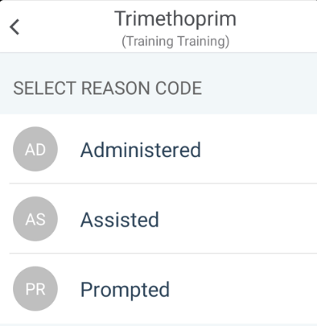

Level 3

Level 2

Level 1

Appendix 3
Care Planner Medication Levels

Care Planner has medication levels for when the Base Staff are entering medication on to the system.
There are Four levels that the person adding the medication can use these are shown below:
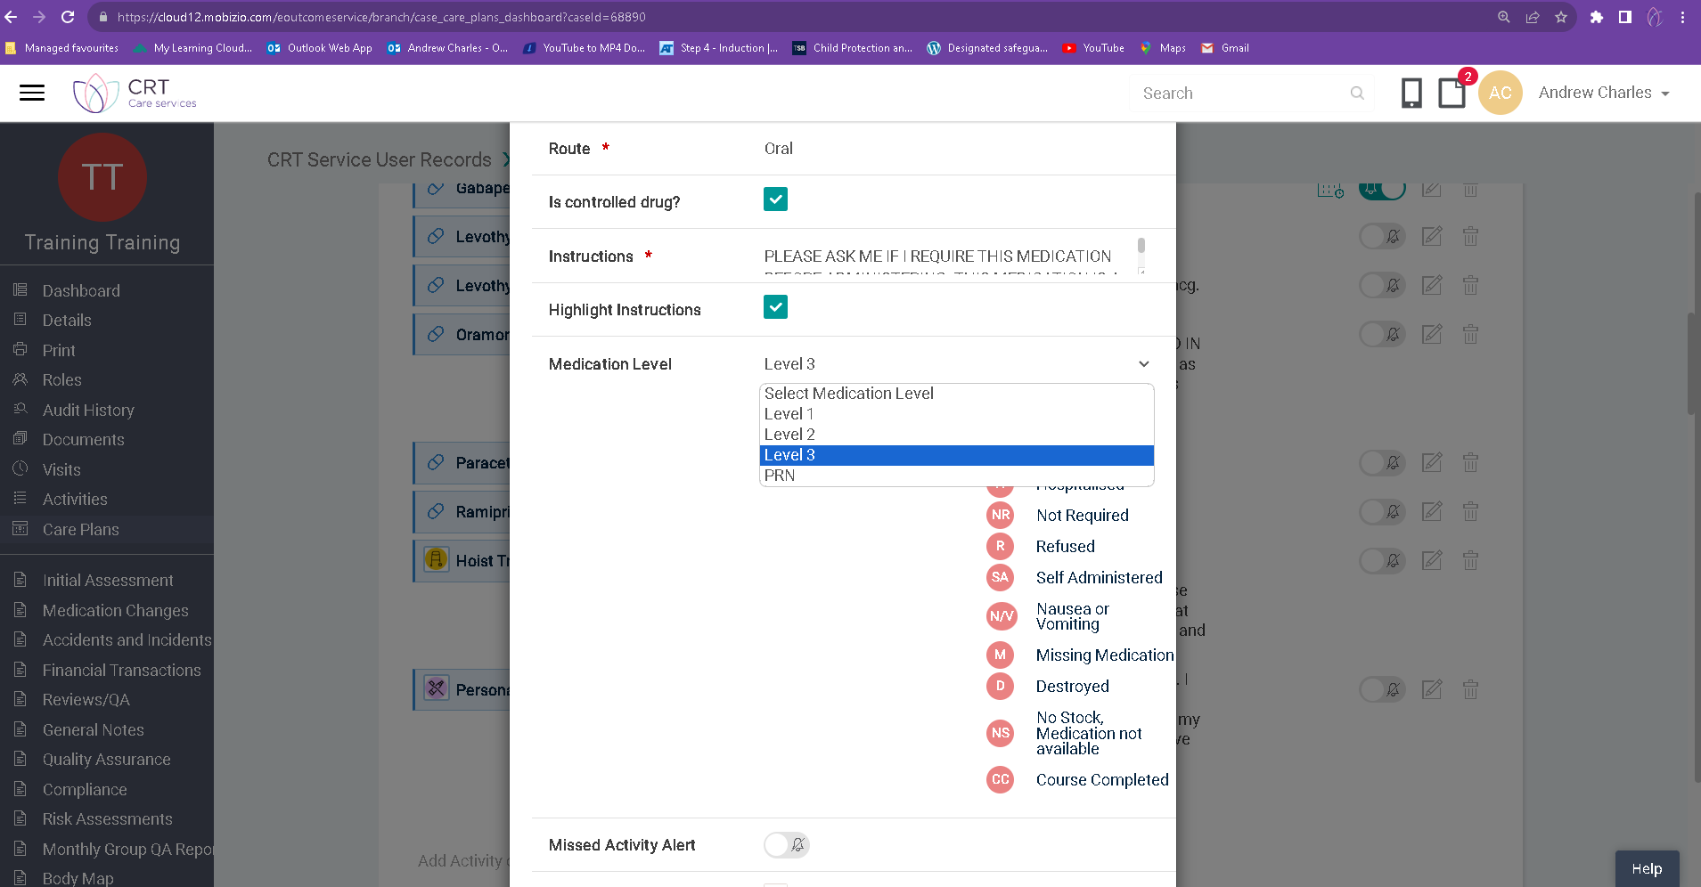
Level 1 – Prompt or Self Administer
Level 2 – Assisted
Level 3 – Administered
Level 4 – PRN [As an when required]
These levels dictate the options that you get when you select Not Completed. Each medication should have a level attached to this that dictates what you are to do when on a visit.
Level 1
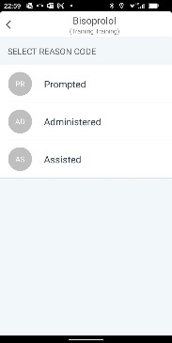
Prompt or Self Administer - The Directions should also include, not just how the person takes the medication, but also what you are to do in relation to this medication. E.g. Asking the person have they taken the medication [Prompt], or checking to see if the medication has been taken [Self Administer]. Please be aware if we have had to prompt someone for more than 3 consecutive days this should be reported to the office, as this may need the person to be reassessed.
Level 2
Assist – The directions for should also include, not just how the person takes the medication, by also what you need to do in relation to supporting the person to take their medications. E.g. Gathering the relevant medications for the individual, and a drink for the person, and then letting the person take their own medication. This may also include opening bottles of medication, but not removing the lid. If we remove the lid this can be interpreted as Administration. We may need to do this for a service user, who may not have the dexterity or strength top open bottles etc.

Level 3
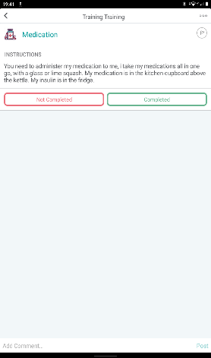
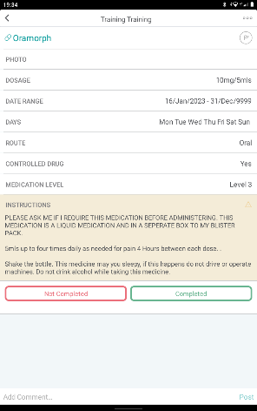
Administer – This is where we are administering the medication to the Service User. You should follow the directions on how to administer the medication to the individual. There is going to be clear directions on how to administer the medication as can be seen in the example.
You also need to follow the guidance that is in the medication guidance task, which should explain how the person likes to take their medications, and where medications are located.
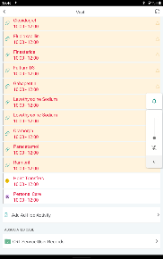
If the person has a medication which is a As and When Required Medication [PRN] then you should ensure that you read the PRN protocol located in the Service user records section of the application.
The PRN protocol will tell you when and
how you can administer the medication to the service user.

Level 4
PRN – This can be used as a level on its own for all PRN medications, the directions in the Instructions, and what is contained within the PRN protocol.
These are a detailed explanation of the Levels that should be recorded in the Care Planner application, so you know when, where and how medication should be administered to the service user.
If you are unsure about how to administer the medication from the information that you have been given. STOP, ring and contact the office / on call for support on how to proceed.

Medication Codes and Explanations

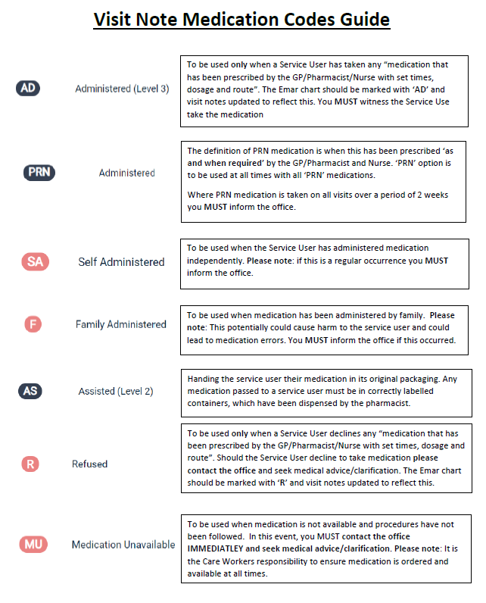

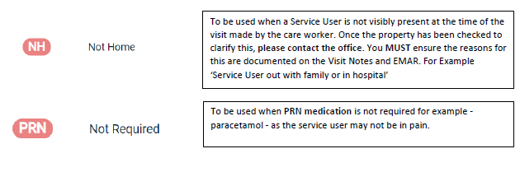

Secondary Dispensing

Secondary dispensing occurs when medication is removed from the container in which it was received from Pharmacy and put into a different one prior to administration.
Other containers may include dispensing pots, unlabelled bottles or boxes, different compliance aids to those dispensed, small bags or envelopes.
Secondary dispensing occurs for a number of reasons.
For example, a Service User may be going out for the afternoon with their family and will not be back for their teatime medication or a Service User may regularly attend a day centre at the same time each week and will be away from the home when medication is due. If the Service User goes on holiday or to stay with family / friends, the family or friend may sort the medication into some form of compliance aid for them.
Another example, medication being left out for the Service User to take at a later time, E.g. Service user does not want to take medication at the time when you are visiting, and ask you to leave it with them to take at a later time.

Why is Secondary Dispensing not recommended?
If the person giving the medicines does not have the original container with the label they cannot be sure that each resident receives the right dose of the right medicine at the right time, as prescribed.
When dispensing a prescription, a pharmacist must legally include the following information on the medicine label:
- name of the medicine and strength
- dose that is on the prescriptions, e.g. the number of tablets, capsules or volume of liquid to be taken
- frequency that is on the prescription, e.g. how often to take the dose
- any special instructions, for example take with food
- quantity supplied
- date the medicine was dispensed
- name of the person the medicine is prescribed for
Another reason for not carrying out Secondary Dispensing, If the medication is left out with the Service User, and they do not take it. Take at a later time i.e. half an hour before the Next visit is when the same dose is given, this could cause an overdose. Therefore medication should not be left with the service user, and if the Service User does not take the medication, it should be recorded as a Refusal, and the reason why explained.

CQC Advice on how to avoid Secondary Dispensing
When a Service User has leave from, staff are required to provide the medicines to be administered while the Service User is away.
- When leave is planned, such as for a longer holiday, the supplying pharmacist should be asked for help.
- This may be met by providing a separate supply of medicines for the full period of a holiday.
- The administration of the medicines in this case would be undertaken by either a carer or accompanying the party or by the person taking responsibility for the Service User whilst away.
- In the case of domiciliary care, i.e. out of the reach/sight of children, protected from light, heat and excessive moisture.
- It may be possible for the Service User’s pharmacist and GP to review the dosing regimen to reduce the frequency or change the timing of dosing. This avoids the need for medication to be given whilst the Service User is away during the day, for example, by prescribing longer-acting medicines that only require dosing morning and evening, or just in the morning.

Secondary dispensing can be avoided by allowing the Service User to take the whole blister pack out with them (if this is deemed appropriate for the Service User).

Every case has to be risk assessed and fully documented in the Service User’s care plan, including the name of the person taking responsibility of the medication whilst away from the Service User’s home.

Scenarios
- A Service user has a PRN medication Oramorph for pain, and can take this medication up to 4 times a day. You offer the medication to the Service User, and they refuse, explaining that they are not in pain and does not need the medication.
This should be recorded On the Application as:
Not Completed
PRN Not Required
In the Comments Section it should be recorded:
Offered the Service user their Oramorph, Service User said “I am not in pain, and do not require the medication.” Medication offered again before leaving and again declined. Explained that they can ask for the medication at the next visit.

- A Service User has Sickness and Diarrhoea, and does not want to take their medication. You have contacted the Pharmacy and asked if the medication and be missed, and Mr Smith Pharmacist at Good Medication Pharmacy, has said it is ok not to administer the medication. Spoke to Michelle Care Coordinator and explained what has been said.

This should be recorded On the Application as:
Not Completed
Nausea and Vomiting
In the Comments Section it should be recorded:
Service user explained on arrival, that they had Sickness and Diarrhoea, and they did not want their medications, due to how they were feeling. Rang the Pharmacist at Good Medication Pharmacy, and spoke to Mr Smith the Pharmacist, who explained that it was ok to miss the medication, and try with the next dose of medication at lunch time, if they refuse again, then to ring the Dr for additional support. Spoke to Michelle in the office, and explained the situation.

- Service user refuses medication, when offered.

This should be recorded On the Application as:
Not Completed
Refused
In the Comments Section it should be recorded:
Offered Service User their medication, and they have refused. I prepared the Breakfast, and then offered the medication again, again they have refused their medication. Rang the Pharmacist at Good Medication Pharmacy, and spoke to Mr Smith the Pharmacist, who explained that it was ok to miss the medication, and try with the next dose of medication at lunch time, if they refuse again, then to ring the Dr for additional support. Spoke to Michelle in the office, and explained the situation. Offered once again before I left, and again Service User refused.

- You have done the Service Users team time call at 1800, and their bedtime call is at 2000. Their medications need to have a 4hr spacing between the doses, and there has only been 2hrs. The Service User asks you to leave the medications with them and they will take them later.
This should be recorded On the Application as:
Not Completed
Refused – We would have to record as a refused as we are unable to leave the medication out with the person as this is secondary dispensing and we cannot do this. Also, there is no code for unable to administer.
In the Comments Section it should be recorded:
Unable to administer the mediation as there has not been enough time between the previous dose and this one. Rang the Pharmacist at Good Medication Pharmacy, and spoke to Mr Smith the Pharmacist, who explained that it was ok to miss the medication, to ring the Dr for additional support, in relation to change medications i.e. a prolonged dose. Spoke to Michelle in the office, and explained the situation.

