**“GetAddressService” AL demo project tested**

This demo will show **how to use Vs Code to AL to create and distribute an extension with NAV 2018** (in this case for NAV 2018 but for Tenerife it will be the same thing).

It will start from the installation of the necessary modules for the use of New Development Environment and will be recreated the demo environment provided by Microsoft step by step.

<https://github.com/Microsoft/AL/tree/master/samples/GetAddressService>

**ABOUT THE “GetAddressService” DEMO**

**“Accurate addresses** are a **must if you ship goods or delivering marketing materials.** This **extension connects to an external service** to verify and get the correct address based on a local address database. Whenever you specify a customer, vendor, contact, or any address in the **United Kingdom**, this extension helps you make verify that you got the right address.”

You need to download **NAV 2018 GB Database** to test this demo: example: **“NAV 2018 GB.zip”**

The demo shown is the one found in the **demo section on the GitHUB page of Microsoft AL**

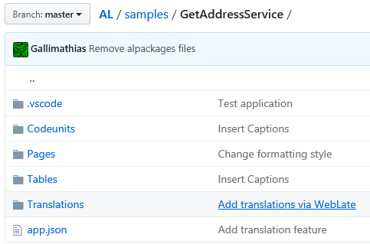

**'Would you like to look for addresses on this post code online?**

In this demo it is possible **to search for an address starting from an online post code**, the system uses the search system in force in the United Kingdom.

To use this demo it is **necessary to use the GB localization of NAV**, it does not work with other localizations.

<https://github.com/Microsoft/AL/tree/master/samples/GetAddressService>

<https://github.com/Microsoft/AL/blob/master/samples/GetAddressService/Codeunits/AddressService.al>

**The “GetAddress” Project**

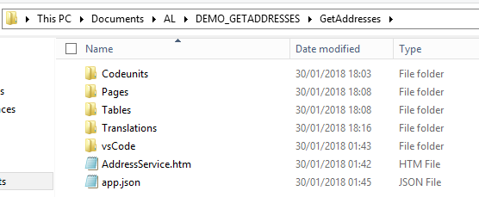

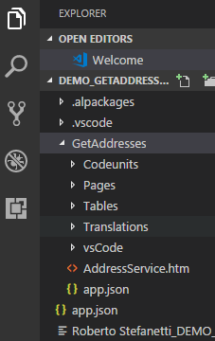

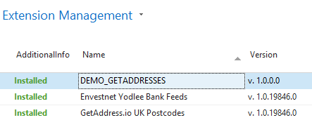

Solution: **GetAddress.io UK Postcodes**

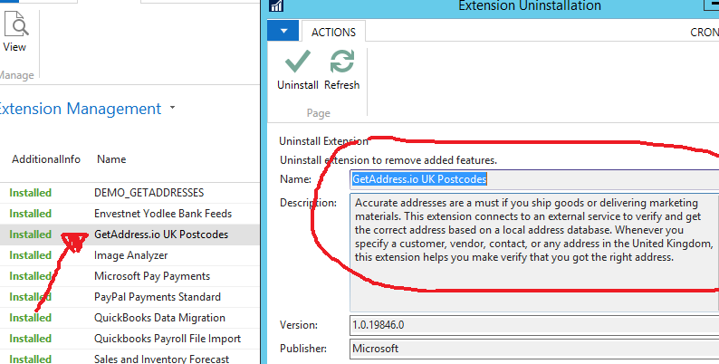

**GetAddress.io UK Postcodes**

**“Accurate addresses** are a must if you ship goods or delivering marketing materials**.** This **extension connects to an external service** to **verify and get the correct address** based on a local address database. Whenever you specify a customer, vendor, contact, or any address in the **United Kingdom**, this extension helps you make verify that you got the right address.”

You need to **get a free API code from getaddress.io** site to test the solution.

<https://getaddress.io>

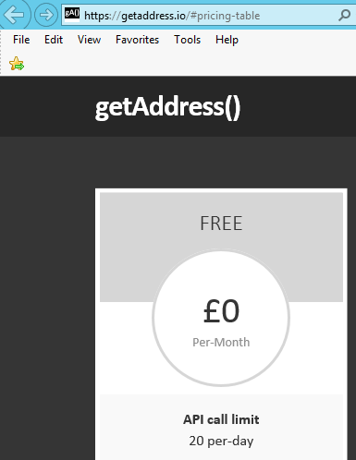

**HOW SYSTEM WORKS**

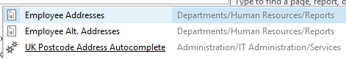

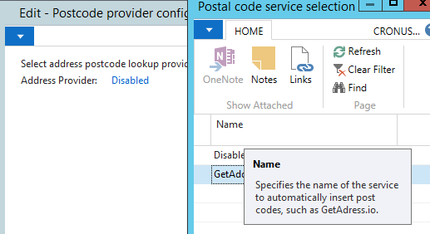

**ENTER THE API CODE (RECEIVED FROM EMAIL)**

|  |
| --- |
| **Your API Key**  XXXXXXXXXXXXXXXXXXXXXXX  **Usage**  [https://api.getAddress.io/find/{postcode}](https://api.getAddress.io/find/%7bpostcode%7d) |

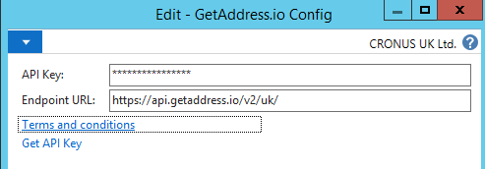

**BINGO!** …now you can call the API

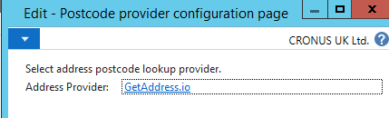

**API Provider is ACTIVE**

**“How-To” run GetAddress.io**

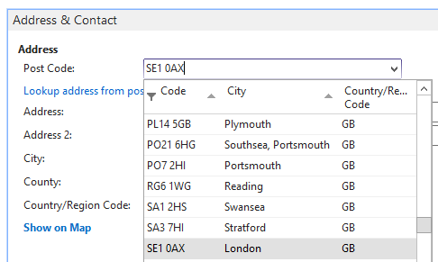

**OnAfterValidate on “Post Code” field** (Test for example with **SE1 0AX** Post Code, a post code with a lot of shipping addresses)

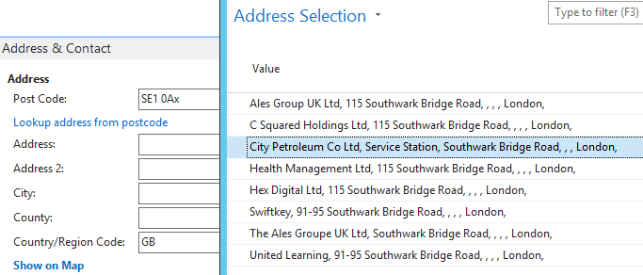

**After Selection, you have the correct address.**

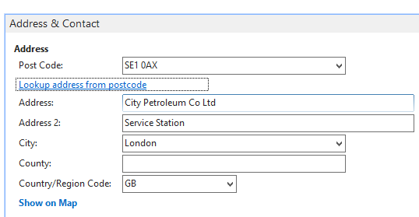

**You are Welcome!**