MULTIMEDIA UNIVERSITY OF KENYA

HILLARY OMONDI OCHIENG CIT-223-016/2022
BACHELOR OF COMPUTER SCIENCE LEARNING AND ADAPTIVE SYSTEMS CAT 1

Question One

Describe learning components using appropriate diagrams.’

  - Input -This is the data fed into the system.
  - Target function ( f : X-> Y ) -This is the true (ideal) mapping from input to output.
  - Training Examples - These are sample input-output pairs used for learning. (x1,y1),(x2,y2),…,(xn,yn)
  - Learning algorithms The procedure that:
Searches through the hypothesis set
Finds the best hypothesis based on training data
  - Final Hypothesis - The chosen model after training.
  - Hypothesis set - The set of all possible models/functions the algorithm can choose from.

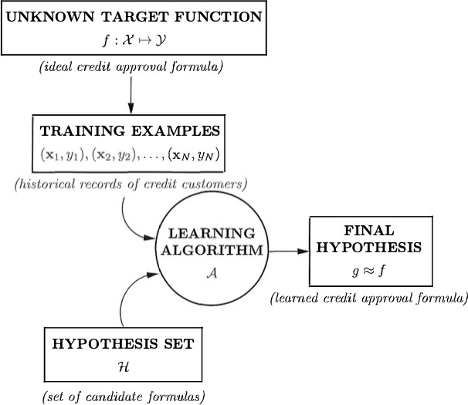

Initial Machine Learning aims to understand pattern classification well. Often many algorithms are used. Using a commented code, write a program to implement MNIST Dataset learning of digits 0 – 9. [10 Marks]

import pandas as pd import numpy as np from math import log2

# Dataset data = [
["Sunny","Hot","High","Weak","No"],
["Sunny","Hot","High","Strong","No"],
["Overcast","Hot","High","Weak","Yes"],
["Rain","Mild","High","Weak","Yes"],
["Rain","Cool","Normal","Weak","Yes"],
["Rain","Cool","Normal","Strong","No"],
["Overcast","Cool","Normal","Strong","Yes"],
["Sunny","Mild","High","Weak","No"],
["Sunny","Cool","Normal","Weak","Yes"],
["Rain","Mild","Normal","Weak","Yes"],
["Sunny","Mild","Normal","Strong","Yes"],
["Overcast","Mild","High","Strong","Yes"],

["Overcast","Hot","Normal","Weak","Yes"],
["Rain","Mild","High","Strong","No"]
]
df = pd.DataFrame(data, columns=["Outlook","Temp","Humidity","Wind","Play"]) # Entropy function
def entropy(target):
values, counts = np.unique(target, return_counts=True) probs = counts / counts.sum()
return -sum(p * log2(p) for p in probs)

# Information Gain
def info_gain(data, feature, target="Play"): total_entropy = entropy(data[target])
values, counts = np.unique(data[feature], return_counts=True) weighted_entropy = sum(
(counts[i]/sum(counts)) *
entropy(data.where(data[feature]==values[i]).dropna()[target]) for i in range(len(values))
)
return total_entropy - weighted_entropy # Compute IG for all features
for col in ["Outlook","Temp","Humidity","Wind"]:
print(col, ":", round(info_gain(df, col), 3))

Question Two

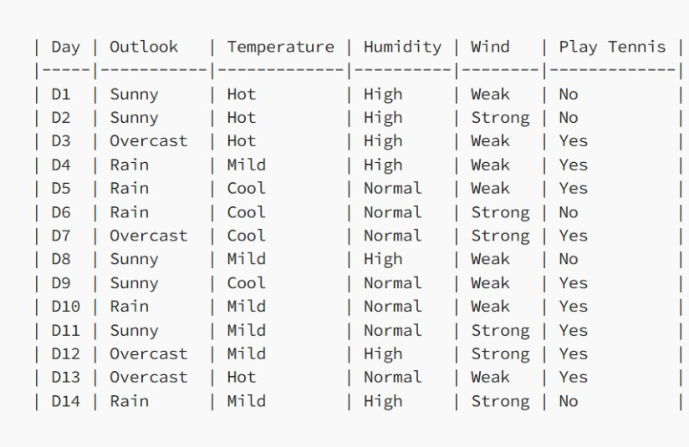

Consider the above dataset of playing decisions . Calculate information gain of each feature.

Step 1: Entropy of Dataset
Total samples = 14, Yes = 9, No = 5
H(S) = -[(9/14)log2(9/14) + (5/14)log2(5/14)] = 0.940

Step 2: Information Gain for Outlook
Sunny: (2 Yes, 3 No) → H ≈ 0.971
Overcast: (4 Yes, 0 No) → H = 0
Rain: (3 Yes, 2 No) → H ≈ 0.971
Weighted Entropy = (5/14)*0.971 + (4/14)*0 + (5/14)*0.971 = 0.694 IG(Outlook) = 0.940 - 0.694 = 0.246

Step 3: Information Gain for Temperature
Hot: (2 Yes, 2 No) → H = 1.000
Mild: (4 Yes, 2 No) → H ≈ 0.918
Cool: (3 Yes, 1 No) → H ≈ 0.811 Weighted Entropy ≈ 0.911 IG(Temperature) = 0.940 - 0.911 = 0.029

Step 4: Information Gain for Humidity
High: (3 Yes, 4 No) → H ≈ 0.985
Normal: (6 Yes, 1 No) → H ≈ 0.592 Weighted Entropy ≈ 0.788 IG(Humidity) = 0.940 - 0.788 = 0.151

Step 5: Information Gain for Wind
Weak: (6 Yes, 2 No) → H ≈ 0.811
Strong: (3 Yes, 3 No) → H = 1.000 Weighted Entropy ≈ 0.892 IG(Wind) = 0.940 - 0.892 = 0.048

Identify the most feasible to split.
Outlook - has the highest Information Gain = 0.246 This means it reduces uncertainty the most.

Write a python code we can use to calculate entropy and information gain. [10 marks]

import pandas as pd import numpy as np from math import log2

# Dataset data = [
["Sunny","Hot","High","Weak","No"],
["Sunny","Hot","High","Strong","No"],
["Overcast","Hot","High","Weak","Yes"],
["Rain","Mild","High","Weak","Yes"],
["Rain","Cool","Normal","Weak","Yes"],
["Rain","Cool","Normal","Strong","No"],
["Overcast","Cool","Normal","Strong","Yes"],
["Sunny","Mild","High","Weak","No"],
["Sunny","Cool","Normal","Weak","Yes"],
["Rain","Mild","Normal","Weak","Yes"],
["Sunny","Mild","Normal","Strong","Yes"],
["Overcast","Mild","High","Strong","Yes"],
["Overcast","Hot","Normal","Weak","Yes"],
["Rain","Mild","High","Strong","No"]
]
df = pd.DataFrame(data, columns=["Outlook","Temperature","Humidity","Wind","Play"]) # Entropy function
def entropy(target):
values, counts = np.unique(target, return_counts=True) probs = counts / counts.sum()
return -sum(p * log2(p) for p in probs)

# Information Gain function
def information_gain(df, feature, target="Play"): total_entropy = entropy(df[target])

values, counts = np.unique(df[feature], return_counts=True)

weighted_entropy = sum( (counts[i] / sum(counts)) *
entropy(df[df[feature] == values[i]][target]) for i in range(len(values))
)
return total_entropy - weighted_entropy # Compute for each feature
for feature in ["Outlook", "Temperature", "Humidity", "Wind"]: print(f"{feature}: {round(information_gain(df, feature), 3)}")

