COA Community Energy Center

## Home Energy Audit Report

|  |
| --- |
|  |

SUBMITTED TO: Me_test1

SUBMITTED BY: Rudolfs DATE: 3 June 2024

## Summary

Energy Audit of your property was conducted on 2024-05-25 We looked into insulation, mechanical equipment, conducted test like blower door test to quantify the energy efficiency of your home. By analyzing collected and all the data that you provided your home energy cost your approximately 3000 yearly. (This report also shows the list of improvements that could lower energy consumption and improve comfort and health)

## Home’s current conditions

|  |  |
| --- | --- |
| Build: Year 2024 | Primary heating fuel: Oil |

|  |  |
| --- | --- |
| Volume: 3000 cubic feet | Secondary heating fuel: |

|  |  |
| --- | --- |
| Area: 3000 square feet | Water heating fuel: |

|  |  |
| --- | --- |
| Net wall area: 600 square feet | Window type: singlepaned |

|  |  |
| --- | --- |
| Ceiling/attic area: 1000 square feet | Window area:200 square feet |

|  |  |
| --- | --- |
| Ceiling height: 5 feet | Door type and area: no_idea, 300 square feet |

## Health and safety

Combustion Gas Spillage Test – FAILED (Emissions Spilled for 60 seconds)

Appliance Carbon Monoxide (CO) Test – PASSED( Detected 24parts per million)

Ambient Carbon Monoxide (CO) Test – PASSED (Detected 20 parts per million)

Combustion Appliance Draft Test – PASSED

Gas leak detection: FAILED, In the kitchen

Other Health & Safety Concerns: There were no further health and/or safety concerns that were identified at the time of your energy audit.

## Air quality

## Insulation levels

|  |  |  |
| --- | --- | --- |
| HOME COMPONENT | YOUR HOME’S R-VALUES | US D.O.E. RECOMMENDED R-VALUES |
| Attics/Ceilings | 40 | 60 |
| Above Ground Walls | 30 | 30 |
| Basement Walls | 50 | 19 |

source [U.S. Department of Energy, Pacific Northwest Labaratory](https://basc.pnnl.gov/information/2009-2021-iecc-and-irc-minimum-insulation-requirements-new-homes)

Here are some picture of your insulation.

|  |
| --- |
|  |

|  |
| --- |
|  |

|  |
| --- |
|  |

|  |
| --- |
|  |

Images of the insulation pictures.

## Air Leakage Test

The blower door test, determined that your homes air leakage rate is 0.5Natural Air Changes per Hour(ACHn) (Should I explain what ACHn is?) CFM50 was 500 with A ring used. (Include photo)

|  |
| --- |
|  |

There was a significant hole in the further rooms closet into the attic

### Your Building on the scale

This scale shows how is your building compare to air leakage standards. Where being closer to zero providing with the best energy saving.

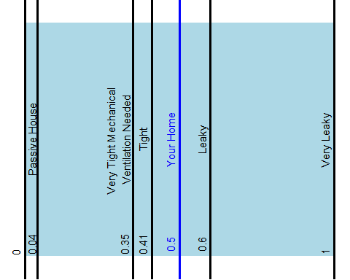

The blower door test and visual inspection detected the following areas for moderate to severe air leakage:

(This would be pictures)

|  |
| --- |
|  |

|  |
| --- |
|  |

|  |
| --- |
|  |

|  |
| --- |
|  |

|  |
| --- |
|  |

|  |
| --- |
|  |

## Heating and Cooling Systems

(Image of heating system) Your home is currently heated with an Oil Your current heating system has the following efficiency and output ratings:

* Heating efficiency = 50
* Annual Fuel Utilization Efficiency (AFUE)(need a new column here)
* Heating output = 3000 Btu/hr.

Your home is cooled with (need new column for cooling type) {r} reference to df.. (I need conditional rendering here) The size, construction, and energy consuming features of your home have all been factored into the calculation of the heating and cooling loads for your home:

* Heating load = 2000 Btu/hr
* Cooling load = 1000Btu/hr

It is important to make sure that a new heating/cooling system is designed to meet the heating and cooling loads of your home. And please keep in mind that any changes to your home (i.e. – air sealing, insulating, etc…) will ultimately decrease your heating load and can lead to saving money on a new heating system by enabling you to purchase a system with a lower energy output.

## Buildings Electricy use

## Energy Bill analysis

