## Energy Audit Report

Homeowner: Me_summer_test1

Address: Me_summer_test1

Auditors: Rudolfs

Contact: mdicommunityenergy@coa.edu, 802 266 0301

Date: 15 July 2024

We conducted an energy assessment of your home on 2024-05-25. This report will tell you what we did, what we found, and what we suggest for your home. These suggestions include information on incentives and financing to make improvements more affordable.



# Table of Contents

Here will be the table of contents

# 1. Summary of your Audit

**1.1 Visual Inspection and Measurements**

We started with a tour and visual inspection of the inside and outside of the home. We identified any visible damage to the building, moisture control strategies, major appliances, and insulation. We measured square footage and volume of the home, as well as the area of all exterior windows and doors. We used a kill-a-watt meter to measure the electricity use of some appliances. During your audit, we used a carbon monoxide meter to measure the ambient carbon monoxide levels throughout the home.

**1.2 Attic**

We entered the attic to check for insulation, air sealing, ventilation, and potential hazards such as mold. Additionally, we visually inspected the attic ventilation and any duct and pipework passing through the attic.

**1.3 Basement**

We visually inspected any appliances in the basement and noted insulation levels, moisture, rodents, and any other concerns.

x <- c("Heating oil")  
if (x == "Heating oil") {  
 print("**1.4 Combustion Appliance Safety**   
We assessed combustion appliances that burn fossil fuels such as propane, heating oil, or kerosene. These include furnaces, boilers, water heaters, and gas ovens.")  
} else if (x == "Propane") {  
 print("**1.4 Combustion Appliance Safety**   
We assessed combustion appliances that burn fossil fuels such as propane, heating oil, or kerosene. These include furnaces, boilers, water heaters, and gas ovens.")  
} else if (x == "Kerosene") {  
 print("**1.4 Combustion Appliance Safety**   
We assessed combustion appliances that burn fossil fuels such as propane, heating oil, or kerosene. These include furnaces, boilers, water heaters, and gas ovens.")  
} else if (x == "Firewood"){  
 print("**1.4 Combustion Appliance Safety**   
We assessed combustion appliances that burn fossil fuels such as propane, heating oil, or kerosene. These include furnaces, boilers, water heaters, and gas ovens.")  
} else if (x == "Pellets") {  
 print("**1.4 Combustion Appliance Safety**   
We assessed combustion appliances that burn fossil fuels such as propane, heating oil, or kerosene. These include furnaces, boilers, water heaters, and gas ovens.")  
} else {  
 print("")  
}

[1] "**1.4 Combustion Appliance Safety** \nWe assessed combustion appliances that burn fossil fuels such as propane, heating oil, or kerosene. These include furnaces, boilers, water heaters, and gas ovens."

**1.5 Blower Door / Air Leakage Test**

We used a large fan in an exterior door to depressurize your house. This allows us to determine the volume of air leakage into the house and to locate bigger air leaks. To find leaks, we used an infrared camera to check for unusually hot and cold spots. We also checked the pressure differences of the rooms to help determine major air leak locations.

## Home’s current conditions

|  |  |
| --- | --- |
| Build: Year 2024 | Primary heating fuel: Oil |

|  |  |
| --- | --- |
| Volume: 3000 cubic feet | Secondary heating fuel: |

|  |  |
| --- | --- |
| Area: 3000 square feet | Water heating fuel: |

|  |  |
| --- | --- |
| Net wall area: 600 square feet | Window type: singlepaned |

|  |  |
| --- | --- |
| Ceiling/attic area: 1000 square feet | Window area:200 square feet |

|  |  |
| --- | --- |
| Ceiling height: 5 feet | Door type and area: no_idea, 300 square feet |

## Health and safety

Combustion Gas Spillage Test – FAILED (Emissions Spilled for 60 seconds)

Appliance Carbon Monoxide (CO) Test – PASSED( Detected 24parts per million)

Ambient Carbon Monoxide (CO) Test – PASSED (Detected 20 parts per million)

Combustion Appliance Draft Test – PASSED

Gas leak detection: FAILED, In the kitchen

Other Health & Safety Concerns: There were no further health and/or safety concerns that were identified at the time of your energy audit.

## Air quality

## Insulation levels

|  |  |  |
| --- | --- | --- |
| HOME COMPONENT | YOUR HOME’S R-VALUES | US D.O.E. RECOMMENDED R-VALUES |
| Attics/Ceilings | 40 | 60 |
| Above Ground Walls | 30 | 30 |
| Basement Walls | 50 | 19 |

source [U.S. Department of Energy, Pacific Northwest Labaratory](https://basc.pnnl.gov/information/2009-2021-iecc-and-irc-minimum-insulation-requirements-new-homes)

Here are some picture of your insulation.

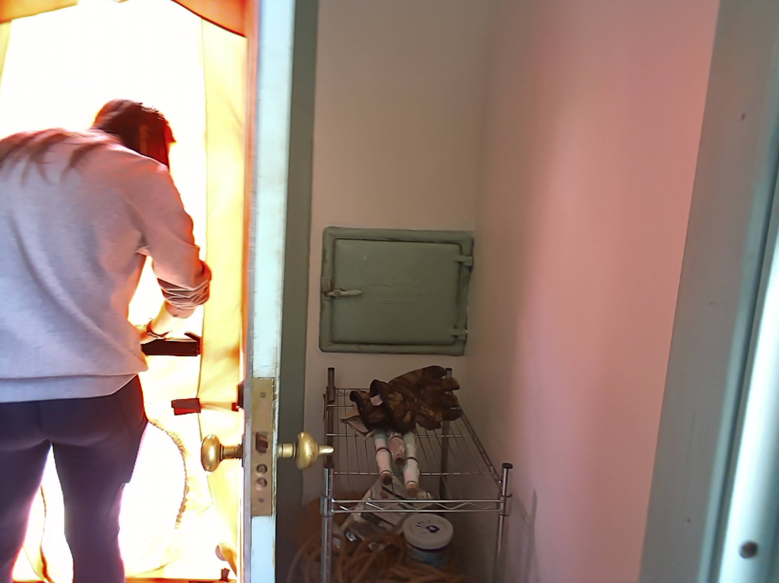

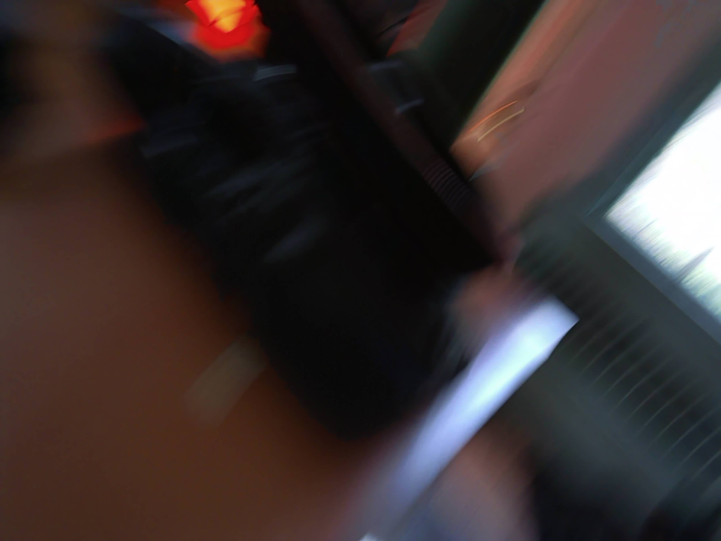

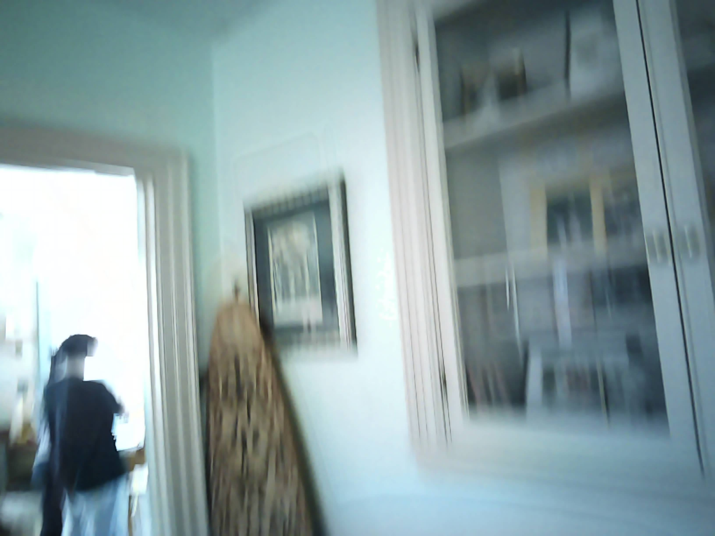

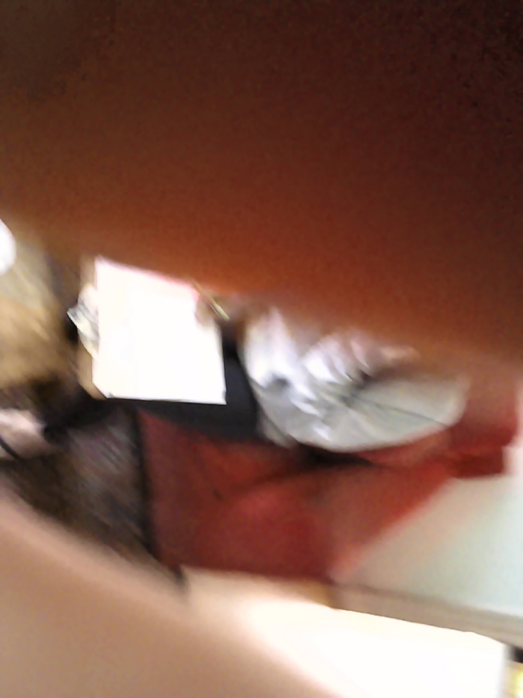

Images of the insulation pictures.

## Blower Door / Air Leakage Test

The blower door test, determined that your homes air leakage rate is 0.5Natural Air Changes per Hour(ACHn) (Should I explain what ACHn is?) CFM50 was 500 with A ring used. (Include photo)

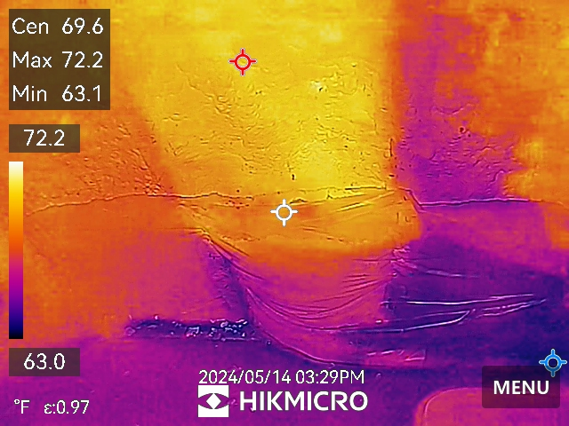

There was a significant hole in the further rooms closet into the attic

### Your Building on the scale

This scale shows how is your building compare to air leakage standards. Where being closer to zero providing with the best energy saving.

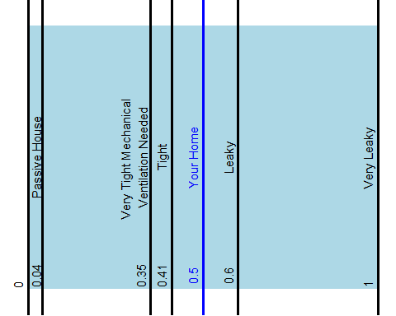

The blower door test and visual inspection detected the following areas for moderate to severe air leakage:

(This would be pictures)

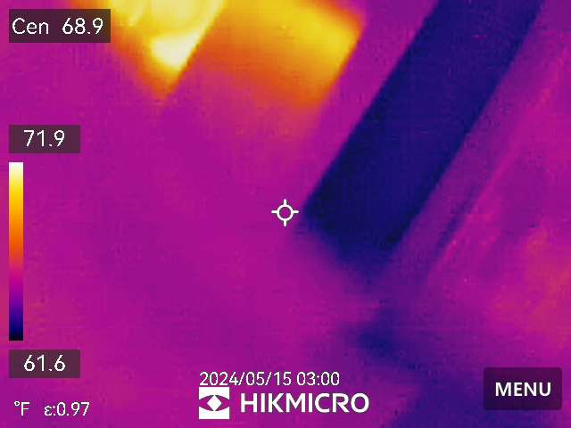



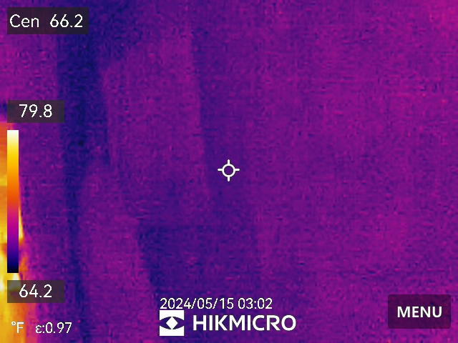



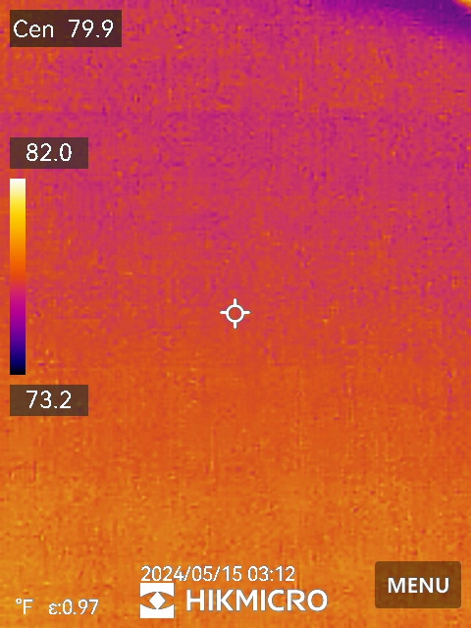



## Heating and Cooling Systems

(Image of heating system) Your home is currently heated with an Oil Your current heating system has the following efficiency and output ratings:

* Heating efficiency = 50
* Annual Fuel Utilization Efficiency (AFUE)(need a new column here)
* Heating output = 3000 Btu/hr.

Your home is cooled with (need new column for cooling type) r code here. (I need conditional rendering here) The size, construction, and energy consuming features of your home have all been factored into the calculation of the heating and cooling loads for your home:

* Heating load = 2000 Btu/hr
* Cooling load = 1000Btu/hr

It is important to make sure that a new heating/cooling system is designed to meet the heating and cooling loads of your home. And please keep in mind that any changes to your home (i.e. – air sealing, insulating, etc…) will ultimately decrease your heating load and can lead to saving money on a new heating system by enabling you to purchase a system with a lower energy output.

## Buildings Electricy use

## Energy Bill analysis

