Maine CyberTech Portal — Platform Case Study
Investor / client-safe narrative: platform scope, security architecture, business modules, engineering maturity, and roadmap
Prepared on: 2026-05-29

Overview
The Maine CyberTech Portal is a modern, security-first operations platform built for managed services workflows. It combines client-facing and admin-facing portal experiences with a strongly governed backend architecture designed around tenant separation, role-based authorization, row-level data security, and secure document handling.

Platform Scope
The platform is designed to support a wide operational surface area inside a single system. That scope includes client onboarding, support ticketing, project tracking, secure document access, contracts, appointments, billing visibility, messaging, and auditability. Rather than splitting these workflows across multiple disconnected systems, the platform brings them together under one security model and one tenant model.

Security Architecture
A defining characteristic of the platform is its database-first security architecture. Users authenticate through Supabase Auth, are represented in application-facing profiles, are attached to organizations through memberships, inherit capabilities through roles and permissions, and are then filtered by row-level security before data is returned. File access follows the same logic through storage policies linked back to document metadata. This creates a stronger foundation than a portal that relies primarily on frontend visibility controls.
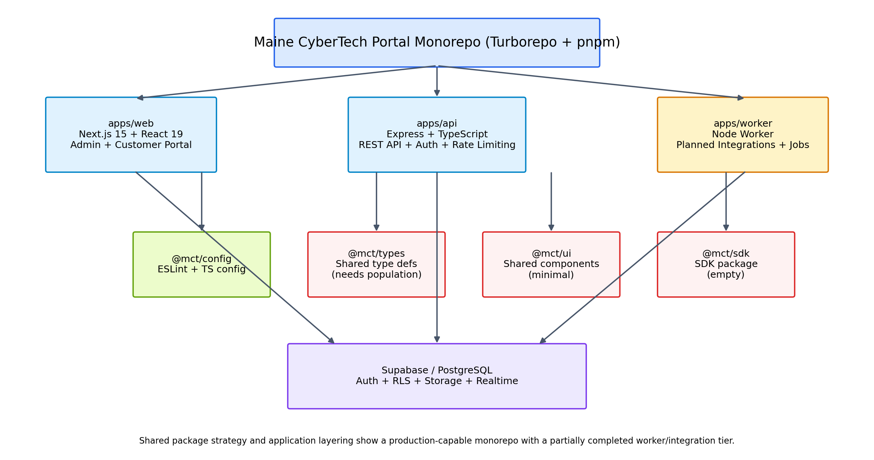
Figure 1. Platform architecture at a glance.

Business Modules
- Customer onboarding and intake workflows
- Support tickets and collaboration
- Projects and task management
- Secure documents with version history and explicit sharing
- Contracts and signer coordination
- Appointments and scheduling
- Billing visibility and payment records
- Messaging and audit logging

Engineering Maturity
The current state reflects strong maturity in the frontend application, backend API, database architecture, testing baseline, and documentation. The key areas still in progress are the asynchronous worker/integration tier, final deployment automation, and deeper consolidation of shared packages for long-term reuse. In other words, the foundation is solid and the remaining work is primarily operationalization.

Roadmap
The near-term roadmap is well-defined and low-risk relative to the platform already in place: clean up obsolete repository artifacts, consolidate shared packages, complete worker integrations, finish deployment automation, and then refresh operational documentation. This is a completion roadmap rather than a redesign roadmap, which is an encouraging maturity signal.
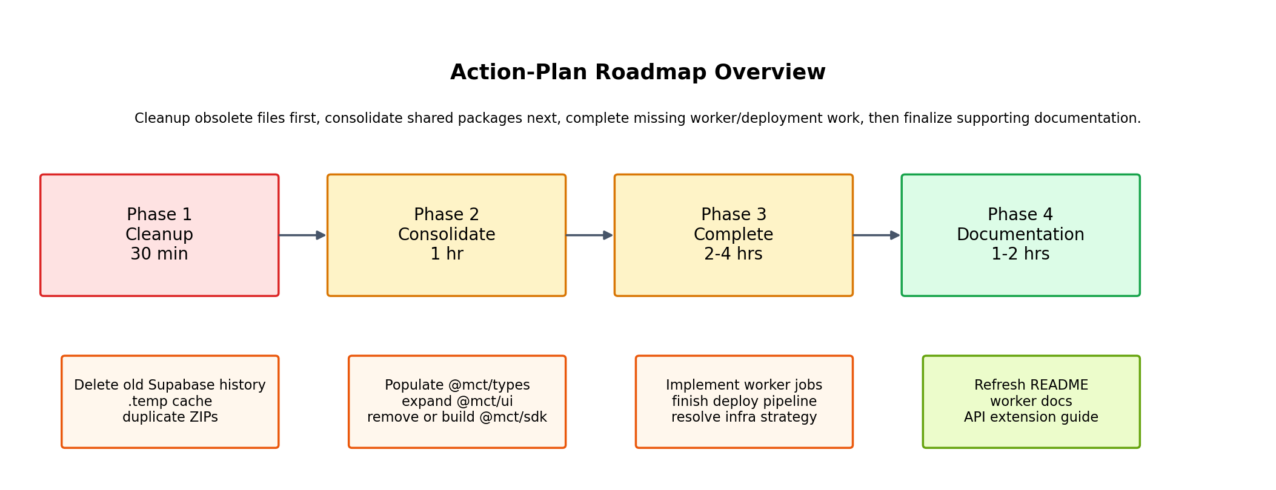
Figure 2. Near-term roadmap from cleanup to operational completion.

Outcome
The portal stands as a credible example of a secure, multi-tenant MSP operations platform with real architectural depth. It already demonstrates strong design decisions around tenant isolation, governance, and document security, while preserving a clear path to finish the remaining worker, deployment, and package-consolidation work.

