Portal Platform Current-State Assessment
Short companion document: what is done, what is missing, what happens next, and estimated effort
Prepared on: 2026-05-29

1. What Is Done
- Frontend (web) is production-ready with admin and customer experiences
- API (api) is production-ready with auth, rate limiting, logging, and error handling
- Supabase/PostgreSQL schema and RLS model are production-ready
- Document/version/permission seed alignment has been validated against the live schema
- Testing and CI/CD lint/test/build workflow foundations are in place
- Documentation is broad and usable for onboarding and handoff

2. What Is Missing
- Background worker tasks are not implemented beyond the framework shell
- Deployment automation is incomplete
- Shared packages (@mct/types, @mct/ui, @mct/sdk) are incomplete or placeholder-level
- Infrastructure-as-code strategy is not implemented
- Repository cleanup remains to be completed
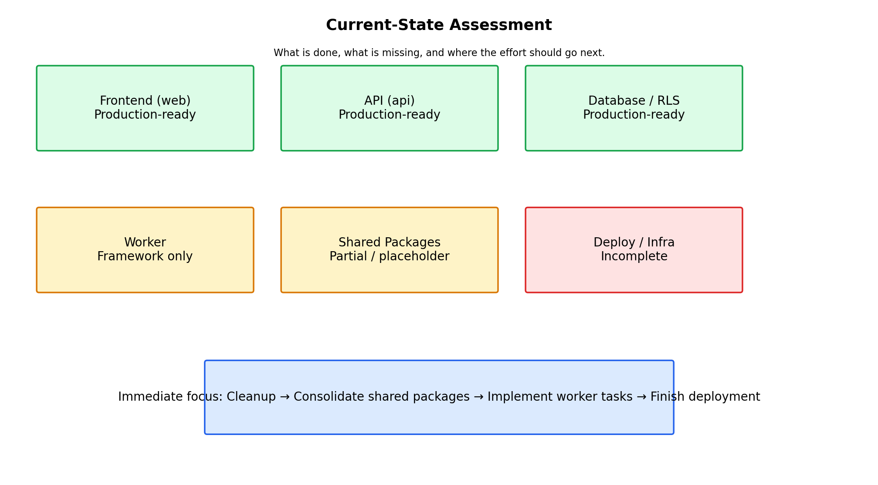
Figure 1. Current-state view of platform maturity across major areas.

3. What Should Happen Next
- Run cleanup first to remove obsolete database artifacts and duplicate archives
- Populate shared types and shared UI, and decide the future of the SDK package
- Implement worker tasks for Stripe, Jira/JSM, M365, and notifications
- Complete deployment workflow and settle the infra approach
- Refresh documentation once the operational pieces are in place

4. Effort Estimate by Phase
- Phase 1 — Cleanup: ~30 minutes
- Phase 2 — Consolidate: ~1 hour
- Phase 3 — Complete: ~2–4 hours
- Phase 4 — Documentation: ~1–2 hours
- Total: ~4–8 hours for the documented next-pass work
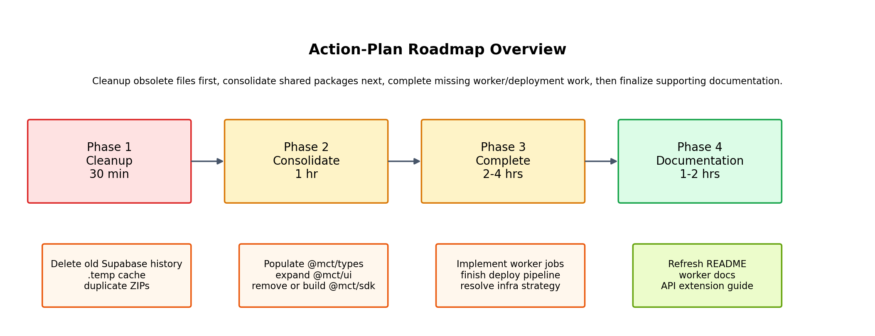
Figure 2. Phase-by-phase roadmap from the uploaded action-plan materials.

5. Executive Bottom Line
The platform is already strong where it matters most: application structure, tenant-aware security, and core portal capability. The remaining work is not a rebuild. It is an operational completion pass focused on cleanup, consolidation, integrations, and deployment.

