Portal Platform Formal Handoff Document
Executive Summary, Technical Appendix, and Portfolio / Case Study
Prepared for: Portal Team / Platform Stakeholders
Prepared on: 2026-05-29

This document consolidates the migration/bootstrap architecture, seed alignment work, permissions model, and platform design outcomes into a formal handoff package.

Executive Summary
The platform that has been built is a multi-tenant MSP/client portal on Supabase and PostgreSQL with organization-based tenancy, approval-gated memberships, role-based and override-based authorization, row-level security, document management with versioning and explicit sharing, and storage policies that follow the same access model as document rows.
The design is security-first: identity begins in auth, application identity is represented in profiles, tenant access is granted through memberships, operational capabilities are assigned through roles and permissions, and final enforcement happens inside PostgreSQL through row-level security and storage policies.

What Has Been Built
- Core tenancy and RBAC foundation (organizations, profiles, roles, permissions, memberships, overrides)
- Automated profile bootstrap from auth users through a trigger-based lifecycle
- Approval-gated organization memberships with contact and workflow metadata
- Document subsystem with document rows, version history, explicit share rules, and aligned storage access
- Business modules for onboarding, tickets, projects, project collaboration, contracts, appointments, billing, chat, and audit logging
- Helper functions for identity, membership approval, role checks, and fine-grained permission evaluation
- RLS policies across the major business modules so enforcement happens in the database rather than only in the application layer
- Seed and verification tooling aligned to the live schema and validated against the hosted dataset

Current Verified Outcome
The latest verification confirms that the exact schema-aligned seed landed successfully in the working environment. The dataset now shows 9 documents, 6 document versions, and 9 document permissions, and the two seeded document storage paths for Acme and Northwind are present. That means the document, version, and permission workflows are functioning against the live schema shape rather than a placeholder structure.

Platform Architecture Overview
The platform follows a consistent security chain. A user signs in as an auth identity, receives a portal profile, is attached to an organization through memberships, inherits capabilities through roles and permissions, and is then filtered by row-level security and storage policies before data or files are returned.
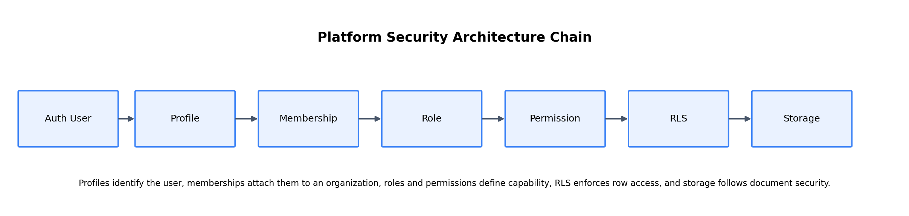
Figure 1. Security architecture chain: profiles → memberships → roles → permissions → RLS → storage.

1. Identity and User Lifecycle
Authentication is anchored in Supabase Auth, while application-facing identity is represented in public.profiles. A database trigger creates a profile automatically when a new auth user is inserted. Profiles store full name, email, title, super-admin state, default organization, and metadata. This separation allows the system to keep authentication concerns distinct from portal identity and workflow concerns.

2. Multi-Tenant Organization Model
Each client or tenant is represented by a row in public.organizations. The organization model includes status, domain, billing details, support plan, and tenant settings. Organization domains can be attached separately, which supports email/domain-based workflows and future onboarding automation.

3. Membership and Approval Model
Memberships connect users to organizations and roles. They also carry workflow state through statuses such as pending, approved, rejected, and suspended. This is critical because the platform does not treat all attached users as active users. Access to most business functions depends on the user being an approved member of the relevant organization.

4. Roles, Permissions, and Overrides
Roles represent broad access tiers such as super_admin, admin, client_admin, technician, and client_user. Permissions are the fine-grained actions that roles inherit through role_permissions. A user-specific override layer allows exceptions when a standard role mapping is not sufficient. The net result is a system that is predictable by default but still flexible enough to handle edge cases cleanly.

5. Database-Native Enforcement
The system relies heavily on helper functions such as is_super_admin(), is_org_member(), is_org_approved_member(), user_has_role(), and user_has_permission(). These helpers are called by row-level security policies across the portal. The result is that the database is the final enforcement engine, reducing risk from accidental overexposure in the frontend or API layer.
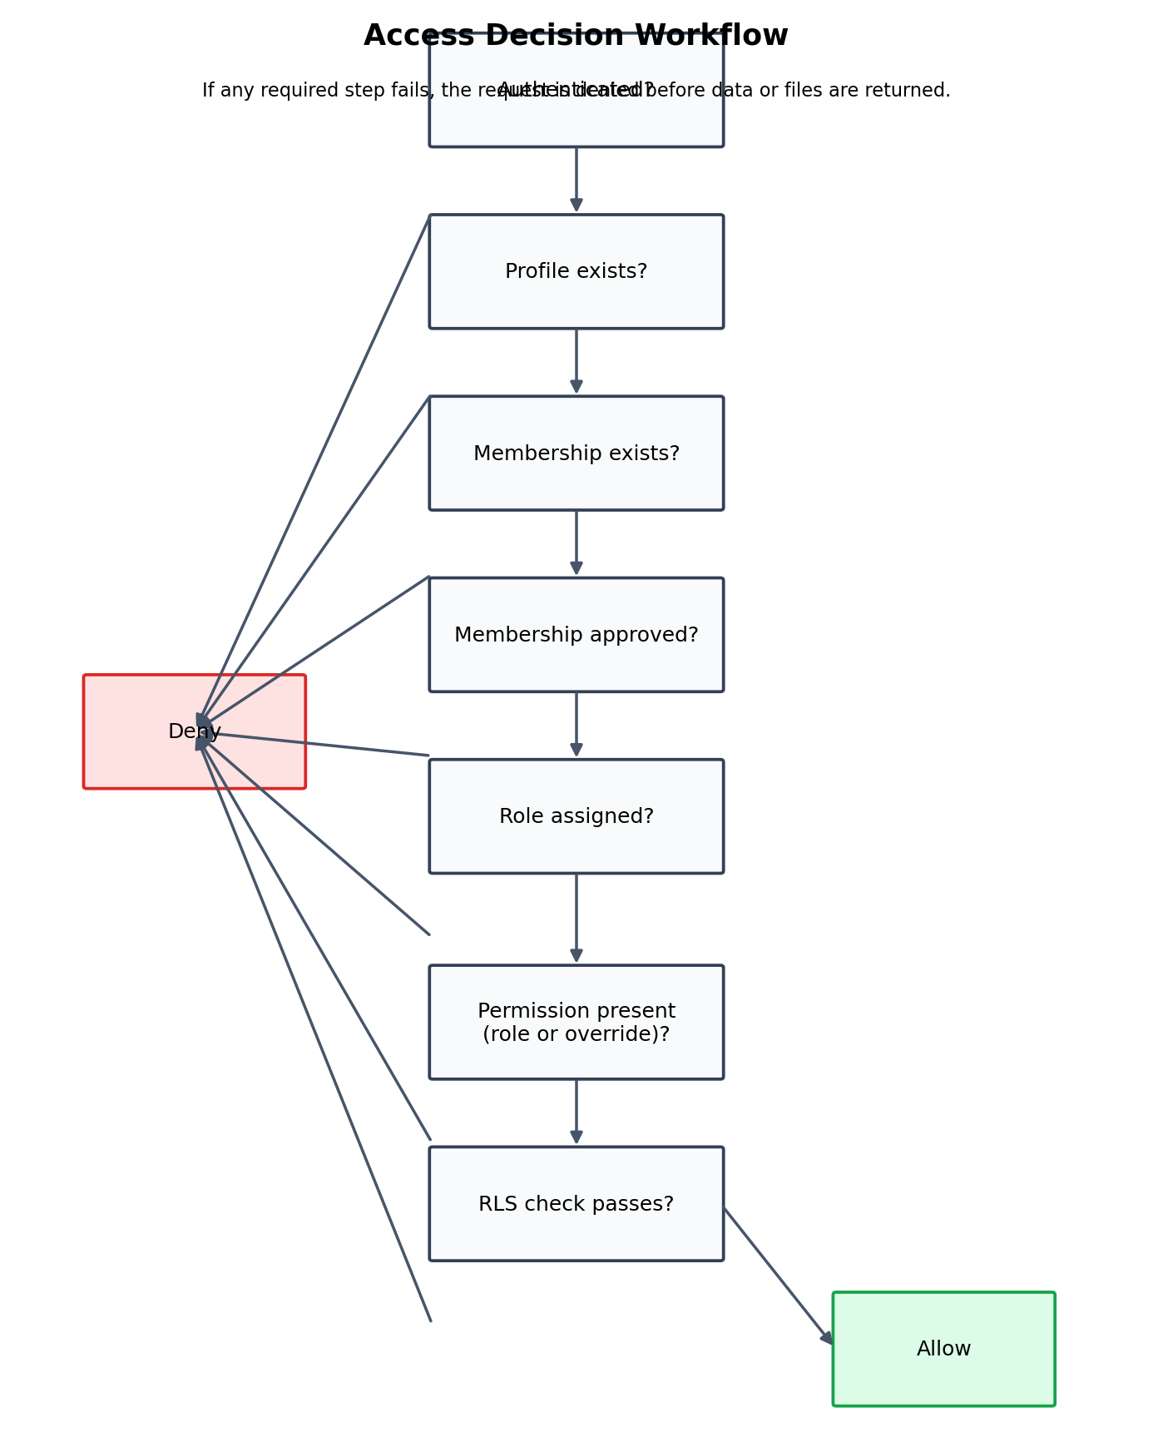
Figure 2. Access decision workflow enforced before row data is returned or changed.

Business Modules Implemented
The consolidated bootstrap and follow-on alignment work establish a broad operational platform rather than a single-purpose portal. The built modules include:
- Onboarding submissions and structured intake data
- Support tickets and ticket comments
- Projects, project members, project tasks, project updates, and task comments
- Document management, versioning, and explicit document sharing
- Contracts and contract signers
- Appointments and scheduling records
- Billing customers, subscriptions, invoices, and payments
- Chat threads and chat messages
- Audit logs for traceability and investigation
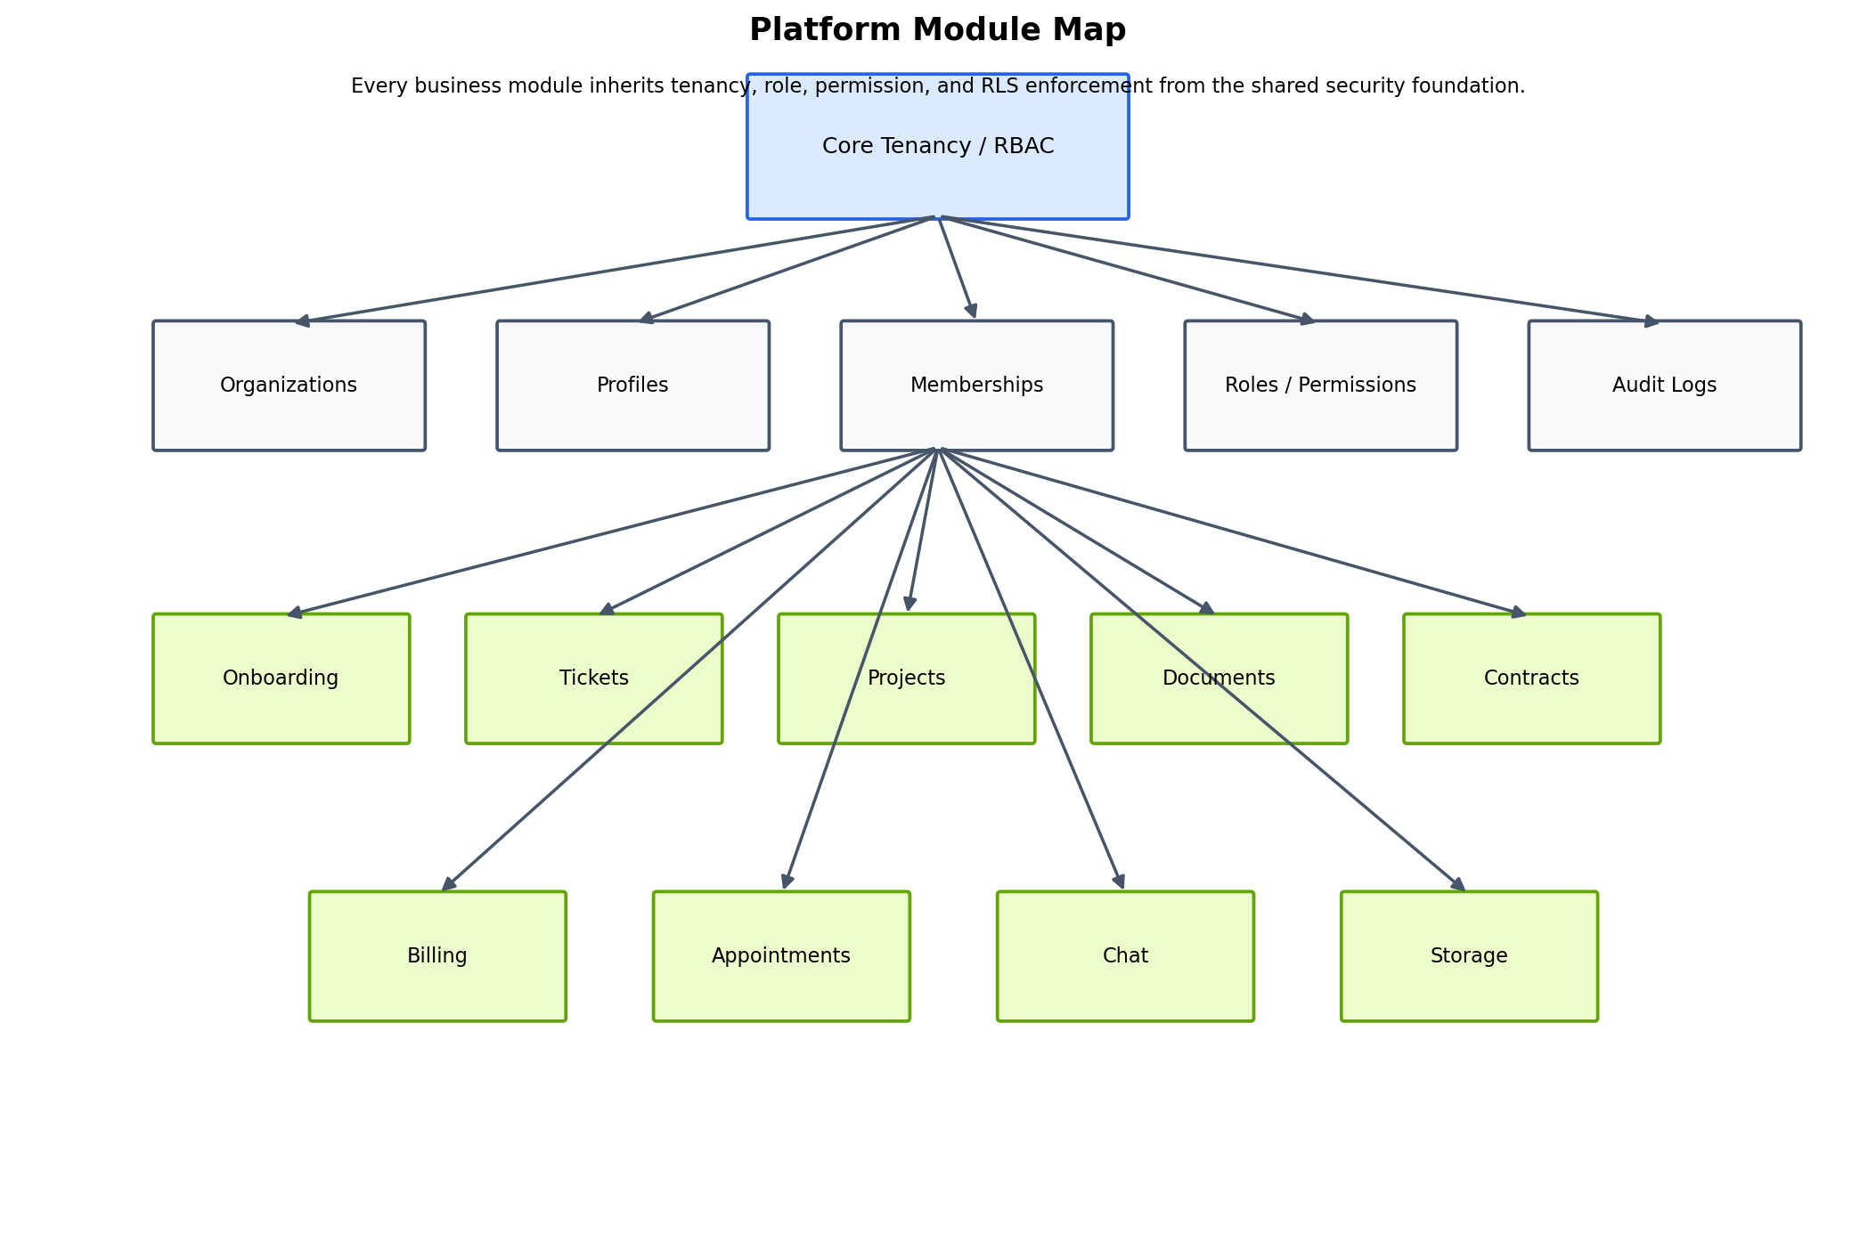
Figure 3. Module map showing business domains inheriting shared tenancy and security controls.

Document and Storage Security Model
The document subsystem is one of the most mature parts of the platform. Documents are represented in public.documents, version history is tracked in public.document_versions, and explicit share rules are stored in public.document_permissions. The document_visibility enum supports private, org, internal, and public states, and storage objects are protected through policies that resolve the matching document row before serving the file.
This means a file is not accessible just because it exists in a bucket. The matching document row, permission logic, and storage policy must all agree. This is the correct pattern for a client portal handling agreements, onboarding packets, internal documents, and customer artifacts.
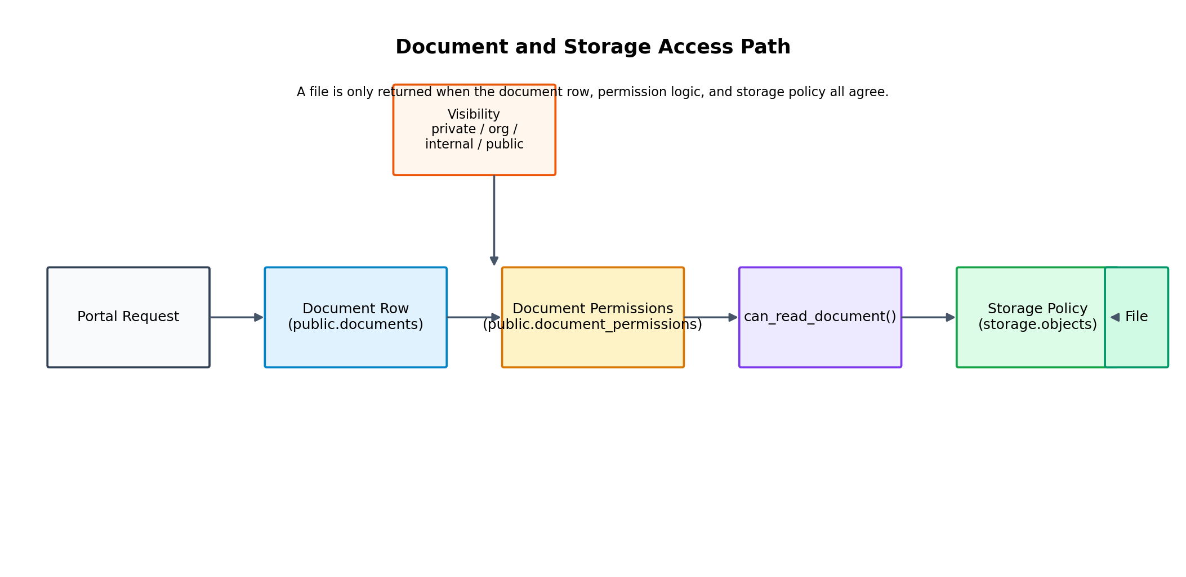
Figure 4. Document and storage access path: document rows, permissions, helper logic, and storage policies all participate in the final read decision.

Seed, Verification, and Operational Handoff
A final exact seed pack was created to align with the live schema. Rather than inventing synthetic auth users, the final seed reuses existing approved members in each organization as uploaders and version authors. This keeps the seed safe for real environments where auth.users is already populated and where foreign keys from documents, document_versions, and memberships resolve back to live identities.
Verification was also aligned to the real schema. It checks core row counts, document visibility distribution, the presence of the seeded Acme and Northwind document storage paths, seeded document version rows, and seeded document permission rows. The latest verification outcome confirmed that those rows exist in the live environment.

Portfolio / Case Study Write-Up

Project Summary
This platform represents the build-out of a modern, security-first MSP portal designed to support both internal administrators and client-side users. The project combines tenant isolation, strong authorization controls, operational workflows, and document security into a single platform architecture. It is suitable for managed services use cases where user access, client separation, approvals, auditability, and file confidentiality must all coexist.

Problem the Platform Solves
Many client portals solve only one narrow workflow such as tickets or file sharing. This platform was designed to solve a broader problem: giving an MSP a single environment where customer onboarding, support, projects, documents, contracts, billing, communication, and audit events can be managed with consistent tenant and security controls.

Approach
The implementation used a database-first security model. Instead of trusting the frontend to hide actions, the system defines clear tenancy, role, permission, and approval structures in PostgreSQL and enforces them with row-level security. That foundation then supports the portal application and storage layer in a consistent way.

What Makes This Build Strong
- Clear separation between identity, tenant membership, and privilege assignment
- Approval-gated access instead of immediate broad activation
- Roles backed by fine-grained permission rows rather than hard-coded UI logic
- Database-enforced RLS across core business modules
- Document/file access tied back to database security checks
- Operational coverage across tickets, projects, onboarding, contracts, billing, messaging, and auditing

Outcome
The result is a platform foundation that can be presented as both a production-ready portal architecture and a case study in secure SaaS design for MSP operations. The verified seed and documentation work demonstrate that the schema, security model, and document workflows are now aligned closely enough to support real handoff, further application development, and internal team onboarding.

Technical Appendix

A. Core Schema Foundations
The consolidated bootstrap creates the foundation for tenancy, RBAC, module data, and security. The exact schema includes enums for membership status, organization status, ticket/project/task states, contract and invoice states, and document visibility. It creates the core tenancy tables, then layers in module tables and later alignment changes for projects and documents.
Identity + RBAC: organizations, organization_domains, profiles, roles, permissions, role_permissions, memberships, user_permission_overrides, notification_preferences
Onboarding: onboarding_submissions
Support: tickets, ticket_comments
Projects: projects, project_members, project_tasks, comments, project_updates, project_task_comments, project_task_comment_reads
Documents: documents, document_versions, document_permissions
Contracts: contracts, contract_signers
Appointments: appointments
Billing: billing_customers, subscriptions, invoices, payments
Messaging: chat_threads, chat_messages
Audit: audit_logs

B. Helper Functions and Triggers
- handle_new_user() to bootstrap profiles from auth users
- set_updated_at() for timestamp maintenance
- is_super_admin(), is_org_member(), is_org_approved_member() as identity and approval helpers
- user_has_role() and user_has_permission() as reusable access evaluation helpers
- approve_project_task() and add_project_task_comment() as workflow-oriented RPCs

C. Exact Live Shape Notes Used in Final Alignment
- documents requires organization_id, uploaded_by, name, storage_bucket, and storage_path and includes title/description/file_name/file_size support
- document_versions requires document_id, version_number, storage_path, and uploaded_by
- document_permissions supports both user_id and role_id with can_view / can_edit / can_share flags
- memberships is uniquely constrained on (organization_id, user_id)
- documents is uniquely constrained on storage_path
- document_versions is uniquely constrained on (document_id, version_number)
- roles.key is the canonical lookup column for seeded role resolution

D. Handoff Recommendations
- Keep the consolidated bootstrap and migration chain under strict source control
- Use the final exact seed and verify files for environment validation
- Treat approved memberships as the operational boundary for real access
- Reserve is_super_admin for a very small set of platform operators
- Prefer role-based permissions over ad hoc overrides wherever possible
- Continue keeping storage access aligned to document metadata and RLS policy logic
- Use the admin guide for team onboarding and troubleshooting workflows

E. Source Basis for This Handoff
This handoff is grounded in the consolidated fresh bootstrap SQL, the live schema snapshots used to align seed behavior, the final exact seed and verification work, and the plain-English admin guide produced during the handoff process.
- supabase_consolidated_fresh_bootstrap_20260529.sql
- seed.sql / verify_seed.sql final exact pack
- portal_admin_permissions_guide.md

Closing Note
This document is intended to serve as both a formal technical handoff and a narrative summary of the platform that has been built. It is structured so that engineering stakeholders, portal administrators, and business decision-makers can all understand the architecture, security model, operational coverage, and current implementation state.

