Portal Platform Formal Handoff Document (Updated)
Monorepo Architecture, Current-State Assessment Addendum, Technical Appendix, and Portfolio / Case Study
Prepared on: 2026-05-29
Audience: Portal Team, Engineering Leadership, Operations Stakeholders, and Future Contributors

This updated handoff consolidates the platform architecture, current implementation state, roadmap, and case-study framing into a single formal package.

Executive Summary
The Maine CyberTech Portal is a security-first, multi-tenant MSP operations platform implemented as a Turborepo monorepo. It combines a production-ready Next.js frontend, a production-ready Express API, a Supabase/PostgreSQL backend with row-level security, and a partially completed worker tier intended for background synchronization and automation.
The current platform is strongest in its core application and security foundations: tenant-aware data design, approval-gated memberships, role-based and override-based authorization, module-level RLS enforcement, and document/file security tied directly to database and storage policy logic. The remaining work is primarily operational: monorepo consolidation, worker implementation, deployment completion, and repository cleanup.

Current Verified Outcome
Recent verification confirms that the exact schema-aligned seed landed successfully in the live environment. The two canonical seeded document paths are present, document version rows exist, and document permission rows exist for the seeded documents. This validates that the document, version, and permission design is aligned to the actual working schema and not only the intended design.

What Has Been Built
- Monorepo application structure with apps/web, apps/api, apps/worker, and shared packages
- Production-ready web portal with admin and customer experiences
- Production-ready REST API with structured logging, rate limiting, environment validation, and centralized error handling
- Supabase/PostgreSQL data layer with organizations, profiles, memberships, roles, permissions, RLS, documents, storage policies, and module tables
- Helper functions and triggers for profile bootstrap, access control, approval checks, and timestamp consistency
- Business modules for onboarding, tickets, projects, project collaboration, documents, contracts, appointments, billing, chat, and audit logging
- Seed and verification artifacts aligned to the real live schema
- Supporting documentation including architecture, admin guidance, codebase analysis, and action planning

Monorepo Application Architecture
The uploaded codebase analysis shows the portal is organized as a Turborepo + pnpm workspace with three applications and four shared package areas. The frontend and API are described as production-ready, while the worker and some shared packages remain partially implemented.
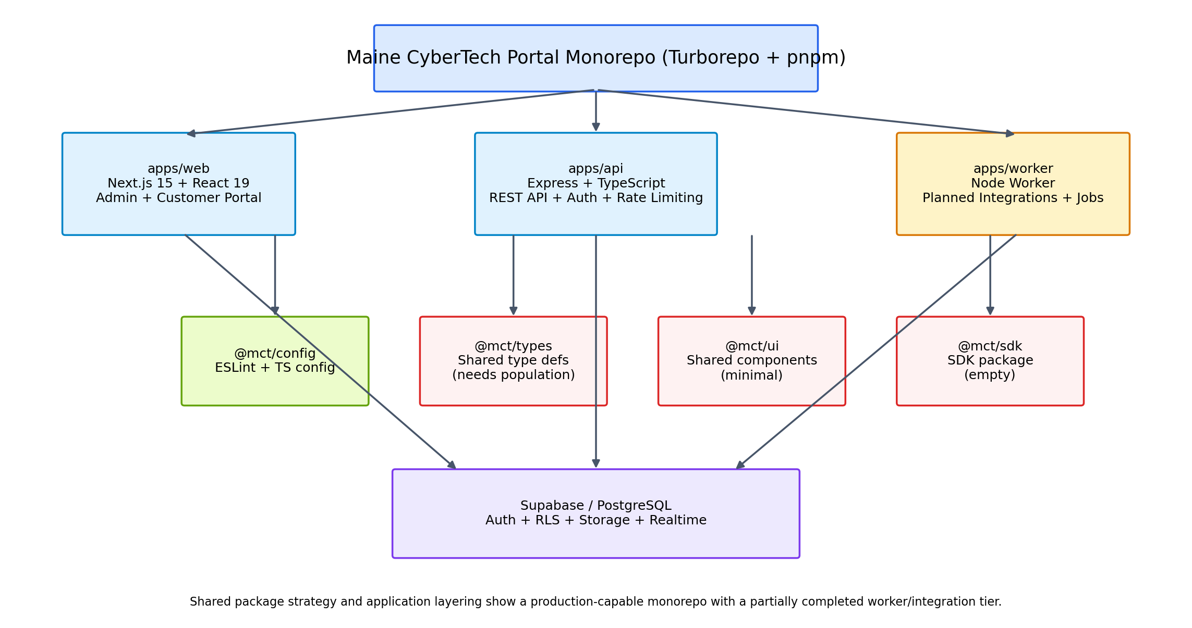
Figure 1. Monorepo architecture: web, API, worker, shared packages, and Supabase/PostgreSQL foundation.

Application Layers
The current application composition can be summarized as follows:
- apps/web: Next.js 15 + React 19 admin dashboard and customer portal routes
- apps/api: Express.js + TypeScript REST API with auth, logging, security middleware, and validation
- apps/worker: Node.js worker framework reserved for asynchronous integrations and scheduled jobs
- @mct/config: active shared build/lint configuration
- @mct/types: intended shared types package, currently needing population
- @mct/ui: intended shared component library, currently minimal
- @mct/sdk: empty SDK package that should be removed or implemented

Current Production-Ready Status

Ready Now
- Frontend / web app: complete admin dashboard and customer portal UI
- API / backend: RESTful service with security, rate limiting, logging, and error handling
- Database: Supabase PostgreSQL with authentication, migrations, and RLS policies
- Testing baseline: Jest configured with coverage thresholds
- CI/CD baseline: lint, test, and build workflows present
- Documentation baseline: README plus codebase analysis and migration / verification material

Partially Complete / Gaps
- Worker tasks remain framework-only and need Stripe, Jira/JSM, M365, and notification logic implemented
- Deployment automation is incomplete, particularly the API deployment workflow and final hosting/orchestration steps
- Shared packages strategy is not fully realized: types, UI, and SDK areas are incomplete or placeholder-level
- Infrastructure-as-code is not established because infra/terraform is still empty
- Repository cleanup is still needed due to obsolete Supabase history, caches, and duplicate archive artifacts
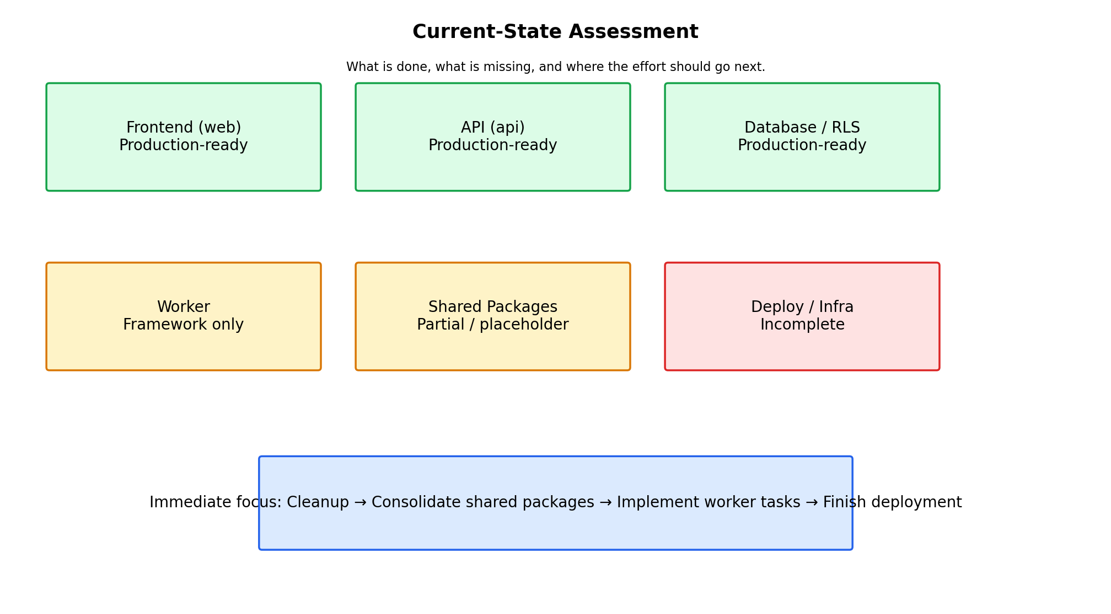
Figure 2. Current-state assessment of platform maturity by major area.

Action-Plan Roadmap
The uploaded action-plan and codebase analysis docs describe a phased completion roadmap. The recommended order is cleanup first, consolidation second, completion of missing technical work third, and documentation refinement fourth.
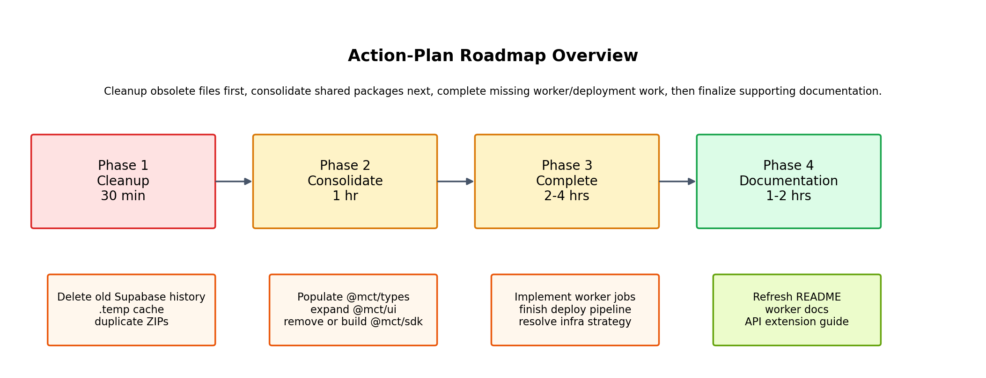
Figure 3. Phase-based roadmap derived from the uploaded action-plan documents.

Phase 1 — Cleanup (≈30 minutes)
- Delete old migrations, patches, and seeds kept under legacy / Old paths
- Delete Supabase CLI temporary cache (.temp)
- Delete duplicate ZIP archives where extracted content is already present
- Remove legacy root artifacts such as package-lock.json if pnpm is the active package manager

Phase 2 — Consolidate (≈1 hour)
- Populate packages/types with shared request, response, and domain types
- Move reusable components into packages/ui and define a consistent shared component API
- Decide whether packages/sdk should be deleted or turned into a real client SDK
- Tighten dependency placement so app-specific packages are not unnecessarily left in the workspace root

Phase 3 — Complete (≈2–4 hours)
- Implement background worker tasks for Stripe reconciliation, Jira/JSM sync, M365 sync, and notifications
- Finish deployment automation in GitHub Actions and align the runtime target (AWS ECS/ECR or another hosting path)
- Decide whether Terraform should be introduced or the empty infra path should be removed
- Add representative test coverage for key frontend and backend paths

Phase 4 — Documentation (≈1–2 hours)
- Refresh the root README with architecture and troubleshooting guidance
- Preserve the codebase mapping and action plan as implementation references
- Add worker implementation and API extension guides
- Retain a formal handoff artifact and admin guide for future contributors

Platform Architecture and Security Model
The platform follows a consistent access chain: auth identity → profile → membership → role → permissions / overrides → row-level security → storage. The security model is database-native, meaning the database decides whether rows and file objects can be returned or changed, rather than relying on the frontend alone to hide unauthorized actions.
- Profiles represent the application-facing identity layer
- Memberships attach a user to an organization and enforce approval state
- Roles define broad access tiers and map to fine-grained permissions
- User permission overrides allow exceptions when role defaults are not enough
- RLS policies enforce those rules across business modules
- Storage policies align file access to the matching document metadata and permission checks

Business Modules Implemented
- Onboarding submissions and intake tracking
- Support tickets and ticket comments
- Projects, project tasks, project updates, task comments, and comment read tracking
- Document management with visibility control, versions, and explicit share rules
- Contracts and contract signer tracking
- Appointments and scheduling data
- Billing mirror tables for customers, subscriptions, invoices, and payments
- Chat threads and messages
- Audit logs for traceability and investigation

Portfolio / Case Study Narrative

Platform Scope
The platform was built to solve a broader operational problem than a simple support portal. It brings customer onboarding, service delivery, project coordination, secure document handling, contracts, billing visibility, messaging, and auditability into a single tenant-aware system.

Security Architecture
What makes the build distinctive is that security is not bolted on after the UI is complete. The tenant model, role model, permission model, row-level security, and storage policies were designed as core platform primitives. That gives the system stronger tenant separation, better auditability, and safer file handling than a portal that relies only on frontend checks.

Engineering Maturity
The codebase analysis indicates strong maturity in the frontend, backend API, database, documentation, and CI/CD test/build layers. The main maturity gaps are in asynchronous worker tasks, final deployment automation, and shared package consolidation. This is a healthy state for a platform that has reached architectural maturity before full operational polish.

Roadmap
The roadmap is now clear and bounded: cleanup obsolete repository artifacts, consolidate shared packages, complete worker/deployment work, and finalize supporting documentation. Because the application core and security model are already solid, the remaining work is mostly operationalization rather than architectural rework.

Technical Appendix

A. Core Monorepo Components
- apps/web: admin dashboard, portal pages, auth callback, SSR integrations
- apps/api: Express entrypoint, middleware, health endpoint, dashboard endpoint, security middleware
- apps/worker: task framework with TODO integrations
- @mct/config: shared TS / ESLint config
- @mct/types / @mct/ui / @mct/sdk: strategic shared packages requiring follow-on work

B. Schema / Security Foundations
- organizations, profiles, roles, permissions, role_permissions, memberships, user_permission_overrides
- documents, document_versions, document_permissions, storage policy alignment
- module tables for onboarding, tickets, projects, contracts, appointments, billing, chat, and audit
- helper functions for profile bootstrap, super-admin checks, organization checks, role checks, and permission checks
- RLS enabled broadly across core business tables

C. Exact Live-Shape Notes Used in Final Seed Alignment
- documents requires organization_id, uploaded_by, name, storage_bucket, and storage_path, with optional title/description/file_name/file_size fields
- document_versions requires document_id, version_number, storage_path, and uploaded_by
- document_permissions supports both role-based and user-based entries with can_view/can_edit/can_share flags
- memberships is unique on organization_id + user_id
- documents is unique on storage_path
- document_versions is unique on document_id + version_number
- roles.key is the canonical role lookup column

D. Handoff Recommendations
- Treat the current platform as architecturally ready but operationally incomplete in worker/deploy/shared package areas
- Use the final exact seed and verify artifacts to validate target environments
- Keep approved memberships as the activation boundary for real access
- Reserve global super-admin rights for a very small operator set
- Finish package consolidation before significant additional feature work if cross-app reuse is a priority
- Resolve deployment and worker implementation before calling the platform fully operationalized

